Wine quality prediction using Regression and Classification Model
Stathopoulou Anna
mscaidl-0123

In this project, we focus on predicting red wine quality using acidity, pH, alcohol, sulphates and other physicochemical features. On this dataset a regression model to predict wine quality score and a classification model to categorize the wines as “good” or “not good” was developed.
For the regression task two models were tested:
- Linear Regression
- Random Forest Regression
Also, for the classification task two models were tested:
- Logistic Regression
- Random Forest Classifier

Exploratory Data Analysis (EDA)

Dataset Overview
Firstly the csv was imported in the project code and the command dataset.head() was used to view the first rows of data and confirm that the dataset was loaded correctly. Also, dataset.info() was used to provide an overview of the variables with their data type and lastly dataset.describe() was used to view display statistics such as mean maximum, minimum etc.
Image 1. First 5 rows of dataset
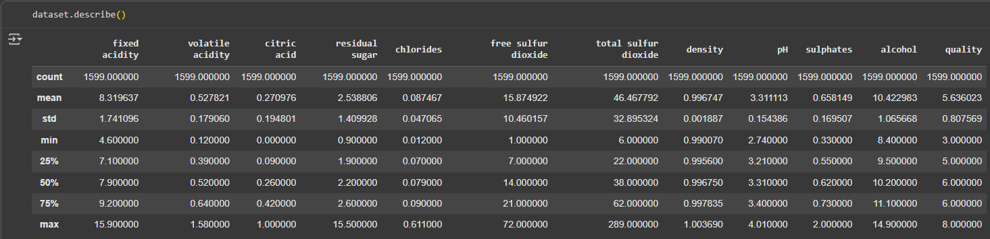
Image 2. Statistics (count, mean, max, min etc.)

Plots
After successfully loading the dataset, the EDA was extended with visualizations. Firstly, boxplots of the physicochemical features was generated to detect outliers and observe the way the data spread. Features such as volatile acidity, citric acid, chlorides, pH, density, sulphates are distributed with a few outliers as shown on the plot below. Other features such as residual sugar and free sulfur dioxide show a large number of outliers and especially total sulfur dioxide reaches extreme value of 300mg/L. Lastly fixed acidity and alcohol show a medium spread with a few outliers. Several variables have extreme values which may negatively impact the linear model.
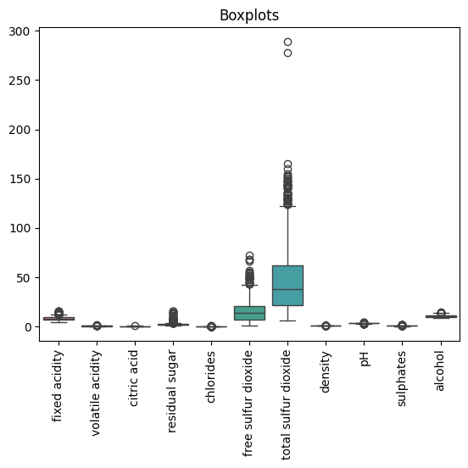
Image 3. Features - Boxplots

In addition, the distribution of wine quality was examined and as shown below the majority of wines are rated as 5 or 6, while extreme values (below 5 and above 6) are rare showing an imbalance of the dataset. In cases like this the regression model may be biased by majority classes so the its performance will be displayed in the evaluation metrics.
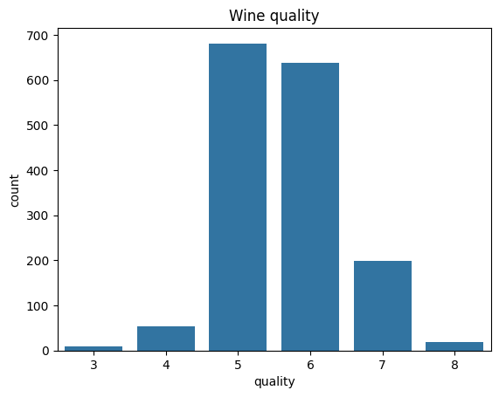
Image 4. Wine quality distribution

Following the analysis, the correlation matrix shows the connection between physicochemical features and wine quality. For example, alcohol shows a positive correlation with quality (0.48) showing that higher alcohol levels are generally associated with higher quality wines. Volatile acidity has a negative correlation with quality (−0.39), meaning that higher levels of volatile acidity correspond to lower ratings. Also, other features such as citric acid (0.23) and sulphates (0.25) show moderate positive connections. Overall, the correlation matrix shows that features such as volatile acidity, alcohol and sulphates are the attributes that affect the wine quality the most.

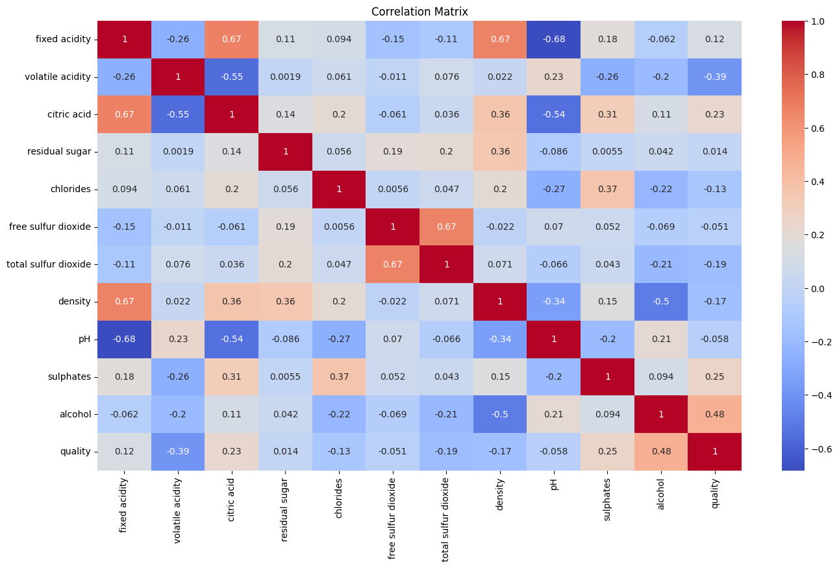
Image 5. Correlation Matrix

Regression

Linear Regression
After splitting the dataset into training (80%) and testing (20%) subsets, the linear regression model was trained and was then evaluated using regression metrics. The results are as follows:
Mean Absolute Error (MAE) = 0.49,
Mean Squared Error (MSE) = 0.40,
Root Mean Squared Error (RMSE) = 0.63,
R² = 0.41
From these values we understand that the model’s predictions diverge from the true quality score by about half a point. However, the low R² value suggests that the model explains only about 40% of the variance in wine quality. This result demonstrates that underfitting occurs when wine quality is not adequately determined by plain linear relationship between the features.
Τhe performance of the model was also visualized through the following plot of true versus predicted quality. In this plot the red line is the perfect prediction and the blue dots indicate the predictions of the model with the x-axis as “True quality” and y-axis as “Predicted quality”. It is obvious that many predictions fall above or below the line and are concentrated mostly around values 5-6 as expected. Also, on extreme values (e.g 3,8) the dispersion from the perfect prediction line is greater showing that the model struggles a lot with minority classes. All the above were expected considering the results on the regressions metrics.
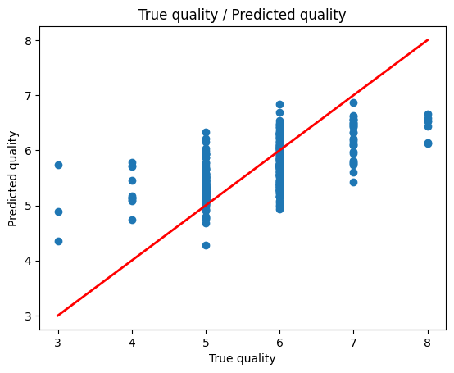
Image 6. Plot of true vs predicted quality – Linear Regression

Random Forest Regression
Random Forest Regression was used to improve the limitations of Linear Regression because Random Forest is more robust to outliers that we had to deal with with the Linear Regression. After splitting the dataset into training (80%) and testing (20%) subsets, we trained the random forest regressor model and was then evaluated using regression metrics. The metrics were:
Mean Absolute Error (MAE) = 0.43,
Mean Squared Error (MSE) = 0.35,
Root Mean Squared Error (RMSE) = 0.59,
R² = 0.47.
From the above result it is understood that the mean absolute error is decreased compared to the linear regression. This means that Random Forest predicts the wine quality more precisely with a small diversion less than a point. Also the mean squared error has also decreased from 0.40 to 0.35 which means that Random Forest not only improves the overall prediction accuracy but it also can handle large error more effectively. Lastly the RMSE is also lower compared to Linear Regression which means that the model can handle outliers better. The increase in R² from 0.40 to 0.48 shows that the model explains variance in wine quality better. All the above results make clear that Random Forest (non-linear model) is more suitable for this dataset as wine quality depends on complex interactions between the features so it is more difficult to capture these interactions with a simple linear model.
Τhe performance of the Random Forest Regression model was also visualized through the following plot of true versus predicted quality. In this plot the red line is the perfect prediction and the green dots indicate the predictions of the Random Forest model with the x-axis as “True quality” and y-axis as “Predicted quality”. It is obvious that compared to Linear Regression many predictions are more tightly concentrated on the diagonal showing better accuracy. Also, on extreme values (e.g 3,8) there are still deviations but overall the spread is smaller and predictions are not as biased as on the Linear Regression model for the majority classes. All the above were expected considering the results on the regressions metrics.
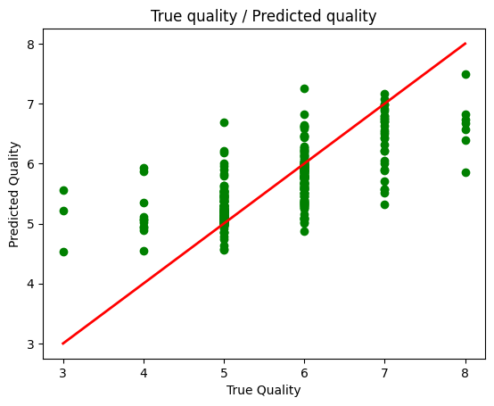
Image 7. Plot of true vs predicted quality – Random Forest

The overall comparison of the regression metrics in each model are shown below:
Regression Results
Model | MAE | MSE | RMSE | R²
Linear Regression | 0.49 | 0.40 | 0.63 | 0.41
Random Forest Regressor | 0.43 | 0.35 | 0.59 | 0.47
Table 1. Regression results of Linear Regression and Random Forest Regressor

Classification

Logistic Regression
For the Classification, the physiochemical features were kept as X and a new column “Label” was assigned to mark the wine as “Good” = 1 and “Not good” = 0. The class distribution was calculated using dataset['label'].value_counts(normalize=True) which showed that approximately 86% of wines are labeled as “Not good” and 14% as “Good”.
The dataset was split in a subset of 80% for training and 20% subset for testing using stratify to keep the class distribution 80%-20% across both subsets. A Logistic Regression model was trained and 5 fold cross validation with F1 score was applied. Choosing accuracy would be misleading in this imbalanced dataset because the model can achieve high accuracy by predicting the majority classes only and fail to predict the minority one. The F1 scores across the folds were:
- Fold 1: 0.59
- Fold 2: 0.45
- Fold 3: 0.56
- Fold 4: 0.36
- Fold 5: 0.57
With mean F1 score of approximately 0.51.
The above variation of values from 0.36 to 0.59 shows that the model is unstable and depends a lot on the particular data split each time which means that Logistic Regression struggles to generalize on imbalanced dataset.
Also, for evaluation of the model a confusion matrix was generated which shows the correct and uncorrect predictions for each class. The model correctly classified 227 wines as “Not Good” and 35 wines as “Good”. However, the model wrongly predicted 50 wines as “Good” and 8 wines as “Not good”. From the above it is obvious that the model can predict better the “Not good” wines because of the class imbalance of the dataset.

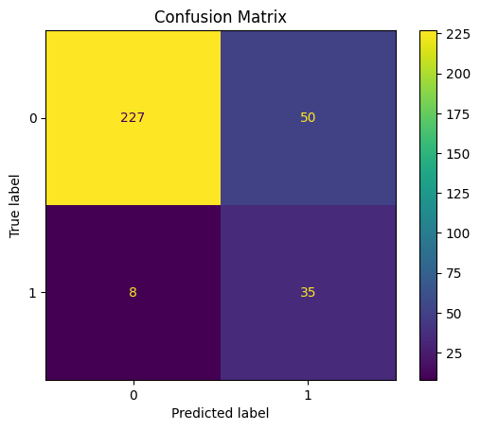
Image 8. Confusion Matrix using Logistic Regression

The results were also evaluated using precision, recall, F1 and accuracy. The model performed well for “Not good” wines with precision 0.97 and recall 0.82. However, it did not perform well for “Good” wines with accuracy 0.41, recall 0.81 and F1 of 0.55. The high recall shows that it successfully identified most of the good wines but it also misclassified 50 not good wines as good (precision 0.41).
Class | Precision | Recall | F1 | Support
0 | 0.97 | 0.82 | 0.89 | 277
1 | 0.41 | 0.81 | 0.55 | 43
Accuracy |  |  | 0.82 | 320
Macro avg | 0.69 | 0.82 | 0.72 | 320
Weighted avg | 0.89 | 0.82 | 0.84 | 320
Table 2. Classification results using Logistic Regression

Random Forest Classifier
To address the problems of Logistic Regression, the Random Forest classifier was implemented because it combines many decision trees each one trained to random subsets of the data. This method reduces variance and makes the model generalize more on the data making it more robust. To enhance the performance hypermarameters were used. Specifically n_estimators=500, max_depth=12, min_samples_leaf=5, min_samples_split=10, max_features=’sqrt’, class_weight={0:1,1:4} (to give importance to minority class) were used. With the above the accuracy of the model went from 0.82 to 0.92. Also, the model performed better on the minority class with precision going from 0.41 on Logistic Regression to 0.72 on Random Forest Classifier and better F1 score (0.68).
Class | Precision | Recall | F1 | Support
0 | 0.95 | 0.96 | 0.95 | 277
1 | 0.72 | 0.65 | 0.68 | 43
Accuracy |  |  | 0.92 | 320
Macro avg | 0.83 | 0.81 | 0.82 | 320
Weighted avg | 0.92 | 0.92 | 0.92 | 320
Table 3. Classification results using Random Forest Classifier

Although on the 5-fold cross validation the mean F1 score got lower than Logistic Regression (from 0.51 to 0.49), it shows that the Random Forest Classifier with the hyperparameters is still performing better that the Logistic Regression.
The model correctly classified 266 wines as “Not Good” and 28 wines as “Good”. However, the model wrongly predicted 11 wines as “Good” and 15 wines as “Not good”. From the above it is clear that the model generalizes better and performs better at predicting correctly the minority class.
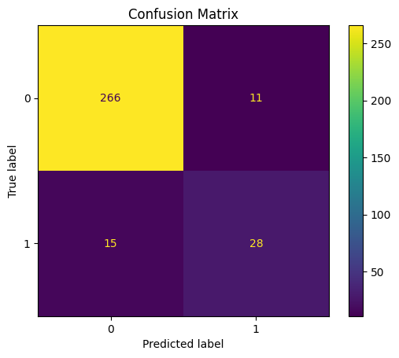
Image 9. Confusion Matrix using Random Forest Classifier

