Project #2

For my second project I would like to create a game with a Farm theme. A farmer has to go and pick up carrots, and other veggies. However, the rabbit jumps out and eats the carrot if you take too long to harvest the filed.

I did some research and found this website as my base <https://gamedevacademy.org/create-a-mobile-html5-farming-game/>.  
*I am be aiming to go a harder rout with this project.*

The name of the game will be HarvestTime and it will have an agricultural theme and backgrounds.

The players job is to pick as many veggies as he can during the time period while destroying the rabbit.

The canvas will be broken into the squares for each plant, player walks around on the perimeters of those squares (lanes of plants) and picks plants, once he sees the rabbit or a beaver showing up – he needs to run and kick him out so the harvest stays in place.

Each veg will cost certain amount of money. Players job is to pick as many expensive plants as possible at the same time getting rid of obstacles such as sneaky rabbit.

As to objects , I am thinking to brake the canvas with a Grid , have a bucket where the veg will fly into, a money jar or a piggy bank, a farmer who is a player, and a few animals such a rabbit , a beaver, a crow etc.

I don’t have a scanner so doing my hand drawing in Paint

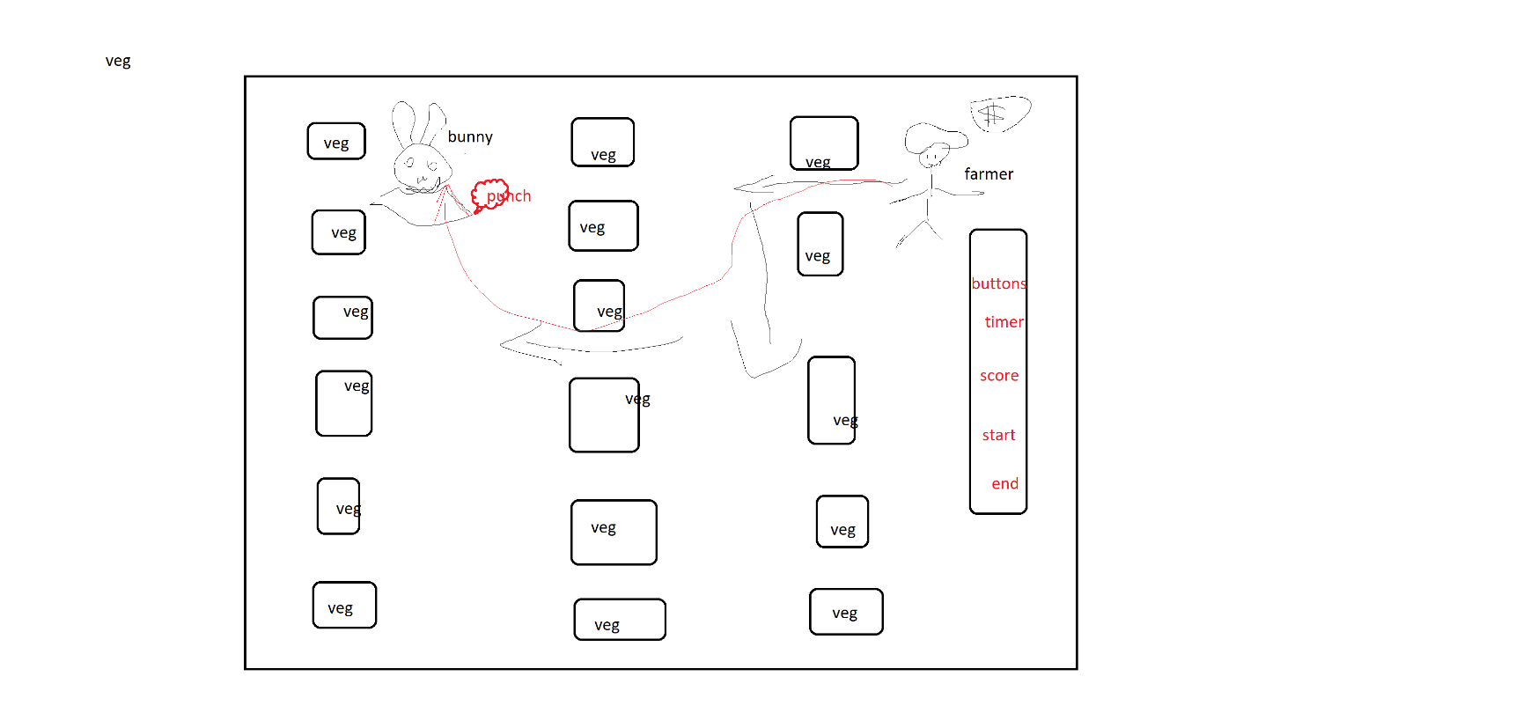

At the border / perimeter of the field ill put bushes, so the farmer can’t run off the screen, and if he tries specific sound will play.

As to sounds I will need to find some animal sounds, eating , crunching and chee-cheeing for money flying into the piggy bank