|  |  |
| --- | --- |
| Title | **A two-part, Phase 1b/2a study to investigate the safety and efficacy of topical Medi‑Solfen for wound analgesia and antisepsis, when used prior to Standard of Care (SOC) (including suture repair) of small to medium, simple skin lacerations in adults** |
| Author: | Oleksandr Savuliak  Junior Statistician |
|  |  |
| Reviewed: | Marius Ardelean  Senior Statistician |
|  |  |
| Approved: | Anna Zaremba  Statistical Programmer |

1. Check library loading correctness:

library(dplyr)

##   
## Attaching package: 'dplyr'

## The following objects are masked from 'package:stats':  
##   
## filter, lag

## The following objects are masked from 'package:base':  
##   
## intersect, setdiff, setequal, union

library(ggplot2)  
library(DBI)  
library(RSQLite)  
library(rmarkdown)  
library(writexl)  
  
  
if (!all(c("dplyr", "ggplot2", "DBI", "RSQLite", "rmarkdown", "writexl") %in% .packages())) {  
 stop("Some libraries failed to load.")  
} else {  
 cat("All libraries loaded successfully.\n")  
}

## All libraries loaded successfully.

1. Simulate the data and display header:

set.seed(123)  
simulated_data <- data.frame(  
 ID = 1:100,  
 Group = sample(c("Control", "Treatment"), 100, replace = TRUE),  
 Age = round(runif(100, 20, 60), 0),  
 Score_Pre = round(runif(100, 50, 80), 1),  
 Score_Post = round(runif(100, 60, 90), 1)  
)  
  
head(simulated_data)

## ID Group Age Score_Pre Score_Post  
## 1 1 Control 44 57.2 83.5  
## 2 2 Control 33 78.9 60.3  
## 3 3 Control 40 68.0 83.4  
## 4 4 Treatment 58 65.5 81.9  
## 5 5 Control 39 62.1 78.9  
## 6 6 Treatment 56 76.4 74.4

1. Data manipulation:

* Create a new column for score difference
* Merge the data with a new table
* Filter for Treatment group only
* Display header.

manipulated_data <- simulated_data %>%  
 mutate(Score_Diff = Score_Post - Score_Pre)  
  
extra_data <- data.frame(  
 ID = sample(1:100, 50),  
 Extra_Info = sample(c("High", "Low"), 50, replace = TRUE)  
)  
merged_data <- manipulated_data %>%  
 left_join(extra_data, by = "ID")  
  
filtered_data <- merged_data %>%  
 filter(Group == "Treatment")  
  
head(filtered_data)

## ID Group Age Score_Pre Score_Post Score_Diff Extra_Info  
## 1 4 Treatment 58 65.5 81.9 16.4 <NA>  
## 2 6 Treatment 56 76.4 74.4 -2.0 <NA>  
## 3 7 Treatment 57 60.9 64.7 3.8 <NA>  
## 4 8 Treatment 44 58.6 60.2 1.6 High  
## 5 11 Treatment 57 64.5 71.7 7.2 Low  
## 6 12 Treatment 32 57.6 73.9 16.3 Low

1. Statistical analysis:

* Perform a t-test on Score_Diff between Control and Treatment groups.

t_test_result <- t.test(  
 Score_Diff ~ Group,  
 data = manipulated_data  
)  
print(t_test_result)

##   
## Welch Two Sample t-test  
##   
## data: Score_Diff by Group  
## t = -1.19, df = 91.246, p-value = 0.2371  
## alternative hypothesis: true difference in means between group Control and group Treatment is not equal to 0  
## 95 percent confidence interval:  
## -7.727674 1.937384  
## sample estimates:  
## mean in group Control mean in group Treatment   
## 8.935088 11.830233

* Perform a linear regression and ANOVA on Score_Pre and Score_Post.

regression_model <- lm(Score_Post ~ Score_Pre + Group, data = simulated_data)  
summary(regression_model)

##   
## Call:  
## lm(formula = Score_Post ~ Score_Pre + Group, data = simulated_data)  
##   
## Residuals:  
## Min 1Q Median 3Q Max   
## -15.5992 -7.2040 -0.1892 7.3229 15.9709   
##   
## Coefficients:  
## Estimate Std. Error t value Pr(>|t|)   
## (Intercept) 69.54978 6.59136 10.552 <2e-16 ***  
## Score_Pre 0.06418 0.10016 0.641 0.523   
## GroupTreatment 2.48833 1.77812 1.399 0.165   
## ---  
## Signif. codes: 0 '***' 0.001 '**' 0.01 '*' 0.05 '.' 0.1 ' ' 1  
##   
## Residual standard error: 8.8 on 97 degrees of freedom  
## Multiple R-squared: 0.02342, Adjusted R-squared: 0.003287   
## F-statistic: 1.163 on 2 and 97 DF, p-value: 0.3168

* Perform ANOVA on Score_Post between Control and Treatment groups.

anova_result <- aov(Score_Post ~ Group, data = simulated_data)  
summary(anova_result)

## Df Sum Sq Mean Sq F value Pr(>F)  
## Group 1 148 148.38 1.927 0.168  
## Residuals 98 7544 76.98

1. Graphical representation:

scatter_plot <- ggplot(simulated_data, aes(x = Score_Pre, y = Score_Post, color = Group)) +  
 geom_point() +  
 labs(title = "Score Pre vs Post", x = "Score Pre", y = "Score Post") +  
 theme_minimal()  
print(scatter_plot)

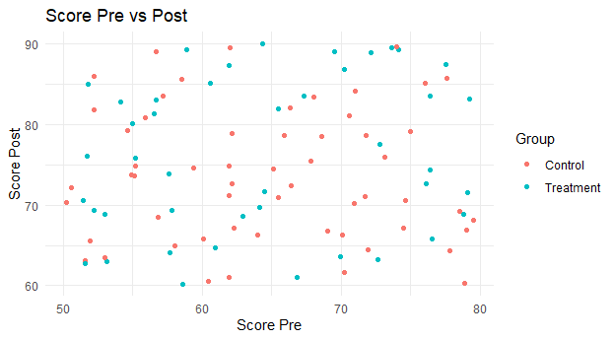

1. Check correctness of data export as .png and subsequent reporting:

# Save the plot  
ggsave("scatter_plot.png", scatter_plot, width = 6.5, height = 3.6)

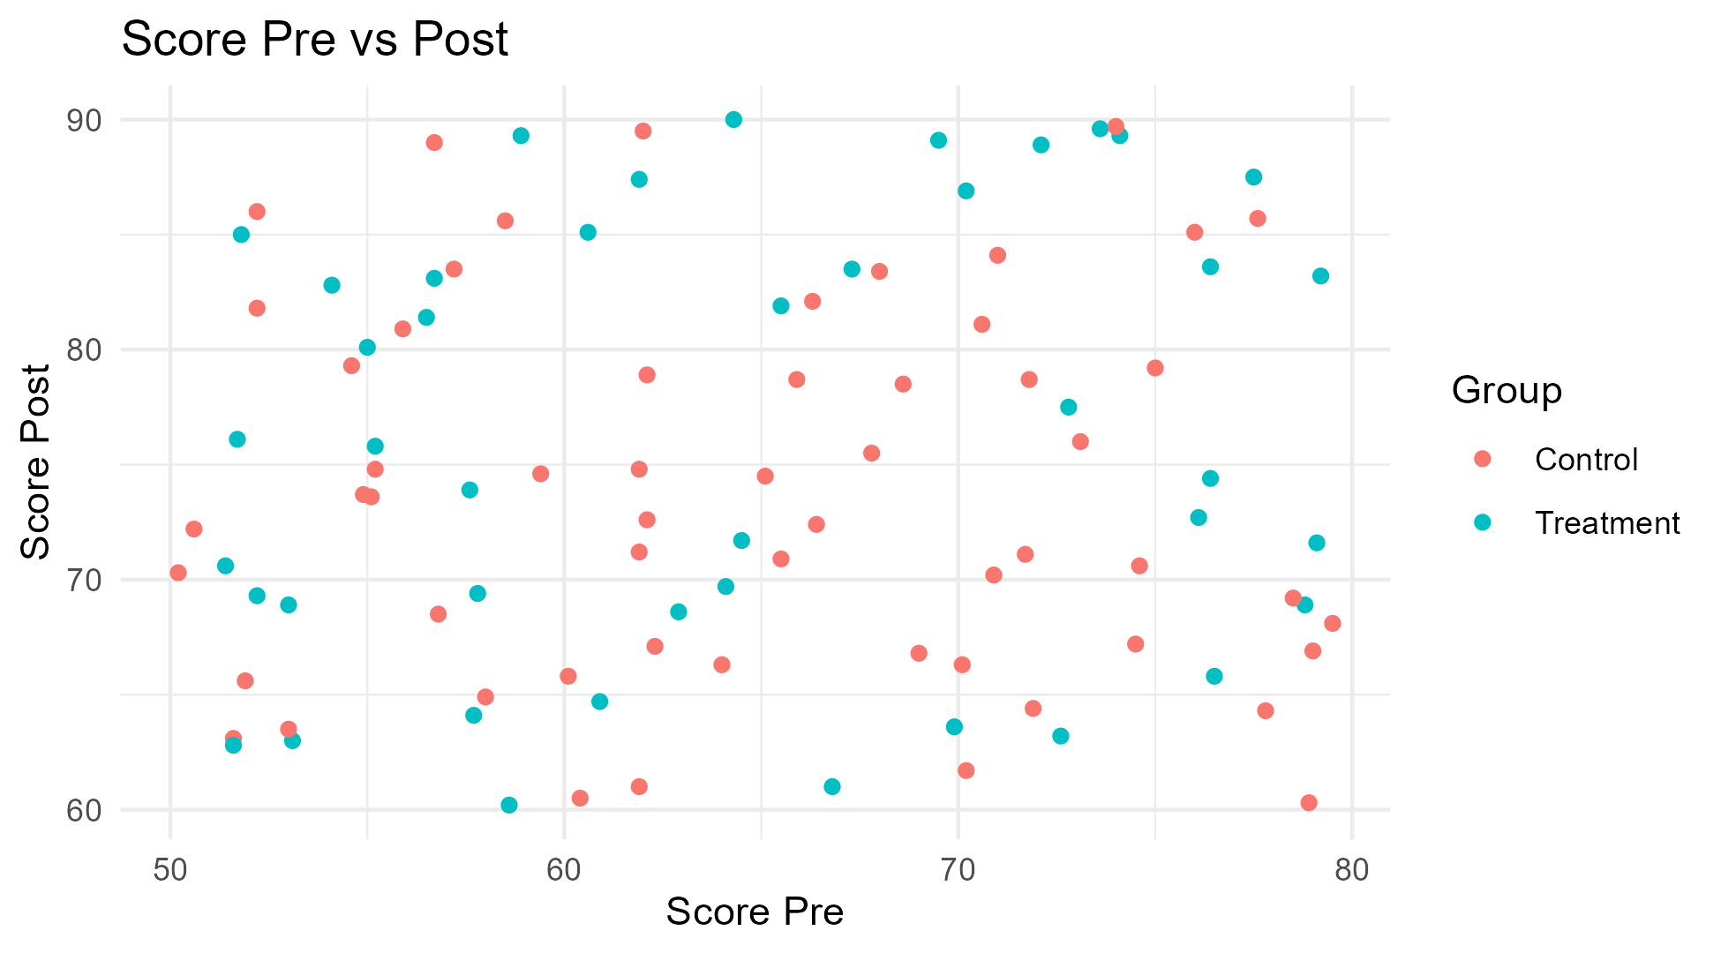

Scatter plot of Score Pre vs Post

1. Check correctness of data export as .xlsx:

# 5. Data Export and Reporting  
# Export data to Excel  
write_xlsx(manipulated_data, "manipulated_data.xlsx")  
  
# Check if the file exists in the current working directory  
if (file.exists("manipulated_data.xlsx")) {  
 cat("The file 'manipulated_data.xlsx' exists in the working directory.\n")  
} else {  
 cat("The file 'manipulated_data.xlsx' does NOT exist in the working directory.\n")  
}

## The file 'manipulated_data.xlsx' exists in the working directory.