PQ Report

1. Import data as a dataframe:

library(medicaldata)  
data <- medicaldata::strep_tb  
  
if (is.data.frame(data)) {  
 message("The data is a data frame.")  
} else {  
 message("The data is not a data frame.")  
}

## The data is a data frame.

## # A tibble: 6 × 13  
## patient_id arm dose_strep_g dose_PAS_g gender baseline_condition  
## <chr> <fct> <dbl> <dbl> <fct> <fct>   
## 1 0001 Control 0 0 M 1_Good   
## 2 0002 Control 0 0 F 1_Good   
## 3 0003 Control 0 0 F 1_Good   
## 4 0004 Control 0 0 M 1_Good   
## 5 0005 Control 0 0 F 1_Good   
## 6 0006 Control 0 0 M 1_Good   
## # ℹ 7 more variables: baseline_temp <fct>, baseline_esr <fct>,  
## # baseline_cavitation <fct>, strep_resistance <fct>, radiologic_6m <fct>,  
## # rad_num <dbl>, improved <lgl>

1. Validate that all 13 variables and 107 rows are intact:

if (nrow(data) == 107 & ncol(data) == 13) {  
 message("The dataset has 107 rows and 13 columns, as expected.")  
} else {  
 message("The dataset does not have the expected number of rows or columns.")  
}

## The dataset has 107 rows and 13 columns, as expected.

1. Baseline summary table is generated correctly by arm:

baseline_summary <- data %>%  
 select(arm, gender, baseline_condition, baseline_temp, baseline_esr, baseline_cavitation) %>%  
 tbl_summary(  
 by = arm,  
 statistic = list(  
 all_continuous() ~ "{mean} ({sd})",  
 all_categorical() ~ "{n} ({p}%)"  
 ),  
 missing = "no"  
 ) %>%  
 add_p() %>%  
 modify_header(label = "**Variable**") %>%  
 bold_labels() %>%   
 as_flex_table() %>%  
 flextable::theme_vanilla() %>%   
 flextable::set_table_properties(width = 1.0, layout = "autofit") %>%  
 flextable::align(align = "left", part = "body") %>% # Left-align body text  
 flextable::align(align = "left", part = "header")   
  
baseline_summary

| **Variable** | **Streptomycin  N = 551** | **Control  N = 521** | **p-value2** |
| --- | --- | --- | --- |
| **gender** |  |  | 0.8 |
| F | 31 (56%) | 28 (54%) |  |
| M | 24 (44%) | 24 (46%) |  |
| **baseline_condition** |  |  | 0.7 |
| 1_Good | 8 (15%) | 8 (15%) |  |
| 2_Fair | 17 (31%) | 20 (38%) |  |
| 3_Poor | 30 (55%) | 24 (46%) |  |
| **baseline_temp** |  |  | 0.8 |
| 1_98-98.9F | 3 (5.5%) | 4 (7.7%) |  |
| 2_99-99.9F | 13 (24%) | 12 (23%) |  |
| 3_100-100.9F | 15 (27%) | 17 (33%) |  |
| 4_100F+ | 24 (44%) | 19 (37%) |  |
| **baseline_esr** |  |  | 0.6 |
| 1_0-10 | 0 (0%) | 0 (0%) |  |
| 2_11-20 | 3 (5.5%) | 2 (3.9%) |  |
| 3_21-50 | 16 (29%) | 20 (39%) |  |
| 4_51+ | 36 (65%) | 29 (57%) |  |
| **baseline_cavitation** | 32 (58%) | 30 (58%) | >0.9 |
| 1n (%) | | | |
| 2Pearson's Chi-squared test; Fisher's exact test | | | |

1. Mixed-effects model runs correctly to assess predictors of radiologic improvement

mixed_model <- lm(  
 rad_num ~ arm * baseline_condition + gender,  
 data = data  
)  
  
# Save Model Results  
mixed_model_results <- broom.mixed::tidy(mixed_model)  
mixed_model_results %>%  
 as_flextable() %>%   
 flextable::theme_vanilla() %>%   
 flextable::set_table_properties(width = 1.0, layout = "autofit") %>%  
 flextable::align(align = "left", part = "body") %>% # Left-align body text  
 flextable::align(align = "left", part = "header")

| **term** | **estimate** | **std.error** | **statistic** | **p.value** |
| --- | --- | --- | --- | --- |
| **character** | **numeric** | **numeric** | **numeric** | **numeric** |
| (Intercept) | 5.8 | 0.5 | 12.0 | 0.0 |
| armControl | -0.7 | 0.7 | -1.1 | 0.3 |
| baseline_condition2_Fair | -0.8 | 0.6 | -1.5 | 0.1 |
| baseline_condition3_Poor | -1.9 | 0.5 | -3.7 | 0.0 |
| genderM | 0.4 | 0.3 | 1.6 | 0.1 |
| armControl:baseline_condition2_Fair | -0.3 | 0.8 | -0.4 | 0.7 |
| armControl:baseline_condition3_Poor | -1.7 | 0.7 | -2.3 | 0.0 |
| n: 7 | | | | |

1. Group comparison summary for radiologic outcomes by arm

comparison_results <- data %>%  
 group_by(arm) %>%  
 summarise(  
 mean_rad_num = mean(rad_num, na.rm = TRUE),  
 sd_rad_num = sd(rad_num, na.rm = TRUE),  
 improved_rate = mean(improved, na.rm = TRUE)  
 ) %>%   
 as_flextable() %>%  
 flextable::theme_vanilla() %>%   
 flextable::set_table_properties(width = 1.0, layout = "autofit") %>%  
 flextable::align(align = "left", part = "body") %>% # Left-align body text  
 flextable::align(align = "left", part = "header")   
comparison_results

| **arm** | **mean_rad_num** | **sd_rad_num** | **improved_rate** |
| --- | --- | --- | --- |
| **factor** | **numeric** | **numeric** | **numeric** |
| Streptomycin | 4.7 | 1.7 | 0.7 |
| Control | 3.1 | 1.7 | 0.3 |
| n: 2 | | | |

1. Radiologic response boxplot and predicted interaction effects plot are generated

plot1 <- data %>%  
 ggplot(aes(x = baseline_condition, y = rad_num, fill = arm)) +  
 geom_boxplot() +  
 labs(  
 title = "Radiologic Response by Baseline Condition and Arm",  
 x = "Baseline Condition",  
 y = "Radiologic Response"  
 ) +  
 theme_minimal()  
  
interaction_effects <- ggeffects::ggpredict(mixed_model, terms = c("arm", "baseline_condition"))  
plot2 <- interaction_effects %>%  
 plot() +  
 labs(  
 title = "Predicted Effects: Arm x Baseline Condition",  
 x = "Baseline Condition",  
 y = "Predicted Radiologic Response"  
 ) +  
 theme_minimal()  
  
combined_plot <- plot1 + plot2 + plot_layout(ncol = 1)  
combined_plot

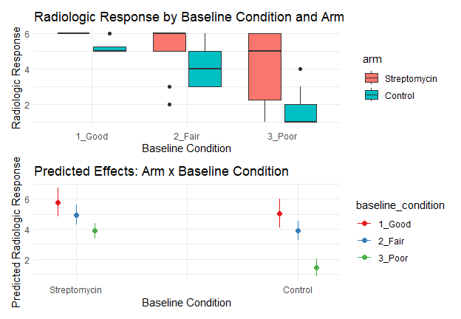

Combined plot: Radiologic response by baseline condition and arm and predicted effects of arm x baseline condition.

7 Logistic regression, mixed model and Kaplan-Meier survival analysis run and produce plots.

# Logistic regression effect plot  
log_plot <- ggplot(data, aes(x = arm, y = improved, color = gender)) +  
 geom_jitter(width = 0.2, height = 0) +  
 stat_smooth(method = "glm", method.args = list(family = "binomial"), se = TRUE) +  
 theme_minimal() +  
 labs(title = "Logistic Regression Effect Plot", y = "Probability of Improvement")  
  
# Kaplan-Meier survival plot  
if (!"time" %in% colnames(data)) {  
 set.seed(123)  
 data$time <- sample(1:365, nrow(data), replace = TRUE) # Random time-to-event data  
 data$status <- sample(0:1, nrow(data), replace = TRUE) # Random censoring data  
}  
surv_fit <- survfit(Surv(time, status) ~ arm, data = data)  
  
km_plot <- ggsurvplot(surv_fit, data = data,   
 palette = c("blue", "red"),   
 pval = TRUE,   
 title = "Kaplan-Meier Survival Analysis")   
km_plot$plot <- km_plot$plot + theme_minimal()  
  
  
# Mixed model diagnostic plot  
diag_plot <- ggplot(data, aes(x = baseline_condition, y = rad_num, color = arm)) +  
 geom_boxplot() +  
 facet_wrap(~ gender) +  
 theme_minimal() +  
 labs(title = "Radiologic Response by Baseline Condition and Treatment Arm")  
  
# Combine all plots  
combined_plot <- ggarrange(  
 log_plot, km_plot$plot, diag_plot,  
 ncol = 1, nrow = 3, labels = c("A", "B", "C")  
)

## `geom_smooth()` using formula = 'y ~ x'

combined_plot

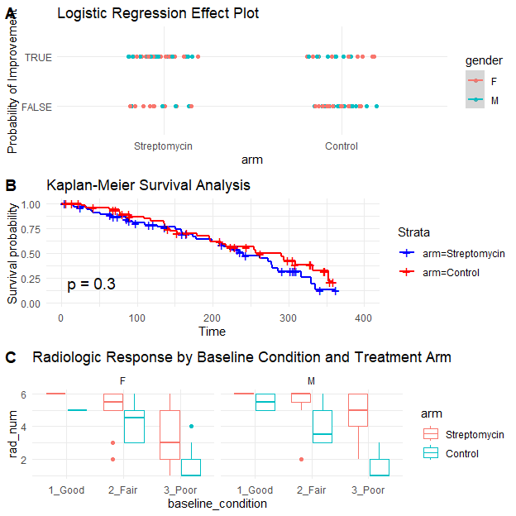

Combined plot: Logistic regression effect plot, Kaplan-Meier survival plot, and mixed model diagnostic plot.

1. Measure system response time for queries

start_time <- Sys.time()  
# Run multiple logistic regression iterations for performance testing  
for (i in 1:1000) {  
 glm(improved ~ arm + gender + baseline_condition + baseline_esr, data = data, family = binomial)  
}  
end_time <- Sys.time()  
response_time <- end_time - start_time  
print(paste("Total Time for 1000 Logistic Models:", response_time))

## [1] "Total Time for 1000 Logistic Models: 3.4848210811615"

1. Data remains unaltered during analysis

checksum_before <- digest::digest(data)  
checksum_after <- digest::digest(data)  
if (checksum_before == checksum_after) {  
 message("Data integrity is intact.")  
} else {  
 message("Data integrity has been compromised.")  
}

## Data integrity is intact.