FluSight Manuscript 2021-2023

CDC FluSight Team

2023-12-07

#### Get data

## Results

The second peak exhibited higher weekly numbers of hospital admissions, with reported national weekly influenza hospital admissions exceeding 1000 for 19 out of 21 of the forecast weeks, though reporting of influenza hospitalizations was not mandatory in the HHS system until February 2, 2022. Weekly numbers of admissions for 2022-23, exceeded 1000 for 27 out of 34 of the forecast weeks.

##### WIS Calculations

##### Forecasts & Observed (Figure 1)

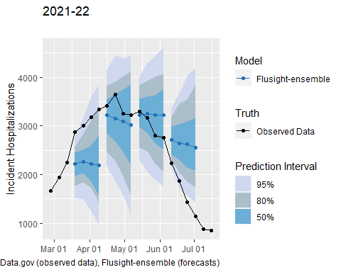

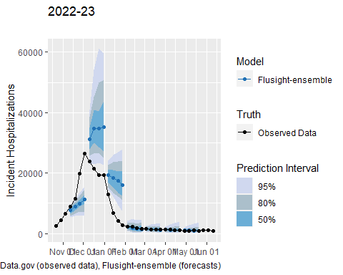

##### Season inc rankings (Table 1)

Table 1

| Model | Absolute WIS | Relative WIS | MAE | 50% Coverage (%) | 95% Coverage (%) | % of Forecasts Submitted |
| --- | --- | --- | --- | --- | --- | --- |
| **2021-2022** | | | | | | |
| CMU-TimeSeries | 12.58 | 0.74 | 18.91 | 39 | 87 | 100 |
| Flusight-ensemble | 13.90 | 0.82 | 20.79 | 41 | 84 | 100 |
| PSI-DICE | 14.09 | 0.83 | 20.17 | 36 | 79 | 100 |
| UMass-trends_ensemble | 14.35 | 0.84 | 22.24 | 71 | 97 | 100 |
| SGroup-RandomForest | 15.47 | 0.91 | 23.87 | 41 | 94 | 100 |
| CEID-Walk | 15.67 | 0.95 | 22.20 | 46 | 80 | 89 |
| Flusight-baseline | 16.99 | 1.00 | 24.10 | 49 | 83 | 100 |
| GT-FluFNP | 17.66 | 1.02 | 23.40 | 32 | 66 | 96 |
| MOBS-GLEAM_FLUH | 17.29 | 1.03 | 22.25 | 25 | 59 | 91 |
| SigSci-TSENS | 17.79 | 1.03 | 24.86 | 38 | 72 | 96 |
| IEM_Health-FluProject | 17.73 | 1.04 | 23.99 | 44 | 82 | 100 |
| CU-ensemble | 18.38 | 1.08 | 25.41 | 37 | 73 | 100 |
| LUcompUncertLab-TEVA | 21.05 | 1.22 | 30.00 | 49 | 85 | 89 |
| UVAFluX-Ensemble | 21.76 | 1.28 | 25.77 | 31 | 58 | 99 |
| LUcompUncertLab-VAR2_plusCOVID | 22.11 | 1.30 | 28.99 | 36 | 72 | 94 |
| UT_FluCast-Voltaire | 23.64 | 1.39 | 35.19 | 50 | 91 | 99 |
| LUcompUncertLab-VAR2K_plusCOVID | 24.52 | 1.42 | 32.43 | 37 | 72 | 89 |
| LUcompUncertLab-VAR2 | 26.02 | 1.53 | 35.04 | 35 | 70 | 94 |
| LUcompUncertLab-VAR2K | 26.86 | 1.56 | 39.35 | 38 | 82 | 89 |
| LosAlamos_NAU-CModel_Flu | 28.78 | 1.69 | 36.14 | 23 | 58 | 100 |
| SGroup-SIkJalpha | 29.11 | 1.71 | 38.60 | 12 | 39 | 100 |
| GH-Flusight | 31.11 | 1.83 | 31.89 | 3 | 9 | 94 |
| SigSci-CREG | 27.36 | 1.93 | 31.00 | 19 | 44 | 89 |
| **2022-2023** | | | | | | |
| MOBS-GLEAM_FLUH | 42.24 | 0.61 | 57.97 | 39 | 77 | 94 |
| CMU-TimeSeries | 44.52 | 0.67 | 65.95 | 42 | 85 | 94 |
| PSI-DICE | 47.49 | 0.70 | 63.17 | 41 | 79 | 100 |
| MIGHTE-Nsemble | 49.02 | 0.72 | 67.50 | 47 | 81 | 96 |
| Flusight-ensemble | 51.74 | 0.76 | 71.04 | 51 | 80 | 100 |
| UMass-trends_ensemble | 53.86 | 0.80 | 79.40 | 63 | 89 | 100 |
| GT-FluFNP | 59.79 | 0.81 | 72.88 | 53 | 74 | 89 |
| CEPH-Rtrend_fluH | 54.22 | 0.83 | 70.47 | 43 | 78 | 90 |
| SGroup-RandomForest | 54.32 | 0.83 | 75.99 | 49 | 84 | 97 |
| CU-ensemble | 62.28 | 0.85 | 75.57 | 46 | 67 | 84 |
| UGA_flucast-OKeeffe | 62.14 | 0.94 | 77.33 | 49 | 72 | 95 |
| SigSci-TSENS | 64.27 | 0.96 | 80.02 | 58 | 74 | 93 |
| Flusight-baseline | 67.69 | 1.00 | 80.05 | 49 | 74 | 100 |
| VTSanghani-ExogModel | 72.43 | 1.00 | 92.57 | 22 | 55 | 81 |
| UNC_IDD-InfluPaint | 61.22 | 1.01 | 77.90 | 32 | 71 | 79 |
| UVAFluX-Ensemble | 78.90 | 1.11 | 94.45 | 13 | 34 | 95 |
| SigSci-CREG | 79.68 | 1.36 | 89.29 | 38 | 62 | 91 |
| JHU_IDD-CovidSP | 129.21 | 1.91 | 174.99 | 41 | 76 | 81 |

## Models Included

forecasts were eligible for inclusion in the 2022-2023 season (106,985) than in the 2021-2022 season (82,660). Fewer types of model forecasts were submitted across the weeks in the 2022-23 season (median 20 models, range: 15 to 26) than the 2021-22 season (median 21 models, range: 15 to 22)

## Relative WIS

6 models in 2021-2022 and 12 models in 2022-2023 outperformed the naive FluSight baseline in relative WIS over the evaluation period (Table 1).

##### Model rank plot (Figure 2)

## Model Ranking

More than three-fourths (79.38% in 2021-2022 and 80.13% in 2022-23) of the FluSight Ensemble forecasts, for both seasons, were ranked among the top 50% of corresponding forecasts (Figure 3). Three models ranked in the top 25% for 2021-22 and 2022-23 seasons respectively: CMU-Timeseries(42.04%, 36.47%), PSI-DICE(39.32%, 40.4%), and MOBS-GLEAM-FLUH(38.18%, 49.22%). Several models, seven in 2021-22 and five in 2022-23, had bimodal rank distributions, with a majority of their forecasts falling in either the bottom 25% or top 25% (Figure 3).

## Relative WIS and Spatial Variation

##### Relative WIS by Location (Figure 3)

Model performance varied by spatial jurisdiction, with state-specific relative WIS values with similar ranges each year with 0.46 to 12.54 in 2021-22 and 0.31 to 12.29 in 2022-23. The relative WIS of the FluSight Ensemble had the smallest range of values across all locations from 0.58 to 1.08 in 2021-22 to 0.63 to 1 in 2022-23 (Figure 4 and Supplemental Figure X boxplot). To further examine forecast performance across jurisdictions, we considered the percent of jurisdictions that the relative WIS value for a given model and location pair was less than the baseline (i.e., lower than 1). The FluSight Ensemble performed better than the baseline for 47 out of 52 forecast jurisdictions. More models performed better than the baseline in 2022-23 than 2021-22. In 2021-22, 5 models performed better than the baseline at least 50% of the time, compared to 12 .

##### Absolute WIS by model (Figure 4 a)

##### Coverage Tables

##### Absolute WIS by week table

## Absolute WIS

Across forecasted weeks, the FluSight Ensemble had a similar median absolute WIS at the 1-week horizon of 8.86 (range: 4.46 to 12.44) for 2021-22, and 8.16 (range: 2.83 to 119.88) for 2022-23. Minimum values occurred on June 25 and May 13, 2023 for the respective seasons. Maximum values occurred on March 19 and November 26, 2022, for the respective seasons (Figure 2). The 2021-22 FluSight Ensemble had a higher median absolute WIS at the 4-week horizon of 19.57 (range: 6.77 to 26.39), compared to the 2022-23 FluSight Ensemble that had a lower median absolute WIS at the 4-week horizon, but broader range, 9.15 (range: 4.19 to 308.53). Minimum values for each season occurred on July 16 and May 13, 2023, respectively. Maximum values for each season occurred on June 04 and December 03, 2022, respectively (Figure 2). Across models, the median absolute WIS values, for 2021-22, at the 1- and 4-week ahead horizons were 11.4 and 27.79 respectively which were lower than the median absolute WIS values for 2022-23, 31.26 and 78.69 (Table XX).

##### Coverage Figures

##### 95% Coverage by model (Figure 4b)

##### 50% coverage by model

## Coverage

The minimum 1-week horizon 95% and 50% coverage values both occurred on March 14, 2022 and March 14, 2022 for 2021-22 and November 21, 2022 and January 09, 2023 for 2022-23, respectively (Figure 2). Across forecasted weeks, the FluSight Ensemble had a high median 95% coverage at the 1-week horizon, although it was slightly higher for the 2022-23 season (98.08%, range: 28.85% to 100%) than the 2021-22 season (87.5%, range: 71.15% to 98.08%). The median 50% coverage for the FluSight Ensemble was also higher for 2022-23 (59.62%, range: 0% to 76.92%) than for 2021-22 (40.38%, range: 21.15% to 55.77%). Similarly, at the 4-week horizon the FluSight Ensemble had a higher median 95% and 50% coverage for 2022-23 (100, range: 15.38% to 100% and 73.08%, range: 1.92% to 90.38%, respectively) than 2021-22 ( 84.62%, range: 61.54% to 100% and 44.23% (range: 23.08% to 61.54%, respectively).

Over the forecast weeks, the 2021-22 FluSight ensemble had slightly higher overall 95% coverage values of 86%, 84.83%, 82.69%, and 82.05% for the 1- to 4-week ahead horizons respectively, compared to the 2022-23 season during which the FluSight ensemble had 95% coverage values of 84.74%, 81.02%, 78.23%, and 77.36% for the 1- to 4-week ahead horizons respectively. A higher proportion of models had higher overall 95% coverage values at the 1-week ahead horizion than at the 4-week ahead horizon for 2022-23 (14 of 18models) than 2021-22 (17 out of 23 models) (Supplemental Table 2). Out of the forecast targets and across forecast weeks, the FluSight ensemble’s 95% prediction interval contained at least 90% of the corresponding observed values only 22.22% and 64.52% of the time, for 2021-22 and 2022-23 respectively. This was more often than most component models (Supplemental Table X).

##### Relative WIS Distribution

#### Plots