第 1 页 共1页

|  |  |  |  |  |  |
| --- | --- | --- | --- | --- | --- |
| 检验编号 | {{report.entrustCode}} | 材料厂家 | {{report.supplierName}} | 到货日期 | {{declareDate}} |
| 材料名称 | {{report.sample}} | 规格型号 | {{report.model}} | 材料批号 | {{report.updateBatchNo}} |
| 验证依据文件编号：{{report.verifyFileCode}} | | | | | |

**验证内容：**

|  |  |  |  |
| --- | --- | --- | --- |
| **一、供方产品检测报告的基本信息确认** | | | |
| 1.材料名称 {{report.basicName}} | | 2.规格型号 {{report.basicModel}} | |
| 3.材料批号 {{report.basicBatchNo}} | | 4.执行标准 {{report.basicStandard}} | |
| 5.生产日期 {{report.basicDate}} | | 6.供货数量 {{report.basicNumber}} | |
| 7.材料颜色 {{report.basicColor}} | | 8其它（ {{report.basicOtherValue}} ）{{report.basicOther}} | |
| **二、供方产品检测报告中各项性能指标的验证** | | | |
| 序号 | 验证项目 | | 验证结果 |

{{?factoryVerifyItemList}}

|  |  |  |
| --- | --- | --- |
| {{_index+1}} | {{inspectionItem}} | {{result}} |

{{/factoryVerifyItemList}}

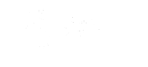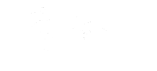

检验员: 复核: