Add Users and Items:
The system prevents duplicate IDs and stores all objects inside HashMaps.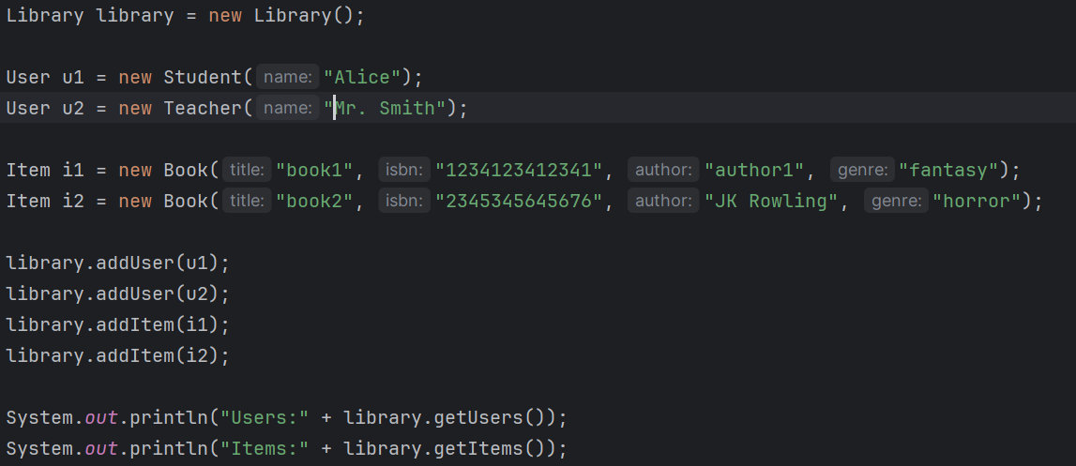
The system checks for duplicate IDs before inserting into map and throws an exception if a duplicate is detected.

Borrowing and Returning Items:
Users can borrow items only if Item is in store and the user themselves meets the borrowing rules, for students they can only borrow up to 5 books, for teachers it's up to 10 items, and admin cannot borrow at all.
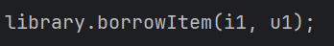
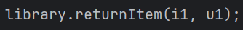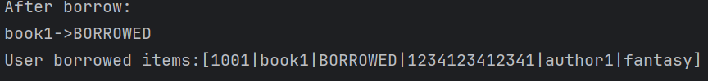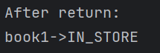
The status of the book changes when its borrowed or returned.
Searching:
There are 3 types of searches implemented in this project: normal loop for title and author, recursive, and stream.
This uses the normal loop for title::
Thus uses the normal loop for author:
This uses recursion: (the recursive method uses an index parameter to iterate through the list until the base case is achieved)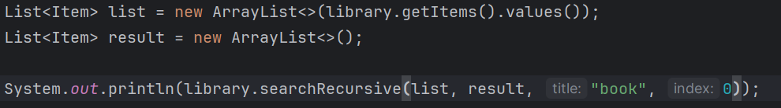
This uses stream:

Sorting Strategies:
There are 2 sorting methods implemented in the project, bubble sort and sort users by name. Here is sort users by name:
