**ANNA FEST’16 HANDBALL FIXTURES**

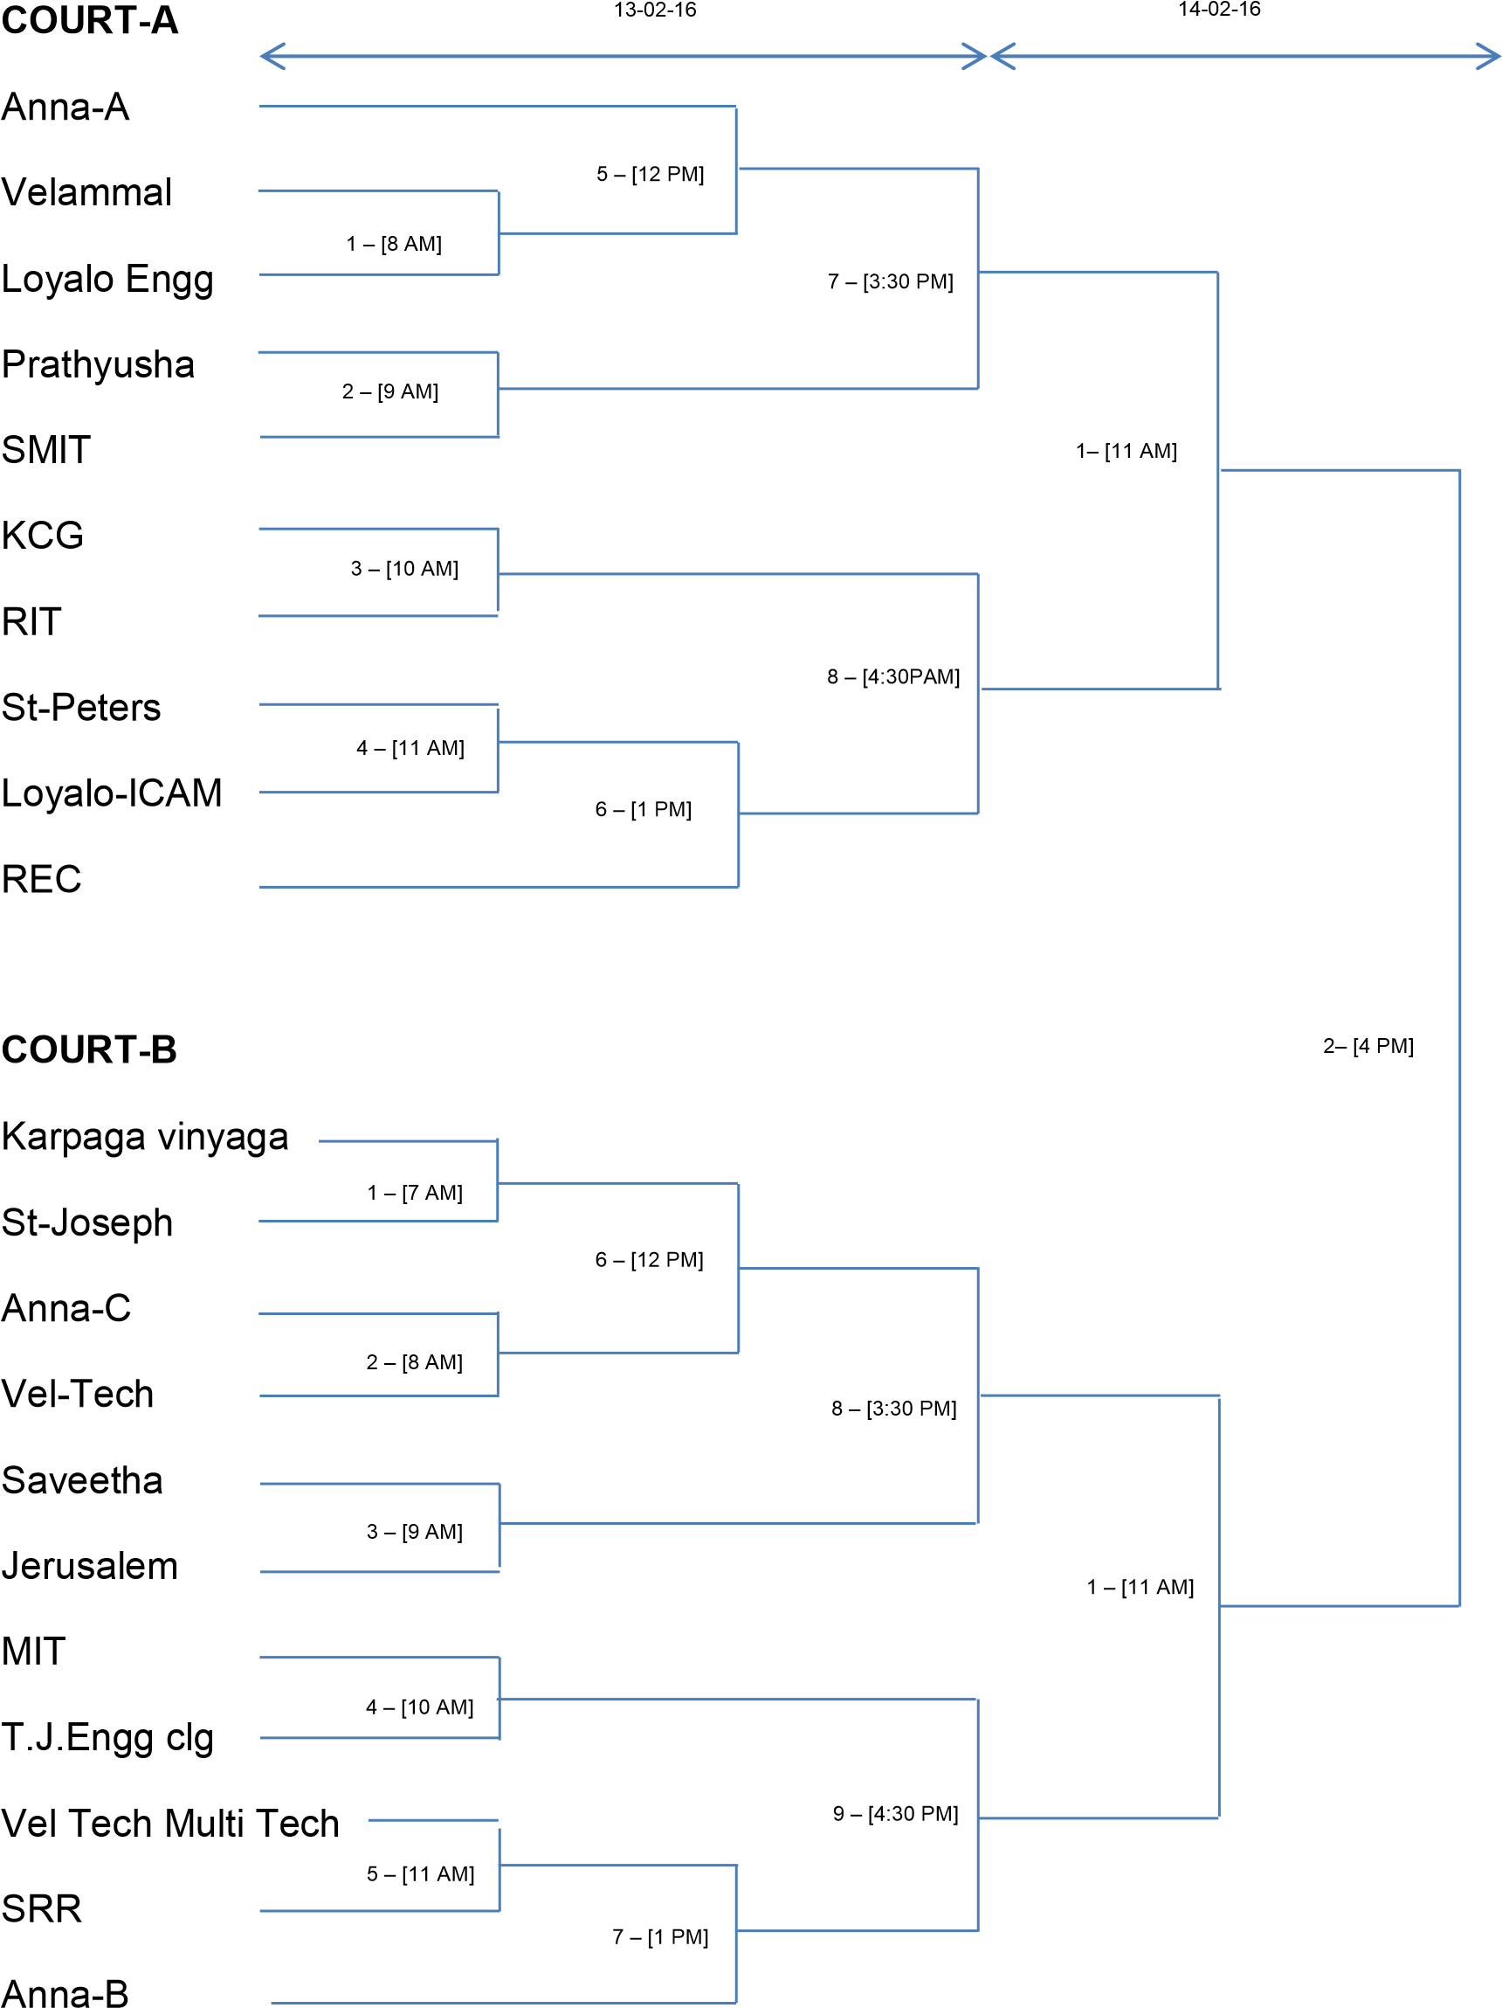

CONTACT

HARI 9500431630

FRANCIS 9688333716