1:
//greatest
#include<iostream>
using namespace std;
int main()
{
int array[3];
int max=0,i;
cout << "Enter the three numbers: ";
for(i=0;i<3;i++)
{
cin >> array[i];
}
for(i=0;i<3;i++)
{
cout << array[i] << "\t";
if(array[i]>max)
max=array[i];
}
cout << "\nThe greatest number is= " <<max;
}
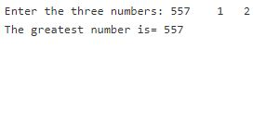

2:
//reverse
#include<iostream>
using namespace std;
int main()
{
int rev=0, rem, n,dummy;
cout << "Enter the number you want to reverse: ";
cin>>n;
cout << n;
dummy=n;
while(n>0)
{
rem=n%10;
rev=rev*10+rem;
n=n/10;
}
cout << "\nThe reverse of " << dummy << " is= " << rev;
return 0;
}

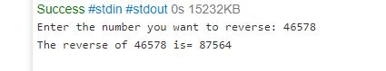

3:
//Convert fahrenheit to celsius
#include<iostream>
using namespace std;
int main()
{
float f,c;
cout << "Enter the temperature in Fahrenheit: \n";
cin >> f;
c=((f-32)*5)/9;
cout << "The temperature in Celsius= " << c;
}
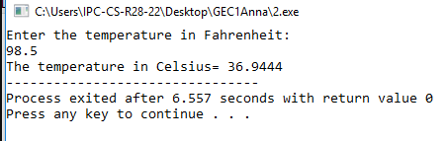

4:
//program4
#include<iostream>
using namespace std;
int main()
{
int n,c=1,sum=0;
cout << "Enter the number of terms: ";
cin >> n;
cout << n;
for(int i=1;i<=n;i++)
{
if(c%2!=0)
{
sum=sum+i;
}
else if(c%2==0)
{
sum=sum-i;
}
c++;
}
cout << "\nSum of series = " << sum;
}

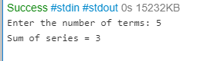

5:
//Program to find the factorial of a number
#include<iostream>
using namespace std;
int main()
{
int n;
cout << "Enter the number whose factorial you want to find: \n";
cin >> n;
int i,fact=1;
for(i=n;i>0;i--)
{
fact=fact*i;
}
cout << "The factorial of the number is=" << fact;
}
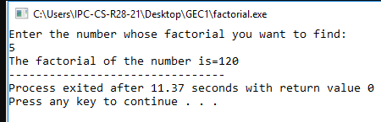

6:
#include <iostream>
using namespace std;
int main()
{
int math,comp, phy, eng;
float p;
cout << "Enter the marks in Maths: ";
cin >> math;
cout << "\nEnter the marks in Computer Science: ";
cin >> comp;
cout << "\nEnter the marks in Physics: ";
cin >> phy;
cout << "\nEnter the marks in English: ";
cin >> eng;
cout << endl;
p=(math+comp+phy+eng)/4;
if(p>=90)
cout << "Grade= AA";
else if(p>=80&&p<90)
cout << "Grade= AB";
else if(p>=70&&p<80)
cout << "Grade= BB";
else if(p>=60&&p<70)
cout << "Grade= BC";
else if(p>=50&&p<60)
cout << "Grade= CC";
else if(p>=45&&p<50)
cout << "Grade= CD";
else if(p>=40&&p<45)
cout << "Grade= DD";
else if(p<40)
cout << "Grade= FR";
return 0;
}

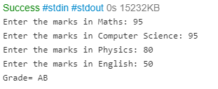

7:
#include<iostream>
using namespace std;
int main()
{
int n,i,c=0;
cout << "Enter the number: ";
cin >> n;
for(i=1;i<n/2;i++)
{
if(n%i==0)
c++;
}
if(c==1)
cout << n << " is a PRIME number.";
else
cout << n << " is NOT a prime number.";
}

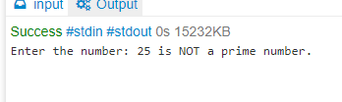

8:
//program to compute the factors of a given number
#include<iostream>
using namespace std;
int main()
{
int n;
cout << "Enter the number:\n";
cin >> n;
int i,d;
cout << "The factors of " << n << " are = \n";
for(i=1;i<=n;i++)
{
if(n%i==0)
cout << i << endl;
}
}
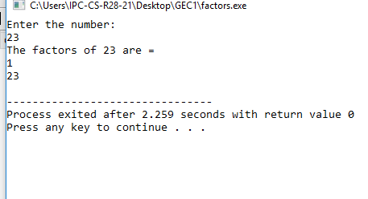

9:
include<iostream>
using namespace std;
int main()
{
int a,b;
cout << "Enter the numbers:";
cin >> a;
cin >> b;
cout << "Before swap:" << endl << "First number=" << a << endl << "Second number=" << b << endl;
a=a+b;
b=a-b;
a=a-b;
cout << "After swap:" << endl << "First number=" << a << endl << "Second number=" << b;
}

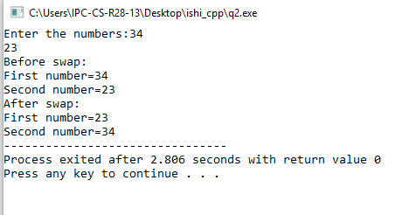

10:
#include<iostream>
using namespace std;
void even(int ar[10])
{
int i;
cout << "\nThe even elements are: " << endl;
for(i=0;i<10;i++)
{
if(ar[i]%2==0)
cout << ar[i] << "\t";
}
}
void odd(int ar[10])
{
int i;
cout << "\nThe odd elements are: " << endl;
for(i=0;i<10;i++)
{
if(ar[i]%2!=0)
cout << ar[i] <<"\t" ;
}
}
void sumav(int ar[10])
{
int sum=0,av,i;
for(i=0;i<10;i++)
{
sum=sum+ar[i];
}
av=sum/10;
cout << "\nThe sum of elements= " << sum;
cout << "\nThe average of elements= " << av;
}
void minmax(int ar[10])
{
int i, min=ar[0], max=0;
for(i=0;i<10;i++)
{
if(ar[i]>max)
max=ar[i];
else if(ar[i]<min)
min=ar[i];
}
cout << "\nMaximum= " <<max;
cout << "\nMiniimum= " <<min;
}
int main()
{
int array[10],i;
cout << "Enter the elements of the array: ";
for(i=0;i<10;i++)
{
cin >> array[i];
}
even(array);
odd(array);
sumav(array);
minmax(array);
}

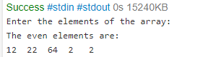

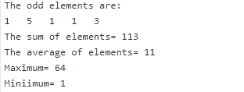

11:
#include<iostream>
using namespace std;
int main()
{
int n;
cout << "Enter the number of lines: \n";
cin >> n;
int i;
int j;
cout << "*" << endl;
for(i=1;i<=n-1;i++)
{
for(j=1;j<=i;j++)
{
cout << "*";
}
cout << endl;
}
}
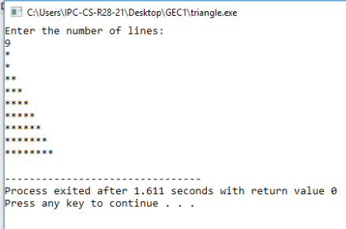

12:
#include<iostream>
using namespace std;
struct employee
{
char name[100];
int num;
float sal,hra;
};
int main()
{
employee e1;
cout << "Enter the Employee name: ";
cin >> e1.name;
cout << "\n Enter the Employee ID: ";
cin >> e1.num;
cout << "\n Enter the Employee Salary: ";
cin >> e1.sal;
cout << "Name of Employee1 : " << e1.name << "\n Employee1 ID: " << e1.num << "\n Employee1 Salary: " << e1.sal;
}
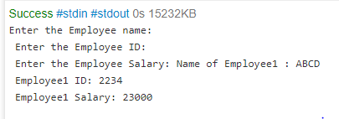

13:
#include<iostream>
using namespace std;
class matrix
{
int m1[3][3],m2[3][3],ans[3][3],i,j;
public:
void getdata()
{
cout << "\nEnter the elements of matrix A:";
for(i=0;i<3;i++)
{
for(j=0;j<3;j++)
{
cin >> m1[i][j];
}
}
cout << "\nEnter the elements of matrix B:";
for(i=0;i<3;i++)
{
for(j=0;j<3;j++)
{
cin >> m2[i][j];
}
}
}
void summatrix()
{
for(i=0;i<3;i++)
{
for(j=0;j<3;j++)
{
ans[i][j]=m1[i][j]+m2[i][j];
}
}
cout << "\nThe sum= " ;
for(i=0;i<3;i++)
{
cout << endl;
for(j=0;j<3;j++)
{
cout<<ans[i][j] << "\t";
}
}
}
void diffmatrix()
{
for(i=0;i<3;i++)
{
for(j=0;j<3;j++)
{
ans[i][j]=m1[i][j]-m2[i][j];
}
}
cout << "\nThe Difference= ";
for(i=0;i<3;i++)
{
cout << endl;
for(j=0;j<3;j++)
{
cout << ans[i][j]<<"\t";
}
}
}
void transpose()
{
int ans2[3][3];
for(i=0;i<3;i++)
{
for(j=0;j<3;j++)
{
ans[i][j]=m1[j][i];
}
}
cout << "\nThe Transpose of A= ";
for(i=0;i<3;i++)
{
cout << endl;
for(j=0;j<3;j++)
{
cout << ans[i][j]<<"\t";
}
}
for(i=0;i<3;i++)
{
for(j=0;j<3;j++)
{
ans2[i][j]=m2[j][i];
}
}
cout << "\nThe Transpose of B= ";
for(i=0;i<3;i++)
{
cout << endl;
for(j=0;j<3;j++)
{
cout << ans2[i][j]<<"\t";
}
}
}
};
int main()
{
matrix sum,diff,trans;
int ch,c=1;
while(c==1)
{
cout << "Press: \n 1.Sum of Matrices. \n 2.Difference between Matrices. \n 3.Transpose of Matrices. \n";
cin >> ch;
if(ch==1)
{
sum.getdata();
sum.summatrix();
}
if(ch==2)
{
diff.getdata();
diff.diffmatrix();
}
if(ch==3)
{
trans.getdata();
trans.transpose();
}
cout << "\nPress 1 to Continue and 0 to Stop:";
cin >> c;
}
}

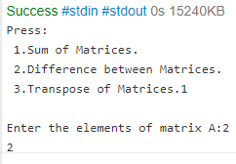
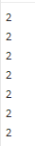

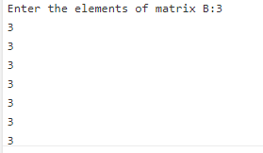
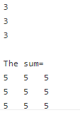
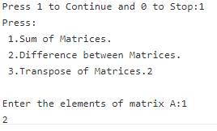

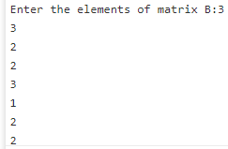
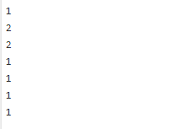
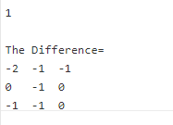

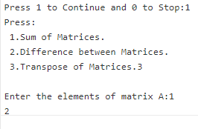
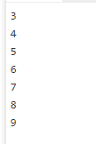
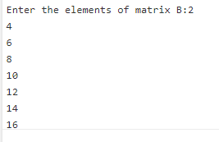

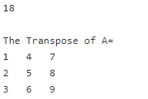
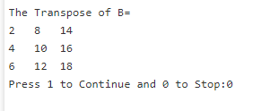

14:

#include<iostream>
using namespace std;
class Person
{
protected:
char name[40];
int age;
public:
void getdata()
{
cout << "\nEnter the name: ";
cin >> name;
cout << "\nEnter the age: ";
cin>> age;
}
void putdata()
{
cout << "\nName: " << name;
cout << "\nAge: " << age;
}
};
class Student :public Person
{
int roll;
public:
void getdata()
{
Person :: getdata();
cout << "\nEnter the roll no: ";
cin >> roll;
}
void putdata()
{
Person :: putdata();
cout << "\nroll no: " << roll;
}
};
class Teacher :public Person
{
int sal;
public:
void getdata()
{
Person :: getdata();
cout << "\nEnter the salary: ";
cin >> sal;
}
void putdata()
{
Person :: putdata();
cout << "\nSalary: " << sal;
}
};
int main()
{
Student s;
Teacher t;
s.getdata();
s.putdata();
t.getdata();
t.putdata();
}

