IDA*算法

171491106 安南 硬件一班

一、实验题目

利用IDA*算法解决问题

二、算法简介

IDA*算法就是基于迭代加深的A*算法,也就是说IDA*=IDA+A*。

与A*差异点：

A*需要大量的计算估值函数来确定优先级，还要使用优先队列和判重、排序等操作,对于方案一类问题不易保存；而IDA*由于是DFS过程，是使用估值函数来剪枝的，方案也更容易保存空间需求减少。

三、实验目的

利用IDA*算法解决拼图问题。

四、实验代码

**package** IDA;

**public** **class** IDA {

//分别代表左、上、右、下四个移动方向的操作数

**private** **int**[] up = {-1,0};

**private** **int**[] down = {1,0};

**private** **int**[] left = {0,-1};

**private** **int**[] right = {0,1};

**private** **final** **int** UP = 0;

**private** **final** **int** DOWN = 2;

**private** **final** **int** LEFT = 1;

**private** **final** **int** RIGHT = 3;

**private** **int** SIZE;

**private** **int**[][] targetPoints;

**private** **static** **int**[] *moves* = **new** **int**[100000];

**private** **static** **long** *ans* = 0;; //当前迭代的"设想代价"

**private** **static** **int**[][] *tState* = {

{1 ,2 ,3 ,4 } ,

{5 ,6 ,7 ,8 } ,

{9 ,10,11,12} ,

{13,14,15,0 }

};

**private** **static** **int**[][] *sState* = {

{2 ,10 ,3 ,4 } ,

{1 ,0,6 ,8 } ,

{5 ,14,7,11} ,

{9,13,15,12 }

};

**private** **static** **int** *blank_row*,*blank_column*;

**public** IDA(**int**[][] state) {

SIZE = state.length;

targetPoints = **new** **int**[SIZE * SIZE][2];

**this**.*sState* = state;

//得到空格坐标

**for**(**int** i=0;i<state.length;i++) {

**for**(**int** j=0;j<state[i].length;j++) {

**if**(state[i][j] == 0) {

*blank_row* = i;

*blank_column* = j;

**break**;

}

}

}

//得到目标点坐标数组

**for**(**int** i=0;i<state.length;i++) {

**for**(**int** j=0;j<state.length;j++) {

targetPoints[*tState*[i][j]][0] = i; //行信息

targetPoints[*tState*[i][j]][1] = j; //列信息

}

}

}

**private** **boolean** canSolve(**int**[][] state) {

**if**(state.length % 2 == 1) { //问题宽度为奇数

**return** (getInversions(state) % 2 == 0);

} **else** { //问题宽度为偶数

**if**((state.length - *blank_row*) % 2 == 1) { //从底往上数,空格位于奇数行

**return** (getInversions(state) % 2 == 0);

} **else** { //从底往上数,空位位于偶数行

**return** (getInversions(state) % 2 == 1);

}

}

}

**public** **static** **void** main(String[] args) {

IDA idaAlgorithm = **new** IDA(*sState*);

**if**(idaAlgorithm.canSolve(*sState*)) {

System.***out***.println("--问题可解，开始求解--");

//以曼哈顿距离为初始最小代价数

**int** j = idaAlgorithm.getHeuristic(*sState*);

System.***out***.println("初始manhattan距离:" + j);

**int** i = -1;//置空默认移动方向

**long** time = System.*currentTimeMillis*();

//迭代加深"最小代价数"

**for**(*ans*=j;;*ans*++) {

**if**(idaAlgorithm.solve(*sState*

,*blank_row*,*blank_column*,0,i,j)) {

**break**;

}

}

System.***out***.println("求解用时:"+(System.*currentTimeMillis*() - time));

idaAlgorithm.printMatrix(*sState*);

**int**[][] matrix = idaAlgorithm.move(*sState*,*moves*[0]);

**for**(**int** k=1;k<*ans*;k++) {

matrix = idaAlgorithm.move(matrix, *moves*[k]);

}

} **else** {

System.***out***.println("--抱歉！输入的问题无可行解--");

}

}

**public** **int**[][] move(**int**[][]state,**int** direction) {

**int** row = 0;

**int** column = 0;

**for**(**int** i=0;i<state.length;i++) {

**for**(**int** j=0;j<state.length;j++) {

**if**(state[i][j] == 0) {

row = i;

column = j;

}

}

}

**switch**(direction) {

**case** UP:

state[row][column] = state[row-1][column];

state[row-1][column] = 0;

**break**;

**case** DOWN:

state[row][column] = state[row+1][column];

state[row+1][column] = 0;

**break**;

**case** LEFT:

state[row][column] = state[row][column-1];

state[row][column-1] = 0;

**break**;

**case** RIGHT:

state[row][column] = state[row][column+1];

state[row][column+1] = 0;

**break**;

}

printMatrix(state);

**return** state;

}

**public** **void** printMatrix(**int**[][] matrix) {

System.***out***.println("------------");

**for**(**int** i=0;i<matrix.length;i++) {

**for**(**int** j=0;j<matrix.length;j++) {

System.***out***.print(matrix[i][j] + " ");

}

System.***out***.println();

}

}

**public** **boolean** solve(**int**[][] state,**int** blank_row,**int** blank_column,

**int** dep,**long** d,**long** h) {

**long** h1;

**boolean** isSolved = **true**;

**for**(**int** i=0;i<SIZE;i++) {

**for**(**int** j=0;j<SIZE;j++) {

**if**(state[i][j] != *tState*[i][j]) {

isSolved = **false**;

}

}

}

**if**(isSolved) {

**return** **true**;

}

**if**(dep == *ans*) {

**return** **false**;

}

**int** blank_row1 = blank_row;

**int** blank_column1 = blank_column;

**int**[][] state2 = **new** **int**[SIZE][SIZE];

**for**(**int** direction=0;direction<4;direction++) {

**for**(**int** i=0;i<state.length;i++) {

**for**(**int** j=0;j<state.length;j++) {

state2[i][j] = state[i][j];

}

}

**if**(direction != d && (d%2 == direction%2)) {

**continue**;

}

**if**(direction == UP) {

blank_row1 = blank_row + up[0];

blank_column1 = blank_column + up[1];

} **else** **if**(direction == DOWN) {

blank_row1 = blank_row + down[0];

blank_column1 = blank_column + down[1];

} **else** **if**(direction == LEFT) {

blank_row1 = blank_row + left[0];

blank_column1 = blank_column + left[1];

} **else** {

blank_row1 = blank_row + right[0];

blank_column1 = blank_column + right[1];

}

**if**(blank_column1 < 0 || blank_column1 == SIZE

|| blank_row1 < 0 || blank_row1 == SIZE) {

**continue** ;

}

state2[blank_row][blank_column] = state2[blank_row1][blank_column1];

state2[blank_row1][blank_column1] = 0;

**if**(direction == DOWN && blank_row1

> targetPoints[state[blank_row1][blank_column1]][0]) {

h1 = h - 1;

} **else** **if**(direction == UP && blank_row1

< targetPoints[state[blank_row1][blank_column1]][0]){

h1 = h - 1;

} **else** **if**(direction == RIGHT && blank_column1

> targetPoints[state[blank_row1][blank_column1]][1]) {

h1 = h - 1;

} **else** **if**(direction == LEFT && blank_column1

< targetPoints[state[blank_row1][blank_column1]][1]) {

h1 = h - 1;

} **else** {

h1 = h + 1;

}

**if**(h1+dep+1>*ans*) { //剪枝

**continue**;

}

*moves*[dep] = direction;

**if**(solve(state2, blank_row1, blank_column1, dep+1, direction, h1)) {

**return** **true**;

}

}

**return** **false**;

}

**public** **int** getHeuristic(**int**[][] state) {

**int** heuristic = 0;

**for**(**int** i=0;i<state.length;i++) {

**for**(**int** j=0;j<state[i].length;j++) {

**if**(state[i][j] != 0) {

heuristic = heuristic +

Math.*abs*(targetPoints[state[i][j]][0] - i)

+ Math.*abs*(targetPoints[state[i][j]][1] - j);

}

}

}

**return** heuristic;

}

**private** **int** getInversions(**int**[][] state) {

**int** inversion = 0;

**int** temp = 0;

**for**(**int** i=0;i<state.length;i++) {

**for**(**int** j=0;j<state[i].length;j++) {

**int** index = i* state.length + j + 1;

**while**(index < (state.length * state.length)) {

**if**(state[index/state.length][index%state.length] != 0

&& state[index/state.length]

[index%state.length] < state[i][j]) {

temp ++;

}

index ++;

}

inversion = temp + inversion;

temp = 0;

}

}

**return** inversion;

}

}

五、实验结果

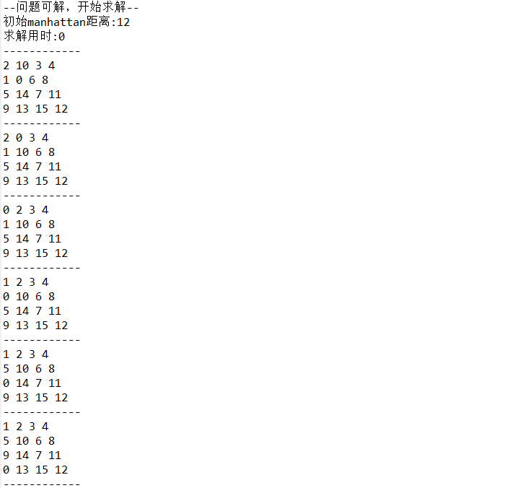

六、实验总结

IDA*的搜索策略是深度优先，不过它搜索最小的节点的子节点时是广度优先，它与IDS算法类似，也是每次搜索完没找到结果就深度+1，但IDS是全部的深度+1，而IDA*是找到的节点的子节点深度+1，它的时间复杂度为O（B^d）空间复杂度是O（b*d）。