**EXPERIMENT 1**

**INTRODUCTION TO JAVA ENVIRONMENT**

* INSTALLATION OF JDK
* SETTING PATH AND CLASS PATH
* INTRODUCTION TO Intellij Idea

**INSTALLING JDK**

**Step 1** Go to <https://www.oracle.com/java/technologies/javase-downloads.html> Click on JDK Download for Java JDK download.

**Step 2** When you click on the Installation link the popup will be open. Login by creating an account with basic credentials.

**Step 3** Once the Java JDK 8 download is complete, run the exe for install JDK. Click Next

**Step 4** Once you install Java in windows, click Close.

**SETTING ENVIRONMENTAL VARIABLES**

**Step 1** Right Click on the My Computer and Select the properties

**Step 2** Click on advanced system settings

**Step 3** Click on Environment Variables

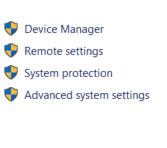

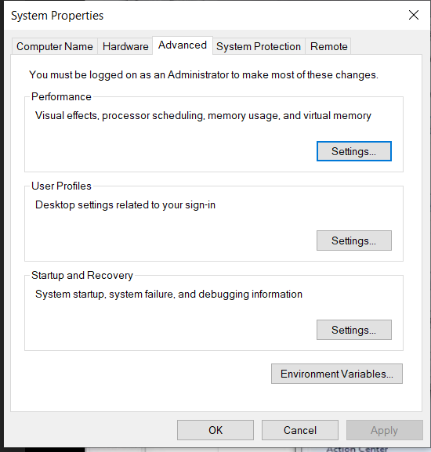

**Step 4** Click on new Button of User variables

**Step 5** Type PATH in the Variable name.

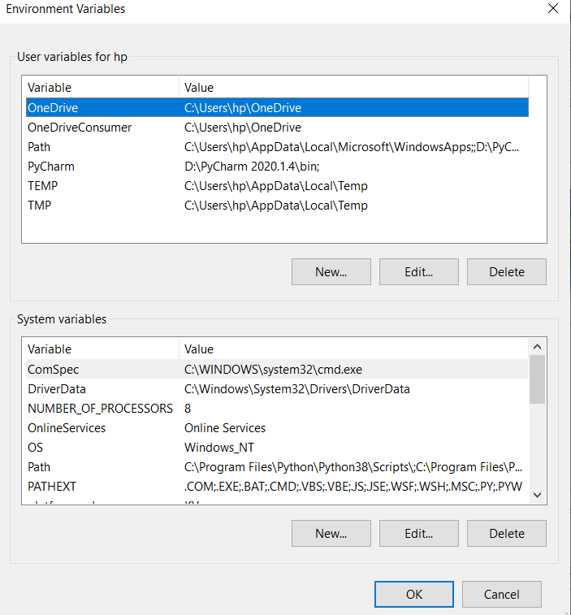

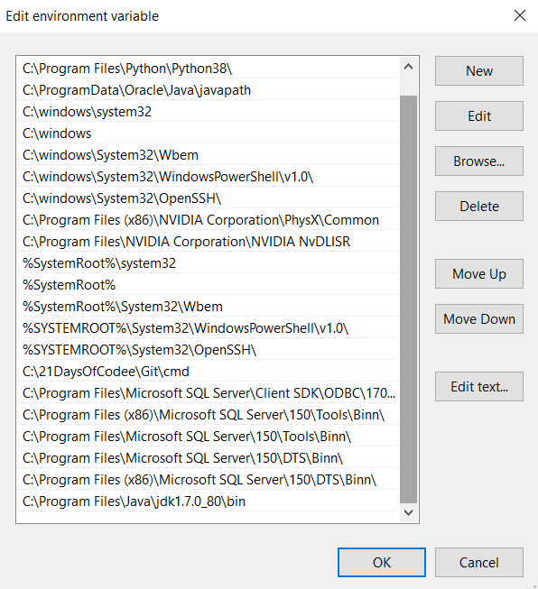

**Step 6** Copy the path of bin folder which is installed in JDK folder.

**Step 7** Go to command prompt and type javac commands.

If you see a screen like below, Java is installed.

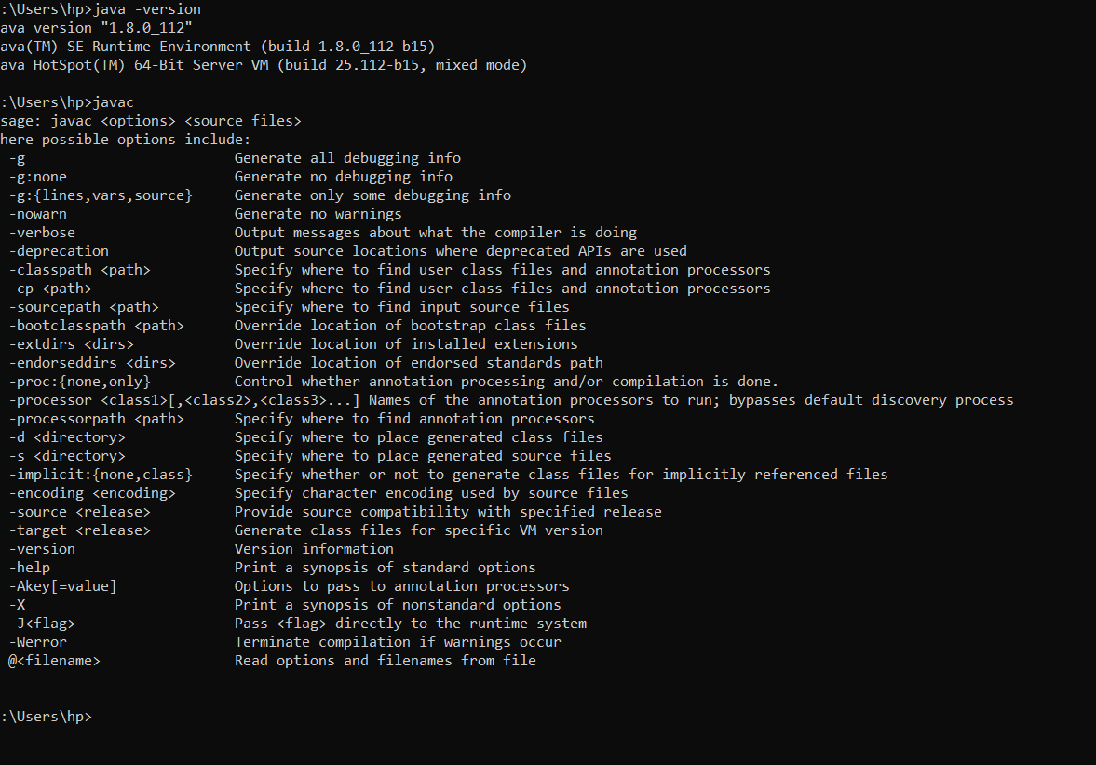

**SETTING UP Intellij Idea**

**Step 1** Navigate to the following URL – https://www.jetbrains.com/idea/download/download-thanks.html?platform=windows&code=IIC and select the download link depending on your system architecture – (Windows, Mac OS or Linux) and download it.

**Step 2**Read the instructions and click next and then finish

**Step 4** Open the icon and then choose the theme and select new project.

**Step 5** Write a small piece of code and run it.

**Step 6**. Installed successfully.

___________________________________________________________________