**EXPERIMENT 3**

**BASIC JAVA PROGRAMMING**

* Find largest of three numbers
* Implement command line calculator
* Write a program using class and object in Java

**MAKING DIRECTORY**

* Open command prompt and enter D drive.
* Make a directory (mkdir) of SAP ID- 500075435.
* Then change directory (cd) into 500075435.
* Make directory lab2.And change directory into lab2
* Make directory q1 and change directory into q1.
* Then , notepad ( Class name).java
* A notepad file will be created.
* Write the code in the notepad.
* To compile: Type javac (classname).java
* To run: java (classname)
* The output will be seen.

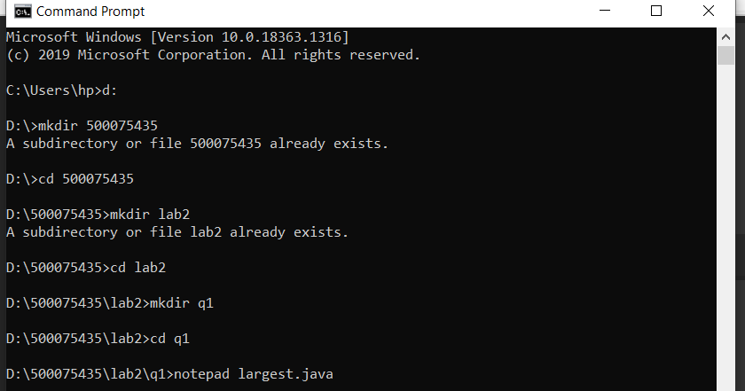

1. **FIND THE LARGEST OF THREE NUMBERS**

In this program we use a simple if , else if , and else statement to compare the variable with other two variables.

**CODE:**

class largest

{

public static void main(String args[])

{

int p=10,q=20,r=18;

if(p>q && p>r)

{

System.out.println("Largest no.="+p);

}

else if(q>p && q>r)

{

System.out.println("Largest no.="+q);

}

else

{

System.out.println("Largest no.="+r);

}

}

}

**OUTPUT:**

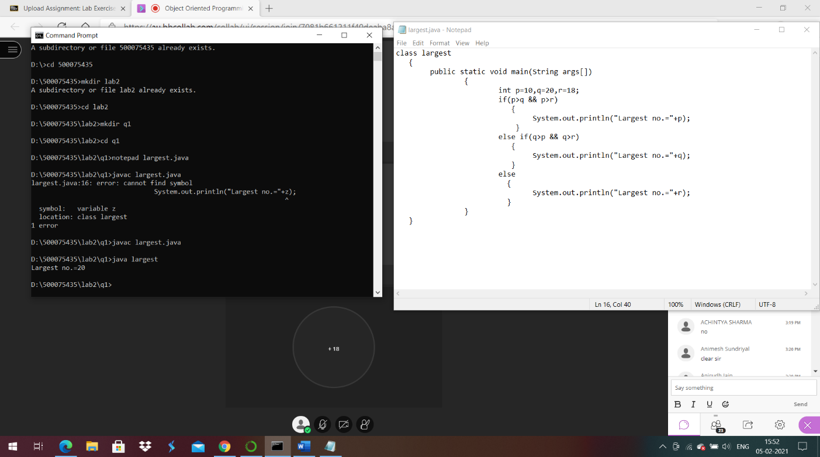

1. **IMPLEMENT COMMAND LINE CALCULATOR**

In this program we convert the entered string into integer by using

int a=Integer.parseInt(args[0]); command . And then print the two variables.

**CODE:**

class cal

{

public static void main(String args[])

{

int a=Integer.parseInt(args[0]);

int b=Integer.parseInt(args[1]);

System.out.println(a+b);

}

}

**OUTPUT:**

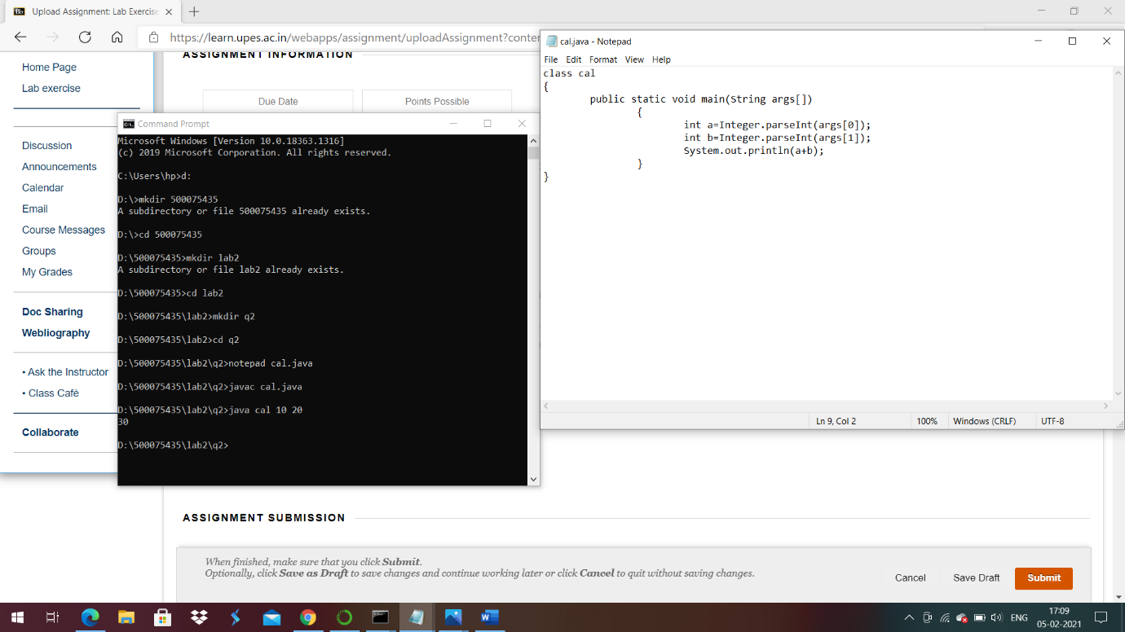

1. **WRITE A PROGRAM USING CLASS AND OBECT**

In this program we create object of a class.

**CODE:**

class objCls

{

public static void main(String args[])

{

SomeClass obj=new SomeClass();

obj.setX(10);

System.out.println(obj.getX());

if(args.length!=0)

{

for(int i=0;i<args.length;i++)

{

System.out.println("Argument "+i+"is:"+args[i]);

}

}

else

{

System.out.println("No CLA");

}

}

}

class SomeClass

{

int x;//State

void setX(int x)

{

System.out.println("Value Setted");

this.x=x;

}

int getX()

{

System.out.println("Value Returned");

return this.x;

}

}

**OUTPUT:**

