**EXPERIMENT-3**

IMPLEMENTING REGRESSION

**Importing Libraries**

#%%

import pandas as pd

import numpy as np

import matplotlib.pyplot as plt

**Collecting Data**

#%%

from sklearn.datasets import make_regression

X, y = make_regression(n_samples=100, n_features=1)

df=pd.DataFrame({'X':X.flatten(),'Y':y})

print(X)

print(y)

#plot regression dataset

plt.scatter(X,y,marker='.')

plt.show()

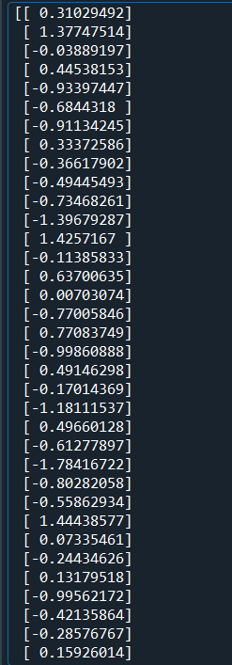

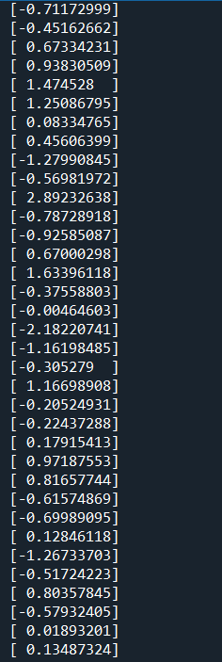

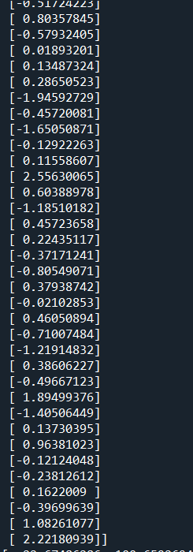

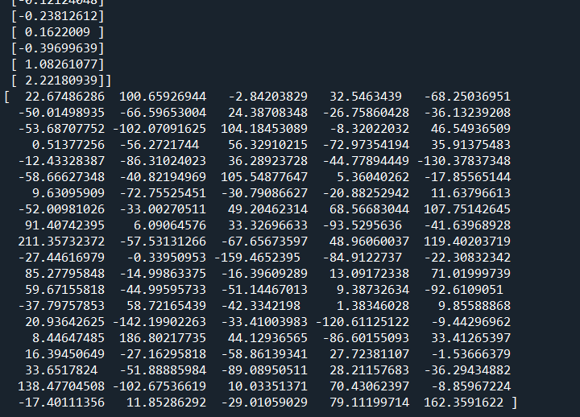

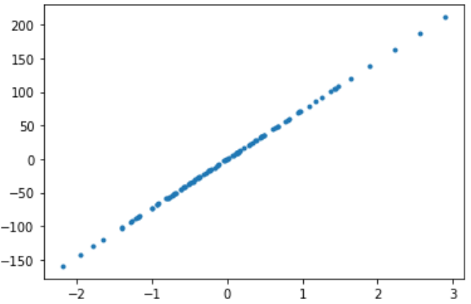

**Preprocessing Data**

#%%

X=df.iloc[:, :-1].values

y=df.iloc[:,1].values

**Creating test and train**

#%%

#Splitting into training and testing

from sklearn.model_selection import train_test_split

X_train, X_test, y_train, y_test = train_test_split(X, y,

test_size=0.10, random_state=1)

**Model Building**

#%%

from sklearn import datasets, linear_model

from sklearn.linear_model import LinearRegression

#%%

# Create linear regression object

reg = linear_model.LinearRegression()

#%%

#Train the model

reg.fit(X_train,y_train)

**Finding coeficients**

#%%

#Coefficients

print("Coeficients",reg.coef_)

#%%

#Intercept

print("Intercept",reg.intercept_)

**Histogram**

#%%

#Plotting histogram

plt.hist(np.squeeze(X))

