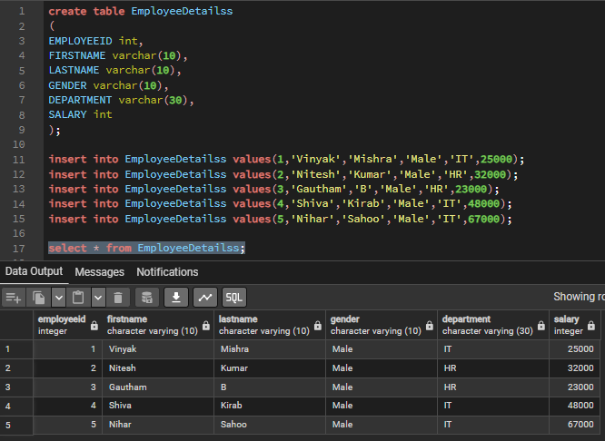

1.Write a query to list the name of all the employees who are working in department IT?
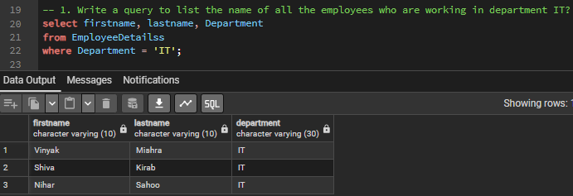

2. Write a query to list the employees name and salary is greater than 48000?
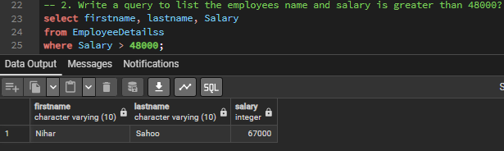

3. Write a query to list the name of all the employees who are not working in department IT?
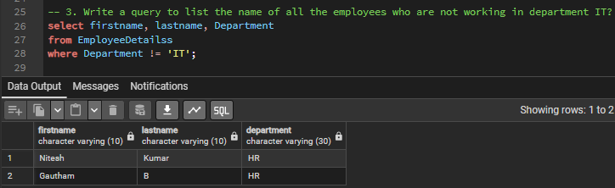

4. Write a query to list the names of all the employees who are working as HR department and drawing a salary less than 30000?
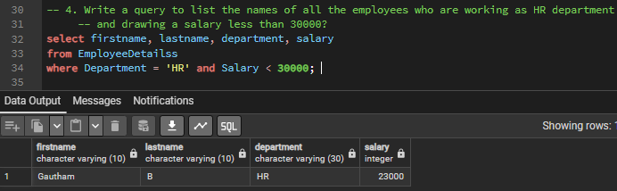

5. Write a query to list the name(First and lastname), Gender of all the employees who department is equal to HR?
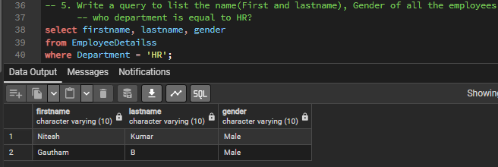

6. WAQ to multiply the salary for each employee with 2000?
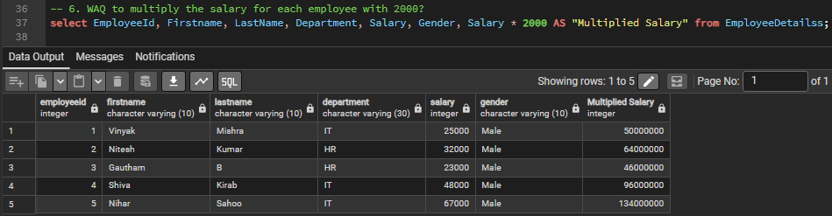

7. WAQ to get the salaries of employees whose are between 20000 and 50000?
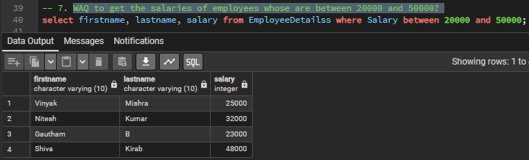

8. WAQ to decrease the salaries for every employee in the employee table with decremented salary of 10000?
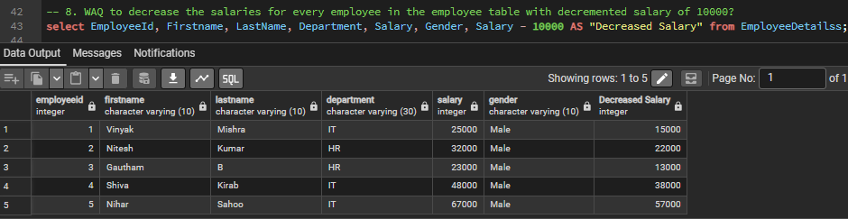

9. WAQ to get the name of employee who letter starts with G?
