- Create a RESTFUL Web Service and Test its Lifecycle as per the below requirements:
- The restful web service is available on the path “Employee”
- The Web service has only one method that returns the list of Employees.
- The method also should display the count of the number of time this method was invoked. HINT : Implement Per-Request / Singleton Lifecycle as per the requirement @Singleton
App.java
package com.wipro.Employee;
import org.springframework.boot.SpringApplication;
import org.springframework.boot.autoconfigure.SpringBootApplication;

@SpringBootApplication
public class App
{
public static void main( String[] args )
{
SpringApplication.run(App.class, args);
}
}
------------------------------------------------------------------------------------------------------
EmployeeController.java

package com.wipro.Employee;
import org.springframework.web.bind.annotation.GetMapping;
import org.springframework.web.bind.annotation.RequestMapping;
import org.springframework.web.bind.annotation.RestController;
import org.springframework.web.context.annotation.RequestScope;

import java.util.Arrays;
import java.util.HashMap;
import java.util.List;
import java.util.Map;

@RestController
@RequestMapping("/employee")
@RequestScope

public class EmployeeController {
private int count = 0;

@GetMapping
public Map<String,Object> getEmployee(){
count++;

List<Employee> employees = Arrays.asList(
new Employee(1,"Asha",50000),
new Employee(2,"Chandru",60000),
new Employee(3,"Kiran",70000)
);

Map<String, Object> response = new HashMap<>();
response.put("count", count);
response.put("employees", employees);

return response;

}
}

Employee.java
package com.wipro.Employee;

public class Employee {
private int id;
private String name;
private double salary;

public Employee() {
}
public Employee(int id, String name,double Salary) {
this.id = id;
this.name = name;
this.salary = salary;

}
public int getId() {
return id;
}
public void setId(int id) {
this.id = id;
}

public String getName() {
return name;
}
public void setName() {
this.name = name;
}
public double getSalary() {
return salary;
}
public void setSalary() {
this.salary = salary;
}
}
Application.properties
server.port = 8096
SINGLETON OUTPUT & POSTMAN SCREENSHOTS
Count Increases Every time after refresh
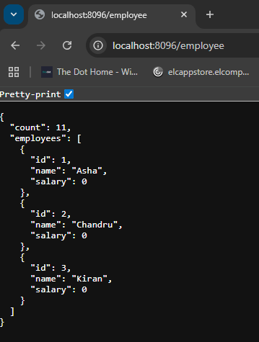

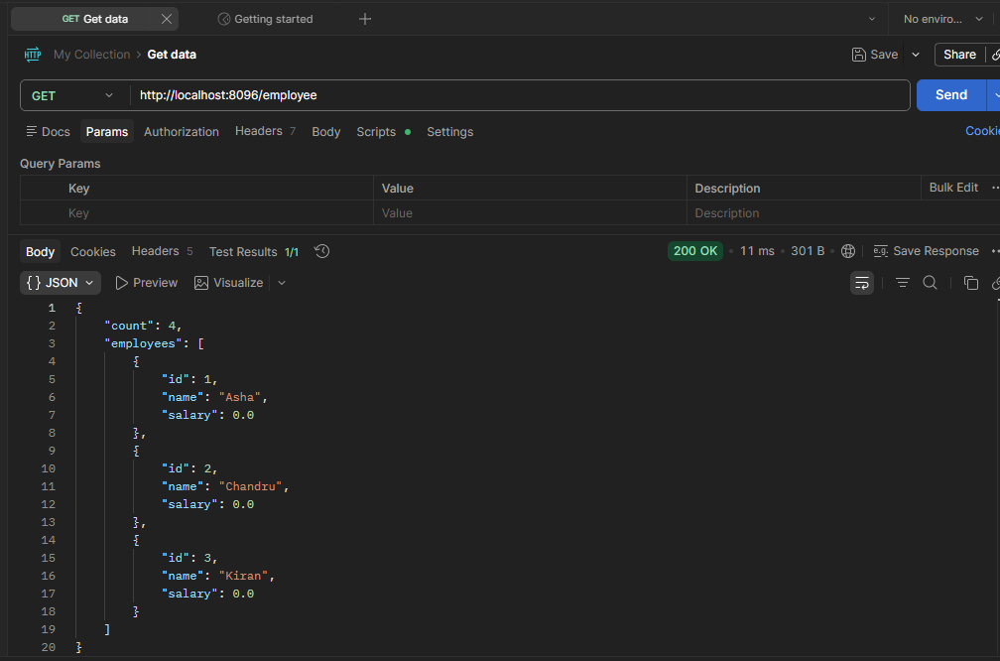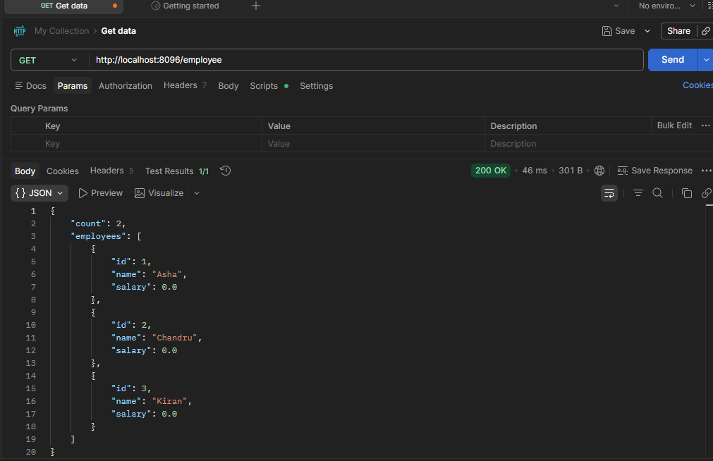

PRE-REQUEST OUTPUT & POSTMAN SCREENSHOTS
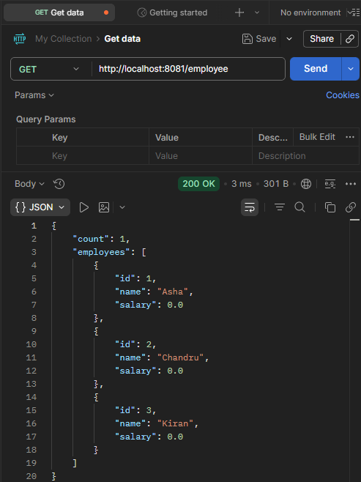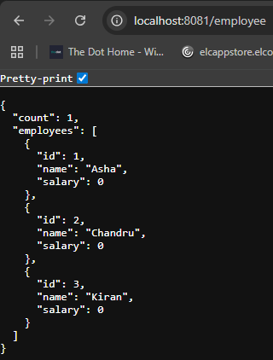

- Create a RESTFUL Web Service and test it as per the below requirements :
- The restful web Service is available on the path “jobs”.
- The web service provides two methods.
- The First method allows the “job seeker” to upload his/her CV/Profile document
- The second method allows the “Job administrators” to download the CV/Profile uploaded by the job seekers.
App.java
package com.wipro.Jobs;
import org.springframework.boot.SpringApplication;
import org.springframework.boot.autoconfigure.SpringBootApplication;

@SpringBootApplication
public class App {
public static void main(String[] args) {
SpringApplication.run(App.class, args);
}
}
Pom.xml
<?xml version="1.0" encoding="UTF-8"?>
<project xmlns="http://maven.apache.org/POM/4.0.0" xmlns:xsi="http://www.w3.org/2001/XMLSchema-instance"
xsi:schemaLocation="http://maven.apache.org/POM/4.0.0 http://maven.apache.org/xsd/maven-4.0.0.xsd">
<modelVersion>4.0.0</modelVersion>

<parent>
<groupId>org.springframework.boot</groupId>
<artifactId>spring-boot-starter-parent</artifactId>
<version>3.4.4</version>
<relativePath/>
</parent>

<groupId>com.wipro</groupId>
<artifactId>Jobs</artifactId>
<version>0.0.1-SNAPSHOT</version>

<name>Jobs</name>
<!-- FIXME change it to the project's website -->
<url>http://www.example.com</url>

<properties>
<java.version>17</java.version>
</properties>
<dependencies>
<dependency>
<groupId>org.springframework.boot</groupId>
<artifactId>spring-boot-starter-web</artifactId>
</dependency>
</dependencies>

<build>
<pluginManagement><!-- lock down plugins versions to avoid using Maven defaults (may be moved to parent pom) -->
<plugins>
<!-- clean lifecycle, see https://maven.apache.org/ref/current/maven-core/lifecycles.html#clean_Lifecycle -->
<plugin>
<artifactId>maven-clean-plugin</artifactId>
<version>3.4.0</version>
</plugin>
<!-- default lifecycle, jar packaging: see https://maven.apache.org/ref/current/maven-core/default-bindings.html#Plugin_bindings_for_jar_packaging -->
<plugin>
<artifactId>maven-resources-plugin</artifactId>
<version>3.3.1</version>
</plugin>
<plugin>
<artifactId>maven-compiler-plugin</artifactId>
<version>3.13.0</version>
</plugin>
<plugin>
<artifactId>maven-surefire-plugin</artifactId>
<version>3.3.0</version>
</plugin>
<plugin>
<artifactId>maven-jar-plugin</artifactId>
<version>3.4.2</version>
</plugin>
<plugin>
<artifactId>maven-install-plugin</artifactId>
<version>3.1.2</version>
</plugin>
<plugin>
<artifactId>maven-deploy-plugin</artifactId>
<version>3.1.2</version>
</plugin>
<!-- site lifecycle, see https://maven.apache.org/ref/current/maven-core/lifecycles.html#site_Lifecycle -->
<plugin>
<artifactId>maven-site-plugin</artifactId>
<version>3.12.1</version>
</plugin>
<plugin>
<artifactId>maven-project-info-reports-plugin</artifactId>
<version>3.6.1</version>
</plugin>
</plugins>
</pluginManagement>
</build>
</project>
JobController.java

package com.wipro.Jobs;

import org.springframework.core.io.InputStreamResource;
import org.springframework.http.HttpHeaders;
import org.springframework.http.MediaType;
import org.springframework.http.ResponseEntity;
import org.springframework.web.bind.annotation.*;
import org.springframework.web.multipart.MultipartFile;

import java.io.*;

@RestController
@RequestMapping("/jobs")

public class JobController {

private static final String UPLOAD_DIR = "uploads";

@PostMapping("/upload")
public ResponseEntity<String> uploadCV(@RequestParam("file") MultipartFile file){
try {
File dir = new File(UPLOAD_DIR);
if(!dir.exists()) {
dir.mkdirs();
}

String fileName = file.getOriginalFilename();
File savedFile = new File(dir, fileName);

try (FileOutputStream fos = new FileOutputStream(savedFile)){
fos.write(file.getBytes());
}
return ResponseEntity.ok("File uploaded successfully: " + fileName);
} catch (Exception e) {
return ResponseEntity.internalServerError()
.body("File upload failed: " + e.getMessage());
}
}

@GetMapping("/download/{fileName}")
public ResponseEntity<InputStreamResource> downloadCV(@PathVariable String fileName){
try {
File file = new File(UPLOAD_DIR, fileName);

if (!file.exists()) {
return ResponseEntity.notFound().build();
}
InputStreamResource resource = new InputStreamResource(new FileInputStream(file));
return ResponseEntity.ok()
.header(HttpHeaders.CONTENT_DISPOSITION, "attachment;filename="+file.getName())
.contentType(MediaType.APPLICATION_OCTET_STREAM)
.contentLength(file.length())
.body(resource);
} catch(Exception e) {
return ResponseEntity.internalServerError().build();
} } }
---------------------------------------------------------------------------------------------------------------------
- Create a RESTful Web Services and Test it as per the below requirements:
- The restful web services is available on the path “Movies”
- The web services helps in managing the detail of movies like movieID, movieName, leadActor, leadActress, MovieDirector and totalCollection.
- The restful web service should support the below services pertaining to movie details :
- “GET” method that returns all the movie detail
- “GET” method that returns the movie detail based on the “movieID” entered
- “POST” method to add new movie entries
- “PUT” method to update existing movie entries
- “DELETE” method at present is NOT SUPPORTED
- Please implement it using “RESTEasy” JAX-RS reference Implementation (RI) ONLY (**Important)
- You can use any database/or collection structure of your choice
-------------------------------------------------------------------------------------------------
App.java

package com.wipro.Movies;

import org.springframework.boot.SpringApplication;
import org.springframework.boot.autoconfigure.SpringBootApplication;

@SpringBootApplication
public class App {
public static void main(String[] args) {
SpringApplication.run(App.class, args);
}
}

------------------------------------------------------------------------------------------------
Pom.xml

<?xml version="1.0" encoding="UTF-8"?>
<project xmlns="http://maven.apache.org/POM/4.0.0"
xmlns:xsi="http://www.w3.org/2001/XMLSchema-instance"
xsi:schemaLocation="http://maven.apache.org/POM/4.0.0 https://maven.apache.org/xsd/maven-4.0.0.xsd">

<modelVersion>4.0.0</modelVersion>

<parent>
<groupId>org.springframework.boot</groupId>
<artifactId>spring-boot-starter-parent</artifactId>
<version>3.3.2</version>
<relativePath/>
</parent>

<groupId>com.wipro</groupId>
<artifactId>Movies</artifactId>
<version>0.0.1-SNAPSHOT</version>
<name>Movies</name>

<properties>
<java.version>17</java.version>
</properties>

<dependencies>
<dependency>
<groupId>org.springframework.boot</groupId>
<artifactId>spring-boot-starter-jersey</artifactId>
</dependency>

<dependency>
<groupId>org.glassfish.jersey.media</groupId>
<artifactId>jersey-media-json-jackson</artifactId>
</dependency>
</dependencies>

<build>
<plugins>
<plugin>
<groupId>org.springframework.boot</groupId>
<artifactId>spring-boot-maven-plugin</artifactId>
</plugin>
</plugins>
</build>
</project>
---------------------------------------------------------------------------------------------------
MovieResource.java

package com.wipro.Movies;

import jakarta.ws.rs.Consumes;
import jakarta.ws.rs.GET;
import jakarta.ws.rs.POST;
import jakarta.ws.rs.PUT;
import jakarta.ws.rs.Path;
import jakarta.ws.rs.PathParam;
import jakarta.ws.rs.Produces;
import jakarta.ws.rs.core.MediaType;
import jakarta.ws.rs.core.Response;

import java.util.Collection;
import java.util.HashMap;
import java.util.Map;

@Path("/movies")
@Produces(MediaType.APPLICATION_JSON)
@Consumes(MediaType.APPLICATION_JSON)
public class MovieResource {

private static final Map<String, Movie> movies = new HashMap<>();

static {
movies.put("M101", new Movie("M101", "Inception", "Leonardo DiCaprio", "Elliot Page", "Christopher Nolan", 950.0));
movies.put("M102", new Movie("M102", "Titanic", "Leonardo DiCaprio", "Kate Winslet", "James Cameron", 2200.0));
}

@GET
public Collection<Movie> getAllMovies() {
return movies.values();
}

@GET
@Path("/{movieID}")
public Response getMovieById(@PathParam("movieID") String movieID) {
Movie movie = movies.get(movieID);

if (movie != null) {
return Response.ok(movie).build();
} else {
return Response.status(Response.Status.NOT_FOUND)
.entity("Movie not found")
.build();
}
}

@POST
public Response addMovie(Movie movie) {
if (movie == null || movie.getMovieID() == null || movie.getMovieID().isBlank()) {
return Response.status(Response.Status.BAD_REQUEST)
.entity("Invalid movie data")
.build();
}

if (movies.containsKey(movie.getMovieID())) {
return Response.status(Response.Status.CONFLICT)
.entity("Movie ID already exists")
.build();
}

movies.put(movie.getMovieID(), movie);
return Response.status(Response.Status.CREATED).entity(movie).build();
}

@PUT
@Path("/{movieID}")
public Response updateMovie(@PathParam("movieID") String movieID, Movie movie) {
if (!movies.containsKey(movieID)) {
return Response.status(Response.Status.NOT_FOUND)
.entity("Movie not found")
.build();
}

movie.setMovieID(movieID);
movies.put(movieID, movie);
return Response.ok(movie).build();
}
}
--------------------------------------------------------------------------------------------------------
JerseyConfig.java

package com.wipro.config;

import org.glassfish.jersey.server.ResourceConfig;
import org.springframework.context.annotation.Configuration;
import org.springframework.stereotype.Component;

import jakarta.ws.rs.ApplicationPath;

@Configuration
@Component
@ApplicationPath("/api")
public class JerseyConfig extends ResourceConfig {

public JerseyConfig() {
register(com.wipro.Movies.MovieResource.class);
}
}

----------------------------------------------------------------------------------------------
Movie.java

package com.wipro.Movies;

public class Movie {

private String movieID;
private String movieName;
private String leadActor;
private String leadActress;
private String director;
private Double boxOfficeCollection;

public Movie() {
}

public Movie(String movieID, String movieName, String leadActor, String leadActress,
String director, Double boxOfficeCollection) {
this.movieID = movieID;
this.movieName = movieName;
this.leadActor = leadActor;
this.leadActress = leadActress;
this.director = director;
this.boxOfficeCollection = boxOfficeCollection;
}

public String getMovieID() {
return movieID;
}

public void setMovieID(String movieID) {
this.movieID = movieID;
}

public String getMovieName() {
return movieName;
}

public void setMovieName(String movieName) {
this.movieName = movieName;
}

public String getLeadActor() {
return leadActor;
}

public void setLeadActor(String leadActor) {
this.leadActor = leadActor;
}

public String getLeadActress() {
return leadActress;
}

public void setLeadActress(String leadActress) {
this.leadActress = leadActress;
}

public String getDirector() {
return director;
}

public void setDirector(String director) {
this.director = director;
}

public Double getBoxOfficeCollection() {
return boxOfficeCollection;
}

public void setBoxOfficeCollection(Double boxOfficeCollection) {
this.boxOfficeCollection = boxOfficeCollection;
}
}

---------------------------------------------------------------------------------------------------

- Please implement the previous requirement(Assignment-3) again, but this time ONLY with Spring REST/Spring MVC5 Reference Implementation (RI) ONLY (**Important)

Movie.java
--------------
package com.wipro.movies_spring;

public class Movie {

private String movieID;
private String movieName;
private String leadActor;
private String leadActress;
private String movieDirector;
private double totalCollection;

public Movie() {
}

public Movie(String movieID, String movieName, String leadActor, String leadActress,
String movieDirector, double totalCollection) {
this.movieID = movieID;
this.movieName = movieName;
this.leadActor = leadActor;
this.leadActress = leadActress;
this.movieDirector = movieDirector;
this.totalCollection = totalCollection;
}

public String getMovieID() {
return movieID;
}

public void setMovieID(String movieID) {
this.movieID = movieID;
}

public String getMovieName() {
return movieName;
}

public void setMovieName(String movieName) {
this.movieName = movieName;
}

public String getLeadActor() {
return leadActor;
}

public void setLeadActor(String leadActor) {
this.leadActor = leadActor;
}

public String getLeadActress() {
return leadActress;
}

public void setLeadActress(String leadActress) {
this.leadActress = leadActress;
}

public String getMovieDirector() {
return movieDirector;
}

public void setMovieDirector(String movieDirector) {
this.movieDirector = movieDirector;
}

public double getTotalCollection() {
return totalCollection;
}

public void setTotalCollection(double totalCollection) {
this.totalCollection = totalCollection;
}
}
MovieController.java
package com.wipro.movies_spring;

import jakarta.annotation.PostConstruct;
import org.springframework.http.HttpStatus;
import org.springframework.http.ResponseEntity;
import org.springframework.web.bind.annotation.*;

import java.util.Collection;
import java.util.HashMap;
import java.util.Map;

@RestController
@RequestMapping("/movies")
public class MovieController {

private final Map<String, Movie> movies = new HashMap<>();

@PostConstruct
public void init() {
movies.put("M101", new Movie("M101", "Inception", "Leonardo DiCaprio", "Elliot Page", "Christopher Nolan", 950.0));
movies.put("M102", new Movie("M102", "Titanic", "Leonardo DiCaprio", "Kate Winslet", "James Cameron", 2200.0));
}

@GetMapping
public Collection<Movie> getAllMovies() {
return movies.values();
}

@GetMapping("/{movieID}")
public ResponseEntity<?> getMovieById(@PathVariable String movieID) {
Movie movie = movies.get(movieID);

if (movie != null) {
return new ResponseEntity<>(movie, HttpStatus.OK);
} else {
return new ResponseEntity<>("Movie not found", HttpStatus.NOT_FOUND);
}
}

@PostMapping
public ResponseEntity<String> addMovie(@RequestBody Movie movie) {
if (movies.containsKey(movie.getMovieID())) {
return new ResponseEntity<>("Movie ID already exists", HttpStatus.CONFLICT);
}

movies.put(movie.getMovieID(), movie);
return new ResponseEntity<>("Movie added successfully", HttpStatus.CREATED);
}

@PutMapping("/{movieID}")
public ResponseEntity<String> updateMovie(@PathVariable String movieID, @RequestBody Movie movie) {
if (movies.containsKey(movieID)) {
movie.setMovieID(movieID);
movies.put(movieID, movie);
return new ResponseEntity<>("Movie updated successfully", HttpStatus.OK);
} else {
return new ResponseEntity<>("Movie not found", HttpStatus.NOT_FOUND);
}
}

@DeleteMapping("/{movieID}")
public ResponseEntity<String> deleteMovie(@PathVariable String movieID) {
return new ResponseEntity<>("DELETE method is not supported", HttpStatus.METHOD_NOT_ALLOWED);
} }
----------------------------------------------------------------------------------------------------------------
MoviesApplication.java
package com.wipro.movies_spring;

import org.springframework.boot.SpringApplication;
import org.springframework.boot.autoconfigure.SpringBootApplication;

@SpringBootApplication
public class MoviesApplication {

public static void main(String[] args) {
SpringApplication.run(MoviesApplication.class, args);
}
}
Pom.xml

<?xml version="1.0" encoding="UTF-8"?>
<project xmlns="http://maven.apache.org/POM/4.0.0"
xmlns:xsi="http://www.w3.org/2001/XMLSchema-instance"
xsi:schemaLocation="http://maven.apache.org/POM/4.0.0 https://maven.apache.org/xsd/maven-4.0.0.xsd">

<modelVersion>4.0.0</modelVersion>

<parent>
<groupId>org.springframework.boot</groupId>
<artifactId>spring-boot-starter-parent</artifactId>
<version>3.4.4</version>
<relativePath/>
</parent>
<groupId>com.wipro</groupId>
<artifactId>movies-spring</artifactId>
<version>0.0.1-SNAPSHOT</version>
<name>movies-spring</name>
<description>Movie API using Spring REST / Spring MVC</description>
<properties>
<java.version>17</java.version>
</properties>
<dependencies>
<dependency>
<groupId>org.springframework.boot</groupId>
<artifactId>spring-boot-starter-web</artifactId>
</dependency>
</dependencies>
</project>
OUTPUT SCREENSHOTS
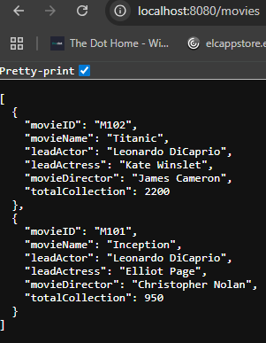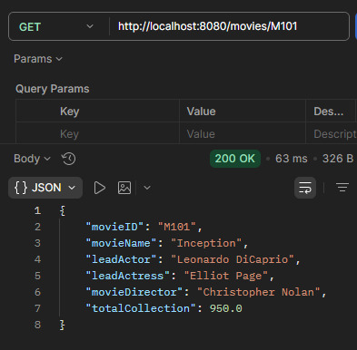

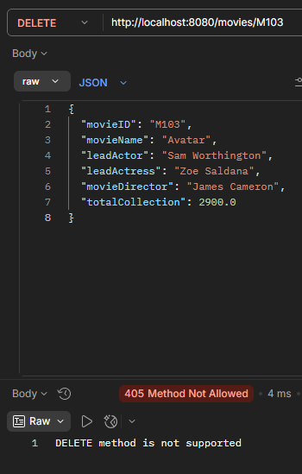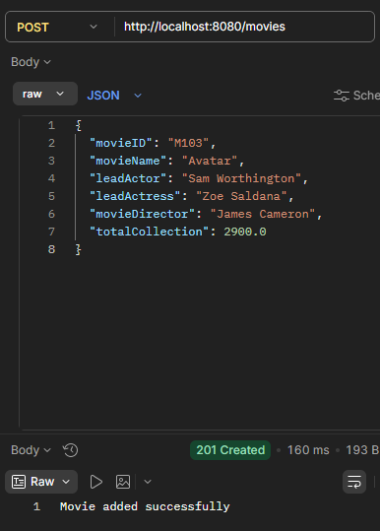

- Please add Basic Authentication to the solution of Assignment-3/4 above to ensure the below:
- “GET” methods need not have any authentication
- “POST” and “PUT” methods will be guarded through basic authentication.
- You can use the hardcoded user ID “admin” and password as “wipro@123” for the same.

Question – 4 : Changes made in pom.xml

<dependency>
<groupId>org.springframework.boot</groupId>
<artifactId>spring-boot-starter-security</artifactId>
</dependency>

Created new Security Config Class
package com.wipro.movies_spring;

import org.springframework.context.annotation.Bean;
import org.springframework.context.annotation.Configuration;
import org.springframework.http.HttpMethod;
import org.springframework.security.config.annotation.web.builders.HttpSecurity;
import org.springframework.security.core.userdetails.User;
import org.springframework.security.core.userdetails.UserDetails;
import org.springframework.security.core.userdetails.UserDetailsService;
import org.springframework.security.crypto.password.NoOpPasswordEncoder;
import org.springframework.security.provisioning.InMemoryUserDetailsManager;
import org.springframework.security.web.SecurityFilterChain;

@Configuration
public class SecurityConfig {

@Bean
public SecurityFilterChain filterChain(HttpSecurity http) throws Exception {

http
.csrf().disable() // disable CSRF for simplicity

.authorizeHttpRequests(auth -> auth
// allow GET without authentication
.requestMatchers(HttpMethod.GET, "/movies/**").permitAll()

// protect POST and PUT
.requestMatchers(HttpMethod.POST, "/movies/**").authenticated()
.requestMatchers(HttpMethod.PUT, "/movies/**").authenticated()

// everything else allowed
.anyRequest().permitAll()
)

.httpBasic(); // enable basic auth

return http.build();
}

@Bean
public UserDetailsService users() {

UserDetails user = User
.withUsername("admin")
.password("wipro@123")
.roles("ADMIN")
.build();

return new InMemoryUserDetailsManager(user);
}

@Bean
@SuppressWarnings("deprecation")
public static NoOpPasswordEncoder passwordEncoder() {
return (NoOpPasswordEncoder) NoOpPasswordEncoder.getInstance();
}
}

OUTPUT SCREENSHOTS

6

- Enhance the “Basic Authentication” solution implemented in the previous assignment (Assignment-5) and replace the web services with SSL based authentication.

MoviesApplication.java

package com.wipro.movies_spring;

import org.springframework.boot.SpringApplication;
import org.springframework.boot.autoconfigure.SpringBootApplication;

@SpringBootApplication
public class MoviesApplication {

public static void main(String[] args) {
SpringApplication.run(MoviesApplication.class, args);
}
}

Application.properties

spring.application.name=movies-spring-demo

server.port=8443
server.ssl.enabled=true
server.ssl.key-store=classpath:keystore.p12
server.ssl.key-store-password=changeit
server.ssl.key-store-type=PKCS12
server.ssl.key-alias=tomcat

server.ssl.key-alias=myssl

SecurityConfig.java

package com.wipro.movies_spring;

import org.springframework.context.annotation.Bean;
import org.springframework.context.annotation.Configuration;
import org.springframework.security.config.Customizer;
import org.springframework.security.config.annotation.web.builders.HttpSecurity;
import org.springframework.security.web.SecurityFilterChain;

@Configuration
public class SecurityConfig {

@Bean
public SecurityFilterChain filterChain(HttpSecurity http) throws Exception {

http
.csrf(csrf -> csrf.disable())
.authorizeHttpRequests(auth -> auth
.anyRequest().permitAll()
)
.requiresChannel(channel -> channel
.anyRequest().requiresSecure()
);

return http.build();
}
}

MovieController.java

package com.wipro.movies_spring;

import jakarta.annotation.PostConstruct;
import org.springframework.http.HttpStatus;
import org.springframework.http.ResponseEntity;
import org.springframework.web.bind.annotation.*;

import java.util.Collection;
import java.util.HashMap;
import java.util.Map;

@RestController
@RequestMapping("/movies")
public class MovieController {

private final Map<String, Movie> movies = new HashMap<>();

@PostConstruct
public void init() {
movies.put("M101", new Movie("M101", "Inception", "Leonardo DiCaprio", "Elliot Page", "Christopher Nolan", 950.0));
movies.put("M102", new Movie("M102", "Titanic", "Leonardo DiCaprio", "Kate Winslet", "James Cameron", 2200.0));
}

@GetMapping
public Collection<Movie> getAllMovies() {
return movies.values();
}

@GetMapping("/{movieID}")
public ResponseEntity<?> getMovieById(@PathVariable String movieID) {
Movie movie = movies.get(movieID);

if (movie != null) {
return new ResponseEntity<>(movie, HttpStatus.OK);
} else {
return new ResponseEntity<>("Movie not found", HttpStatus.NOT_FOUND);
}
}

@PostMapping
public ResponseEntity<String> addMovie(@RequestBody Movie movie) {
if (movies.containsKey(movie.getMovieID())) {
return new ResponseEntity<>("Movie ID already exists", HttpStatus.CONFLICT);
}

movies.put(movie.getMovieID(), movie);
return new ResponseEntity<>("Movie added successfully", HttpStatus.CREATED);
}

@PutMapping("/{movieID}")
public ResponseEntity<String> updateMovie(@PathVariable String movieID, @RequestBody Movie movie) {
if (movies.containsKey(movieID)) {
movie.setMovieID(movieID);
movies.put(movieID, movie);
return new ResponseEntity<>("Movie updated successfully", HttpStatus.OK);
} else {
return new ResponseEntity<>("Movie not found", HttpStatus.NOT_FOUND);
}
}

@DeleteMapping("/{movieID}")
public ResponseEntity<String> deleteMovie(@PathVariable String movieID) {
return new ResponseEntity<>("DELETE method is not supported", HttpStatus.METHOD_NOT_ALLOWED);
}
}

Movie.java

package com.wipro.movies_spring;

public class Movie {

private String movieID;
private String movieName;
private String leadActor;
private String leadActress;
private String movieDirector;
private double totalCollection;

public Movie() {
}

public Movie(String movieID, String movieName, String leadActor, String leadActress,
String movieDirector, double totalCollection) {
this.movieID = movieID;
this.movieName = movieName;
this.leadActor = leadActor;
this.leadActress = leadActress;
this.movieDirector = movieDirector;
this.totalCollection = totalCollection;
}

public String getMovieID() {
return movieID;
}

public void setMovieID(String movieID) {
this.movieID = movieID;
}

public String getMovieName() {
return movieName;
}

public void setMovieName(String movieName) {
this.movieName = movieName;
}

public String getLeadActor() {
return leadActor;
}

public void setLeadActor(String leadActor) {
this.leadActor = leadActor;
}

public String getLeadActress() {
return leadActress;
}

public void setLeadActress(String leadActress) {
this.leadActress = leadActress;
}

public String getMovieDirector() {
return movieDirector;
}

public void setMovieDirector(String movieDirector) {
this.movieDirector = movieDirector;
}

public double getTotalCollection() {
return totalCollection;
}

public void setTotalCollection(double totalCollection) {
this.totalCollection = totalCollection;
}
}
Pom.xml
<?xml version="1.0" encoding="UTF-8"?>
<project xmlns="http://maven.apache.org/POM/4.0.0"
xmlns:xsi="http://www.w3.org/2001/XMLSchema-instance"
xsi:schemaLocation="http://maven.apache.org/POM/4.0.0 https://maven.apache.org/xsd/maven-4.0.0.xsd">

<modelVersion>4.0.0</modelVersion>

<parent>
<groupId>org.springframework.boot</groupId>
<artifactId>spring-boot-starter-parent</artifactId>
<version>3.4.4</version>
<relativePath/>
</parent>

<groupId>com.wipro</groupId>
<artifactId>movies-spring</artifactId>
<version>0.0.1-SNAPSHOT</version>
<name>movies-spring</name>
<description>Movie API using Spring REST / Spring MVC</description>

<properties>
<java.version>17</java.version>
</properties>

<dependencies>
<dependency>
<groupId>org.springframework.boot</groupId>
<artifactId>spring-boot-starter-web</artifactId>
</dependency>

<dependency>
<groupId>org.springframework.boot</groupId>
<artifactId>spring-boot-starter-security</artifactId>
</dependency>
</dependencies>

</project>

OUTPUT SCREENSHOT

