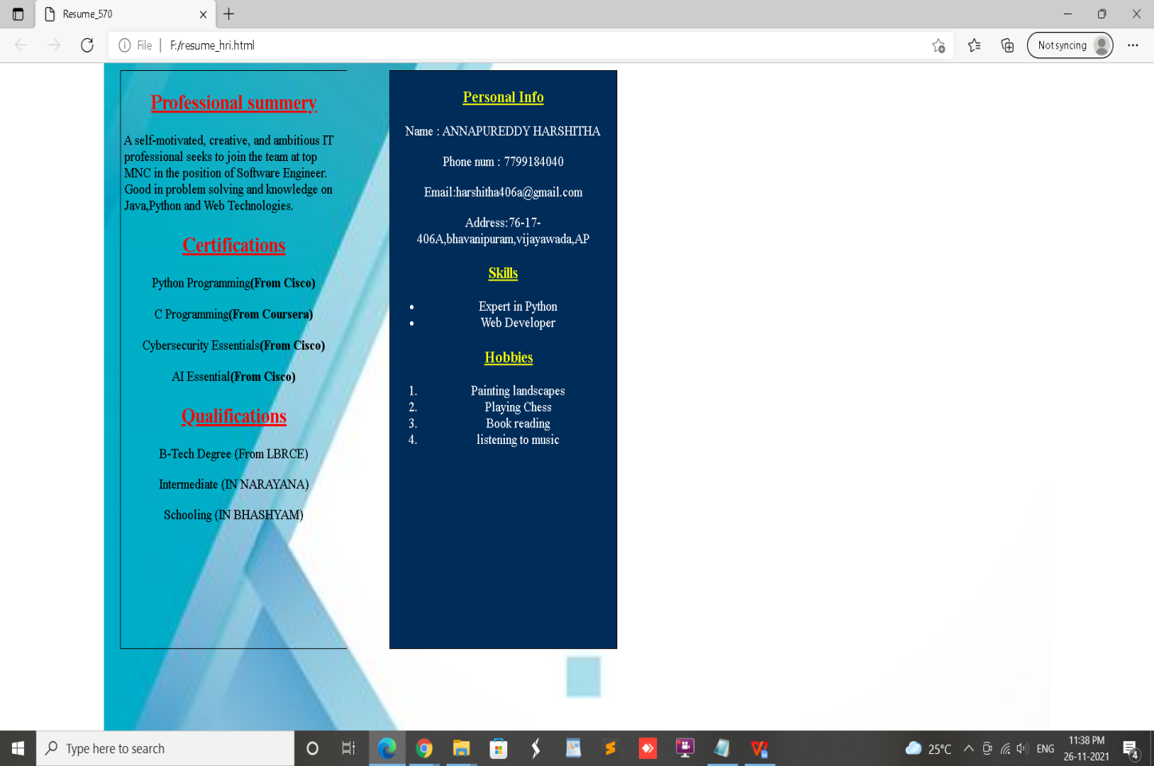

# Code for this

<!DOCTYPE html>

<html>

<head>

<title>Resume_570</title>

</head>

<style >

body{

background-image: url('resume_bg1.jpg');

background-repeat:no-repeat;

background-size:82%;

background-position:center;

}

.div1{

width: 300px;

height: 650px;

border:1.5px solid black;

float: left;

margin-left: 10%;

border-right:none;

background-color: none;

}

.div2{

width: 300px;

height: 650px;

border:1.5px solid black;

float: right;

margin-right: 46.5%;

background-color: #002C5A;

}

img{

margin-left: 25%;

}

.div2 h3{

text-align: center;

color:yellow;

font-family: Times New Roman

}

.div2 p{

text-align: center;

color:#fff;

font-family: Times New Roman;

}

.div2 ul{

text-align: center;

color:#fff;

font-family:Times New Roman;

}

.div2 ol{

text-align: center;

color:#fff;

font-family: Times New Roman;

}

.div1 h2{

text-align: center;

font-family: Times New Roman

}

.div1 p{

text-align: center;

font-family: Times New Roman;

}

</style>

<body>

<div class="div1">

<h2><u><font color="Red">Professional summery</font></u></h2>

&nbsp;A self-motivated, creative, and ambitious IT &nbsp;professional seeks to join the

team at top &nbsp;MNC in the position of Software Engineer.

&nbsp;Good in problem solving and knowledge on &nbsp;

&nbsp;Java,Python and Web Technologies.

<h2><u><font color="Red">Certifications</font></u></h2>

<p>Python Programming<b>(From Cisco)</b></p>

<p>C Programming<b>(From Coursera)</b></p>

<p>Cybersecurity Essentials<b>(From Cisco)</b></p>

<p>AI Essential<b>(From Cisco)</b></p>

<h2><u><font color="RED">Qualifications</font></u></h2>

<p>B-Tech Degree (From LBRCE)<br></p>

<p>Intermediate (IN NARAYANA) </p>

<p>Schooling (IN BHASHYAM) </p>

</div>

<div class="div2">

<h3><u>Personal Info</u></h3>

<p>Name : ANNAPUREDDY HARSHITHA</p>

<p>Phone num : 7799184040</p>

<p>Email:harshitha406a@gmail.com</p>

<p>Address:76-17-406A,bhavanipuram,vijayawada,AP</p>

<h3><u>Skills</u></h3>

<ul>

<li>Expert in Python</li>

<li>Web Developer</li>

</ul>

<h3>&nbsp;&nbsp;&nbsp;<u>Hobbies</u></h3>

<ol>

<li>Painting landscapes</li>

<li>Playing Chess</li>

<li>Book reading</li>

<li>listening to music</li>

</ol>

</div>

</body>

</html>