INTERNATIONAL INSTITUTE OF MEDICAL SCIENCE AND TECNOLOGY COUNCIL
(IIMSTC, BANGLORE)


MAJOR PROJECT REPORT ON MACHINE LEARNING
“FITFUSION: A SMART AI-DRIVEN PERSONAL GYM TRAINER FOR IMPROVING EXERCISE ACCURACY AND MONITORING USER PERFORMANCE AT HOME”
Submitted by

Cohort-18-DSML

Aptha H P |  | 1EW22IS011
Dimple K B Anmol C Satakhed  Annapurna Deshmukh Muzamil Pasha N Varun R  Madhu Chandrika V  Vinay M N Keerthana A L |  | 1EW22AI011  4JN22RI005  3DG22AD006  1CD22EE029  1ST22CS238  1AT22IS059  1MV22EC122  1ST22AD021
Kruthanva R Yuktha V Iram Sultana Ananya M  Pratham Jaiswal Kothapalli Yashwanth |  | 1KS22CS063  1MV22EC126  4VM22IS017 IAT22IS011 1AY22CD039  1EW22CS070
 | Under the guidance of:
 | Ms. Disha
 | Project Supervisor

ABSTRACT

The rapid advancement of digital health technologies has transformed how individuals approach fitness and personal well-being. However, many existing fitness applications fail to provide an integrated, intelligent, and user-centric solution that combines workout planning, real-time tracking, and meaningful progress insights. Beginners, in particular, often lack proper guidance, structured routines, and motivation, while managing workout data across multiple platforms becomes inconvenient. To address these challenges, this project presents FitFusion, an AI-powered fitness tracking and workout planning platform designed to deliver a unified and guided workout experience.
FitFusion is a full-stack web-based application that integrates modern web development frameworks with machine learning-based pose estimation. The system utilizes MediaPipe Pose to perform real-time human posture detection using a standard webcam, enabling repetition counting, movement tracking, and basic form analysis without requiring wearable devices. This approach improves accessibility and ensures that users can perform guided workouts efficiently from home environments.
The platform is organized into four primary modules: user and profile management, exercise library and planner, workout studio with pose tracking, and session saving with analytics. Users can register, set preferences, and personalize their fitness journey. The exercise library offers categorized workouts and curated plans based on target muscle groups. The workout studio provides real-time tracking with skeleton overlay visualization and repetition counting, forming the core interactive component. Additionally, workout sessions are stored and analysed to present insights such as duration, repetitions, and estimated calories through an intuitive dashboard.
The system is implemented using FastAPI for backend services, React for frontend development, and SQLite for data storage. This architecture ensures efficient API handling, smooth user interaction, and scalability for future improvements. By integrating these technologies, FitFusion creates a seamless pipeline for managing workout data and delivering actionable insights.
This project aligns with the United Nations Sustainable Development Goal (SDG) 3: Good Health and Well-being, which focuses on promoting healthy lifestyles and improving overall well-being. FitFusion contributes to this goal by encouraging regular physical activity, providing accessible fitness guidance, and enabling users to monitor their progress effectively.

TABLE OF CONTENTS

S No. | Contents | Page No.
1 | Introduction | 4
2 | Problem Statement | 6
3 | Literature Survey | 7
4 | System Architecture | 10
5 | System Implementation | 13
6 | System Testing | 17
7 | Results | 20
8 | Conclusion | 24

CHAPTER 1

INTRODUCTION

In recent years, the importance of maintaining a healthy lifestyle has gained significant attention due to the increasing prevalence of sedentary habits, stress, and lifestyle-related diseases. Regular physical activity is widely recognized as a key factor in improving overall health, enhancing mental well-being, and preventing chronic conditions such as obesity, cardiovascular diseases, and diabetes. However, despite growing awareness, many individuals struggle to maintain consistency in their fitness routines due to lack of motivation, improper guidance, and limited access to structured workout programs. The emergence of digital fitness solutions has attempted to bridge this gap, yet existing systems often fall short in delivering a comprehensive and intelligent user experience.
Most conventional fitness applications primarily focus on basic functionalities such as step counting, calorie tracking, or providing static workout routines. While these features are useful, they do not address critical aspects such as real-time posture correction, personalized workout planning, and continuous performance monitoring. Beginners, in particular, face challenges in understanding correct exercise techniques, which can lead to ineffective workouts or even injuries. Additionally, switching between multiple applications for planning, tracking, and analyzing workouts creates inconvenience and reduces user engagement. These limitations highlight the need for an integrated platform that combines guidance, tracking, and analytics into a single cohesive system.
With advancements in artificial intelligence and computer vision, new opportunities have emerged to enhance digital fitness platforms. Pose estimation technologies enable systems to analyze human body movements in real time using visual input, making it possible to provide feedback on exercise performance without the need for specialized hardware. This innovation opens the door to creating accessible and cost-effective fitness solutions that can be used in home environments. By leveraging such technologies, it is possible to design systems that not only track user activity but also guide them toward performing exercises correctly and consistently.
The proposed project, FitFusion, is developed as an AI-powered fitness tracking and workout planning platform aimed at addressing these challenges. The system is designed as a full-stack web application that integrates frontend, backend, and machine learning components to deliver a seamless user experience. One of the core features of FitFusion is its camera-based workout tracking system, which utilizes pose estimation techniques to detect body landmarks and monitor user movements during exercises. This allows the platform to count repetitions, track activity, and provide visual feedback through a skeleton overlay, thereby enhancing user awareness and engagement.

FitFusion is structured into multiple functional modules to ensure clarity, scalability, and efficient system operation. The user and profile management module handles authentication, personalization, and goal setting, enabling users to tailor the platform according to their fitness objectives. The exercise library and planner module provides categorized workouts and curated routines, helping users choose exercises based on target muscle groups and preferences. The workout studio module serves as the interactive core, where real-time pose tracking and repetition counting take place. Finally, the session saving and analytics module stores workout data and presents it through dashboards, allowing users to analyze their progress over time.
From a technical perspective, the system is implemented using modern web technologies and frameworks. The frontend is developed using React, ensuring a responsive and user-friendly interface, while the backend is powered by FastAPI for efficient API handling and system performance. SQLite is used as a lightweight database to manage user data, workout sessions, and historical records. The integration of these technologies results in a robust architecture capable of supporting real-time interactions and future scalability. Additionally, the use of MediaPipe Pose for pose estimation provides a reliable and efficient solution for detecting and analyzing human movements.
The development of FitFusion not only demonstrates the practical application of artificial intelligence in the fitness domain but also emphasizes the importance of user-centric design in digital solutions. By combining workout planning, real-time tracking, and performance analytics into a single platform, the system aims to improve user engagement and promote consistency in fitness routines. Furthermore, the project highlights how accessible technologies can be utilized to create affordable solutions that cater to a wide range of users, including those who may not have access to professional training resources.
This project is aligned with global initiatives such as the United Nations Sustainable Development Goal 3: Good Health and Well-being, which focuses on ensuring healthy lives and promoting well-being for all. By encouraging regular exercise and providing intelligent fitness guidance, FitFusion contributes toward improving individual health outcomes. It also supports innovation in digital infrastructure, aligning with SDG 9, by showcasing how emerging technologies can be effectively applied to solve real-world problems.
In conclusion, the introduction of FitFusion represents a step toward the evolution of smart fitness systems that integrate artificial intelligence with user-friendly design. The platform addresses key limitations of existing fitness applications by offering a unified, intelligent, and scalable solution for workout planning and tracking. Through its innovative features and structured architecture, FitFusion aims to make fitness more engaging, accessible, and data-driven, ultimately empowering users to achieve their health and wellness goals.

CHAPTER 2

PROBLEM STATEMENT

In today’s digital era, although numerous fitness applications are available, they often fail to provide a comprehensive and intelligent solution that effectively supports users throughout their fitness journey. Many individuals struggle to maintain consistency in workouts due to lack of motivation, improper guidance, and absence of real-time feedback. Existing applications typically offer static workout plans or basic tracking features, but they do not ensure whether exercises are performed correctly, which is especially challenging for beginners.
A major limitation of current systems is the absence of real-time posture monitoring and accurate repetition tracking without the use of additional wearable devices. Users are often required to manually log workouts, which can lead to inaccuracies and reduced engagement. Furthermore, fitness data such as workout history, progress metrics, and performance insights are frequently scattered across different platforms, making it difficult for users to monitor improvement effectively.
There is also a lack of personalization in many fitness solutions, where users do not receive structured workout recommendations based on their preferences and goals. Without proper feedback and analytics, users may perform exercises incorrectly, reducing effectiveness and increasing the risk of injury. These challenges highlight the need for a unified, intelligent fitness platform that integrates workout planning, real-time tracking, posture analysis, and progress monitoring into a single system.

Objectives
The primary objective of the FitFusion project is to design and develop an AI-powered fitness platform that provides an integrated and user-friendly solution for workout planning, tracking, and analysis. The specific objectives are:
- To develop an integrated fitness platform that combines workout planning, real-time tracking, and performance analytics in a single system.
- To implement real-time pose estimation using computer vision (MediaPipe Pose) for accurate posture detection during exercises.
- To enable automatic repetition counting and activity monitoring through webcam input, eliminating manual tracking.
- To design a structured exercise library and workout planner for guided and categorized fitness routines.
- To support health and well-being initiatives by encouraging consistent workouts, aligned with the United Nations Sustainable Development Goal 3 (Good Health and Well-being).

CHAPTER 3

LITERATURE SURVEY

The study of AI-based fitness systems has evolved significantly with the integration of computer vision, machine learning, and lightweight pose estimation frameworks. The reviewed literature collectively emphasizes the transition from traditional sensor-based fitness tracking toward camera-based, intelligent, and real-time workout monitoring systems. These research works form the conceptual and technical foundation for developing advanced fitness platforms such as FitFusion.
A survey on AI-based workout tracking systems highlights the overall landscape of fitness technologies, focusing on the use of computer vision and sensor-based approaches for monitoring physical activity. The study identifies pose estimation as a key technique for tracking exercises but also points out the lack of comparative analysis in terms of real-time accuracy. Similarly, the AI Fitness Trainer preprint introduces a system capable of providing real-time feedback using pose detection algorithms. While it demonstrates the feasibility of posture correction, it suffers from limitations related to dataset size and scalability, which restrict its application in diverse real-world scenarios.
The paper on real-time human pose estimation (2006.11718) presents a deep learning-based approach for detecting human key points with high precision. This work plays a crucial role in enabling systems to understand body posture and movement. However, its high computational cost makes it less suitable for lightweight or resource-constrained environments. Addressing this issue, MediaPipe-based systems using BlazePose models offer a more efficient alternative by providing real-time performance with reduced computational requirements. These systems utilize joint angle calculations and heuristic or machine learning approaches such as KNN for repetition counting and posture evaluation. Despite their efficiency, they face challenges in generalization, personalization, and maintaining accuracy under varying conditions.
Several studies, including those published in IJERT and other implementations of AI fitness trainers, focus on repetition counting and form analysis using joint angle calculations. These approaches are effective for specific exercises but are often limited in supporting a wide range of workout types. Additionally, systems such as AI Personal Fitness Trainer using MediaPipe and OpenCV introduce features like customized workout plans, progress tracking, and real-time feedback, enhancing user engagement. However, they remain dependent on external factors such as camera quality and lighting conditions, which can impact performance.

Further advancements are seen in systems like AI Human Fitness Tracker using computer vision, which incorporate modular architectures and audio feedback mechanisms to improve user interaction. While these systems eliminate the need for wearable sensors and improve accessibility, they still face issues such as latency and limited personalization. The concept of virtual fitness trainers extends this idea by integrating computer vision, machine learning, and natural language processing to create interactive user interfaces. These systems support multiple exercises and provide real-time feedback but raise concerns regarding data privacy and require large datasets for training robust models.
Another significant contribution is the on-device real-time smartphone-based exercise repetition counting system, which emphasizes privacy-focused design and low-latency processing by eliminating cloud dependency. Although this approach improves data security and usability, it is constrained by limited computational power of mobile devices and reduced accuracy compared to high-end systems.
Overall, the literature reveals that while significant progress has been made in AI-based fitness tracking, key challenges remain unresolved. These include limited exercise support, lack of personalization, dependency on environmental conditions, computational constraints, and insufficient real-world robustness. The insights gained from these studies directly influence the design of FitFusion, which aims to combine real-time pose estimation, efficient system architecture, and user-centric features into a unified platform. By addressing the identified limitations, the proposed system seeks to provide a more scalable, accurate, and accessible fitness solution.
Recent advancements in AI-based fitness systems have also focused on temporal modeling techniques to better understand motion over time rather than relying solely on static frame analysis. Approaches using sequence-based models such as Long Short-Term Memory (LSTM) networks and Temporal Convolutional Networks (TCNs) enable more accurate recognition of dynamic exercises by capturing movement continuity and transitions. This improves the system’s ability to detect improper form and provide more context-aware feedback. However, these models demand higher computational power and larger annotated datasets, which limits their feasibility for real-time applications on low-resource devices.
Another important aspect gaining attention is user personalization and adaptive feedback. Most existing systems operate on generalized models that do not account for variations in individual body structure, flexibility, or fitness levels. Recent research explores adaptive learning techniques that tailor feedback and workout recommendations based on user performance over time. While this enhances user engagement and effectiveness, it introduces challenges related to data collection, model complexity, and privacy concerns. Addressing these issues is essential for developing more intelligent, user-centric fitness platforms like FitFusion.

Literature Survey – AI Gym Trainer
Paper Title | Details (Short Abstract) | Ideas Taken | Limitations
A Survey on AI-Based Workout Tracking System | Reviews AI-based fitness tracking using computer vision and sensors. | Pose estimation for tracking exercises. | No real-time accuracy comparison.
AI Fitness Trainer (Preprint) | AI trainer providing feedback using pose detection. | Real-time posture correction. | Limited dataset and scalability.
Real-Time Human Pose Estimation (2006.11718) | Deep learning model for real-time human keypoint detection. | Keypoint detection. | High computational cost.
AI Fitness Trainer Using Human Pose Estimation (IJERT) | Counts reps and analyzes exercise form using pose estimation. | Rep counting using joint angles. | Supports limited exercises.
MediaPipe-Based Workout Monitoring System Using BlazePose Models | Uses MediaPipe + BlazePose, joint angle calculation, KNN/heuristics for rep counting & posture correction | Real-time posture feedback, angle-based evaluation, lightweight models | Poor generalization, limited personalization, accuracy issues
AI Personal Fitness Trainer using MediaPipe & OpenCV | AI trainer with pose estimation, angle comparison, customized workout plans | Personalized workout plans, progress tracking, real-time feedback | Limited adaptability, depends on camera quality
AI Human Fitness Tracker using Computer Vision with MediaPipe | Camera-based system, joint-angle logic, audio feedback, no wearables | Sensor-free tracking, audio feedback, modular architecture | Lighting issues, latency, limited personalization
Virtual Fitness Trainer Using AI | Combines CV + ML + NLP, real-time pose detection, feedback & UI | Multi-exercise tracking, real-time feedback, UI-based interaction | Data privacy concerns, needs large dataset
AI Fitness Trainer (Ira Nath et al.) | Uses pose estimation + datasets, evaluates exercises using angle comparison | Dataset-based evaluation, cost-effective AI trainer | Limited real-world robustness, lacks adaptive learning

CHAPTER 4

SYSTEM ARCHITECTURE

The FitFusion system is designed as an integrated architecture that combines real-time video processing, machine learning, and web-based application components to deliver an intelligent fitness tracking solution. The system begins with the user interacting through the frontend interface, where they select workouts and initiate a session. Once the workout starts, the webcam captures live video input, which acts as the primary data source for the system.
This video stream is passed to the pose estimation module, implemented using MediaPipe Pose, where human body landmarks are detected in real time. The detected keypoints are then processed further to compute joint angles and body movements, which form the basis for analysing exercise performance. Using this processed data, the system performs repetition counting and posture evaluation, enabling accurate tracking of user activity during workouts.
The processed results, including repetition count, movement status, and workout metrics, are then sent to the backend server (FastAPI). The backend handles the core application logic, including managing user sessions, validating data, and coordinating communication between components. It also stores relevant workout information such as duration, repetitions, and estimated calories in the SQLite database for future reference.
Finally, the stored data is retrieved and displayed on the frontend dashboard, where users can view their workout performance, history, and progress through visual analytics. This completes the cycle of data flow from input to analysis and visualization.
Overall, the architecture shown in your diagram represents a pipeline-based system, where data flows sequentially from video input to pose detection, processing, backend storage, and user visualization. This design ensures real-time feedback, efficient processing, and a seamless user experience while maintaining a lightweight and scalable structure.
Additionally, the system incorporates asynchronous communication between the frontend and backend to handle multiple user requests efficiently without delays. Security mechanisms such as JWT-based authentication ensure that user data and sessions are protected. The modular design allows easy scalability, enabling future enhancements like adding new exercises or advanced analytics features. Error handling and validation mechanisms are also implemented to maintain system reliability during real-time processing. Furthermore, cloud deployment ensures accessibility from anywhere, making the system practical and user-friendly.

4.1 FRONTEND:

The frontend is built as a single-page application (SPA) using React. It handles UI rendering, user interactions, real-time webcam feed, pose skeleton overlay, and API communication with the backend.

Modules:

Authentication Module – Login, Register, JWT token storage, protected routes.

Exercise Library UI – Categorized grid (Strength, Cardio, Core, etc.) with form cues & target muscles.

Workout Planner UI – Drag-drop or curated session builder.

Workout Studio (Camera Page) – Webcam access via getUserMedia(), real-time canvas overlay for skeleton & rep counter.

Dashboard & History – Charts, past sessions, calories/minutes summary.

Profile & Preferences – User goals, fitness level, save settings.
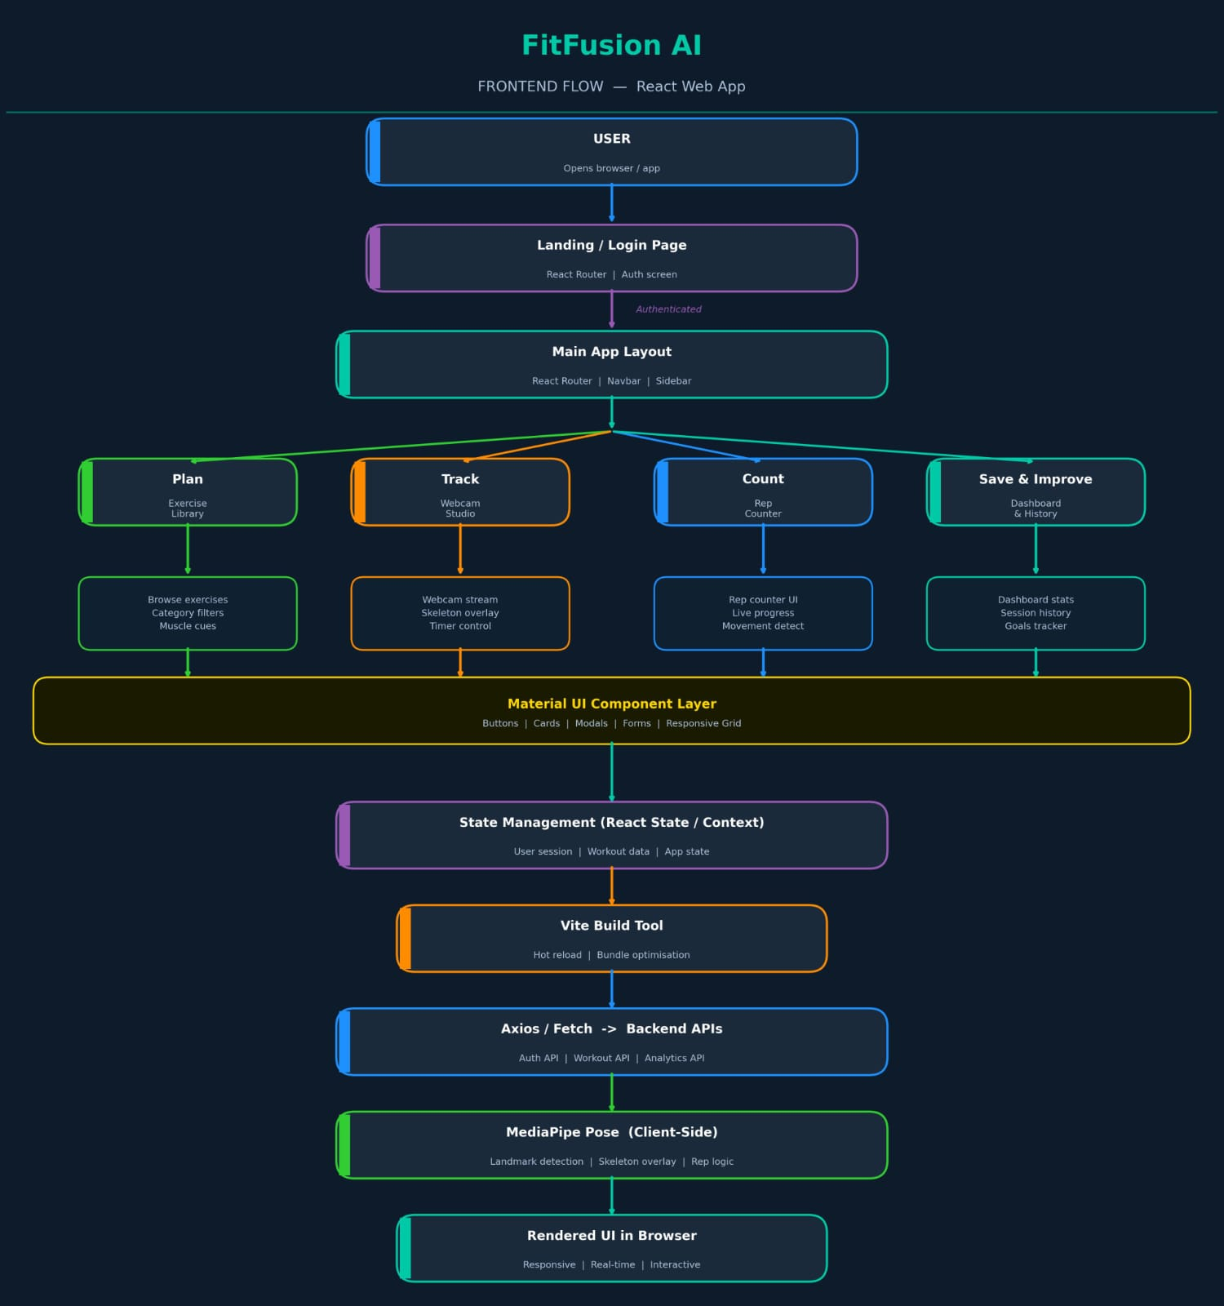

Fig 4.1 Frontend Architecture

4.2 BACKEND:

The backend provides REST APIs, manages database, handles authentication, and optionally runs pose tracking logic (can be frontend or backend based on design – here we assume frontend does lightweight rep logic; backend stores data).

Modules:

Authentication Module – Handles user registration and login. Generates and verifies JWT tokens for secure API access.

User Profile Module – Stores and manages user personal details, fitness goals, and experience level. Provides CRUD operations for profile data.

Exercise Library Module – Serves exercise database including names, categories, instructions, and target muscles. Supports search and filtering by category.

Workout Planner Module – Allows users to create, save, and edit custom workout plans. Retrieves plans when user starts a session.

Session Tracking Module – Receives and stores completed workout data (reps, duration, calories). Associates each session with the logged-in user.

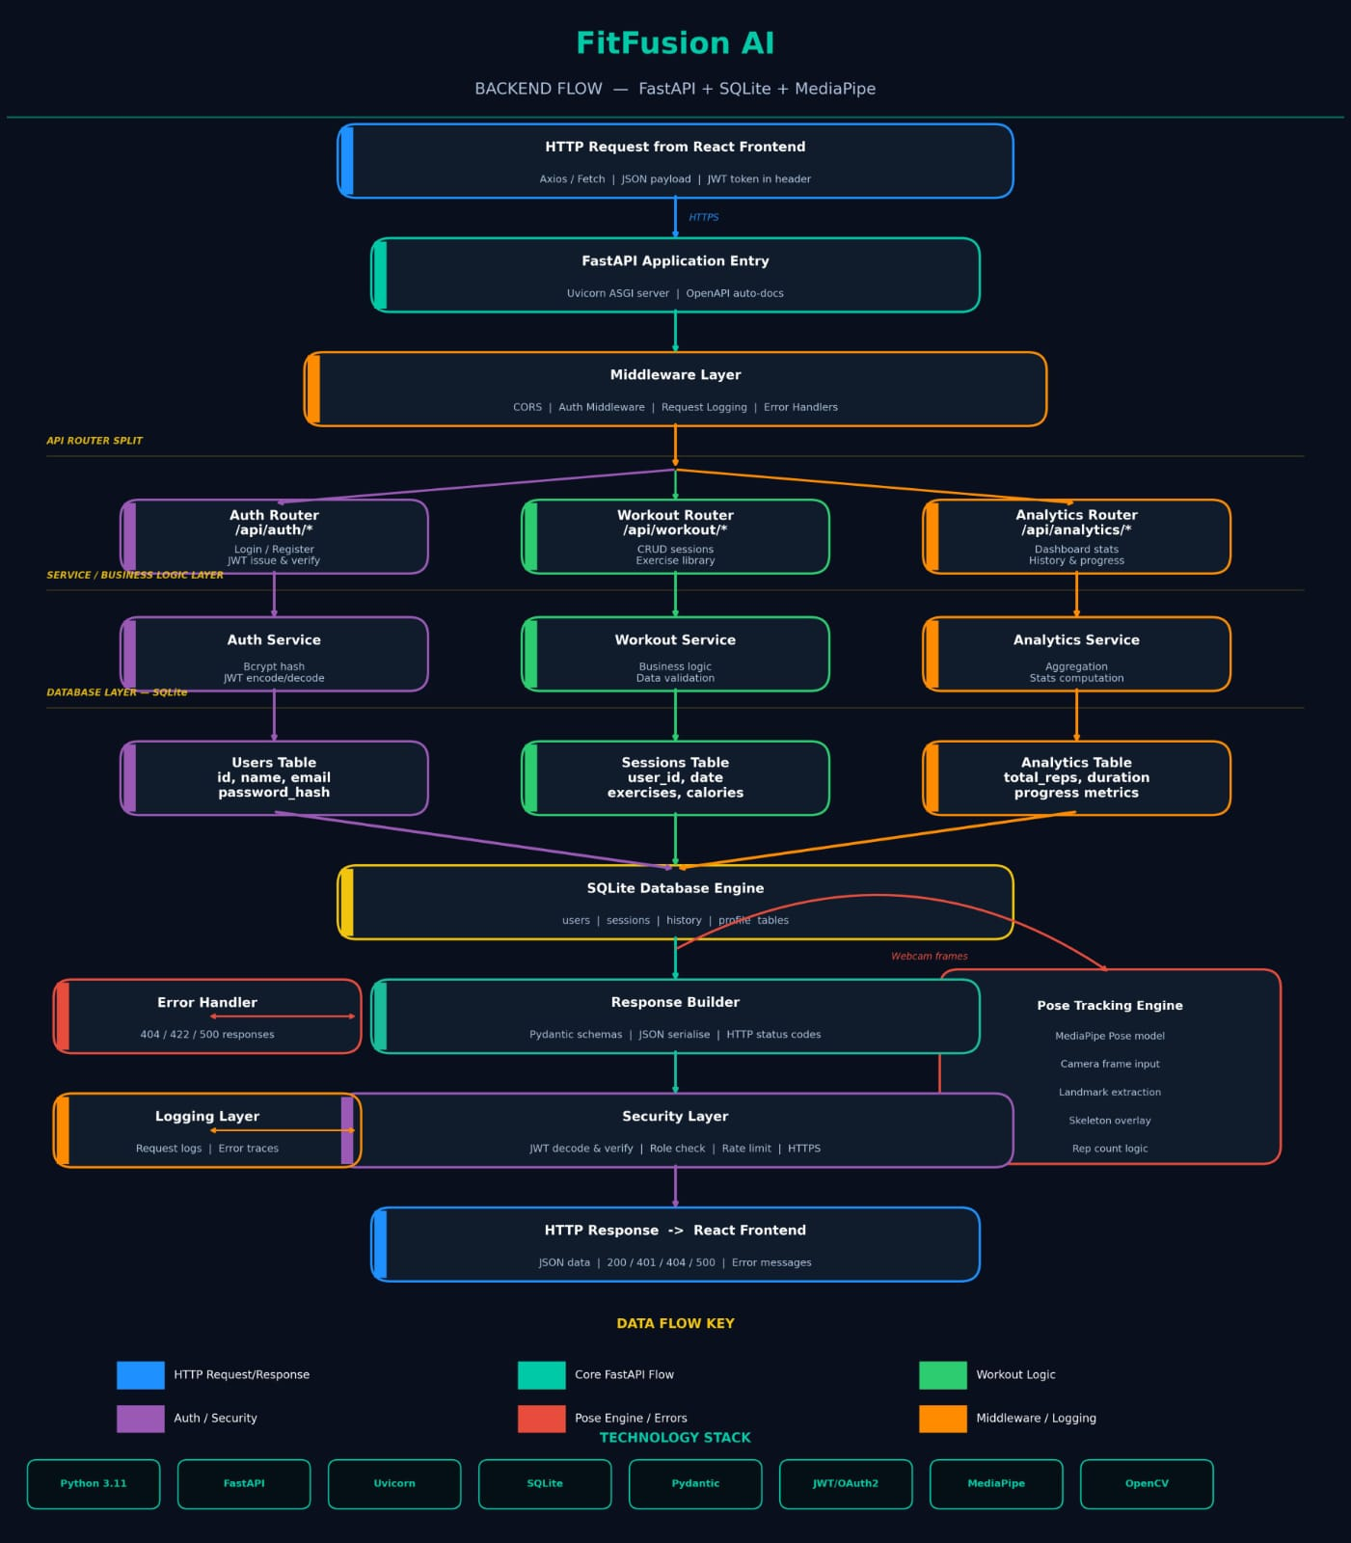
Analytics Module – Aggregates session history to calculate weekly trends and totals. Provides JSON data for dashboard charts and progress insights.

Fig 4.2 Backend Architecture

CHAPTER 5

SYSTEM IMPLEMENTATION

The FitFusion system is implemented as a full-stack web application that integrates frontend, backend, database, and machine learning components to deliver a real-time fitness tracking solution. The development process follows a modular and scalable architecture to ensure efficient performance and ease of deployment.

5.1 Frontend Implementation
The frontend of the FitFusion system is developed using React as a Single Page Application (SPA), providing a dynamic, responsive, and user-friendly interface. The application is designed with a modular component-based architecture, which improves code reusability, maintainability, and scalability. It ensures seamless navigation without page reloads, enhancing overall user experience.
The frontend consists of multiple functional modules:
- Authentication Module:
This module handles user registration and login interfaces. It manages form validation, error handling, and secure storage of JWT tokens in the browser to maintain user sessions.
- Exercise Library Interface:
Displays a categorized list of exercises with details such as descriptions and target muscle groups. It allows users to browse and select exercises based on their fitness goals.
- Workout Planner Interface:
This is the core interactive component where real-time workout tracking occurs. It uses the getUserMedia() API to access the webcam and capture live video. A canvas overlay is implemented to render pose skeletons and display repetition counts dynamically.
- Dashboard and Profile Interface:
This module displays workout analytics such as total sessions, calories burned, and progress trends using visual charts. It also allows users to manage personal details, fitness goals, and preferences, enabling effective tracking and personalization of their fitness journey.

5.2 Backend Implementation
The backend of the FitFusion system is developed using FastAPI, a modern Python-based web framework known for its high performance, scalability, and ease of development. It serves as the core component responsible for handling business logic, managing data flow, and ensuring secure communication between the frontend and database. The backend follows a RESTful API architecture, enabling efficient interaction with the frontend application..
The backend system is structured into multiple modules, each responsible for a specific functionality:
- Authentication Module:
This module handles user registration and login functionalities. It uses JSON Web Tokens (JWT) for secure authentication and authorization. Passwords are securely stored using hashing techniques, and protected routes ensure that only authenticated users can access sensitive data. Additionally, token-based session management is implemented to maintain user sessions securely, and token expiration mechanisms are used to enhance security by limiting unauthorized access over time.

- User Profile Module:
This module manages user-related information such as personal details, fitness goals, and experience level. It provides CRUD (Create, Read, Update, Delete) operations, allowing users to update their profiles and preferences.

- Exercise Library Module:
The backend maintains a structured database of exercises, including categories, descriptions, and target muscle groups. APIs are provided to fetch and filter exercises based on user requirements.

- Workout Planner Module:
This module allows users to create, modify, and store customized workout plans. It handles the logic for saving user-defined routines and retrieving them during workout sessions.

- Session Tracking Module:
The session module receives workout data such as repetition count, duration, and estimated calories from the frontend. It processes and stores this data in the database, linking each session to the respective user.

- Analytics Module:
This module aggregates stored workout data to generate insights such as weekly progress, total workouts, and performance trends. It provides structured JSON responses that are used by the frontend dashboard for visualization.

In addition to these modules, the backend performs request validation, error handling, and data serialization using Pydantic models. It ensures that all incoming and outgoing data follows a consistent format. The use of asynchronous request handling in FastAPI improves system performance and allows the application to handle multiple requests efficiently

5.3 Database Implementation
SQLite is used as the database for storing application data. It maintains tables for users, exercises, workout plans, and session history. The database ensures efficient storage, retrieval, and management of data, with each workout session linked to a specific user for personalized tracking.
5.4 Machine Learning Implementation
The system utilizes Media Pipe Pose for real-time human pose estimation. The model processes video frames captured from the webcam and detects body landmarks. Joint angles are calculated from these key points, and a threshold-based algorithm is applied to count repetitions and analyze movements. This
enables accurate tracking of exercises without the need for wearable devices.
5.5 System Integration
All components of the system are integrated through a structured pipeline. The frontend captures user input and video data, which is processed for pose detection. The computed results are sent to the backend, where they are validated and stored in the database. The processed data is then retrieved and displayed on the dashboard as analytics and progress metrics.

5.6 Deployment Implementation
The system is initially tested in a local environment and later deployed to cloud platforms. The backend is hosted on Render, while the frontend is deployed on Vercel. GitHub is used for version control and code management. Environment variables are configured to connect the frontend with the deployed backend API. The final system is accessible through a public HTTPS URL.
- The project is first executed locally using separate environments for frontend and backend to ensure proper functionality.
- The complete source code is uploaded to a GitHub repository for version tracking and collaboration.
- The backend service is deployed on Render with required build and start configurations.
- The frontend application is deployed on Vercel using optimized build settings for faster performance.
- Environment variables (e.g., API base URL) are configured to establish secure communication between frontend and backend.
- HTTPS deployment ensures secure data transfer and enables browser features such as camera access.
- Final deployment is tested to verify all modules, including authentication, workout tracking, and analytics, work correctly in the live environment.
- Continuous monitoring is performed after deployment to ensure system stability and detect any runtime issues.
- Cross-browser testing is conducted to ensure compatibility across different web browsers and devices.
- Performance optimization techniques such as code minification and efficient API handling are applied for faster loading.

CHAPTER 6

TEST CASES

6. API Testing and Results

  - User Registration API – Input Interface
Figure 6.1: User Registration Endpoint in Swagger UI

The above figure illustrates the POST /api/auth/register endpoint available in the Swagger interface. It displays the required input fields such as full name, username, email, and password. The request body is configured using the application/x-www-form-urlencoded format. This interface is used to manually test the user registration functionality by providing valid or invalid input data.

6.2 Successful API Response
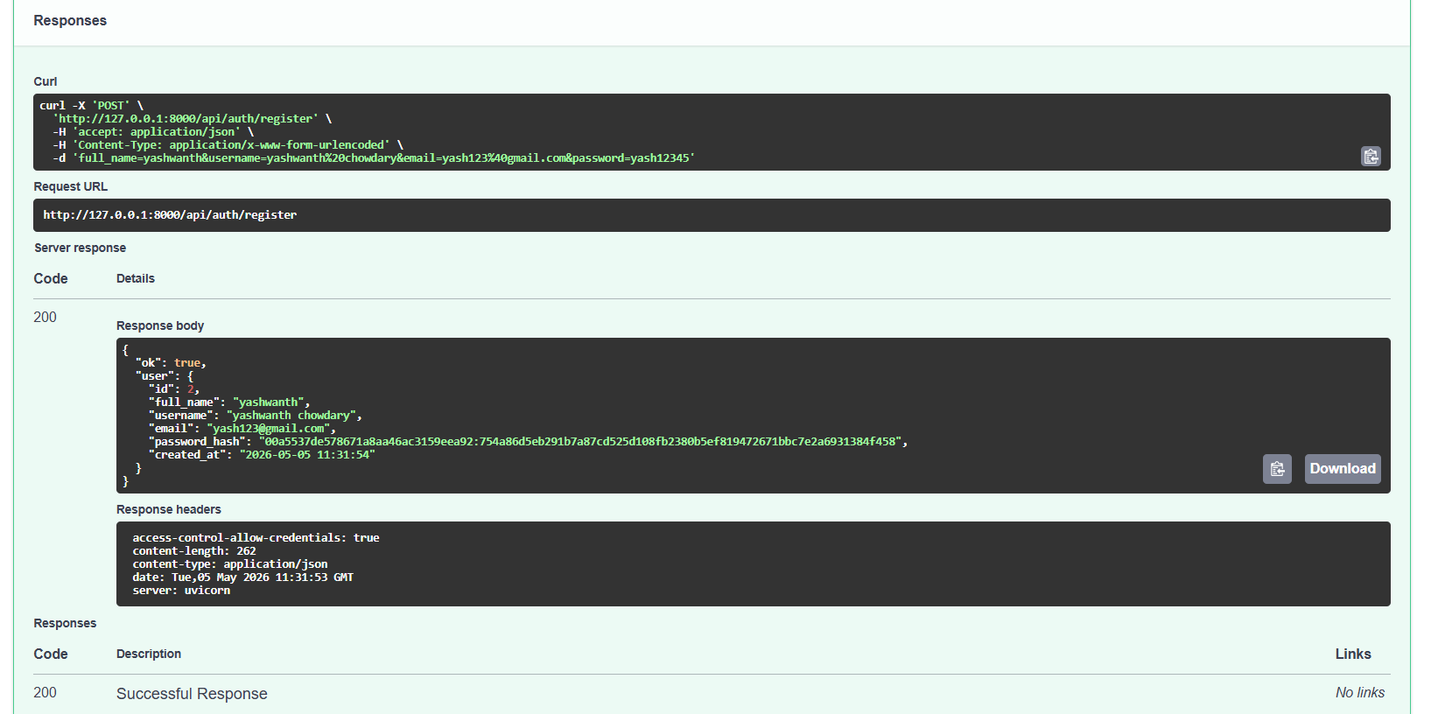

Figure 6.2: Response of User Registration API

The figure shows the successful execution of the registration API with a 200 OK status code. The response body contains user-related information including user ID, full name, username, email, and an encrypted password (hash). This confirms that the backend system is correctly processing the request and storing user data securely.

  - Overview of Available API Endpoints

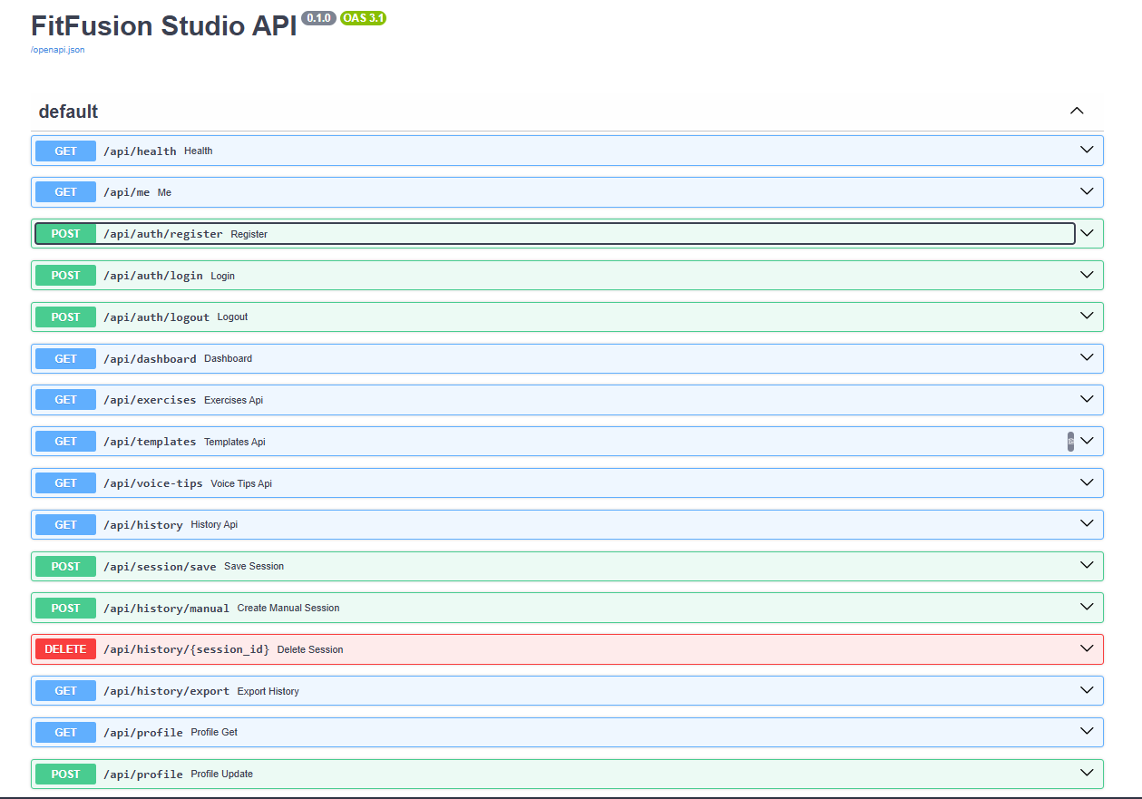
Figure 6.3: FitFusion API Endpoints List

The above figure presents the complete list of API endpoints available in the FitFusion system. It includes endpoints related to authentication (register, login, logout), dashboard, exercises, templates, history, and user profile management. This overview helps in understanding the overall backend architecture and the functionalities supported by the system.

Summary:
The API testing was successfully performed using Swagger UI, ensuring that all endpoints function correctly with expected inputs and outputs. The results confirm the reliability and proper integration of the backend services.

CHAPTER 7
RESULTS
The FitFusion system was successfully developed and tested as a full-stack web-based fitness tracking platform integrating computer vision and modern web technologies. The system demonstrated effective real-time performance in detecting human posture and counting exercise repetitions using webcam input. The integration of MediaPipe Pose enabled accurate detection of body landmarks and joint movements, allowing the system to track exercises without the need for external sensors or wearable devices.

During testing, the repetition counting feature was able to provide consistent results for exercises such as squats, push-ups, and arm raises under standard lighting conditions. Minor variations in accuracy were observed when there were rapid movements, poor lighting, or incorrect camera positioning. However, the system was able to handle most real-world scenarios with acceptable accuracy, demonstrating its practical usability.

The backend system, implemented using FastAPI, efficiently handled user authentication, data processing, and communication with the frontend. Workout session data, including repetition count, duration, and estimated calories, was successfully stored in the SQLite database and retrieved for analysis. The analytics module generated meaningful insights such as total workouts, session trends, and progress tracking, which were displayed through the frontend dashboard.

The frontend interface, developed using React, provided a responsive and interactive user experience. Users were able to register, log in, select exercises, perform workouts in the camera-based workout studio, and view their performance metrics in real time. The system was tested across multiple sessions, and it maintained stable performance with smooth interaction between components.

Overall, the results indicate that the FitFusion system effectively achieves its objective of combining real-time workout tracking, posture analysis, and performance monitoring into a unified platform. The system demonstrates the feasibility of using AI-based pose estimation for building accessible and cost-effective fitness solutions

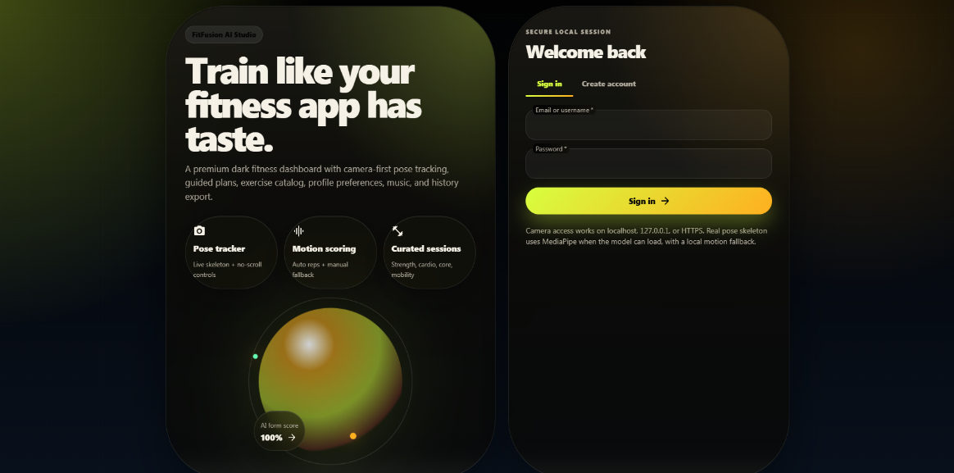
Fig 7.1 Landing & Authentication Interface

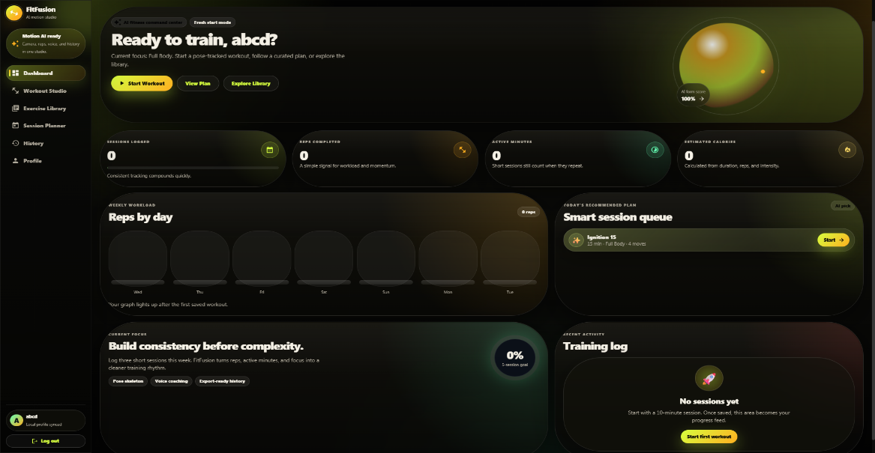
The FitFusion system provides a well-designed entry interface for user authentication and onboarding. Users can register and log in securely through the system, ensuring proper access control. The interface highlights key features such as pose tracking, motion scoring, and curated workout sessions. The integration of authentication with the backend ensures that user sessions are managed securely and efficiently.
Fig 7.2 Dashboard (User Performance Overview)

The dashboard serves as the central hub for monitoring user activity and performance. It displays key metrics such as total workout sessions, repetitions completed, active minutes, and estimated calories burned. The system successfully retrieves data from the backend and presents it in an organized and interactive format. Progress tracking and training logs provide users with insights into their workout consistency and improvements over time.


Fig 7.3 Exercise Library

The exercise library offers a structured catalog of workouts, including exercises such as push-ups, squats, lunges, and more. Each exercise is categorized based on difficulty level, muscle group, and recommended repetitions. Users can easily browse, filter, and select exercises. This module enhances usability by providing clear instructions and direct access to start workouts, supporting a seamless fitness experience.

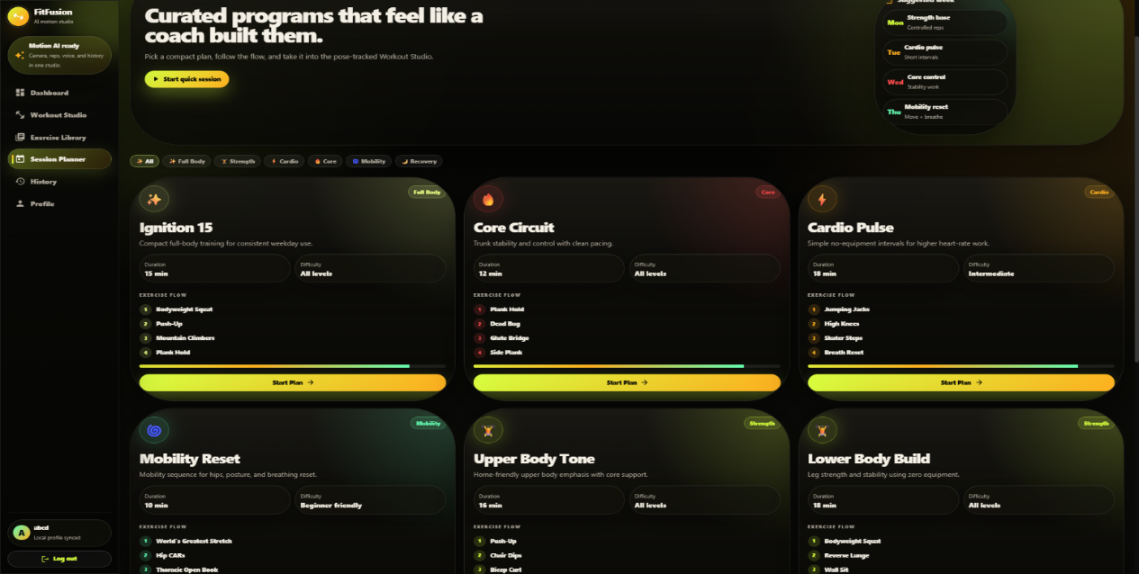
Fig 7.4 Session Planner

The session planner presents curated workout programs designed for different fitness goals such as strength, cardio, and mobility. Each plan includes details like duration, difficulty level, and sequence of exercises. The system enables users to follow structured workout routines, improving engagement and consistency. This feature demonstrates the platform’s ability to provide guided fitness planning.

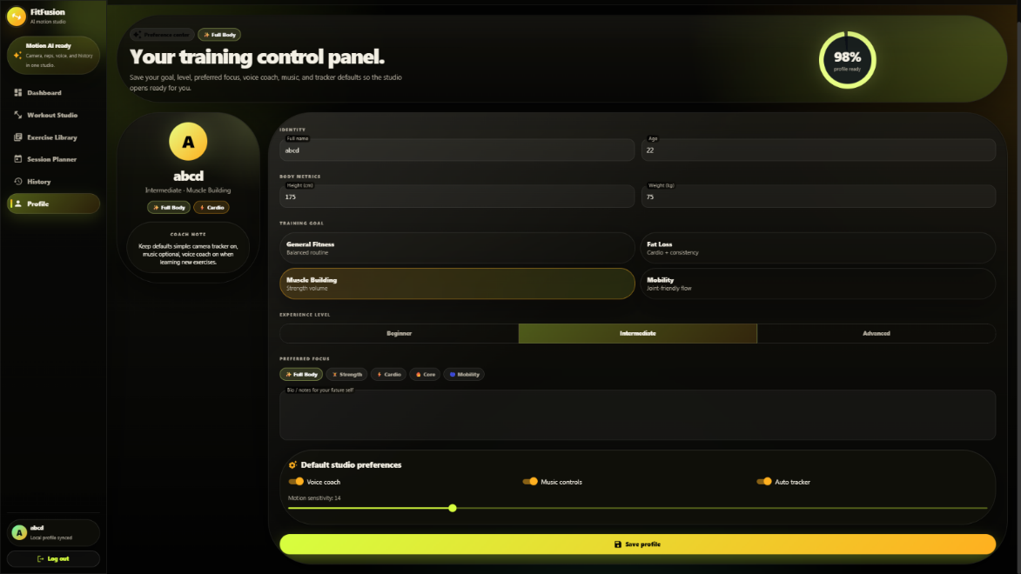
Fig 7.5 Profile Management

The profile section allows users to view and manage their personal information, such as username and account details. The backend securely handles data retrieval and updates through authenticated APIs, ensuring only authorized access. This module integrates authentication with database management, maintaining data privacy and providing a personalized user experience.

Real-Time Pose Tracking & Rep Counting
The system effectively performs real-time posture detection and rep counting using webcam input. With MediaPipe, it accurately tracks body movements without external sensors. Rep counting remains consistent for exercises like squats, push-ups, and arm raises, with minor variations in challenging conditions.

Backend Processing & Data Management
The backend system, implemented using FastAPI, efficiently handled user authentication, data processing, and communication with the frontend. Workout session data, including repetition count, duration, and estimated calories, was successfully stored in the SQLite database. The analytics module processed this data to generate meaningful insights such as total workouts, session trends, and progress tracking.

Overall System Performance
The frontend, built with React, provides a responsive and interactive user experience. The system maintains stable performance with smooth integration between frontend, backend, and computer vision components, effectively delivering a unified AI-based fitness platform.

CHAPTER 8

CONCLUSION

The FitFusion project successfully addresses the limitations of traditional fitness applications by providing an integrated, intelligent, and user-centric fitness tracking platform. By combining real-time pose estimation, workout planning, and performance analytics, the system offers a comprehensive solution that enhances user engagement and promotes consistency in fitness routines.

The implementation of MediaPipe Pose enables accurate posture detection and repetition counting without requiring specialized hardware, making the system accessible to a wide range of users. The use of FastAPI for backend development ensures efficient data handling, secure authentication, and scalable system architecture, while the React-based frontend provides an intuitive and responsive user interface.

Through this project, it is evident that computer vision and machine learning techniques can be effectively applied in the fitness domain to create practical and impactful solutions. The system not only simplifies workout tracking but also provides meaningful insights that help users monitor their progress and improve their performance over time.

Although the system performs well under standard conditions, certain limitations such as sensitivity to lighting, camera positioning, and variations in user movement were observed. These challenges highlight potential areas for future improvement, including enhanced pose estimation models, improved rep counting algorithms, and integration of personalized workout recommendations.

In conclusion, FitFusion represents a significant step toward the development of intelligent fitness systems that are accessible, scalable, and user-friendly. The project successfully demonstrates how modern technologies can be leveraged to promote health and well-being, aligning with global initiatives such as Sustainable Development Goal 3. With further enhancements, the system has the potential to evolve into a more advanced and widely usable fitness platform.

