BID DATA LAB

Annapurna.B.Neelakari
1NT20IS401

Creating database
> use annu
switched to db annu
> db
annu
> db.createCollection("annu");
{ "ok" : 1 }



>

INSERTION(one, many)

db.annu.insertOne({ "name": "yashodha", "dept": "ISE"})
{
"acknowledged" : true,
"insertedId" : ObjectId("628320474feaad263e5ea5be")
}

db.annu.insertMany([{ "name": "reuben", "dept": "ISE"},{"name" : "Nikhil", "dept": "ISE"}])
{
"acknowledged" : true,
"insertedIds" : [
ObjectId("628320f84feaad263e5ea5bf"),
ObjectId("628320f84feaad263e5ea5c0")
]
}
> db.annu.insertMany([{ "name": "reuben", "dept": "ISE"},{"name" : "Nikhil", "dept": "ISE"},{"name": "asha", "dept": "ISE"},{ "name": "teju", "dept" : "ISE"}])
{
"acknowledged" : true,
"insertedIds" : [
ObjectId("628321744feaad263e5ea5c1"),
ObjectId("628321744feaad263e5ea5c2"),
ObjectId("628321744feaad263e5ea5c3"),
ObjectId("628321744feaad263e5ea5c4")
]
}
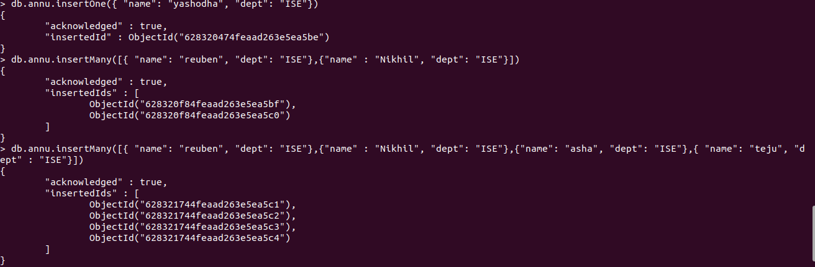

> db.annu.find()
{ "_id" : ObjectId("628320474feaad263e5ea5be"), "name" : "yashodha", "dept" : "ISE" }
{ "_id" : ObjectId("628320f84feaad263e5ea5bf"), "name" : "reuben", "dept" : "ISE" }
{ "_id" : ObjectId("628320f84feaad263e5ea5c0"), "name" : "Nikhil", "dept" : "ISE" }
{ "_id" : ObjectId("628321744feaad263e5ea5c1"), "name" : "reuben", "dept" : "ISE" }
{ "_id" : ObjectId("628321744feaad263e5ea5c2"), "name" : "Nikhil", "dept" : "ISE" }
{ "_id" : ObjectId("628321744feaad263e5ea5c3"), "name" : "asha", "dept" : "ISE" }
{ "_id" : ObjectId("628321744feaad263e5ea5c4"), "name" : "teju", "dept" : "ISE" }
>
> db.annu.find().pretty()
{
"_id" : ObjectId("628320474feaad263e5ea5be"),
"name" : "yashodha",
"dept" : "ISE"
}
{
"_id" : ObjectId("628320f84feaad263e5ea5bf"),
"name" : "reuben",
"dept" : "ISE"
}
{
"_id" : ObjectId("628320f84feaad263e5ea5c0"),
"name" : "Nikhil",
"dept" : "ISE"
}
{
"_id" : ObjectId("628321744feaad263e5ea5c1"),
"name" : "reuben",
"dept" : "ISE"
}
{
"_id" : ObjectId("628321744feaad263e5ea5c2"),
"name" : "Nikhil",
"dept" : "ISE"
}
{
"_id" : ObjectId("628321744feaad263e5ea5c3"),
"name" : "asha",
"dept" : "ISE"
}
{
"_id" : ObjectId("628321744feaad263e5ea5c4"),
"name" : "teju",
"dept" : "ISE"
}
>
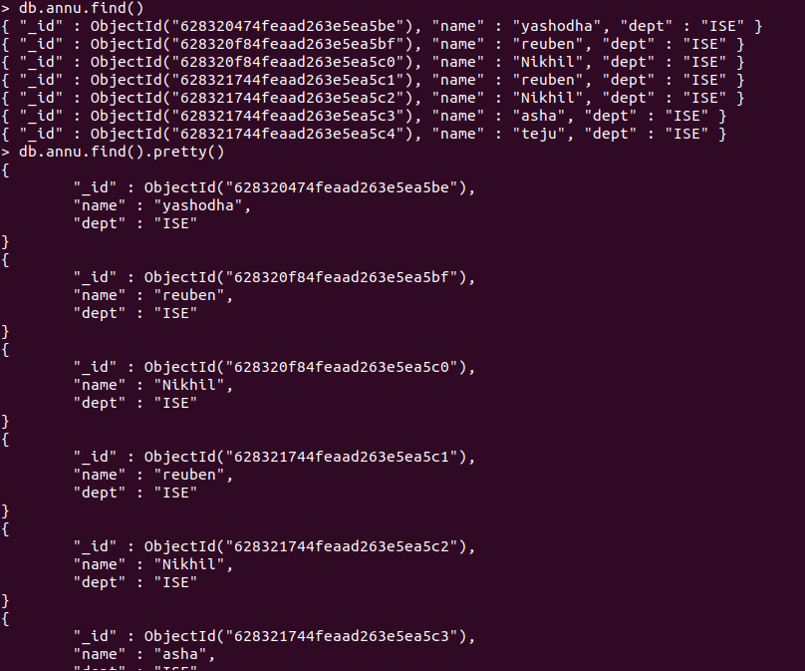

UPDATE using set and unset

> db.annu.updateOne({ "name" : "reuben"},{$set : {"dept" : "CSE"} })
{ "acknowledged" : true, "matchedCount" : 1, "modifiedCount" : 1 }
> db.annu.find().pretty()
{
"_id" : ObjectId("628320474feaad263e5ea5be"),
"name" : "yashodha",
"dept" : "ISE"
}
{
"_id" : ObjectId("628320f84feaad263e5ea5bf"),
"name" : "reuben",
"dept" : "CSE"
}
{
"_id" : ObjectId("628320f84feaad263e5ea5c0"),
"name" : "Nikhil",
"dept" : "ISE"
}
{
"_id" : ObjectId("628321744feaad263e5ea5c1"),
"name" : "reuben",
"dept" : "ISE"
}
{
"_id" : ObjectId("628321744feaad263e5ea5c2"),
"name" : "Nikhil",
"dept" : "ISE"
}
{
"_id" : ObjectId("628321744feaad263e5ea5c3"),
"name" : "asha",
"dept" : "ISE"
}
{
"_id" : ObjectId("628321744feaad263e5ea5c4"),
"name" : "teju",
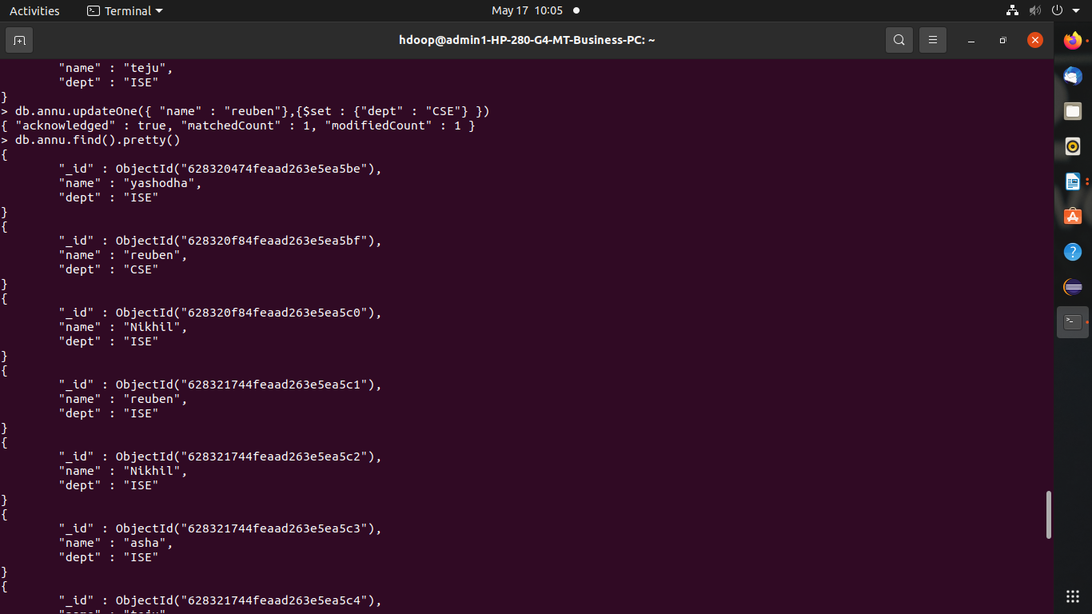
"dept" : "ISE"
> db.annu.updateMany({}, {$set: {"college" : "NMIT"} })
{ "acknowledged" : true, "matchedCount" : 7, "modifiedCount" : 7 }

> db.annu.find().pretty()
{
"_id" : ObjectId("628320474feaad263e5ea5be"),
"name" : "yashodha",
"dept" : "ISE",
"college" : "NMIT"
}
{
"_id" : ObjectId("628320f84feaad263e5ea5bf"),
"name" : "reuben",
"dept" : "CSE",
"college" : "NMIT"
}
{
"_id" : ObjectId("628320f84feaad263e5ea5c0"),
"name" : "Nikhil",
"dept" : "ISE",
"college" : "NMIT"
}
{
"_id" : ObjectId("628321744feaad263e5ea5c1"),
"name" : "reuben",
"dept" : "ISE",
"college" : "NMIT"
}
{
"_id" : ObjectId("628321744feaad263e5ea5c2"),
"name" : "Nikhil",
"dept" : "ISE",
"college" : "NMIT"
}
{
"_id" : ObjectId("628321744feaad263e5ea5c3"),
"name" : "asha",
"dept" : "ISE",
"college" : "NMIT"
}
{
"_id" : ObjectId("628321744feaad263e5ea5c4"),
"name" : "teju",
"dept" : "ISE",
"college" : "NMIT"
}
>

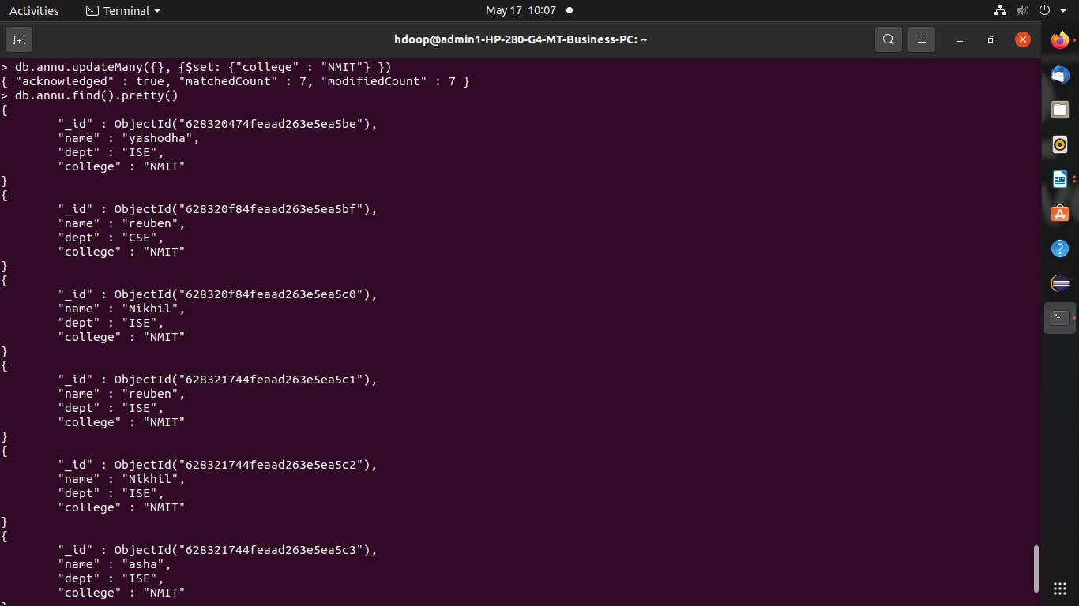

db.annu.updateOne( {"name" : "nikhil"}, { $unset : { "dept" : "ISE" }})
{ "acknowledged" : true, "matchedCount" : 0, "modifiedCount" : 0 }
> db.annu.updateOne( {"name" : "Nikhil"}, { $unset : { "dept" : "ISE" }})
{ "acknowledged" : true, "matchedCount" : 1, "modifiedCount" : 1 }
> db.annu.find().pretty()
{
"_id" : ObjectId("628320474feaad263e5ea5be"),
"name" : "yashodha",
"dept" : "ISE",
"college" : "NMIT"
}
{
"_id" : ObjectId("628320f84feaad263e5ea5c0"),
"name" : "Nikhil",
"college" : "NMIT"
}
{
"_id" : ObjectId("628321744feaad263e5ea5c1"),
"name" : "reuben",
"dept" : "ISE",
"college" : "NMIT"
}
{
"_id" : ObjectId("628321744feaad263e5ea5c2"),
"name" : "Nikhil",
"dept" : "ISE",
"college" : "NMIT"
}
{
"_id" : ObjectId("628321744feaad263e5ea5c3"),
"name" : "asha",
"dept" : "ISE",
"college" : "NMIT"
}
{
"_id" : ObjectId("628321744feaad263e5ea5c4"),
"name" : "teju",
"dept" : "ISE",
"college" : "NMIT"}

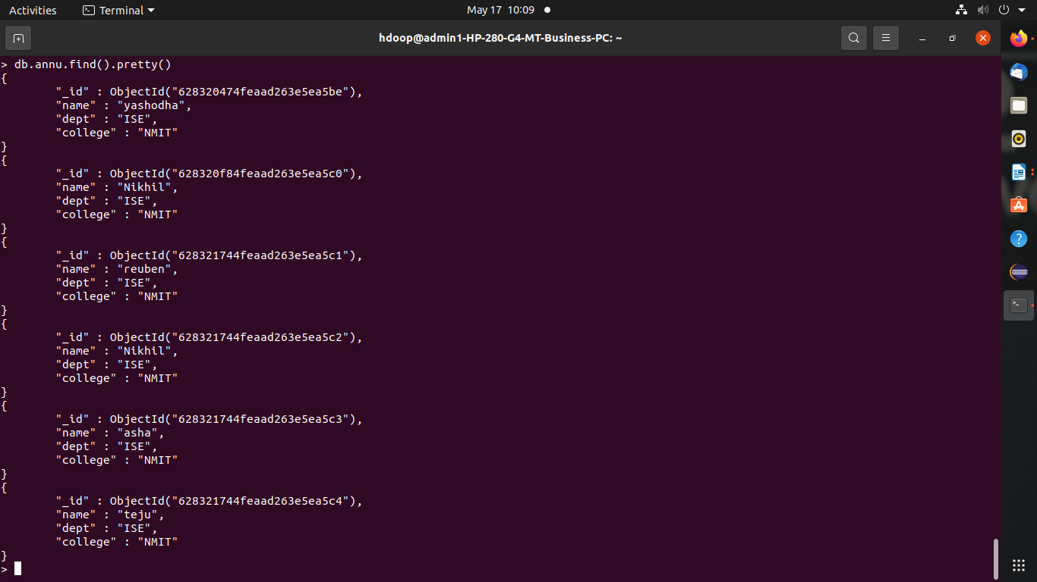

Delete

> db.annu.deleteOne({ "name" : "reuben" })
{ "acknowledged" : true, "deletedCount" : 1 }
> db.annu.find().pretty()
{
"_id" : ObjectId("628320474feaad263e5ea5be"),
"name" : "yashodha",
"dept" : "ISE",
"college" : "NMIT"
}

{
"_id" : ObjectId("628320f84feaad263e5ea5c0"),
"name" : "Nikhil",
"dept" : "ISE",
"college" : "NMIT"
}
{
"_id" : ObjectId("628321744feaad263e5ea5c1"),
"name" : "reuben",
"dept" : "ISE",
"college" : "NMIT"
}
{
"_id" : ObjectId("628321744feaad263e5ea5c2"),
"name" : "Nikhil",
"dept" : "ISE",
"college" : "NMIT"
}
{
"_id" : ObjectId("628321744feaad263e5ea5c3"),
"name" : "asha",
"dept" : "ISE",
"college" : "NMIT"
}
{
"_id" : ObjectId("628321744feaad263e5ea5c4"),
"name" : "teju",
"dept" : "ISE",
"college" : "NMIT"
}
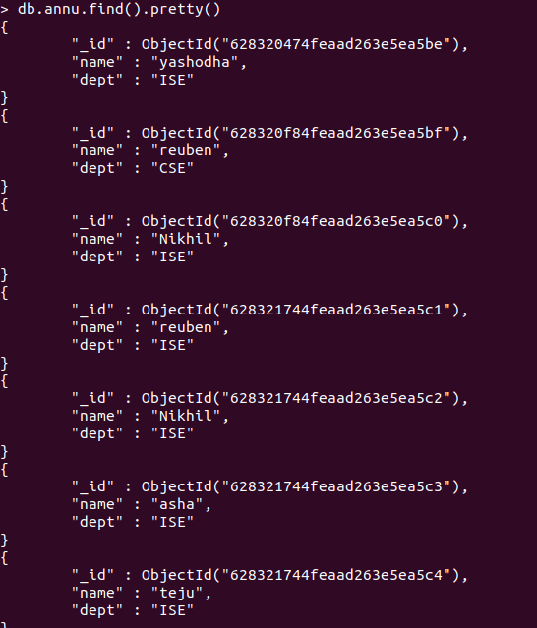

Replace

> db.annu.replaceOne( {"name" : "teju"}, {"name" : "swati", "dept" : "ISE","college" : "NMIT"})
{ "acknowledged" : true, "matchedCount" : 1, "modifiedCount" : 1 }

> db.annu.find().pretty()

"_id" : ObjectId("628320474feaad263e5ea5be"),
"name" : "yashodha",
"dept" : "ISE",
"college" : "NMIT"
}
{
"_id" : ObjectId("628320f84feaad263e5ea5c0"),
"name" : "Nikhil",
"college" : "NMIT"
}
{
"_id" : ObjectId("628321744feaad263e5ea5c1"),
"name" : "reuben",
"dept" : "ISE",
"college" : "NMIT"
}
{
"_id" : ObjectId("628321744feaad263e5ea5c2"),
"name" : "Nikhil",
"dept" : "ISE",
"college" : "NMIT"
}
{
"_id" : ObjectId("628321744feaad263e5ea5c3"),
"name" : "asha",
"dept" : "ISE",
"college" : "NMIT"
}
{
"_id" : ObjectId("628321744feaad263e5ea5c4"),
"name" : "swati",
"dept" : "ISE",
"college" : "NMIT"
}
>
