DATE:2-7-2022

NAME:SUCHITHRA RAJ M
USN:1NT19IS162

BD LAB

1.creating employee database

use suchithraemployeeDB
switched to db suchithraemployeeDB
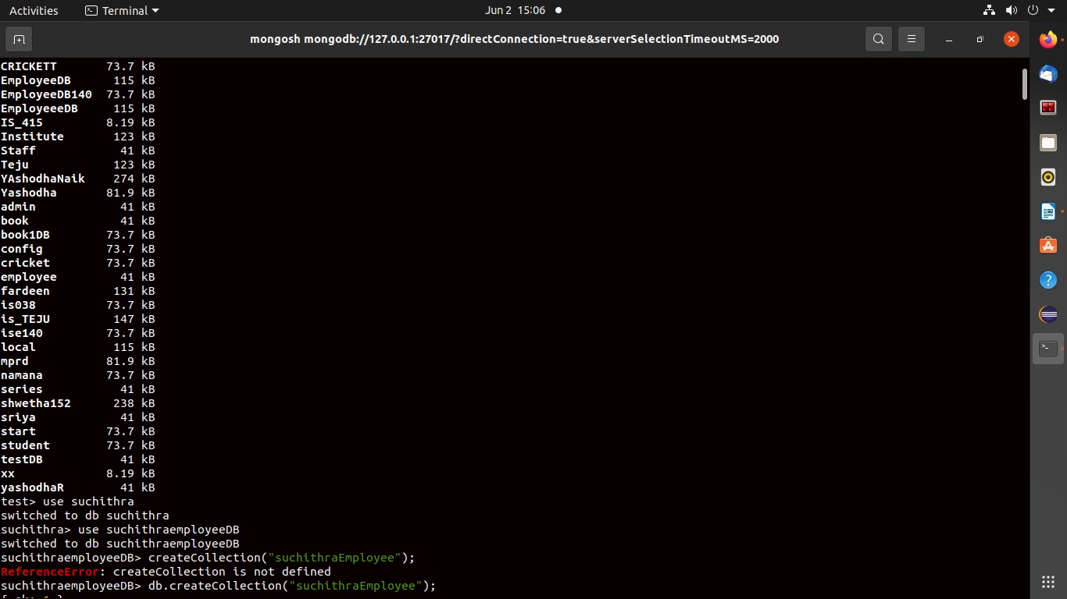

2. creating and inserting values into suchithra_employee collection

suchithraemployeeDB> db.createCollection("suchithra_employee")
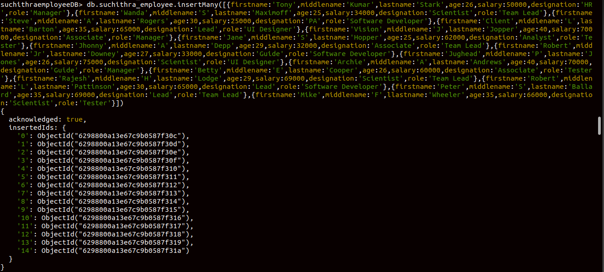
{ ok: 1 }

displaying the documents

suchithraemployeeDB> db.suchithra_employee.find().pretty()
[
{
_id: ObjectId("6298800a13e67c9b0587f30c"),
firstname: 'Tony',
middlename: 'Kumar',
lastname: 'Stark',
age: 26,
salary: 50000,
designation: 'HR',
role: 'Manager'
},
{
_id: ObjectId("6298800a13e67c9b0587f30d"),
firstname: 'Wanda',
middlename: 'S',
lastname: 'Maximoff',
age: 25,
salary: 34000,
designation: 'Scientist',
role: 'Team Lead'
},
{
_id: ObjectId("6298800a13e67c9b0587f30e"),
firstname: 'Steve',
middlename: 'A',
lastname: 'Rogers',
age: 30,
salary: 25000,
designation: 'PA',
role: 'Software Developer'
},
{
_id: ObjectId("6298800a13e67c9b0587f30f"),
firstname: 'Client',
middlename: 'L',
lastname: 'Barton',
age: 35,
salary: 65000,
designation: 'Lead',
role: 'UI Designer'
},
{
_id: ObjectId("6298800a13e67c9b0587f310"),
firstname: 'Vision',
middlename: 'J',
lastname: 'Jopper',
age: 40,
salary: 70000,
designation: 'Associate',
role: 'Manager'
},
{
_id: ObjectId("6298800a13e67c9b0587f311"),
firstname: 'Jane',
middlename: 'S',
lastname: 'Hopper',
age: 25,
salary: 62000,
designation: 'Analyst',
role: 'Tester'
},
{
_id: ObjectId("6298800a13e67c9b0587f312"),
firstname: 'Jhonny',
middlename: 'A',
lastname: 'Depp',
age: 29,
salary: 32000,
designation: 'Associate',
role: 'Team Lead'
},
{
_id: ObjectId("6298800a13e67c9b0587f313"),
firstname: 'Robert',
middlename: 'Jr',
lastname: 'Downey',
age: 27,
salary: 33000,
designation: 'Guide',
role: 'Software Developer'
},
{
_id: ObjectId("6298800a13e67c9b0587f314"),
firstname: 'Jughead',
middlename: 'P',
lastname: 'Jones',
age: 26,
salary: 75000,
designation: 'Scientist',
role: 'UI Designer'
},
{
_id: ObjectId("6298800a13e67c9b0587f315"),
firstname: 'Archie',
middlename: 'A',
lastname: 'Andrews',
age: 40,
salary: 70000,
designation: 'Guide',
role: 'Manager'
},
{
_id: ObjectId("6298800a13e67c9b0587f316"),
firstname: 'Betty',
middlename: 'E',
lastname: 'Cooper',
age: 26,
salary: 60000,
designation: 'Associate',
role: 'Tester'
},
{
_id: ObjectId("6298800a13e67c9b0587f317"),
firstname: 'Rajesh',
middlename: 'H',
lastname: 'Lodge',
age: 29,
salary: 69000,
designation: 'Scientist',
role: 'Team Lead'
},
{
_id: ObjectId("6298800a13e67c9b0587f318"),
firstname: 'Robert',
middlename: 'L',
lastname: 'Pattinson',
age: 30,
salary: 65000,
designation: 'Lead',
role: 'Software Developer'
},
{
_id: ObjectId("6298800a13e67c9b0587f319"),
firstname: 'Peter',
middlename: 'S',
lastname: 'Ballard',
age: 35,
salary: 69000,
designation: 'Lead',
role: 'Team Lead'
},
{
_id: ObjectId("6298800a13e67c9b0587f31a"),
firstname: 'Mike',
middlename: 'F',
llastname: 'Wheeler',
age: 35,
salary: 66000,
designation: 'Scientist',
role: 'Tester'
}
]
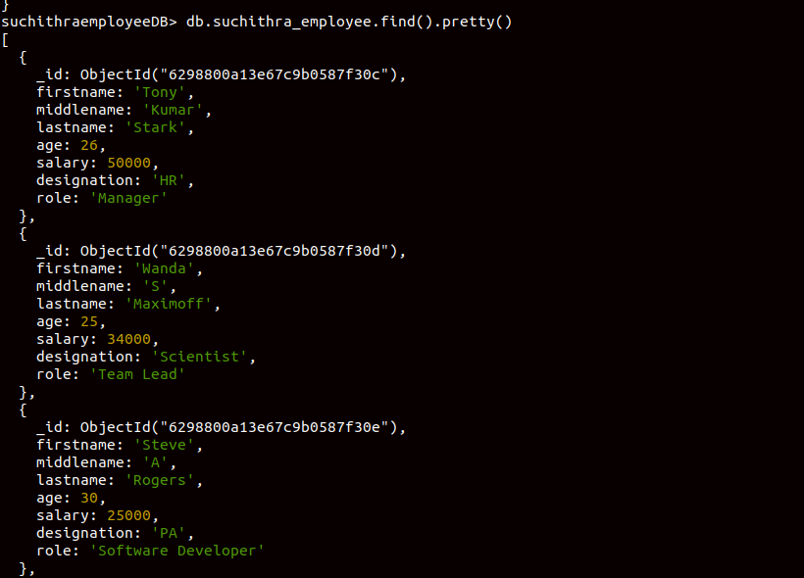

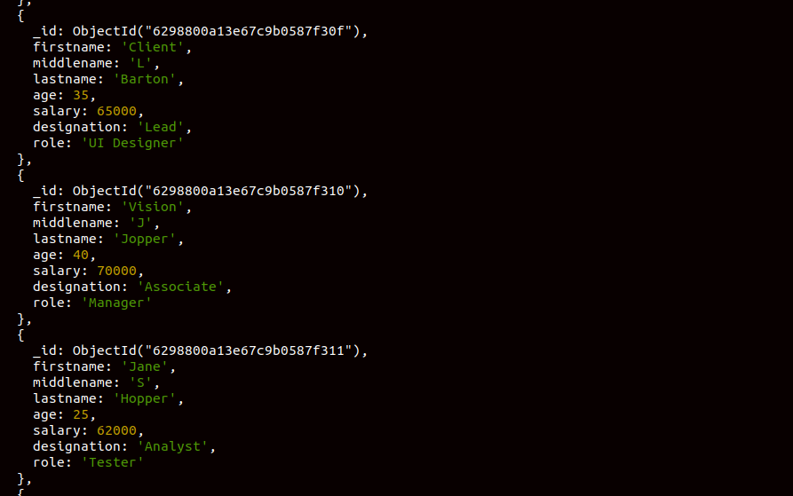

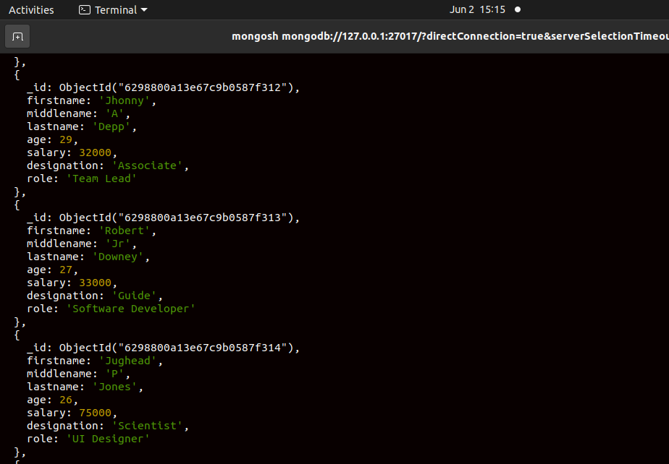

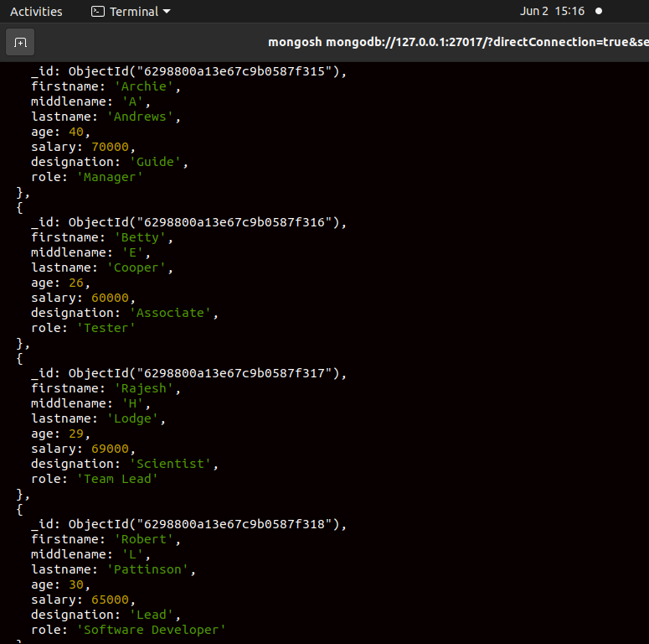

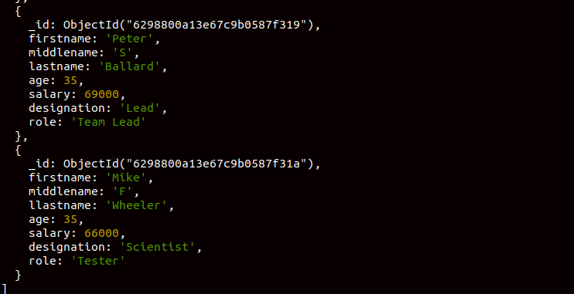

Queries
List all the records having salary in the range of 20000 – 35000(Exclusive)

suchithraemployeeDB> db.suchithra_employee.find({salary:{$gt:20000,$lt:35000}})
[
{
_id: ObjectId("6298800a13e67c9b0587f30d"),
firstname: 'Wanda',
middlename: 'S',
lastname: 'Maximoff',
age: 25,
salary: 34000,
designation: 'Scientist',
role: 'Team Lead'
},
{
_id: ObjectId("6298800a13e67c9b0587f30e"),
firstname: 'Steve',
middlename: 'A',
lastname: 'Rogers',
age: 30,
salary: 25000,
designation: 'PA',
role: 'Software Developer'
},
{
_id: ObjectId("6298800a13e67c9b0587f312"),
firstname: 'Jhonny',
middlename: 'A',
lastname: 'Depp',
age: 29,
salary: 32000,
designation: 'Associate',
role: 'Team Lead'
},
{
_id: ObjectId("6298800a13e67c9b0587f313"),
firstname: 'Robert',
middlename: 'Jr',
lastname: 'Downey',
age: 27,
salary: 33000,
designation: 'Guide',
role: 'Software Developer'
}
]

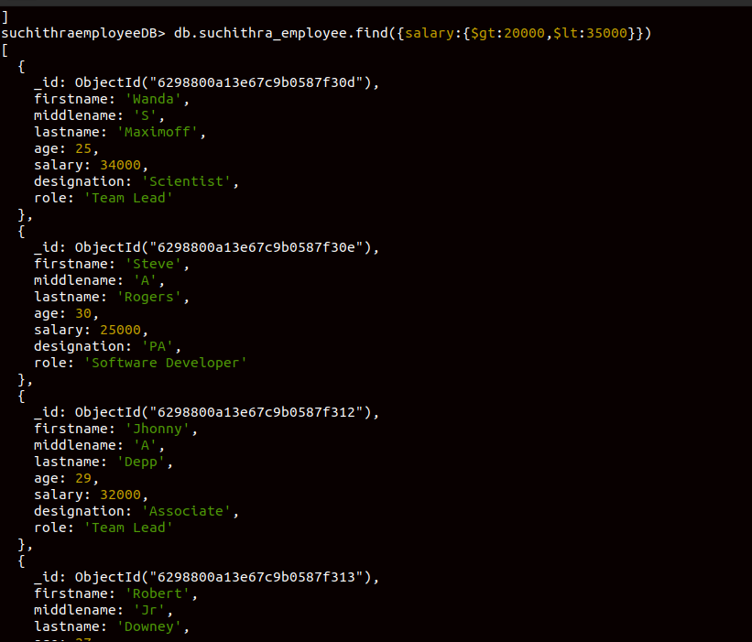

List all the Employee whose Middle name is "Kumar"
suchithraemployeeDB> db.suchithra_employee.find({'middlename':'Kumar'})
[
{
_id: ObjectId("6298800a13e67c9b0587f30c"),
firstname: 'Tony',
middlename: 'Kumar',
lastname: 'Stark',
age: 26,
salary: 50000,
designation: 'HR',
role: 'Manager'
}
]
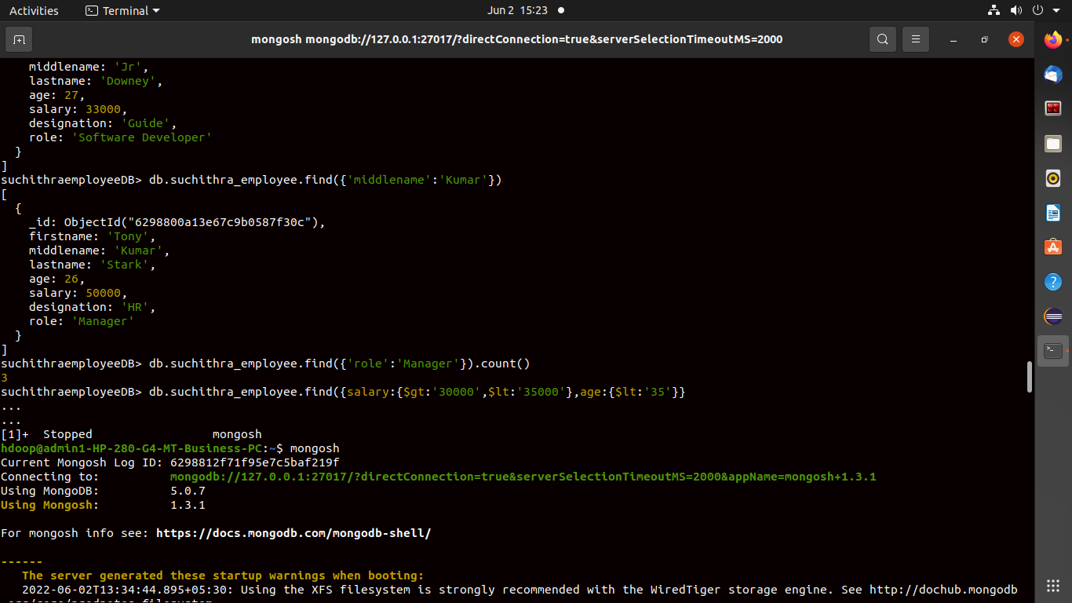

Count the number of Employees who has a role "Manager" in the Role
suchithraemployeeDB> db.suchithra_employee.find({'role':'Manager'}).count()
3

Find out all the documents who have age < 35 and salary in the range of 30000-35000

suchithraemployeeDB> db.suchithra_employee.find({salary:{$gt:30000,$lt:35000},age:{$lt:35}})
[
{
_id: ObjectId("6298800a13e67c9b0587f30d"),
firstname: 'Wanda',
middlename: 'S',
lastname: 'Maximoff',
age: 25,
salary: 34000,
designation: 'Scientist',
role: 'Team Lead'
},
{
_id: ObjectId("6298800a13e67c9b0587f312"),
firstname: 'Jhonny',
middlename: 'A',
lastname: 'Depp',
age: 29,
salary: 32000,
designation: 'Associate',
role: 'Team Lead'
},
{
_id: ObjectId("6298800a13e67c9b0587f313"),
firstname: 'Robert',
middlename: 'Jr',
lastname: 'Downey',
age: 27,
salary: 33000,
designation: 'Guide',
role: 'Software Developer'
}
]

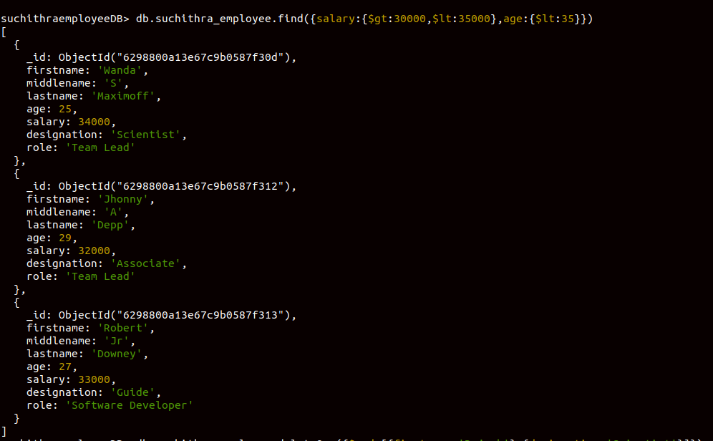

Delete an Employee whose "Firstname" is "Rajesh" and having the designation as "Scientist"

suchithraemployeeDB> db.suchithra_employee.deleteOne({$and:[{firstname:'Rajesh'},{designation:'Scientist'}]})
{ acknowledged: true, deletedCount: 1 }
suchithraemployeeDB> db.suchithra_employee.find().pretty()
[
{
_id: ObjectId("6298800a13e67c9b0587f30c"),
firstname: 'Tony',
middlename: 'Kumar',
lastname: 'Stark',
age: 26,
salary: 50000,
designation: 'HR',
role: 'Manager'
},
{
_id: ObjectId("6298800a13e67c9b0587f30d"),
firstname: 'Wanda',
middlename: 'S',
lastname: 'Maximoff',
age: 25,
salary: 34000,
designation: 'Scientist',
role: 'Team Lead'
},
{
_id: ObjectId("6298800a13e67c9b0587f30e"),
firstname: 'Steve',
middlename: 'A',
lastname: 'Rogers',
age: 30,
salary: 25000,
designation: 'PA',
role: 'Software Developer'
},
{
_id: ObjectId("6298800a13e67c9b0587f30f"),
firstname: 'Client',
middlename: 'L',
lastname: 'Barton',
age: 35,
salary: 65000,
designation: 'Lead',
role: 'UI Designer'
},
{
_id: ObjectId("6298800a13e67c9b0587f310"),
firstname: 'Vision',
middlename: 'J',
lastname: 'Jopper',
age: 40,
salary: 70000,
designation: 'Associate',
role: 'Manager'
},
{
_id: ObjectId("6298800a13e67c9b0587f311"),
firstname: 'Jane',
middlename: 'S',
lastname: 'Hopper',
age: 25,
salary: 62000,
designation: 'Analyst',
role: 'Tester'
},
{
_id: ObjectId("6298800a13e67c9b0587f312"),
firstname: 'Jhonny',
middlename: 'A',
lastname: 'Depp',
age: 29,
salary: 32000,
designation: 'Associate',
role: 'Team Lead'
},
{
_id: ObjectId("6298800a13e67c9b0587f313"),
firstname: 'Robert',
middlename: 'Jr',
lastname: 'Downey',
age: 27,
salary: 33000,
designation: 'Guide',
role: 'Software Developer'
},
{
_id: ObjectId("6298800a13e67c9b0587f314"),
firstname: 'Jughead',
middlename: 'P',
lastname: 'Jones',
age: 26,
salary: 75000,
designation: 'Scientist',
role: 'UI Designer'
},
{
_id: ObjectId("6298800a13e67c9b0587f315"),
firstname: 'Archie',
middlename: 'A',
lastname: 'Andrews',
age: 40,
salary: 70000,
designation: 'Guide',
role: 'Manager'
},
{
_id: ObjectId("6298800a13e67c9b0587f316"),
firstname: 'Betty',
middlename: 'E',
lastname: 'Cooper',
age: 26,
salary: 60000,
designation: 'Associate',
role: 'Tester'
},
{
_id: ObjectId("6298800a13e67c9b0587f318"),
firstname: 'Robert',
middlename: 'L',
lastname: 'Pattinson',
age: 30,
salary: 65000,
designation: 'Lead',
role: 'Software Developer'
},
{
_id: ObjectId("6298800a13e67c9b0587f319"),
firstname: 'Peter',
middlename: 'S',
lastname: 'Ballard',
age: 35,
salary: 69000,
designation: 'Lead',
role: 'Team Lead'
},
{
_id: ObjectId("6298800a13e67c9b0587f31a"),
firstname: 'Mike',
middlename: 'F',
llastname: 'Wheeler',
age: 35,
salary: 66000,
designation: 'Scientist',
role: 'Tester'
}
]

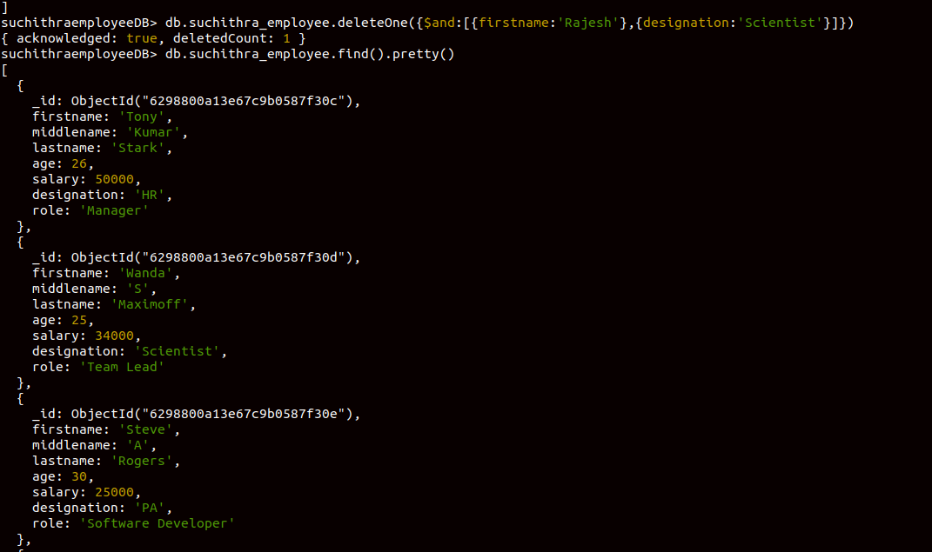

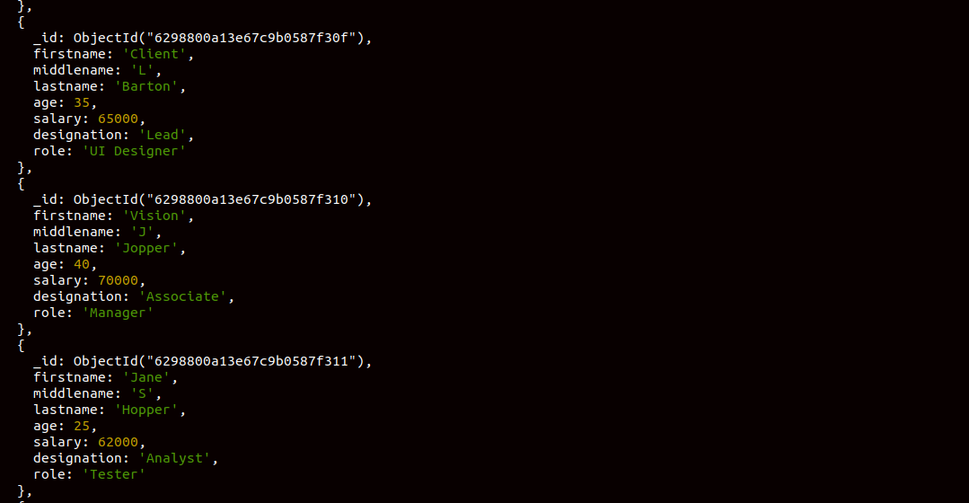

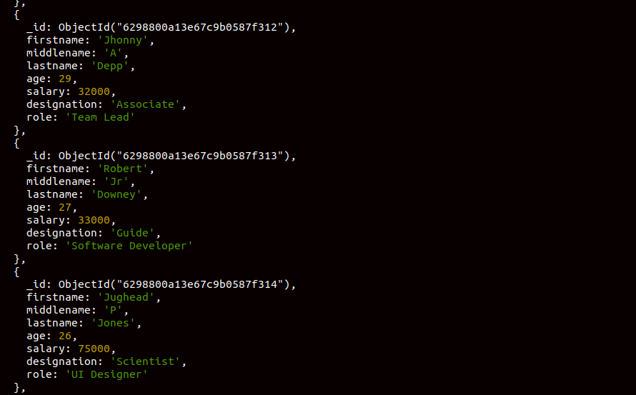

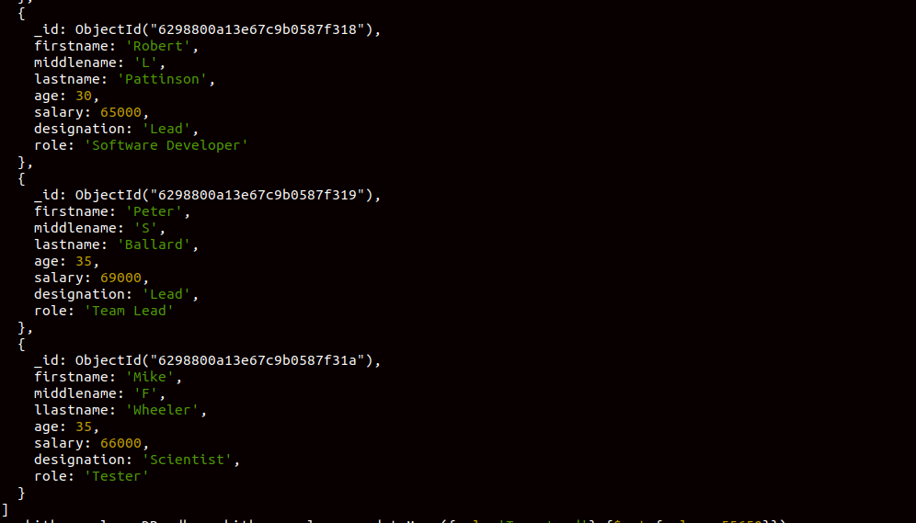

Update all the Employees whose role is "Team Lead" with a salary of 55650 INR

suchithraemployeeDB> db.suchithra_employee.updateMany({role:'Team Lead'},{$set:{salary:55650}})
{
acknowledged: true,
insertedId: null,
matchedCount: 3,
modifiedCount: 3,
upsertedCount: 0
}
suchithraemployeeDB> db.suchithra_employee.find().pretty()
[
{
_id: ObjectId("6298800a13e67c9b0587f30c"),
firstname: 'Tony',
middlename: 'Kumar',
lastname: 'Stark',
age: 26,
salary: 50000,
designation: 'HR',
role: 'Manager'
},
{
_id: ObjectId("6298800a13e67c9b0587f30d"),
firstname: 'Wanda',
middlename: 'S',
lastname: 'Maximoff',
age: 25,
salary: 55650,
designation: 'Scientist',
role: 'Team Lead'
},
{
_id: ObjectId("6298800a13e67c9b0587f30e"),
firstname: 'Steve',
middlename: 'A',
lastname: 'Rogers',
age: 30,
salary: 25000,
designation: 'PA',
role: 'Software Developer'
},
{
_id: ObjectId("6298800a13e67c9b0587f30f"),
firstname: 'Client',
middlename: 'L',
lastname: 'Barton',
age: 35,
salary: 65000,
designation: 'Lead',
role: 'UI Designer'
},
{
_id: ObjectId("6298800a13e67c9b0587f310"),
firstname: 'Vision',
middlename: 'J',
lastname: 'Jopper',
age: 40,
salary: 70000,
designation: 'Associate',
role: 'Manager'
},
{
_id: ObjectId("6298800a13e67c9b0587f311"),
firstname: 'Jane',
middlename: 'S',
lastname: 'Hopper',
age: 25,
salary: 62000,
designation: 'Analyst',
role: 'Tester'
},
{
_id: ObjectId("6298800a13e67c9b0587f312"),
firstname: 'Jhonny',
middlename: 'A',
lastname: 'Depp',
age: 29,
salary: 55650,
designation: 'Associate',
role: 'Team Lead'
},
{
_id: ObjectId("6298800a13e67c9b0587f313"),
firstname: 'Robert',
middlename: 'Jr',
lastname: 'Downey',
age: 27,
salary: 33000,
designation: 'Guide',
role: 'Software Developer'
},
{
_id: ObjectId("6298800a13e67c9b0587f314"),
firstname: 'Jughead',
middlename: 'P',
lastname: 'Jones',
age: 26,
salary: 75000,
designation: 'Scientist',
role: 'UI Designer'
},
{
_id: ObjectId("6298800a13e67c9b0587f315"),
firstname: 'Archie',
middlename: 'A',
lastname: 'Andrews',
age: 40,
salary: 70000,
designation: 'Guide',
role: 'Manager'
},
{
_id: ObjectId("6298800a13e67c9b0587f316"),
firstname: 'Betty',
middlename: 'E',
lastname: 'Cooper',
age: 26,
salary: 60000,
designation: 'Associate',
role: 'Tester'
},
{
_id: ObjectId("6298800a13e67c9b0587f318"),
firstname: 'Robert',
middlename: 'L',
lastname: 'Pattinson',
age: 30,
salary: 65000,
designation: 'Lead',
role: 'Software Developer'
},
{
_id: ObjectId("6298800a13e67c9b0587f319"),
firstname: 'Peter',
middlename: 'S',
lastname: 'Ballard',
age: 35,
salary: 55650,
designation: 'Lead',
role: 'Team Lead'
},
{
_id: ObjectId("6298800a13e67c9b0587f31a"),
firstname: 'Mike',
middlename: 'F',
llastname: 'Wheeler',
age: 35,
salary: 66000,
designation: 'Scientist',
role: 'Tester'
}
]
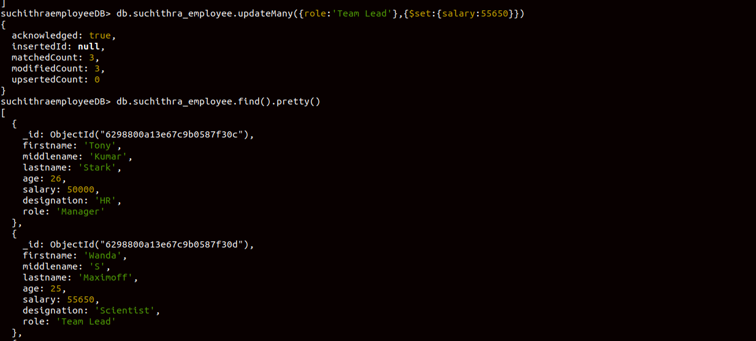
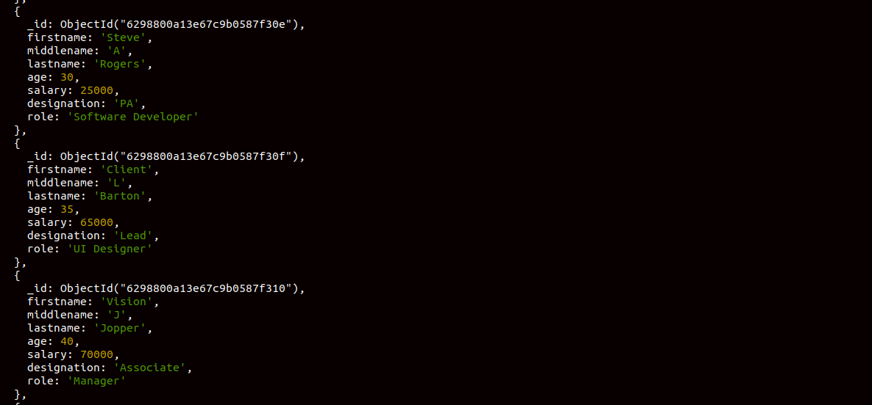
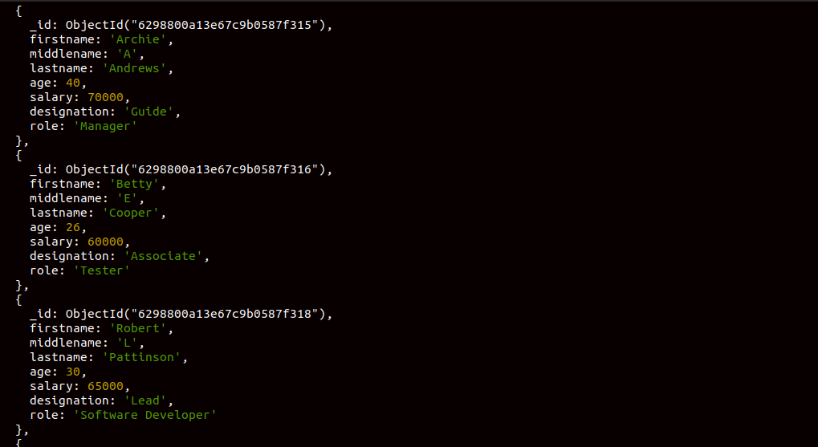
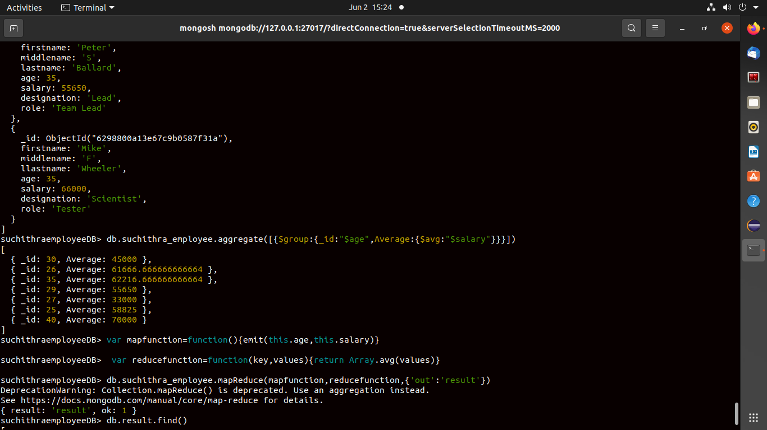

Group all the Employees by their age(common age should be there) and calculate the average salary obtained in the each group
suchithraemployeeDB> db.suchithra_employee.aggregate([{$group:{_id:"$age",Average:{$avg:"$salary"}}}])
[
{ _id: 30, Average: 45000 },
{ _id: 26, Average: 61666.666666666664 },
{ _id: 35, Average: 62216.666666666664 },
{ _id: 29, Average: 55650 },
{ _id: 27, Average: 33000 },
{ _id: 25, Average: 58825 },
{ _id: 40, Average: 70000 }
]

Apply the map-reduce to perform the above operation and obtain the results

suchithraemployeeDB> var mapfunction=function(){emit(this.age,this.salary)}
suchithraemployeeDB> var reducefunction=function(key,values){return Array.avg(values)}
suchithraemployeeDB> db.suchithra_employee.mapReduce(mapfunction,reducefunction,{'out':'result'})
DeprecationWarning: Collection.mapReduce() is deprecated. Use an aggregation instead.
See https://docs.mongodb.com/manual/core/map-reduce for details.
{ result: 'result', ok: 1 }
suchithraemployeeDB> db.result.find()
[
{ _id: 30, value: 45000 },
{ _id: 26, value: 61666.666666666664 },
{ _id: 35, value: 62216.666666666664 },
{ _id: 29, value: 55650 },
{ _id: 27, value: 33000 },
{ _id: 25, value: 58825 },
{ _id: 40, value: 70000 }
]
