26-05-2022

NAME:SUCHITHRA RAJ M
USN:1NT19IS162

creating database
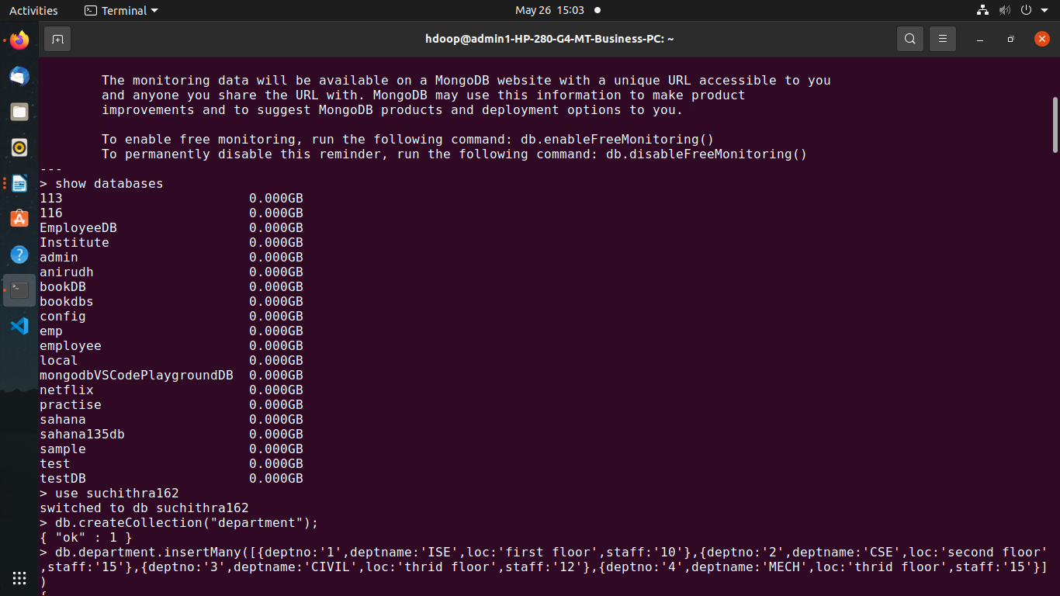

creating collection suchi and inserting values

db.createCollection("suchi");
{ "ok" : 1 }
> db.suchi.insertMany([{name:'Tony',address:'bangalore',sex:'m',age:'21'},{name:'wanda',address:'LA',sex:'f',age:'26'},{name:'steve',address:'bangalore',sex:'m',age:'26'},{name:'peter',address:'mandya',sex:'m',age:'19'},{name:'natasha',address:'LA',sex:'f',age:'34'}])
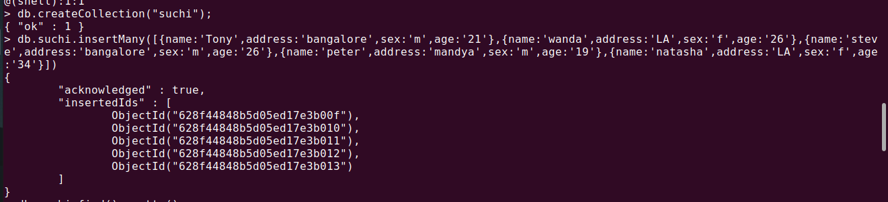
t
to display we use db.suchi.find().pretty()
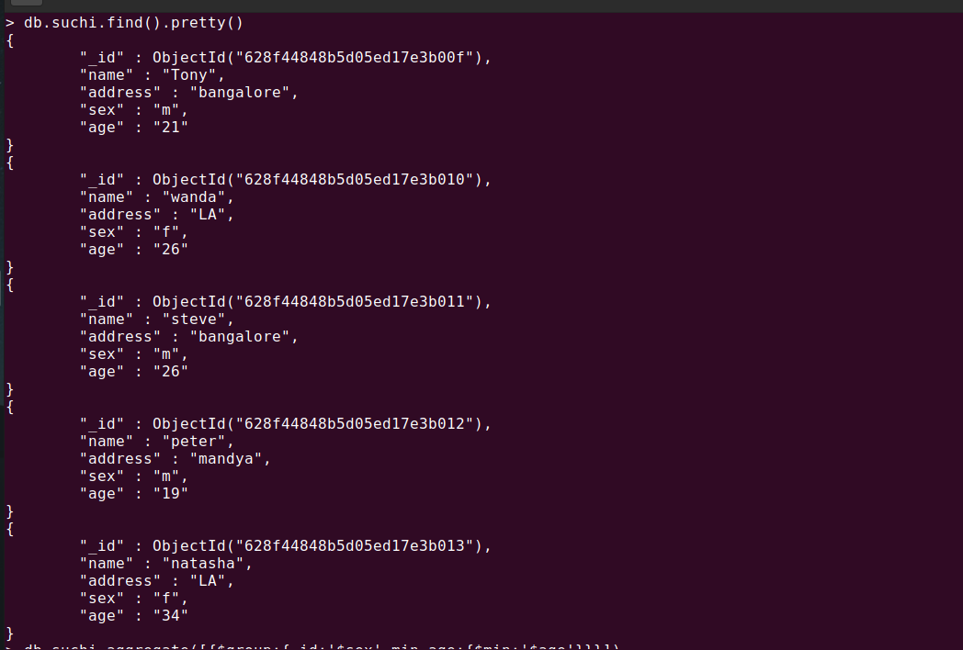

AGGREGATE FUNCTIONS

1.MINIMUM
db.suchi.aggregate([{$group:{_id:'$sex',min_age:{$min:'$age'}}}])
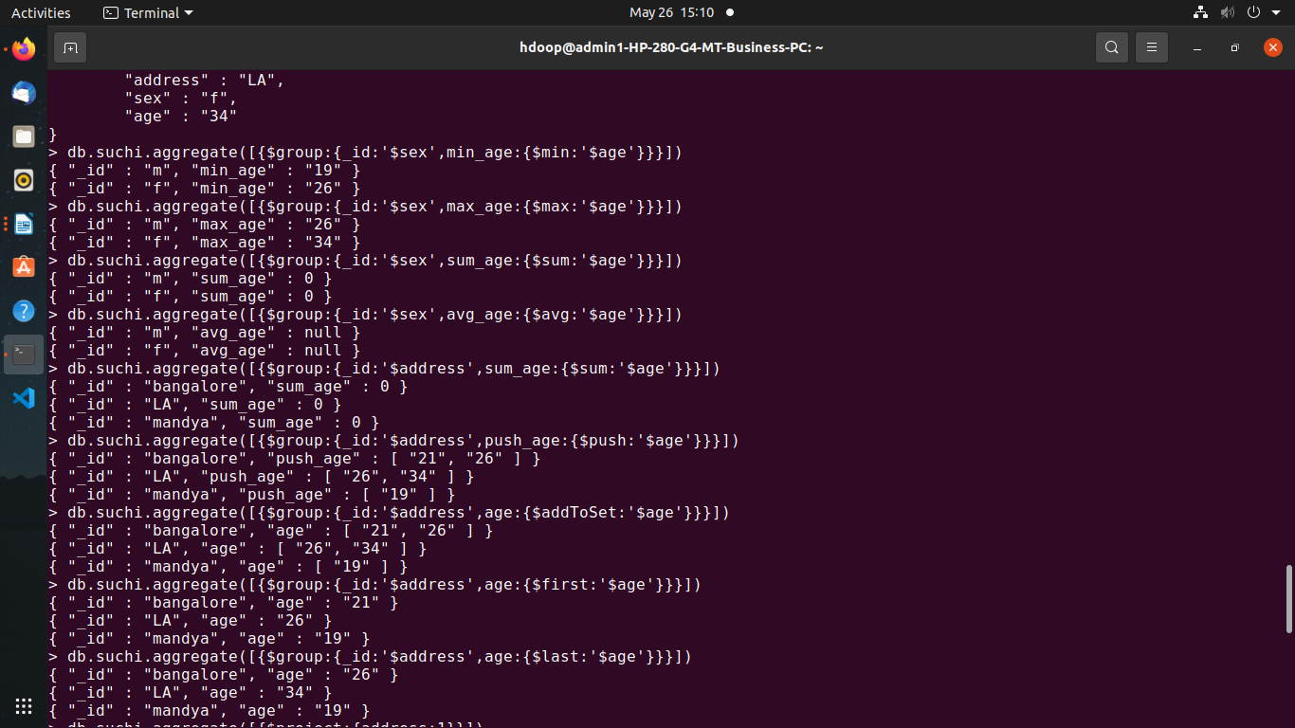

2.MAXIMUM
> db.suchi.aggregate([{$group:{_id:'$sex',max_age:{$max:'$age'}}}])
u

3.PUSH
> db.suchi.aggregate([{$group:{_id:'$address',push_age:{$push:'$age'}}}])
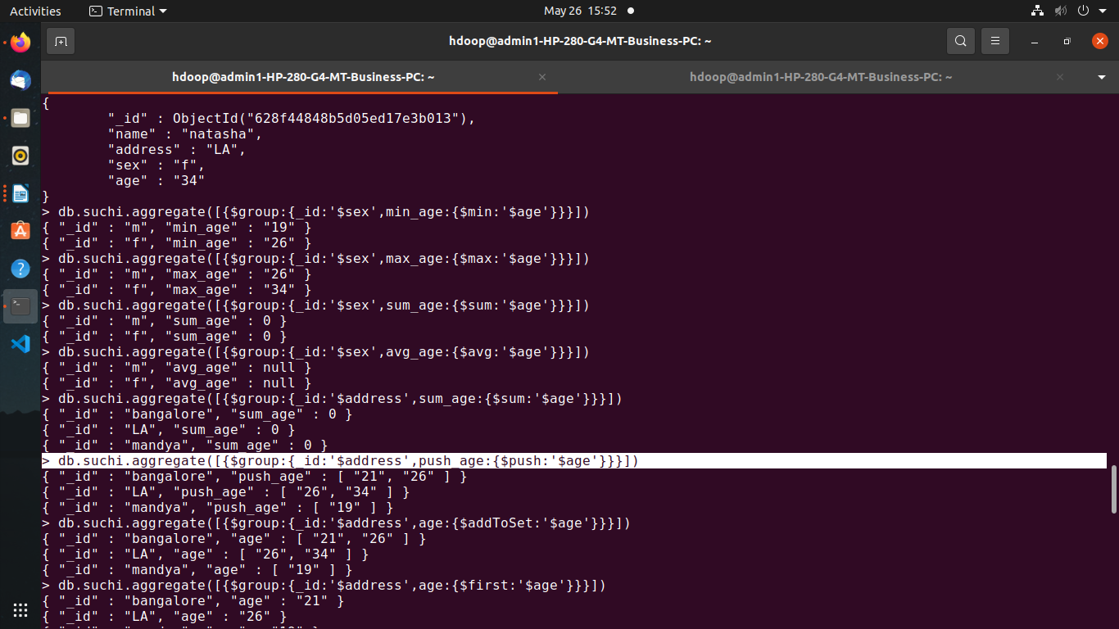
o

4.ADDTOSET
> db.suchi.aggregate([{$group:{_id:'$address',age:{$addToSet:'$age'}}}])
I

5.FIRST
> db.suchi.aggregate([{$group:{_id:'$address',age:{$first:'$age'}}}])
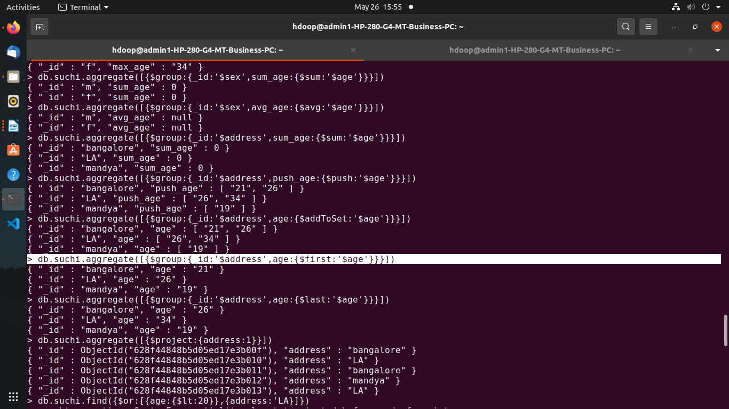
O

6.LAST
> db.suchi.aggregate([{$group:{_id:'$address',age:{$last:'$age'}}}])
U

PROJECT
> db.suchi.aggregate([{$project:{address:1}}])

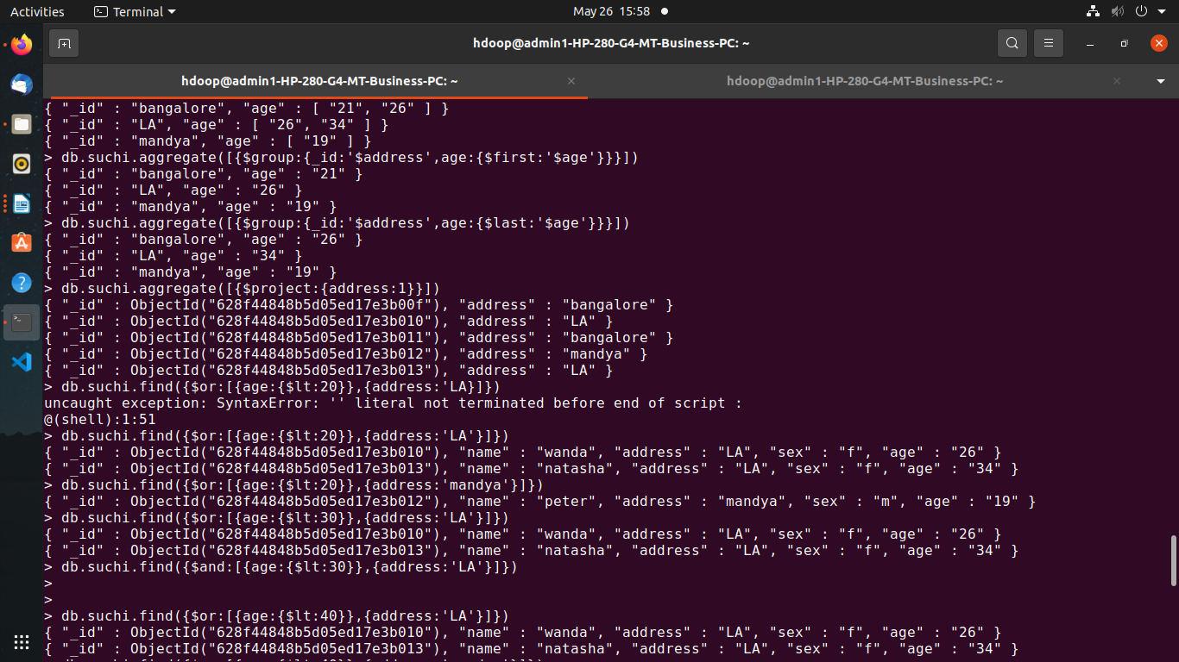
1

OR OPERATION
> db.suchi.find({$or:[{age:{$lt:'20'}},{address:'LA'}]})
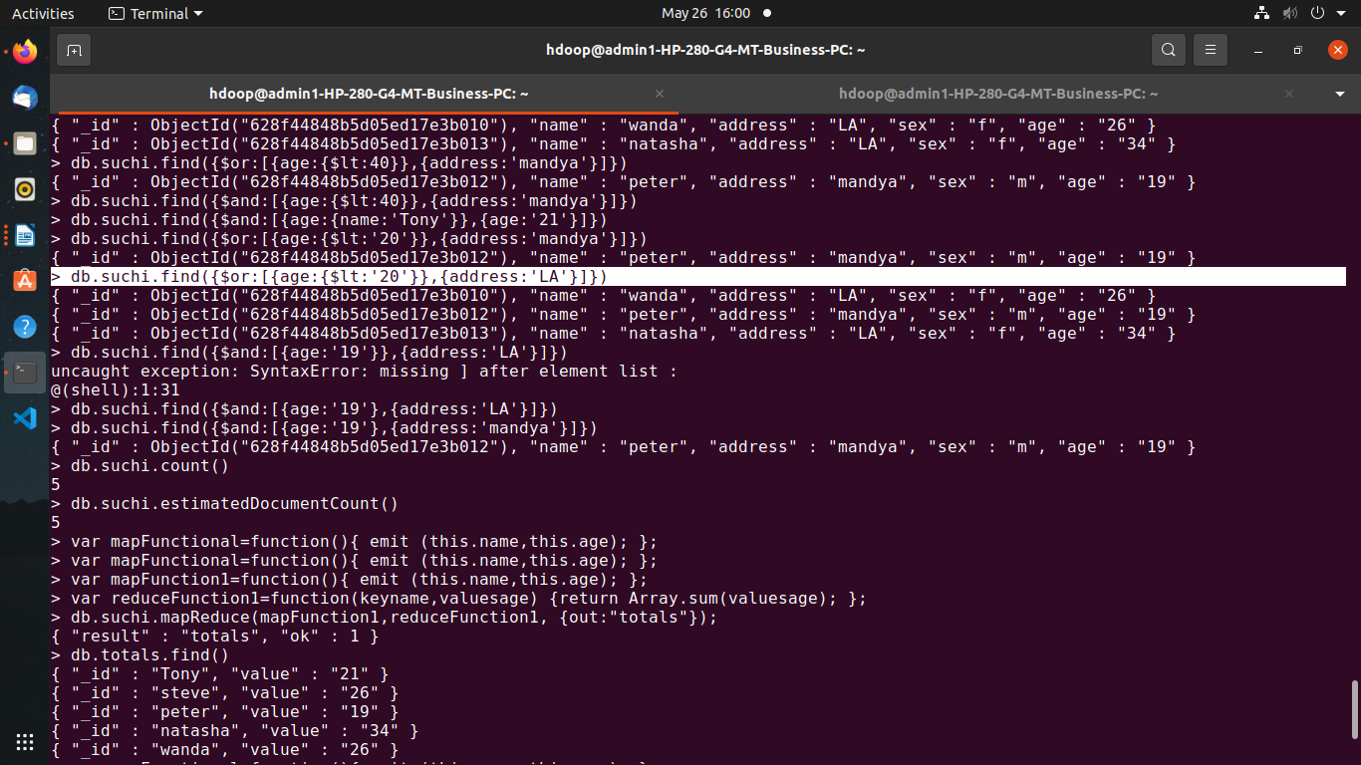
A

AND OPERATION
> db.suchi.find({$and:[{age:'19'},{address:'mandya'}]})
COUNT

> db.suchi.count()
5
> db.suchi.estimatedDocumentCount()
5
O

MAP REDUCE

> var mapFunctional=function(){ emit (this.name,this.age); };
> var mapFunction1=function(){ emit (this.name,this.age); };
> var reduceFunction1=function(keyname,valuesage) {return Array.sum(valuesage); };
> db.suchi.mapReduce(mapFunction1,reduceFunction1, {out:"totals"});
{ "result" : "totals", "ok" : 1 }
> db.totals.find()
{ "_id" : "Tony", "value" : "21" }
{ "_id" : "steve", "value" : "26" }
{ "_id" : "peter", "value" : "19" }
{ "_id" : "natasha", "value" : "34" }
{ "_id" : "wanda", "value" : "26" }
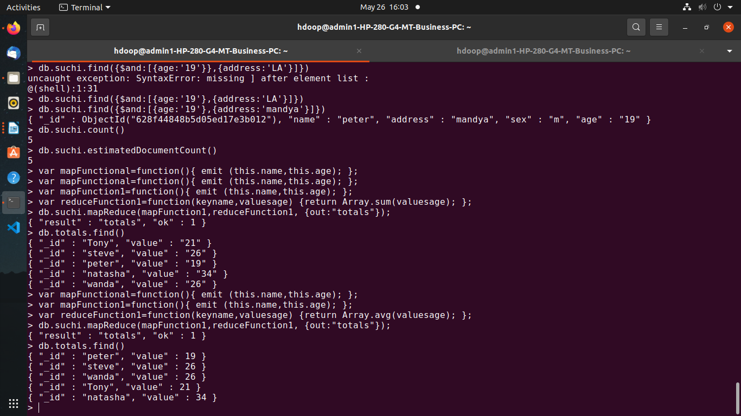
p

> var mapFunctional=function(){ emit (this.name,this.age); };
> var mapFunction1=function(){ emit (this.name,this.age); };
> var reduceFunction1=function(keyname,valuesage) {return Array.avg(valuesage); };
> db.suchi.mapReduce(mapFunction1,reduceFunction1, {out:"totals"});
{ "result" : "totals", "ok" : 1 }
> db.totals.find()
{ "_id" : "peter", "value" : 19 }
{ "_id" : "steve", "value" : 26 }
{ "_id" : "wanda", "value" : 26 }
{ "_id" : "Tony", "value" : 21 }
{ "_id" : "natasha", "value" : 34 }

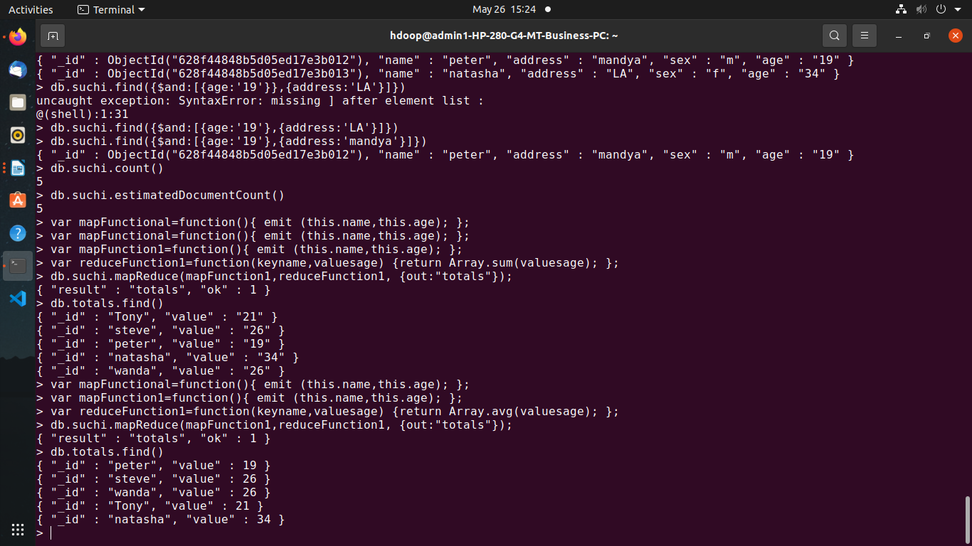

26-05-2022

Checking whether Hadoop is installed

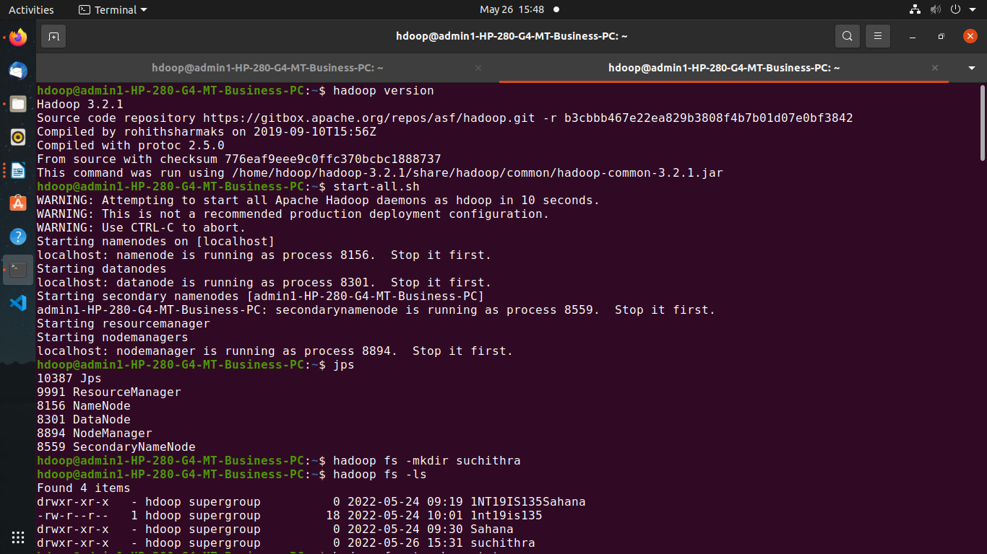

Creating a directory named by my name

Listing all the files and directories present

Creating empty file

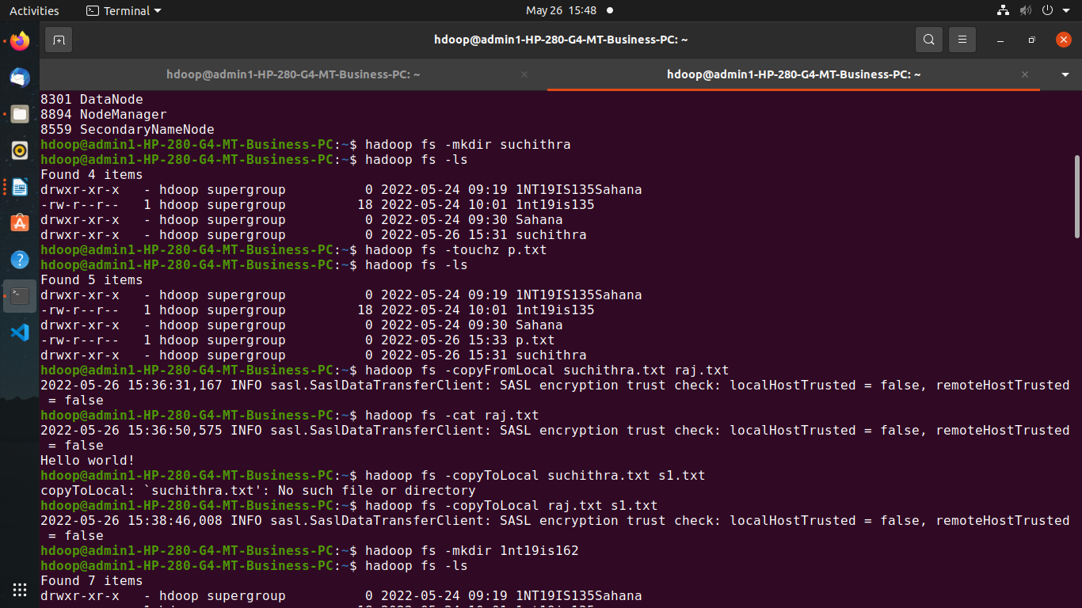

Create a file in your local system to terminal and cat command

Copy to local



Creating another directory with usn

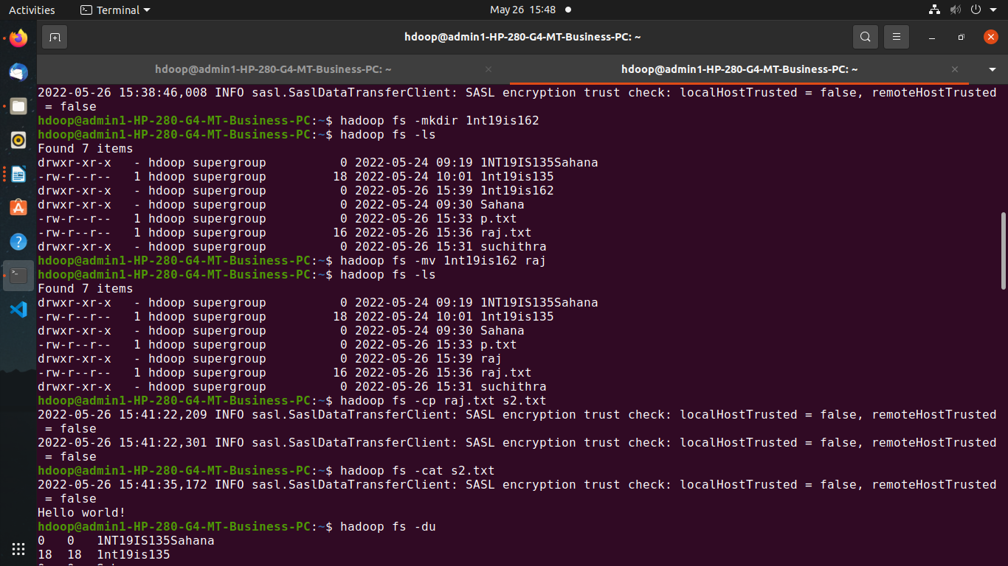

Moving usn directory inside name directory

Coping text from one file to another

Size of the file and directory

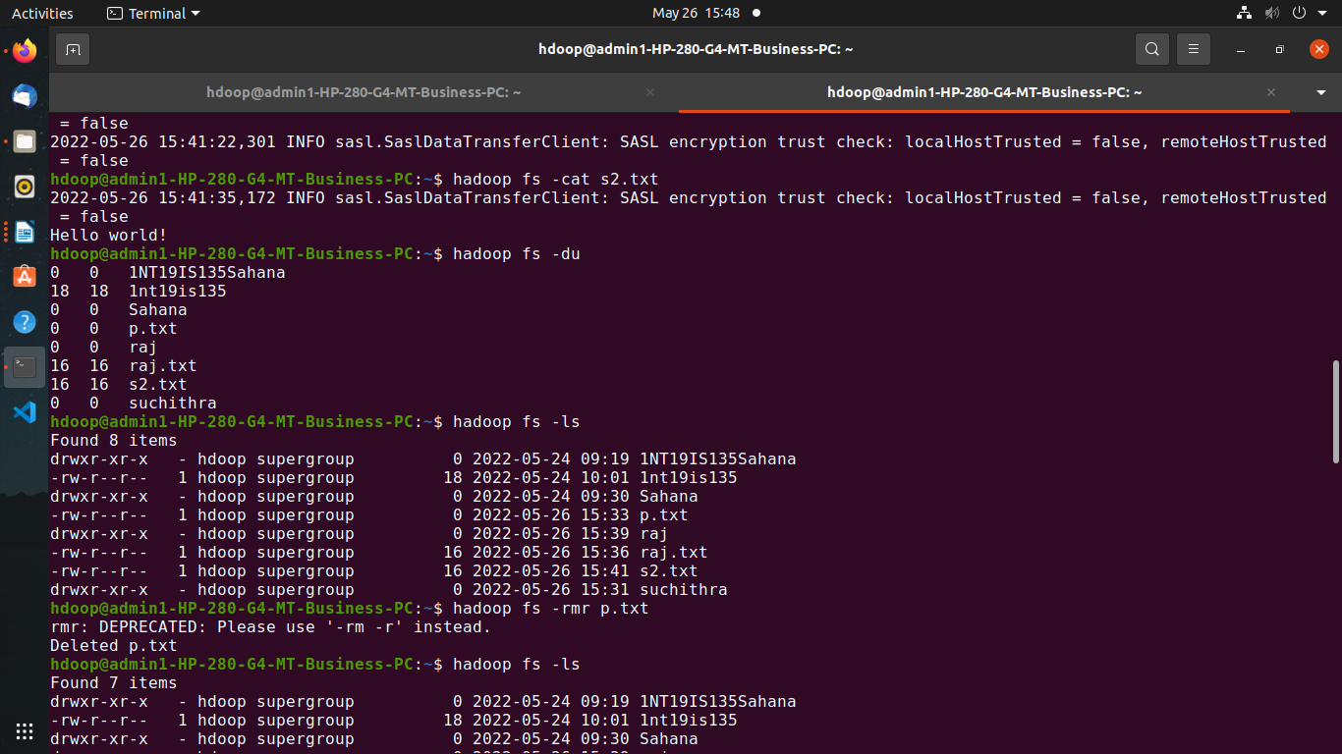

Delete the files

Total size of all files and directory

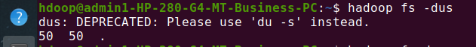

Check time and date of particular file
