Annapurna.B.neelakari
1NT20IS401

INSERT ONE

> db.movie.insertOne({"name":"RRR"});
{
"acknowledged" : true,
"insertedId" : ObjectId("6246c8df26e1a0a654c03d14")

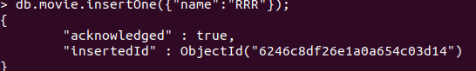
}

INSERTMANY

> db.movie.insertMany([{"name":"jamies"},{"name":"akash"}]);
{
"acknowledged" : true,
"insertedIds" : [
ObjectId("6246c8fa26e1a0a654c03d15"),
ObjectId("6246c8fa26e1a0a654c03d16")
]
}
> db.movie.find().pretty()
{ "_id" : ObjectId("6246bfd426e1a0a654c03d11") }
{ "_id" : ObjectId("6246c75126e1a0a654c03d12"), "name" : "sushi" }
{ "_id" : ObjectId("6246c75126e1a0a654c03d13"), "name" : "akash" }
{ "_id" : ObjectId("6246c8df26e1a0a654c03d14"), "name" : "RRR" }
{ "_id" : ObjectId("6246c8fa26e1a0a654c03d15"), "name" : "jamies" }
{ "_id" : ObjectId("6246c8fa26e1a0a654c03d16"), "name" : "akash" }

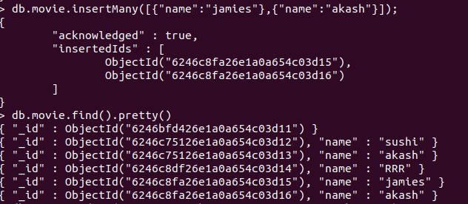

UPDATE(SET &UNSET)

> db.movie.update({'name':'sushi'},{$unset:{'name':'hjqw'}})
WriteResult({ "nMatched" : 1, "nUpserted" : 0, "nModified" : 1 })
> db.movie.find().pretty()
{ "_id" : ObjectId("6246bfd426e1a0a654c03d11") }
{ "_id" : ObjectId("6246c75126e1a0a654c03d12") }
{ "_id" : ObjectId("6246c75126e1a0a654c03d13"), "name" : "akash" }
{ "_id" : ObjectId("6246c8df26e1a0a654c03d14"), "name" : "RRR" }
{ "_id" : ObjectId("6246c8fa26e1a0a654c03d15"), "name" : "jamies" }

{ "_id" : ObjectId("6246c8fa26e1a0a654c03d16"), "name" : "akash" }
> db.movie.update({'name':'RRR'},{$set:{'name':'sky'}})
WriteResult({ "nMatched" : 1, "nUpserted" : 0, "nModified" : 1 })
> db.movie.find().pretty()
{ "_id" : ObjectId("6246bfd426e1a0a654c03d11") }
{ "_id" : ObjectId("6246c75126e1a0a654c03d12") }
{ "_id" : ObjectId("6246c75126e1a0a654c03d13"), "name" : "akash" }
{ "_id" : ObjectId("6246c8df26e1a0a654c03d14"), "name" : "sky" }
{ "_id" : ObjectId("6246c8fa26e1a0a654c03d15"), "name" : "jamies" }
{ "_id" : ObjectId("6246c8fa26e1a0a654c03d16"), "name" : "akash" }

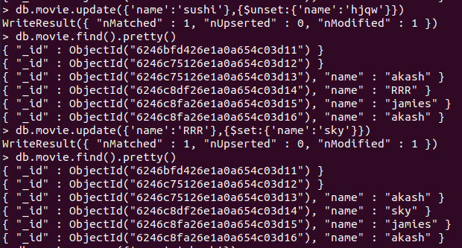

REMOVE

> db.movie.remove({'name':'akash'})
WriteResult({ "nRemoved" : 2 })
> db.movie.find().pretty()
{ "_id" : ObjectId("6246bfd426e1a0a654c03d11") }
{ "_id" : ObjectId("6246c75126e1a0a654c03d12") }
{ "_id" : ObjectId("6246c8df26e1a0a654c03d14"), "name" : "sky" }
{ "_id" : ObjectId("6246c8fa26e1a0a654c03d15"), "name" : "jamies" }
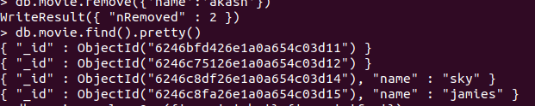

FIND

db.movie.find().pretty()
{ "_id" : ObjectId("6246bf7a26e1a0a654c03d0f"), "name" : "RRR" }
{ "_id" : ObjectId("6246bfd426e1a0a654c03d10"), "name" : "RRR" }
{ "_id" : ObjectId("6246bfd426e1a0a654c03d11"), "name" : "yyy" }

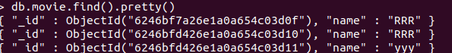

REPLACE

> db.movie.replaceOne({'name':'sky'},{'name':'fox'})
{ "acknowledged" : true, "matchedCount" : 1, "modifiedCount" : 1 }
> db.movie.find().pretty()
{ "_id" : ObjectId("6246bfd426e1a0a654c03d11") }
{ "_id" : ObjectId("6246c75126e1a0a654c03d12") }

{ "_id" : ObjectId("6246c8df26e1a0a654c03d14"), "name" : "fox" }
{ "_id" : ObjectId("6246c8fa26e1a0a654c03d15"), "name" : "jamies" }
>

