**Bigdata Lab**

**Annapurna.b.neelakari**

**1NT20IS401**

**AGGREGATE COMANDS**:

> db.annapurna.insertMany([{_id:0,name:"Pepperoni",size:"small",price:19,quantity:10,date:ISODate("2021-03-13T08:14:30Z")},{_id:1,name:"Pepperoni",size:"medium",price:20,quantity:20,date:ISODate("2021-03-13T09:13:24Z")},{_id:2,name:"Pepperoni",size:"large",price:21,quantity:30,date:ISODate("2021-03-17T09:22:12Z")},{_id:3,name:"Cheese",size:"small",price:12,quantity:15,date:ISODate("2021-03-13T11:21:39.736Z")},{_id:4,name:"Cheese",size:"medium",price:13,quantity:50,date:ISODate("2022-01-12T21:23:13.331Z")},{_id:5,name:"Cheese",size:"large",price:14,quantity:10,date:ISODate("2022-01-12T05:08:13Z")}])

{ "acknowledged" : true, "insertedIds" : [ 0, 1, 2, 3, 4, 5 ] }



**OUTPUT OF AGGREGARE:**

> db.annapurna.aggregate([{$match:{size:"medium"}},{$group:{_id:"$name",totalQuantity:{$sum:"$quantity"}}}])

{ "_id" : "Pepperoni", "totalQuantity" : 20 }

{ "_id" : "Cheese", "totalQuantity" : 50 }

>

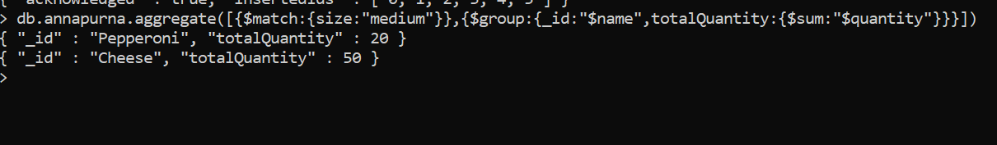

**PIPELINE AGGREGATE FUNCTIONS**

db.yashodha.aggregate([{$match:{name:"Chandu"}},{$group:{_id:"$name",count:{$count:{}}}},{$sort:{count:1}},{$limit:1}])

{ "_id" : "Chandu", "count" : 1 }

> db.yashodha.aggregate([{$group:{_id:"$name",count:{$count:{}}}},{$sort:{count:1}},{$limit:1}])

{ "_id" : "Bindu", "count" : 1 }

> db.yashodha.aggregate([{$group:{_id:"$name",count:{$count:{}}}},{$sort:{count:1}},{$limit:4}])

{ "_id" : "Akash", "count" : 1 }

{ "_id" : "Bindu", "count" : 1 }

{ "_id" : "Arpita", "count" : 1 }

{ "_id" : "Chandu", "count" : 1 }

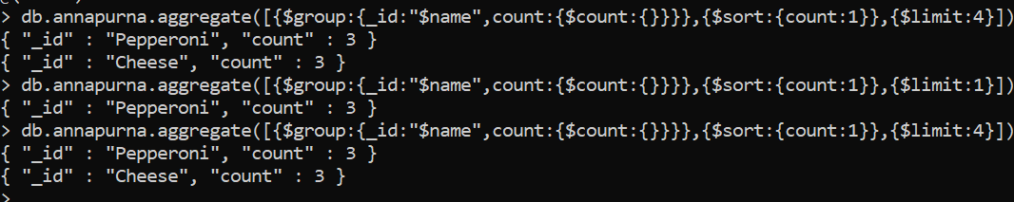

**Mapreduce in mongodb**

> db.annapurna.insertMany([ { "_id" : ObjectId("625fe32ded3d662f49bf6b47"), "name" : "LMN", "age" : 20 }, { "_id" : ObjectId("625fe321ed3d662f49bf6b46"), "name" : "ABC", "age" : 20 }, { "_id" : ObjectId("625fe312ed3d662f49bf6b45"), "name" : "ABC", "age" : 10 }, { "_id" : ObjectId("625fe32ded3d662f49bf6b47"), "name" : "LMN", "age" : 30 } ])



> var mapc = function(){emit(this.name, this.age)}

> var redc = function(key, value){return Array.sum(value)}

> db.annapurna.mapReduce(mapc, redc,{out:"myresult"}) ;

{ "result" : "myresult", "ok" : 1 }

