[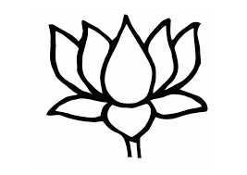](https://www.google.co.in/imgres?imgurl=https%3A%2F%2Fwww.edupics.com%2Fcoloring-page-lotus-dm11002.jpg&imgrefurl=https%3A%2F%2Fwww.edupics.com%2Fcoloring-page-lotus-i11002.html&docid=YuAu_SLmK-ZEHM&tbnid=3LDQSlb0TGIXbM%3A&vet=10ahUKEwjgo9HfnNnYAhWGpJQKHRUSAksQMwjEAihjMGM..i&w=750&h=531&bih=887&biw=1882&q=lotus%20images&ved=0ahUKEwjgo9HfnNnYAhWGpJQKHRUSAksQMwjEAihjMGM&iact=mrc&uact=8) [](http://www.google.co.in/url?sa=i&rct=j&q=&esrc=s&source=images&cd=&cad=rja&uact=8&ved=0ahUKEwis-JWXndnYAhWJHpQKHWvMA48QjRwIBw&url=http%3A%2F%2Fwww.heroesprojectindia.org%2F2016%2F07%2Frose-coloring-pages%2Fstunning-rose-coloring-pages-33-for-coloring-site-with-rose-coloring-pages%2F&psig=AOvVaw0oOQw4OyK8NytbBWtkWncE&ust=1516080211834426)

[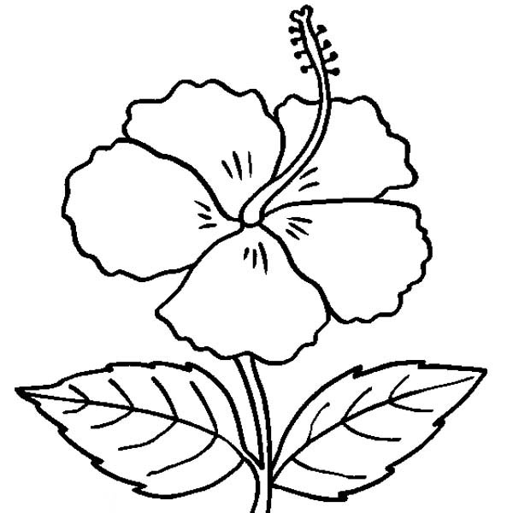](http://www.google.co.in/url?sa=i&rct=j&q=&esrc=s&source=images&cd=&cad=rja&uact=8&ved=0ahUKEwjP1YPCndnYAhUCjpQKHdmcDOMQjRwIBw&url=http%3A%2F%2Fwww.coloringbpr.com%2F2016%2F10%2Fhibiscus-flower-coloring-pages-68265%2Ffree-hibiscus-flower-coloring-pages%2F&psig=AOvVaw0UmCmt1zDpt8bmpLN6OJAz&ust=1516080296637334) 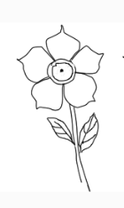

[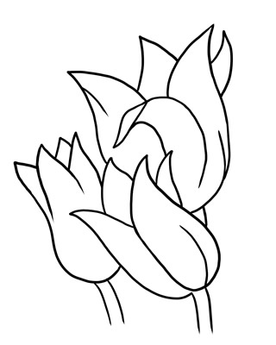](http://www.google.co.in/url?sa=i&rct=j&q=&esrc=s&source=images&cd=&cad=rja&uact=8&ved=0ahUKEwjvyeDBntnYAhXFGZQKHdhuAroQjRwIBw&url=http%3A%2F%2Fwww.clipartpanda.com%2Fclipart_images%2Fheart-clip-art-outline-heart-3462519&psig=AOvVaw0F6BkxTfT-elyOL8r54BVQ&ust=1516080590730674) [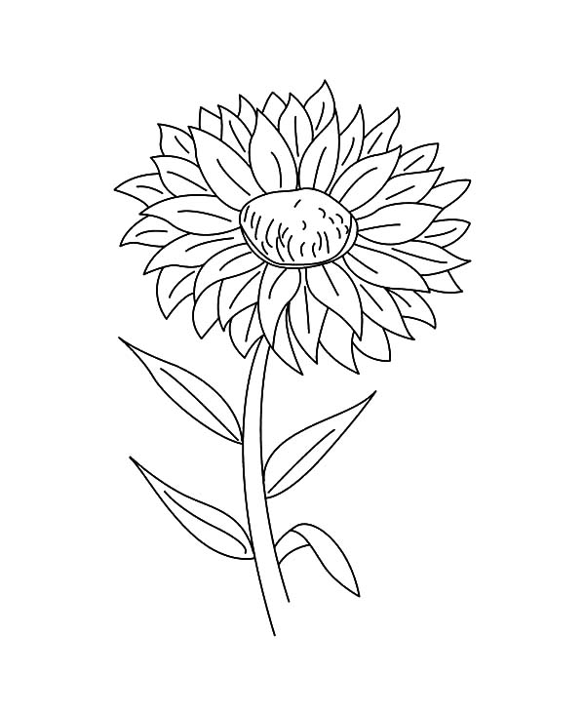](http://www.google.co.in/url?sa=i&rct=j&q=&esrc=s&source=images&cd=&cad=rja&uact=8&ved=0ahUKEwj9wt-qn9nYAhWFE5QKHar1CCoQjRwIBw&url=http%3A%2F%2Fwww.bulkcolor.com%2Faster-flower-outline-coloring-pages%2F&psig=AOvVaw3zpRh4R68Q5u7JlxF8umE9&ust=1516080823453935)

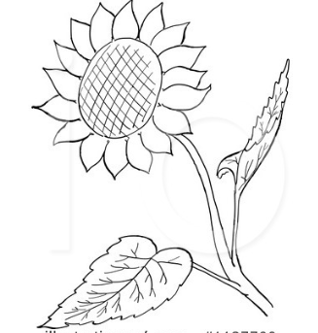 [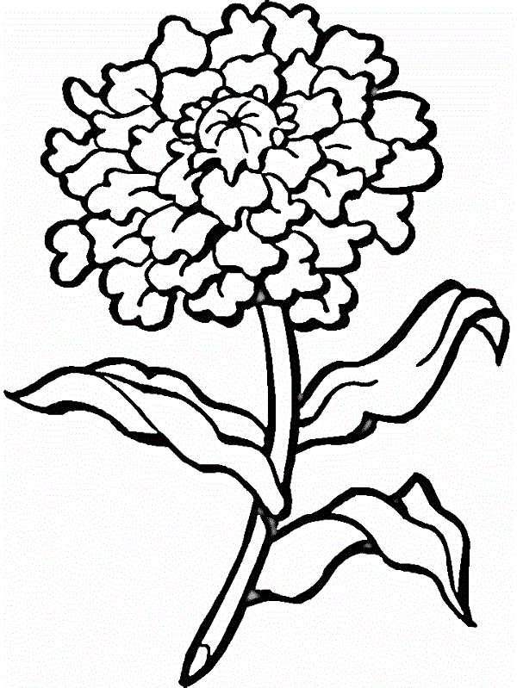](http://www.google.co.in/url?sa=i&rct=j&q=&esrc=s&source=images&cd=&cad=rja&uact=8&ved=&url=http%3A%2F%2Fcoloringsmart.com%2Ftag%2Fmarigold&psig=AOvVaw3qFIM1IC9OJ0jk6Xls9HFf&ust=1516081028575515)

