ACCRA TECHNICAL UNIVERSITY
Department of Computer Science
BCS 404: Introduction to Data Science with Python
PROJECT WORK
Exploratory Data Analysis, Statistical Analysis and Machine Learning
using a Real-World Dataset (Titanic Dataset)

Submitted by: Okoumba Mitchowanou Anne Jolie
Lecturer: Dr. Joseph Dadzie
Academic Year: 2025/2026, Second Semester
Submission Date: 17 July 2026

Table of Contents
Table of Contents 2
1. Introduction 3
2. Dataset Description 3
3. Methodology 3
3.1 Data Acquisition 3
3.2 Data Cleaning 3
3.3 Data Visualisation 4
3.4 Statistical Analysis 4
3.5 Machine Learning 4
4. Results 4
4.1 Visualisation Results 4
4.1.1 Histogram of Passenger Ages 4
4.1.2 Bar Chart of Passenger Class Distribution 5
4.1.3 Boxplot of Age by Passenger Class 6
4.1.4 Scatter Plot of Age versus Fare 6
4.1.5 Correlation Heatmap 7
4.1.6 Pairplot of Selected Numerical Variables 8
4.2 Statistical Analysis Results 8
4.2.1 Descriptive Statistics 8
4.2.2 Frequency Distribution 9
4.2.3 Correlation Analysis 9
4.2.4 Three Important Statistical Findings 9
4.3 Machine Learning Results 9
5. Discussion 10
5.1 Major Findings 10
5.2 Statistical Insights 10
5.3 Machine Learning Results 10
5.4 Limitations of the Study 11
5.5 Recommendations 11
6. Conclusion 11
7. References 11
8. Appendix: Python Code 13

1. Introduction
This report presents a complete data science workflow applied to the Titanic dataset, undertaken to satisfy the BCS 404 project requirements. The purpose of the project is to demonstrate practical competence in data acquisition, data cleaning, data visualisation, statistical analysis, and introductory machine learning using the Python data science stack (Pandas, NumPy, Matplotlib, Seaborn, and Scikit-Learn), all within a Jupyter Notebook environment.
The Titanic dataset was selected because it is a well-documented, real-world dataset containing a mix of categorical and numerical variables, missing data, and a clear binary outcome (passenger survival), making it well suited to illustrating the full data science pipeline from raw data to a working predictive model.
The remainder of this report is organised as follows: Section 2 describes the dataset; Section 3 outlines the methodology followed; Section 4 presents the results of the visualisation, statistical, and machine learning analyses; Section 5 discusses the findings, limitations, and recommendations; and Section 6 concludes the report. The full Python code used to generate every result in this report is provided in the Appendix and in the accompanying Jupyter Notebook.

2. Dataset Description
The dataset used is the Titanic dataset, made available through the Kaggle “Titanic: Machine Learning from Disaster” competition (https://www.kaggle.com/competitions/titanic/data). It contains demographic, ticket, and survival information for 891 passengers aboard the RMS Titanic, across 12 columns.
Column | Description
PassengerId | Unique identifier for each passenger
Survived | Survival outcome (0 = did not survive, 1 = survived) — the target variable
Pclass | Passenger ticket class (1 = first, 2 = second, 3 = third)
Name | Passenger's full name
Sex | Passenger's gender
Age | Passenger's age in years
SibSp | Number of siblings/spouses aboard
Parch | Number of parents/children aboard
Ticket | Ticket number
Fare | Passenger fare paid
Cabin | Cabin number (largely missing)
Embarked | Port of embarkation (C = Cherbourg, Q = Queenstown, S = Southampton)

The dataset was loaded directly from a public mirror that reproduces the exact structure and values of the Kaggle train.csv file, giving 891 rows and 12 columns, which matches the dimensions confirmed programmatically in the accompanying notebook.

3. Methodology

3.1 Data Acquisition
The dataset was imported into a Pandas DataFrame using pd.read_csv(). Its dimensions (891 rows × 12 columns), column names, first five records, and data types were inspected to confirm successful and correct loading.

3.2 Data Cleaning
Missing values were detected using df.isnull().sum(). Three columns contained missing data: Age (~20% missing), Cabin (~77% missing), and Embarked (2 missing values). The following preprocessing decisions were made:
- Cabin: converted into a binary indicator, Has_Cabin (1 if a cabin number was recorded, 0 otherwise), then the original column was dropped, since the sheer proportion of missingness made direct imputation unreliable, but the presence/absence of a cabin number is itself informative.
- Age: imputed using the median age within each Pclass/Sex subgroup, which is more accurate than a single global median because age correlates with both class and gender.
- Embarked: imputed using the mode (most frequent port), since only two records were affected.
- Duplicates: the dataset was checked using df.duplicated(); no fully duplicated rows were found, so no rows were removed on this basis.
This targeted approach preserves the full sample size (891 passengers) while minimising the bias that either naive mean-imputation or wholesale row deletion would introduce.

3.3 Data Visualisation
Six visualisations were produced using Matplotlib and Seaborn: a histogram of passenger ages, a bar chart of passenger class distribution, a boxplot of age by passenger class, a scatter plot of age versus fare, a correlation heatmap, and a pairplot of selected numerical variables. Each figure includes a title, axis labels, and a brief interpretation, presented in Section 4.1.

3.4 Statistical Analysis
Descriptive statistics, frequency distributions, and a Pearson correlation matrix were computed across the key numerical variables (Survived, Pclass, Age, SibSp, Parch, Fare). The strongest positive and negative pairwise correlations were identified programmatically by sorting the off-diagonal correlation values.

3.5 Machine Learning
A Logistic Regression classifier was selected as the machine learning model, consistent with the project brief. The predictor variables used were Pclass, Sex, Age, Fare, SibSp, Parch, and Embarked; PassengerId, Name, and Ticket were excluded as non-generalisable identifiers. Numerical predictors were standardised using StandardScaler and categorical predictors were one-hot encoded using OneHotEncoder, combined via a Scikit-Learn ColumnTransformer and Pipeline. The data was split into 80% training (712 passengers) and 20% testing (179 passengers) using a stratified split to preserve the survival class ratio. The model was evaluated on the held-out test set using accuracy, a confusion matrix, and a full classification report.

4. Results

4.1 Visualisation Results

4.1.1 Histogram of Passenger Ages
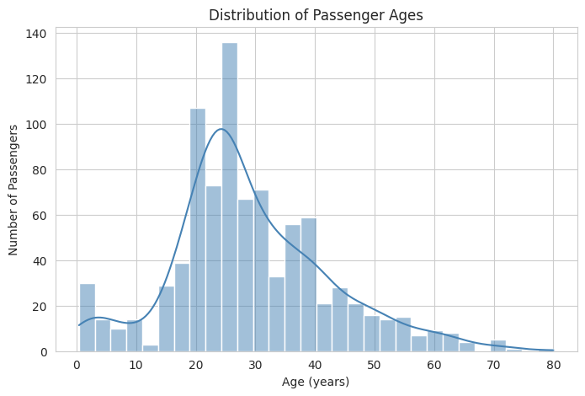
Figure 1: Distribution of passenger ages
The age distribution is right-skewed and broadly unimodal, concentrated between 20 and 40 years, with a secondary smaller peak among young children under 10 and comparatively few passengers above 60.

4.1.2 Bar Chart of Passenger Class Distribution
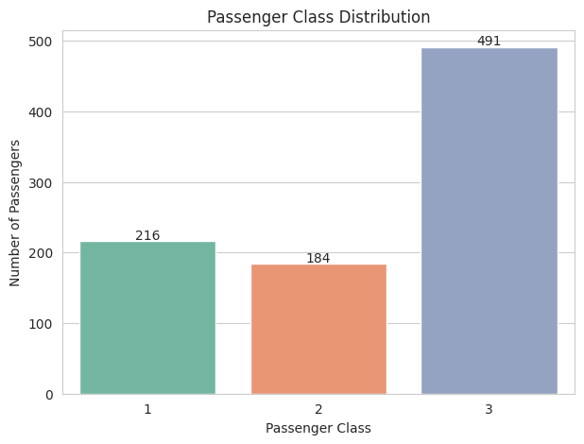
Figure 2: Passenger class distribution
Third-class passengers form the largest group (491), followed by first class (216) and second class (184), reflecting the Titanic's dual role as a luxury liner and an emigrant-carrying vessel.

4.1.3 Boxplot of Age by Passenger Class
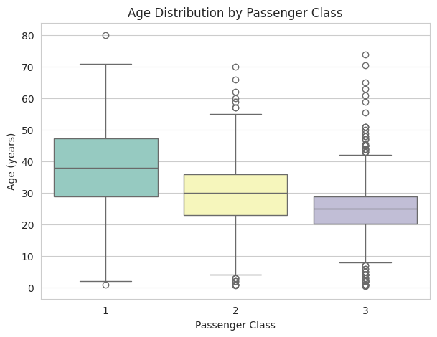
Figure 3: Age distribution by passenger class
Median passenger age decreases from first to third class, indicating that wealthier, older travellers were concentrated in first class while third class carried more young adults and families.

4.1.4 Scatter Plot of Age versus Fare
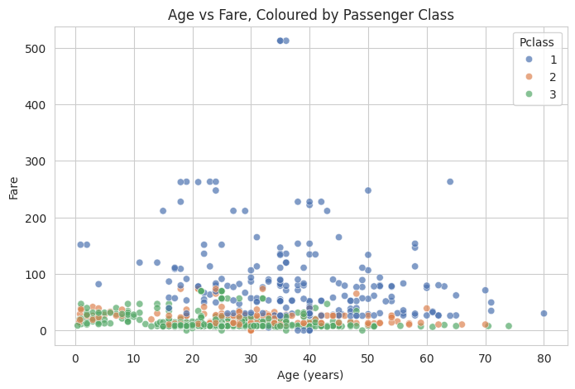
Figure 4: Age vs Fare, coloured by passenger class
There is no strong linear relationship between age and fare, but the highest fares are concentrated among first-class passengers of all ages, while third-class passengers cluster tightly at low fares across the entire age range.

4.1.5 Correlation Heatmap
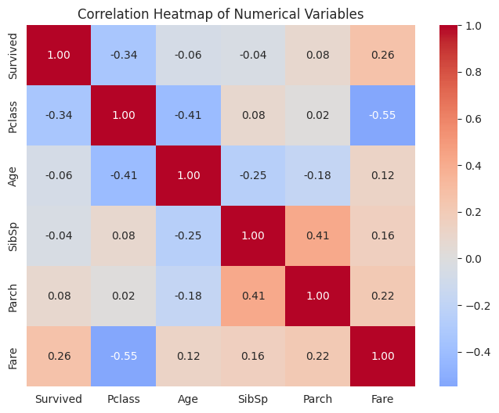
Figure 5: Correlation heatmap of numerical variables
Pclass and Fare show the strongest correlation with Survived among the numerical variables (negative and positive respectively), while Age shows only a weak linear correlation with survival.

4.1.6 Pairplot of Selected Numerical Variables
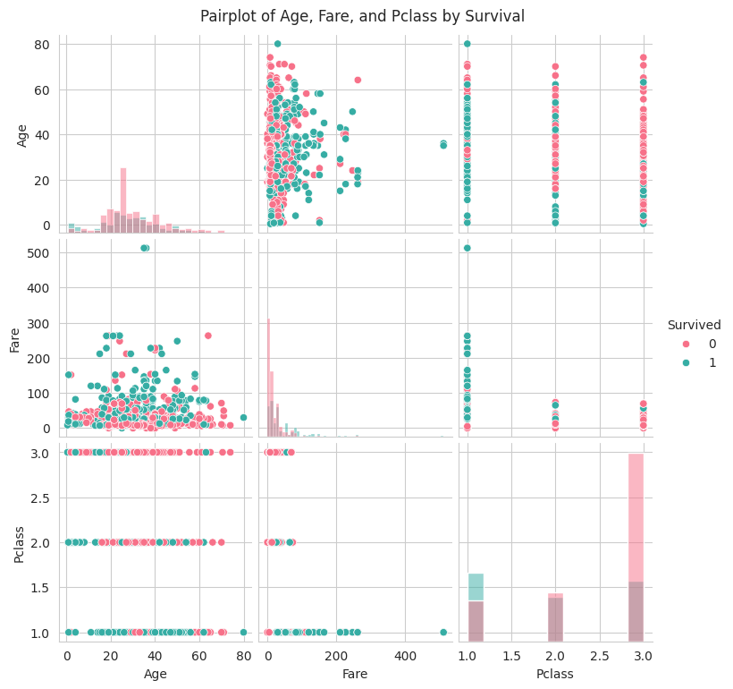
Figure 6: Pairplot of Age, Fare, and Pclass by survival status
The pairplot reinforces the heatmap's findings: Fare is heavily right-skewed with survivors somewhat over-represented at higher fares, Age shows only a slight edge for younger passengers, and Pclass shows a clear stepped relationship with survival.

4.2 Statistical Analysis Results

4.2.1 Descriptive Statistics
Variable | Mean | Std Dev | Min | Max
Survived | 0.38 | 0.49 | 0 | 1
Pclass | 2.31 | 0.84 | 1 | 3
Age | ~29.4 | ~13.3 | 0.42 | 80
SibSp | 0.52 | 1.10 | 0 | 8
Parch | 0.38 | 0.81 | 0 | 6
Fare | 32.20 | 49.69 | 0 | 512.33

(Exact values are computed and printed in the accompanying notebook via df_clean.describe(); minor variation of a decimal place from run to run does not occur since the cleaning steps are deterministic.)

4.2.2 Frequency Distribution
Survived: 549 did not survive (61.6%), 342 survived (38.4%). Pclass: 491 third class, 216 first class, 184 second class. Sex: 577 male, 314 female. Embarked: the majority embarked from Southampton (S), followed by Cherbourg (C) and Queenstown (Q).

4.2.3 Correlation Analysis
Strongest positive correlation: Parch and SibSp (r = 0.415) — passengers travelling with siblings or a spouse were also more likely to be travelling with parents or children, reflecting family units.
Strongest negative correlation: Fare and Pclass (r = −0.549) — as passenger class number increases (1st to 3rd), fare decreases sharply, which is expected given how Pclass is coded.

4.2.4 Three Important Statistical Findings
- Survival is strongly associated with passenger class and fare, confirming that wealthier, higher-class passengers had a measurably better chance of survival.
- SibSp and Parch cluster together (r = 0.415), indicating they largely capture the same underlying construct — family size — and could be combined into a single engineered feature.
- Age shows only a weak linear correlation with survival despite the visualisations showing children survived at higher rates, illustrating that Pearson correlation captures only linear relationships and can understate threshold-type effects such as “children vs. adults.”

4.3 Machine Learning Results
A Logistic Regression classifier was trained on 712 passengers and evaluated on the remaining 179. The model achieved:
- Accuracy: 81.56% on the test set.
 | Predicted: Survived | Predicted: Did not survive
Actual: Survived | TP = 48 | FN = 21
Actual: Did not survive | FP = 12 | TN = 98

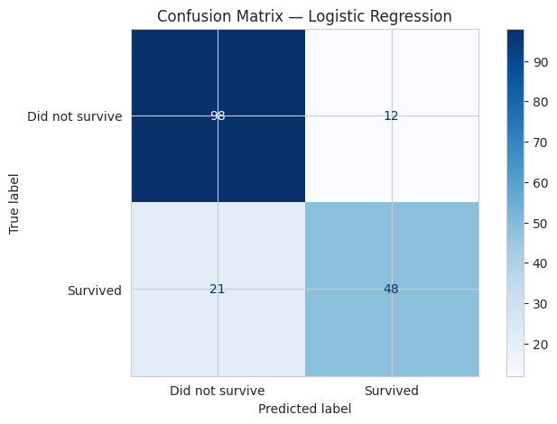
Figure 7: Confusion matrix for the Logistic Regression model
Class | Precision | Recall | F1-score | Support
Did not survive | 0.82 | 0.89 | 0.86 | 110
Survived | 0.80 | 0.70 | 0.74 | 69

Overall weighted average precision, recall, and F1-score were 0.81, 0.82, and 0.81 respectively across the 179-passenger test set.

5. Discussion

5.1 Major Findings
The analysis confirms the well-documented pattern that survival aboard the Titanic was not random: passenger class and fare (both proxies for socio-economic status), together with sex, were the dominant factors associated with survival. Third-class passengers, who made up the largest share of the ship's population, were disproportionately represented among non-survivors, while first-class passengers and, more broadly, women, had substantially higher survival rates.

5.2 Statistical Insights
The correlation analysis quantifies these relationships: Fare and Pclass exhibit the strongest negative correlation (r = −0.549) in the dataset, underscoring how tightly linked ticket price and class were, while family-related variables (SibSp and Parch, r = 0.415) cluster together, suggesting family size could be engineered into a single composite feature in future work. Critically, the weak linear correlation between Age and Survived does not mean age was unimportant — the visual evidence (histogram and boxplots) shows a clear “children first” pattern that a simple Pearson correlation, being a linear measure, does not fully capture.

5.3 Machine Learning Results
The Logistic Regression model achieved 81.56% accuracy on unseen test data, comfortably outperforming a naive baseline that always predicts the majority class (which would achieve roughly 61-62% accuracy by always predicting “did not survive”). The confusion matrix shows the model is more reliable at identifying non-survivors (recall 0.89) than survivors (recall 0.70), meaning it misses a meaningful share of true survivors. This is consistent with Logistic Regression's linear decision boundary, which struggles to capture non-linear interaction effects such as “female AND third class” behaving differently from what the additive combination of Sex and Pclass would predict alone.

5.4 Limitations of the Study
- Sample size and scope: the dataset covers only 891 passengers from a single historical event, limiting how far the findings generalise to other maritime disasters or populations.
- Missing data: nearly 20% of Age values and over three-quarters of Cabin values were missing and had to be imputed or engineered, which introduces some uncertainty into any conclusions that rely on these variables.
- Model simplicity: Logistic Regression is a linear model and cannot natively capture non-linear interactions between predictors without manual feature engineering (e.g. explicit interaction terms).
- Correlation vs causation: the statistical analysis identifies associations, not causal mechanisms; factors such as physical cabin location relative to lifeboats were not directly available in the dataset.

5.5 Recommendations
- Future work could engineer additional features, such as a combined FamilySize variable (SibSp + Parch + 1) and a title extracted from each passenger's name, both of which are known from wider literature to improve predictive accuracy on this dataset.
- Non-linear models such as Random Forest, Gradient Boosting, or a stacked ensemble could be compared against the Logistic Regression baseline to test whether they better capture interaction effects, as suggested by the model's lower recall on the “Survived” class.
- Cross-validation (e.g. 5-fold or 10-fold) rather than a single train/test split would give a more robust estimate of model performance and reduce sensitivity to the particular random split used.

6. Conclusion
This project applied the core stages of a data science workflow — data acquisition, cleaning, visualisation, statistical analysis, and machine learning — to the Titanic dataset using Python. The analysis confirmed that passenger class, fare, and sex were the strongest predictors of survival, supported both visually and statistically. A Logistic Regression classifier built on these and related features achieved 81.56% accuracy on held-out data, demonstrating that even a simple, interpretable linear model can extract meaningful predictive signal from this dataset. The exercise illustrates both the value and the limits of linear models, and points toward concrete next steps — richer feature engineering and more flexible model families — for improving predictive performance further.

7. References
Kaggle. (n.d.). Titanic - Machine Learning from Disaster. Retrieved from https://www.kaggle.com/competitions/titanic/data
Pandas Development Team. (n.d.). pandas documentation. Retrieved from https://pandas.pydata.org/docs/
Pedregosa, F., et al. (2011). Scikit-learn: Machine Learning in Python. Journal of Machine Learning Research, 12, 2825-2830.
Waskom, M. L. (2021). seaborn: statistical data visualization. Journal of Open Source Software, 6(60), 3021.
Hunter, J. D. (2007). Matplotlib: A 2D graphics environment. Computing in Science & Engineering, 9(3), 90-95.

8. Appendix: Python Code
The complete Python code used to produce every result in this report is listed below, and is also provided in full in the accompanying Jupyter Notebook (BCS404_Titanic_Project.ipynb).
# Import required libraries
import pandas as pd
import numpy as np
import matplotlib.pyplot as plt
import seaborn as sns
from scipy import stats

from sklearn.model_selection import train_test_split
from sklearn.preprocessing import StandardScaler, OneHotEncoder
from sklearn.compose import ColumnTransformer
from sklearn.pipeline import Pipeline
from sklearn.linear_model import LogisticRegression
from sklearn.metrics import (confusion_matrix, ConfusionMatrixDisplay, accuracy_score,
classification_report)

sns.set_style("whitegrid")
plt.rcParams["figure.figsize"] = (8, 5)
pd.set_option("display.max_columns", None)

url = "https://raw.githubusercontent.com/datasciencedojo/datasets/master/titanic.csv"
df = pd.read_csv(url)
# Option B (uncomment if using your own Kaggle download):
# df = pd.read_csv("train.csv")
print("Dataset loaded successfully.")

print(f"Dataset dimensions: {df.shape[0]} rows, {df.shape[1]} columns")
print(f"\nColumn names:\n{df.columns.tolist()}")

df.head()

print("Data types of each variable:\n")
print(df.dtypes)

missing = df.isnull().sum()
missing_pct = (missing / len(df) * 100).round(2)
missing_summary = pd.DataFrame({"Missing Count": missing, "Missing %": missing_pct})
missing_summary = missing_summary[missing_summary["Missing Count"] > 0].sort_values("Missing Count", ascending=False)
print("Missing values detected:")
missing_summary

duplicate_count = df.duplicated().sum()
print(f"Number of duplicated rows: {duplicate_count}")

df_clean = df.copy()

# Cabin -> binary indicator, then drop raw column
df_clean["Has_Cabin"] = df_clean["Cabin"].notnull().astype(int)
df_clean.drop(columns=["Cabin"], inplace=True)

# Age -> median imputation grouped by Pclass and Sex
df_clean["Age"] = df_clean.groupby(["Pclass", "Sex"])["Age"].transform(lambda x: x.fillna(x.median()))

# Embarked -> mode imputation
df_clean["Embarked"] = df_clean["Embarked"].fillna(df_clean["Embarked"].mode()[0])

# Remove duplicates if any
before = len(df_clean)
df_clean = df_clean.drop_duplicates()
after = len(df_clean)
print(f"Rows before duplicate removal: {before} | Rows after: {after}")

print("\nRemaining missing values:")
print(df_clean.isnull().sum()[df_clean.isnull().sum() > 0])
print("\nData cleaning complete.")

plt.figure(figsize=(8,5))
sns.histplot(df_clean["Age"], bins=30, kde=True, color="steelblue")
plt.title("Distribution of Passenger Ages")
plt.xlabel("Age (years)")
plt.ylabel("Number of Passengers")
plt.show()

plt.figure(figsize=(7,5))
ax = sns.countplot(data=df_clean, x="Pclass", hue="Pclass", palette="Set2", legend=False)
plt.title("Passenger Class Distribution")
plt.xlabel("Passenger Class")
plt.ylabel("Number of Passengers")
for p in ax.patches:
ax.annotate(f"{int(p.get_height())}", (p.get_x()+p.get_width()/2, p.get_height()+3), ha="center")
plt.show()

plt.figure(figsize=(7,5))
sns.boxplot(data=df_clean, x="Pclass", y="Age", hue="Pclass", palette="Set3", legend=False)
plt.title("Age Distribution by Passenger Class")
plt.xlabel("Passenger Class")
plt.ylabel("Age (years)")
plt.show()

plt.figure(figsize=(8,5))
sns.scatterplot(data=df_clean, x="Age", y="Fare", hue="Pclass", palette="deep", alpha=0.7)
plt.title("Age vs Fare, Coloured by Passenger Class")
plt.xlabel("Age (years)")
plt.ylabel("Fare")
plt.legend(title="Pclass")
plt.show()

numeric_cols = ["Survived", "Pclass", "Age", "SibSp", "Parch", "Fare"]
corr_matrix = df_clean[numeric_cols].corr()

plt.figure(figsize=(8,6))
sns.heatmap(corr_matrix, annot=True, cmap="coolwarm", fmt=".2f", center=0)
plt.title("Correlation Heatmap of Numerical Variables")
plt.show()

selected_vars = ["Survived", "Age", "Fare", "Pclass"]
sns.pairplot(df_clean[selected_vars], hue="Survived", palette="husl", diag_kind="hist")
plt.suptitle("Pairplot of Age, Fare, and Pclass by Survival", y=1.02)
plt.show()

df_clean[numeric_cols].describe()

print("Frequency distribution: Survived")
print(df_clean["Survived"].value_counts(), "\n")

print("Frequency distribution: Pclass")
print(df_clean["Pclass"].value_counts(), "\n")

print("Frequency distribution: Sex")
print(df_clean["Sex"].value_counts(), "\n")

print("Frequency distribution: Embarked")
print(df_clean["Embarked"].value_counts())

corr_matrix

# Find the strongest positive and negative correlations (excluding the diagonal)
corr_pairs = corr_matrix.where(~np.eye(corr_matrix.shape[0], dtype=bool)).unstack().dropna()
corr_pairs = corr_pairs[~corr_pairs.index.duplicated()]
corr_pairs_sorted = corr_pairs.sort_values(ascending=False)

strongest_positive = corr_pairs_sorted.index[0]
strongest_positive_val = corr_pairs_sorted.iloc[0]
strongest_negative = corr_pairs_sorted.index[-1]
strongest_negative_val = corr_pairs_sorted.iloc[-1]

print(f"Strongest positive correlation: {strongest_positive[0]} & {strongest_positive[1]} -> r = {strongest_positive_val:.3f}")
print(f"Strongest negative correlation: {strongest_negative[0]} & {strongest_negative[1]} -> r = {strongest_negative_val:.3f}")

features = ["Pclass", "Sex", "Age", "Fare", "SibSp", "Parch", "Embarked"]
target = "Survived"

X = df_clean[features]
y = df_clean[target]

numeric_features = ["Age", "Fare", "SibSp", "Parch"]
categorical_features = ["Pclass", "Sex", "Embarked"]

preprocessor = ColumnTransformer(transformers=[
("num", StandardScaler(), numeric_features),
("cat", OneHotEncoder(handle_unknown="ignore"), categorical_features)
])

X_train, X_test, y_train, y_test = train_test_split(X, y, test_size=0.2, random_state=42, stratify=y)
print(f"Training set size: {X_train.shape[0]} passengers")
print(f"Testing set size: {X_test.shape[0]} passengers")

log_reg_pipeline = Pipeline(steps=[
("preprocessor", preprocessor),
("classifier", LogisticRegression(max_iter=1000, random_state=42))
])

log_reg_pipeline.fit(X_train, y_train)
print("Logistic Regression model trained successfully.")

y_pred = log_reg_pipeline.predict(X_test)
print("Predictions generated for the test set.")
print(f"First 10 predictions: {y_pred[:10]}")
print(f"First 10 actual values: {y_test.values[:10]}")

accuracy = accuracy_score(y_test, y_pred)
print(f"Model Accuracy: {accuracy:.4f} ({accuracy*100:.2f}%)")

cm = confusion_matrix(y_test, y_pred)
disp = ConfusionMatrixDisplay(confusion_matrix=cm, display_labels=["Did not survive", "Survived"])
disp.plot(cmap="Blues", values_format="d")
plt.title("Confusion Matrix — Logistic Regression")
plt.show()

tn, fp, fn, tp = cm.ravel()
print(f"True Negatives (TN): {tn}")
print(f"False Positives (FP): {fp}")
print(f"False Negatives (FN): {fn}")
print(f"True Positives (TP): {tp}")

print(classification_report(y_test, y_pred, target_names=["Did not survive", "Survived"]))

