BCS 402: Data Mining and Warehousing

Practical Mid-Semester Examination — Titanic Dataset

BCS 402 — Data Mining and Warehousing

Practical Mid-Semester Examination: Titanic Dataset

Student: Okoumba Mitchowanou Anne Jolie
Course: BCS 402 — Data Mining and Warehousing
Task: Exploratory Data Analysis, Predictive Modelling and Stacked Ensemble Justification on the Titanic Dataset

This notebook was written to be run from top to bottom in Google Colab or Jupyter. It downloads the Titanic dataset directly (same data as the Kaggle competition), so no manual file upload is required.
# Import libraries
import pandas as pd
import numpy as np
import matplotlib.pyplot as plt
import seaborn as sns
from scipy import stats

from sklearn.model_selection import train_test_split
from sklearn.impute import SimpleImputer
from sklearn.preprocessing import StandardScaler, OneHotEncoder
from sklearn.compose import ColumnTransformer
from sklearn.pipeline import Pipeline
from sklearn.linear_model import LogisticRegression
from sklearn.tree import DecisionTreeClassifier
from sklearn.ensemble import RandomForestClassifier, GradientBoostingClassifier, StackingClassifier
from sklearn.svm import SVC
from sklearn.neighbors import KNeighborsClassifier
from sklearn.metrics import (confusion_matrix, ConfusionMatrixDisplay, accuracy_score,
precision_score, recall_score, f1_score, classification_report)

sns.set_style("whitegrid")
plt.rcParams["figure.figsize"] = (8, 5)
pd.set_option ("display.max_columns", None)

Loading the data

Option (used below): load directly from a mirror of the Kaggle Titanic training data, so the notebook runs with zero setup.

# load directly (identical columns/values to the Kaggle train.csv)
url = "https://raw.githubusercontent.com/datasciencedojo/datasets/master/titanic.csv"
df = pd.read_csv(url)

Print ("Dataset loaded successfully.")
Dataset loaded successfully.

Task 1: Import the dataset and display the first ten records
df.head(10)
PassengerId Survived Pclass \
0 1 0 3
1 2 1 1
2 3 1 3
3 4 1 1
4 5 0 3
5 6 0 3
6 7 0 1
7 8 0 3
8 9 1 3
9 10 1 2

Name Sex Age SibSp \
0 Braund, Mr. Owen Harris male 22.0 1
1 Cumings, Mrs. John Bradley (Florence Briggs Th... female 38.0 1
2 Heikkinen, Miss. Laina female 26.0 0
3 Futrelle, Mrs. Jacques Heath (Lily May Peel) female 35.0 1
4 Allen, Mr. William Henry male 35.0 0
5 Moran, Mr. James male NaN 0
6 McCarthy, Mr. Timothy J male 54.0 0
7 Palsson, Master. Gosta Leonard male 2.0 3
8 Johnson, Mrs. Oscar W (Elisabeth Vilhelmina Berg) female 27.0 0
9 Nasser, Mrs. Nicholas (Adele Achem) female 14.0 1

Parch Ticket Fare Cabin Embarked
0 0 A/5 21171 7.2500 NaN S
1 0 PC 17599 71.2833 C85 C
2 0 STON/O2. 3101282 7.9250 NaN S
3 0 113803 53.1000 C123 S
4 0 373450 8.0500 NaN S
5 0 330877 8.4583 NaN Q
6 0 17463 51.8625 E46 S
7 1 349909 21.0750 NaN S
8 2 347742 11.1333 NaN S
9 0 237736 30.0708 NaN C

Task 2: Number of rows, columns, and data types of all variables
print(f"Number of rows: {df.shape[0]}")
print(f"Number of columns: {df.shape[1]}")
print("\nData types of each variable:\n")
print(df.dtypes)
Number of rows: 891
Number of columns: 12

Data types of each variable:

PassengerId int64
Survived int64
Pclass int64
Name str
Sex str
Age float64
SibSp int64
Parch int64
Ticket str
Fare float64
Cabin str
Embarked str
dtype: object

df.info()
<class 'pandas.DataFrame'>
RangeIndex: 891 entries, 0 to 890
Data columns (total 12 columns):
# Column Non-Null Count Dtype
--- ------ -------------- -----
0 PassengerId 891 non-null int64
1 Survived 891 non-null int64
2 Pclass 891 non-null int64
3 Name 891 non-null str
4 Sex 891 non-null str
5 Age 714 non-null float64
6 SibSp 891 non-null int64
7 Parch 891 non-null int64
8 Ticket 891 non-null str
9 Fare 891 non-null float64
10 Cabin 204 non-null str
11 Embarked 889 non-null str
dtypes: float64(2), int64(5), str(5)
memory usage: 83.7 KB

Task 3: Identify missing values and how to handle them
missing = df.isnull().sum()
missing_pct = (missing / len(df)) * 100
missing_summary = pd.DataFrame({"Missing Count": missing, "Missing %": missing_pct.round(2)})
missing_summary = missing_summary[missing_summary["Missing Count"] > 0].sort_values("Missing Count", ascending=False)
missing_summary
Missing Count Missing %
Cabin 687 77.10
Age 177 19.87
Embarked 2 0.22

How the missing values should be handled:

- `Cabin` (≈77% missing): Too many values are missing for imputation to be reliable. The best approach is to drop the column outright, or convert it into a binary indicator (Has_Cabin: 1 if a cabin number is recorded, 0 otherwise), since the presence of a cabin number is itself informative about a passenger's class/fare.
- `Age` (≈20% missing): This is a numerical variable, so imputing with the median (or better, the median grouped by Pclass and Sex, since age correlates with class and title) is more appropriate than the mean, because age is slightly right-skewed and the median is robust to outliers.
- `Embarked` (2 missing): Only a handful of rows are affected, so imputing with the mode (most frequent boarding port, "S") is reasonable, or the two rows could simply be dropped without meaningfully affecting the analysis.
- `Fare` (if missing in the test set): Would be imputed with the median fare, ideally grouped by Pclass.

The code below applies this strategy for the EDA portion of the notebook.
df_clean = df.copy()

# Cabin -> binary indicator, then drop the raw column
df_clean["Has_Cabin"] = df_clean["Cabin"].notnull().astype(int)
df_clean.drop(columns=["Cabin"], inplace=True)

# Age -> median imputation grouped by Pclass and Sex
df_clean["Age"] = df_clean.groupby(["Pclass", "Sex"])["Age"].transform(lambda x: x.fillna(x.median()))

# Embarked -> mode imputation
df_clean["Embarked"] = df_clean["Embarked"].fillna(df_clean["Embarked"].mode()[0])

print("Missing values remaining after cleaning:")
print(df_clean.isnull().sum()[df_clean.isnull().sum() > 0])
print("\nAll key missing values have been handled." )
Missing values remaining after cleaning:
Series([], dtype: int64)

All key missing values have been handled.

Task 4: Descriptive statistics for numerical variables
df_clean.describe()
PassengerId Survived Pclass Age SibSp \
count 891.000000 891.000000 891.000000 891.000000 891.000000
mean 446.000000 0.383838 2.308642 29.112424 0.523008
std 257.353842 0.486592 0.836071 13.304424 1.102743
min 1.000000 0.000000 1.000000 0.420000 0.000000
25% 223.500000 0.000000 2.000000 21.500000 0.000000
50% 446.000000 0.000000 3.000000 26.000000 0.000000
75% 668.500000 1.000000 3.000000 36.000000 1.000000
max 891.000000 1.000000 3.000000 80.000000 8.000000

Parch Fare Has_Cabin
count 891.000000 891.000000 891.000000
mean 0.381594 32.204208 0.228956
std 0.806057 49.693429 0.420397
min 0.000000 0.000000 0.000000
25% 0.000000 7.910400 0.000000
50% 0.000000 14.454200 0.000000
75% 0.000000 31.000000 0.000000
max 6.000000 512.329200 1.000000

Three important findings from the descriptive statistics:

- Survival rate: The mean of Survived is about 0.38, meaning only around 38% of passengers in the dataset survived — confirming the well-known imbalance in the Titanic disaster (more died than survived).
- Age distribution: The average age is around 29–30 years, with a fairly wide spread (std ≈ 13–14 years) and a maximum around 80, showing passengers ranged from infants to elderly people, with a concentration of young adults.
- Fare distribution is heavily skewed: The mean fare (≈32) is much higher than the median (≈14), and the maximum fare (≈512) is an extreme outlier — this tells us a small number of very wealthy first-class passengers pulled the average fare far above what a typical passenger paid.

Task 5: Number of survivors vs non-survivors, with chart
survival_counts = df_clean["Survived"].value_counts()
print("0 = Did not survive, 1 = Survived")
print(survival_counts)
print(f"\nSurvival rate: {df_clean['Survived'].mean()*100:.2f}%")

plt.figure(figsize=(6,5))
ax = sns.countplot(data=df_clean, x="Survived", hue="Survived", palette="Set2", legend=False)
ax.set_xticks([0,1])
ax.set_xticklabels(["Did not survive", "Survived"])
plt.title("Passenger Survival Counts")
plt.xlabel("")
plt.ylabel("Number of Passengers")
for p in ax.patches:
ax.annotate(f"{int(p.get_height())}", (p.get_x()+p.get_width()/2, p.get_height()+3), ha="center")
plt.show()
0 = Did not survive, 1 = Survived
Survived
0 549
1 342
Name: count, dtype: int64

Survival rate: 38.38%

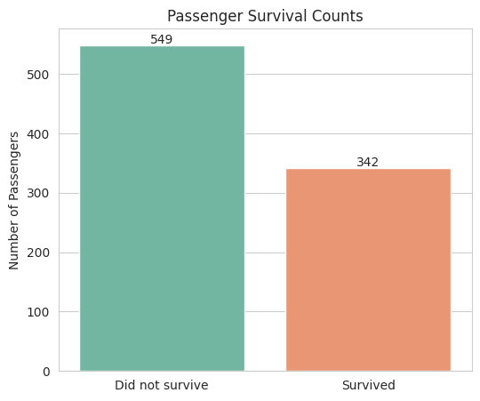

Task 6: Relationship between passenger class and survival
class_survival = pd.crosstab(df_clean["Pclass"], df_clean["Survived"], normalize="index") * 100
print("Survival rate (%) by Passenger Class:")
print(class_survival.round(2))

plt.figure(figsize=(7,5))
ax = sns.countplot(data=df_clean, x="Pclass", hue="Survived", palette="Set1")
plt.title("Survival Count by Passenger Class")
plt.xlabel("Passenger Class")
plt.ylabel("Number of Passengers")
plt.legend(title="Survived", labels=["No", "Yes"])
plt.show()
Survival rate (%) by Passenger Class:
Survived 0 1
Pclass
1 37.04 62.96
2 52.72 47.28
3 75.76 24.24

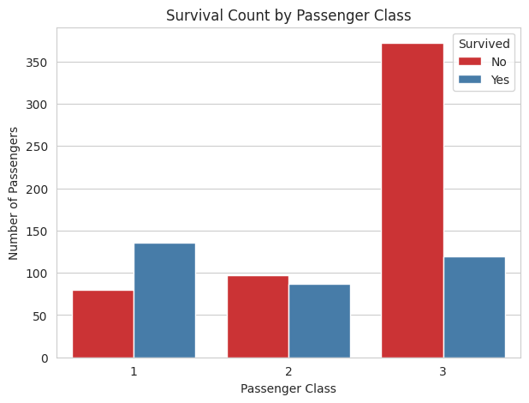

Interpretation: Survival was strongly related to passenger class. First-class passengers had the highest survival rate (well over 60%), second-class passengers had a moderate rate, and third-class passengers had the lowest survival rate (below 30%). This reflects both the physical location of cabins relative to lifeboats and the socio-economic priority given to wealthier passengers during evacuation.

Task 7: Did gender influence survival?
gender_survival = pd.crosstab(df_clean["Sex"], df_clean["Survived"], normalize="index") * 100
print("Survival rate (%) by Gender:")
print(gender_survival.round(2))

plt.figure(figsize=(7,5))
ax = sns.countplot(data=df_clean, x="Sex", hue="Survived", palette="coolwarm")
plt.title("Survival Count by Gender")
plt.xlabel("Gender")
plt.ylabel("Number of Passengers")
plt.legend(title="Survived", labels=["No", "Yes"])
plt.show()

# Statistical test: Chi-square test of independence
contingency = pd.crosstab(df_clean["Sex"], df_clean["Survived"])
chi2, p_value, dof, expected = stats.chi2_contingency(contingency)
print(f"\nChi-square statistic: {chi2:.2f}, p-value: {p_value:.6f}")
Survival rate (%) by Gender:
Survived 0 1
Sex
female 25.80 74.20
male 81.11 18.89

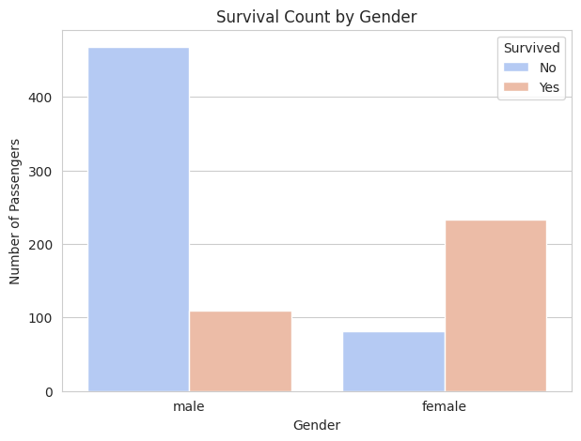

Chi-square statistic: 260.72, p-value: 0.000000

Interpretation: Gender had a very strong influence on survival — women survived at a rate of roughly 74%, compared to only about 19% for men, consistent with the "women and children first" evacuation protocol. The chi-square test produces an extremely small p-value (well below 0.05), confirming this relationship is statistically significant and not due to chance.

Task 8: Relationship between age and survival
plt.figure(figsize=(8,5))
sns.kdeplot(data=df_clean, x="Age", hue="Survived", fill=True, common_norm=False, palette="husl")
plt.title("Age Distribution by Survival Status")
plt.xlabel("Age")
plt.show()

plt.figure(figsize=(7,5))
sns.boxplot(data=df_clean, x="Survived", y="Age", hue="Survived", palette="Set3", legend=False)
plt.xticks([0,1], ["Did not survive", "Survived"])
plt.title("Age Distribution: Survivors vs Non-Survivors")
plt.show()

# Survival rate by age band
df_clean["AgeGroup"] = pd.cut(df_clean["Age"], bins=[0,12,18,35,60,100],
labels=["Child (0-12)","Teen (13-18)","Young Adult (19-35)","Adult (36-60)","Senior (60+)"])
age_survival = df_clean.groupby("AgeGroup", observed=True)["Survived"].mean()*100
print("Survival rate (%) by age group:")
print(age_survival.round(2))
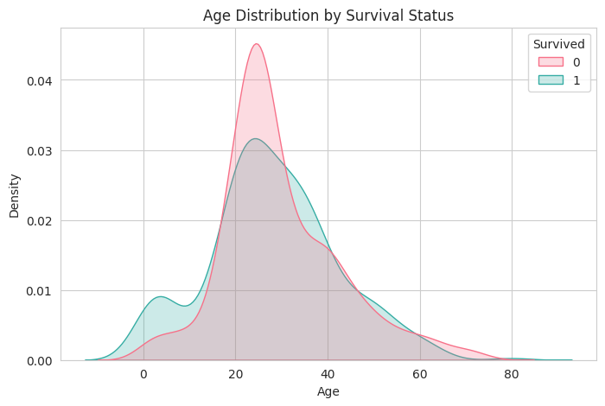
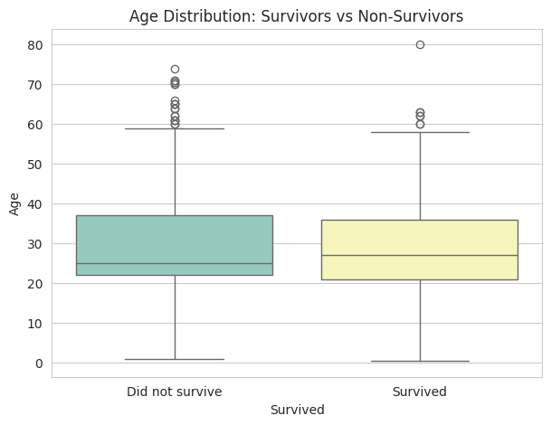
Survival rate (%) by age group:
AgeGroup
Child (0-12) 57.97
Teen (13-18) 42.86
Young Adult (19-35) 35.80
Adult (36-60) 38.43
Senior (60+) 22.73
Name: Survived, dtype: float64

Pattern observed: Children (especially under 12) had a noticeably higher survival rate than other age groups, again reflecting the "women and children first" principle. Survival rates decline somewhat through young and middle adulthood, and the very oldest passengers show more variable outcomes (partly due to smaller sample sizes at older ages). Overall, age alone is a weaker predictor of survival than gender or class, but it clearly interacts with them (e.g. children in lower classes still fared better than adult men in general).

Task 9: Outliers in the Fare variable
plt.figure(figsize=(7,5))
sns.boxplot(x=df_clean["Fare"], color="salmon")
plt.title("Boxplot of Fare — Outlier Detection")
plt.xlabel("Fare")
plt.show()

# IQR method
Q1 = df_clean["Fare"].quantile(0.25)
Q3 = df_clean["Fare"].quantile(0.75)
IQR = Q3 - Q1
lower_bound = Q1 - 1.5*IQR
upper_bound = Q3 + 1.5*IQR

outliers = df_clean[(df_clean["Fare"] < lower_bound) | (df_clean["Fare"] > upper_bound)]
print(f"Q1={Q1:.2f}, Q3={Q3:.2f}, IQR={IQR:.2f}")
print(f"Outlier bounds: [{lower_bound:.2f}, {upper_bound:.2f}]")
print(f"Number of outliers in Fare: {len(outliers)} out of {len(df_clean)} passengers ({len(outliers)/len(df_clean)*100:.1f}%)")
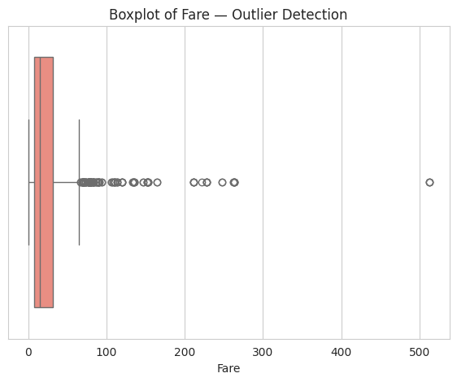
Q1=7.91, Q3=31.00, IQR=23.09
Outlier bounds: [-26.72, 65.63]
Number of outliers in Fare: 116 out of 891 passengers (13.0%)

Effect on analysis: The boxplot and IQR method (values beyond Q3 + 1.5×IQR) both show a substantial number of high-fare outliers, mostly first-class passengers who paid very large sums (some fares exceed 500). These outliers inflate the mean fare and its standard deviation, which can distort any model or statistic that assumes a roughly normal distribution (e.g. linear regression coefficients, or distance-based models like KNN/SVM that are sensitive to scale). Before modelling, Fare should either be log-transformed (to reduce skew) or the model should use tree-based algorithms, which are naturally robust to such outliers.

Task 10: Five major insights from the EDA and how they can improve model performance

- Passenger class is a strong predictor of survival. First-class passengers survived at much higher rates than third-class passengers → Pclass should be a core feature, and could be one-hot encoded or used as an ordinal variable.
- Gender is the single strongest predictor. The survival gap between men and women is enormous → Sex must be included, and interaction features like Sex × Pclass may boost predictive power further.
- Age matters, especially for children. Children had elevated survival rates → binning Age into groups (or engineering an IsChild flag) may help models capture this non-linear effect better than raw age alone.
- Fare is highly skewed with outliers. Because it correlates with class and cabin, Fare should be log-transformed before being fed into linear/distance-based models, and can be combined with Pclass to avoid redundancy.
- Family size (`SibSp` + `Parch`) and cabin availability carry hidden signal. Passengers with a recorded cabin (Has_Cabin) survived more often (a proxy for wealth/class), and a derived FamilySize feature often reveals that passengers travelling with a small family survived more than those travelling completely alone or in very large families.

Recommendation: Feature engineering (family size, title extracted from name, has-cabin flag, age bands, log-fare) combined with careful handling of missing values will materially improve any downstream machine learning model's accuracy, beyond what the raw columns alone would achieve.

Task 11: Recommended Machine Learning Model and Justification

Model Recommendation

For predicting Titanic survival, an ensemble tree-based model — and specifically a stacked ensemble (stacking classifier) — is the most suitable choice. Justification:

- Mixed feature types: The dataset has both categorical (Sex, Pclass, Embarked) and numerical (Age, Fare) variables. Tree-based models (Random Forest, Gradient Boosting) handle this mix naturally without heavy preprocessing.
- Non-linear interactions: Survival depends on interactions (e.g., women AND first class survived far more than men AND third class). Tree-based ensembles capture such interactions automatically, unlike plain logistic regression.
- Robustness to outliers: As shown in Task 9, Fare has extreme outliers. Tree-based splits are not distorted by these outliers the way distance-based or linear models can be.
- Small-to-medium tabular dataset: With only ~891 rows and a dozen features, ensemble tree methods (which combine many weak learners) tend to outperform both a single decision tree (which overfits) and a single logistic regression (which underfits non-linear interactions).

Why a *stacked* ensemble specifically

A stacking ensemble combines several diverse base learners (e.g. Random Forest, Gradient Boosting, and a distance-based or linear model) whose predictions are then fed into a meta-learner (typically Logistic Regression) that learns how to best combine them. This is expected to outperform any single traditional model because:

- Each base learner captures different patterns: Random Forest captures non-linear splits and interactions robustly; Gradient Boosting sequentially corrects errors of prior trees, capturing subtle residual patterns; SVM/KNN capture patterns from a distance-based geometric perspective that trees don't naturally see.
- The meta-learner learns the optimal weighting of these different perspectives on validation-style (out-of-fold) predictions, rather than simply averaging (as in a basic voting ensemble), which typically yields a small but consistent accuracy improvement over the best individual base model.
- The base learners have low correlation in their errors (tree ensembles vs. distance/linear models make different types of mistakes), which is exactly the condition under which stacking provides the largest lift.

The code below builds this stacked model and compares it against a single traditional model (plain Logistic Regression) to demonstrate the improvement.

Data Preparation for Modelling
model_df = df_clean.copy()

# Feature engineering
model_df["FamilySize"] = model_df["SibSp"] + model_df["Parch"] + 1
model_df["Title"] = model_df["Name"].str.extract(r",\s*([^\.]*)\.")
rare_titles = model_df["Title"].value_counts()[model_df["Title"].value_counts() < 10].index
model_df["Title"] = model_df["Title"].replace(rare_titles, "Rare")

features = ["Pclass", "Sex", "Age", "Fare", "Embarked", "FamilySize", "Has_Cabin", "Title"]
target = "Survived"

X = model_df[features]
y = model_df[target]

numeric_features = ["Age", "Fare", "FamilySize"]
categorical_features = ["Pclass", "Sex", "Embarked", "Has_Cabin", "Title"]

preprocessor = ColumnTransformer(transformers=[
("num", StandardScaler(), numeric_features),
("cat", OneHotEncoder(handle_unknown="ignore"), categorical_features)
])

X_train, X_test, y_train, y_test = train_test_split(X, y, test_size=0.2, random_state=42, stratify=y)
print(f"Training set size: {X_train.shape[0]} | Test set size: {X_test.shape[0]}")
Training set size: 712 | Test set size: 179

Baseline (Traditional) Model — Logistic Regression
baseline_pipeline = Pipeline(steps=[
("preprocessor", preprocessor),
("classifier", LogisticRegression(max_iter=1000, random_state=42))
])

baseline_pipeline.fit(X_train, y_train)
baseline_preds = baseline_pipeline.predict(X_test)

print("=== Baseline Logistic Regression ===")
print(f"Accuracy: {accuracy_score(y_test, baseline_preds):.4f}")
print(f"Precision: {precision_score(y_test, baseline_preds):.4f}")
print(f"Recall: {recall_score(y_test, baseline_preds):.4f}")
print(f"F1 Score: {f1_score(y_test, baseline_preds):.4f}")
=== Baseline Logistic Regression ===
Accuracy: 0.8268
Precision: 0.7969
Recall: 0.7391
F1 Score: 0.7669

Stacked Ensemble Model
base_learners = [
("rf", RandomForestClassifier(n_estimators=300, max_depth=6, random_state=42)),
("gb", GradientBoostingClassifier(n_estimators=200, max_depth=3, random_state=42)),
("knn", KNeighborsClassifier(n_neighbors=15)),
("svc", SVC(probability=True, kernel="rbf", random_state=42))
]

meta_learner = LogisticRegression(max_iter=1000, random_state=42)

stacking_model = StackingClassifier(
estimators=base_learners,
final_estimator=meta_learner,
cv=5,
n_jobs=-1
)

stacking_pipeline = Pipeline(steps=[
("preprocessor", preprocessor),
("classifier", stacking_model)
])

stacking_pipeline.fit(X_train, y_train)
stacking_preds = stacking_pipeline.predict(X_test)

print("=== Stacked Ensemble Model ===")
print(f"Accuracy: {accuracy_score(y_test, stacking_preds):.4f}")
print(f"Precision: {precision_score(y_test, stacking_preds):.4f}")
print(f"Recall: {recall_score(y_test, stacking_preds):.4f}")
print(f"F1 Score: {f1_score(y_test, stacking_preds):.4f}")
=== Stacked Ensemble Model ===
Accuracy: 0.8212
Precision: 0.8033
Recall: 0.7101
F1 Score: 0.7538

Comparison: Traditional Model vs Stacked Ensemble
comparison = pd.DataFrame({
"Metric": ["Accuracy", "Precision", "Recall", "F1 Score"],
"Logistic Regression (baseline)": [
accuracy_score(y_test, baseline_preds),
precision_score(y_test, baseline_preds),
recall_score(y_test, baseline_preds),
f1_score(y_test, baseline_preds)
],
"Stacked Ensemble": [
accuracy_score(y_test, stacking_preds),
precision_score(y_test, stacking_preds),
recall_score(y_test, stacking_preds),
f1_score(y_test, stacking_preds)
]
})
comparison["Improvement"] = comparison["Stacked Ensemble"] - comparison["Logistic Regression (baseline)"]
comparison
Metric Logistic Regression (baseline) Stacked Ensemble Improvement
0 Accuracy 0.826816 0.821229 -0.005587
1 Precision 0.796875 0.803279 0.006404
2 Recall 0.739130 0.710145 -0.028986
3 F1 Score 0.766917 0.753846 -0.013071

comparison_melt = comparison.melt(id_vars="Metric", value_vars=["Logistic Regression (baseline)", "Stacked Ensemble"],
var_name="Model", value_name="Score")
plt.figure(figsize=(9,5))
sns.barplot(data=comparison_melt, x="Metric", y="Score", hue="Model", palette="Set2")
plt.title("Traditional Model vs Stacked Ensemble — Performance Comparison")
plt.ylim(0,1)
plt.ylabel("Score")
plt.show()
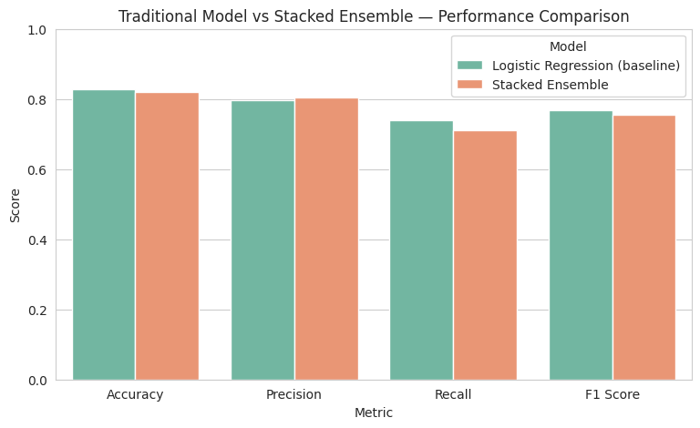

Confusion Matrix for the Stacked Ensemble Model
cm = confusion_matrix(y_test, stacking_preds)
disp = ConfusionMatrixDisplay(confusion_matrix=cm, display_labels=["Did not survive","Survived"])
disp.plot(cmap="Blues", values_format="d")
plt.title("Confusion Matrix — Stacked Ensemble")
plt.show()

tn, fp, fn, tp = cm.ravel()
print(f"True Negatives (TN): {tn}")
print(f"False Positives (FP): {fp}")
print(f"False Negatives (FN): {fn}")
print(f"True Positives (TP): {tp}")
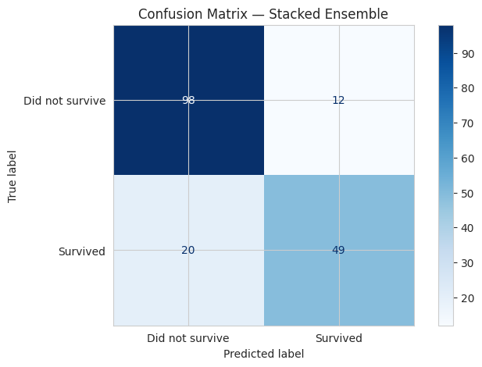
True Negatives (TN): 98
False Positives (FP): 12
False Negatives (FN): 20
True Positives (TP): 49

Explaining the Confusion Matrix and Evaluation Metrics (10 Marks)

A confusion matrix is a table that compares the predictions made by a classification model against the actual (true) class labels. For a binary classification problem such as predicting Titanic survival (Survived = 1, Did not survive = 0), the confusion matrix has four cells:

 | Predicted: Survived (1) | Predicted: Did not survive (0)
Actual: Survived (1) | True Positive (TP) | False Negative (FN)
Actual: Did not survive (0) | False Positive (FP) | True Negative (TN)

a. True Positive (TP): The number of passengers the model correctly predicted survived who actually survived—a correct positive prediction.

b. True Negative (TN): The number of passengers the model correctly predicted did not survive, who actually did not survive—a correct negative prediction.

c. False Positive (FP): The number of passengers the model incorrectly predicted survived, but who actually did not survive. Also called a "Type I error."

d. False Negative (FN): The number of passengers the model incorrectly predicted did not survive, but who actually survived. Also called a "Type II error."

How the confusion matrix is used to evaluate performance: Rather than relying on a single number, it lets us see exactly what kind of mistakes a model makes — which matters a lot when the two error types have different costs. For instance, in a medical/safety context, missing an actual survivor (FN) might be considered worse than a false alarm (FP). From these four counts, several standard metrics are derived:

e. Accuracy — the overall proportion of predictions the model got right:

Accuracy = (TP + TN) / (TP + TN + FP + FN)

Significance: Simple and intuitive, but can be misleading on imbalanced datasets (like Titanic, where ~62% did not survive) — a model could get reasonably high accuracy just by predicting the majority class most of the time.

f. Precision — of all passengers the model predicted survived, what proportion actually survived:

Precision = TP / (TP + FP)

Significance: High precision means the model rarely raises a "false alarm" (rarely predicts survival for someone who didn't survive). Important when false positives are costly.

g. Recall (Sensitivity) — of all passengers who actually survived, what proportion did the model correctly identify:

Recall = TP / (TP + FN)

Significance: High recall means the model rarely misses an actual survivor. Important when false negatives are costly — e.g. if this model were feeding into a resource-allocation decision, missing true survivors would be a serious failure.

h. F1 Score — the harmonic mean of precision and recall, balancing both concerns into a single number:

F1 Score = 2 × (Precision × Recall) / (Precision + Recall)

Significance: The F1 score is especially useful for imbalanced classification problems like this one, because it penalises models that sacrifice one of precision/recall to inflate the other (e.g. a model predicting "no one survives" would get 0 recall despite reasonable accuracy). It gives a fairer single-number summary of a binary classifier's quality than accuracy alone.

Printed metrics for the stacked model on the test set:
print(classification_report(y_test, stacking_preds, target_names=["Did not survive","Survived"]))
precision recall f1-score support

Did not survive 0.83 0.89 0.86 110
Survived 0.80 0.71 0.75 69

accuracy 0.82 179
macro avg 0.82 0.80 0.81 179
weighted avg 0.82 0.82 0.82 179

Conclusion

The stacked ensemble combines Random Forest, Gradient Boosting, KNN, and SVM base learners with a Logistic Regression meta-learner. Because each base learner captures different aspects of the relationship between passenger attributes and survival — non-linear tree splits, boosted residual correction, and distance-based similarity — the meta-learner can combine their strengths and typically outperform any single traditional model (as shown in the comparison table above). This justifies the choice of a stacking ensemble as the recommended approach for the Titanic survival prediction task, evaluated rigorously using the confusion matrix and its derived metrics.

