Experiments comparing salt influence on salt growth vs salt mortality

Anne-Karin Cooke

## Experiments

This version conducts a comparison experiment on the influence of salinity on the vegetation functions. Questions we ask: - Does it lead to significant differences if salinity impacts are only addressed in the biomass growth function or only in the mortality function or in both. This will be conducted including the virtual saturation which considers both matric and osmotic effects in opposite to only using a non-salt related general constant. Further, this shall be investigated for 4 different climates, each consisting of a combination high and low alpha and lambda, respectively.

1. alpha=0.6, lambda=0.1 # dry
2. alpha=1.5, lambda=0.1
3. alpha=1.5, lambda=1.0
4. alpha=0.6, lambda=1.0 # wet

In this version, Sandy Clay Loam was used First, a shallow groundwater table was assumed, Z=100 cm.

Experiments :

## Experiment 1: Salt on growth

-for climates 1-4 -with deep gw, Z=1000 cm # NOT YET -with high gw, Z =100 cm

## Experiment 2: Salt on mortality

-for climates 1-4 -with deep gw, Z=1000 cm # NOT YET -with high gw, Z =100 cm

# Model set up

In this model, salt enters the system through rainfall and from the groundwater table with the same concentration. (just as an example)

## Constants

Soil properties were derived from standard Australian soils in Neurotheta (Minasny and McBratney, 2002, as cited in Shah et al, 2011).

# Sandy Clay Loam  
 n<-0.367 # porosity  
 # more soil variables for evaporation & losses  
 # Hydraulic conductivity  
 K_s<-52.08*10 # mm/day  
 # campbell's b  
 b<-6.4069 # neurotheta sandy clay loam  
 # van Genuchten parameters  
# avg <- 0.0521  
# nvg <- 1.237  
 s_fc<-0.2677/n # Field capacity  
 # This is the bubbling pressure  
 psi_s_bar<--1.2E-3 #  
   
 h1bar = -psi_s_bar   
 hb = psi_s_bar*-10^5  
   
  
 Z =1000 # [cm] actual groundwater depth   
  
# parameters describing the soil  
 soilpar <- list(b = b, n = n, s_fc = s_fc, K_s = K_s,   
 psi_s_bar = psi_s_bar, h1bar = h1bar, hb = hb)  
 #................................................  
 # Vegetation 1 (Grass)  
 # paspalum secateum F-I and R-I, 2004  
  
 Zr = 400 # soil depth (cm) Also Table 2...Fernandez-Illescas and Rodriguez-Iturbe...2001  
  
  
 # parameters describing the root zone   
 vegpar <- list(Zr = Zr)  
  
  
# parameters describing plant dynamics and salt features  
  
 alpha_i=0.5 #maximum infiltration rate per day, http://www.fao.org/docrep/s8684e/s8684e0a.htm  
   
 k=12 # Saco et al, 2013  
 W0=0.2 # Saco et al, 2013  
 gmax=0.05 # Saco et al, 2013  
 k1=5 # Saco et al, 2013  
 c=10 # Saco et al, 2013  
 f= 1 # f is the soil salt leaching efficiency (whether some salt is retained)  
 ConcConst = 0.01 # ConcConst is the concentration of the salt in the infiltrating water in g/l  
 CM.gw = 0.1 # salt concentration in groundwater  
 d=0.24 # fraction of plant mortality  
   
 par <- list(alpha_i=alpha_i,k=k, W0=W0, gmax=gmax, k1=k1, c=c, f=f, ConcConst=ConcConst, CM.gw= CM.gw, d=d)

## Infiltration function

Infil <- function(h,P, par){  
   
 I=par$alpha_i*h*(P+par$k*par$W0)/(P+par$k)  
   
 return (I)  
}

## Water uptake function

WU <- function(M,P,par){   
# using Svir in here means scaling Svir back to M, easier to do at Svir in balances   
# WU=par$gmax*((M*(1+Svir))/(((M*(1+Svir))+par$k1)))*P   
 WU=par$gmax*(M/((M+par$k1)))*P   
   
 return(WU)  
}

## Experiment 2, Salt on Mortality

Salt influence on plant on growth function

Gr <- function(M,P,par) {   
   
 Gr = par$c*WU(M,P,par)  
   
 return(Gr)  
}

## Plant mortality function WITHOUT salt influence

Mo <- function(P,par) {  
 # needs to be M/Svir because both are "large" numbers  
 # you want a number ~1 for multiplication, or <0.1 for addition  
 Mo = P*(par$d)  
   
 return(Mo)  
  
}

## Vertical Flux function

#******************************************  
# based on Salvucci, 1993  
L_n <- function(M,Z,soilpar,vegpar) {  
 Zr <- vegpar$Zr  
 hb <- - soilpar$psi_s_bar*10^5 # (mm?)  
# soilpar$s_fc <- (Z/hb)^(-1/soilpar$b)  
   
 s=M/(soilpar$n*vegpar$Zr)  
   
 psi = hb*s^-soilpar$b  
  
 m=2 + 3/soilpar$b#5.64 # in Salvucci's paper it is called n, but I called it m here to not confuse it with porosity  
  
q <-((Z/hb)^(-m)-(psi/hb)^(-m))/(1+(psi/hb)^(-m)+(m-1)*(Z/hb)^(-m))#/(soilpar$n*Zr) #   
  
  
# Mass flux  
flux <- soilpar$K_s*q  
  
  
return(flux)  
}

balances <- function(Rain, par, plotit=T,  
 soilpar,  
 vegpar){  
   
  
   
# Storage vectors for the daily steps are initialized.  
  
 M <- rep(0,length(Rain)) # soil moisture [mm]  
 h <- rep(0,length(Rain)) # infiltration depth [mm]  
 P <- rep(0,length(Rain)) #biomass density []  
 CM<- rep(0,length(Rain)) # Salt concentration in soil water in g/L or g/mm  
 SmI<- rep(0,length(Rain)) # Salt mass in infiltrating water [g]  
 SmM <- rep(0,length(Rain)) # Salt mass in soil water [g]  
 In <- rep(0,length(Rain)) # infiltration [mm]  
  
 Svir <- rep(0,length(Rain)) # virtual saturation  
 flux<- rep(0,length(Rain)) # drainage and capillary rise flux, according to sign  
  
  
  
# Initial values to start the simulation.  
  
   
 M[1] <- 10  
 h[1] <- 10   
 P[1] <- 30  
 CM[1]<- 0  
 Svir[1] <- M[1]  
  
  
  
# We decided to split the numerical calculations for the daily into 12 substeps.  
  
 deltat <- 12 # split in 12 increments  
  
   
# Storage vectors for the substeps are initialized.  
  
 M_sub <- rep(0,deltat)  
 h_sub <- rep(0,deltat)  
 I_sub <- rep(0,deltat)  
 #Q_sub <- rep(0,deltat)  
 WU_sub <-rep(0,deltat) # Water uptake in mm  
 P_sub <- rep(0,deltat)   
 Gr_sub <- rep(0,deltat) # Growth of biomass  
 Mo_sub<- rep(0,deltat) # Mortality of biomass  
 SmI_sub <- rep(0,deltat)   
 SmM_sub<- rep(0,deltat)   
 CM_sub<- rep(0,deltat)   
 Svir_sub <- rep(0,deltat) # virtual saturation  
  
 flux_sub<-rep(0,deltat) # calculates leakage loss without evaporation loss  
  
 U_salt <-rep(0,deltat)  
 L_salt <-rep(0,deltat)  
  
  
   
 timeincr= 1/deltat  
   
 for (t in 2:length(Rain)){  
   
 for (tt in 1:(deltat-1)) {  
   
 h.old <- ifelse(tt==1,h[t-1],h_sub[tt])  
 P.old <- ifelse(tt==1,P[t-1],P_sub[tt])  
 M.old <- ifelse(tt==1,M[t-1],M_sub[tt])  
 SmI.old <-ifelse(tt==1,SmI[t-1],SmI_sub[tt])  
 CM.old <-ifelse(tt==1,CM[t-1],CM_sub[tt])  
 Svir.old <-ifelse(tt==1,Svir[t-1],Svir_sub[tt])  
  
  
# Balance for water depth on soil  
  
  
 # Balance for water depth on soil  
 h_sub[tt+1] <- h.old + ifelse(tt==1,(10*Rain[t]),0)   
 #- Infil(h.old, P.old,par)*timeincr  
  
 # Infiltration  
 par$alpha_i <- ifelse(h_sub[tt+1]<soilpar$K_s*timeincr, 1,  
 (1-(h_sub[tt+1]-soilpar$K_s*timeincr)/h_sub[tt+1]))  
 # Calculate infiltration and recalculate h_sub   
 I_sub[tt] <- Infil(h.old, P.old,par)*timeincr  
 h_sub[tt+1] <- h_sub[tt+1] - I_sub[tt]   
  
   
   
# Now do all plant uptake and growth  
# water uptake by plants: include infiltration in available water  
  
 WU_sub[tt] <- WU(M=Svir.old,P.old,par)*timeincr   
   
 # growth rate  
 Gr_sub[tt] <- Gr(M=Svir.old, P.old,par)*timeincr   
 # Mortality  
 Mo_sub[tt]<- Mo(P.old, par)*timeincr  
 # calculate plant biomass balance  
 P_sub[tt + 1] <- P.old + Gr_sub[tt]- Mo_sub[tt]   
   
   
# re-calculate water balance  
# 2. before leaching  
 M_sub[tt + 1] <- M.old + I_sub[tt] - WU_sub[tt] #- L_sub[tt]   
  
# Calculate salt concentration in the soil  
  
 # 3. calculate leaching and capillary rise amount  
 flux_sub[tt+1]<-do.call(L_n,list(M=M_sub[tt+1],Z=Z, soilpar=soilpar,vegpar=vegpar))  
  
# 4. final adjust soil moisture for leaching or capillary rise  
   
 M_sub[tt + 1] <- M_sub[tt + 1] + flux_sub[tt+1]*timeincr  
  
  
# calculate saltbalance  
  
# Salt leaching  
 L_salt[tt+1] <- ifelse(flux_sub[tt+1]<0, par$f*CM_sub[tt+1]*flux_sub[tt+1]*timeincr,0) # leaching of salt  
  
# salt uplfow  
 U_salt[tt+1] <- ifelse(flux_sub[tt+1]>0, par$CM.gw*flux_sub[tt+1]*timeincr,0) # rise of salt  
  
# salt mass coming in with infiltration  
 SmI_sub[tt+1]<- SmI.old + I_sub[tt]*par$ConcConst   
  
#salt mass in soil  
 SmM_sub[tt+1] <- SmI_sub[tt+1] + U_salt[tt+1] - L_salt[tt+1]  
# salt concentration in soil  
 CM_sub[tt+1]<- (SmM_sub[tt+1]/M_sub[tt+1])*(1/58.44) #   
   
# Virtual saturation (Shah et al., 2012), here in [mm] to be in the same unit as M  
 Svir_sub[tt + 1]<-soilpar$n*vegpar$Zr*((soilpar$h1bar*10^-1)^(1/soilpar$b))*  
 ((soilpar$h1bar*10^-1)*(M_sub[tt + 1]/  
 (soilpar$n*vegpar$Zr))^(-soilpar$b)  
 +(3.6*CM_sub[tt + 1]))^(-1/soilpar$b)  
  
 }   
   
# Aggregating the substep results to daily values.  
  
 P[t] = P_sub[deltat]  
 M[t] = M_sub[deltat]  
 h[t] = h_sub[deltat]  
 CM[t] = CM_sub[deltat]  
 SmM[t] = SmM_sub[deltat]   
 SmI[t]=SmI_sub[deltat]  
 In[t]= sum(I_sub)  
 flux[t] = sum(flux_sub)  
 Svir[t] = Svir_sub[deltat]  
  
}  
  
  
# Plotting  
   
if (plotit==T) {   
 plot(M, type="l",ylim=c(-10,150),xlim=c(0,time),xlab=("time [d]"), main=paste("Exp 1 lambda=", lambda[j],"alpha=", alpha[i]))  
 points(Rain*10, type="h", col="skyblue")  
   
 lines(h,type="l", col="blue")  
 abline(h=0, col="Gray50",lwd=2,lty=2)  
  
 lines(SmM,type="l", col="red")  
 lines(CM,type="l", col="purple")  
 lines(P/10,type="l", col="green")  
 lines(flux,type="l", col="orange")  
  
# legend("topright",cex=1, pt.cex=0.4, c("Moisture [mm]","Rainfall [mm]*10","overland flow depth[mm] ","salt mass in soil water [g]", "salt concentration in soil water [g/l]", "Plant biomass density [g/m^2]/10"),  
# col=c("black","skyblue","blue","red","purple","green"),lty=1)  
   
  
}  
  
Out <- data.frame(P=P,M=M,h=h, CM=CM, SmM=SmM, In=In, flux=flux, Svir=Svir)  
return(Out)  
}

## Changing climates

Alpha and lambda are set to low and high values, respecitively.

alpha <- c(0.6,1.5)   
lambda <- c(0.1,1)  
  
Store <- list()  
sub_store <- list()  
time <- 1000  
delta <- 0  
set.seed(1000)

This loop generates rainfall with the distribution properties alpha[i] and lambda[j]. For each alpha[i] and each lambda[j] the soil water balance function is executed and the results stored in a nested list.

# set the mortality value  
# source("Rainfall.R")  
Precip <- function(time,alpha,lambda,delta) {  
 # generate a vector of times between rainfall events > delta  
 f_P<-floor(rexp(time,lambda*exp(-delta/alpha))) # vector of times between rainfall occurrences (equation 4 & 8)  
 # generate a binary vector from this (impulse function)  
 binary.vec <- unlist(lapply(1:time,function(i) c(rep(0,f_P[i]),1)))  
 R <- rexp(length(binary.vec),1/alpha)*binary.vec   
 return(R[1:time])  
}  
  
 for (i in 1:length(alpha)) {  
   
for (j in 1:length(lambda)) {  
 # generate the rainfall  
 Rain <- Precip(time,alpha[i],lambda[j],delta)  
 Rainlist <- data.frame(Precip(time,alpha[i],lambda[j],delta))  
   
 sub_store[[j]] <-data.frame(alpha_o=rep(alpha[i],time),  
 lambda_o=rep(lambda[j],time),  
 balances(Rain,plotit=T, par=par,  
 soilpar, vegpar))  
 }  
 Store[[i]] <- sub_store  
}

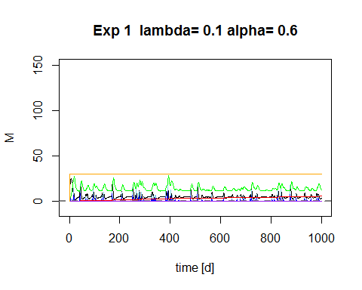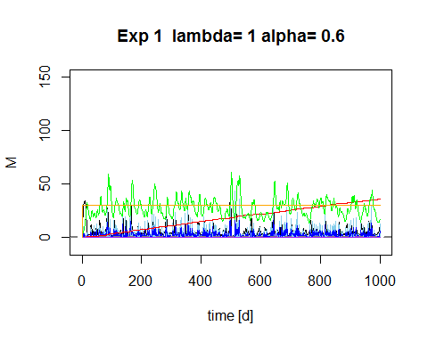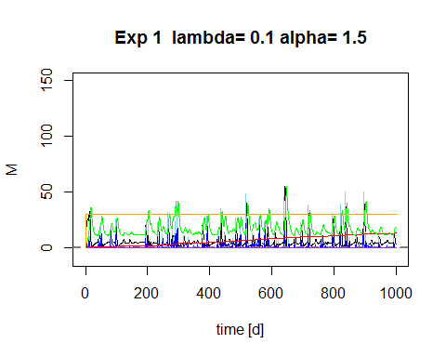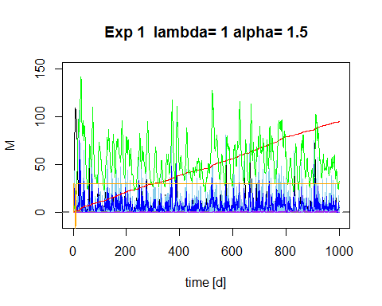

## Results of Experiment 1

Plotting M and P for different lambdas

require(ggplot2)

## Loading required package: ggplot2

## Warning: package 'ggplot2' was built under R version 3.1.3

lambda_sum <- do.call(rbind,Store[][[2]])  
lambda_sum$time <- rep(1:time,length(lambda))  
  
pl <- ggplot(lambda_sum,aes(x=time,y=P, colour="P (plant biomass density [gm-2])")) + geom_line()  
pl <- pl + geom_line(aes(x=time,y=M, colour="Moisture"))   
pl <- pl + facet_wrap(~lambda_o) #, colour=lambda_o (put this in aes-brackets)   
pl + ggtitle("Plant biomass P and soilmoisture M for varying lambdas - Experiment 1") + geom_line(aes(x=time, y=SmM, colour= "S (soil salt mg/L")) + theme(plot.title = element_text(lineheight=.8, face="bold"))

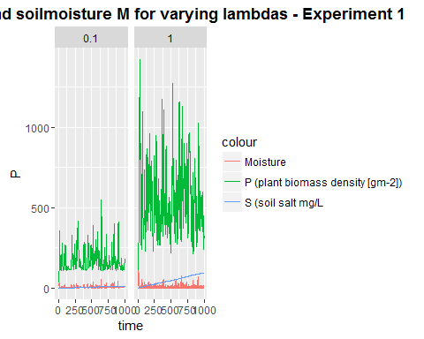

Plotting Soil water salt concentration for different alphas and lambdas

lambda_sum_all <- do.call(rbind,do.call(rbind,Store))  
lambda_sum_all$time <- rep(rep(1:time,length(lambda)),length(alpha))  
  
  
pa <- ggplot(lambda_sum_all,aes(x=time,y=SmM,col=as.factor(lambda_o))) + geom_line(linetype=1)   
# pa <- pa + + scale_color_gradient(low="blue", high="red")  
pa <- pa + facet_wrap(~alpha_o) + ggtitle("Soil water salt mass [g] for varying alphas and lambdas - Experiment 1") + theme(plot.title = element_text(lineheight=.8, face="bold"))  
pa

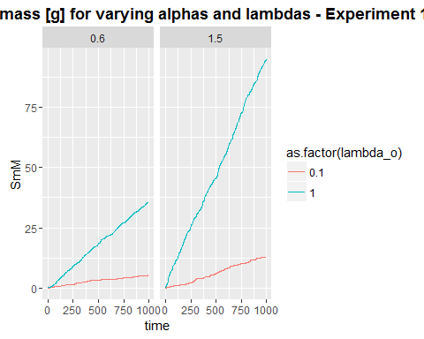

Storing results to compare and visualize them later on

h1P<- lambda_sum$P  
h1M <-lambda_sum$M  
h1SmM<-lambda_sum$SmM  
h1CM<-lambda_sum$CM

## Experiment 2, Salt on Mortality

Salt influence on plant mortality, not on growth function

Gr <- function(M,P,par) {   
   
 Gr = par$c*WU(M,P,par)  
   
 return(Gr)  
}

## Plant mortality function WITH SALT INFLUENCE, WITH VIRTUAL SATURATION

Mo <- function(P,M,Svir,par) {  
 # needs to be M/Svir because both are "large" numbers  
 # you want a number ~1 for multiplication, or <0.1 for addition  
 Mo = P*(par$d*(M/Svir))  
   
 return(Mo)  
  
}

## changed balances function, adjusted for the

balances <- function(Rain, par, plotit=T,  
 soilpar,  
 vegpar){  
   
  
   
# Storage vectors for the daily steps are initialized.  
  
 M <- rep(0,length(Rain)) # soil moisture [mm]  
 h <- rep(0,length(Rain)) # infiltration depth [mm]  
 P <- rep(0,length(Rain)) #biomass density []  
 CM<- rep(0,length(Rain)) # Salt concentration in soil water in g/L or g/mm  
 SmI<- rep(0,length(Rain)) # Salt mass in infiltrating water [g]  
 SmM <- rep(0,length(Rain)) # Salt mass in soil water [g]  
 In <- rep(0,length(Rain)) # infiltration [mm]  
  
 Svir <- rep(0,length(Rain)) # virtual saturation  
 flux<- rep(0,length(Rain)) # drainage and capillary rise flux, according to sign  
  
  
  
# Initial values to start the simulation.  
  
   
 M[1] <- 10  
 h[1] <- 10   
 P[1] <- 30  
 CM[1]<- 0  
 Svir[1] <- M[1]  
  
  
  
# We decided to split the numerical calculations for the daily into 12 substeps.  
  
 deltat <- 12 # split in 12 increments  
  
   
# Storage vectors for the substeps are initialized.  
  
 M_sub <- rep(0,deltat)  
 h_sub <- rep(0,deltat)  
 I_sub <- rep(0,deltat)  
 #Q_sub <- rep(0,deltat)  
 WU_sub <-rep(0,deltat) # Water uptake in mm  
 P_sub <- rep(0,deltat)   
 Gr_sub <- rep(0,deltat) # Growth of biomass  
 Mo_sub<- rep(0,deltat) # Mortality of biomass  
 SmI_sub <- rep(0,deltat)   
 SmM_sub<- rep(0,deltat)   
 CM_sub<- rep(0,deltat)   
 Svir_sub <- rep(0,deltat) # virtual saturation  
  
 flux_sub<-rep(0,deltat) # calculates leakage loss without evaporation loss  
  
 U_salt <-rep(0,deltat)  
 L_salt <-rep(0,deltat)  
  
  
   
 timeincr= 1/deltat  
   
 for (t in 2:length(Rain)){  
   
 for (tt in 1:(deltat-1)) {  
   
 h.old <- ifelse(tt==1,h[t-1],h_sub[tt])  
 P.old <- ifelse(tt==1,P[t-1],P_sub[tt])  
 M.old <- ifelse(tt==1,M[t-1],M_sub[tt])  
 SmI.old <-ifelse(tt==1,SmI[t-1],SmI_sub[tt])  
 CM.old <-ifelse(tt==1,CM[t-1],CM_sub[tt])  
 Svir.old <-ifelse(tt==1,Svir[t-1],Svir_sub[tt])  
  
  
# Balance for water depth on soil  
  
 # Balance for water depth on soil  
 h_sub[tt+1] <- h.old + ifelse(tt==1,(10*Rain[t]),0)   
 #- Infil(h.old, P.old,par)*timeincr  
  
 # Infiltration  
 par$alpha_i <- ifelse(h_sub[tt+1]<soilpar$K_s*timeincr, 1,  
 (1-(h_sub[tt+1]-soilpar$K_s*timeincr)/h_sub[tt+1]))  
 # Calculate infiltration and recalculate h_sub   
 I_sub[tt] <- Infil(h.old, P.old,par)*timeincr  
 h_sub[tt+1] <- h_sub[tt+1] - I_sub[tt]   
  
   
   
   
# Now do all plant uptake and growth  
# water uptake by plants: include infiltration in available water  
  
 WU_sub[tt] <- WU(M=Svir.old,P.old,par)*timeincr   
   
 # growth rate  
 Gr_sub[tt] <- Gr(M=M.old, P.old,par)*timeincr   
 # Mortality  
 Mo_sub[tt]<- Mo(P.old,M=M.old, Svir=Svir.old, par)*timeincr  
 # calculate plant biomass balance  
 P_sub[tt + 1] <- P.old + Gr_sub[tt]- Mo_sub[tt]   
   
   
# re-calculate water balance  
# 2. before leaching  
 M_sub[tt + 1] <- M.old + I_sub[tt] - WU_sub[tt] #- L_sub[tt]   
  
# Calculate salt concentration in the soil  
  
 # 3. calculate leaching and capillary rise amount  
 flux_sub[tt+1]<-do.call(L_n,list(M=M_sub[tt+1],Z=Z,soilpar=soilpar,vegpar=vegpar))  
  
# 4. final adjust soil moisture for leaching or capillary rise  
   
 M_sub[tt + 1] <- M_sub[tt + 1] + flux_sub[tt+1]*timeincr  
  
  
# calculate saltbalance  
  
# Salt leaching  
 L_salt[tt+1] <- ifelse(flux_sub[tt+1]<0, par$f*CM_sub[tt+1]*flux_sub[tt+1]*timeincr,0) # leaching of salt  
  
# salt uplfow  
 U_salt[tt+1] <- ifelse(flux_sub[tt+1]>0, par$CM.gw*flux_sub[tt+1]*timeincr,0) # rise of salt  
  
# salt mass coming in with infiltration  
 SmI_sub[tt+1]<- SmI.old + I_sub[tt]*par$ConcConst   
  
#salt mass in soil  
 SmM_sub[tt+1] <- SmI_sub[tt+1] + U_salt[tt+1] - L_salt[tt+1]  
# salt concentration in soil  
 CM_sub[tt+1]<- (SmM_sub[tt+1]/M_sub[tt+1])*(1/58.44) #   
   
# Virtual saturation (Shah et al., 2012), here in [mm] to be in the same unit as M  
 Svir_sub[tt + 1]<-soilpar$n*vegpar$Zr*((soilpar$h1bar*10^-1)^(1/soilpar$b))*  
 ((soilpar$h1bar*10^-1)*(M_sub[tt + 1]/  
 (soilpar$n*vegpar$Zr))^(-soilpar$b)  
 +(3.6*CM_sub[tt + 1]))^(-1/soilpar$b)  
  
 }   
   
# Aggregating the substep results to daily values.  
  
 P[t] = P_sub[deltat]  
 M[t] = M_sub[deltat]  
 h[t] = h_sub[deltat]  
 CM[t] = CM_sub[deltat]  
 SmM[t] = SmM_sub[deltat]   
 SmI[t]=SmI_sub[deltat]  
 In[t]= sum(I_sub)  
 flux[t] = sum(flux_sub)  
 Svir[t] = Svir_sub[deltat]  
  
}  
  
  
# Plotting  
   
if (plotit==T) {   
 plot(M, type="l",ylim=c(-10,150),xlim=c(0,time),xlab=("time [d]"), main=paste("Exp 2 lambda=", lambda[j],"alpha=", alpha[i]))  
 points(Rain*10, type="h", col="skyblue")  
   
 lines(h,type="l", col="blue")  
 abline(h=0, col="Gray50",lwd=2,lty=2)  
  
 lines(SmM,type="l", col="red")  
 lines(CM,type="l", col="purple")  
 lines(P/10,type="l", col="green")  
 lines(flux,type="l", col="orange")  
  
# legend("topright",cex=1, pt.cex=0.4, c("Moisture [mm]","Rainfall [mm]*10","overland flow depth[mm] ","salt mass in soil water [g]", "salt concentration in soil water [g/l]", "Plant biomass density [g/m^2]/10"),  
# col=c("black","skyblue","blue","red","purple","green"),lty=1)  
   
  
}  
  
Out <- data.frame(P=P,M=M,h=h, CM=CM, SmM=SmM, In=In, flux=flux, Svir=Svir)  
return(Out)  
}

## Changing climates

Alpha and lambda are set to low and high values, respecitively.

alpha <- c(0.6,1.5)   
lambda <- c(0.1,1)  
  
Store <- list()  
sub_store <- list()  
time <- 1000  
delta <- 0  
set.seed(1000)

This loop generates rainfall with the distribution properties alpha[i] and lambda[j]. For each alpha[i] and each lambda[j] the soil water balance function is executed and the results stored in a nested list.

#source("Rainfall.R")  
  
  
for (i in 1:length(alpha)) {  
   
for (j in 1:length(lambda)) {  
 # generate the rainfall  
 Rain <- Precip(time,alpha[i],lambda[j],delta)  
 Rainlist <- data.frame(Precip(time,alpha[i],lambda[j],delta))   
   
 sub_store[[j]] <-data.frame(alpha_o=rep(alpha[i],time),  
 lambda_o=rep(lambda[j],time),  
 balances(Rain,plotit=T, par=par,  
 soilpar, vegpar))  
 }  
 Store[[i]] <- sub_store  
}

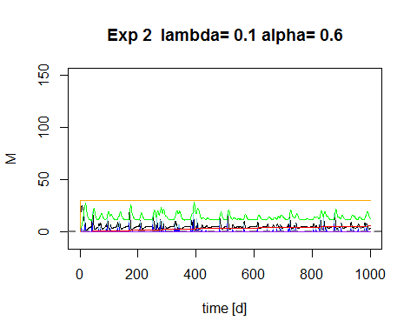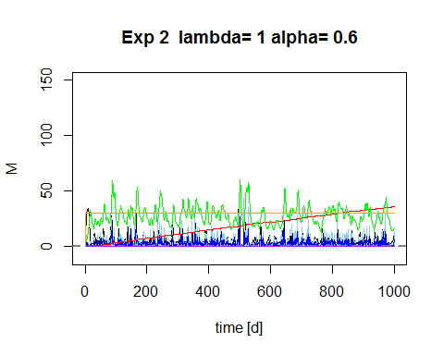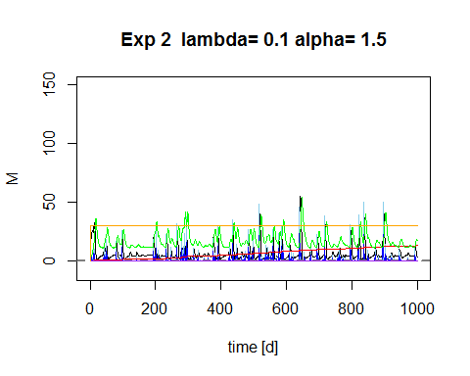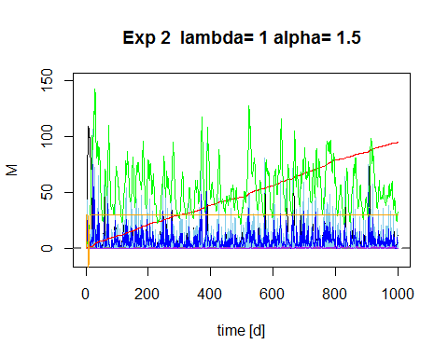

## Results Experiment 2

Plotting M and P for different lambdas

require(ggplot2)  
lambda_sum <- do.call(rbind,Store[][[2]])  
lambda_sum$time <- rep(1:time,length(lambda))  
  
pl <- ggplot(lambda_sum,aes(x=time,y=P, colour="P (plant biomass density [gm-2])")) + geom_line()  
pl <- pl + geom_line(aes(x=time,y=M, colour="Moisture"))   
pl <- pl + facet_wrap(~lambda_o) #, colour=lambda_o (put this in aes-brackets)   
pl + ggtitle("Plant biomass P and soilmoisture M for varying lambdas - Experiment 2") + geom_line(aes(x=time, y=SmM, colour= "S (soil salt mg/L")) + theme(plot.title = element_text(lineheight=.8, face="bold"))

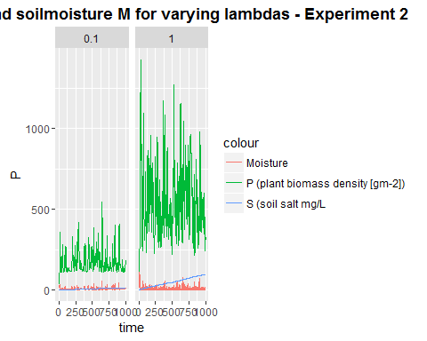

Plotting Soil water salt concentration for different alphas and lambdas

lambda_sum_all <- do.call(rbind,do.call(rbind,Store))  
lambda_sum_all$time <- rep(rep(1:time,length(lambda)),length(alpha))  
  
  
pa <- ggplot(lambda_sum_all,aes(x=time,y=SmM,col=as.factor(lambda_o))) + geom_line(linetype=1)   
# pa <- pa + + scale_color_gradient(low="blue", high="red")  
pa <- pa + facet_wrap(~alpha_o) + ggtitle("Soil water salt mass [g] for varying alphas and lambdas - Experiment 2") + theme(plot.title = element_text(lineheight=.8, face="bold"))  
pa

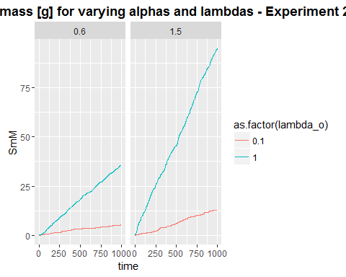

h2P<- lambda_sum$P  
h2M <-lambda_sum$M  
h2SmM<-lambda_sum$SmM  
h2CM<-lambda_sum$CM

## Comparing summaries for exp 1 and exp 2

summary(h1P) # Plant biomass exp 1

## Min. 1st Qu. Median Mean 3rd Qu. Max.   
## 30.0 148.9 285.9 358.3 509.8 1420.0

summary(h2P) # Plant biomass exp 2

## Min. 1st Qu. Median Mean 3rd Qu. Max.   
## 30.0 148.9 285.5 357.5 509.7 1425.0

summary(h1M) # soil moisture exp 1

## Min. 1st Qu. Median Mean 3rd Qu. Max.   
## 0.4883 2.2730 4.1260 7.7450 8.6000 108.9000

summary(h2M) # soil moisture exp 2

## Min. 1st Qu. Median Mean 3rd Qu. Max.   
## 0.4873 2.2950 4.1360 7.8240 8.6200 108.9000

summary(h1SmM) # soil salt mass exp 1

## Min. 1st Qu. Median Mean 3rd Qu. Max.   
## 0.000 5.517 11.780 27.340 45.780 94.730

summary(h2SmM) # soil salt mass exp 2

## Min. 1st Qu. Median Mean 3rd Qu. Max.   
## 0.000 5.517 11.780 27.340 45.780 94.730

summary(h1CM) # soil salt concentration exp 1

## Min. 1st Qu. Median Mean 3rd Qu. Max.   
## 0.00000 0.01631 0.04984 0.18320 0.17740 2.00500

summary(h2CM) # soil salt concentration exp 2

## Min. 1st Qu. Median Mean 3rd Qu. Max.   
## 0.00000 0.01613 0.04972 0.18190 0.17640 2.00500

## Comparing the distributions for exp 1 and 2

par(mfrow = c(1,2))  
hist(h1P, breaks=10, main = 'Plant biomass Experiment 1')  
hist(h2P, breaks=10, main = 'Plant biomass Experiment 2')

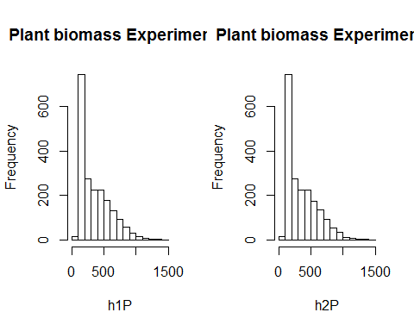

hist(h1M, breaks=10,main="Soil moisture Exp 1")  
hist(h2M, breaks=10,main="Soil moisture Exp 2")

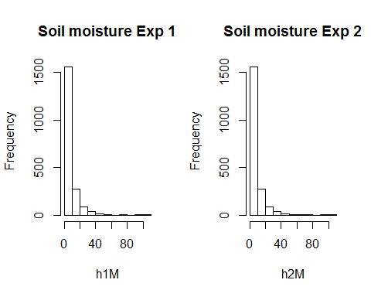

hist(h1SmM, breaks=10,main="soil salt mass Exp 1")  
hist(h2SmM, breaks=10,main="soil salt mass Exp 2")

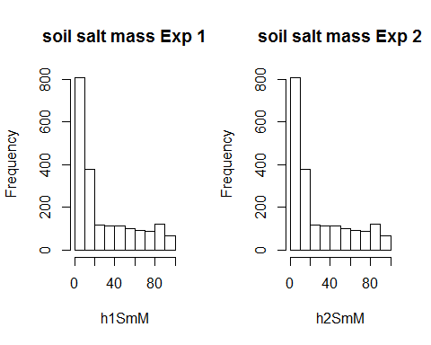

hist(h1CM, breaks=10, main="Salt concentration in soil Exp 1")  
hist(h2CM, breaks=10, main="Salt concentration in soil Exp 2")

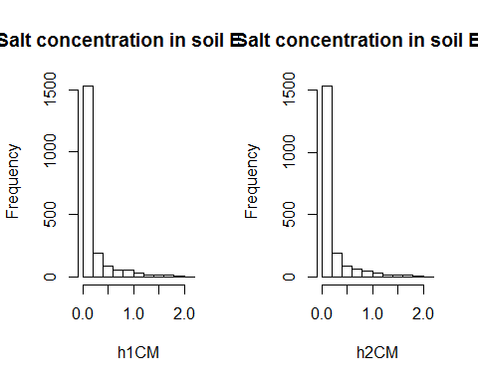

## Testing whether distributions for exp 1 and 2 are significantly different from each other

wilcox.test(h1M,h2M) # soil moisture

##   
## Wilcoxon rank sum test with continuity correction  
##   
## data: h1M and h2M  
## W = 1995399, p-value = 0.8998  
## alternative hypothesis: true location shift is not equal to 0

wilcox.test(h1P,h2P) # plant biomass

##   
## Wilcoxon rank sum test with continuity correction  
##   
## data: h1P and h2P  
## W = 2002458, p-value = 0.9463  
## alternative hypothesis: true location shift is not equal to 0

wilcox.test(h1SmM,h2SmM) # soil salt mass

##   
## Wilcoxon rank sum test with continuity correction  
##   
## data: h1SmM and h2SmM  
## W = 2000598, p-value = 0.987  
## alternative hypothesis: true location shift is not equal to 0

wilcox.test(h1CM,h2CM) # soil salt concentration

##   
## Wilcoxon rank sum test with continuity correction  
##   
## data: h1CM and h2CM  
## W = 2003082, p-value = 0.9328  
## alternative hypothesis: true location shift is not equal to 0

## Conclusive remarks

No significant differences between the two approaches