Testing 3 different groundwater tables

Anne-Karin Cooke

## Experiments

1. alpha=0.6, lambda=0.1 # dry
2. alpha=1.5, lambda=0.1
3. alpha=1.5, lambda=1.0
4. alpha=0.6, lambda=1.0 # wet

In this version, Sandy Clay Loam was used.

Experiments :

## Experiment 1: Z = 100 cm

-for climates 1-4 Z = 100

## Experiment 2: Z= 250 cm

-for climates 1-4 Z=250

## Experiment 3: Z= 500 cm

-for climates 1-4 Z= 500

# Model set up

In this model, salt enters the system through rainfall and from the groundwater table with the same concentration. (just as an example)

## Constants

Soil properties were derived from standard Australian soils in Neurotheta (Minasny and McBratney, 2002, as cited in Shah et al, 2011).

# Sandy Clay Loam  
 n<-0.367 # porosity  
 # more soil variables for evaporation & losses  
 # Hydraulic conductivity  
 K_s<-52.08*10 # mm/day  
 # campbell's b  
 b<-6.4069 # neurotheta sandy clay loam  
 # van Genuchten parameters  
# avg <- 0.0521  
# nvg <- 1.237  
 s_fc<-0.2677/n # Field capacity  
 # This is the bubbling pressure  
 psi_s_bar<--1.2E-3 #  
   
 h1bar = -psi_s_bar   
 hb = psi_s_bar*-10^5  
   
  
  
 Z =1000 # [cm] actual groundwater depth   
  
# parameters describing the soil  
 soilpar <- list(b = b, n = n, s_fc = s_fc, K_s = K_s,   
 psi_s_bar = psi_s_bar, h1bar = h1bar, hb = hb)  
 #................................................  
 # Vegetation 1 (Grass)  
 # paspalum secateum F-I and R-I, 2004  
  
 Zr = 400 # soil depth (cm) Also Table 2...Fernandez-Illescas and Rodriguez-Iturbe...2001  
  
  
 # parameters describing the root zone   
 vegpar <- list(Zr = Zr)  
  
  
# parameters describing plant dynamics and salt features  
  
 alpha_i=0.5 #maximum infiltration rate per day, http://www.fao.org/docrep/s8684e/s8684e0a.htm  
   
 k=12 # Saco et al, 2013  
 W0=0.2 # Saco et al, 2013  
 gmax=0.05 # Saco et al, 2013  
 k1=5 # Saco et al, 2013  
 c=10 # Saco et al, 2013  
 f= 1 # f is the soil salt leaching efficiency (whether some salt is retained)  
 ConcConst = 0.01 # ConcConst is the concentration of the salt in the infiltrating water in g/l  
 CM.gw = 0.1 # salt concentration in groundwater  
 d=0.24 # fraction of plant mortality  
   
 par <- list(alpha_i=alpha_i,k=k, W0=W0, gmax=gmax, k1=k1, c=c, f=f, ConcConst=ConcConst, CM.gw= CM.gw, d=d)

## Infiltration function

Infil <- function(h,P, par){  
   
 I=par$alpha_i*h*(P+par$k*par$W0)/(P+par$k)  
   
 return (I)  
}

## Water uptake function

WU <- function(M,P,par){   
# using Svir in here means scaling Svir back to M, easier to do at Svir in balances   
# WU=par$gmax*((M*(1+Svir))/(((M*(1+Svir))+par$k1)))*P   
 WU=par$gmax*(M/((M+par$k1)))*P   
   
 return(WU)  
}

Precip <- function(time,alpha,lambda,delta) {  
 # generate a vector of times between rainfall events > delta  
 f_P<-floor(rexp(time,lambda*exp(-delta/alpha))) # vector of times between rainfall occurrences (equation 4 & 8)  
 # generate a binary vector from this (impulse function)  
 binary.vec <- unlist(lapply(1:time,function(i) c(rep(0,f_P[i]),1)))  
 R <- rexp(length(binary.vec),1/alpha)*binary.vec   
 return(R[1:time])  
}

## Vertical Flux function

#******************************************  
# based on Salvucci, 1993  
L_n <- function(M,Z,soilpar,vegpar) {  
 Zr <- vegpar$Zr  
 hb <- - soilpar$psi_s_bar*10^5 # (mm?)  
# soilpar$s_fc <- (Z/hb)^(-1/soilpar$b)  
   
 s=M/(soilpar$n*vegpar$Zr)  
   
 psi = hb*s^-soilpar$b  
   
  
 m=2 + 3/soilpar$b  
  
q <-((Z/hb)^(-m)-(psi/hb)^(-m))/(1+(psi/hb)^(-m)+(m-1)*(Z/hb)^(-m))#/(soilpar$n*Zr) #   
  
# Mass flux  
  
flux <- soilpar$K_s*q  
  
  
return(flux)  
}

## Experiment

Salt influence on Plant growth function AND on mortality

Gr <- function(M,P,par) {   
   
 Gr = par$c*WU(M,P,par)  
   
 return(Gr)  
}

## Plant mortality function WITH SALT INFLUENCE, WITH VIRTUAL SATURATION

Mo <- function(P,M,Svir,par) {  
 # needs to be M/Svir because both are "large" numbers  
 # you want a number ~1 for multiplication, or <0.1 for addition  
 Mo = P*(par$d*(M/Svir))  
   
 return(Mo)  
  
}

## balances function

balances <- function(Rain, par, plotit=T,  
 soilpar,  
 vegpar){  
   
  
   
# Storage vectors for the daily steps are initialized.  
  
 M <- rep(0,length(Rain)) # soil moisture [mm]  
 h <- rep(0,length(Rain)) # infiltration depth [mm]  
 P <- rep(0,length(Rain)) #biomass density []  
 CM<- rep(0,length(Rain)) # Salt concentration in soil water in g/L or g/mm  
 SmI<- rep(0,length(Rain)) # Salt mass in infiltrating water [g]  
 SmM <- rep(0,length(Rain)) # Salt mass in soil water [g]  
 In <- rep(0,length(Rain)) # infiltration [mm]  
  
 Svir <- rep(0,length(Rain)) # virtual saturation  
 flux<- rep(0,length(Rain)) # drainage and capillary rise flux, according to sign  
  
  
  
# Initial values to start the simulation.  
  
   
 M[1] <- 3  
 h[1] <- 10   
 P[1] <- 3  
 CM[1]<- 0  
 Svir[1] <- M[1]  
  
  
  
# We decided to split the numerical calculations for the daily into 12 substeps.  
  
 deltat <- 12 # split in 12 increments  
  
   
# Storage vectors for the substeps are initialized.  
  
 M_sub <- rep(0,deltat)  
 h_sub <- rep(0,deltat)  
 I_sub <- rep(0,deltat)  
 #Q_sub <- rep(0,deltat)  
 WU_sub <-rep(0,deltat) # Water uptake in mm  
 P_sub <- rep(0,deltat)   
 Gr_sub <- rep(0,deltat) # Growth of biomass  
 Mo_sub<- rep(0,deltat) # Mortality of biomass  
 SmI_sub <- rep(0,deltat)   
 SmM_sub<- rep(0,deltat)   
 CM_sub<- rep(0,deltat)   
 Svir_sub <- rep(0,deltat) # virtual saturation  
  
 flux_sub<-rep(0,deltat) # calculates leakage loss without evaporation loss  
  
 U_salt <-rep(0,deltat)  
 L_salt <-rep(0,deltat)  
  
  
   
 timeincr= 1/deltat  
   
 for (t in 2:length(Rain)){  
   
 for (tt in 1:(deltat-1)) {  
   
 h.old <- ifelse(tt==1,h[t-1],h_sub[tt])  
 P.old <- ifelse(tt==1,P[t-1],P_sub[tt])  
 M.old <- ifelse(tt==1,M[t-1],M_sub[tt])  
 SmI.old <-ifelse(tt==1,SmI[t-1],SmI_sub[tt])  
 CM.old <-ifelse(tt==1,CM[t-1],CM_sub[tt])  
 Svir.old <-ifelse(tt==1,Svir[t-1],Svir_sub[tt])  
  
  
# Balance for water depth on soil  
 h_sub[tt+1] <- h.old + ifelse(tt==1,(10*Rain[t]),0)   
 #- Infil(h.old, P.old,par)*timeincr  
  
 # Infiltration  
 par$alpha_i <- ifelse(h_sub[tt+1]<soilpar$K_s*timeincr, 1,  
 (1-(h_sub[tt+1]-soilpar$K_s*timeincr)/h_sub[tt+1]))  
 # Calculate infiltration and recalculate h_sub   
 I_sub[tt] <- Infil(h.old, P.old,par)*timeincr  
 h_sub[tt+1] <- h_sub[tt+1] - I_sub[tt]   
   
   
# Now do all plant uptake and growth  
# water uptake by plants: include infiltration in available water  
  
 WU_sub[tt] <- WU(M=Svir.old,P.old,par)*timeincr   
   
 # growth rate  
 Gr_sub[tt] <- Gr(M=Svir.old, P.old,par)*timeincr   
 # Mortality  
 Mo_sub[tt]<- Mo(P.old,M=M.old, Svir=Svir.old, par)*timeincr  
 # calculate plant biomass balance  
 P_sub[tt + 1] <- P.old + Gr_sub[tt]- Mo_sub[tt]   
   
   
# re-calculate water balance  
# 2. before leaching  
 M_sub[tt + 1] <- M.old + I_sub[tt] - WU_sub[tt] #- L_sub[tt]   
  
# Calculate salt concentration in the soil  
  
 # 3. calculate leaching and capillary rise amount  
 flux_sub[tt+1]<-do.call(L_n,list(M=M_sub[tt+1],Z=Z,soilpar=soilpar,vegpar=vegpar))  
  
# 4. final adjust soil moisture for leaching or capillary rise  
   
 M_sub[tt + 1] <- M_sub[tt + 1] + flux_sub[tt+1]*timeincr  
  
  
# calculate saltbalance  
  
# Salt leaching  
 L_salt[tt+1] <- ifelse(flux_sub[tt+1]<0, par$f*CM_sub[tt+1]*flux_sub[tt+1]*timeincr,0) # leaching of salt  
  
# salt uplfow  
 U_salt[tt+1] <- ifelse(flux_sub[tt+1]>0, par$CM.gw*flux_sub[tt+1]*timeincr,0) # rise of salt  
  
# salt mass coming in with infiltration  
 SmI_sub[tt+1]<- SmI.old + I_sub[tt]*par$ConcConst   
  
#salt mass in soil  
 SmM_sub[tt+1] <- SmI_sub[tt+1] + U_salt[tt+1] - L_salt[tt+1]  
  
# salt concentration in soil  
 CM_sub[tt+1]<- SmM_sub[tt+1]/M_sub[tt+1]  
   
# Virtual saturation (Shah et al., 2012), here in [mm] to be in the same unit as M  
 Svir_sub[tt + 1]<-soilpar$n*vegpar$Zr*((soilpar$h1bar)^(1/soilpar$b))*  
 ((soilpar$h1bar)*(M_sub[tt + 1]/  
 (soilpar$n*vegpar$Zr))^(-soilpar$b)  
 +(3.6*CM_sub[tt + 1]))^(-1/soilpar$b)  
  
 }   
   
# Aggregating the substep results to daily values.  
  
 P[t] = P_sub[deltat]  
 M[t] = M_sub[deltat]  
 h[t] = h_sub[deltat]  
 CM[t] = CM_sub[deltat]  
 SmM[t] = SmM_sub[deltat]   
 SmI[t]=SmI_sub[deltat]  
 In[t]= sum(I_sub)  
 flux[t] = sum(flux_sub)  
 Svir[t] = Svir_sub[deltat]  
  
}  
  
  
# Plotting  
   
if (plotit==T) {   
 plot(M, type="l",ylim=c(0,100),xlim=c(0,time),xlab=("time [d]"), main=paste("Exp 1 lambda=", lambda[j],"alpha=", alpha[i]))  
 points(Rain*10, type="h", col="skyblue")  
   
 lines(h,type="l", col="blue")  
 abline(h=0, col="Gray50",lwd=2,lty=2)  
  
 lines(SmM,type="l", col="red")  
 lines(CM,type="l", col="purple")  
 lines(P/10,type="l", col="green")  
  
 legend("topright",cex=1, pt.cex=0.4, c("Moisture [mm]","Rainfall [mm]*10","overland flow depth[mm] ","salt mass in soil water [g]", "salt concentration in soil water [g/l]", "Plant biomass density [g/m^2]/10"),  
 col=c("black","skyblue","blue","red","purple","green"),lty=1)  
   
  
}  
  
Out <- data.frame(P=P,M=M,h=h, CM=CM, SmM=SmM, In=In, flux=flux, Svir=Svir)  
return(Out)  
}

## Changing climates

Alpha and lambda are set to low and high values, respecitively.

alpha <- c(0.6,1.5)   
lambda <- c(0.1,1)  
  
Store <- list()  
sub_store <- list()  
time <- 1000  
delta <- 0  
set.seed(1000)

This loop generates rainfall with the distribution properties alpha[i] and lambda[j]. For each alpha[i] and each lambda[j] the soil water balance function is executed and the results stored in a nested list.

#source("Rainfall.R")  
  
  
for (i in 1:length(alpha)) {  
   
for (j in 1:length(lambda)) {  
 # generate the rainfall  
 Rain <- Precip(time,alpha[i],lambda[j],delta)  
 Rainlist <- data.frame(Precip(time,alpha[i],lambda[j],delta))   
   
 sub_store[[j]] <-data.frame(alpha_o=rep(alpha[i],time),  
 lambda_o=rep(lambda[j],time),  
 balances(Rain,plotit=T, par=par,  
 soilpar, vegpar))  
 }  
 Store[[i]] <- sub_store  
}

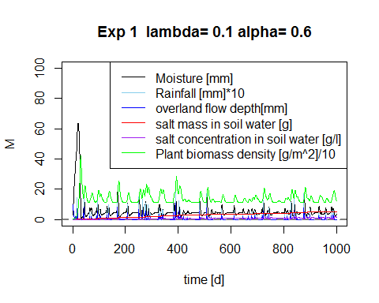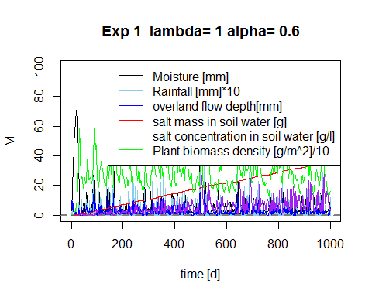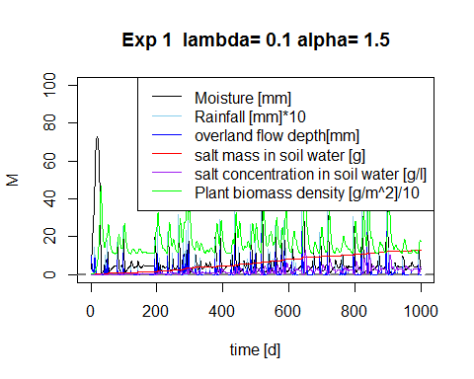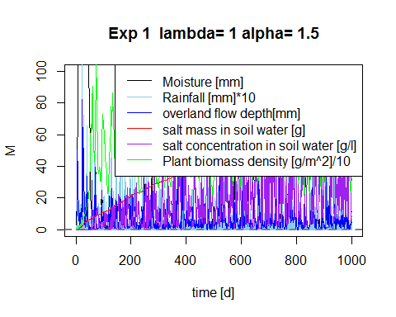

## Results Experiment 2

Plotting M and P for different lambdas

require(ggplot2)

## Loading required package: ggplot2

## Warning: package 'ggplot2' was built under R version 3.1.3

lambda_sum <- do.call(rbind,Store[][[2]])  
lambda_sum$time <- rep(1:time,length(lambda))  
  
pl <- ggplot(lambda_sum,aes(x=time,y=P, colour="P (plant biomass density [gm-2])")) + geom_line()  
pl <- pl + geom_line(aes(x=time,y=M, colour="Moisture"))   
pl <- pl + facet_wrap(~lambda_o) #, colour=lambda_o (put this in aes-brackets)   
pl + ggtitle("Plant biomass P and soilmoisture M for varying lambdas - Experiment 2") + geom_line(aes(x=time, y=SmM, colour= "S (soil salt mg/L")) + theme(plot.title = element_text(lineheight=.8, face="bold"))

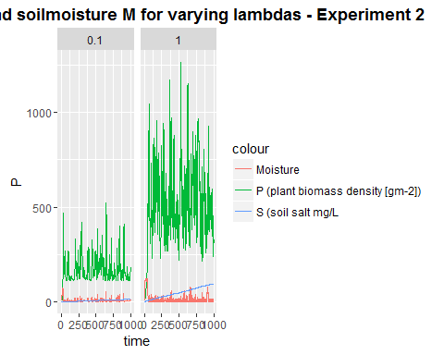

Plotting Soil water salt concentration for different alphas and lambdas

lambda_sum_all <- do.call(rbind,do.call(rbind,Store))  
lambda_sum_all$time <- rep(rep(1:time,length(lambda)),length(alpha))  
  
  
pa <- ggplot(lambda_sum_all,aes(x=time,y=SmM,col=as.factor(lambda_o))) + geom_line(linetype=1)   
# pa <- pa + + scale_color_gradient(low="blue", high="red")  
pa <- pa + facet_wrap(~alpha_o) + ggtitle("Soil water salt mass [g] for varying alphas and lambdas - Experiment 2") + theme(plot.title = element_text(lineheight=.8, face="bold"))  
pa

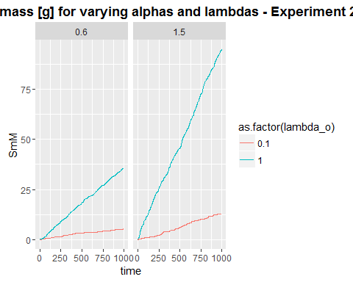

Z1P<- lambda_sum$P  
Z1M <-lambda_sum$M  
Z1SmM<-lambda_sum$SmM  
Z1CM<-lambda_sum$CM

## Z = 250

This loop generates rainfall with the distribution properties alpha[i] and lambda[j]. For each alpha[i] and each lambda[j] the soil water balance function is executed and the results stored in a nested list.

#source("Rainfall.R")  
  
Z = 2500  
  
for (i in 1:length(alpha)) {  
   
for (j in 1:length(lambda)) {  
 # generate the rainfall  
 Rain <- Precip(time,alpha[i],lambda[j],delta)  
 Rainlist <- data.frame(Precip(time,alpha[i],lambda[j],delta))   
   
 sub_store[[j]] <-data.frame(alpha_o=rep(alpha[i],time),  
 lambda_o=rep(lambda[j],time),  
 balances(Rain,plotit=T, par=par,  
 soilpar, vegpar))  
 }  
 Store[[i]] <- sub_store  
}

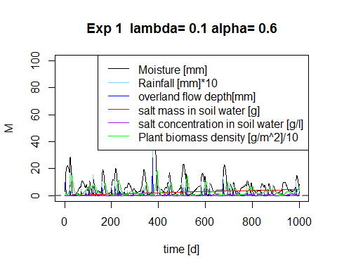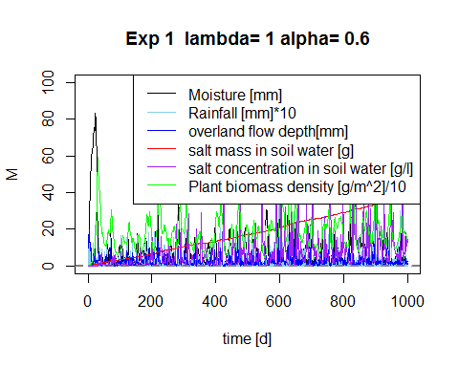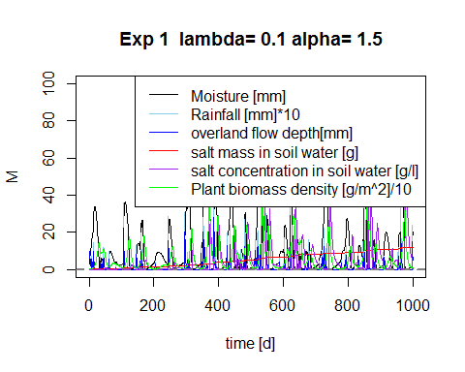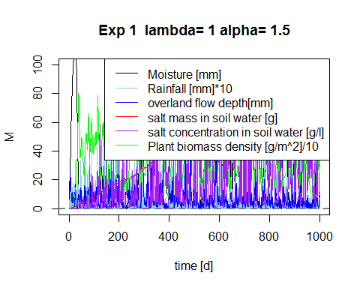

Plotting M and P for different lambdas

require(ggplot2)  
lambda_sum <- do.call(rbind,Store[][[2]])  
lambda_sum$time <- rep(1:time,length(lambda))  
  
pl <- ggplot(lambda_sum,aes(x=time,y=P, colour="P (plant biomass density [gm-2])")) + geom_line()  
pl <- pl + geom_line(aes(x=time,y=M, colour="Moisture"))   
pl <- pl + facet_wrap(~lambda_o) #, colour=lambda_o (put this in aes-brackets)   
pl + ggtitle("Plant biomass P and soilmoisture M for varying lambdas - Experiment 2") + geom_line(aes(x=time, y=SmM, colour= "S (soil salt mg/L")) + theme(plot.title = element_text(lineheight=.8, face="bold"))

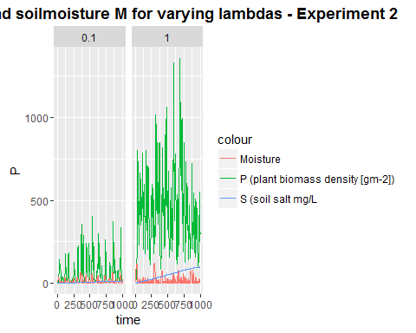

Plotting Soil water salt concentration for different alphas and lambdas

lambda_sum_all <- do.call(rbind,do.call(rbind,Store))  
lambda_sum_all$time <- rep(rep(1:time,length(lambda)),length(alpha))  
  
  
pa <- ggplot(lambda_sum_all,aes(x=time,y=SmM,col=as.factor(lambda_o))) + geom_line(linetype=1)   
# pa <- pa + + scale_color_gradient(low="blue", high="red")  
pa <- pa + facet_wrap(~alpha_o) + ggtitle("Soil water salt mass [g] for varying alphas and lambdas - Experiment 2") + theme(plot.title = element_text(lineheight=.8, face="bold"))  
pa

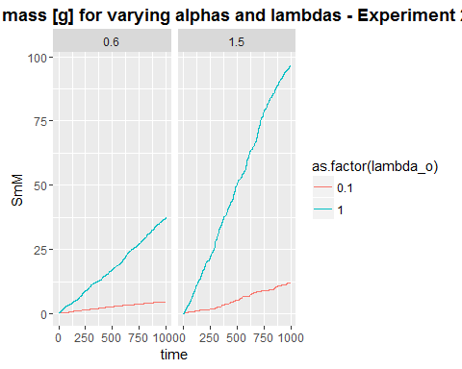

Z2P<- lambda_sum$P  
Z2M <-lambda_sum$M  
Z2SmM<-lambda_sum$SmM  
Z2CM<-lambda_sum$CM

## Z = 500

This loop generates rainfall with the distribution properties alpha[i] and lambda[j]. For each alpha[i] and each lambda[j] the soil water balance function is executed and the results stored in a nested list.

#source("Rainfall.R")  
Z = 5000  
  
for (i in 1:length(alpha)) {  
   
for (j in 1:length(lambda)) {  
 # generate the rainfall  
 Rain <- Precip(time,alpha[i],lambda[j],delta)  
 Rainlist <- data.frame(Precip(time,alpha[i],lambda[j],delta))   
   
 sub_store[[j]] <-data.frame(alpha_o=rep(alpha[i],time),  
 lambda_o=rep(lambda[j],time),  
 balances(Rain,plotit=T, par=par,  
 soilpar, vegpar))  
 }  
 Store[[i]] <- sub_store  
}

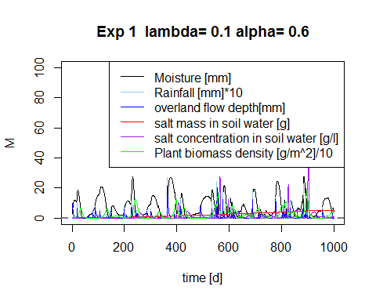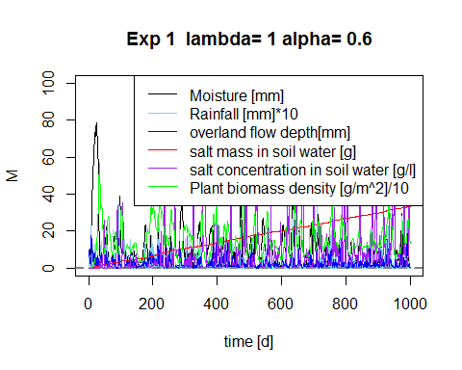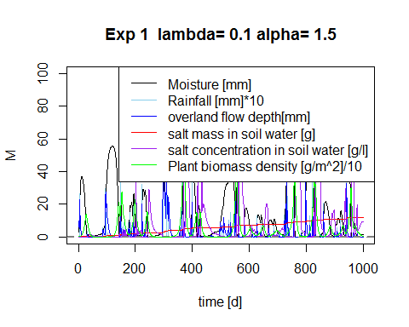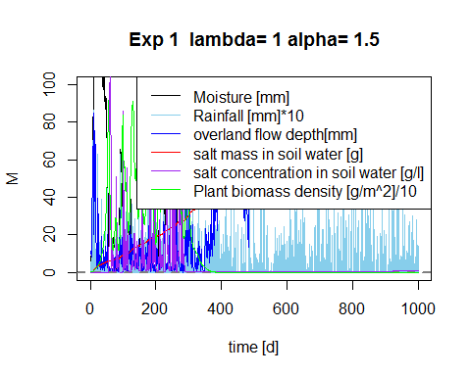

Plotting M and P for different lambdas

require(ggplot2)  
lambda_sum <- do.call(rbind,Store[][[2]])  
lambda_sum$time <- rep(1:time,length(lambda))  
  
pl <- ggplot(lambda_sum,aes(x=time,y=P, colour="P (plant biomass density [gm-2])")) + geom_line()  
pl <- pl + geom_line(aes(x=time,y=M, colour="Moisture"))   
pl <- pl + facet_wrap(~lambda_o) #, colour=lambda_o (put this in aes-brackets)   
pl + ggtitle("Plant biomass P and soilmoisture M for varying lambdas - Experiment 2") + geom_line(aes(x=time, y=SmM, colour= "S (soil salt mg/L")) + theme(plot.title = element_text(lineheight=.8, face="bold"))

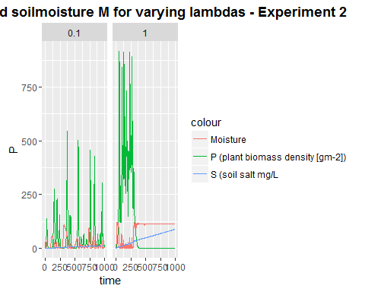

Plotting Soil water salt concentration for different alphas and lambdas

lambda_sum_all <- do.call(rbind,do.call(rbind,Store))  
lambda_sum_all$time <- rep(rep(1:time,length(lambda)),length(alpha))  
  
  
pa <- ggplot(lambda_sum_all,aes(x=time,y=SmM,col=as.factor(lambda_o))) + geom_line(linetype=1)   
# pa <- pa + + scale_color_gradient(low="blue", high="red")  
pa <- pa + facet_wrap(~alpha_o) + ggtitle("Soil water salt mass [g] for varying alphas and lambdas - Experiment 2") + theme(plot.title = element_text(lineheight=.8, face="bold"))  
pa

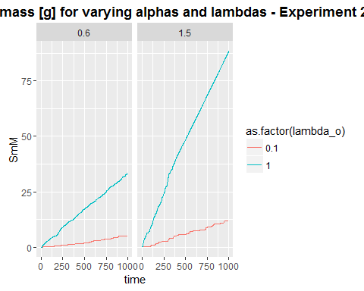

Z3P<- lambda_sum$P  
Z3M <-lambda_sum$M  
Z3SmM<-lambda_sum$SmM  
Z3CM<-lambda_sum$CM

## Comparing summaries

par(mfrow = c(1,3))  
summary(Z1P) # Plant biomass Z=100

## Min. 1st Qu. Median Mean 3rd Qu. Max.   
## 3.0 145.2 274.7 341.0 481.6 1264.0

summary(Z2P) # Plant biomass Z=250

## Min. 1st Qu. Median Mean 3rd Qu. Max.   
## 2.982 33.320 170.000 245.900 410.700 1356.000

summary(Z3P) # Plant biomass Z=500

## Min. 1st Qu. Median Mean 3rd Qu. Max.   
## 0.000 0.000 8.977 85.380 75.440 915.400

summary(Z1M) # soil moisture Z=100

## Min. 1st Qu. Median Mean 3rd Qu. Max.   
## 0.5103 2.3990 4.2650 10.4800 9.5970 122.1000

summary(Z2M) # soil moisture Z=250

## Min. 1st Qu. Median Mean 3rd Qu. Max.   
## 0.1069 1.4020 5.2780 13.3900 16.2500 120.1000

summary(Z3M) # soil moisture Z=500

## Min. 1st Qu. Median Mean 3rd Qu. Max.   
## 0.02411 2.60400 32.10000 52.79000 112.70000 120.20000

summary(Z1SmM) # soil salt mass Z=100

## Min. 1st Qu. Median Mean 3rd Qu. Max.   
## 0.000 5.517 11.780 27.340 45.780 94.730

summary(Z2SmM) # soil salt mass Z=250

## Min. 1st Qu. Median Mean 3rd Qu. Max.   
## 0.00 4.43 10.83 27.60 50.30 96.83

summary(Z3SmM) # soil salt mass Z=500

## Min. 1st Qu. Median Mean 3rd Qu. Max.   
## 0.000 5.802 10.710 26.310 48.460 88.370

summary(Z1CM) # soil salt concentration Z=100

## Min. 1st Qu. Median Mean 3rd Qu. Max.   
## 0.0000 0.8834 2.8020 10.2500 9.7920 125.0000

summary(Z2CM) # soil salt concentration Z=250

## Min. 1st Qu. Median Mean 3rd Qu. Max.   
## 0.0000 0.5652 2.6190 18.9400 12.6700 587.5000

summary(Z3CM) # soil salt concentration Z=500

## Min. 1st Qu. Median Mean 3rd Qu. Max.   
## 0.0000 0.3396 0.6132 7.8830 2.1200 384.1000

## Comparing the distributions

par(mfrow = c(1,3))  
hist(Z1P, breaks=10, main = 'Plant biomass Z=100')  
hist(Z2P, breaks=10, main = 'Plant biomass Z=250')  
hist(Z3P, breaks=10, main = 'Plant biomass Z=500')

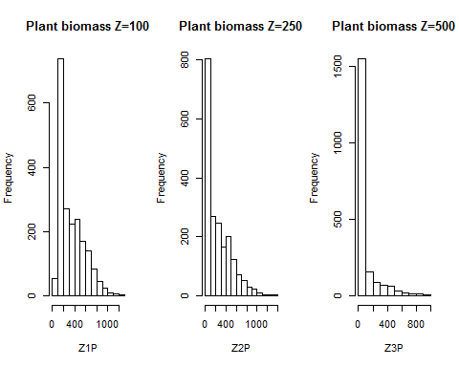

hist(Z1M, breaks=10,main="Soil moisture Z=100")  
hist(Z2M, breaks=10,main="Soil moisture Z=250")  
hist(Z3M, breaks=10,main="Soil moisture Z=500")

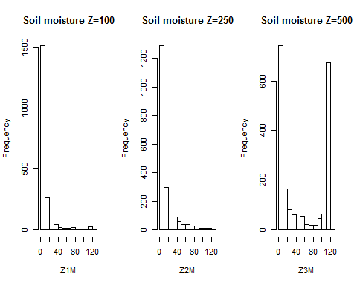

hist(Z1SmM, breaks=10,main="soil salt mass Z=100")  
hist(Z2SmM, breaks=10,main="soil salt mass Z=250")  
hist(Z3SmM, breaks=10,main="soil salt mass Z=500")

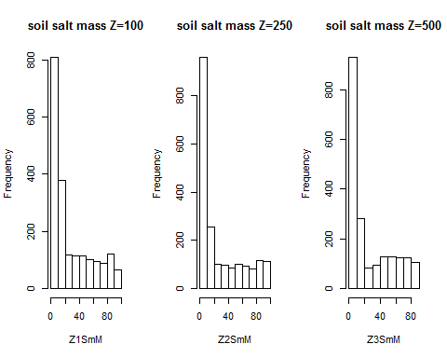

hist(Z1CM, breaks=10, main="Salt concentration in soil Z=100")  
hist(Z2CM, breaks=10, main="Salt concentration in soil Z=250")  
hist(Z3CM, breaks=10, main="Salt concentration in soil Z=500")

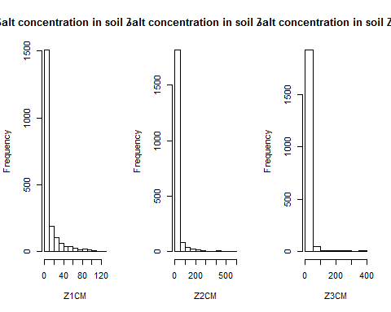

## Statistical tests

wilcox.test(Z1M,Z2M) # soil moisture

##   
## Wilcoxon rank sum test with continuity correction  
##   
## data: Z1M and Z2M  
## W = 2000030, p-value = 0.9994  
## alternative hypothesis: true location shift is not equal to 0

wilcox.test(Z2M,Z3M) # soil moisture

##   
## Wilcoxon rank sum test with continuity correction  
##   
## data: Z2M and Z3M  
## W = 1246673, p-value < 2.2e-16  
## alternative hypothesis: true location shift is not equal to 0

wilcox.test(Z1M,Z3M) # soil moisture

##   
## Wilcoxon rank sum test with continuity correction  
##   
## data: Z1M and Z3M  
## W = 1269941, p-value < 2.2e-16  
## alternative hypothesis: true location shift is not equal to 0

wilcox.test(Z1P,Z2P) # Plant biomass

##   
## Wilcoxon rank sum test with continuity correction  
##   
## data: Z1P and Z2P  
## W = 2597873, p-value < 2.2e-16  
## alternative hypothesis: true location shift is not equal to 0

wilcox.test(Z2P,Z3P) # Plant biomass

##   
## Wilcoxon rank sum test with continuity correction  
##   
## data: Z2P and Z3P  
## W = 3147201, p-value < 2.2e-16  
## alternative hypothesis: true location shift is not equal to 0

wilcox.test(Z1P,Z3P) # Plant biomass

##   
## Wilcoxon rank sum test with continuity correction  
##   
## data: Z1P and Z3P  
## W = 3523517, p-value < 2.2e-16  
## alternative hypothesis: true location shift is not equal to 0

wilcox.test(Z1SmM,Z2SmM) # soil salt mass

##   
## Wilcoxon rank sum test with continuity correction  
##   
## data: Z1SmM and Z2SmM  
## W = 2076433, p-value = 0.03636  
## alternative hypothesis: true location shift is not equal to 0

wilcox.test(Z2SmM,Z3SmM) # soil salt mass

##   
## Wilcoxon rank sum test with continuity correction  
##   
## data: Z2SmM and Z3SmM  
## W = 1990231, p-value = 0.7891  
## alternative hypothesis: true location shift is not equal to 0

wilcox.test(Z1SmM,Z3SmM) # soil salt mass

##   
## Wilcoxon rank sum test with continuity correction  
##   
## data: Z1SmM and Z3SmM  
## W = 2062326, p-value = 0.08789  
## alternative hypothesis: true location shift is not equal to 0

wilcox.test(Z1CM,Z2CM) # salt conc

##   
## Wilcoxon rank sum test with continuity correction  
##   
## data: Z1CM and Z2CM  
## W = 2035073, p-value = 0.3369  
## alternative hypothesis: true location shift is not equal to 0

wilcox.test(Z2CM,Z3CM) # salt conc

##   
## Wilcoxon rank sum test with continuity correction  
##   
## data: Z2CM and Z3CM  
## W = 2627879, p-value < 2.2e-16  
## alternative hypothesis: true location shift is not equal to 0

wilcox.test(Z1CM,Z3CM) # salt conc

##   
## Wilcoxon rank sum test with continuity correction  
##   
## data: Z1CM and Z3CM  
## W = 2746083, p-value < 2.2e-16  
## alternative hypothesis: true location shift is not equal to 0

## Conclusive remarks