# Explanations detect_3Dcells_vf.ijm

This macro was launched after a Cell detection with Cellpose (https://www.cellpose.org), whose ROIs have been saved in zip file whose ending can be specified at the beginning of the macro:

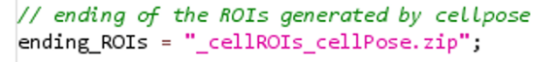

Any segmentation algorithm can be used, provided that the results are saved as a ZIP file containing ROIs compatible with Fiji, and that each ROI includes the corresponding slice information.

1/ The macro asks the user to choose the image to treat:

2/ The macro asks for some parameters:

* The channel of the cells
* The slices to analyze (if some slices are out of focus, remove them from the analysis because Cellpose may have found ROIs in all slices even if the signal is unfocused)
* The minimal size for a cell on one slice (to remove small incorrect ROIs)

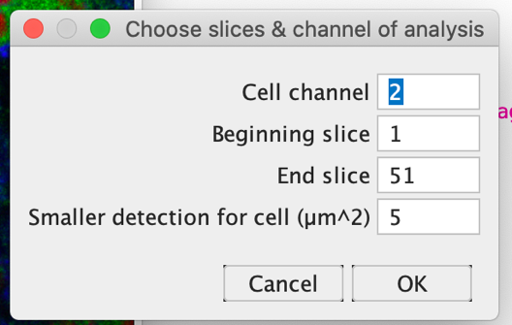

3/ The macro asks the user to draw rectangles around the cells to analyze, add each one to the ROI Manager.

. Be careful **that the cells are in the rectangle for all slices (Z)** because ROIs touching the border will be removed; do not hesitate to make it a bit bigger than the cell it-self. Once all cells are framed click OK:

4/ For each ROI (i.e. each cell), one after the other, the user can modify (**on all slices**) the detection for the current cell; once all corrections are done, click on OK:

**So that the volume is precise, each slice should have a ROI** !

If you want to delete a ROI, select it and click on “Delete” (**careful you may need to uncheck/check “Show All” to update the display**):

Then redraw it and click “Add” or the “t” keyboard (it will automatically add the ROI to the manager, but at the end) (**careful you may need to uncheck/check “Show All” to update the display**):

*Examples of bad detections:*

2 ROIs found on the image Cell not entirely detected Cell touching the border: removed

from analysis

5/ For each cell is computed the volume, that is the sum of the areas multiplied by the z-step

And a “label image”:

*Are saved for the treated image:*

* The ROIs of analysis
* Each Z-crop with the ROIs corrected by the user in a subfolder named after the image
* The result table with the volumes
* The image with each selected cell with the same number in each slice

