# Macro to compile results from quantif_comets_EB1_v*.ijm

We recall that in macro quantif_comets_EB1_v*.ijm, not all comets could be measured in term of sizes (we decided to keep only the one for which the gaussian fit did work), which means that 2 results tables are saved: one for ALL comets (contain the distance to the pole and will be used to determine the total number of comets for this pole) and one for the comets which size has been determined (which contain for those, sizes and distance to the pole).

A/ Macro to count the comets: ***macro_nbComets_perImage_vf***

1/ The macro asks for the folder to treat (treated by quantif_comets_EB1_v*.ijm):

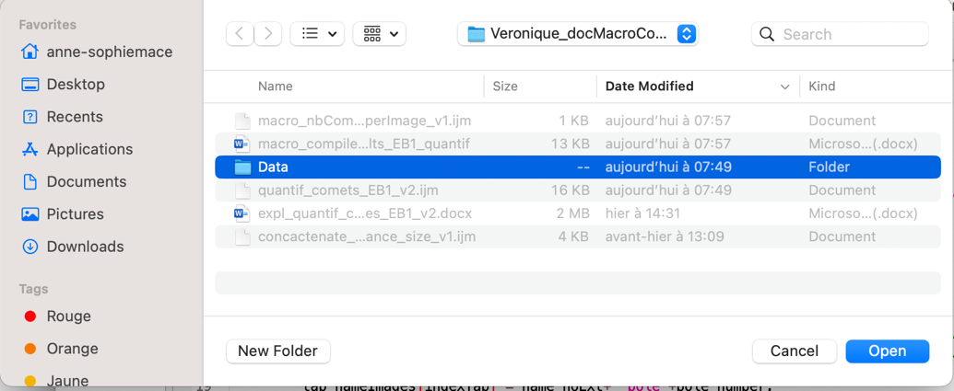

2/ Each file containing all comets information is read and the number of comets is stored in a table (with the image name).

3/ The result table is made and saved within the original folder:

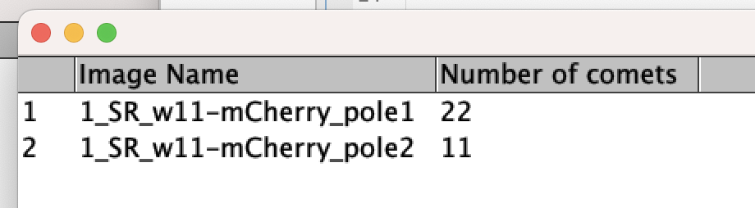

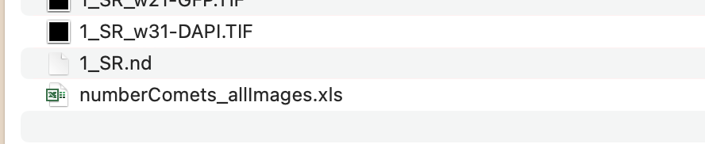

B/ Macro to compile distance to pole and size of comets: ***macro_concactenate_EB1_distance_size_vf.ijm***

1/ The macro asks for the folder to treat (treated by quantif_comets_EB1_v*.ijm):

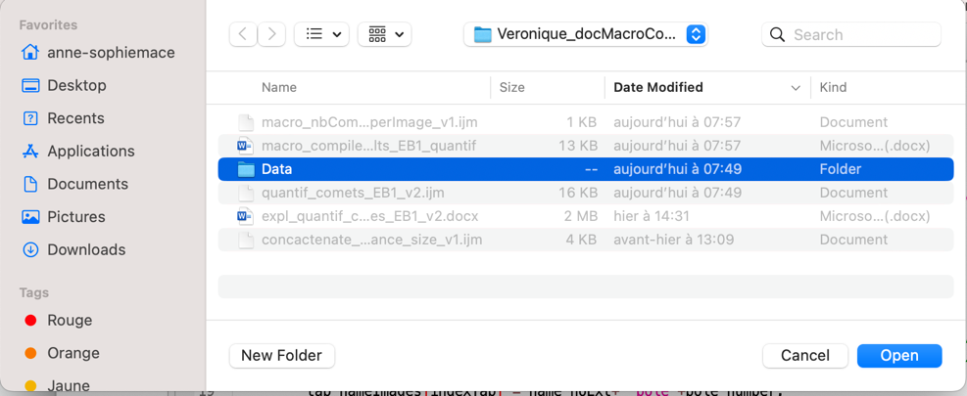

2/ The user is asked what he wants to merge:

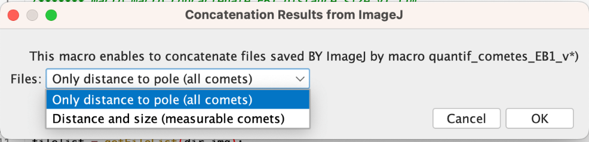

3/ All corresponding files are read to create a Result table containing all results:

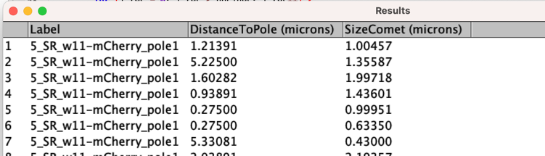or 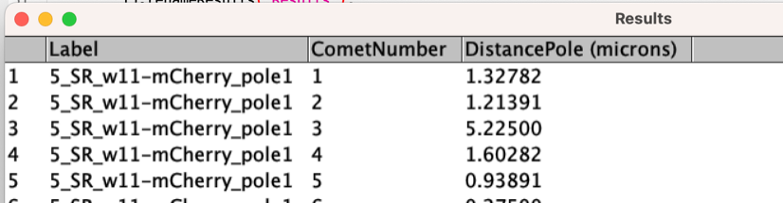

Which is saved in the folder given in step 1/:

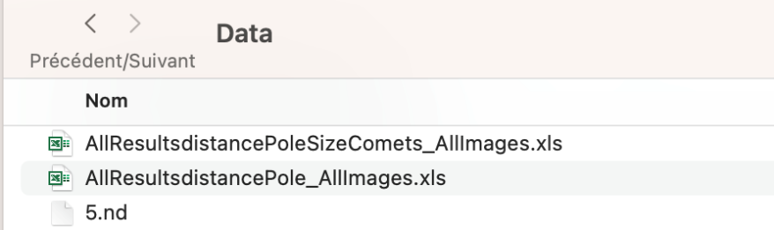

(file “AllResults_distancePole_AllImages" or “AllResults_istancePoleSizeComets_AllImages.xls” depending on the choice in step 2/)

Careful: so that the merge works correctly all the images in the folder should have the same unit of calibration:

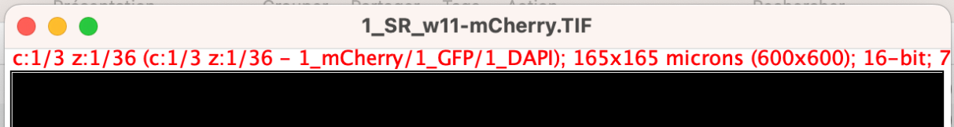

Otherwise result will be wrong (several columns + offset on the result):

