# Macro detectPigment_quantifySignalAround_vf.ijm

The purpose of this macro is to detect pigments (seen as black spots) on a transmitted light image and to analyse signal in other channels around those pigments. The pigments can *also* be present in another fluorescent channel.

Careful, this macro is compatible with **Fiji 1.52p** and not later versions! In following versions, the detected pigments are not located at the correct slice. We think (but did not check) that this could be corrected by using *ROI.setPosition(slice)* for each ROI, function that was added in version 1.53b.

If the version is not 1.52p, the macro stops with this error:

## **A/ Steps of the macro:**

1/ The macro asks for the image to analyse:

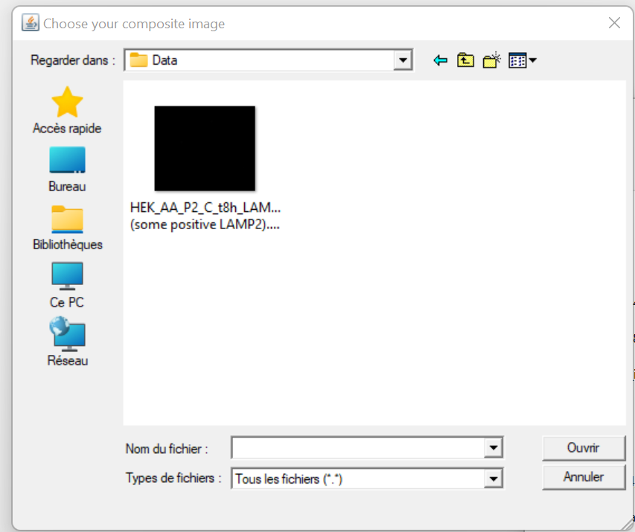

This stack image should have at least a transmitted light channel. On this channel, the pigments are detected as the “black spots”. In the following they may be called “black” pigments.

2/ The macro makes a pause so that the user can look at the slices to keep:

The user should check which slices contain significant (not out of focus) signal and click OK when done.

3/ The user must fill parameters from acquisition and for analysis; this is a very important step to obtain a correct detection:

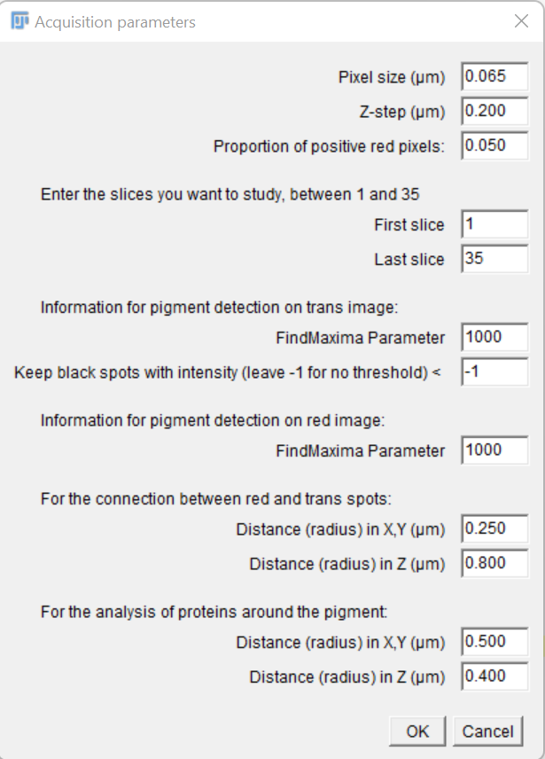

Slices to keep for analysis (remove out of focus slices for a more precise analysis)

Accepted distance between black and red pigments to be considered the same (distance due to axial chromatic aberration)

Parameter for detection of pigments on the red image: Find Maxima parameter (see below for explanations)

Proportion of positive (i.e. above a threshold) pixel in red channel to consider a black pigment red

Parameters for detection of pigments on the transmitted light image:

* Find Maxima parameter (see below for more explanations)
* Threshold: we keep spots with minimum < to the value (-1: we keep all the spots)

Pixel size of the image & step in Z (both in µm)

Spheroid size for analysis of the intensity in other channel(s) around the pigment, in (X,Y,Z)

*Ex:* with a pixel size of 0.1µm, a Z-step of 0.2µm:

* If “*For the connexion between red and trans spots*” the values are in (X,Y) **0.2µm** (= 2 pixels) and in Z **0.4µm** (=2 slices), for a black pigment detected in pixel , a red pigment located in pixel such as:

is considered the **same pigment**.

* If “*For the analysis of proteins around the pigment*” the values are in (X,Y) **0.5µm** (= 5 pixels) and in Z **0.4µm** (=2 slices), all intensity analysis (final result table) will be done within a spheroid, centred on the pigment detected by the FindMaxima and of radius 5 pixels in (X,Y) and on 5 slices: the one of the pigment + 2 above + 2 below

4/ The macro asks the channels correspondence and as an option if pigments should also be detected on the red channel:

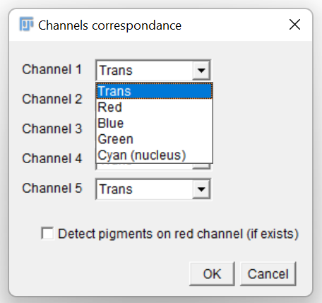

For any other channel than the “Cyan (nucleus)”, signal will be analysed around the pigment and results will appear in the final Results table.

5/ Draw all the ROIs of study (they must be added in the Manager to be treated):

The code continues if at least one ROI has been drawn (it keeps asking you to draw one otherwise).

6/ For each ROI drawn in step 5:

a/ Pigment detection is performed on the transmitted light image (thanks to a FindMaxima on the Minimum z-projection of the transmitted light channel, pigments are detected-as black spots- and are kept only the ones below the threshold specified in the interface of step 3/). The user can (manually) remove some of the pigments:

**Be careful not to remove the ROIs cell.**

b/ [*Optional*] If in step 4/ the “*Detect pigments on red channel (if exists)”* was checked and one channel was specified as “Red”, the same appears for the red channel; the names of the spots contain trans and/or red depending on the channel on which it was detected:

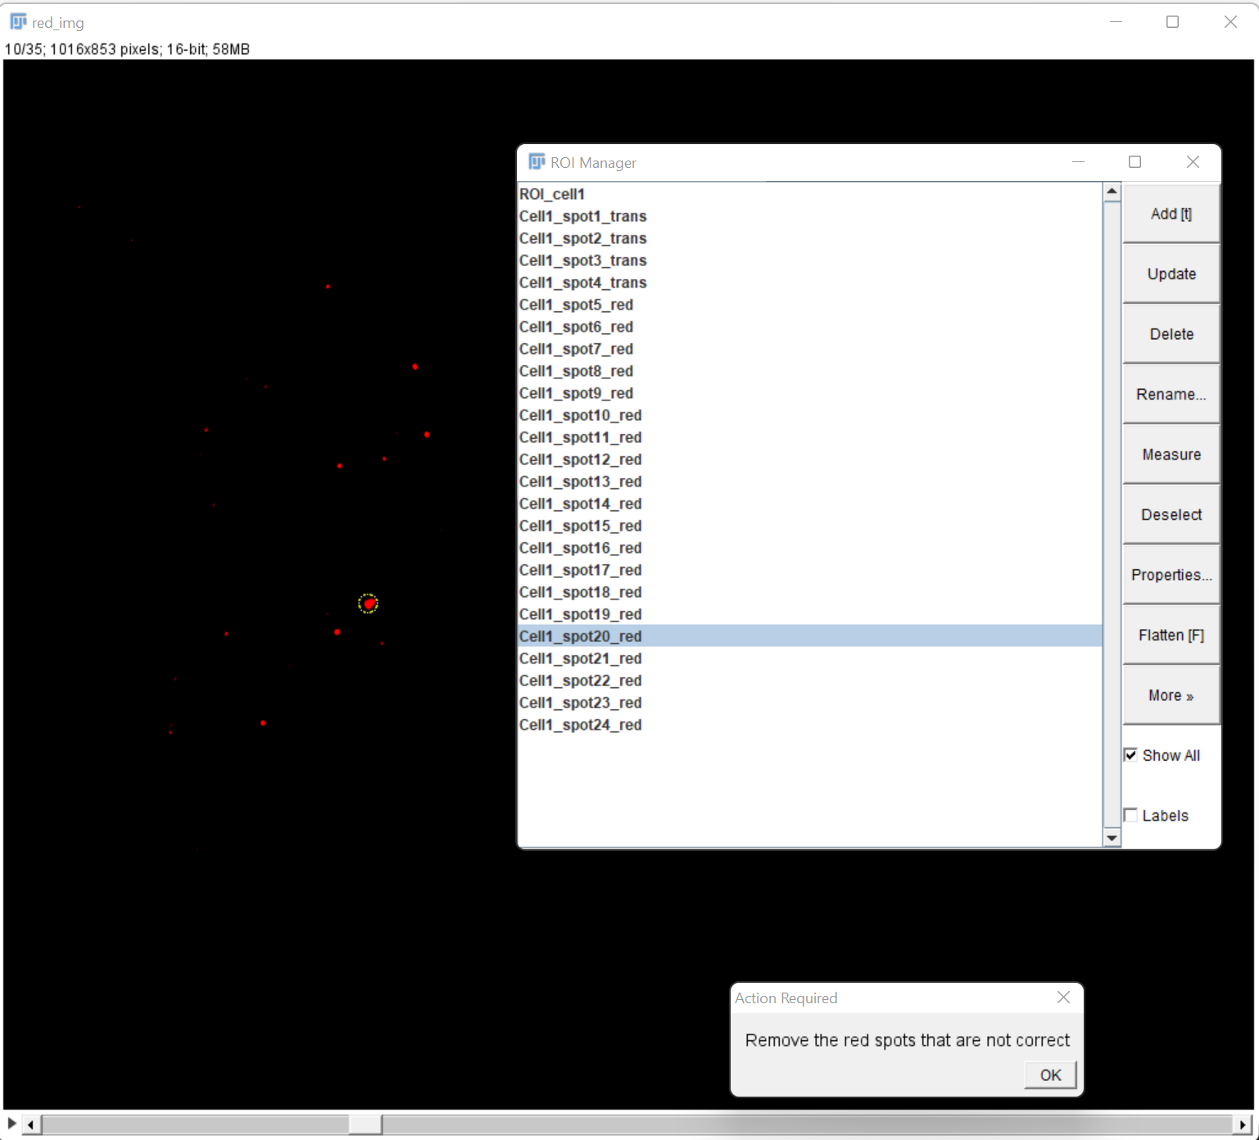

Due to axial chromatic aberration the same pigment in red and transmitted light can be a bit shifted; for this reason, the macro “associates” (i.e. considers as the same) 2 spots (trans & red) if they are located in a spheroid centred on the black spot; the radius in X,Y and number of slices in Z are chosen in the interface in the parameters “*For the connection between red and trans spots*”:

c/ For the channels specified red/green/blue chosen in interface 4/, a threshold is applied on the maximum-z projection (automatic Triangle method), and used on the stack to define the presence or absence of the corresponding proteins:

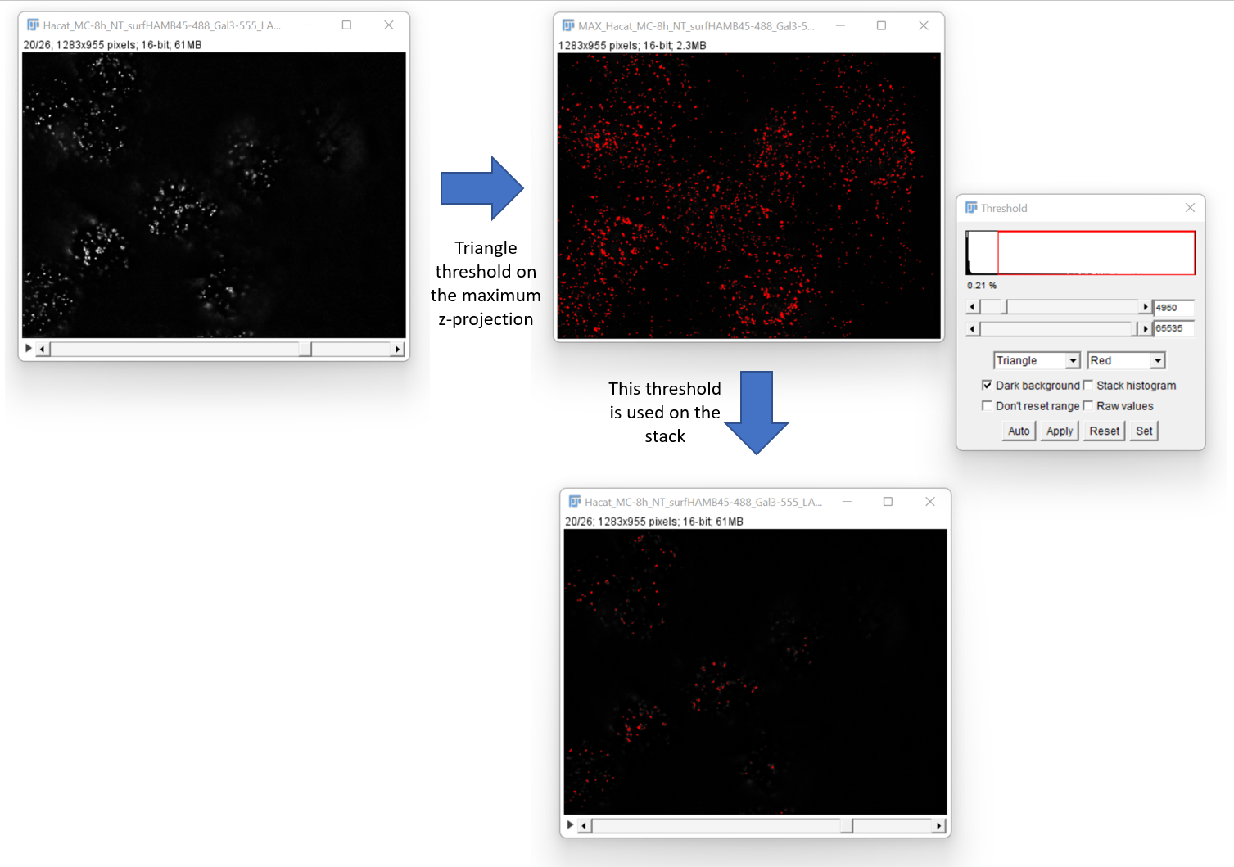

7/ The result table recapitulates for each channel analysed in 6/b/:

* Max and mean values are calculated on the spheroid defines in the interface of step 3/ in the part “*For the analysis of proteins around the pigment*”
* Positiveness for one channel is computed as yes if the maximum in the spheroid is above the threshold computed in step 6/c/

This result table as well as the ROIs (cell(s) + pigments) are saved in the folder containing the data.

**How to choose the find maxima parameters?**

*Transmitted light channel:*

* Duplicate the stack for the channel of transmitted light channel, for the slices you will use for the analysis
* Perform the “Minimum Intensity” Z-projection (Image > Stacks > Z project…)
* Adjust Brightness & Contrast if necessary (this Option will be blocked once you launched FindMaxima)
* Process> Find Maxima on this image. Check the best parameter for “Prominence” (use the “Preview point selection” check); be careful to check “Light Background”; this best “Prominence” value is the one you should enter in step 3/

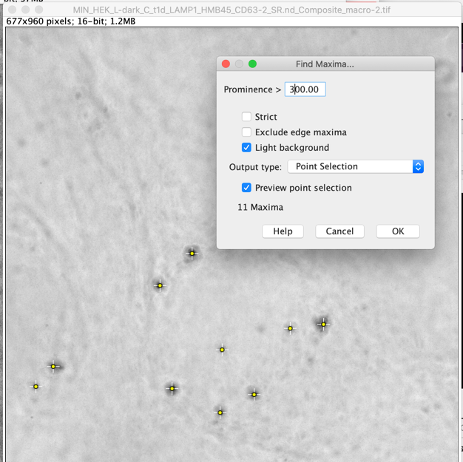

*Red:*

* Duplicate the stack for the channel red channel, for the slices you will use for the analysis
* Perform the “Maximum Intensity” Z-projection (Image > Stacks > Z project…)
* Adjust Brightness & Contrast if necessary (this Option will be blocked once you launched FindMaxima)
* Process> Find Maxima on this image. Check the best parameter for “Prominence” (use the “Preview point selection” check); be careful to un-check “Light Background”; this best “Prominence” value is the one you should enter in step 3/

