# Explanations distancePigments_nucleus_vf.ijm

This macro should be launched after the macro *detectPigment_quantifySignalAround_vf.ijm*.

The associated image should have as last channel the nucleus (called cyan)

(-> This could easily be modified by asking the user the channel of nucleus)

1/ The macro asks to load a **ROI set** (generated by the macro *detectPigment_quantifySignalAround_vf.ijm*); if the file is not a .zip, the macro will exit with this message:

From this ROI set, the macro detects the image name and the possible sub-stack performed to keep only the slices of interest.

2/ The macro asks for the XY and Z-steps in µm:

3/ On the last channel, on the maximum z-projection, a threshold (Otsu method after a subtract background) is applied to create a mask. Sequentially for each cell, an object detection is performed on the mask.

* If only one object of area over 100 pixels is detected in the ROI of the cell, it is considered as the nucleus and the corresponding Z is defined as the slice with maximum standard deviation:

*Z= 7 defined as the « focal » plane*

The user is asked to check and re-draw if necessary the nucleus for the corresponding cell:

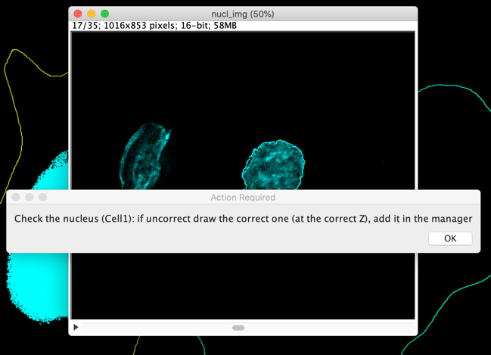

* If more than one object (of area over 100 pixels) is detected, the user is directly asked to draw the correct nucleus (**at the correct Z**):

4/ For each pigment loaded in the zip file (detected before, with the macro *detectPigment_quantifySignalAround_vf.ijm*), the (Euclidian) distance between this pigment, located in , and the nucleus, located in is computed thanks to:

This distance is saved in an excel file, in the folder containing the image, with the image name and finishing by “*distanceNucleus_eachPigment.xls*”

5/ In addition some characteristics of each nucleus are computed, especially an approximative radius, as the average of the major and minor axis divided by 2:

Original ROI Fit ellipse of the ROI Minor & Major axis

In the publication, are presented the subtraction between the positions computed in step 4/ and the average radius.

At the end of the macro are saved (in the folder containing the data):

* The ROIs of cells (from previous macro) and nuclei
* The Result table with distance from the nucleus center for each pigment:

* A Result table with characteristics of the nuclei:

