# Explanations macro detectPigment_generalisation_v3.ijm

Please be sure that the Fiji version you are using is **1.52p**; unfortunately, a change in version 1.53 makes that the macro **does not work properly anymore but will not show an error message**; especially the pigment ROIs are not associated to the correct slice anymore and this distorts the result because the intensity analysis will not be done on the correct slice.

We think that adding the *Roi.setPosition(channel, slice, frame);* for each oval representing the pigment would deal with this issue but this was not tested.

The Plugin (available in the Github folder, under “Plugins” folder) “Min/Max projection Height Map” is compulsory for this macro. To be short, this Plugin computes the Max/Min projection as in Image>Stacks>Z-projection but also created a “Height Map” indicated for each pixel on which slice its maximum (or minimum depending on the chosen option) was reached

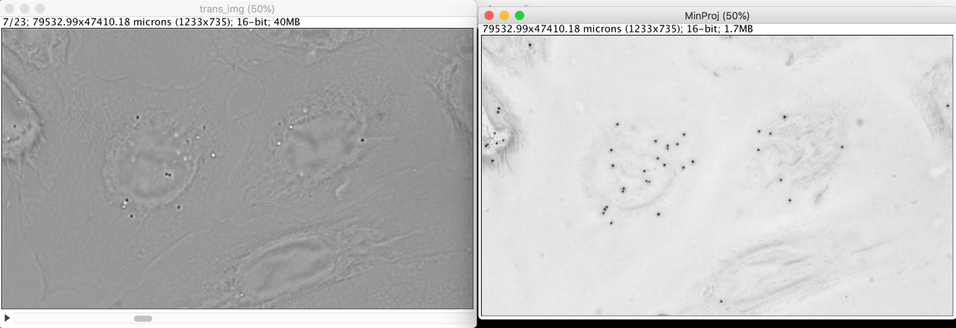

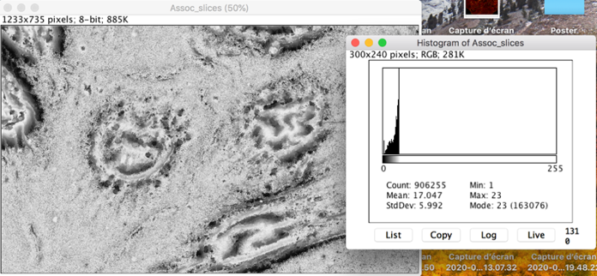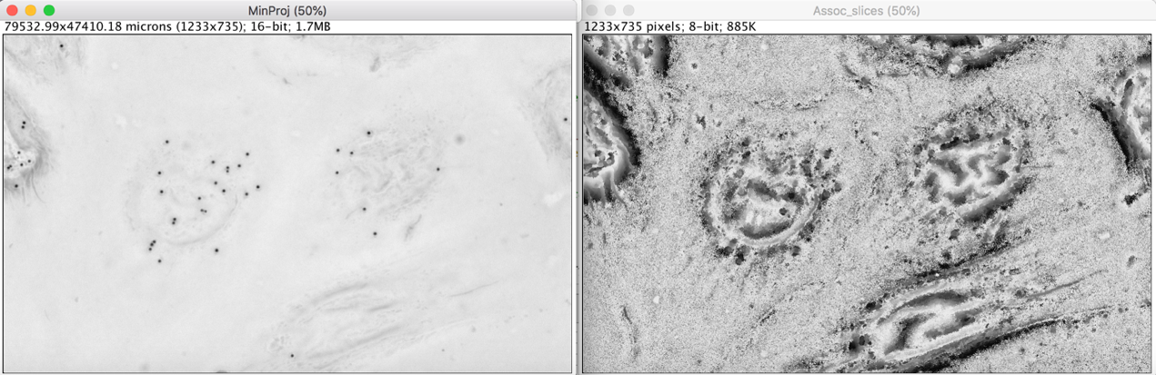

Height map

*Height map histogram: values between 1 and 23 (the number of slices)*

Minimum projection

The value at a pixel (x,y) indicated on which slice, the maximum (resp. minimum) was reached.

## **Steps of the macro**

1/ Choose the image to treat : should be a multi-tiff, Z-stack, several colors, 1 time point.

2/ A pause is made to check the slices you want to remove from the analysis (out of focus too big):

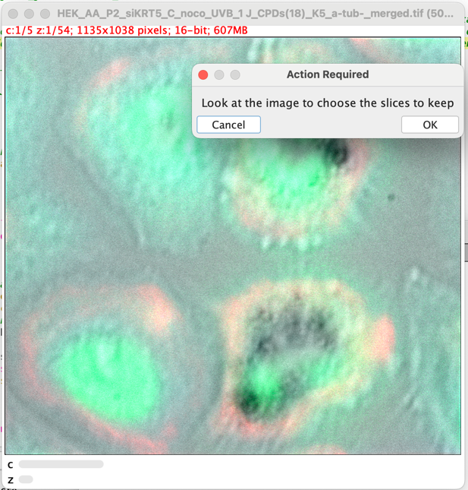

3/ Associate each channel to its correspondence:

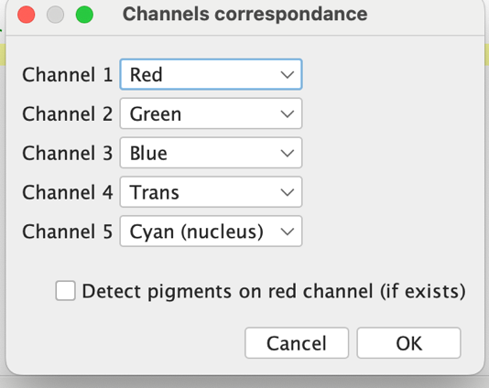

The **Trans channel is compulsory** and is the one on which pigments will be detected. Not that the detection of the pigments in step 6/ is done with the Fiji function FindMaxima (light Background) on the Min Projection of the kept slices; the user should manually **test the values before launching this code** (and put the selected value in the interface in step 3/) otherwise detection may be incorrect.

In the analysis that were made, pigment were also sometimes present in another channel: the red one; that’s why the code offers the possibility to also detect pigments on the Red channel; this option is ignored if there is no channel specified as “Red”.

Channels specified as “Red”, Green” or “Blue” will have their intensity studied around the detected pigments (see step 7/)

*Note that a/ the Cyan (nucleus) is the only one that is ignored in the macro: put this value to all the channels you want to exclude from analysis; b/ the maximum number of channels for analysis is 3 (and you should put them at the distinct values Red/Green/Blue because otherwise the Result table will not show the 3 values)*

3/ Fill the interface with parameters for the analysis:

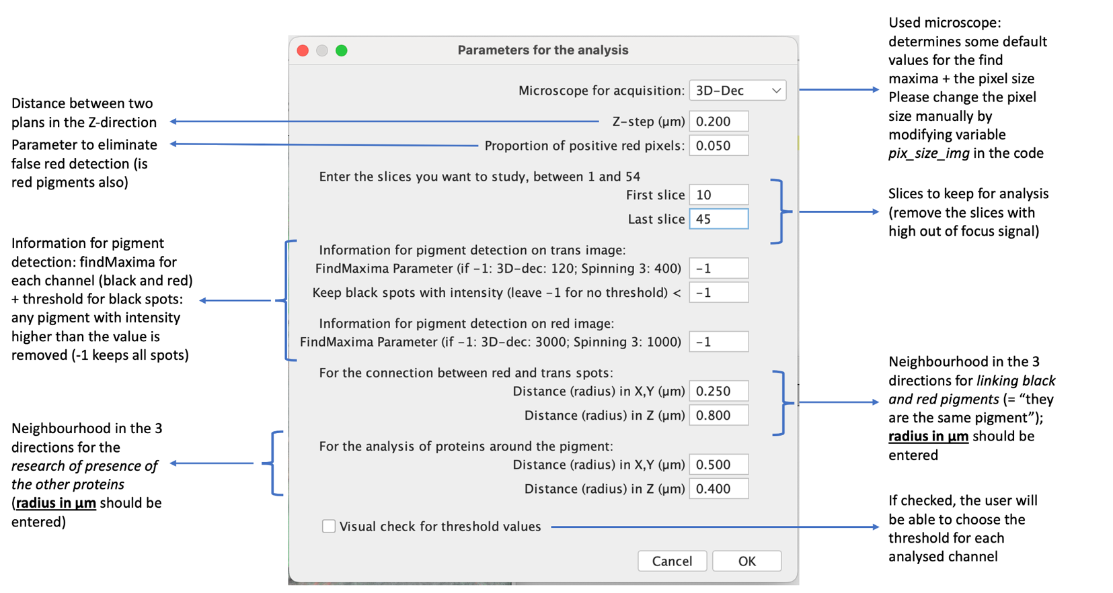

4/ Draw all the cells you want to analyze, one by one and add them in the Manager:

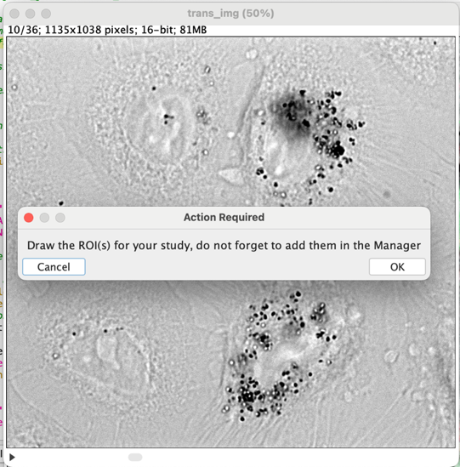

5/ For each cell sequentially, the macro asks to check the pigments on the trans channel and eventually remove/add some (use the ROI Manager to do so):

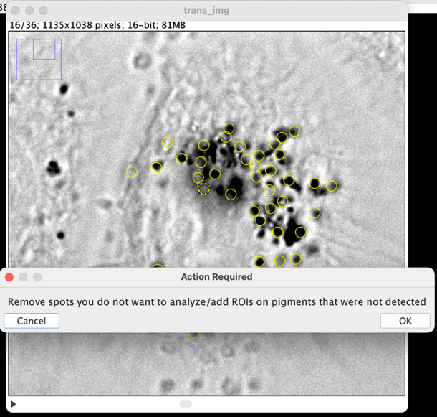

Note that each pigment (circles in the ROI Manager) is associated to a slice and the ROI appears only on this slice. The slice association is done thanks to the Plugin “Min/Max projection Height Map”; more precisely we consider that the Z position of the pigment is the slice of the darkest point of the pigment (i.e. the one detected by the Find Maxima function).

6/ [Optional] If there is a red channel and the user asked to detect pigments on this one also, the steps 5/ is duplicated but on the red channel. If a black and red pigment are “close enough” they are considered the same; “close enough” is defined by the user in the step 3/ as “For the connection between red and trans spots”. The parameter "Proportion of positive red pixels" is also used here to eliminate false positive: if a red pigment is detected with the FindMaxima function but it’s quite isolated the pigment is not considered. More precisely, the proportion of pixels above a defined value (the same as step 7/a/) defines the consideration or not of a pigment.

7/ For the red/green/blue channel is specified the following computations are performed and result table created:

a/ On a maximum z-projection of the channel, the Triangle Threshold [1] is computed and the value is stored

* Note that if the user checked the option “Visual check for threshold values”, the threshold can be manually chosen.

b/ On a circle of size defined in step 3/ (Parameters in “For the analysis of proteins around the pigment”) in the 3 directions, starting from the pigment coordinates defined earlier, the maximum value and mean values are computed and stored in the Results table.

c/ On the same circle, the proportion of voxels above the threshold is computed and stored in the final table

d/ The pigment is considered positive the maximum value is above the threshold defined just before -> this criterion should depend on the type of signal of your channels and could be modified if more diffuse.



*Reference [1]: Zack, G. W., Rogers, W. E., & Latt, S. A. (1977). Automatic measurement of sister chromatid exchange frequency. Journal of Histochemistry &amp; Cytochemistry, 25(7), 741–753.*[*doi:10.1177/25.7.70454*](https://doi.org/10.1177/25.7.70454)

In this macro are saved (and eventually re-used in other macros):

* The Result table
* The threshold values of step 7/a/
* A ROI file containing: all the ROIs of the cells, the pigments of each cell; note that the kept slices are also put in the name of the file in order to continue analysis using the same slices.