Explanation interfaceAlign_SaveEachFrame_SubsamplingOption_v4
This version is no longer distributed as a standalone executable due to the integration of parallel computing features, which are incompatible with the executable format. To run the application, double-click the provided interfaceAlign_SaveEachFrame_SubsamplingOption_v4_launch.bat file. Please note that this file is currently configured for use on the Offline 2 system. While it can be adapted for other computers, it currently includes hardcoded file paths and dependencies specific to this machine and its Python installation.
This version is similar to v3 just working on 4 images in parallel. Here is a copy of the v3 documentation and below a procedure on how to make it work on another computer:
The interface is very minimal in this version, as it only works with the .TIF format (images are read using the memmap function, which only supports this format). The user must select the folder to be processed (all .tif files will be processed; they must have at least the alignment channel located at the same “position”), the alignment channel, and an optional subsampling to apply (XY only):
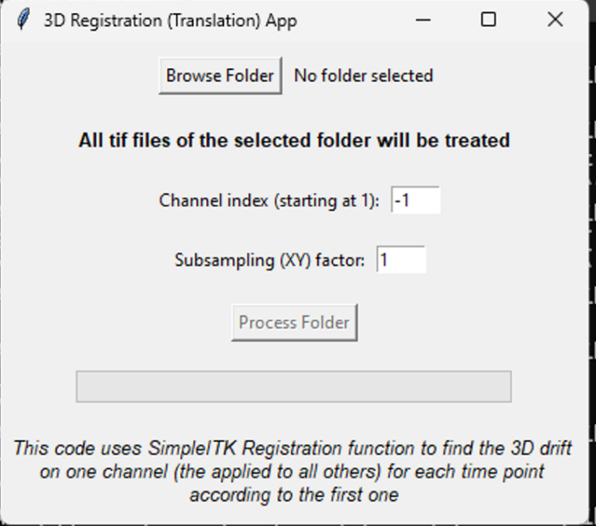
Note that the subsampling is applied after the transformation has been computed (the transformation itself is calculated at the “best resolution” to ensure maximum accuracy). The terminal displays the progress of the processed images.
In this version, the voxel size and the timestamp are written into the final image (copied from the original image or recalculated in the case of subsampling). As before, the alignment consists of a 3D translation computed using SimpleITK. However, in this version, a subfolder is created for each image, containing each aligned frame for each channel. This approach allows the Python code to load into memory only the first frame (the reference) and the frame to be aligned (which changes at each iteration). In addition, a infoSize.csv file specifies how many channels, slices (possibly increased by the registration), and frames make up the final stack. Note that the transformations are also saved incrementally in the transfos.npy file (Python format) in case of a code bug (or a forced interruption). Now, resuming the computation from this file has not been tested yet and remains to be implemented.
After all images are treated, Fiji is launched (“headless”) to reconstruct the images (this approach was chosen because reconstruction often crashed when implemented directly in the Python code).
Important: for this to work, a configuration file config_FijiPath.txt must be located in the same directory as the python file [specific to v4]. This file contains the path to the Fiji executable (see screenshot of the file below). The path should ideally not contain spaces (this has not been verified).
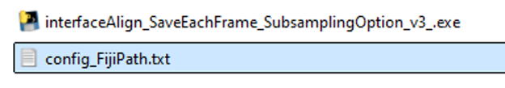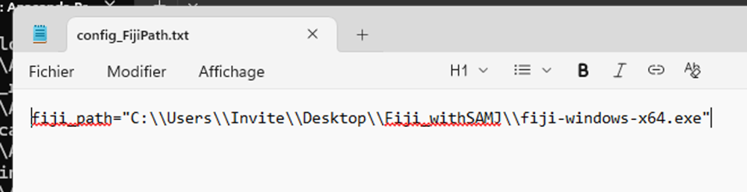
Additionally, the macro createHyperstack_afterPythonAlign_v*.ijm must be placed in Fiji’s macro folder (accessible via File > Show Folder > Macros).
If the reconstruction fails, either due to a Fiji issue or because it crashes—this error message has already been observed below in an apparently “random” manner, as relaunching the same process later worked:
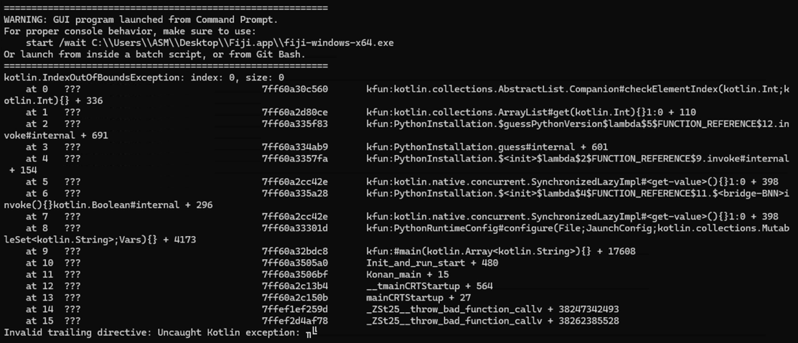
the macro createHyperstack_afterPythonAlign_v*.ijm can be run directly from Fiji. It simply asks for the input folder, which is the same folder selected in the interface. It then checks each subfolder and, if the infoSize.csv file exists, opens the image as an Image Sequence and converts it into a hyperstack using the values stored in this file. Note that if the reconstructed image already exists, the folder is skipped.
This is an example of a folder after reconstruction (cropped image for the test):
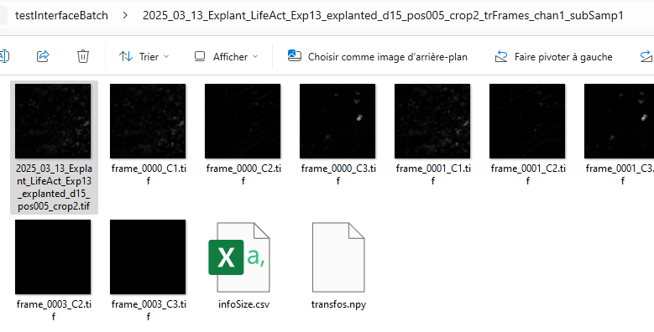
When everything goes well for the reconstruction, you should see that:
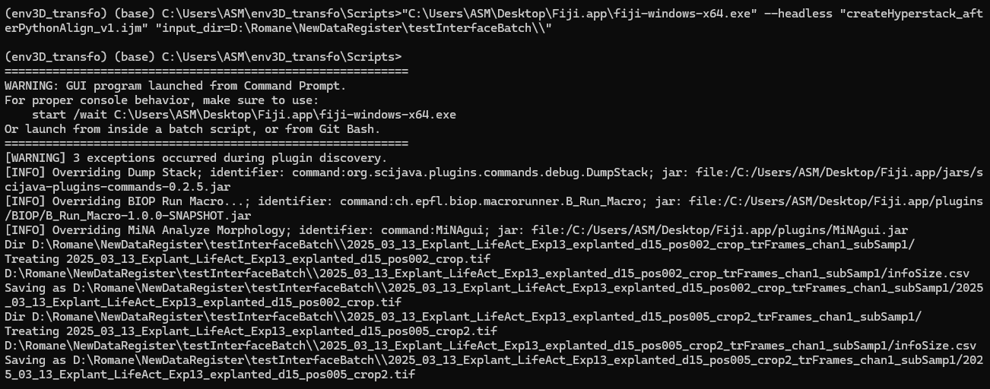

To make it work on another computer:
1/ Installation of the conda environment:
- conda create -n envTransfo3D python=3.12
- conda activate envTransfo3D
- pip install -r pathToRequirementsFile
This requirement file contains:
altgraph==0.17.4
numpy==2.3.4
packaging==25.0
pefile==2023.2.7
pillow==12.0.0
psutil==7.1.3
pyinstaller==6.16.0
pyinstaller-hooks-contrib==2025.9
pywin32-ctypes==0.2.3
setuptools==80.9.0
simpleitk==2.5.2
tifffile==2025.10.16
2/ Copy the script interfaceAlign_SaveEachFrame_SubsamplingOption_v4.py in a specific folder, with full path scriptFolder (it may be better that there is no space in it -> to be tested); put config_FijiPath.txt in the same folder.
3/ Modify accordingly interfaceAlign_SaveEachFrame_SubsamplingOption_v4_launch.bat:
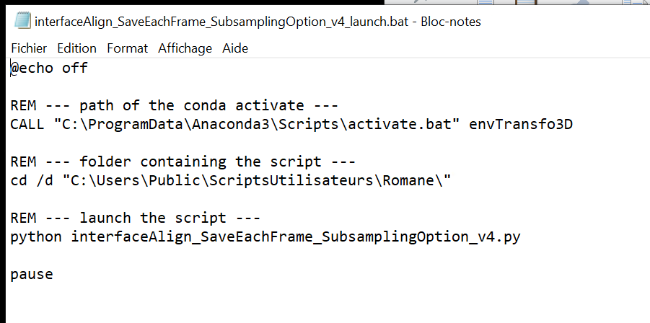
To know where is “activate.bat”, do “conda env list” and the first one should give the path containing the Scripts folder (check that it’s here of course) :
