Modele de regression lineaire

Anne-Valerie Jeudy

2022-12-10

## Donnees sur le credit bancaire

donnees<-read.csv("CreditBancaire1.csv.csv")

## Creation du modele de regression lineaire

model<-lm(Jours~Credit+Type,data=donnees)  
model

##   
## Call:  
## lm(formula = Jours ~ Credit + Type, data = donnees)  
##   
## Coefficients:  
## (Intercept) Credit TypeConsommation TypeProduction   
## 8.519e+01 -5.484e-06 -1.486e+01 1.498e+01

summary(model)

##   
## Call:  
## lm(formula = Jours ~ Credit + Type, data = donnees)  
##   
## Residuals:  
## Min 1Q Median 3Q Max   
## -96.26 -69.22 -49.06 17.29 270.22   
##   
## Coefficients:  
## Estimate Std. Error t value Pr(>|t|)   
## (Intercept) 8.519e+01 1.275e+01 6.681 1.63e-10 ***  
## Credit -5.484e-06 1.182e-05 -0.464 0.643   
## TypeConsommation -1.486e+01 1.472e+01 -1.009 0.314   
## TypeProduction 1.498e+01 2.532e+01 0.591 0.555   
## ---  
## Signif. codes: 0 '***' 0.001 '**' 0.01 '*' 0.05 '.' 0.1 ' ' 1  
##   
## Residual standard error: 104 on 241 degrees of freedom  
## Multiple R-squared: 0.007512, Adjusted R-squared: -0.004842   
## F-statistic: 0.608 on 3 and 241 DF, p-value: 0.6104

## Affichage des coefficients estimes, ceux de student et les probabilites

modele <- summary(lm(Jours~Credit+Type, data=donnees))  
 Coef.Est<-modele$coefficients[, 1]  
 T.Values<-modele$coefficients[, 3]  
 P.Values<-modele$coefficients[, 4]  
data1<-data.frame(Coef.Est,T.Values,P.Values)   
data1

## Coef.Est T.Values P.Values  
## (Intercept) 8.519082e+01 6.6809256 1.630050e-10  
## Credit -5.483559e-06 -0.4637417 6.432514e-01  
## TypeConsommation -1.485726e+01 -1.0090929 3.139421e-01  
## TypeProduction 1.497503e+01 0.5913659 5.548295e-01

## Mise en valeur des coefficients

data2<-data.frame(Coef.Est,T.Values)  
data2

## Coef.Est T.Values  
## (Intercept) 8.519082e+01 6.6809256  
## Credit -5.483559e-06 -0.4637417  
## TypeConsommation -1.485726e+01 -1.0090929  
## TypeProduction 1.497503e+01 0.5913659

## Representation graphique

## Warning in abline(model): only using the first two of 4 regression coefficients

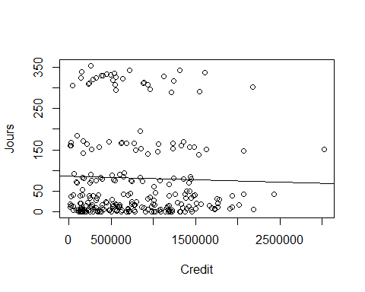

# Creation d’une fonction generant les coefficients

Coeff<-function(data){

Stat0<- summary(lm(y~., data = data))

Coef.Est<-Stat0 $coefficients\left[,1\right]T.Values<−Stat0$ coefficients[, 3]

return(data.frame(Coef.Est,T.Values)) }