**ASSIGNMENT-1**

1. Show the details of all employees.  
     
   Ans: Select * from emp;

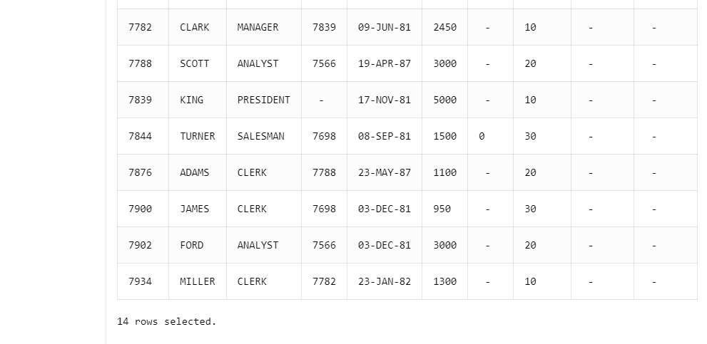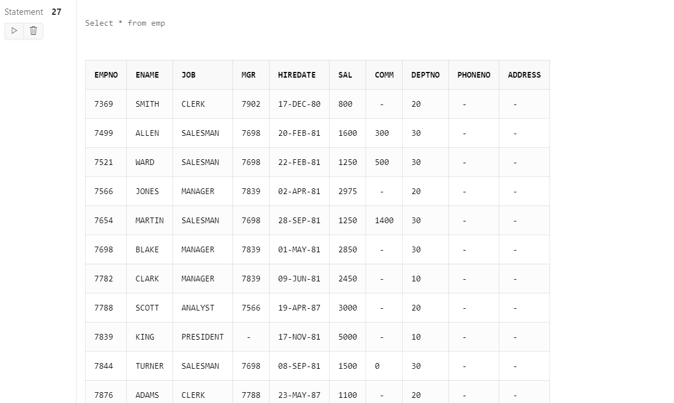

1. 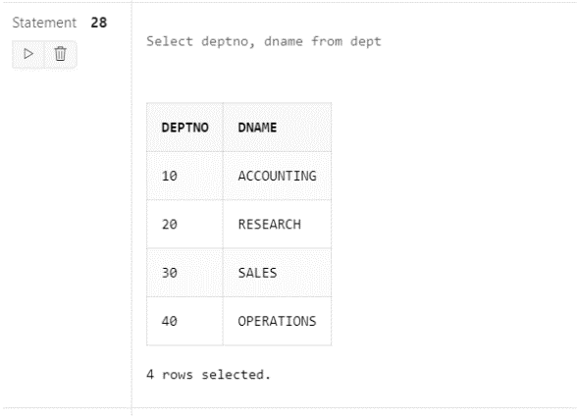Show the department no. and name of all departments.  
     
   Ans: Select deptno, dname from dept
2. Display the employee id, name and department no of all employees whose department no

is 20.

Ans: Select EMPNO, ENAME, DEPTNO from emp WHERE DEPTNO=20;

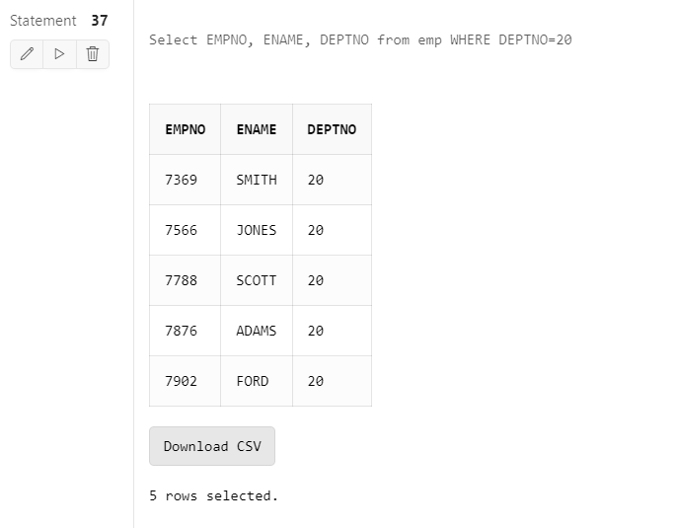

1. Display the details of all employees where department no should be in descending order.

Ans: Select * from emp ORDER BY deptno desc;

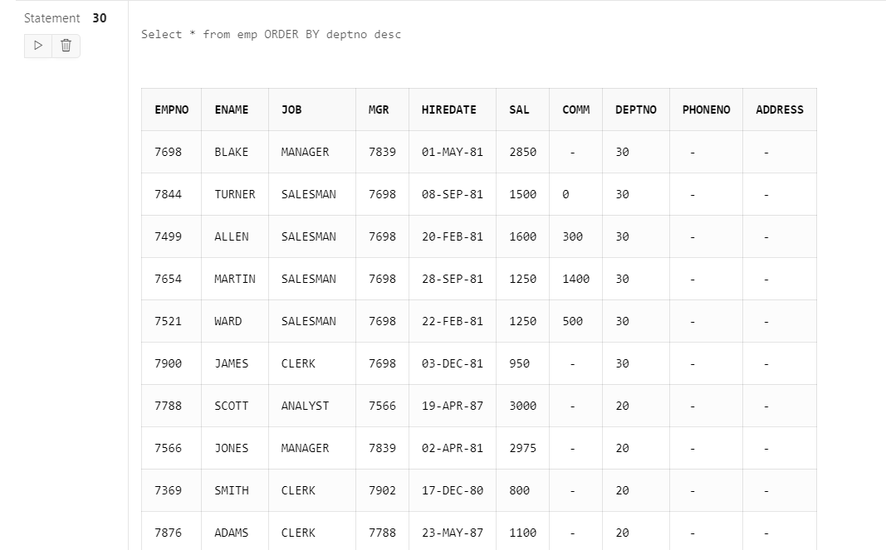

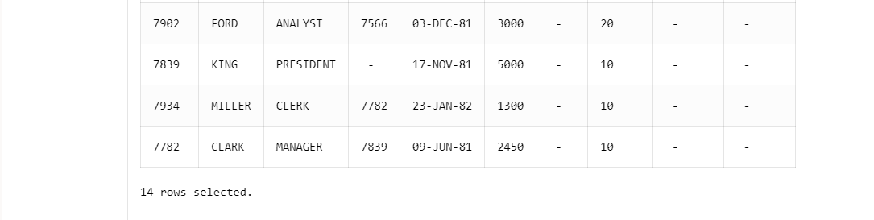

1. Show all available jobs in the employee table.

Ans: Select DISTINCT job from emp;

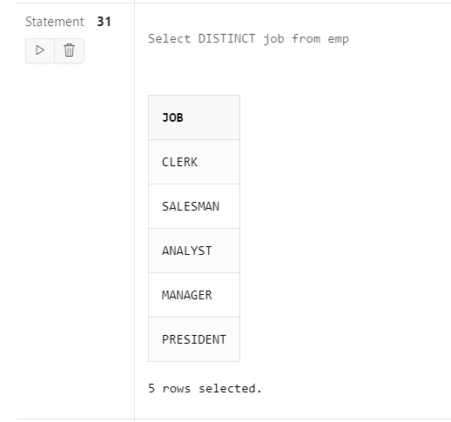

1. Show the name, Annual Salary and department no of employees who works as a clerk in

department 20.

Ans: Select ENAME, SAL, DEPTNO from emp WHERE job=’CLERK’ and DEPTNO=20;

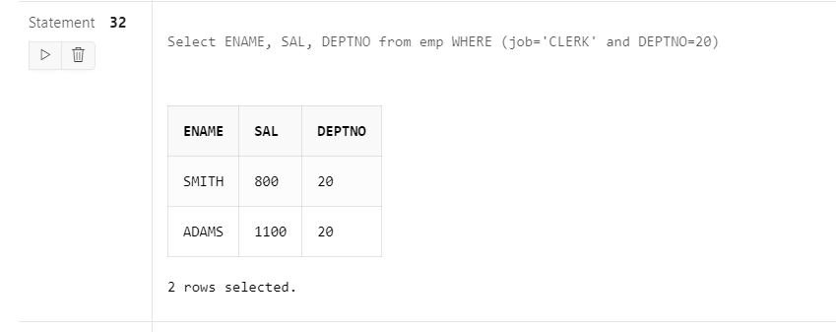

1. Show the name and HIRED date of those employee whose name start with ‘S’ or second

character is ‘C’.

Ans: Select ENAME, HIREDATE from emp where ENAME like ’S%’ or ENAME like ’_C%’;

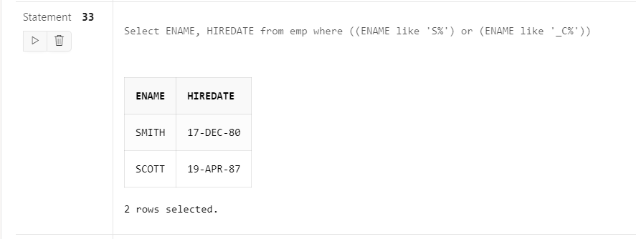

1. Show the name, hire date and salary of those employee who are not a manager.

Ans: Select ENAME, HIREDATE, SAL from emp WHERE NOT job=’MANAGER’;

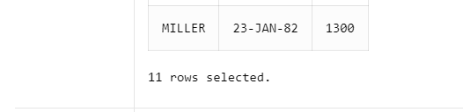

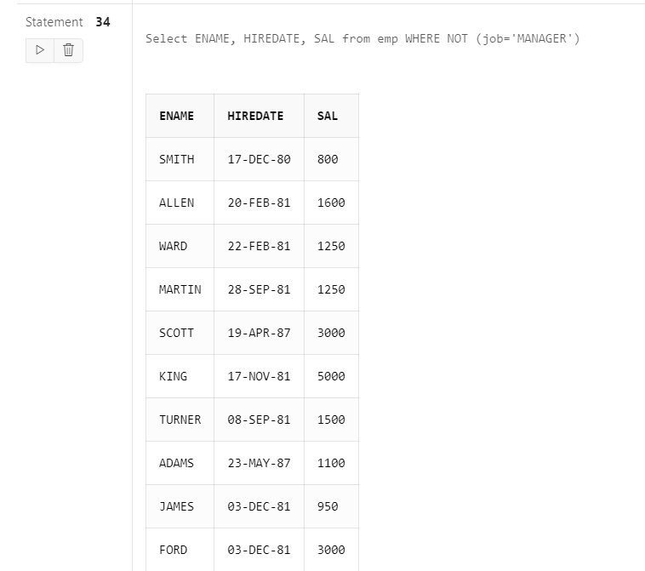

1. Display all employee names in title case and length of the name.

Ans: SELECT INITCAP(ENAME) AS TitleCaseName, LENGTH(ENAME) AS NameLength FROM EMP;

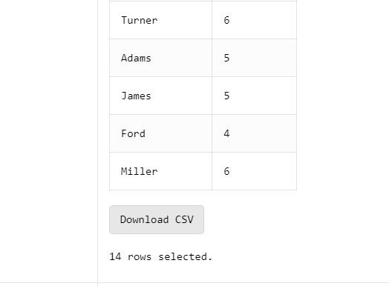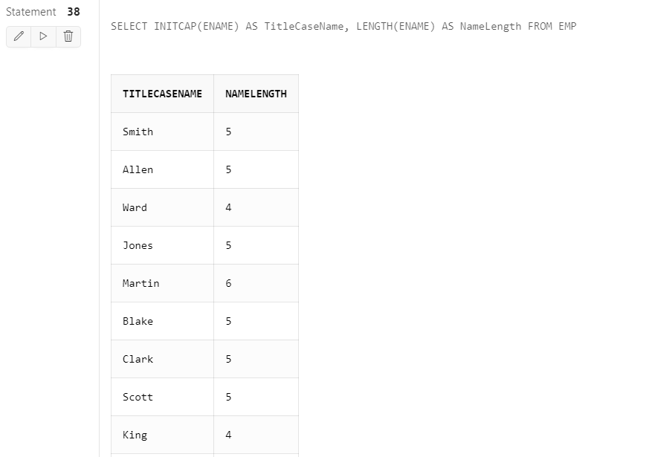

1. Display the name of employee who gets the salary between 4000 to 6000.

Ans: Select ENAME from emp WHERE SAL>=4000 and SAL<=6000;

