**ASSIGNMENT – 4**

**Question:**

Consider a BANK database. Each bank can have multiple branches, and each branch can have

multiple accounts and loans. Assumptions also can be made. Design an ER diagram and database schema for the system. Specify the primary key, foreign key and other constraints for all required tables. Draw the ER diagram in MS Word.

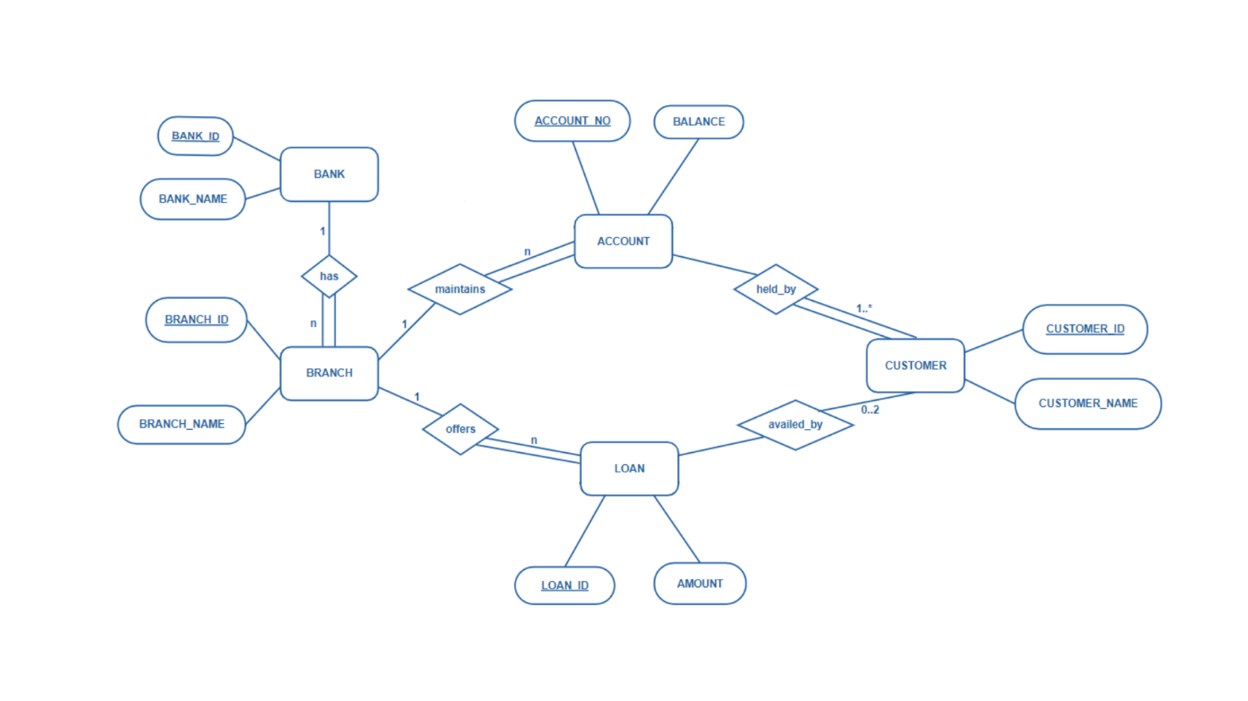 **E-R Diagram:**

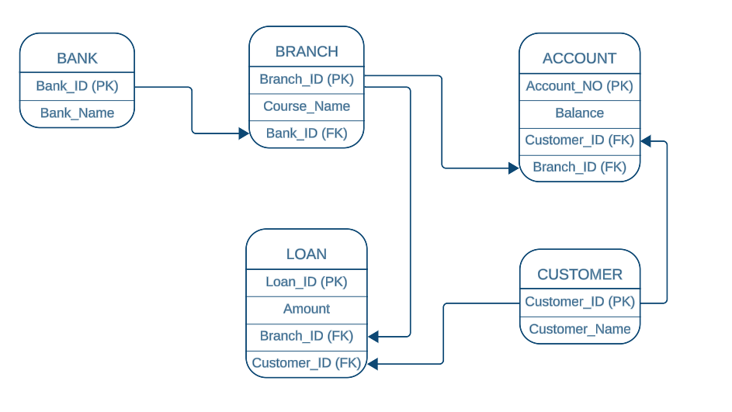**Database Schema:**

1. 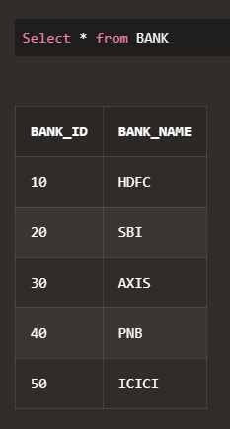**Insert at least five tuples in each table.**

-- BANK Table

Create Table BANK (

BANK_ID number (2) PRIMARY KEY,

BANK_NAME varchar (100) NOT NULL);

Insert into BANK values (10,'HDFC');

Insert into BANK values (20, 'SBI');

Insert into BANK values (30, 'AXIS');

Insert into BANK values (40, 'PNB');

Insert into BANK values (50, 'ICICI');

-- BRANCH Table

Create Table Branch (

BRANCH_ID number (3) PRIMARY KEY,

BRANCH_NAME varchar (100) NOT NULL,

BANK_ID number (2),

Foreign key (BANK_ID) REFERENCES bank (BANK_ID) on DELETE CASCADE);

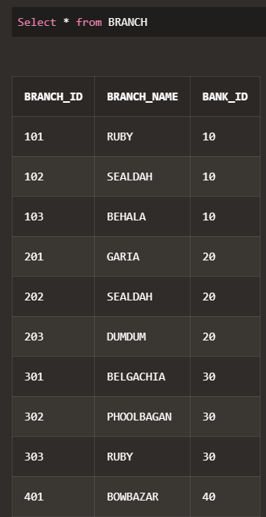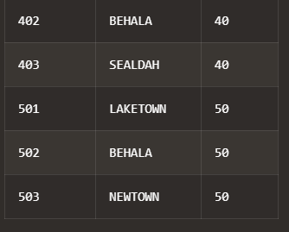

Insert into BRANCH values (101, 'RUBY', 10);

Insert into BRANCH values (102, 'SEALDAH', 10);

Insert into BRANCH values (103, 'BEHALA', 10);

Insert into BRANCH values (201, 'GARIA', 20);

Insert into BRANCH values (202, 'SEALDAH', 20);

Insert into BRANCH values (203, 'DUMDUM', 20);

Insert into BRANCH values (301, 'BELGACHIA', 30);

Insert into BRANCH values (302, 'PHOOLBAGAN', 30);

Insert into BRANCH values (303, 'RUBY', 30);

Insert into BRANCH values (401, 'BOWBAZAR', 40);

Insert into BRANCH values (402, 'BEHALA', 40);

Insert into BRANCH values (403, 'SEALDAH', 40);

Insert into BRANCH values (501, 'LAKETOWN', 50);

Insert into BRANCH values (502, 'BEHALA', 50);

Insert into BRANCH values (503, 'NEWTOWN', 50);

-- CUSTOMER Table

Create Table CUSTOMER (

CUSTOMER_ID number (5) PRIMARY KEY,

CUSTOMER_NAME varchar (100) NOT NULL);

Insert into CUSTOMER values (10101, 'ABHAY');

Insert into CUSTOMER values (10201, 'SHAHANA');

Insert into CUSTOMER values (10301, 'MANISH');

Insert into CUSTOMER values (20201, 'STELLA');

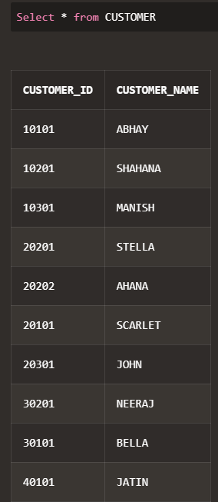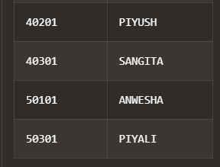

Insert into CUSTOMER values (20202, 'AHANA');

Insert into CUSTOMER values (20101, 'SCARLET');

Insert into CUSTOMER values (20301, 'JOHN');

Insert into CUSTOMER values (30201, 'NEERAJ');

Insert into CUSTOMER values (30101, 'BELLA');

Insert into CUSTOMER values (40101, 'JATIN');

Insert into CUSTOMER values (40201, 'PIYUSH');

Insert into CUSTOMER values (40301, 'SANGITA');

Insert into CUSTOMER values (50101, 'ANWESHA');

Insert into CUSTOMER values (50301, 'PIYALI');

-- ACCOUNT Table

Create Table ACCOUNT (

ACCOUNT_NO number (11) PRIMARY KEY,

BALANCE decimal (10, 2),

CUSTOMER_ID number (5),

BRANCH_ID number (3),

Foreign key (CUSTOMER_ID) REFERENCES Customer (CUSTOMER_ID) on DELETE CASCADE,

Foreign key (BRANCH_ID) REFERENCES Branch (BRANCH_ID) on DELETE CASCADE);

Insert into ACCOUNT values (55690129329, 35486.12, 10101, 101);

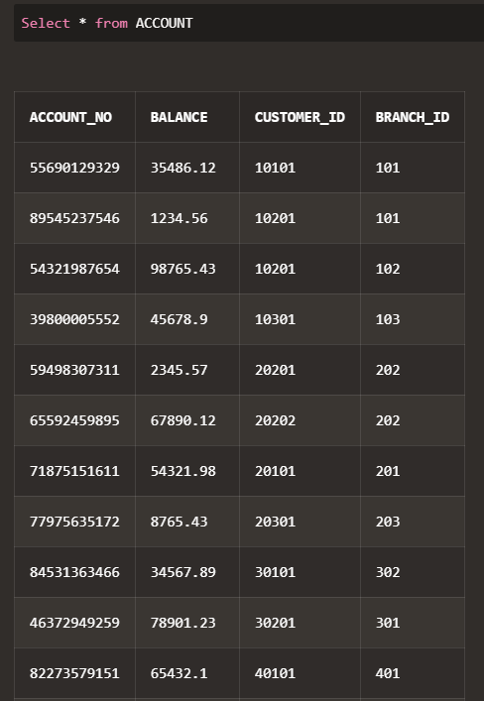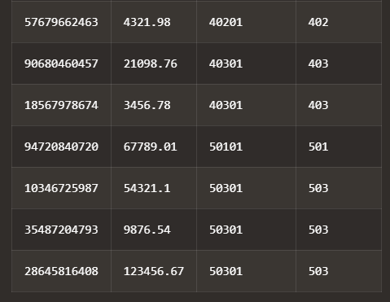

Insert into ACCOUNT values (89545237546, 1234.56, 10201, 101);

Insert into ACCOUNT values (54321987654, 98765.43, 10201, 102);

Insert into ACCOUNT values (39800005552, 45678.90, 10301, 103);

Insert into ACCOUNT values (59498307311, 2345.57, 20201, 202);

Insert into ACCOUNT values (65592459895, 67890.12, 20202, 202);

Insert into ACCOUNT values (71875151611, 54321.98, 20101, 201);

Insert into ACCOUNT values (77975635172, 8765.43, 20301, 203);

Insert into ACCOUNT values (84531363466, 34567.89, 30101, 302);

Insert into ACCOUNT values (46372949259, 78901.23, 30201, 301);

Insert into ACCOUNT values (82273579151, 65432.10, 40101, 401);

Insert into ACCOUNT values (57679662463, 4321.98, 40201, 402);

Insert into ACCOUNT values (90680460457, 21098.76, 40301, 403);

Insert into ACCOUNT values (18567978674, 3456.78, 40301, 403);

Insert into ACCOUNT values (94720840720, 67789.01, 50101, 501);

Insert into ACCOUNT values (10346725987, 54321.10, 50301, 503);

Insert into ACCOUNT values (35487204793, 9876.54, 50301, 503);

Insert into ACCOUNT values (28645816408, 123456.67, 50301, 503);

-- LOAN Table

Create Table LOAN (

LOAN_ID number (6) PRIMARY KEY,

LOAN_AMOUNT decimal (12, 2),

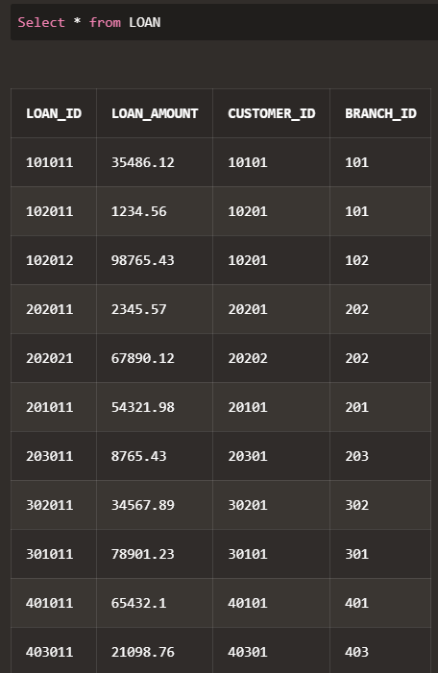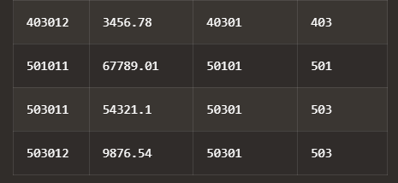

CUSTOMER_ID number (5),

BRANCH_ID number (3),

Foreign key (CUSTOMER_ID) REFERENCES Customer (CUSTOMER_ID) on DELETE CASCADE,

Foreign key (BRANCH_ID) REFERENCES Branch (BRANCH_ID) on DELETE CASCADE);

Insert into LOAN values (101011, 35486.12, 10101, 101);

Insert into LOAN values (102011, 1234.56, 10201, 101);

Insert into LOAN values (102012, 98765.43, 10201, 102);

Insert into LOAN values (202011, 2345.57, 20201, 202);

Insert into LOAN values (202021, 67890.12, 20202, 202);

Insert into LOAN values (201011, 54321.98, 20101, 201);

Insert into LOAN values (203011, 8765.43, 20301, 203);

Insert into LOAN values (302011, 34567.89, 30201, 302);

Insert into LOAN values (301011, 78901.23, 30101, 301);

Insert into LOAN values (401011, 65432.10, 40101, 401);

Insert into LOAN values (403011, 21098.76, 40301, 403);

Insert into LOAN values (403012, 3456.78, 40301, 403);

Insert into LOAN values (501011, 67789.01, 50101, 501);

Insert into LOAN values (503011, 54321.10, 50301, 503);

Insert into LOAN values (503012, 9876.54, 50301, 503);

1. **Every customer must have at least one account but is restricted to at most two loans at a time.**

Alter table CUSTOMER

Add ACCOUNT_NO number (11) NOT NULL

Add constraint FK foreign key (ACCOUNT_NO) REFERENCES account (ACCOUNT_NO);

Create TRIGGER MaxLoansPerCustomer

Before insert on LOAN

For each row

BEGIN

DECLARE loan_count INT;

Select COUNT (*) INTO loan_count

from LOAN

where CUSTOMER_ID = NEW.CUSTOMER_ID;

IF loan_count >= 2 THEN

SIGNAL SQLSTATE '45000'

SET MESSAGE_TEXT = 'A customer can have a maximum of 2 loans.';

END IF;

END;

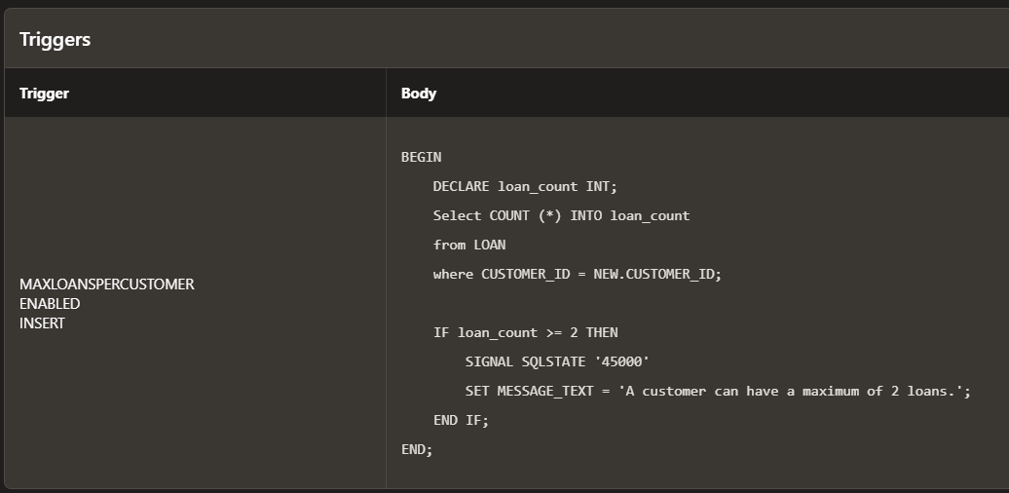

1. **Give all the account details of a person who has accounts in SBI.**

Select A.*

from ACCOUNT A

join BRANCH B ON A.Branch_ID = B.Branch_ID

join BANK K ON B.Bank_ID = K.Bank_ID

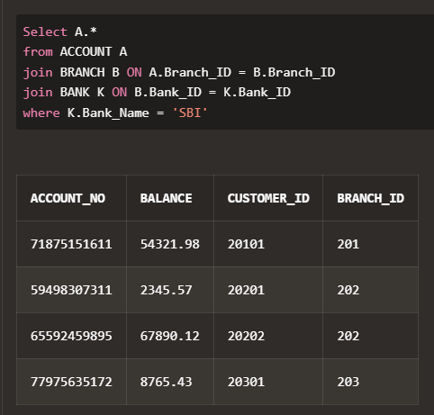where K.Bank_Name = 'SBI';

1. **Find the account holder name who has more than 2 accounts.**

Select CUSTOMER_NAME

from CUSTOMER

where CUSTOMER_ID in (

select A. CUSTOMER_ID

from ACCOUNT A

group by A. CUSTOMER_ID

having COUNT(A.ACCOUNT_No) > 2);

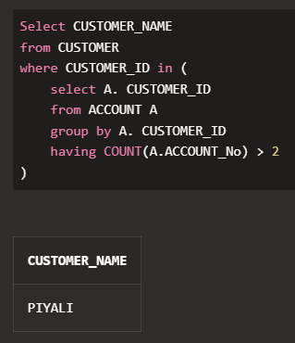

1. **Rename the accounts table as account details.**

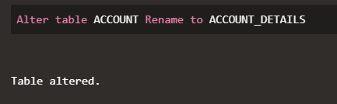Alter table ACCOUNT Rename to ACCOUNT_DETAILS;

1. **Find the loan amount and loan taken from which bank for each account holder.**

Select C.Customer_Name, L.Loan_Amount, B.Bank_Name

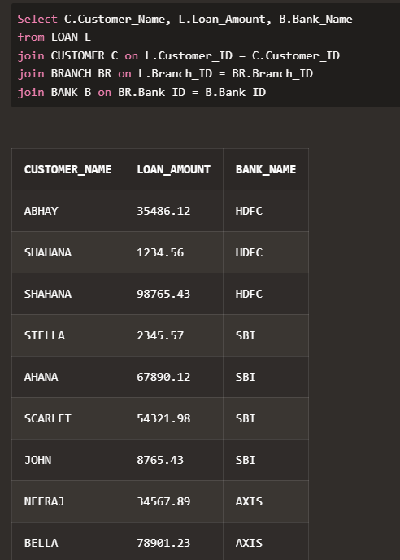from LOAN L

join CUSTOMER C on L.Customer_ID = C.Customer_ID

join BRANCH BR on L.Branch_ID = BR.Branch_ID

join BANK B on BR.Bank_ID = B.Bank_ID;

1. **Find the account no. and account holder name who has not taken any loan.**

Select A.Account_No, C.Customer_Name

from ACCOUNT_DETAILS A

join CUSTOMER C on A.Customer_ID = C.Customer_ID

left join LOAN L on A.Customer_ID = L.Customer_ID

where L.Loan_ID IS NULL;

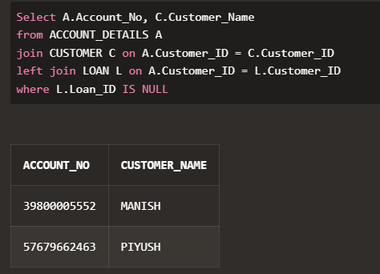

1. **Delete the account of all the persons who had accounts in PNB, Sealdah branch.**

Delete from ACCOUNT_DETAILS

where BRANCH_ID =

(Select Branch_ID from BRANCH where BRANCH_NAME = 'Sealdah'

and BANK_ID = (Select BANK_ID from BANK where BANK_NAME = 'PNB'));

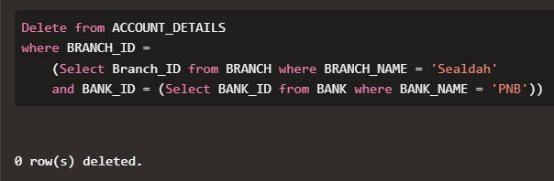

1. **Update the branch to SBI, Salt Lake branch for all the persons who had a SBI account in**

**Sealdah branch.**

Update BRANCH

set BRANCH_NAME ='SALT LAKE'

where BANK_ID = (select BANK_ID from BANK where BANK_NAME = 'SBI')

and BRANCH_NAME = 'SEALDAH';

1. 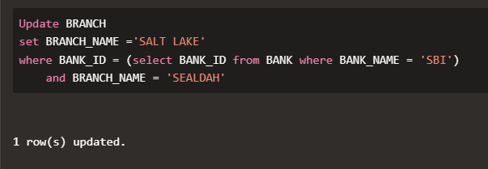**Find the maximum account balance of a person with account no 54321987654 among all of his accounts.**

Select MAX(Balance)

from ACCOUNT_DETAILS

where CUSTOMER_ID =

(select CUSTOMER_ID from ACCOUNT_DETAILS where ACCOUNT_NO = 54321987654);

