**PL/SQL Assignment 1, 2024**

1. Write a PL/SQL code to print Today is fall on weekend or weekdays using if else statement.

DECLARE

todays_date DATE;

current_day VARCHAR(9);

BEGIN

todays_date := sysdate;

current_day := TO_CHAR(todays_date, 'day');

current_day := INITCAP(current_day);

current_day := RTRIM(current_day);

IF current_day='Sunday' OR current_day='Saturday' THEN

dbms_output.put_line ('Today is fall on weekend');

ELSE

'Today is fall on weekdays');

dbms_output.put_line (

END IF;

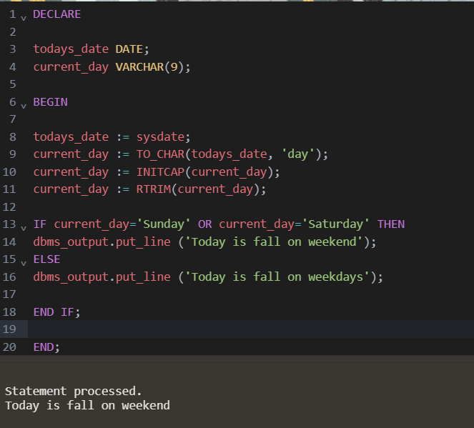END;

[today here is referred to 26/10/2024 which is Saturday hence weekend]

1. Write a PL/SQL code to check that an inputted a single character is vowel or not. If vowel THEN display which vowel it is.

DECLARE

input_char CHAR;

c CHAR;

BEGIN

input_char := 'a';

c := INITCAP (input_char);

IF c='A' OR c='E' OR c='I' OR c='O' OR c='U' THEN

dbms_output.put_line ('Character is a vowel');

dbms_output.put_line ('The character is ' || input_char);

ELSE

dbms_output.put_line ('Character is a consonant');

END IF;

END;

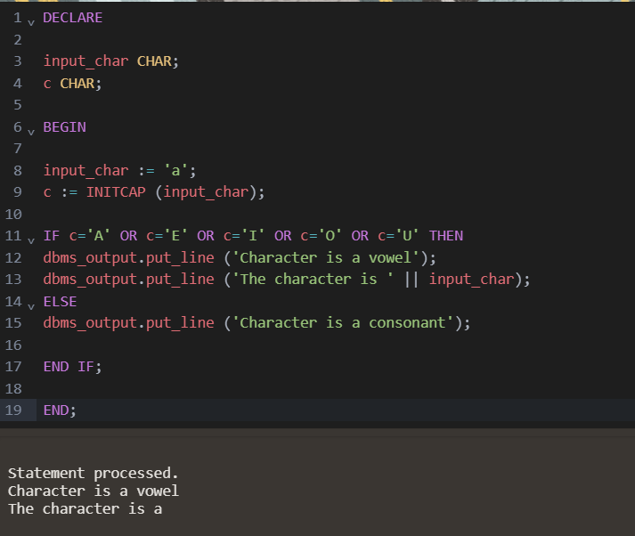

1. Write a PL/SQL code block to find out the sum of first twenty natural numbers

(1+2+3+4+5+6+7+8+9+10+-----+20 this series).

DECLARE

s NUMBER := 0;

BEGIN

FOR i IN 1..20 LOOP

s := i+s;

END LOOP;

dbms_output.put_line ('sum = ' || s);

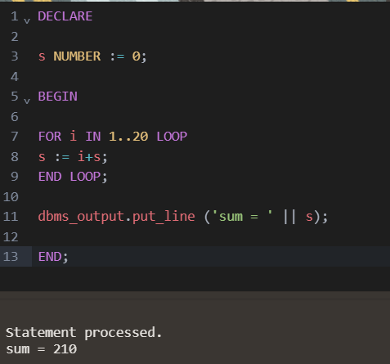END;

1. Write a PL/SQL block that will ask for two numbers and one operand (+, -, *, /). THEN

it will calculate and display the result.

DECLARE

a NUMBER;

b NUMBER;

op CHAR;

res NUMBER;

BEGIN

a := 5;

b := 7;

op := '+';

IF op='+' THEN

res := a+b;

ELSIF op='-' THEN

res := ABS(a-b);

ELSIF op='*' THEN

res := a*b;

ELSIF op = '/' THEN

IF b=0 THEN

dbms_output.put_line ('cannot divide by 0');

ELSE

res := a/b;

END IF;

ELSE

dbms_output.put_line ('wrong inputs');

END IF;

dbms_output.put_line ('result is = ' || res);

END;

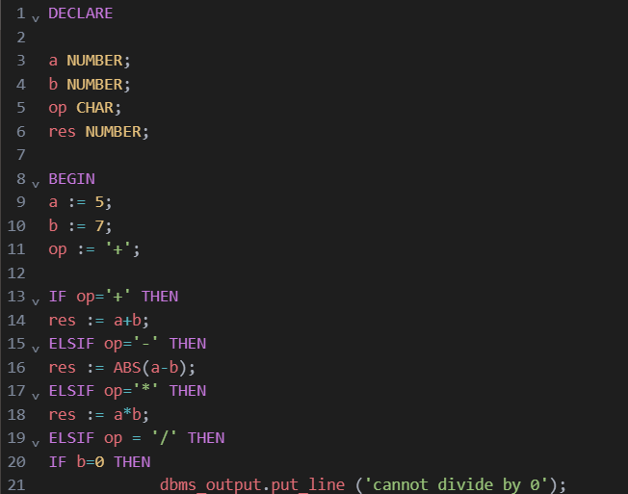

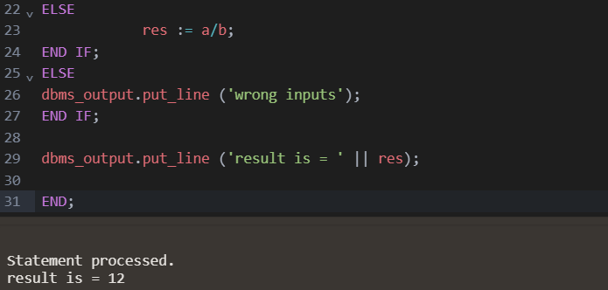

1. Write a PL/SQL code block to display a number in a reverse way.

DECLARE

num NUMBER := 325;

res NUMBER := 0;

BEGIN

WHILE num>0 LOOP

res := res * 10 + MOD(num,10);

num := FLOOR(num/10);

END LOOP;

dbms_output.put_line ('result is = ' || res);

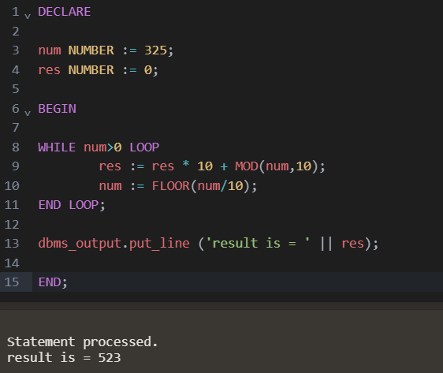END;

1. Write a PL/SQL block to display the dates of this month which are Tuesday.

DECLARE

start_date DATE := TRUNC(SYSDATE, 'MM');

end_date DATE := LAST_DAY(start_date);

BEGIN

DBMS_OUTPUT.PUT_LINE ('Tuesdays in ' || TO_CHAR(start_date, 'Month YYYY') || ':');

WHILE start_date <= end_date LOOP

IF TO_CHAR(start_date, 'D') = '3' THEN

DBMS_OUTPUT.PUT_LINE (TO_CHAR(start_date, 'DD-Mon-YYYY'));

END IF;

start_date := start_date + 1; -- Move to the next day

END LOOP;

END;

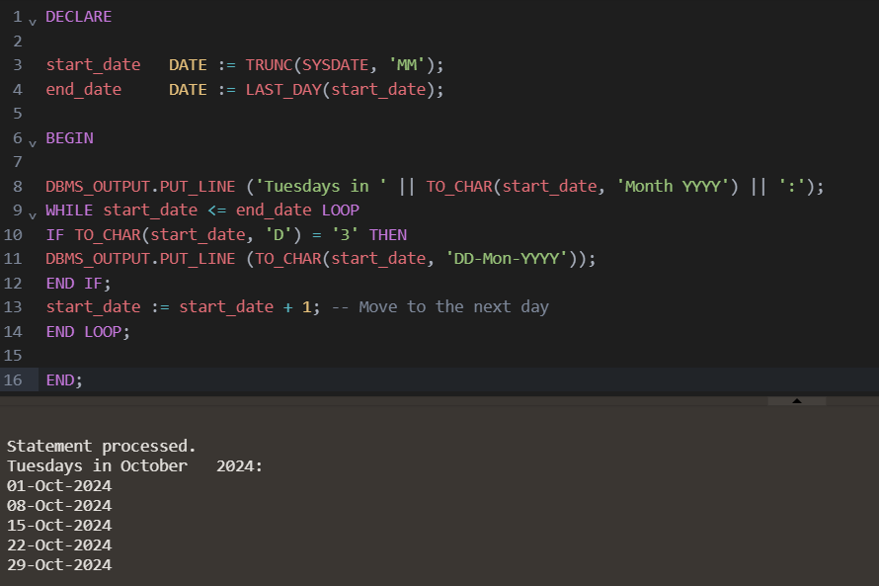

1. Write a program in PL/SQL to print the prime numbers between 1 to50.

DECLARE

s NUMBER := 0;

f NUMBER := 0;

BEGIN

FOR i IN 1..50 LOOP

f := 0;

FOR j in 2..i/2 LOOP

IF MOD(i,j) = 0 THEN

f := 1;

END IF;

END LOOP;

IF f = 0 THEN

dbms_output.put_line (i || ' is Prime');

END IF;

END LOOP;

END;

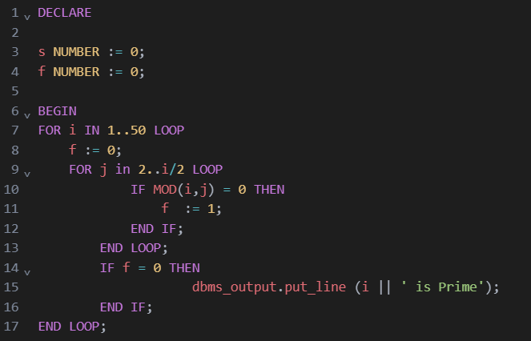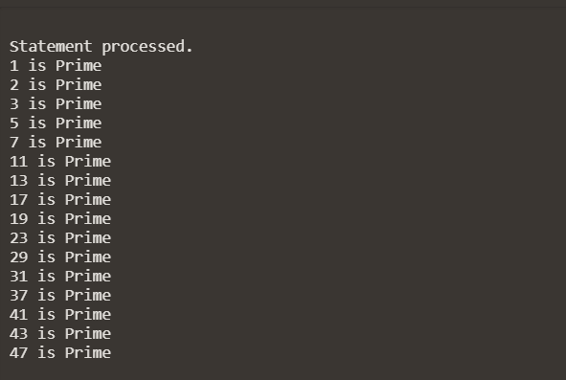

1. Write a program in PL/SQL to print the sum of digits of a number [eg: 635=14].

DECLARE

num NUMBER := 325;

res NUMBER := 0;

BEGIN

WHILE num>0 LOOP

res := res + MOD(num,10);

num := FLOOR(num/10);

END LOOP;

dbms_output.put_line ('result is = ' || res);

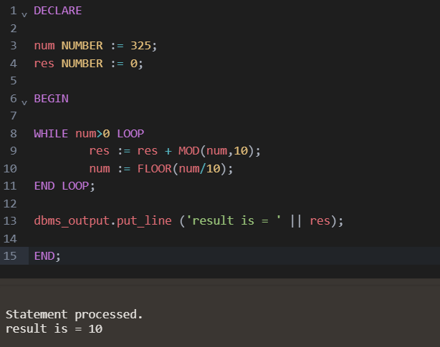END;