**ASSIGNMENT-2**

1. Display the Name, manager Id, and hire date of all employees who are either clerk or works in dept 20. The date should be in the following format:

DATE_HIRED

Seventeenth December, 1980

Second April, 1981

ANS: select ename, mgr, to_char(hiredate,'DDSPTH month YYYY') as DATE_HIRED

from emp

where job='CLERK' or deptno=20;

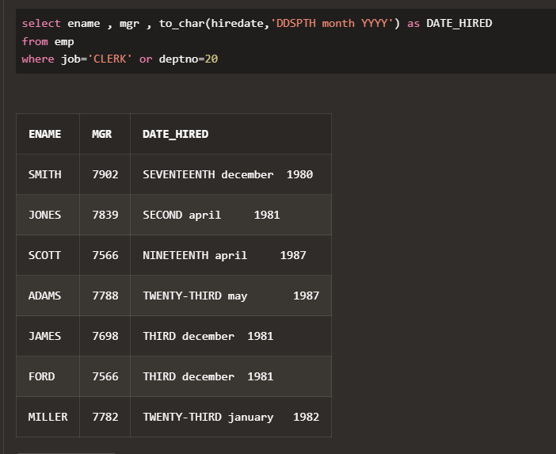

1. List the employee name and old salary and new increased salary by 25% and expressed as a whole number.

ANS: select ename, sal as old_sal, round(1.25*sal) as new_sal from emp;

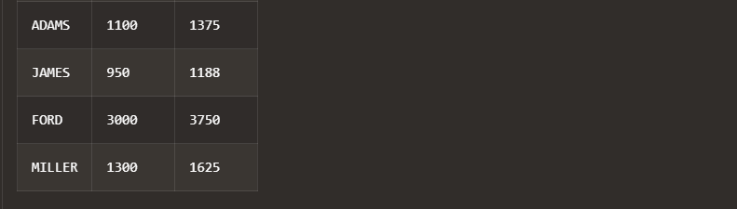 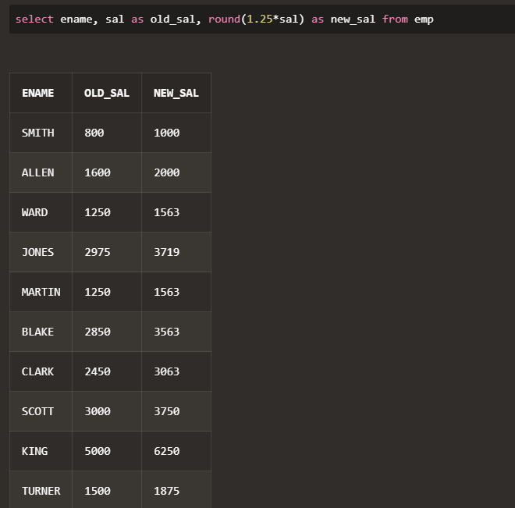

1. List the employee name and salary where name is displayed as left justified and salary

with right justified.

ANS: select rpad(ename,30,' '), lpad(sal,30,' ') from emp;

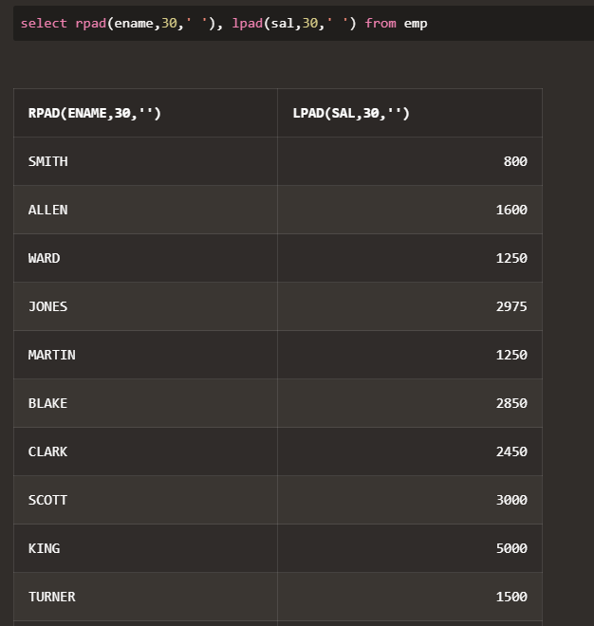

1. Produce the output as follows (for all employees)

ROLE OF THE EMPLOYEE

Name1 (<Job of Name 1>)

Name2 (<Job of Name 2>)

........

Note: Only first character of Name and job will be in uppercase.

ANS: select INITCAP(ename)||'('||INITCAP(job)||')' as ROLE_OF_THE_EMPLOYEE from emp;



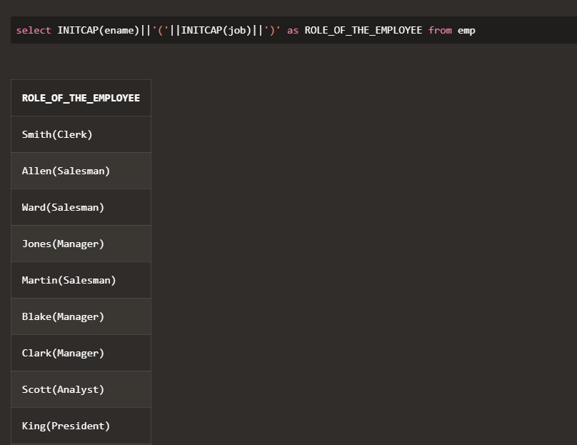

1. Give the details of an employees with job is clerk (enter the job value clerk as input).

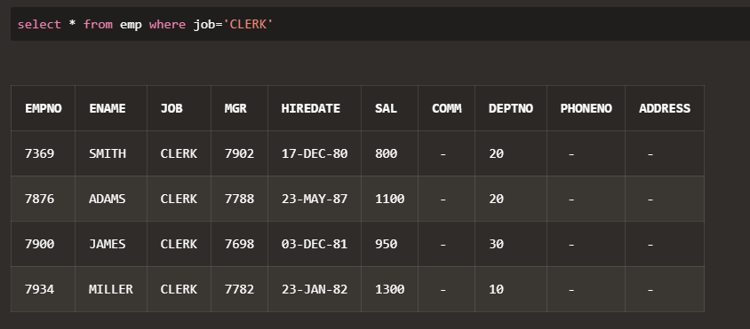ANS: select * from emp where job='CLERK';

1. Display each employee name with hiredate and salary review date. Assume that date is

one year after hiredate. Order the output in ascending review date order.

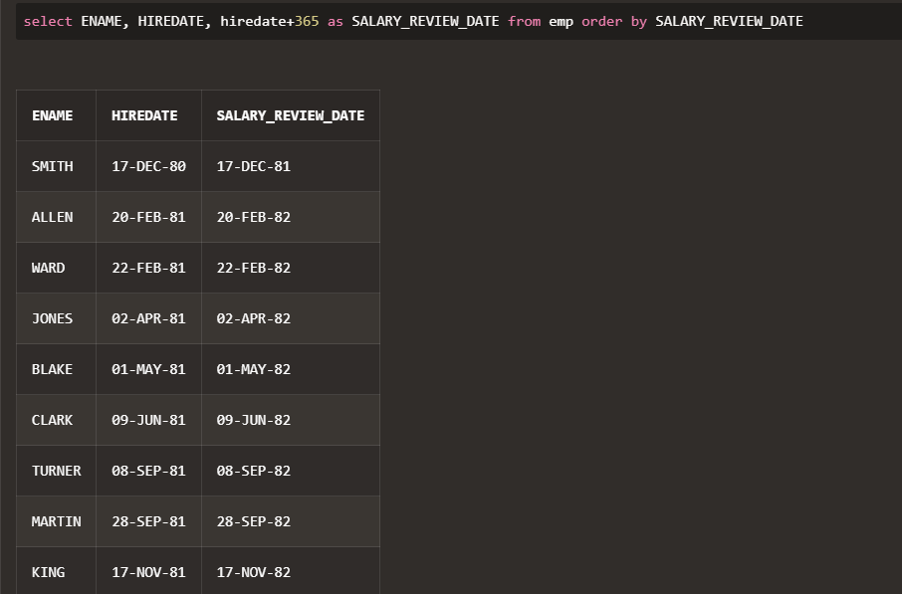ANS: select ENAME, HIREDATE, hiredate+365 as SALARY_REVIEW_DATE from emp order by SALARY_REVIEW DATE;

1. Find the employees(s) who earn the highest salary in each job type sort in descending

salary order(Use IN operator and subqueries)

ANS: select * from EMP E

where SAL in (select max(SAL) from EMP group by JOB)

order by SAL DESC;

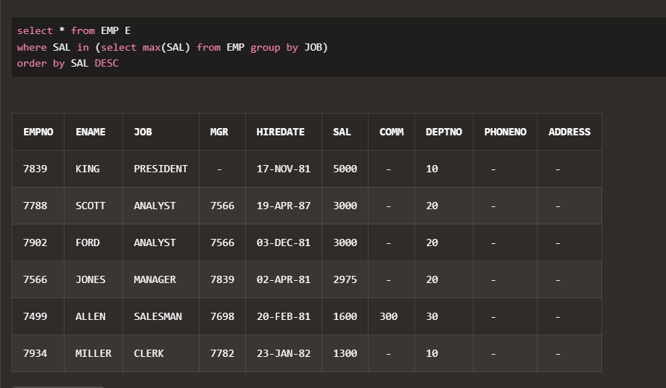

1. Find the most recently hired employee in each department (give number only).

ANS: select * from EMP E

where HIREDATE in (select MAX(hiredate) from EMP where DEPTNO=E.DEPTNO);

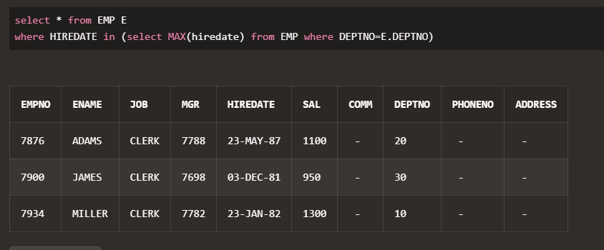

1. Show the name of the department and no of employees who works in that department.

Sort in department number.

ANS: select DNAME,count(E.EMPNO) from emp E, dept D

where E.DEPTNO = D.DEPTNO

group by D.DEPTNO, D.DNAME

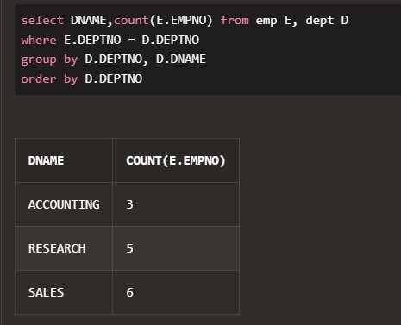order by D.DEPTNO;

1. Display the Id, name, salary and the salary grade for any employee who earns the

maximum salary for their department. Sort in department number.

ANS: select E.EMPNO, E.ENAME, E.SAL, S.GRADE

from emp E, salgrade S

where E.SAL IN(select MAX(sal)

from EMP group by DEPTNO) and

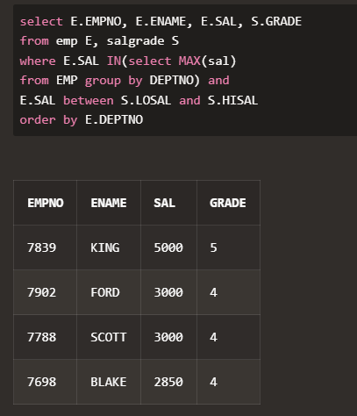E.SAL between S.LOSAL and S.HISAL order by E.DEPTNO;

1. In which year did most people join the company? Display the year and number of

employees.

ANS: select to_char(HIREDATE,'YYYY') as YEAR, count(EMPNO) as NO_OF_EMPLOYEES from emp

group by to_char(HIREDATE,'YYYY') having count(EMPNO)= (select MAX(count(EMPNO))

from emp group by to_char(HIREDATE,'YYYY'));

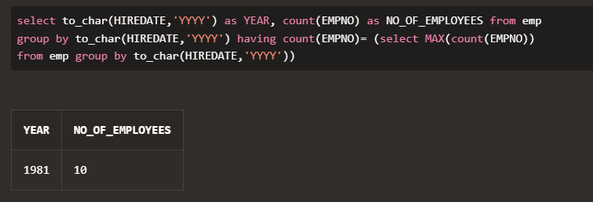

1. Show every alternate row in employee table.

ANS: Select * from(Select EMPNO, ENAME,JOB, MGR, HIREDATE,

SAL, COMM, DEPTNO, PHONENO, ADDRESS, ROWNUM RN from emp)

where MOD(RN,2)=1;

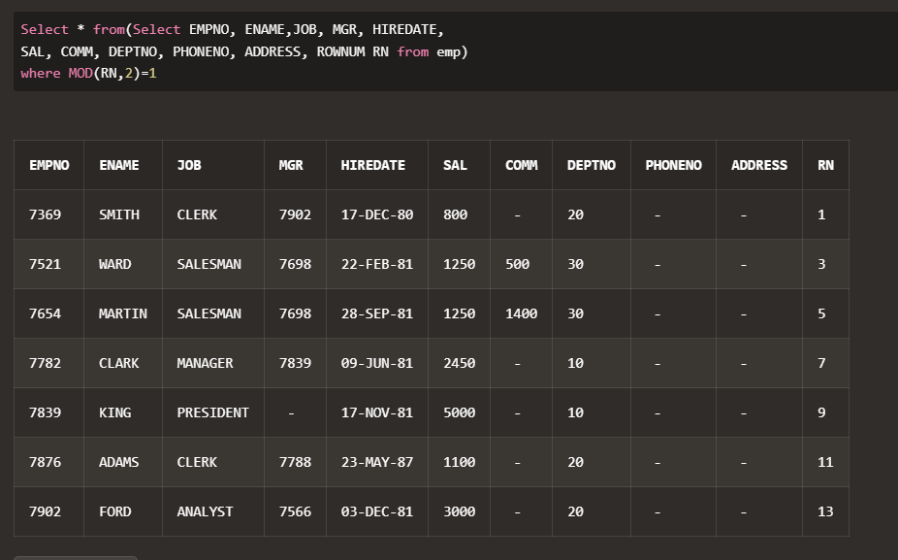

1. Display the total salary of all employees. Total salary = salary + commission.

ANS: select ename, sal, sal+nvl(comm,0) as total_salary from emp;

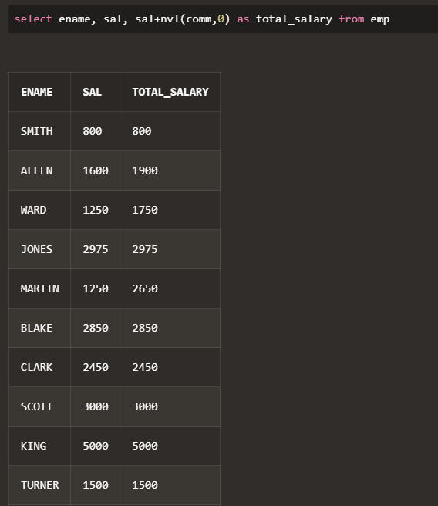

1. Display the department name and available jobs in that department.

ANS: select DISTINCT d.dname as DEPARTMENT, e.job as AVAILABLE_JOBS

from emp e, dept d

WHERE d.deptno = e.deptno

ORDER BY dname;

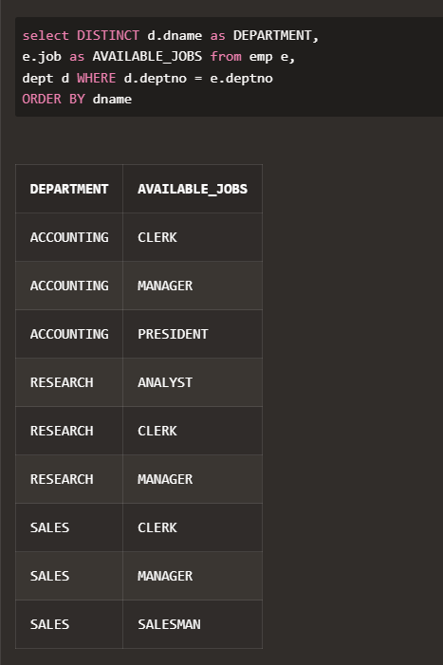

1. Display all the available departments and the employee(s) works under it.

ANS: SELECT DISTINCT D.DNAME AS DEPARTMENT,

E.* FROM EMP E, DEPT D WHERE D.DEPTNO = E.DEPTNO

