Pre-breeding Atlantic puffins (Fratercula arctica) are disappearing from Faroese colonies
ANNE N.M.A. AUSEMS¹, JENS-KJELD JENSEN²
¹Department of Ecoscience, Aarhus University, Denmark. (anneausems@ecos.au.dk)
²Nólsoy, Faroe Islands

ABSTRACT
Ongoing climate change and increasing human-induced environmental change are causing substantial declines in seabirds. The Atlantic puffin (Fratercula arctica; hereafter puffin) is one such species, experiencing declines across it’s north Atlantic range. While much of the declines in puffins are indirect, for example due to reduced food availability causing large-scale breeding failure, direct threats such as hunting may push already struggling populations over the edge. At the same time, samples from harvested puffins provide a unique opportunity to dissect and analyse a healthy segment of the population. Here, we analysed 13 years (1995-2008) of data on female puffins harvested in Føroyar (Eng. the Faroe Islands) to determine whether the ratio of confirmed breeders (i.e., those females with ‘convoluted’ oviducts, indicating that had laid an egg at least once in their lifetime) in the harvested sample increased over time. We also scored brood patch as a proxy for ongoing breeding in the sample year, as the harvest was carried out well into the chick rearing period and hormonal brood patches (without active breeding attempt) should have disappeared. We found that the ratio of confirmed breeders increased from approximately 15% in the earlier study years to 78% in 2008, and that within birds without a brood patch, the ratio of confirmed breeders increased as well. Together, we showed that young, pre-breeding birds disappeared from the sample, suggesting a severe lack of recruitment. While the hunt is unlikely to be the main driver of the population decline in Føroyar, even reduced harvesting is likely unsustainable under currect conditions.
Key words: demographics, seabirds, traditional harvest, recruitment, brood patch, seabird conservation

INTRODUCTION
Global climate change and increasing human-induced environmental change are causing large-scale declines in many seabird species (Dias et al., 2019). Some threats have indirect effects, for example, climate change may cause a decline in food availability leading to lower breeding success, and eventually observable population declines (Fayet et al., 2021), while others directly cause mortality, such as bycatch and hunting. In long-lived species such as seabirds, changes in adult survival can have strong effects on population dynamics (Doherty et al., 2004; Jenouvrier et al., 2005), so even minor threats directly affecting it can have large impacts, especially on already vulnerable species. In contrast, the elasticity of the population growth rate to breeding success and recruitment rate is relatively low, but they can react strongly to changes in environmental conditions (Jenouvrier et al., 2005), thus ultimately having the strongest effect on population growth rate overall (Miles et al., 2015).
Atlantic puffins (Fratecula arctica; hereafter ‘puffin’) are rapidly declining across most of their European range (BirdLife International, 2021), and they are classified as ‘Vulnerable’ globally and ‘Endangered’ in Europe (BirdLife International, 2018). Puffin population declines are largely linked to changes in food availability causing declines in breeding success (Fayet et al., 2021) and thus recruitment rate leading to increases in the age of the population (Ausems et al., 2026). Generally, puffins start breeding when they are between 4 and 5 years, though occasionally they can start at 3 years old and often the first breeding attempt is at a later age (Lowther et al., 2020). Annual survival of both immatures and adults is high (Sandvik et al., 2008), though immature survival may vary between sites and years (see Ashcroft, 1979), and immatures are highly philopatric (Sandvik et al., 2008).
In Føroyar (Eng. Faroe Islands; Fig. 1), harvesting puffins is a long-stranding, culturally important tradition, where hunters catch flying puffins from set locations on land using a special made net. Puffins are a widespread species in the islands, with an estimated 550,000 breeding pairs in approximately 100 colonies (Hammer et al., 2014; Jensen et al., 2005). However, as in other areas, their population shows observed, but unquantified, declines in Føroyar. Overharvesting has long been understood to negatively affect the local population (Jensen & Olsen, 2020), and, on Nólsoy (Fig. 1), the harvest was voluntarily halted in 2009 until the population was deemed stable enough in 2021 to sustain limited harvesting (Ausems et al., 2026).
Puffin hunters, or fowlers, follow a set of rules, intended to ensure only young, prospecting birds are caught and catching breeding adults is avoided (Jensen, 2010). Puffin harvesting is restricted to the chick-rearing period as this makes it easier to distinguish breeding adults and prospecting juveniles (Jensen, 2010). During the breeding season, puffins take part in ‘wheeling-flight’, where large groups of birds fly in circles or figure-8’s over the colony and surrounding water (Lowther et al., 2020). It is assumed that only prospecting birds take part in this behaviour, while breeding adults will either be identifiable by them carrying fish to their nest or directly heading back to sea to collect more food for the chick (Jensen, 2010). Puffins do not necessarily display this behaviour every day, rather they come to the colony on specific landkomudagur when weather conditions are favourable, which are the preferred hunting days. Hunters only trap birds taking part in the wheeling-flight behaviour. In addition, if a bird with wet bill and cheeks is caught, it is released again, as that is a sign of a bird having just delivered fish to its young.
However, ongoing global climate change and anthropogenic impacts have altered puffin breeding phenology and propensity. In northern latitudes, puffins are breeding later (Burr et al., 2016) in response to environmental conditions (Durant et al., 2004). Furthermore, birds are forced to forage further offshore to find sufficient food, leading to increases in breeding failures (Fayet et al., 2021). Together, these changes may affect the efficacy of the self-imposed rules; non-incubating partners and failed breeders may take part in the ‘wheeling-flight’ behaviour without showing the tell-tale signs of being of breeding age.
Using a 20-year dataset on legally harvested puffins (Løgtingslóg Um Fuglaveiðu, Sum Seinast Broytt Við Løgtingslóg Nr. 70 Frá 22. Mai 2023, 1984), we tested whether adults of breeding age were harvested. We hypothesise that, as the overall age of the population is increasing and the proportion of young (i.e., <4 calendar years) is declining (Ausems et al., 2026), the ratio of adults of breeding age in the sample increased over the study period. Secondly, we tested whether breeding propensity changed over time by assessing brood patch presence in the sample. Brood patch formation is induced by hormones before the breeding season (Jones, 1971) but it quickly disappears when a bird is not incubating an egg (Bailey, 1952). While the presence of a brood patch can be a misleading sign of breeding status (McFarlane Tranquilla et al., 2003), we assumed that, at the time of the puffin hunt, prospecting and failed breeders would have refeathered their brood patch while actively incubating birds still retained theirs. We predicted that birds of breeding age would be less likely to have a brood patch later in the study period, indicating increased breeding failures or an increase in birds foregoing breeding.

Methods
Between 1989 and 2008, J-KJ inspected 5472 randomly selected puffins harvested on the islands of Nólsoy from 1989 to 2006, and on Mykines from 2007 and 2008 (Table 1), when no puffins could be obtained on Nólsoy (Fig. 1). Puffins were harvested from July 2nd, with an official end-date of August 8th, although this was not always adhered to and the latest sample in our dataset was harvested August 15th. J-KJ acquired an arbitrary number of puffins (range: 9, 450; median: 277.5; Table 1) from the hunters when they returned to the village. Hunters placed the harvested puffins in a big pile on the ground prior to processing. From one pile per hunting day, J-KJ collected a random sample by closing his eyes when selecting birds. The estimated number of harvested puffins between 1996 and 2008 ranged from 207 (2007) to 13,324 (1999; Table 1) but similar counts do not exist for the period between 1989 and 1995.
J-KJ scored the presence or absence of a brood patch before dissecting all individuals to determine their sex starting in 1995. For females, J-KJ determined whether they had ever laid an egg by assessing the oviduct; a straight oviduct indicates that a female never laid an egg, while a ‘convoluted’ oviduct indicates that a female has laid an egg and therefore is of breeding age (Van Franeker, 2004). For males, it is impossible to determine whether they have bred before. Based on bill characteristics, we could only determine their age up to 4 years (Ausems et al., 2026) which is generally too young to be of breeding age (Lowther et al., 2020). Therefore, we only included females for which their breeding status could be determined in our analyses (n = 1995). We removed individuals for which breeding state could not be determined (n = 74) and individuals for which brood patch was not scored (n = 3).
We fitted a Bayesian generalised linear model (glm) with logistic regression [logit link, Bernoulli family; function brm, package brms; Bürkner (2017)] with breeding status (0 = never bred; 1 = has bred) as response variable. We included study year and brood patch presence (0 = absent; 1 = present) with an interaction as covariates. We used weakly informative priors: a normal (0, 1.5) prior on the brood patch presence and year × brood patch presence interaction, a more skeptical normal (0, 1) prior on the year trend, and the default Student-t (3, 0, 2.5) prior on the intercept. We centered year around the mean, and scaled it in decades, so the year prior constrains the plausible per-decade change in breeding probability. We confirmed that these priors implied plausible values using prior predictive checks [pp_check with type = “stat” and stat = “mean”; Bürkner (2017)], before fitting the model to the data. We ran six chains, each with 4000 iterations of which 2000 were discarded as warmup, and without thinning.
We assessed Markov Chain Monte Carlo (MCMC) convergence by inspecting trace plots for all parameters (Gabry et al., 2019), confirming that $\hat{R}$ values were close to 1 [≤ 1.01; Vehtari et al. (2021)], and that effective sample sizes (bulk/tail ESS) were high for all fixed effects [i.e., > 100 per chain; Vehtari et al. (2021)]. We evaluated posterior predictive fit graphically using pp_check (Bürkner, 2017), comparing the observed distribution of breeding status to the posterior predictive distribution (Gabry et al., 2019; Gelman et al., 1996). We assessed out-of-sample predictive performance using approximate leave-one-out cross-validation (PSIS-LOO) assuming a good fit if the Pareto k value was < 0.7 for all observations [function loo; Bürkner (2017); Vehtari et al. (2017); Vehtari et al. (2024)].
As a robustness check, we tested whether brood patch detectability drifted over time within confirmed breeding-age females, with a second GLM with brood patch presence as response variable and year as covariate, including only breeding-age females (n = 469). We used the same priors as for the full model, excluding the interaction term. As a second robustness check to confirm that the low sample size (n = 5) in 2007 did not have an undue effect on the overall outcome, we refit the full model excluding 2007.

Results
The model passed the validation checks (Appendix 1) with all $\hat{R}$ ≤ 1.001 and high ESS (bulk/tail ESS > 8,900 of 12,000 post-warmup draws). All Pareto k estimates were < 0.7 (expected log pointwise predictive density (ELPD) ± standard error (SE) = -856.24 ± 26.99, effective parameters ± SE = 3.69 ± 0.28). The robustness check models also passed all checks (Appendix 1).
The GLM showed an increase in the ratio of females that had bred over time (Fig. 2), with a stronger increase within females without a brood patch than females with a brood patch (Fig. 3). Averaged across the sample (integrating over the observed proportion of brood patch presence; Fig. 2), the model-predicted probability of having bred increased from 0.14 (95% CI: 0.12–0.16) in 1995 to 0.47 (95% CI: 0.41–0.53) in 2008, an increase of 0.33 (95% CI: 0.26–0.40) over the study period. Breeding odds increased by a factor of 5.65 (95% CI: 3.88-7.99; posterior probability of an increase = 100.0%) per decade in females without a brood patch (the baseline for the model) and 2.92 (95% CI: 0.98-7.08; posterior probability of an increase = 97.3%) for females with a brood patch (Table 2; Fig. 3).
We found no credible trend in brood patch presence within confirmed breeding-age female (odds ratio 0.90/decade; 95% CI [0.56-1.44]; posterior probability = 67.7; Fig. 4). Removing 2007 did not change the model predictions (Δ odds ratio, full model minus 2007-excluded refit: intercept +0.00, year +0.00, brood patch presence -0.06, interaction +0.00).

Discussion
Our results show that the self-imposed rules were reasonably effective early in the study period when approximately 15-30% of the female harvest were birds of confirmed breeding age (Table 1). However, in the later years leading up to the suspension of the harvest, the number of birds of confirmed breeding age steeply increased to a peak of 78% (Table 1). Furthermore, by including brood patch presence in the model, we showed that 1) bird of breeding age are not more or less likely to attempt breeding in a given year, and 2) within the group of birds without a brood patch, birds of breeding age are more prevalent (Fig. 2). Together, this indicates that the group of non-breeding birds is disappearing from the sample, rather than brood patch detectability changing in birds of breeding age.
While our previous work (Ausems et al., 2026) showed a clear disappearance of the younger birds from the sample, we were not able to age individuals past 4 calendar years. Our current study only includes female birds, as we cannot confirm breeding status in males (Van Franeker, 2004), but considering the strong pair bond and the fact that males tend to start breeding at a slightly earlier age (Ashcroft, 1979), we believe our results reflect the state of the entire population. Combined, both studies (this study and Ausems et al., 2026) strongly suggest that recruitment rate is insufficient (Miles et al., 2015), and young birds are disappearing.
Besides the absence of younger birds, older, breeding-age birds may be more likely to be caught as breeding success declining in much of the north Atlantic range (Fayet et al., 2021; Miles et al., 2015). Failed breeders often remain in the area, joining the prospecting birds in the ‘wheeling-flight’ behaviour (Lowther et al., 2020), thus increasing the likelihood of being captured. With increased food shortages due to climate change and anthropogenic pressures (Fayet et al., 2021), more breeding attempts fail. Secondly, puffin phenology is affected by environmental conditions (Durant et al., 2004), with puffins breeding later in more recent years (Major et al., 2021). Therefore, the hunting season may start to overlap with the incubation period, when the off-duty parent may join the ‘wheeling-flight’ behaviour, rather than purely the chick-rearing period when both parents are on duty.
Overall, we believe that the harvested sample, although intentionally biased towards younger birds, represents an ongoing trend in the whole Faroese, and potentially north Atlantic, population of insufficient recruitment in puffins causing an aging effect in the overall population (Ausems et al., 2026; Fayet et al., 2021; Miles et al., 2015). While we do not think the traditional harvest is the main driver behind the population collapse in Føroyar, as this is most likely caused by ongoing climate change and food shortages (Ausems et al., 2026; Fayet et al., 2021; Miles et al., 2015), it may push an already struggling population over the edge (Johnson & Nielsen, 2024). In fact, in Iceland, where a similar hunting tradition exists, even greatly reduced harvesting is deemed unsustainable in current conditions (Johnson et al., 2024).

Acknowledgements
We would like to thank René Hansen for collecting and sharing the harvest numbers and Trevor MacLaurin for double checking our statistical methods. Most importantly, we would like to thank the hunters who shared puffins for use in this study. Puffins were obtained using private funds and a small contribution from Havstovan - Faroe Marine Research Institute.

REFERENCES
Ashcroft, R. E. (1979). Survival Rates and Breeding Biology of Puffins on Skomer Island, Wales. Ornis Scandinavica, 10(1), 100. https://doi.org/10.2307/3676349
Ausems, A. N. M. A., Jakubas, D., Jensen, J., & Wojczulanis–Jakubas, K. (2026). Variation in food availability affects the population age structure of Atlantic puffins Fratercula Arctica in the Faroe Islands. Wildlife Biology, e01546. https://doi.org/10.1002/wlb3.01546
Bailey, R. E. (1952). The Incubation Patch of Passerine Birds. The Condor, 54(3), 121–136. https://doi.org/10.2307/1365062
BirdLife International. (2018). Fratercula Arctica. The IUCN Red List of threatened species. E.T22694927A132581443. https://doi.org/10.2305/IUCN.UK.2018-2.RLTS.T22694927A132581443.en
BirdLife International. (2021). Species factsheet: Fratercula Arctica. https://datazone.birdlife.org/species/factsheet/atlantic-puffin-fratercula-arctica
Bürkner, P.-C. (2017). brms: An R package for Bayesian multilevel models using Stan. Journal of Statistical Software, 80(1), 1–28. https://doi.org/10.18637/jss.v080.i01
Burr, Z. M., Varpe, Ø., Anker‐Nilssen, T., Erikstad, K. E., Descamps, S., Barrett, R. T., Bech, C., Christensen‐Dalsgaard, S., Lorentsen, S., Moe, B., Reiertsen, T. K., & Strøm, H. (2016). Later at higher latitudes: Large‐scale variability in seabird breeding timing and synchronicity. Ecosphere, 7(5), e01283. https://doi.org/10.1002/ecs2.1283
Dias, M. P., Martin, R., Pearmain, E. J., Burfield, I. J., Small, C., Phillips, R. A., Yates, O., Lascelles, B., Borboroglu, P. G., & Croxall, J. P. (2019). Threats to seabirds: A global assessment. Biological Conservation, 237, 525–537. https://doi.org/10.1016/j.biocon.2019.06.033
Doherty, P. F., Jr., Schreiber, E. A., Nichols, J. D., Hines, J. E., Link, W. A., Schenk, G. A., & Schreiber, R. W. (2004). Testing life history predictions in a long-lived seabird: A population matrix approach with improved parameter estimation. Oikos, 105(3), 606–618. https://doi.org/10.1111/j.0030-1299.2004.13119.x
Durant, J. M., Anker-Nilssen, T., Hjermann, D. Ø., & Stenseth, N. Chr. (2004). Regime shifts in the breeding of an Atlantic puffin population. Ecology Letters, 7(5), 388–394. https://doi.org/10.1111/j.1461-0248.2004.00588.x
Fayet, A. L., Clucas, G. V., Anker-Nilssen, T., Syposz, M., & Hansen, E. S. (2021). Local prey shortages drive foraging costs and breeding success in a declining seabird, the Atlantic puffin. Journal of Animal Ecology, 90, 1152–1164.
Gabry, J., Simpson, D., Vehtari, A., Betancourt, M., & Gelman, A. (2019). Visualization in Bayesian Workflow. Journal of the Royal Statistical Society Series A: Statistics in Society, 182(2), 389–402. https://doi.org/10.1111/rssa.12378
Gelman, A., Meng, X.-L., & Stern, H. (1996). Posterior predictive assessment of model fitness via realized discrepancies. Statistica Sinica, 6(4), 733–807. https://www3.stat.sinica.edu.tw/statistica/j6n4/j6n41/j6n41.htm
Hammer, S., Madsen, J., Jensen, J.-K., Pedersen, K., & Bloch, D. (2014). Færøsk Trækfugleatlas – the Faroese bird migration atlas (p. 177). Fróðskapur, Faroe University Press.
Jenouvrier, S., Barbraud, C., Cazelles, B., & Weimerskirch, H. (2005). Modelling population dynamics of seabirds: Importance of the effects of climate fluctuations on breeding proportions. Oikos, 108(3), 511–522. https://doi.org/10.1111/j.0030-1299.2005.13351.x
Jensen, J.-K. (2010). Puffin fowling-a fowling day on Nólsoy, Faroe Islands. Føroya Skúlabókagrunnur.
Jensen, J.-K., Bloch, D., & Olsen, B. (2005). List of birds seen in the Faroe Islands. In Føroya fuglafrøḥifelag and Føroya skúlabókagrunnur. Føroya Náttúrugripasavn, Tórshavn, Faroe Islands.
Jensen, J.-K., & Olsen, B. (2020). Traditions for puffin fowling in the Faroe Islands the last decades. Journal of Nature Faroe Islands, 1, 3–17.
Johnson, F. A., & Nielsen, Ó. K. (2024). Regional demography of Icelandic rock ptarmigan and its implications for harvest management. Ecological Solutions and Evidence, 5(4), e12390. https://doi.org/10.1002/2688-8319.12390
Johnson, F. A., Walters, C. J., & Hansen, E. S. (2024). Icelandic puffin stock assessments. Umhverfisstofnun (Environment Agency of Iceland). https://www.researchgate.net/publication/381954204_Icelandic_puffin_stock_assessments_2024
Jones, R. E. (1971). The Incubation Patch of Birds. Biological Reviews, 46(3), 315–339. https://doi.org/10.1111/j.1469-185X.1971.tb01048.x
Løgtingslóg Um Fuglaveiðu, Sum Seinast Broytt Við Løgtingslóg Nr. 70 Frá 22. Mai 2023 (1984).
Lowther, P. E., Diamond, A. W., Kress, S. W., Robertson, G. J., Russell, K., Nettleship, D. N., Kirwan, G. M., Christie, D. A., Sharpe, C. J., Garcia, E. F. J., & Boesman, P. F. D. (2020). Atlantic puffin (Fratercula arctica), ver. 1.0. In S. M. Billerman (Ed.), Birds of the world. Cornell Laboratory of Ornithology. https://doi.org/10.2173/bow.atlpuf.01
Major, H. L., Durham, S. E., Fana, N., Rivers, J. E., & Diamond, A. W. (2021). Contrasting phenological and demographic responses of Atlantic Puffin (Fratercula arctica) and Razorbill (Alca torda) to climate change in the Gulf of Maine. Elementa: Science of the Anthropocene, 9(1), 00033. https://doi.org/10.1525/elementa.2021.00033
McFarlane Tranquilla, L. A., Bradley, R. W., Lank, D. B., Williams, T. D., Lougheed, L. W., & Cooke, F. (2003). The Reliability of Brood Patches in Assessing Reproductive Status in the Marbled Murrelet: Words of Caution. Waterbirds, 26(1), 108–118. https://doi.org/10.1675/1524-4695(2003)026[0108:TROBPI]2.0.CO;2
Miles, W. T. S., Mavor, R., Riddiford, N. J., Harvey, P. V., Riddington, R., Shaw, D. N., Parnaby, D., & Reid, J. M. (2015). Decline in an Atlantic Puffin Population: Evaluation of Magnitude and Mechanisms. PLOS ONE, 10(7), e0131527. https://doi.org/10.1371/journal.pone.0131527
Sandvik, H., Erikstad, K. E., Fauchald, P., & Tveraa, T. (2008). High survival of immatures in a long-lived seabird: Insights from a long-term study of the Atlantic puffin (Fratercula arctica). Auk, 125, 723–730.
Van Franeker, J. A. (2004). Save the north sea fulmar study manual 1: Collection and dissection procedures (Alterra-Rapport No. 672; p. 38). Alterra. https://edepot.wur.nl/40451
Vehtari, A., Gelman, A., & Gabry, J. (2017). Practical Bayesian model evaluation using leave-one-out cross-validation and WAIC. Statistics and Computing, 27(5), 1413–1432. https://doi.org/10.1007/s11222-016-9696-4
Vehtari, A., Gelman, A., Simpson, D., Carpenter, B., & Bürkner, P.-C. (2021). Rank-Normalization, Folding, and Localization: An Improved Rˆ for Assessing Convergence of MCMC (with Discussion). Bayesian Analysis, 16(2), 667–718. https://doi.org/10.1214/20-BA1221
Vehtari, A., Simpson, D., Gelman, A., Yao, Y., & Gabry, J. (2024). Pareto smoothed importance sampling. Journal of Machine Learning Research, 25(72), 1–58.

Fig. 1. Location of the study sites (red dots) in Føroyar.
Fig. 2. Temporal change in the probability of harvesting female Atlantic puffins (Fratercula arctica) of confirmed breeding age in Føroyar. Bars show the observed percentage of breeding females per year. The solid line shows the estimate from a Bayesian generalised linear model and the shaded band shows the 95% credible interval. The estimates are marginalised over each study year’s observed brood patch composition. The vertical bars show the percentage of females of confirmed breeding age in the sample.
Fig. 3. Temporal change in the probability of harvesting female Atlantic puffins (Fratercula arctica) of confirmed breeding age in Føroyar, with or without brood patches. The solid lines show the estimates from a Bayesian generalised linear model and the shaded band shows the 95% credible intervals.
Fig. 4. Temporal change in brood patch presence in female Atlantic puffins (Fratercula arctica) of confirmed breeding age harvested in Føroyar. The solid line shows the estimate from a Bayesian generalised linear model and the shaded band shows the 95% credible interval.

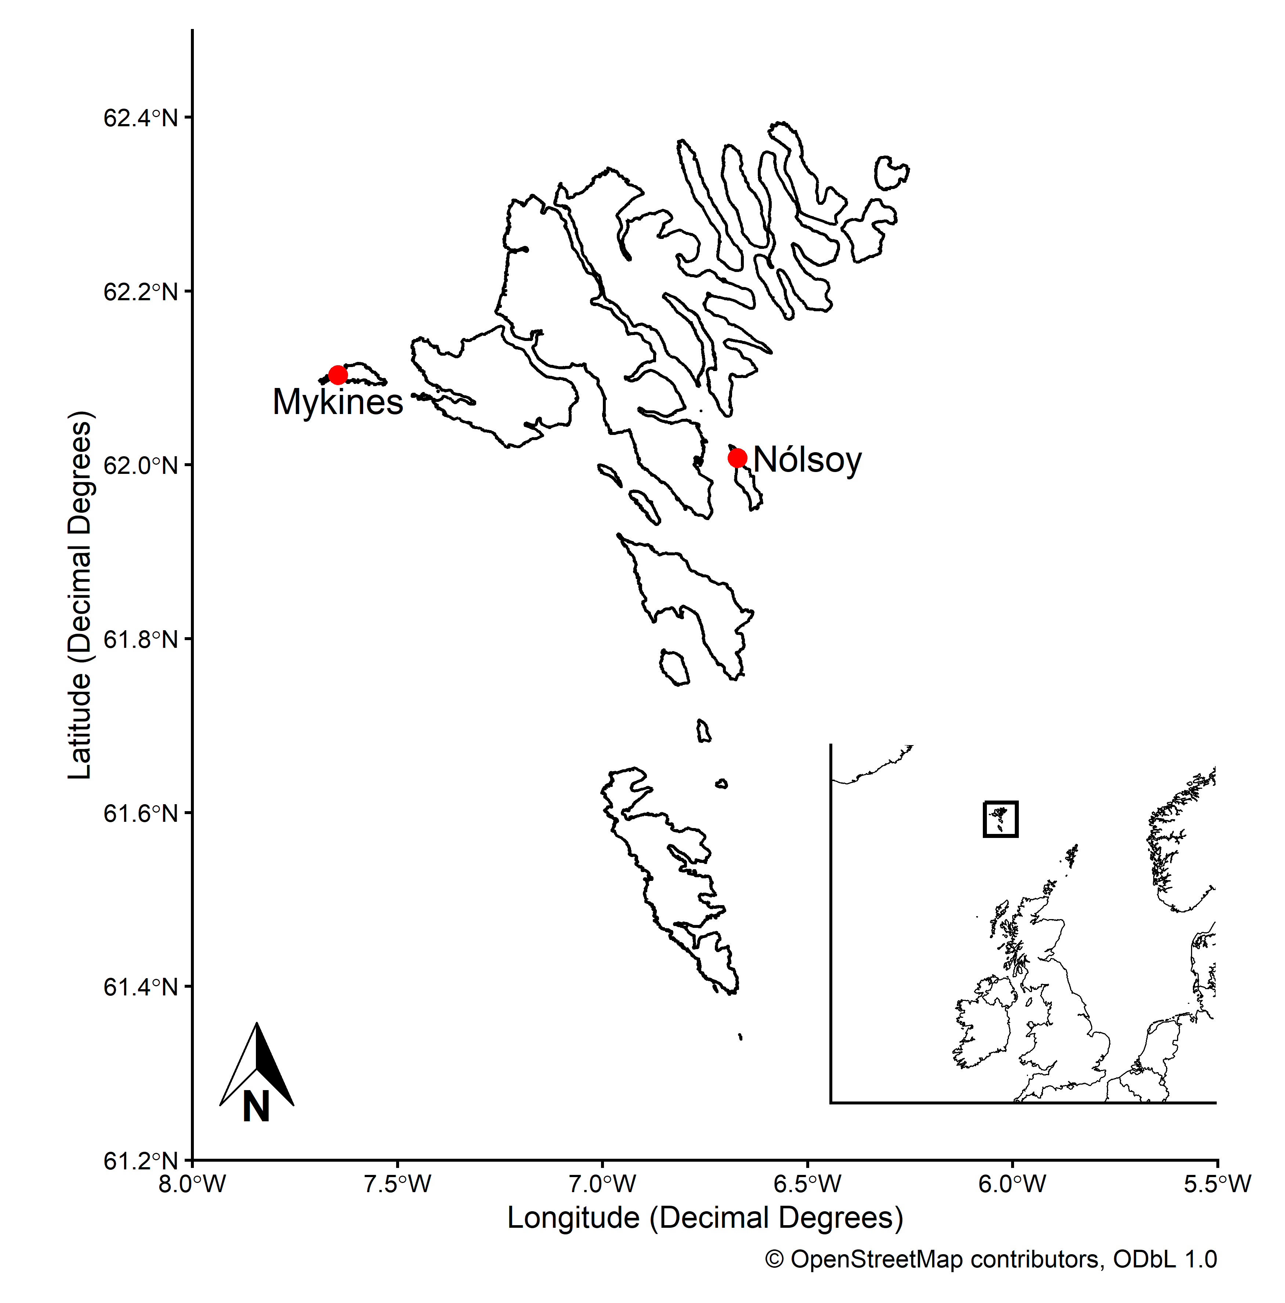
Fig. 1

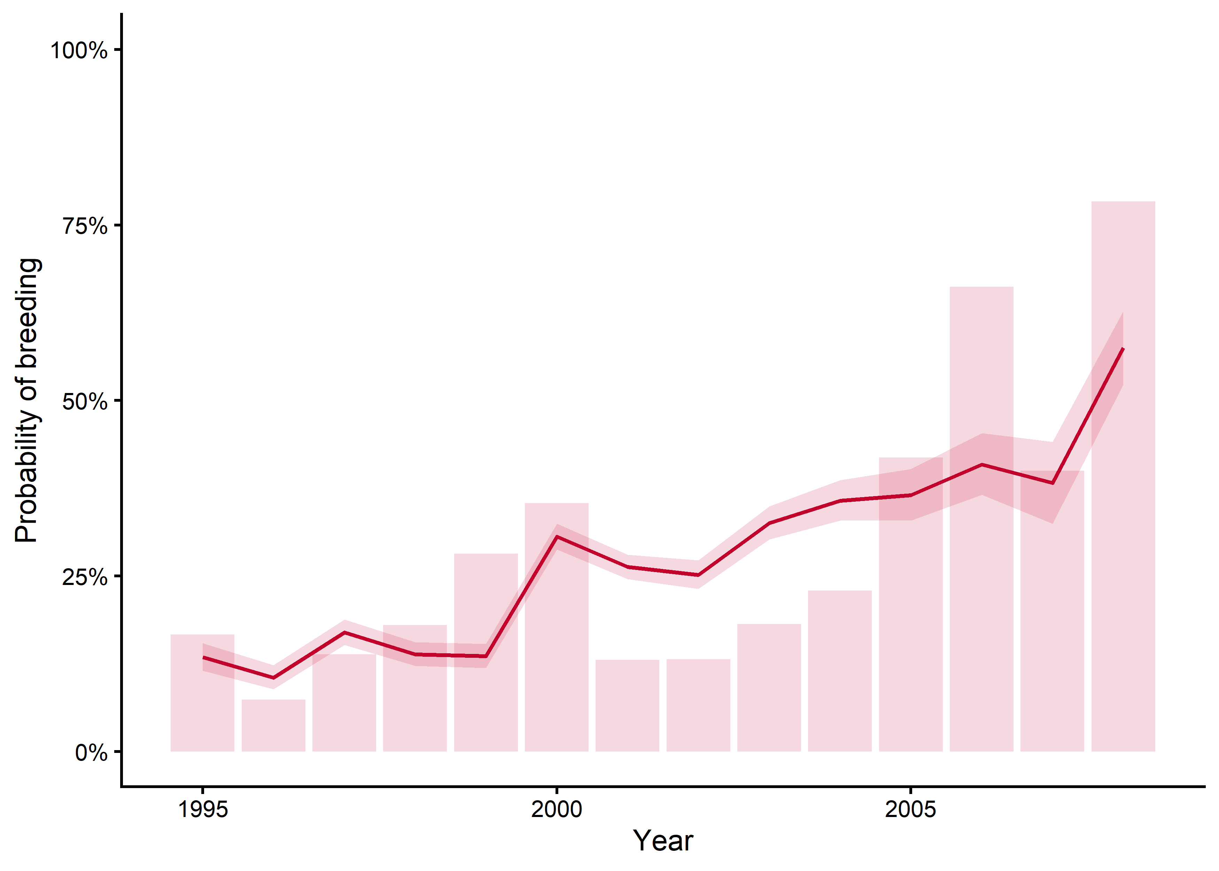
Fig. 2

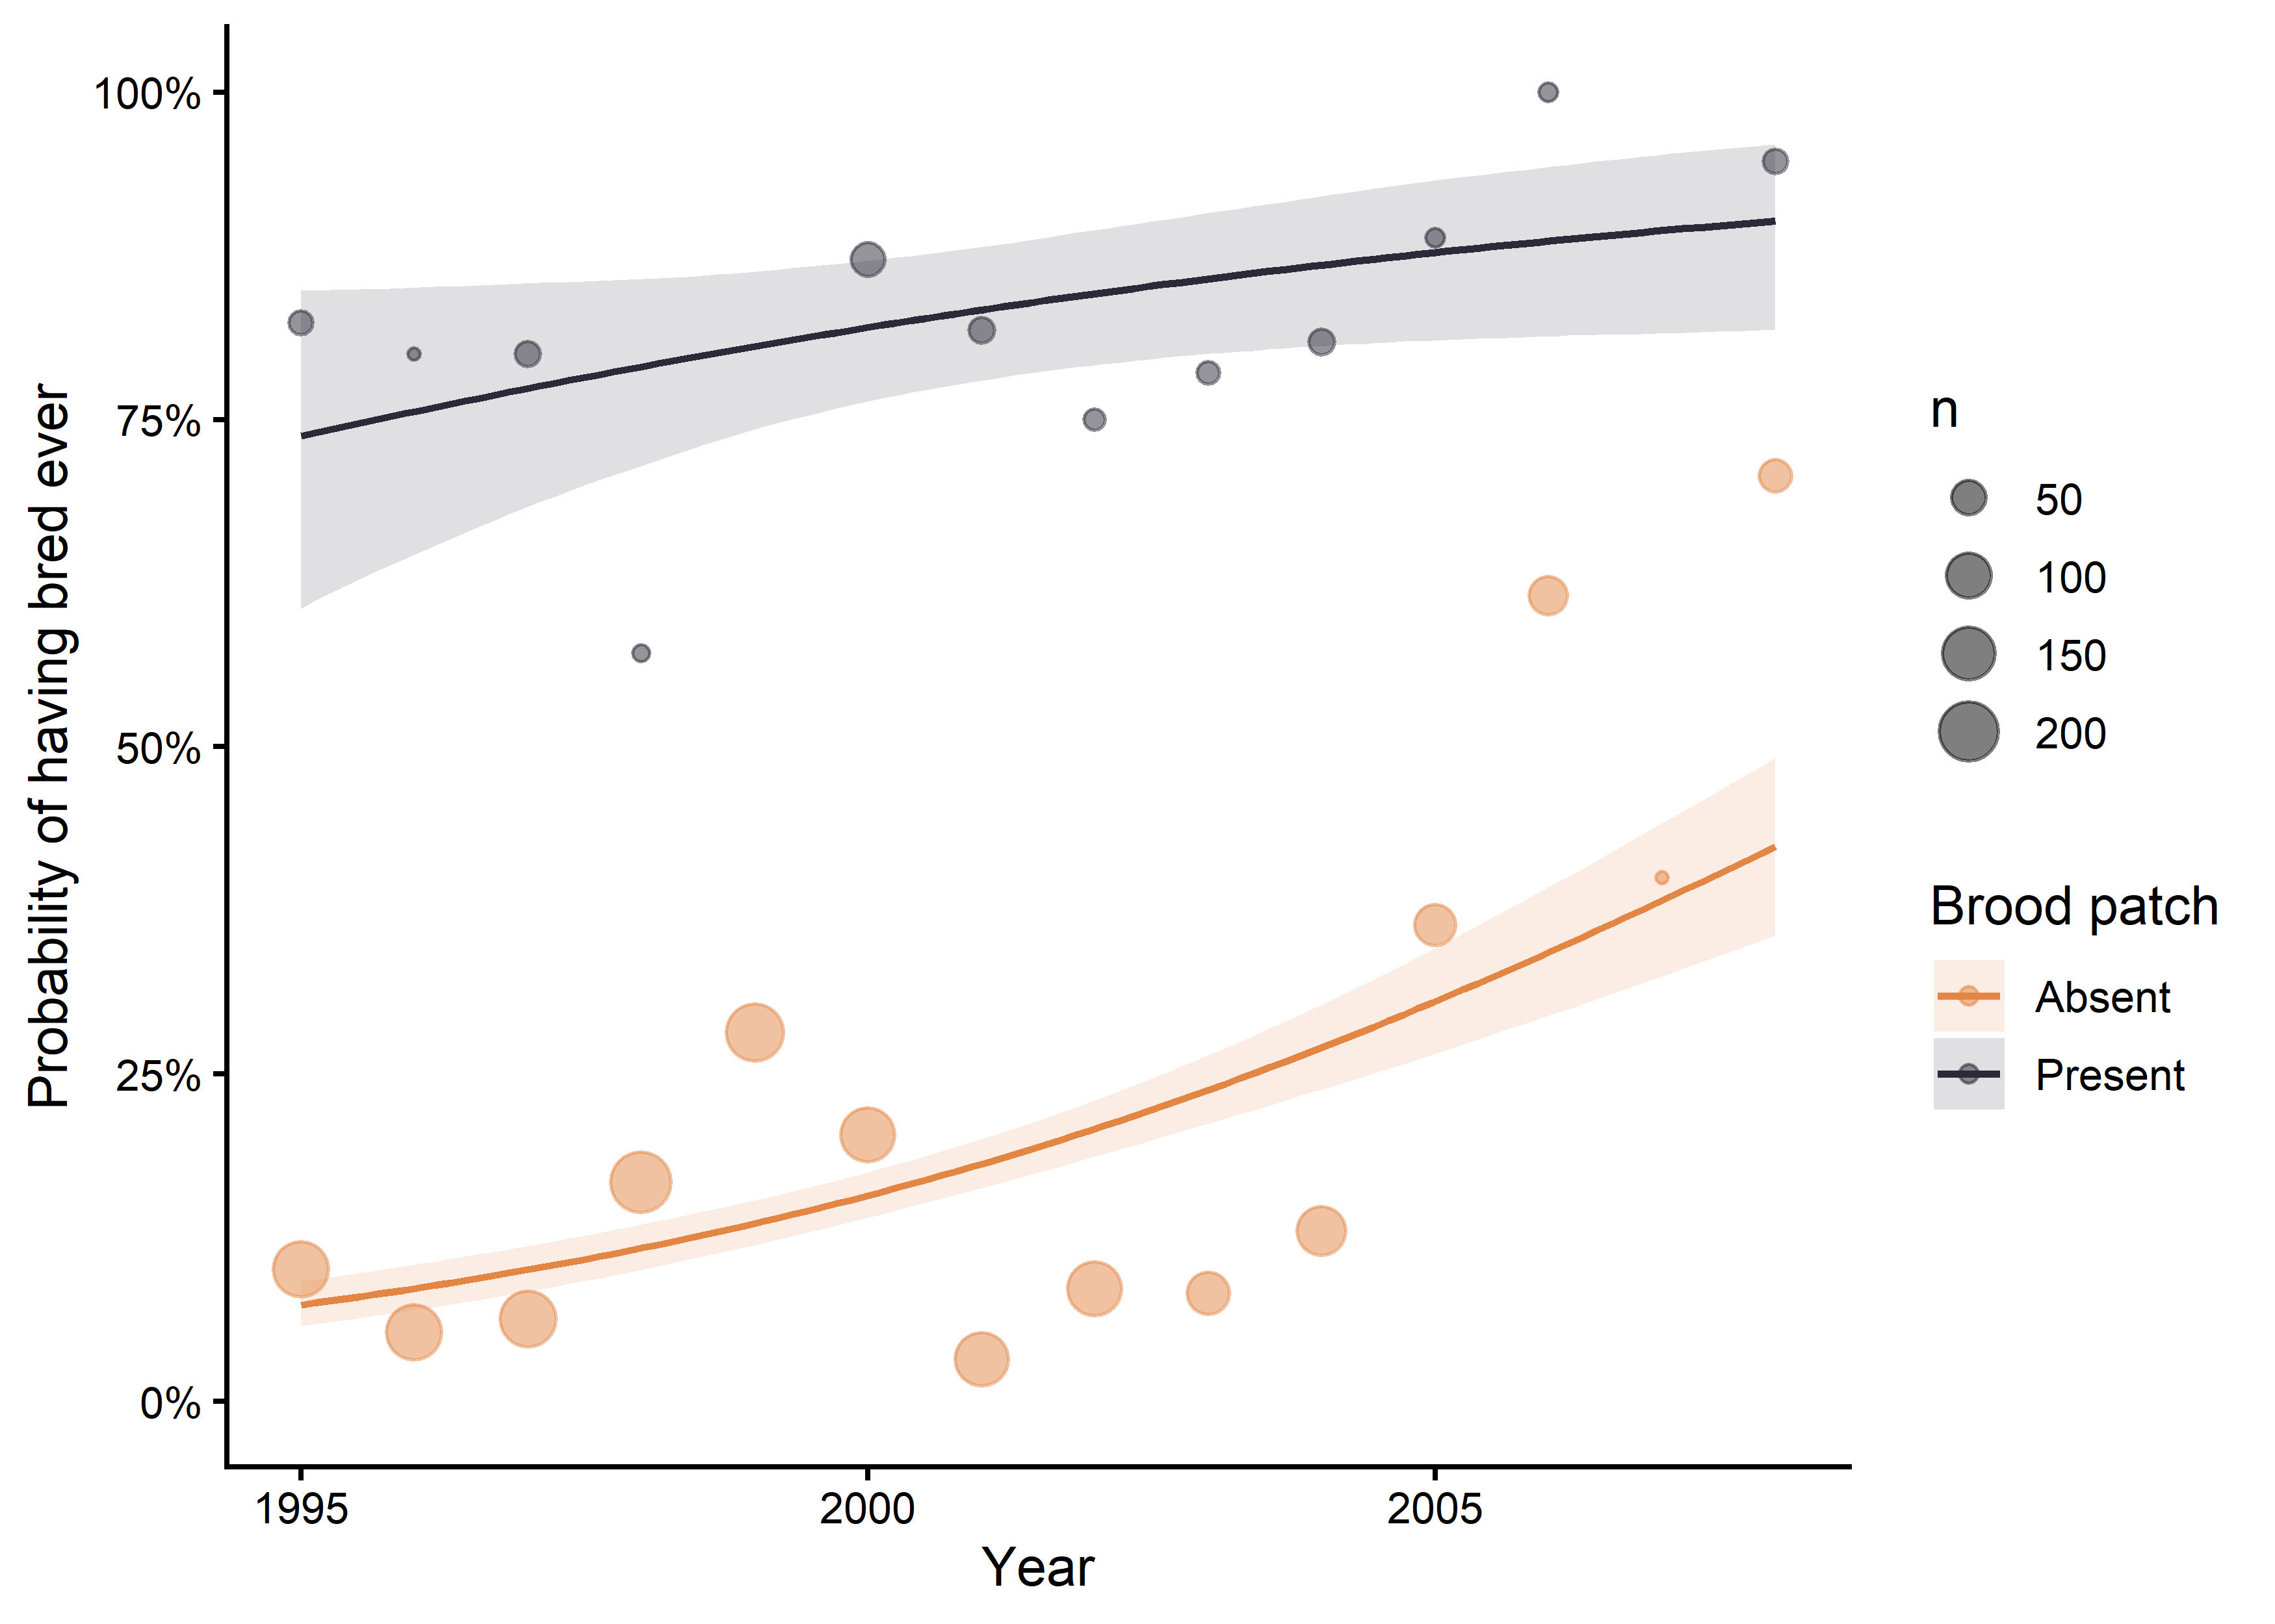
Fig. 3

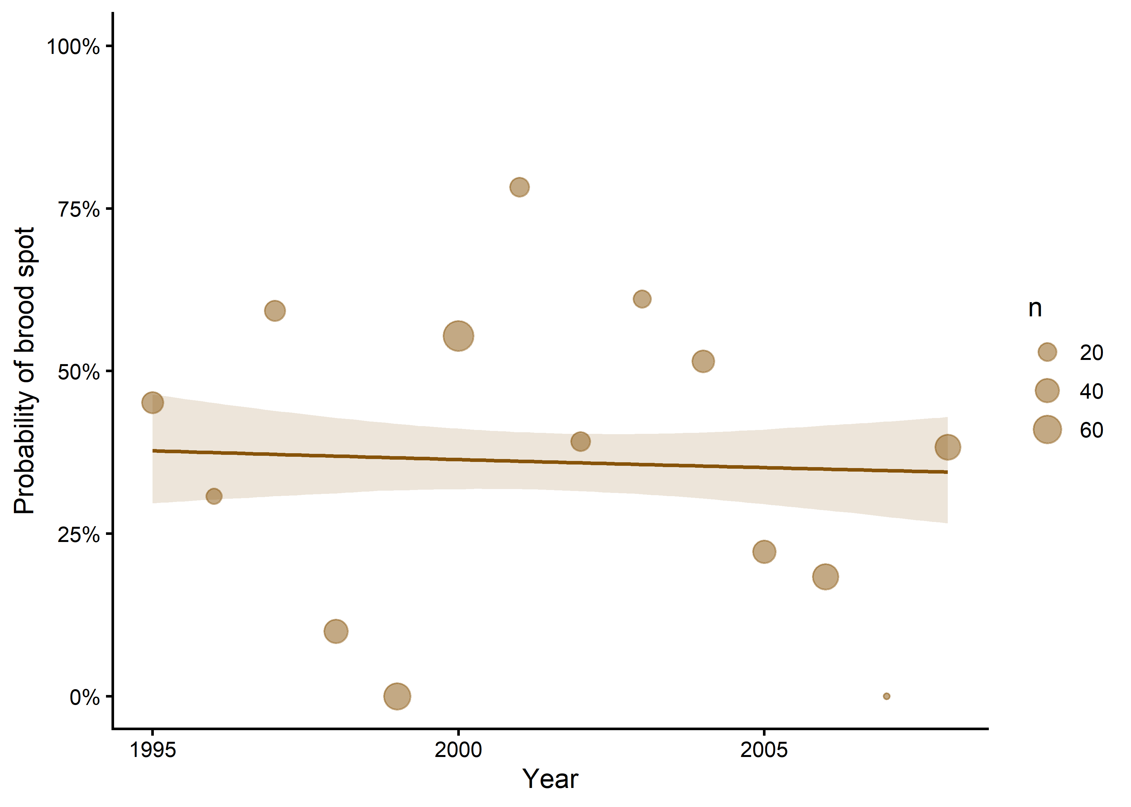
Fig. 4

TABLE 1. Estimated annual puffin harvest and sample sizes, Nólsoy (1989–2006) and Mykines (2007–2008), Føroyar. Sample sizes are presented for the total sample size and the number of females in the sample. The percentage of females that had bred is shown as % (n).
Year | Estimated harvest | Sample size | Females | % Bred (n)
1989 | NA | 259 | NA | NA
1990 | NA | 120 | NA | NA
1991 | NA | 119 | NA | NA
1992 | NA | 161 | NA | NA
1993 | NA | 201 | NA | NA
1994 | NA | 296 | NA | NA
1995 | NA | 402 | 186 | 17% (31)
1996 | 8188 | 350 | 176 | 7% (13)
1997 | 6976 | 446 | 195 | 14% (27)
1998 | 8277 | 450 | 222 | 18% (40)
1999 | 13324 | 439 | 188 | 28% (53)
2000 | 12758 | 424 | 209 | 35% (74)
2001 | 10992 | 390 | 176 | 13% (23)
2002 | 5874 | 379 | 175 | 13% (23)
2003 | 1798 | 200 | 99 | 18% (18)
2004 | 5050 | 296 | 144 | 23% (33)
2005 | 1851 | 193 | 86 | 42% (36)
2006 | 1596 | 198 | 74 | 66% (49)
2007 | 207 | 9 | 5 | 40% (2)
2008 | 335 | 140 | 60 | 78% (47)

TABLE 2. Odds ratios for all fixed effects of the Bayesian generalised linear model testing temporal changes in the breeding status of Atlantic puffins (Fratercula arctica) harvest in Føroyar (1995-2008). The model included breeding status (0 = never bred, 1 = has bred) as response variable, and year, brood patch (0 = absent, 1 = present), and their interaction as covariates.
 | Estimate | Lower 95% CI | Upper 95% CI
Intercept | 0.19 | 0.16 | 0.21
Year (in decades) | 5.55 | 3.88 | 7.99
Brood patch (BP) | 24.85 | 16.99 | 37.13
Year: BP | 0.46 | 0.17 | 1.32

