Development of an R-based Analytical Pipeline for Non-Targeted Detection and Chemical Profiling of Illicit Drug Waste in Environmental Samples
Anne Hinten and Gabriella Brouwers
Avans University of Applied Sciences, School of Life Sciences and Technology
Breda, the Netherlands
Illicit production of synthetic drugs generates large quantities of chemical waste that are frequently disposed of illegally, posing environmental and forensic challenges. The chemical composition of these waste streams is highly variable and often consists of complex mixtures of precursors, synthesis by-products, solvents, and drug residues. Non-targeted liquid chromatography-mass spectrometry (LC-MS) provides opportunities to characterize these samples without requiring predefined target compounds. The aim of this study was to develop an R-based workflow for the analysis of non-targeted LC-MS data and to investigate chemical similarities among environmental samples associated with illicit drug waste. LC-MS data from 47 environmental samples and 13 procedural blanks were processed using MS-DIAL and analysed in R. Following log-transformation and median normalization, multidimensional scaling (MDS) was used to evaluate similarities between samples. The analysis demonstrated a clear separation between environmental samples and procedural blanks and revealed partial clustering according to sampling location, although overlap remained between several locations. Layer-resolved analysis showed no clear clustering according to sampling depth, suggesting that geographical origin contributes more strongly to chemical variation than vertical stratification within waste containers. Suspect screening against a database of 41 drug-related compounds resulted in the tentative identification of 22 compounds, including amphetamines, MDMA and its precursors, cocaine-related compounds, cathinones, adulterants, and synthesis solvents. Heatmap visualization supported the MDS results by revealing similarities in compound distributions between locations while also highlighting location-specific chemical signatures. The developed workflow successfully integrated non-target LC-MS data processing, multivariate analysis, suspect screening, and visualization into a reproducible framework for the investigation of illicit drug waste. The agreement between the MDS analyses and heatmap visualizations demonstrated that chemical composition contributes to the observed clustering patterns. These findings highlight the value of computational metabolomics approaches for environmental monitoring and forensic investigations and provide a foundation for future studies on source attribution and compound identification.

Introduction
Illicit production of synthetic drugs such as amphetamine and 3,4-methylenedioxymethamphetamine (MDMA) represents a growing environmental and forensic challenge in the Netherlands. The manufacture of these compounds generates substantial quantities of chemical waste, including solvents, acids, precursor residues, reaction by-products, and other hazardous substances. Because clandestine drug laboratories operate outside regulatory control, waste streams are frequently discarded directly into the environment, contaminating soil, groundwater, and surface water systems. In particular, the southern regions of the Netherlands, including Noord-Brabant, have experienced an increasing number of illegal dumping incidents associated with synthetic drug production, raising concerns regarding environmental contamination, ecological toxicity, and public health risks.(Koppen et al., 2022)
The chemical composition of synthetic drug waste is highly variable and depends strongly on the synthesis route, precursor compounds, and production conditions used during manufacturing. As a result, illegally dumped waste often contains complex mixtures of organic and inorganic compounds that may persist in the environment and complicate forensic investigations. Previous studies have demonstrated that chemical profiling of clandestine drug waste can provide valuable information regarding synthesis pathways, precursor usage, and links between geographically separated dumping locations(Peters et al., 2025). Advanced analytical techniques such as liquid chromatography coupled to mass spectrometry (LC-MS) have therefore become increasingly important for the detection and characterization of these chemically diverse waste streams.
Non-targeted LC-MS approaches are particularly valuable in forensic and environmental investigations because they enable the detection of both known and previously unidentified compounds without requiring predefined target analytes (Reymond et al., 2021). By generating comprehensive chemical fingerprints, non-target screening allows for comparison between samples based on overall compositional similarity rather than solely on the presence or absence of specific compounds. Combined with multivariate statistical analyses and network-based approaches, these methods can reveal hidden relationships between samples, identify clustering patterns, and support the identification of common origins or synthesis procedures.
In this study, a non-targeted LC-MS workflow was developed to investigate chemical similarities among environmental samples associated with synthetic drug waste. Raw LC-MS data generated using MS-DIAL were processed and analysed in R using a combination of statistical and metabolomics-oriented packages. Data preprocessing included logarithmic transformation, and median-based normalization to reduce technical variability and improve comparability across samples. Exploratory quality assessment was performed using boxplots, followed by multidimensional scaling (MDS) analyses to evaluate clustering patterns based on sampling location and stratified sample layers within waste containers. Particular attention was given to layered samples originating from different phases within dumped waste mixtures, enabling investigation of chemical heterogeneity within individual waste containers.
Subsequently, metabolite annotation was performed based on measured mass-to-charge (m/z) values using MetaboAnnotation, allowing tentative identification of compounds contributing to observed clustering patterns. Heatmap visualization was then applied to explore intensity distributions and relationships among annotated features across all samples. By integrating non-target LC-MS analysis, statistical normalization, multivariate visualization, and compound annotation, this study aims to provide deeper insight into the chemical composition and relatedness of illicit drug waste samples and to demonstrate the value of computational metabolomics approaches in environmental forensic investigations.

Materials & Methods

Sampling and Data Acquisition
Drug waste samples were collected from five location types: BH (n = 11), G (n = 10), H (n = 15), M (n = 7), and T (n = 3), supplemented with 13 procedural blanks prepared using ultrapure water (Milli-Q). Samples were analysed on a SCIEX ZenoTOF 7600 QTOF mass spectrometer (AB Sciex) coupled to a SCIEX ExionLC system, using electrospray ionization (ESI) in positive ionization mode. Chromatographic separation was performed on a Waters Acquity UPLC BEH C18 column (100 × 2.1 mm, 1.7 μm; Waters, Wexford, Ireland; catalogue number 186002352). Mobile phase A consisted of 0.1% formic acid in Milli-Q water, while mobile phase B consisted of 0.1% formic acid in acetonitrile (ULC/MS grade, Biosolve Chemie). The gradient elution program started at A:B (95:5), increased to A:B (0:100) over 7 min, was maintained at 100% B for 3 min, and returned to 95:5 within 0.1 s, followed by 1 min 50 s of re-equilibration. The flow rate was 0.4 mL min⁻¹, injection volume 5 μL, and column temperature 40 °C. Total run time was 12 min. MS1 and MS2 data were acquired in centroid mode over an m/z range of 50–1000 Da. The declustering potential was set to 80 V; collision energy was 10 V for MS1 and 35 V for MS2, with a collision energy spread of 10 V for MS2. Accumulation times were 0.15 s (MS1) and 0.10 s (MS2).

Data Preprocessing
Raw data were processed in MS-DIAL (v5.5.260323) using Linear Weighted Moving Average smoothing (level 3), a minimum peak height of 500, MS1 tolerance of 1 mDa, MS2 tolerance of 25 mDa, and retention time alignment tolerance of 1 min. Gap filling and blank filtering were enabled, applying a sample-maximum-to-blank-mean ratio ≥ 5. The aligned dataset contained 2,225 features across 60 samples, with MS/MS spectra available for 99.2% of features. Peak areas, m/z values, retention times, adducts, and MS/MS spectra were exported as CSV.

Feature Matrix Construction
The MS-DIAL export file was programmatically converted into a feature-by-sample intensity matrix. Unique feature identifiers were generated by concatenating the measured m/z and retention time values, after which all sample intensity columns were extracted while non-informative summary columns were removed. The resulting count table (features x samples) served as the input for all downstream normalization and multivariate analysis.

Data Handling and Experimental Design
The full MS-DIAL feature matrix (including blanks) was imported into R en log₂-transformed. Sample metadata (location and waste-layer classification) was incorporated as experimental factors. All samples were retained for multivariate analysis to preserve the full chemical diversity.

Normalization and Quality Control
Median-normalized intensities were used as input for multivariate analysis. To visually assess normalization performance, boxplots were generated from a randomized subset of three samples per location group, due to the uneven spread of sample amounts across the different groups. This subset was also used for a secondary MDS check to confirm structural consistency.

Multidimensional Scaling (MDS)
Global similarity patterns were evaluated using MDS implemented via edgeR’s DGEList structure. MDS plots were generated using glMDSPlot() (Glimma), grouping samples by location and waste-layer. This approach enabled visualization of clustering patterns, location-specific chemical signatures, and potential batch effects without relying on prior compound identification.
In addition to non-target analysis, suspect-based identification was performed to explore compound identification and compound similarities between samples.

Suspect Annotation
A reference database was assembled with 41 drug-related compounds, based on exact monoisotopic masses verified through PubChem. The database include cocaine and its metabolites, cutting agents, amphetamines, MDMA precursors, 2C-B analogues, opioids, cathinones, and synthetic solvents. Annotation was performed using the Bioconductor package MetaboAnnotation (Rainer et al., 2022) in R through the matchMz() function with Mass2MzParam, where theoretical adduct m/z values ([M+H]⁺, [M+2H]²⁺, [M+NH₄]⁺, [M+CH₃CN+H]⁺) were matched against measured values within tolerances of 0.005 Da and 10 ppm. Annotation confidence levels were assigned according to Schymanski et al. (2014): Level 2 (< 5 ppm) and Level 3 (5-10 ppm).

Normalisation and Blank Correction
Peak areas were normalized using median normalization (normalizeMedianValues (), limma; Ritchie et al., 2015). Subsequently, the mean signal intensity observed in procedural blanks was subtracted from each normalized sample in a per-feature basis. Negative values resulting from this correction were set to zero.

Visualization and Implementation
Mean peak areas of annotated features were visualized per drug category and sample group using heatmaps generated with ggplot2 (Wickham, 2016) and a log₁₊ transformed viridis color scale. The complete data-processing workflow was implemented in R (version ≥ 4.3) using the packages MetaboAnnotation, MetaboCoreUtils, limma, tidyverse, and viridis, and is publicly available via GitHub (Project_Bioinformatics_Drug_waste).
In addition to suspect-based identification, a non-targeted analysis was performed to explore global chemical variation across sampling locations.

Results

Data acquisition and feature detection
Mass spectrometry-based metabolomics data were initially processed using MS-DIAL. After preprocessing with MS-DIAL, the alignment dataset consisted of 2.225 features over 47 samples and 13 procedural blanks. The most frequently present adduct types were [M+2H]²⁺ (n = 1262; 56,7%), [M+H]⁺ (n = 767; 34,5%), [M+CH₃CN+H]⁺ (n = 106; 4,8%) and [M+NH₄]⁺ (n = 90; 4,0%). Raw peak intensities were log2-transformed after addition of a pseudocount of 1 to stabilize variance and reduce heteroscedasticity. To reduce systematic variation between samples, median normalization was applied using the normalizeMedianValues function. Normalization was performed on the log2-transformed dataset to improve comparability of feature intensities across samples.

Multidimensional scaling and normalization
Multidimensional scaling (MDS) was first performed on the full dataset, including all biological samples and procedural blanks. This analysis provided an overview of the global structure of the metabolomic data and showed a clear distinction between blank controls and biological samples, indicating that background signals were separated from biological variation.
Within the biological samples, a general tendency for clustering according to sampling location was observed; however, this separation was not complete. Several locations showed partial overlap in ordination space, suggesting that inter-location variability is present but not strongly pronounced across all groups. In particular, samples from locations H and BH exhibited substantial overlap (figure 1), while M and G samples also showed partial intermixing. In contrast, T samples appeared somewhat more distinct, although still not fully separated from other groups. These patterns indicate that while spatial location contributes to variation in metabolomic profiles, it is not the sole or dominant driver of sample separation in the full dataset.
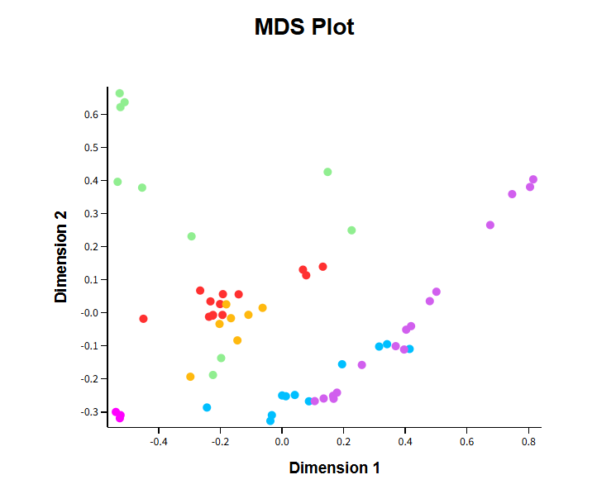
Figure 1, MDS plot of all samples following median normalization. Blank samples are indicated in red. Remaining samples are colour-coded by sampling location: G (green), T (pink), H (purple), M (yellow), and BH (blue).

To further reduce the influence of sample-to-sample variability on visual interpretation and to better balance group representation, a reduced dataset was generated consisting of three randomly selected samples per experimental group, together with procedural blank controls. This approach was applied to facilitate clearer visualization of group-level structure in both multivariate and univariate analyses.
Boxplot analysis of the reduced dataset was performed to assess the effect of normalization on intensity distributions across groups. The resulting profiles showed comparable log2 intensity ranges between locations, indicating that median normalization effectively reduced inter-sample variability and improved comparability across samples (Figure 2b).
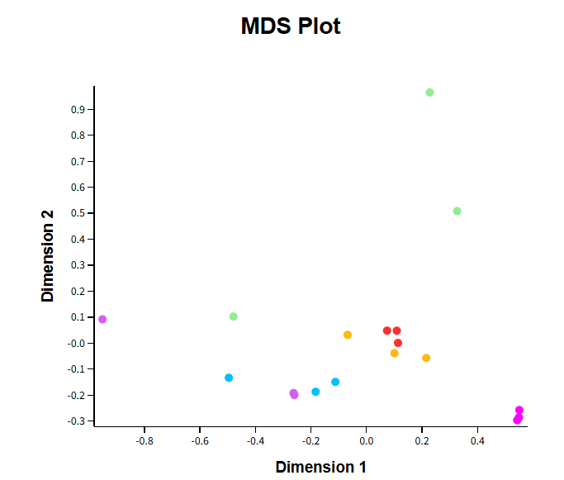 | 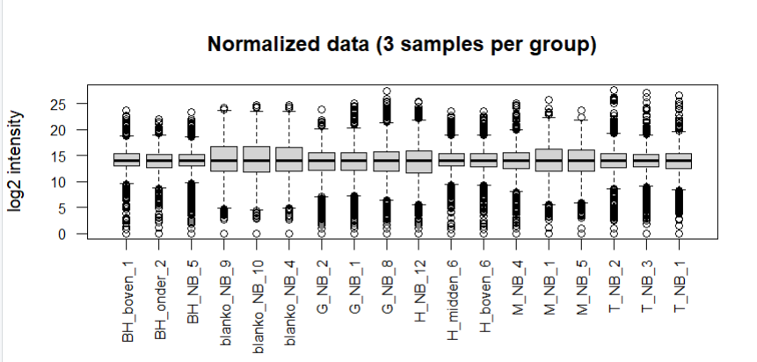
Figure 2a, MDS plot showing three randomly selected samples per location together with three blank controls. following median normalization Blank samples are shown in red. The remaining samples are colour-coded by location: G (green), T (pink), H (purple), M (yellow), and BH (blue). | Figure 2b, Boxplot showing three randomly selected samples per location together with three blank controls. The y-axis represents log2 intensity, while the x-axis shows the individual samples grouped by location. following median normalization
Multidimensional scaling analysis of the reduced dataset (Figure 2a) demonstrated an improved visual separation of samples according to sampling location compared to the full dataset. While some overlap between groups remained, samples more consistently clustered within their respective locations. Blank controls formed a distinct cluster separate from the biological samples, consistent with their background origin and supporting the effectiveness of the preprocessing and normalization workflow.
To further investigate potential sub-structuring within locations, an additional MDS analysis was performed focusing specifically on samples from locations H and BH. For these locations, samples were additionally stratified according to sampling depth (layer), as these were the only locations where consistent sampling across multiple layers was available. This allowed for a more detailed assessment of whether vertical variation contributed to the observed metabolomic differences within these spatial groups.
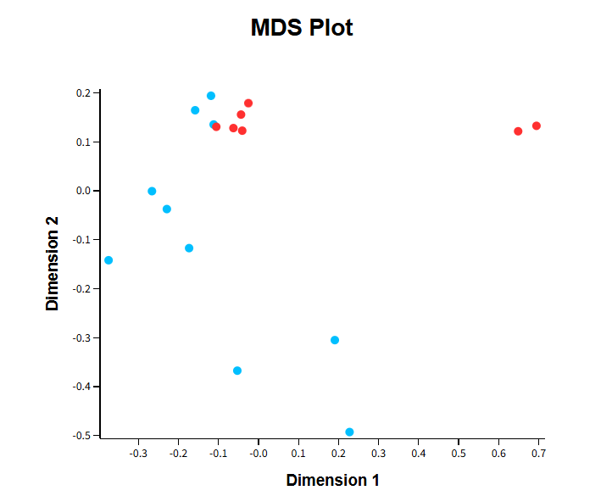 | 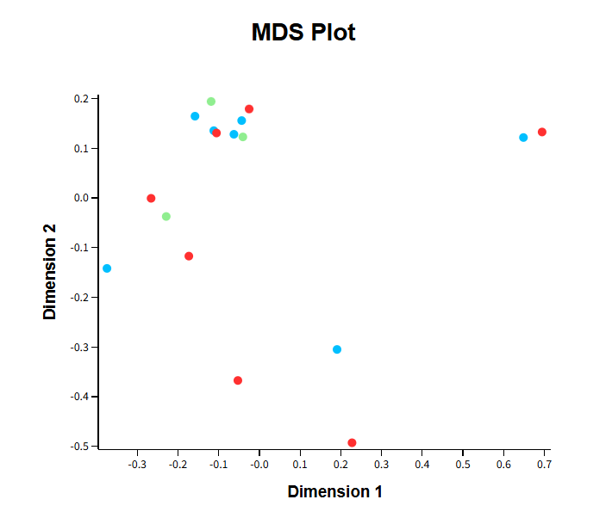
Figure 3a. MDS plot showing samples from locations BH (blue) and H (red), including samples collected from multiple layers. | Figure 3b. MDS plot showing samples from locations BH and H, including samples collected from multiple layers. Samples are colour-coded by layer: top layer (blue), middle layer (green), and bottom layer (red).

Table 1. Suspect annotations (Level 2 and 3) based on m/z matching against the reference database. Mass errors are expressed in ppm. Annotation levels follow the Schymanski et al. (2014) confidence framework.
Compound | Category | Adduct | Obs. m/z | Δ ppm | Level
Amphetamine | amphetamine | [M+H]⁺ | 136.112 | <1 | 2
Methamphetamine | amphetamine | [M+H]⁺ | 150.128 | <2 | 2
MDMA | amphetamine | [M+H]⁺ | 194.118 | <5 | 2
MDA | amphetamine | [M+H]⁺ | 180.102 | <5 | 2
MDEA | amphetamine | [M+H]⁺ | 208.133 | <5 | 2
Ephedrine | amphetamine precursor | [M+H]⁺ | 166.123 | <3 | 2
Pseudoephedrine | amphetamine precursor | [M+H]⁺ | 166.123 | <3 | 2
Phenylacetone (P2P) | amphetamine precursor | [M+H]⁺ | 135.081 | <2 | 2
Phenylacetaldehyde | amphetamine precursor | [M+H]⁺ | 121.065 | <3 | 2
PMK (3,4-MDP2P) | MDMA precursor | [M+H]⁺ | 193.086 | <4 | 2
Safrole | MDMA precursor | [M+H]⁺ | 163.075 | <5 | 2
Cocaine | cocaine | [M+H]⁺ | 304.155 | <5 | 2
Ecgonine | cocaine | [M+H]⁺ | 186.113 | <3 | 2
Cocaethylene | cocaine | [M+H]⁺ | 318.170 | <5 | 2
Mephedrone | cathinone | [M+H]⁺ | 178.122 | <5 | 2
Lidocaine | adulterant | [M+H]⁺ | 235.180 | <3 | 2
Phenacetin | adulterant | [M+H]⁺ | 180.102 | <5 | 2
Tramadol | opioid | [M+H]⁺ | 264.196 | <5 | 2
Methadone | opioid | [M+H]⁺ | 310.217 | <5 | 2
Toluene | solvent | [M+H]⁺ | 93.070 | <5 | 2
Acetone | solvent | [M+H]⁺ | 59.049 | <3 | 2
Benzaldehyde | solvent | [M+H]⁺ | 107.049 | <4 | 2
2C-H | 2CB | [M+H]⁺ | 182.118 | 5-10 | 3

Obs. = observed; Δ ppm = mass error in parts per million. Ephedrine and pseudoephedrine share an identical exact mass and cannot be distinguished by MS1 alone.
Within this layer-resolved analysis, no clear clustering of samples according to sampling depth was observed (Figure 3a–b). Samples from different layers were largely interspersed within the same ordination space, and no consistent separation between top, middle, and bottom layers could be identified. This may indicate that sampling depth does not strongly influence the metabolomic profiles under the current conditions; however, it cannot be excluded that the lack of separation is related to sampling variability or incomplete physical separation between layers during collection. Instead, variation appeared to be driven primarily by location rather than depth, suggesting that spatial position at the larger scale is a more important determinant of metabolomic differences than vertical stratification within these locations.

Suspect annotation
Matching of the 2.225 features against the 41-compound reference database using MetaboAnnotation::matchMz() yielded annotations for 22 unique compounds (Level 2: mass error < 5 ppm; Level 3 5-10 ppm; Schymanski et al., 2014). The complete annotation list is presented in Table 1. Detected compounds included substances associated with amphetamine synthesis (amphetamine, methamphetamine, ephedrine, phenylacetone), MDMA production (MDMA, MDA, MDEA, PMK, safrole), cocaine and its metabolites (cocaine, ecgonine, cocaethylene), cathinones (mephedrone), adulterants (phenacetin, lidocaine), and synthesis solvents (toluene, acetone, benzaldehyde).

Distribution of Drug Categories Across Sample Groups
Mean peak areas of annotated features per drug category sample group are shown in Figure 4. All nine categories were detectable across all five sample groups, apart from 2CB in sample group T. The cathinone category displayed the strongest signal in group G and M, with group G showing a distinctly dark tile indicating a mean peak area exceeding 1 x 10⁵. Cocaine-related compounds showed the highest signal in group M, while amphetamine-related compounds were relatively uniformly distributed but most prominent in G and H. Solvents and opioids showed a more homogeneous distribution across all groups.
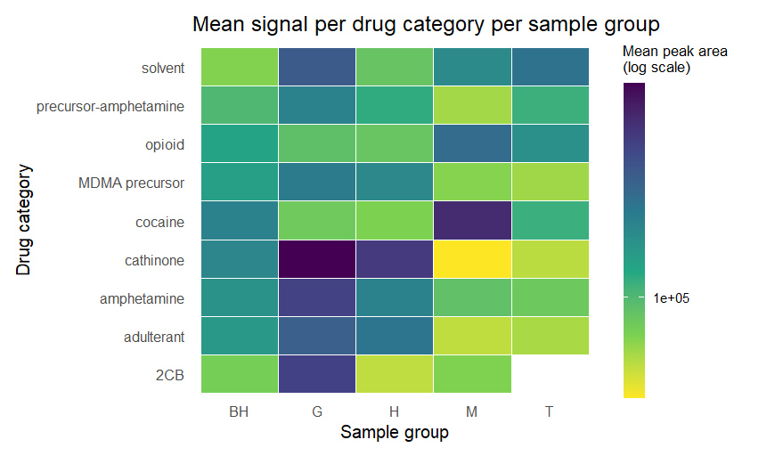
Figure 4. Mean peak area per drug category per sample group following median normalisation and blank correction. Colour intensity is log₁p-transformed; darker = higher signal. Sample groups are BH, G, H, M and T

Chemical Fingerprint per Compound
Figure 5 shows the signal distribution per individual annotated compound. Ecgonine (cocaine metabolite) displayed the highest signal of all compounds in sample group BH, indicating a strong presence of cocaine-related compounds at that location. Cocaine itself showed the highest mean signal in group M. Mephedrone (cathinone) and toluene (solvent) were most prominent in group G. Amphetamine precursors including phenylacetone (P2P), phenylacetaldehyde, and ephedrine were relatively uniformly present across BH, G and H, consistent with amphetamine synthesis activity at multiple locations. MDMA and its associated precursors (PMK, safrole) were detectable in all groups but strongest in G and H.
Lidocaine and phenacetin (adulterants) showed a broad detection profile across all groups, consistent with their widespread use as cutting agents across multiple drug types. Opioids (tramadol, methadone) were present at low signal levels across all groups, without a clear concentration at any single location.
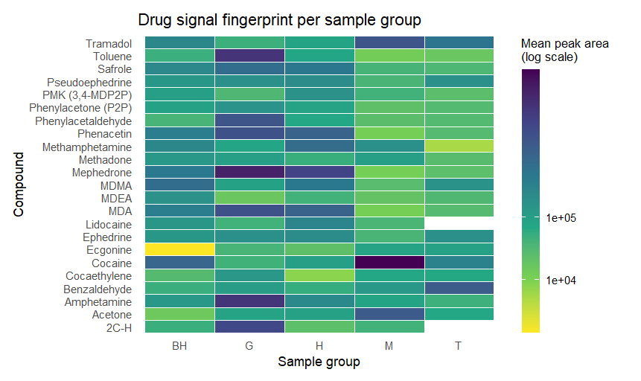
Figure 5. Chemical fingerprint profile per annotated compound per sample group following median normalisation and blank correction. Colour intensity is log₁p-transformed; darker = higher signal. Compounds are ordered alphabetically. Sample groups are BH, G, H, M and T. Empty cells indicate a peak area of zero after blank correction.

Discussion
The aim of this study was to develop an R-based workflow for the analysis of non-targeted LC-MS data from environmental samples associated with illicit drug waste and to investigate whether chemical similarities could be used to distinguish between sampling locations and waste layers. The main findings were that median normalization effectively reduced technical variation between samples, that samples showed partial clustering according to sampling location, and that no clear separation based on waste-layer depth was observed. In addition, suspect screening identified compounds associated with amphetamine, MDMA, cocaine, cathinones, adulterants, and synthesis solvents across multiple locations.
These findings are relevant for both environmental and forensic investigations. Illegal disposal of synthetic drug waste represents an increasing environmental problem in the Netherlands, and creates complex mixtures of contaminants that are difficult to characterize using targeted analytical approaches alone. As described by Reymond et al. (2021), non-targeted LC-MS methods provide a broader overview of chemical composition and can reveal similarities between samples that may not be evident from individual target compounds. The workflow developed in this study demonstrates how computational metabolomics tools can be used to explore these complex datasets and identify chemical patterns associated with illicit drug production.
The clustering patterns observed in MDS analyses are generally consistent with previous studies reporting that chemical profiles can be used to distinguish between different drug production environments and synthesis routes (Peters et al., 2025). The clear separation between procedural blanks and environmental samples indicates that the detected variation was primarily driven by sample composition rather than analytical background signals. Furthermore, the partial clustering according to sampling location suggests that geographical origin contributes to differences in chemical composition.
The heatmap analyses support these observations. Samples that clustered relatively closely in the MDS plots generally displayed similar distribution of annotated compound classes in the heatmaps. For example, the substantial overlap between locations H and BH in the MDS analysis corresponded with comparable profiles of amphetamine-related compounds, MDMA precursors, solvents, and adulterants. Similarly, the partial overlap between locations G and M may be explained by the presence of several shared compound categories. AT the same time, the heatmap revealed location-specific differences that likely contributed to the remaining separation observed in the MDS plots. For instance, mephedrone and toluene showed particularly high intensities in group G, whereas cocaine-related compounds were most abundant in groups M and BH. Together, these findings suggest that both shared and location-specific chemical signatures contribute to the observed clustering patterns.
An interesting finding was the absence of clear clustering according to waste-layer depth. Because layered waste samples may originate from different disposal events or phases within a waste container, some degree of chemical stratification could have been expected. However, samples from top, middle, and bottom layers were largely interspersed in the MDS plots. One explanation may be that the waste mixtures were already substantially mixed before sampling, reducing any original stratification. Another possibility is that the chemical differences between layers are relatively small compared with the difference between locations. The results therefore suggest that location is a more important determinant of overall chemical composition than sampling depth within a container.
The suspect-screening results further support the forensic relevance of the analysed samples. Several compounds associated with the amphetamine and MDMA synthesis, including amphetamine, methamphetamine, ephedrine, phenylacetone, PMK, and safrole, were detected across multiple locations. In addition, cocaine-related compounds, cathinones, adulterants, and synthesis solvents were identified. These findings are in agreement with previous reports describing the diverse chemical composition of illicit drug waste and demonstrate that non-targeted approaches can capture a broad range of relevant substances within a single analytical workflow.
Several limitations should be considered when interpreting the results. First, compound annotations were based on accurate mass matching and therefore represent tentative identifications corresponding to Schymanski confidence levels 2 and 3. Structural confirmation using reference standards or spectral library matching was not performed. Second, the suspect database consisted of only 41 compounds and therefore represents only a subset of the potentially thousands of compounds present in synthetic drug waste. Third, sample numbers differed considerably between locations, which may have influenced clustering patterns and reduced statistical robustness. In addition, the reduced dataset used for visualization may not fully reflect the variability present within the complete dataset. Finally, environmental factors, such as degradation processes, matrix effects, and sample handling may have influenced the detected chemical profiles.
Future studies could strengthen the current findings by including larger and more balanced sample sets, expanding suspect databases with additional synthesis by-products and emerging psychoactive substances, and performing MS/MS-based structural confirmation of annotated compounds. The incorporation of molecular networking and other advanced metabolomics approaches could further improve the identification of unknown compounds and provide additional insight into relationships between samples. Furthermore, integrating quantitative analyses with non-targeted screening may help establish stronger links between chemical composition, synthesis routes, and waste origins.
Overall, the developed workflow successfully combined data preprocessing, normalization, multivariate analysis, suspect screening, and visualization into a reproducible framework for the investigation of illicit drug waste. The agreement between the MDS analysis and heatmap visualizations demonstrates that non-targeted LC-MS data can provide meaningful insight into chemical similarities and differences between environmental samples. These results highlight the potential of computational metabolomics approaches to support environmental monitoring and forensic investigations of synthetic drug waste.

Conclusions
This study demonstrates that non-targeted LC-MS combined with computational metabolomics is a valuable approach for the characterization of illicit drug waste. MDS analysis revealed partial clustering according to sampling location, while no clear separation based on waste-layer depth was observed. Suspect screening identified compounds associated with amphetamine, MDMA, cocaine, cathinones, adulterants, and synthesis solvents, highlighting the complex chemical composition of these waste streams. The agreement between the MDS plots and heatmap visualizations indicates that differences in chemical composition contribute to the observed clustering patterns. Overall, the developed workflow provides a reproducible framework for environmental and forensic investigations of illicit drug waste.

Acknowledgements
The authors would like to thank Dr. Maureen Hummel for valuable discussions and advice throughout the project. We are grateful to Dr. Jos F.H.M. Brouwers and Daan van Nassauw for valuable discussions, input throughout the project and for providing the data for the project.

References
Github (Project_Bioinformatics_Drug_waste, https://github.com/AnneH-06/Project_Bioinformatics_Minor_Drug_waste )
Koppen, A., Wijnands-Kleukers, A. P. G., Gresnigt, F. M. J., & De Lange, D. W. (2022). Clinical toxicology of exposures to chemicals from clandestine drug laboratories: A literature review. Clinical Toxicology, 60, 559. https://doi.org/10.1080/15563650.2021.2011734
Peters, R., et al. (2025). The identification of synthetic drug laboratories based on the detection of precursors. Forensic Science International, 367. https://doi.org/10.1016/j.forsciint.2025.112474
Rainer, J., Gatto, L., & Lewis, S. E. (2022). MetaboAnnotation: Mass spectrometry-based metabolite annotation in R. Metabolites, 12(2), 173. https://doi.org/10.3390/metabo12020173
Reymond, N., et al. (2021). Retrospective suspect and non-target screening combined with similarity measures to prioritize MDMA and amphetamine synthesis markers in wastewater. Science of the Total Environment, 811, 152275. https://doi.org/10.1016/j.scitotenv.2021.152275
Ritchie, M. E., Phipson, B., Wu, D., Hu, Y., Law, C. W., Shi, W., & Smyth, G. K. (2015). limma powers differential expression analyses for RNA-sequencing and microarray studies. Nucleic Acids Research, 43(7), e47. https://doi.org/10.1093/nar/gkv007
Schymanski, E. L., Jeon, J., Gulde, R., Fenner, K., Ruff, M., Singer, H. P., & Hollender, J. (2014). Identifying small molecules via high resolution mass spectrometry: Communicating confidence. Environmental Science & Technology, 48(4), 2097–2098. https://doi.org/10.1021/es5002105
Tsugawa, H., Cajka, T., Kind, T., Ma, Y., Higgins, B., Ikeda, K., ... Arita, M. (2015). MS-DIAL: Data-independent MS/MS deconvolution for comprehensive metabolome analysis. Nature Methods, 12(6), 523–526. https://doi.org/10.1038/nmeth.3393
Wickham, H. (2016). ggplot2: Elegant graphics for data analysis. Springer.
Wickham, H., Averick, M., Bryan, J., Chang, W., McGowan, L. D. A., François, R., Grolemund, G., Hayes, A., Henry, L., Hester, J., Kuhn, M., Pedersen, T. L., Miller, E., Bache, S. M., Müller, K., Ooms, J., Robinson, D., Seidel, D. P., Spinu, V., ... Yutani, H. (2019). Welcome to the tidyverse. Journal of Open Source Software, 4(43), 1686. https://doi.org/10.21105/joss.01686

