PESTPP-IES Instruction on How to Use parameter optimization, coupled with PHREEQC input and output files.
Pest ++ manual read p.124ff
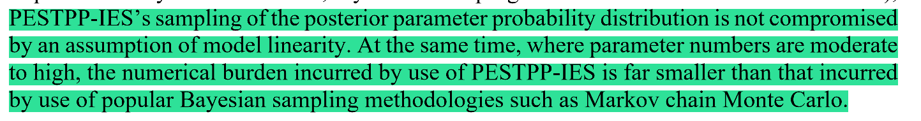
The classical finite-difference approach used in PEST relies on explicit numerical derivatives to estimate how changes in model parameters affect simulated observations. This is done by perturbing one parameter at a time—typically by a small positive and negative increment—and re-running the model to calculate the corresponding changes in outputs. These sensitivities form the Jacobian matrix, which is then used in a gradient-based optimization algorithm such as the Gauss–Levenberg–Marquardt method. While this method is mathematically rigorous, it can be computationally expensive because the number of model runs scales with the number of parameters, and it may struggle in highly nonlinear systems where local derivatives do not adequately represent model behavior. In contrast, the Iterative Ensemble Smoother (IES) adopts a derivative-free, covariance-based approach. Instead of perturbing parameters individually, IES generates an ensemble of parameter sets representing prior uncertainty, runs the model for each ensemble member, and infers sensitivities from the statistical relationships between parameter variability and observation variability. These covariances reflect how groups of parameters jointly influence model outputs, making IES more robust to nonlinearity and parameter interactions. Parameter updates are applied to the entire ensemble using Bayesian formulas that incorporate both model–data misfit and prior uncertainty. This process is repeated iteratively until convergence, producing not a single optimal parameter set but a posterior ensemble that reflects calibrated parameter values and associated uncertainty. Consequently, IES often requires fewer model runs, is more stable in complex systems, and naturally provides uncertainty quantification alongside calibration.
- Download PEST++ suit from the GitHub site https://github.com/usgs/pestpp. You can also find the documentation there https://github.com/usgs/pestpp/tree/master/documentation
- Download PEST from here to get supporting executables: https://pesthomepage.org/downloads

Establish a successful PEST run

We need to create all the needed input files for a PEST run. You can read about the different input files and their contents in the PEST documentation. The three needed input files are:
  - Control file (.pst file)
  - Instruction files (.ins files)
  - Template file (.tpl files)
Use the 01_create_inp_files.py program to create the files. Use TEMPCHEK, INSCHEK and PESTCHEK to check if the files were created correctly. Open the terminal in the location where the files were stored and call the executable and the filename, e.g., PESTCHEK control.pst.
In the control file I usually call a python or a .bat file to run the model. It helps to deal with the problems that the command lines get very long.
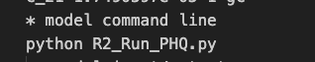

Control file of PEST++IES
You can use the standard PEST suits control file but you can also make some adjustments by adding it in the written form like this.
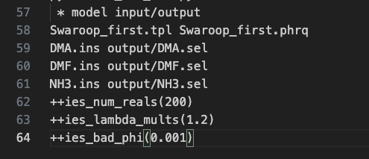.
Find all the potential control variables here in the manual p. 150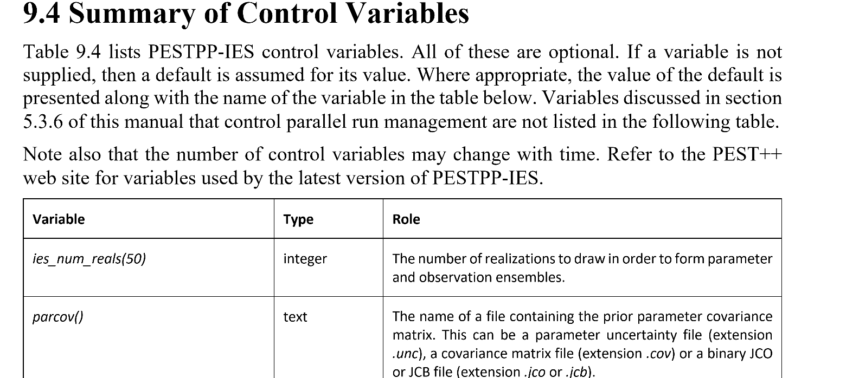

Start PESTPP IES run
Start the run in terminal with the standard command pestpp-ies control.pst, control.pst being the control file you have initiated and checked with PESTCHEK.

Postprocessing
- Check if your parameter bounds are reached; if yes, adjust. In the figure below it can be seen for K2 that some upper bound with 0.2 is reached, this has to be adjusted to get a better parameter uncertainty description.
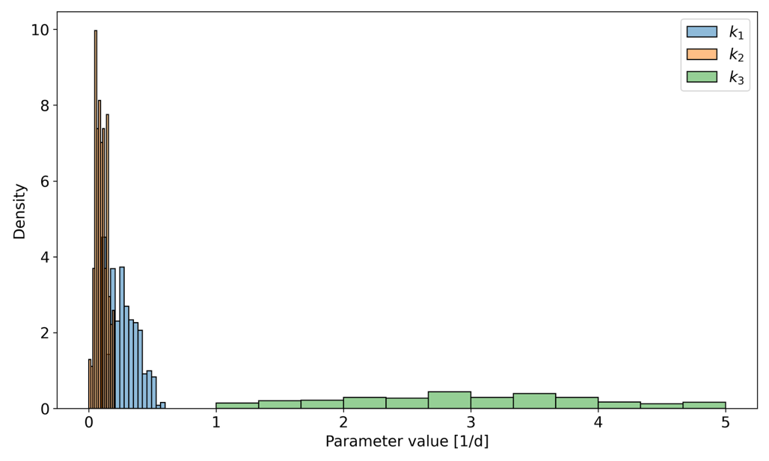
- Check the upper
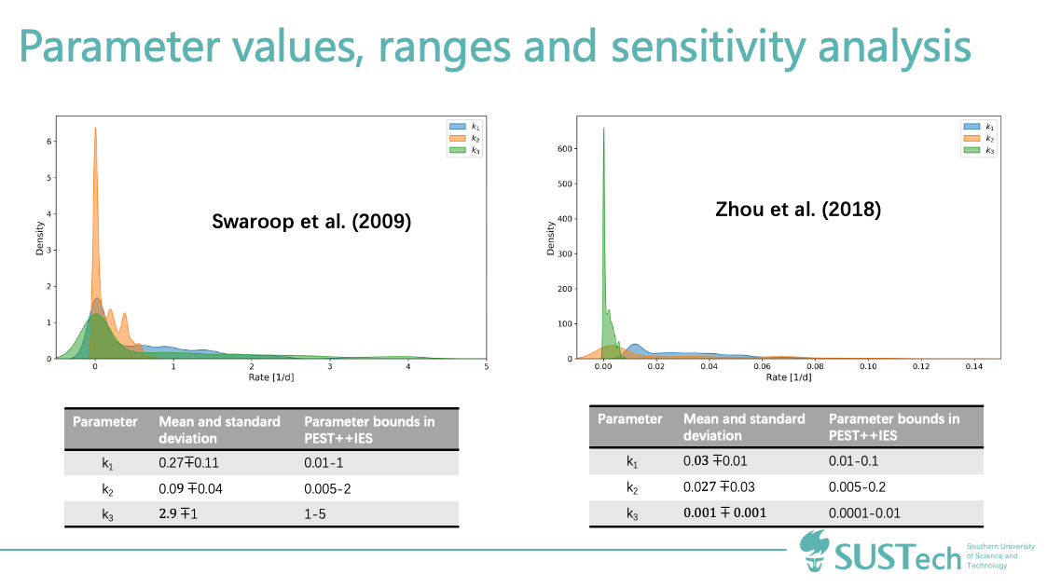

Parallelize

