**Progress Report Week 1**

**Group Name: A**

**Part I: Ice core analysis:**

Exploring the data: The data was stored in NIfTI (.nii) format. The volume has the dimensions of 512x512x512, a voxel size of 0.2x0.2x0.2cm3, and the intensities stored in a float64 but ITK-SNAP is only able to load it as a float32 bit-representation in the range from 0 to 1. An example slice and histogram of the intensities are shown in Figure 1.

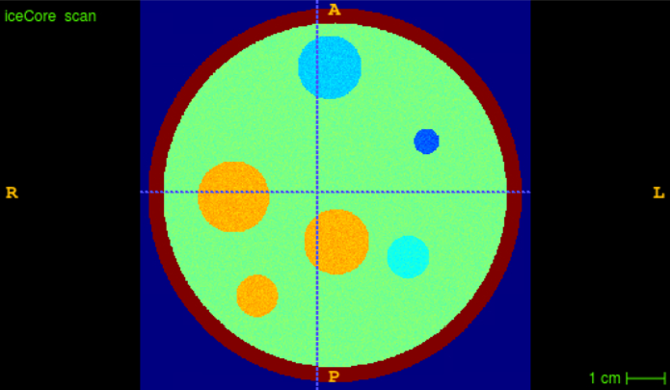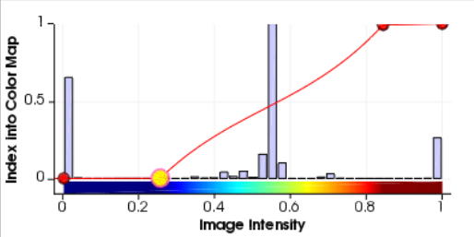

**Figure 1:** Example slice and histogram of voxel intensities.

Identifying bubbles of 18O: The colormap and contrast range was adjusted to easily distinguish the various air bubble types from one another (see Figure 2).

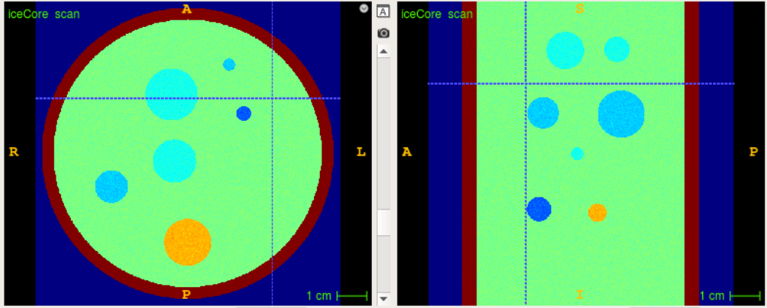

**Figure 2:** The orange bubbles are CH4, the light blue bubbles are 18O isotope, the medium blue bubbles are 16O isotope and the dark blue bubbles are N2O.

Counting and measuring bubbles of 18O: Using the ruler tool of ITK-SNAP (see Figure 3) we detect the following:

* Number of 18O bubbles: 15
* Approximately having the following diameters: [9, 12, 14, 11, 16, 22, 15, 8, 13, 17, 18, 16, 13, 13, 11] mm.

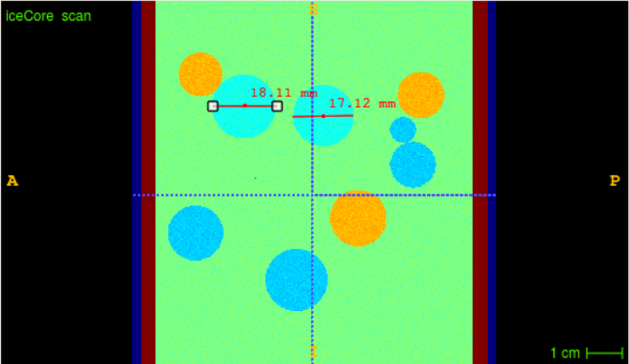

**Figure 3:** Example of measuring two 18O bubbles.

Analysis: We then calculate the proportion of 18O bubbles in the ice core

The volume of core cylinder: 2.5*106 mm2

The total volume of 18O bubbles: 9.6*103 mm2

The density: Proportion? 0.3%

**Part II: MNIST Classification:**

Exploring the data:

The MNIST dataset consists of 60000 training and 10000 testing images of handwritten digits, each of size 28 x 28. Examples from each of the 10 classes are shown in Figure 4.

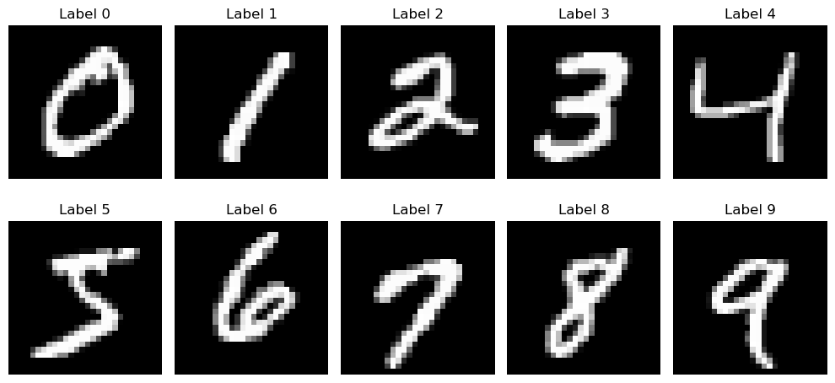

**Figure 4:** Examples of each of the ten labels in the MNIST dataset

Testing a small MLP model for classification: First we test a relatively small fully connected MLP, consisting of 2 hidden layers of size 10. This gives the model 8070 trainable parameters. In addition, the model uses ReLU activation functions for the hidden layers and a logarithmic softmax function for the output. The loss is calculated using Cross Entropy Loss and the model uses the Adam optimizer with a learning rate of 0.01, and is trained for 25 epochs.

The training and test loss curves are shown in Figure 5. We see that the model trains well and shows no signs of overfitting, and the model achieves an accuracy above 90%..

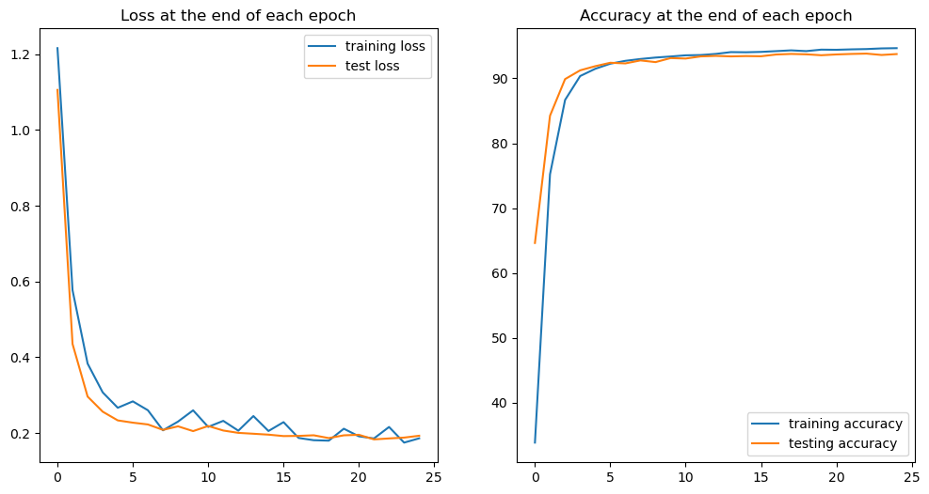

**Figure 5:** Loss and accuracy graphs recorded during both training and testing of the small model

Testing a large MLP model for classification: Train a model with approximately 100k trainable parameters.

The model consists of 4 hidden layers of size 128 for the first two and 64 for the latter two, which gives the model 130058 trainable parameters, but otherwise with the same settings as the small model. The training and test loss curves are shown in Figure 6. We see that the model is beginning to overfit, meaning that it has become too familiar with the training data. In the end however, it achieves an accuracy of above 95%, meaning that it still performs well.

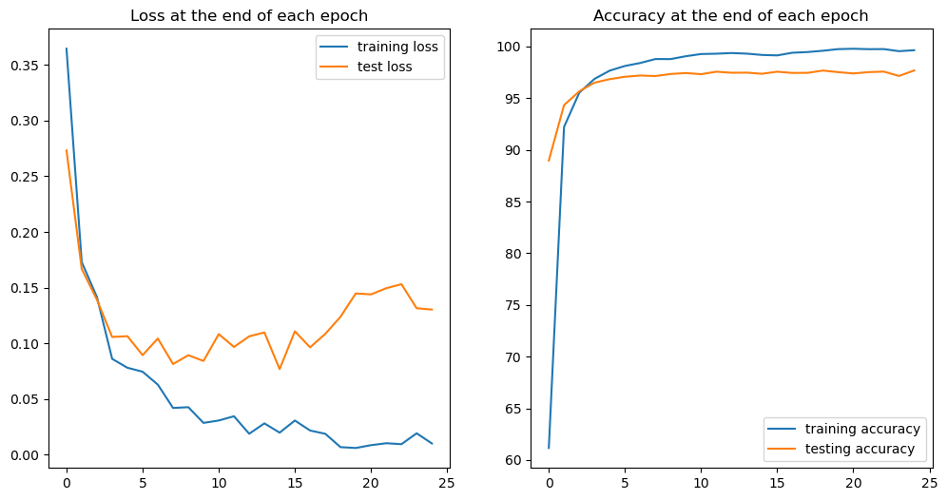

**Figure 6:** Loss and accuracy graphs recorded during both training and testing of the large model

mid-sized: approx. 25k

Testing a “mid-sized” MLP model for classification: The model consists of 3 hidden layers of size 32, 16 and 8 respectively, which gives the model 25874 trainable parameters, but otherwise with the same settings as the small model. The training and test loss curves are shown in Figure 7. We see that the model shows some initial signs of overfitting, but not as much as the large model. Similarly, it also achieves a higher final accuracy than the small model, but not quite as much as the large model. Examples of misclassified test images are shown in Figure 8.

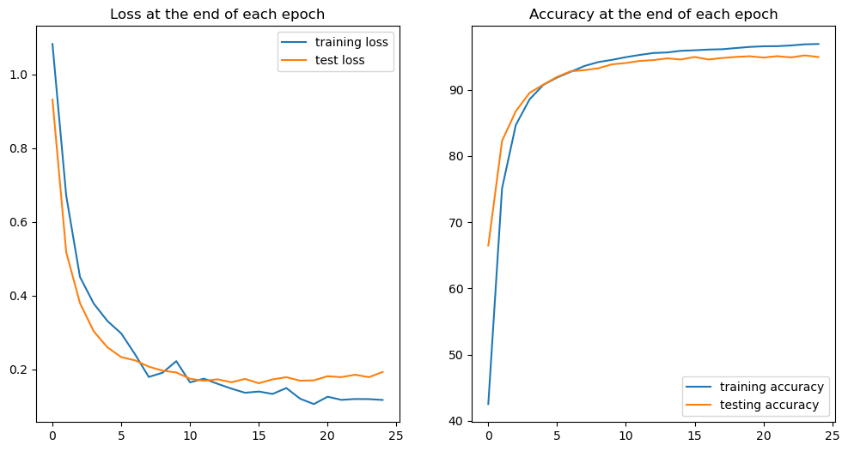

**Figure 7:** Loss and accuracy graphs recorded during both training and testing of the medium-sized model

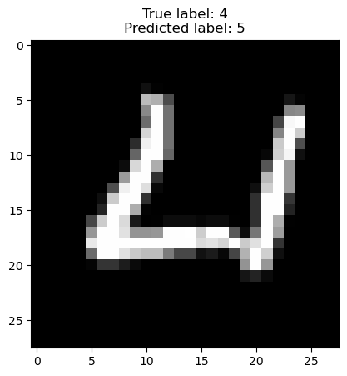

**Figure 8:** Example of a misclassified image.