Title
Large winter home ranges in urban habitats for a very short distance migrant, the Northern Cardinal (Cardinalis cardinalis)
Authors
Cousineau, Anne-Marie¹; Frei, Barbara^{1,2}; Gahbauer, Marcel A.³ ; Elliott, Kyle H.¹
1: Department of Natural Resource Sciences, McGill University, Ste. Anne de Bellevue, Québec, Canada
2: Science and Technology Branch, Environment and Climate Change Canada, Montreal, Québec, Canada
3: Canadian Wildlife Services, Environment and Climate Change Canada, Ottawa, Ontario, Canada
Corresponding author’s address
21111 Rue Lakeshore Ste Anne-de-Bellevue, H9X 3V9, QC, Canada
anne-marie.cousineau@mail.mcgill.ca

Acknowledgements
(1) We would like to thank all the dedicated staff and volunteers at the McGill Bird Observatory, especially Shawna Sevigny and Ana Morales for banding the Northern Cardinals, installing Motus tags, assisting with translocations over both years, and teaching me bird banding and tag deployment Tracking cardinals over eight months was a true team effort—thank you to Mackenzie Guest, Lauren Dobie, Nathanya Goudreau, Florence Piché-Lebel, Laurianne Fallu, Elliana Tomasso and Mathilde Lefvert for your essential help in the field. Special thanks to Jean and Richard Gregson for hosting a Motus tower in their backyard for this project.
(2) We also want to thank our reviewers for providing insightful feedback. We are grateful for McGill University and the Social Science and Humanities Research Council (SSHRC) for funding this project, along with Environment and Climate Change Canada for providing 80 Lotek NanoTags across two field seasons.
(3) All birds were banded under Animal Use Protocol 2007-5446 from McGill University and federal banding permits 10973, 10973B, 10973D issued by the Canadian Wildlife Service, and radio-tagged under Animal Use Protocol 22BF01 and 23BF01 from Environment and Climate Change Canada.
(4) We declare no conflicts of interest.
(5) Marcel Gahbauer, Anne-Marie Cousineau, Kyle Elliott and Barbara Frei conceived the idea, design and experiment. Anne-Marie Cousineau performed the experiments. Anne-Marie Cousineau wrote the paper, Kyle Elliott and Barbara Frei substantially edited the paper. Marcel Gahbauer provided valuable reviewing and editing input. Anne-Marie Cousineau, Barbara Frei and Kyle Elliott developed and designed the methods. Anne-Marie Cousineau analyzed the data.
(6) Analyses reported in this article can be reproduced using the data provided by Cousineau (2025).
Data from: Large winter home ranges in urban habitats for a very short distance migrant, the Northern Cardinal (Cardinalis cardinalis). Ornithology / Ornithological Applications. Data DOI will be added once data deposition completed.

Abstract
Urban green spaces are critical for maintaining biodiversity and supporting wildlife, especially in heavily urbanized environments. In temperate regions, winter brings significant challenges for resident bird species, which can be compounded or alleviated in urban regions. To better understand how birds use urban habitats during winter, we experimentally translocated Northern Cardinals (Cardinalis cardinalis) among sites spanning an urbanization gradient in Montreal, Canada, and used VHF telemetry to quantify their home range size, habitat selection across spatial scales and habitat associations. Cardinal populations increased across the northeastern United States and southeastern Canada in the past 100 years with most cardinals restricted to cities, likely due to the presence of bird feeders. Total home range size was larger at the urban site than at the peri-urban site, yet core home range size did not differ significantly among sites. Habitat selection occurred at the smallest scales measurable (25-50 m) across all sites (urban/suburban/peri-urban) implying very fine-scale selection. This emphasizes the importance of microhabitat features such as vegetation structure and bird feeder presence. Habitat associations varied across the urban gradient, except for proximity to bird feeders which was consistently related to habitat use by cardinals. In less urbanized areas, birds selected for vertically complex vegetation, likely because cardinals select shrubby, edge habitat. In more urbanized areas, birds were more likely to use areas with a greater density of roads, implying cardinals select the most residential areas. The observed differences in space use and habitat associations across the urban gradient suggest that cardinals may exhibit behavioral flexibility in response to urbanization. This highlights the importance of fine-scale ecological understanding to guide green space management for urban-adapted species year-round.
Keywords: behavioral flexibility, fine-scale movement, habitat association, home range size, manual VHF telemetry, non-breeding period, scale of habitat selection, urbanization gradient
Lay summary
- Urban green spaces can help wildlife survive in cities, but little is known about how birds use these spaces during the winter months in northern climates.
- We tracked Northern Cardinals in Montreal, Canada, using small radio transmitters to follow where they move during winter.
- By tracking these birds, we quantified how much space they used and what kinds of places they favoured in areas ranging from greener neighbourhoods to denser parts of the city.
- Cardinals spending the winter in the most built-up areas used larger territories and relied on resources found close by, such as vegetation features and human-provided food sources like bird feeders.
- Overall, cardinals showed a strong ability to adjust to city life, suggesting that well-designed urban green spaces can support urban-adapted birds year-round.

Introduction
Urbanization is accelerating worldwide (Wang et al. 2012; Elmqvist et al. 2013; Simkin et al. 2022), altering landscapes and bringing novel challenges to wildlife including habitat fragmentation, habitat loss, and chronic pollution (Lowry et al. 2013; Seress and Liker 2015; Murray et al. 2019; Vaz et al. 2023). Future global urban expansion could lead to an additional 11-33 million hectares of habitat loss by 2100, with a disproportionately large increase in habitat fragmentation (Li et al. 2022).
This habitat loss and fragmentation can in turn reshape wildlife spatial ecology, including patterns of home range size and movement. A meta-analysis showed both birds and mammals had smaller home ranges in urban areas and that urbanization restricts spatial movements for most animals (O’Donnell and delBarco-Trillo 2020). During the breeding period, the communication distance of Zonotrichia leucophrys (White-crowned Sparrows) in the San-Francisco Bay was highly predictive of its territory size, highlighting that in the urban landscape, noise pollution may drive songbirds into smaller home ranges in the breeding season (Simberloff et al. 2023). Nonetheless, most research on urban birds occurs in the breeding season, and there is far less in winter, and those studies that do exist contrast with breeding season studies. This knowledge gap is important because birds often exhibit different behaviours outside of the breeding season. For example, Cardinalis cardinalis (Northern Cardinals) form winter flocks (while vigorously defending their territories against conspecifics during the breeding season) and alter their patterns of space use during the non-breeding season in Kentucky (Ritchison and Omer 1990). Consequently, factors influencing habitat use during winter may differ substantially from those operating during the breeding season.
Birds respond to these urban pressures through behavioural adjustments, reflecting both challenges and opportunities, including increased predation pressure, heightened disturbances, novel anthropogenic resources and human-made structures. To compensate for disturbances from noise, light and human activity, some birds may change their nesting behaviour—for example by nesting higher in the canopy (e.g., Pica pica (Eurasian Magpie); Šálek et al. 2020) or using off-ground artificial surfaces increasing fitness (e.g., Junco hyemalis (Dark-eyed Junco); Bressler et al., 2020). Urban habitats can also provide foraging opportunities which can be exploited by some species like Falco peregrinus (Peregrine Falcon). F. peregrinus was shown to use buildings as perches and nesting sites, capitalizing on disoriented migratory birds wandering near lit glass structures (Kauffman et al. 2003; DeCandido and Allen 2006; Altwegg et al. 2014). Although some species can adapt and thrive in urban areas, urban tolerance varies across species and across annual cycles, with urban tolerance peaking during the winter months (potentially due to the urban heat island effect) (Callaghan et al. 2021).
Habitat use in the city can differ significantly from that in rural environments, even within a single species. These differences can reflect hierarchical habitat selection (Johnson 1980), as animals select habitat at multiple spatial scales—from geographic range (first order), to the home range of an individual (second order), to the selection of specific patches for daily activities (third and fourth orders). In the urban context those decisions are influenced by novel pressures such as human disturbances, artificial structures, and altered resource availability. Quantifying habitat use by comparing used locations with what is available in the habitat can provide valuable insights into how wildlife responds to urbanization and identify habitat features that are more strongly associated with both occurrence and space use (Manly et al. 2002; Poirier et al. 2024).
Urban birds may outperform rural birds during winter, when natural resources are less available and weather is harsher. Cities can provide a more stable wintering environment for bird species that use feeders or that are generalists or omnivores (i.e., corvids), which exploit anthropogenic resources in winter (Jokimäki et al. 2022). In other cases, cities can serve as refuge during periods of extreme weather, as local colonization of cities by birds increased during the colder conditions due to cities acting as heat islands (Latimer and Zuckerberg 2021). Nonetheless, occupancy dynamics in temperate regions during winter are highly species-specific, with thermal tolerance playing an important role in determining which species would be able to persist in urban environments during this season. Moreover, energy demands for small resident passerines increase with latitude in winter, meaning that birds spending their winter in regions such as southern Quebec must consume significantly more energy to maintain their body temperatures than those wintering farther south—which is especially challenging given the scarcity of resources during the cold months (Fristoe 2015). Despite these physiological and environmental challenges, along with the potential added effects of urbanization, winter remains an underrepresented season in experimental, ecological research (Dinh et al. 2023). This gap in knowledge highlights the importance of investigating how birds are occupying urban habitats in winter, particularly in temperate regions where winter survival is a major limiting factor for resident bird species.
To address this gap, we studied Cardinalis cardinalis (Northern Cardinal) across an urban gradient in one of Canada’s largest cities, Montreal, Quebec. Cardinals are large songbirds (weighing 40 to 45 grams), which allows for deployment of radio tags capable of lasting almost the entirety of the non-breeding season. In the last 100 years, cardinals expanded their distribution range northwards, and have been anecdotally closely associated to urban and suburban landscapes in those areas (Beddall 1963; Smith et al. 2011; Robert et al. 2019). They are able to thrive and persist across a wide range of urbanization gradients, from suburban neighbourhoods to densely populated areas of the city. Cardinals are now resident in southern Quebec, a region of extreme cold (sometimes reaching -27 ˚C with wind chill; Environment and Climate Change Canada) and limited natural food sources during the winter months (Government of Canada 2004; Turcotte and Desrochers 2005). As part of a translocation experiment, we captured and released individuals at sites distributed along this urbanization gradient in Montreal to evaluated how they are using such habitat. We tracked weekly movements to assess how the birds adjust their movements and habitat use after being displaced into environments with varying levels of urbanization.
This study has four objectives: (i) investigate how cardinals’ home range size varies across an urbanization gradient through the winter season, (ii) quantify the scale at which cardinals are associated with certain factors of their habitat, (iii) determine the relative strength of anthropogenic and natural vegetation to predict habitat use by cardinals during the non-breeding season, and (iv) document the spring movements from non-breeding to breeding grounds. We predicted that wintering cardinals require larger home ranges (both core and total) and select habitats at larger scales when in dense urban locations due to food sources being more scattered (Havlíček et al. 2022). In addition, we predicted that locations with bird feeders, lower human population density and a complex vertical vegetation structure would be associated with a higher probability of cardinals using said locations. Finally, we predicted that cardinals would transition from their breeding sites in forested/canopy covered areas towards residential areas in the fall to take advantage of bird feeders during winter, reversing the movement in spring.

Materials and methods

Study locations
The island of Montreal is located in southern Quebec, Canada, with a population of ~2 million people coupled with high population density. The city’s climate is comprised of four distinct seasons with cold winters (temperatures can range between -23 ˚C and 4 ˚C during the month of January) and warm summers (with temperatures sometimes exceeding 30 ˚C; WeatherSpark). This research was conducted at three study sites (Figure 1) with varying levels of urbanization. Each site includes two release locations randomly assigned to the individuals. The peri-urban site is located on the western end of the island of Montreal at the McGill Bird Observatory (MBO; 45˚25’51.4”N 73˚56’18.5”W). The MBO is part of the 30 km² Grand parc de l’Ouest. The suburban site is located in the Town of Baie d’Urfé (45˚24’39.2”N 73˚55’50.0”W). The urban study site is located in the Notre-Dame-de-Grâce neighbourhood of the city (45˚27’35.7”N 73˚38’30.2”W). Because cardinals can be found in all three sites, we assumed that the translocated birds would be able to survive and thrive at each location.
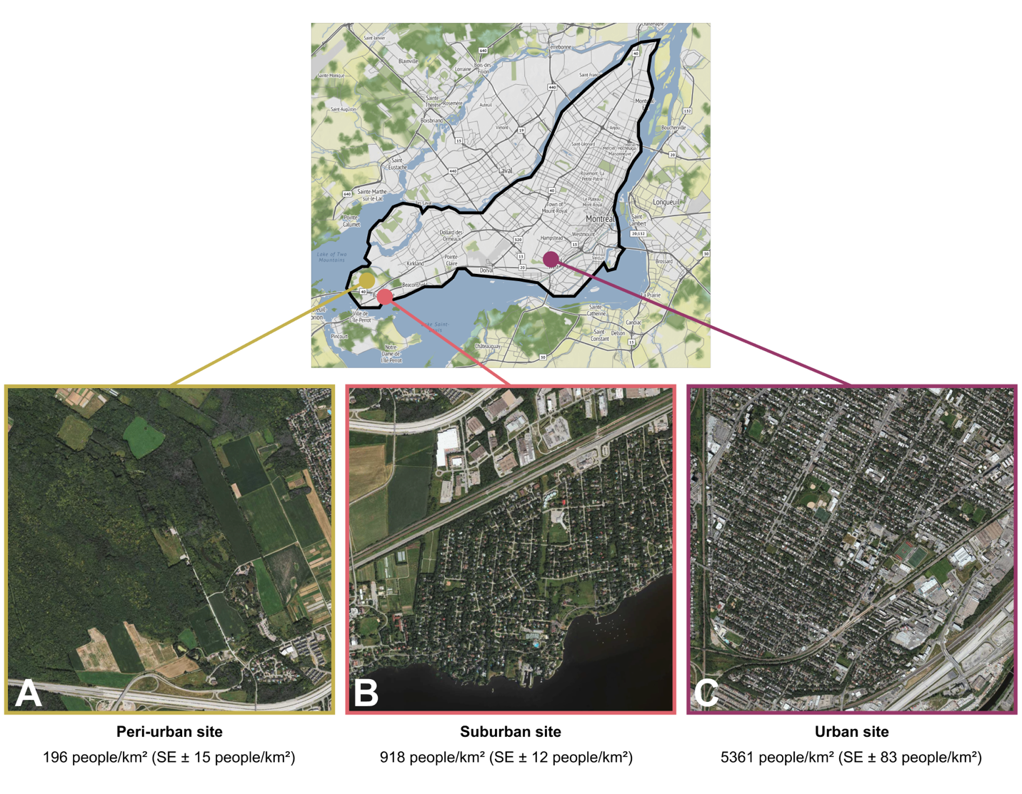Figure 1. Study locations on the Island of Montreal A) The peri-urban site is at the McGill Bird Observatory (2% of the area covered by streets and/or roads). B) The suburban site (5% of the area covered by streets and/or roads) is located in the residential Town of Baie d’Urfé. C) The urban site (13% of the area covered by streets and/or roads) is located in Notre-Dame-de-Grâce neighbourhood.
The three translocation sites differed significantly in their level of urbanization, following a Kruskal-Wallis test and a Bonferroni-corrected pairwise Wilcoxon test (p < 0.001) based on human population density data from the Cancensus Program R package (von Bergmann et al. 2021), using census data from the Government of Canada for the year 2021. All three sites are characterized by relatively high levels of green space compared to the broader urban context of Montreal. The gradient used here ranges from the higher percentages of canopy covers in the peri-urban site to the median canopy cover for the Montreal area (~ 26%) (HealthyDesign.City 2021). As such, this gradient does not fully capture the extent of urbanization present across the entire city and should be interpreted as a localized urbanization gradient. We did try translocating cardinals to an area with lower canopy cover early on, but due to two immediate mortalities we decided to omit this site.

Radio tagging, banding & translocation
All birds were caught during routine fall migration monitoring at MBO and were fitted with colour bands and Motus NanoTags following standard banding and morphological measurements (see Supplemental Information). Cardinals translocated to sites away from the peri-urban location (suburban and urban), as well as control birds held at the peri-urban site, underwent a holding time of 45 minutes before release to standardize treatment amongst individuals. For the winter of the year 2022-2023 (winter 1), we were able to consistently track 20 birds released as control at the peri-urban site, which served as a pilot winter to assess the feasibility of the project. During the winter of 2023-2024 (winter 2), we tagged and banded 45 birds, with 15 individuals translocated to the urban site, 15 translocated to the suburban site and 15 released as controls at the peri-urban site. In 2024-2025 (winter 3), we tagged and banded 42 birds, with 5 individuals released as controls at the peri-urban site, 16 individuals translocated to the suburban site and 21 individuals translocated to the urban site.
Although tags used in the present study were lighter than those used in previous work on cardinals, we considered the potential for tag effects when interpreting our results. A study from Barron et al., (2013) showed that during the reproductive season, cardinals with tags (weighing 1.6 g [double the 0.8 g of the tags used in the present study]) attached defended their nests less vigorously, but did not change their provisioning effects. Cardinal nests with tagged parents also had lower daily survival rates and were less likely to fledge offspring (Barron et al. 2013). However, these tag effects were relatively modest and observed across diverse habitats, making it improbable that they would only manifest in our dense urban site while remaining undetected in peri-urban and suburban locations. Birds were banded under Animal Use Protocol 2007-5447 from McGill University and federal banding permits 10973, 10973B, 10973D issued by the Canadian Wildlife Service, and radio-tagged under Animal Use Protocol 22BF01 and 23BF01 from Environment and Climate Change Canada.

Cardinals’ abundance and seasonal distribution
We used the number of cardinals recorded per party hour in Audubon Christmas Bird Count data to compare the historical abundance of cardinals in Quebec, Canada, against the states of Maine, New York, New Hampshire and Vermont (United States) (National Audubon Society 2020).

Non-breeding season tracking and home range estimations
The birds were monitored using an array of automated Motus towers and handheld telemetry receivers. We conducted manual radio tracking of each individual two to three times per week between the months of October and May each year. The areas monitored were ~5 km² (500 ha) at the peri-urban site, ~6 km² (600 ha) for the suburban site and ~18 km² (1800 ha) for the urban site. Tracking effort and spatial coverage differed among sites due to logistical constraints associated with weather conditions and the structure of the landscape. At the peri-urban site, the absence of road networks and lower levels of signal interference allowed for the tracking team to move more freely and locate the individuals more rapidly, resulting in a smaller monitored area. In contrast, tracking the birds in suburban and urban areas meant that the tracking team’s movements were constrained by road access, built infrastructure, private land and higher levels of radio interference. In addition, individuals released at the suburban and urban sites often moved farther away from their release location, requiring the tracking team to search across larger areas to maintain contact with tagged birds. These differences in spatial coverage reflect practical limitations of tracking birds in the heterogeneous landscape of urban environments and should be considered when comparing movement patterns across sites. The people tracking the birds by hand (trackers) aimed to record at least one GPS location for each individual per week using a Garmin ETREX 22x GPS. Trackers would typically spend 5 hours tracking per session, twice per week, and started by first tracking down newly relocated birds and/or birds with known recent locations. Once these individuals are found, trackers would move on to expand their search areas to try and find missing individuals. Details on the tracking method used and estimations of precision can be found in the Supplemental Information section.
For all three study sites, we calculated the average home range size using the Kernel Density Estimation (KDE). The home range derived from the utilization distribution (UD) represents the minimum area containing a specified proportion of an individual’s space use (in the present case, the cardinals’ GPS location recorded in the field) with the kernelUD function from the adehabitatHR: Home Range Estimation R package version 0.4.22 (Worton 1989; Calenge 2023, 2024). For example, the 95% home range represents the smallest area in which there is a 95% probability of finding the individual. We selected the 50% and 95% contours to investigate respectively the core area used within the home range of the birds and the broader home range excluding the most extreme locations (outliers). A minimum of 5 GPS locations were required to adequately run the function to calculate the KDEs meaning that individuals with fewer points than this threshold were excluded. Between 5 and 48 points per individual were used to estimate the KDEs, with the average number of points per bird being 18.

Resource Selection Function
We compared ‘used’ vs. ‘available’ habitat using a resource selection function for cardinals during the non-breeding season and across an urban gradient. We used environmental and anthropogenic variables extracted from available spatial data as well that collected in the field. This included mean and standard deviation (SD) of vegetation height (1m resolution) from OpenForest (Government and Municipalities of Quebec 2016), distance to nearest bird feeder (collected through systematic field observations), human population density data (census unit) using the Cancensus R package (von Bergmann et al. 2021) and spatial data on the streets and road from the island of Montreal (Ville de Montréal 2018). Unused locations were derived at a 1:1 ratio by creating random locations within 300 meters of the used location, at a random angle. We used the matched case-control design elaborated by Fortin and have applied a 300 meters buffer to reflect the median daily bird movement (Fortin et al. 2005, 2009). Because this is a population-level resource selection function, in which individual IDs are included as random effects and used-available pairs from all individuals are evaluated together, there is no required minimum number of locations per individual, as it would be the case for an individual-level RSF. The average number of true observations for each individual ranges from 5 to 48 with an average number of points of 18. Having a ratio of 1:1, the same numbers apply for the random observations. The data extracted was scaled and centered before running the models.
We built our candidate model set to compare the relative strengths of anthropogenic and natural vegetation variables to predict cardinal habitat use. This included four a priori hypothesis-based models including, (1) the “Full model” (Used ~ Mean vegetation height + Sd vegetation height + Population density + Road length + Distance to nearest feeder + (1|Winter) + (1|Site) + (1|ID)), including all of the variables, plus the winter (years of sampling), relocation site and bird ID as random effects to account for the additive importance of anthropogenic and natural vegetation variables, (2) the “Vegetation height” model (Used ~ Mean vegetation height + (1|Winter) + (1|Site) + (1|ID)), assuming the vertical height of vegetation was the dominant variable related to habitat use by cardinals, (3) the “Sd vegetation height” model (Used ~ Sd vegetation height + (1|Winter) + (1|Site) + (1|ID)), assuming that cardinal habitat use is related to vertical vegetation composition, and (4) the “Anthropogenic” model (Used ~ Population density + Road length + Distance to nearest feeders + (1|Winter) + (1|Site) + (1|ID)), which assumed that cardinal habitat use would be related to anthropogenic variable We also included a “Null” model, with random effects only (Used ~ + (1|Winter) + (1|Site) + (1|ID)). We ranked all fiver models according to the corrected Akaike Information Criterion (AICc) following the method previously described by Burnham and Anderson (2002). We used Variance Inflation Factor (VIF) to test for multicollinearity (variables with VIF values > 10 were considered to have problematic collinearity and were removed) among predictor variables and Hosmer-Lemeshow as a goodness-of-fit test (Hosmer and Lemesbow 1980). VIFs ranged between 1.05 and 3.31 across all predictor variables. All statistical analysis were performed using Program R version 4.4.2 (R Core Team 2024).

Scale-of-effect
We first identified the scale-of-effect (i.e., the spatial extent at which landscape variables have the strongest relationship with a species’ response) by extracting variables at four spatial scales (25, 50, 100, 200 meters; Martin & Fahrig, 2012). These spatial scales were chosen because they cover a wide range of possible scale-of-effect that are relevant in urban ecology, considering that habitat heterogeneity is scale-dependent. However, because scale-of-effect analyses identify the spatial extent that best predicts responses to the tested range, these values should be interpreted as indicating generally fine or coarse spatial responses rather than precise ecological thresholds. For each scale we ran generalized linear mixed models (GLMMs) at each study location using all five predictor variables as well as year, site, and individual ID as random effects. We ranked models using Akaike Information Criterion (AICc) values, which take into account small sample sizes (Burnham and Anderson 2002). The best model was identified as having the lowest AICc value. We also calculated the $∆$AICc to evaluate competing models following Burnham and Anderson (2002) (models with a $∆$AICc < 2 were considered to have substantial support, competing with the best model and models with a $∆$AICc > 10 were deemed to have no support, not competing with the best model). We acknowledge that low per-individual sample sizes might reduce the precision of the scale-of-effect estimates, as models fitted on few observations per individual could be susceptible individual-level variation driving apparent scale preferences. To try mitigating this, we included the individuals’ IDs as random effect, and we interpret scale-of-effect results at the population level rather than an individual level habitat selection.
Because the four buffer sizes represent nested spatial extents, we expect the variables extracted from these buffers to be positively correlated. We assessed cross-scale correlations for each predictor type using Pearson’s “r”. Correlations were highest for human population density (r = 0.96-0.99 across all sites), moderate for mean vegetation heights (r = 0.37-0.94) and road length (r = 0.32-0.95), and lowest for SD vegetation height (r = 0.33-0.84), decreasing with increasing scale separation in all cases. Variables from different scales were never included within the same model—each candidate model uses a single buffer size—so cross-scale correlations do not inflate within-model multicollinearity (all VIF < 10). The buffer comparison therefore constitutes a scale-selection exercise rather than a multi-scale additive approach. Once the scale-of-effect was determined for each location, we conducted a resource selection function.

Results
Historical and seasonal context of Cardinals in southern Quebec
To place our winter telemetry results in the context of the species’ recent expansion into southern Quebec and its seasonal dynamics within the study region, we summarized long-term regional abundance and local banding records. In southern Quebec, cardinals have increased in abundance since the 1970s, reflecting the species’ well-documented northward range expansion from the northeastern United States into southern Quebec beginning in the 1960s (Figure 2).

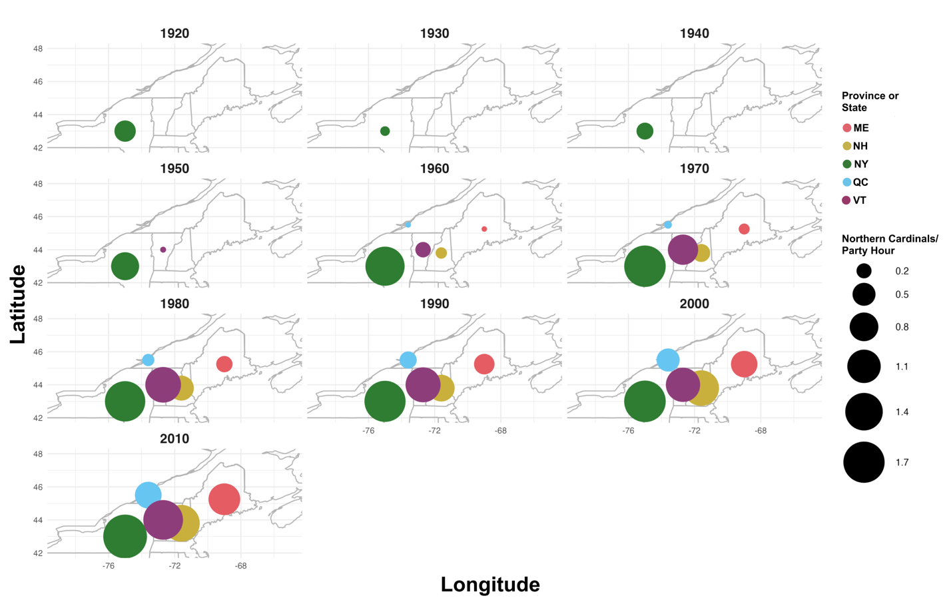
Figure 2. Number of cardinals observations per party hour between the 1920s and the 2010s according to state (United States) or province (Canada) as part of the Audubon Christmas Bird Count.
Nineteen years of banding data from the McGill Bird Observatory also revealed distinct seasonal patterns in captures (Figure 3). Capture rates were higher during the fall monitoring program (~0.75 birds/h) than during the spring program (~0.27 birds/h), accompanied by a greater proportion of unbanded individuals, indicating an influx of new birds in late fall. Although most fall captures were juveniles or individuals of unknown age (Figure S1B, C), adults also exhibited peaks in mid-May and late July (Figure S1A), suggesting that both post-fledging dispersal and local movements between breeding and wintering areas contribute to seasonal variation in captures.
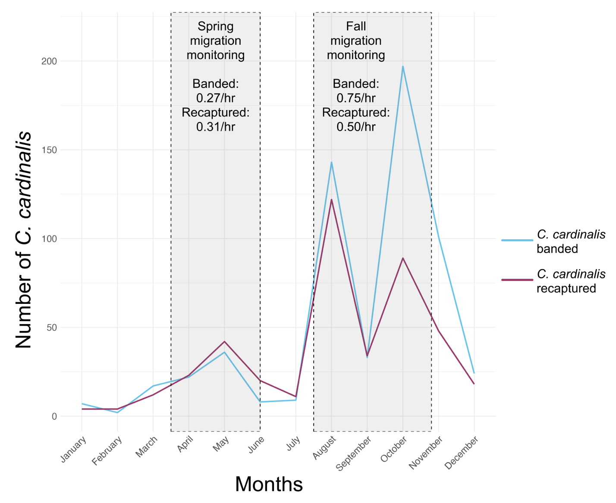Figure 3. Number of cardinals banded and recaptured at the McGill Bird Observatory (peri-urban site) between 2004 and 2022 in Montreal, Quebec, Canada. The grey boxes highlight the duration of the spring and fall migration monitoring programs, along with the approximate number of cardinals banded and recaptured per hours of mist-net being opened during the season.

Telemetry tracking of cardinals across an urban gradient
Across three consecutive winters, we were able to track multiple individuals at all three sites and gather valuable information regarding cardinals’ survival through the study (Table 1).
Table 1. Number of cardinals tracked 1 and 3 months after initial release, with apparent survival (48.15% average) and fated survival (including individuals presumed alive but outside the study area; 71% average), including known mortality events/probable causes across three sites in Montreal, Quebec, Canada between 2022 and 2025.
Site | Total number of cardinals | # tracked 1 month (apparent survival) | # tracked 3 months (apparent survival) | Missing individuals after 3 months | Confirmed mortality events and probable cause of death
Peri-urban | 41 | 34 (83%) | 28 (68%) | 13 | 6  Predation (n = 4)  Unknown (n = 2)
Suburban | 31 | 19 (61%) | 18 (58%) | 13 | 4  Predation (n = 2)  Disease (n = 1)  Unknown (n = 1)
Urban | 36 | 11 (31%) | 6 (17%) | 30 | 3  Predation (n = 1)  Window collision (n = 2)

Telemetry tracking was conducted 2 to 3 days per week by three people between October and May 2022-2024, for a total of ~288 days of tracking per winter. We recorded a total of 688 unique detections at the peri-urban site, 411 at the suburban site, and 265 at the urban site. The tracking team covered the maximum amount of ground possible during each outing, to record as many individuals as feasible.

Core areas and home ranges of cardinals across an urban gradient
We estimated core areas and home ranges for individuals with $≥$ 5 recorded GPS locations (36 individuals from the peri-urban site, 13 from the suburban site and 9 from the urban site; Figure 4). Mean core area sizes ($±$ SE) were 0.15 $±$ 0.04 km² (n = 36) at the peri-urban site, 0.08 $±$ 0.02 km² (n = 13) at the suburban site, and 0.28 $±$ 0.11 km² (n = 9) at the urban site. Mean total home range sizes ($±$ SE) were 0.61 $±$ 0.13 km² (n = 36) at the peri-urban site, 0.56 $±$ 0.11 km² (n = 13) at the suburban site, and 1.53 $±$ 0.52 km² (n = 9) at the urban site. These sample sizes represent the number of cardinals that could be included in the respective KDE analyses. Core and total home range sizes were not normally distributed (Shapiro-Wilk tests: core, W = 0.624, p < 0.001; total, W = 0.698, p < 0.001), so areas were log-transformed prior to analysis. Following transformation, the data met assumptions of normality (Shapiro-Wilk test: 50% KDE, W = 0.970, p = 0.159; 95% KDE, W = 0.969, p = 0.150) and homogeneity of variance (Levene’s test: 50% KDE, F_{2,55} = 1.07, p = 0.350; 95% KDE, F_{2,55} = 0.61, p = 0.547). Mean core home range size was highest at the urban site (Figure 4), but differences among sites were not statistically significant (ANOVA: p = 0.077). There was a significant difference among the three study sites regarding total home ranges (ANOVA: F_{2, 55} = 3.45, p = 0.04). Post-hoc Tukey’s honestly significant difference tests showed that the only significant difference was between the total home ranges of cardinals at our urban site being larger than cardinals at the peri-urban site (mean difference = 1.24, 95% CI [0.09, 2.38], p = 0.03); no other pairwise differences were statistically significant.
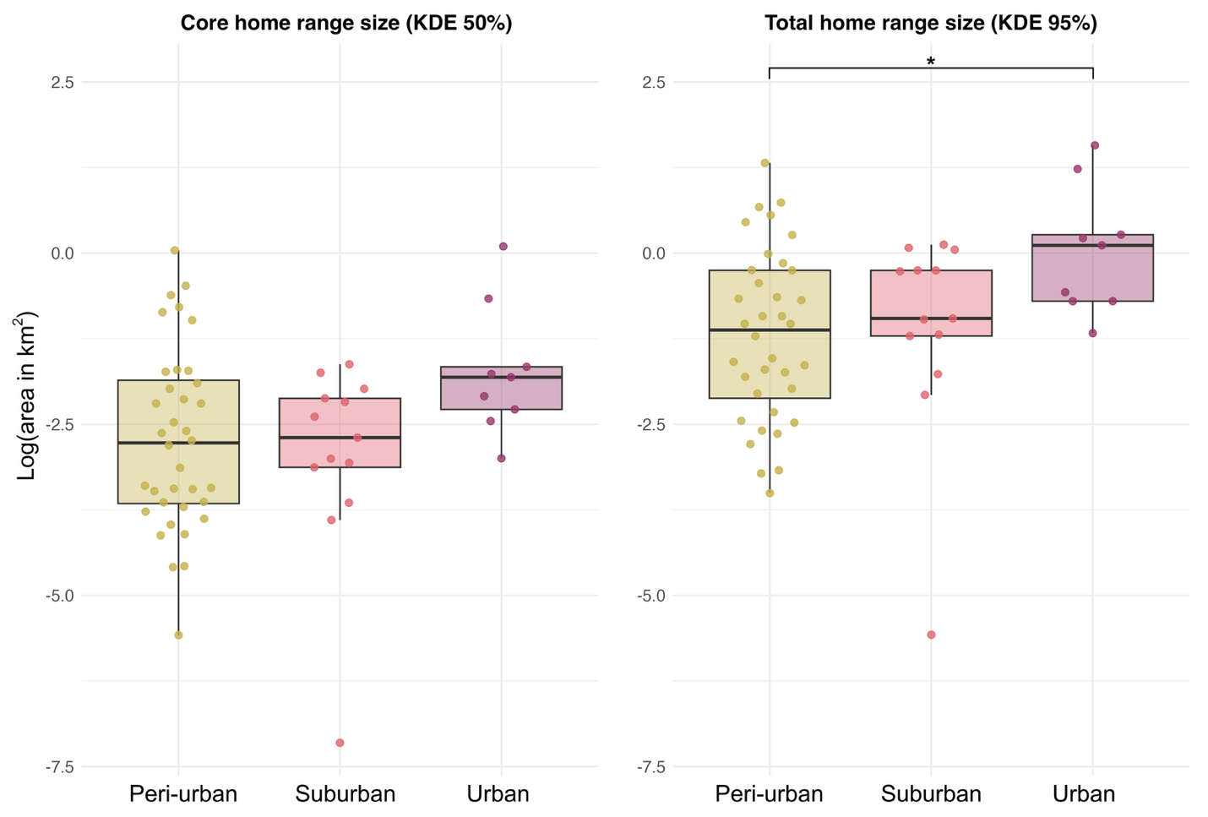Figure 4. Boxplot comparison of the core (KDE 50%) and total (KDE 95%) home ranges of cardinals in three study sites (peri-urban, suburban and urban) in Montreal, Quebec, Canada during winters between the years 2022 and 2025. The area in km² was log-transformed, and each data point corresponds to an individual’s home range (area log-transformed).

Scale of association to habitat
We compared AICc among models fit with landscape covariates measured at four different spatial scales (25, 50, 100 and 200 m radius around resighting locations). At the peri-urban site, the 50 m scale model best explained cardinal’s movements (Δ AICc > 4 relative to all other scales). At both the suburban and urban sites, the 25 m scale model performed best (Δ AICc > 10 relative to all other scales). Because the landscape variables we measured at different spatial scales are inherently correlated, these results indicate the scale at which habitat structure shows the strongest statistical association with cardinal’s movements, rather than reflecting a direct causal scale of effect.

Resource selection: used vs. available habitats
Due to differences of urbanization level and scales of effect, resource selection function models were run separately for each study site. For the peri-urban site, the global model explained the most variation seen in the data (Δ AICc > 10 relative to all other models, Supplementary Material Table S2). The full model reduced deviance by ~11.3% relative to the null model. For the suburban site, we selected the anthropogenic covariates model (human population and road density) as the most parsimonious model. Although the global model had a slightly lower AICc, the difference between the two models was very small (Δ AICc < 0.5 relative to the top model), indicating similar support for both models. Therefore, we retained the simpler anthropogenic covariates model, which reduced deviance by ~16.6% relative to the null model. Lastly for the urban site, the global model was the best-supported candidate model (Δ AICc > 3 relative to the next best model). The global model reduced deviance by ~10.5% relative to the null model. The best model for each study site was then used to generate prediction plots on the probability of use of the habitat by cardinals according to the model variables (Table 3).
Table 3. Model parameters for the three resource selection models predicting the presence/absence of 56 cardinals within (25 or 50 m-radius) areas based on the average vegetation height (in meters) and its standard deviation, along with human-related environmental features such as human population density (in people/km²), road length (in meters) and distance to the nearest bird feeder (in meters). The study site, year (winter) of sampling and the individual’s identification (ID) are included as random effects in each model.
Study Site | Variable | Coefficient estimate | Standard error | z | p
Peri-Urban | Global model – 50 meters  Mean vegetation height (m)  Standard deviation of the mean vegetation height  Mean population density (person/km²)  Road length (m)  Distance to the nearest bird feeder (m) | -1.272  1.107  -0.095  0.023  -0.347 | 0.153  0.114  0.111  0.110  0.068 | -8.329  9.709  -0.858  0.207  -5.067 | <0.001  <0.001  0.391  0.836  <0.001
Suburban | Anthropogenic covariates model – 25 meters  Mean population density (person/km²)  Road length (m)  Distance to the nearest bird feeder (m) | -0.486  1.238  -0.427 | 0.135  0.136  0.128 | -3.603  9.138  -3.342 | <0.001  <0.001  <0.001
Urban | Global model – 25 meters  Mean vegetation height (m)  Standard deviation of the mean vegetation height  Mean population density (person/km²)  Road length (m)  Distance to the nearest bird feeder (m) | 0.252  -0.458  -0.212  0.736  -0.392 | 0.180  0.191  0.131  0.135  0.141 | 1.399  -2.405  -1.620  5.438  -2.772 | 0.162  0.016  0.105  <0.001  0.006

Prediction plots of the significant fixed effects from the resource selection functions show that cardinal associations with urban habitat features varied among sites (Figure 5). In the peri-urban site, the use of the habitat by the cardinals decreases as the mean vegetation height increases (Figure 5A), while the use of the habitat by the birds increases with greater variability in vegetation height (Figure 5B). The probability of use of the habitat by cardinals also decreases as the distance to the nearest bird feeder increases (Figure 5C). In our suburban site, cardinals’ habitat use shows little relationship with population density (Figure 5D) but increases as the mean road length increases (Figure 5E). Like our peri-urban site, the use of the habitat by the birds also decreases as the distance to the nearest feeder increases at the suburban site (Figure 5F). At the urban site, cardinals’ probability of using the habitat decreases with increasing vegetation height standard deviation, although uncertainty is high (Figure 5G). The cardinals’ association to habitat also increased with mean road length and decreased with increasing distance to the nearest feeders. Across sites, proximity to feeders and structural complexity of the infrastructures or the vegetation consistently influenced the probability of habitat use, yet specific relationships varied. Taken together, these results indicate that winter habitat association by cardinals varies across the urbanization gradient. While feeder availability appears to be consistently associated with a higher probability of cardinals using the habitat across all sites, the habitat features associated with cardinal presence differed among the peri-urban, suburban and urban sites. This suggests that patterns of habitat use are largely context dependent.
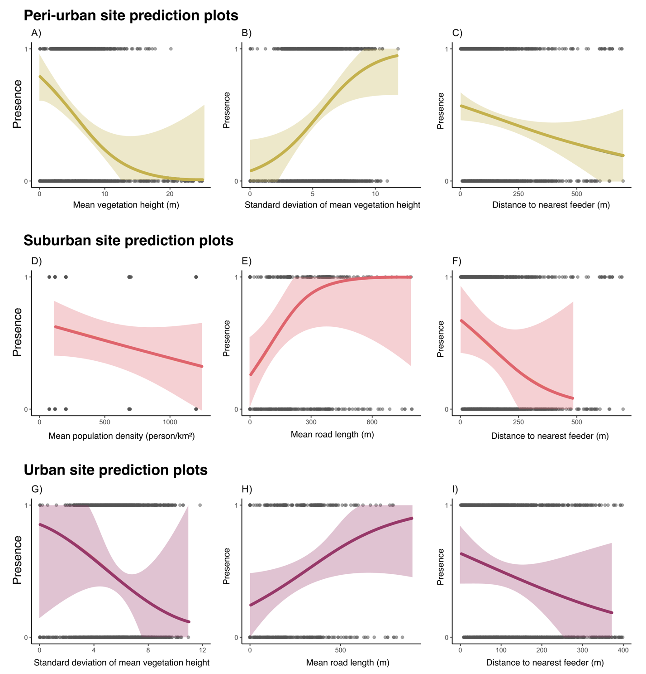Figure 5. Probability of habitat use by cardinals in a 50 m radius for the suburban site and 25 m radius for both the peri-urban and urban sites, as predicted by a generalized linear mixed effects model. Shaded areas represent 67% confidence intervals around the predicted probabilities. The model’s fixed effect variables are described in Table 3, and for each model, random effects were sampling years, translocation site and bird ID.

Discussion
This study examined winter space use, habitat associations and apparent survival of cardinals across an urban gradient. Although habitat associations differed among sites, broad patterns emerged. Individuals relocated at the urban site exhibited larger home ranges and lower apparent survival, than their counterparts at the suburban and peri-urban sites, while associations with environmental variables varied across the urbanization gradient. Proximity to bird feeders was consistently associated with cardinal occurrence across all sites, and individuals at the suburban and urban sites were primarily resighted in private urban green spaces (UGS) rather than larger public UGS. These findings suggest that winter habitat use by cardinals may vary according to local habitat conditions and resource availability, while anthropogenic food sources appear to be associated with space use across our range of urban environments. More broadly, our results indicate that private UGS may represent an important component of the habitat usage of the cardinals during winter season in southern Quebec.

Larger home ranges at urban site and the importance of bird feeders
Individuals at the urban site had the largest total (KDE 95%) home ranges, although this finding should be interpreted cautiously given the small sample size at this location (n = 9) and the limited number of locations available for some of the home range estimates. In addition, we did not have a truly rural site, which may also have had larger home ranges. Because we could not capture the full spectrum of urbanization, the relationship to territory size may not be linear (i.e., larger home ranges in rural and urban areas compared to smaller home ranges in peri-urban and suburban areas). P. domesticus in urban landscapes occupied smaller home ranges compared to their rural counterparts through the breeding season (Vangestel et al. 2010). O’Donnell (2020) also suggested that birds in urban environments generally tend to have smaller home ranges. However, female cardinals venture out of their territory more often when they had supplemental feeding, compared to females that did not have access to supplemental food, leading to a trend towards larger home ranges (Humbird and Neudorf 2008). In our case, we found the opposite trend. By mapping the location of visible bird feeders, we obtained a coarse estimate of feeder density at all sites: the peri-urban site had ~13 feeders/km², the suburban site had ~35 feeders/km² and the urban site had ~12 feeders/km². Although these estimates provide useful context for interpreting site-level differences, they are not representative of all the feeders available and adequately maintained for the cardinals and should therefore be interpreted cautiously. One possible explanation is that the lower feeder density at the urban site, coupled with a potentially more challenging urban matrix, may have been associated with more extensive movements between reliable resource points. Because feeder density was not directly incorporated into our home range analyses, this interpretations should be considered as being on the speculative side. Conversely, the higher feeder density observed at the suburban site might have reduced the distance needed to move among reliable food resources. However, we want to point out that our study was not designed to test this mechanism directly. Future studies that are explicitly quantifying feeder availability and incorporating it into movement analyses would be valuable to evaluate whether variation in feeder density in urban areas is associated with winter home range size.

Lower apparent survival at urban site
While the apparent survival of cardinals was quite similar between the peri-urban site (on average 65% after 3 months) and the suburban site (on average 57% after 3 months), it was much lower at the urban location (on average 16% after 3 months). Our apparent survival rates (which may have been influenced by emigration, which we could not account for) for the peri-urban and suburban locations are consistent with previously established annual survival in Ohio (50.5% ± 10.3 SE to 78.3% ± 7.6 SE) and in Washington D.C. (between 40 to 70%) in the United States (Shustack 2008; Evans et al. 2015). However, the low survival rates that we are seeing in the urban location appear notably lower than rates previously reported for urban habitats, though direct comparisons are complicated by differences in study design, season and the definition given to apparent survival across studies. Cardinals’ annual apparent survival was even greater as the amount of impervious surfaces (used as indicator of urbanization) increases from low to moderate in Washington D.C. (Evans et al. 2015). The lower survival in the urban environment is likely attributable to a higher concentration of anthropogenic threats; it was the only site with confirmed window collisions and indeed 67% of confirmed mortality were window collisions. Urban areas present multiple mortality risks for birds, including window collisions, strikes by vehicle and predation by domestic cats (Loss et al. 2014; Ibáñez-Álamo et al. 2020; Lopes et al. 2024). These risks also apply in suburban areas, but to a lesser extent. Specifically, our urban site had a far higher density of windows than our other sites, with many multi-level low-rise buildings (whereas none at other sites) which we hypothesise could have contributed to elevated collision risk. An alternative explanation is that the individuals translocated to the urban site survived but moved farther away from their release site and were beyond the area monitored (> 18 km²). We cannot rule out this explanation, and both processes—true mortality and undetected emigration—may have contributed to the low apparent survival at our urban site. Given the confirmed window collisions and the higher density of anthropogenic hazards, we tentatively favour a mortality driven interpretation but acknowledge this remains uncertain. A further hypothesis is that cardinals faced higher risks by moving in a larger area in the urban habitat, a matrix comprised of many threats including domestic cat predation, window collisions, and vehicle strikes in comparison to the suburban and peri-urban areas.

Small scale of association to habitat regardless of urbanization level
Cardinals were associated with habitat features at different spatial scales across our study sites, with the strongest model support occurring at 50 meters for the peri-urban site, and 25 meters for both the suburban and urban sites. While this difference is modest and should be interpreted cautiously, the overall pattern is consistent with cardinals responding to relatively fine-grained habitat features across all sites, regardless of urbanization level. Because telemetry locations and environmental layers contain some level of spatial uncertainty, and because habitat variables measured at adjacent scales are correlated to some level, the estimated scale for the strongest association should be interpreted as an approximation rather than a precise measure of the scale at which cardinals select habitat features. In particular, the spatial error associated with telemetry locations (10-15 m) approaches the difference between our finest scales (25-50 m), further limiting our ability to distinguish between habitat association at these adjacent scales. This aligns with broader research suggesting that the magnitude and direction of species’ responses to urbanization reflects landscape-scale differences within cities (Fidino et al. 2021). Moreover, recent work on migratory birds passing through urban areas via stopover sites highlighted the value of multiscale habitat assessment since different processes can come into play at different spatial resolution (Guo et al. 2023). Although our study design did not test this directly, the slightly smaller scale of the strongest model supported for the suburban and urban sites is consistent with the idea that habitat configuration may influence habitat association in more urbanized areas. More broadly, our data suggest that habitat associations were detected at a relatively fine spatial scale across the urban gradient, which appears to be consistent with previous work indicating that small habitat patches could contribute and support bird communities in urban areas (Dale 2018). Nineteen years of banding data at the peri-urban site demonstrated that the proportion of unbanded to banded birds was similar over most of the year, implying a mostly resident population, yet there was a distinct peak of new birds in late fall (Fig. S3), suggesting a local, “very short-distance” migration (including post-fledging dispersal) for cardinals. Our findings highlight the potential value of considering multiple spatial scales when evaluating habitat use in urban areas, and are consistent with previous studies suggesting that fine-scale habitat characteristics may be relevant to resident species in urbanized habitats (Litteral and Shochat 2017; Guo et al. 2023). In our case, bird feeders and vegetation structure had an important impact from the smallest scales (third order habitat selection) to the entire range (first order habitat selection).

Variation of habitat associations across an urbanization gradient
Cardinals were associated with different environmental and anthropogenic habitat variables across an urban gradient, indicating that habitat associations are different among the peri-urban, suburban and urban sites. The one consistent association across study sites was the relationship between cardinals’ habitat use and a shorter distance to the closest bird feeder—which is indeed apparent even at the scale of the entire range (Fig. 2; Robb et al. 2008).This is unsurprising as cardinals are one of the most common species at bird feeders within its range, especially during autumn and winter (Horn et al. 2014). We also found a significant relationship with another anthropogenic variable, wherein cardinals were more likely to be found in areas with higher road cover (which may reflect higher residential development) in both the suburban and urban sites. This pattern is consistent with previous work showing a positive association between cardinals and urbanized landscapes during the breeding season (Evans et al. 2015). Comparatively, cardinal associations with natural cover differed across our urbanization gradient. At the urban site, cardinals avoided the areas of highly contrasted vegetation structures, while at the peri-urban site they were more likely to occupy an area with an elevated standard deviation. These findings suggest that vegetation structure may be associated with winter habitat use, which is consistent with a previous study in Delaware and Maryland identifying that vegetation structure is a particularly important variable in urban areas, specifically for cardinals during the breeding season (Duren et al. 2017). Post-fledging cardinals in urban areas strongly select for habitat with a complex understory vegetation (Ausprey and Rodewald 2011). We did not find evidence of the same association in the peri-urban site. The reason for this discrepancy remains unclear, although variation in habitat availability or habitat heterogeneity among sites may be contributing factors. The importance of vegetation architecture and composition in birds’ habitat selection is most likely scale-dependent (Deppe and Rotenberry 2008). Our scale of effect analysis suggests that cardinals selected their wintering habitats at a larger scale at the peri-urban location, compared to the urban site. It is possible that scale-dependent differences in vegetation cues contribute to this pattern, although we caution that the difference between the scales (25 m vs. 50 m) is modest and that this interpretation remains speculative without a direct test of the vegetation composition effect.

Implications
We highlight the importance of fine-scale habitat features and resource availability in shaping winter ecology of a resident songbird along an urban gradient. The context-dependent responses we observed underscore the importance of considering local habitat conditions and resources availability when managing UGS for resident bird species. In particular, the reliance on bird feeders and avoidance of large public UGS suggests that private UGS may play a disproportionately important role in supporting certain overwintering birds. This highlights the often-overlooked importance of private UGS in conservation, even though they are a dominant and highly diverse part of nature in cities (Goddard et al. 2010; Hutt-Taylor and Ziter 2022). While our study species is not one of conservation concern, it is culturally recognized and may serve as an important species to connect people to nature in urban areas. As urban development intensifies, integrating biodiversity-friendly practices such as preserving vertically complex vegetation and enhancing connectivity between small habitat patches may help sustain populations of resident birds that rely on UGS during the winter. Together, our results highlight how habitat association by a resident bird species is shaped by both landscape-level context and fine-scale resource availability. This multi-scale perspective demonstrates the importance of considering hierarchical habitat use in urban ecology and conservation. More broadly, our findings join a growing body of work emphasizing the ecological importance of urban landscape’s elements and highlight the need for inclusive UGS planning that includes both public and private green infrastructures.

Literature Cited
Altwegg R, Jenkins A, Abadi F (2014) Nestboxes and immigration drive the growth of an urban Peregrine Falcon Falco peregrinus population. Ibis 156:107–115. https://doi.org/10.1111/ibi.12125
Ausprey IJ, Rodewald AD (2011) Postfledging Survivorship and Habitat Selection Across A Rural-To-Urban Landscape Gradient. The Auk 128:293–302. https://doi.org/10.1525/auk.2011.10158
Barron DG, Weatherhead PJ, Brawn JD (2013) A Test of Radio-Transmitter Effects on Parental Investment and Productivity in the Northern Cardinal. The Condor 115:669–676. https://doi.org/10.1525/cond.2013.120149
Beddall B (1963) Range Expansion of the Cardinal and Other Birds in the Northeastern States. Wilson Bull 75:140–158
Bressler SA, Diamant ES, Tingley MW, Yeh PJ (2020) Nests in the cities: adaptive and non-adaptive phenotypic plasticity and convergence in an urban bird. Proc R Soc B Biol Sci 287:20202122. https://doi.org/10.1098/rspb.2020.2122
Burnham KP, Anderson DR (2002) Model Selection and Multimodel Inference, 2nd edn.
Calenge C (2023) Home Range Estimation in R: the adehabitatHR Package
Calenge C (2024) adehabitatHR: Home Range Estimation
Callaghan CT, Cornwell WK, Poore AGB, et al (2021) Urban tolerance of birds changes throughout the full annual cycle. J Biogeogr 48:1503–1517. https://doi.org/10.1111/jbi.14093
Dale S (2018) Urban bird community composition influenced by size of urban green spaces, presence of native forest, and urbanization. Urban Ecosyst 21:1–14. https://doi.org/10.1007/s11252-017-0706-x
DeCandido R, Allen D (2006) Nocturnal hunting by Peregrine Falcons at the Empire State building, New York City. Wilson J Ornithol 118:53–58. https://doi.org/10.1676/1559-4491(2006)118%5B0053:NHBPFA%5D2.0.CO;2
Deppe JL, Rotenberry JT (2008) Scale-dependent habitat use by fall migratory birds: vegetation structure, floristics, and geography. Ecol Monogr 78:461–487. https://doi.org/10.1890/07-0163.1
Dinh KV, Albini D, Orr JA, et al (2023) Winter is coming: Interactions of multiple stressors in winter and implications for the natural world. Glob Change Biol 29:6834–6845. https://doi.org/10.1111/gcb.16956
Duren AM, Williams CK, D’amico V (2017) Microhabitat Factors Associated with Occupancy of Songbirds in Suburban Forest Fragments in the Eastern United States. Am Midl Nat 178:189–202. https://doi.org/10.1674/0003-0031-178.2.189
Elmqvist T, Fragkias M, Goodness J, et al (2013) Urbanization, biodiversity and ecosystem services: challenges and opportunities: a global assessment. Springer Nature
Environment and Climate Change Canada Historical Climate Data - [Montréal/Pierre Elliott Trudeau International Airport]
Evans BS, Ryder TB, Reitsma R, et al (2015) Characterizing avian survival along a rural‐to‐urban land use gradient. Ecology 96:1631–1640. https://doi.org/10.1890/14-0171.1
Fidino M, Gallo T, Lehrer EW, et al (2021) Landscape‐scale differences among cities alter common species’ responses to urbanization. Ecol Appl 31:e02253. https://doi.org/10.1002/eap.2253
Fortin D, Beyer HL, Boyce MS, et al (2005) Wolves influence elk movements: behavior shapes a trophic cascade in Yellowstone National Park. Ecology 86:1320–1330. https://doi.org/10.1890/04-0953
Fortin D, Fortin M-E, Beyer HL, et al (2009) Group-size-mediated habitat selection and group fusion–fission dynamics of bison under predation risk. Ecology 90:2480–2490. https://doi.org/10.1890/08-0345.1
Frei B, Morales A, Cousineau A-M, Beauchamp A (2024) Montreal Northern Cardinal Winter Movements (Project 882)
Fristoe TS (2015) Energy use by migrants and residents in North American breeding bird communities. Glob Ecol Biogeogr 24:406–415. https://doi.org/10.1111/geb.12262
Goddard MA, Dougill AJ, Benton TG (2010) Scaling up from gardens: biodiversity conservation in urban environments. Trends Ecol Evol 25:90–98. https://doi.org/10.1016/j.tree.2009.07.016
Government and Municipalities of Quebec (2016) Lidar - Digital models (terrain, canopy, slope, level curve) - Open Government Portal. https://open.canada.ca/data/en/dataset/5e5d2750-d129-4952-b9fc-f824c5e480b4. Accessed 17 Nov 2025
Government of Canada (2004) Extreme cold. In: Extreme Cold. https://www.canada.ca/en/health-canada/services/healthy-living/your-health/environment/extreme-cold.html. Accessed 21 June 2026
Guo F, Buler JJ, Smolinsky JA, Wilcove DS (2023) Autumn stopover hotspots and multiscale habitat associations of migratory landbirds in the eastern United States. Proc Natl Acad Sci 120:e2203511120. https://doi.org/10.1073/pnas.2203511120
Havlíček J, Riegert J, Fuchs R (2022) A comparison of foraging-range sizes, flight distances and foraging habitat preferences in urban and rural House Sparrow (Passer domesticus) populations. Ibis 164:1227–1242. https://doi.org/10.1111/ibi.13072
HealthyDesign.City (2021) HealthyPlan.City
Horn DJ, Johansen SM, Wilcoxen TE (2014) Seed and feeder use by birds in the United States and Canada. Wildl Soc Bull 38:18–25. https://doi.org/10.1002/wsb.365
Hosmer DW, Lemesbow S (1980) Goodness of fit tests for the multiple logistic regression model. Commun Stat - Theory Methods 9:1043–1069. https://doi.org/10.1080/03610928008827941
Humbird SK, Neudorf DLH (2008) The effects of food supplementation on extraterritorial behavior in female Northern Cardinals. The Condor 110:392–395. https://doi.org/10.1525/cond.2008.8427
Hutt-Taylor K, Ziter CD (2022) Private trees contribute uniquely to urban forest diversity, structure and service-based traits. Urban For Urban Green 78:127760. https://doi.org/10.1016/j.ufug.2022.127760
Ibáñez-Álamo JD, Morelli F, Benedetti Y, et al (2020) Biodiversity within the city: Effects of land sharing and land sparing urban development on avian diversity. Sci Total Environ 707:135477. https://doi.org/10.1016/j.scitotenv.2019.135477
Johnson DH (1980) The Comparison of Usage and Availability Measurements for Evaluating Resource Preference. Ecology 61:65–71. https://doi.org/10.2307/1937156
Jokimäki J, Kaisanlahti-Jokimäki M-L, Suhonen J (2022) Long-Term Winter Population Trends of Corvids in Relation to Urbanization and Climate at Northern Latitudes. Animals 12:1820. https://doi.org/10.3390/ani12141820
Kauffman MJ, Frick WF, Linthicum J (2003) Estimation of habitat-specitif demography and population growth for Peregrine Falcons in California. Ecol Appl 13:1802–1816. https://doi.org/10.1890/01-5324
Latimer CE, Zuckerberg B (2021) Habitat loss and thermal tolerances influence the sensitivity of resident bird populations to winter weather at regional scales. J Anim Ecol 90:317–329. https://doi.org/10.1111/1365-2656.13332
Li G, Fang C, Li Y, et al (2022) Global impacts of future urban expansion on terrestrial vertebrate diversity. Nat Commun 13:1628. https://doi.org/10.1038/s41467-022-29324-2
Litteral J, Shochat E (2017) The Role of Landscape-Scale Factors in Shaping Urban Bird Communities. In: Murgui E, Hedblom M (eds) Ecology and Conservation of Birds in Urban Environments. Springer International Publishing, Cham, pp 135–159
Lopes AC, Rocha GOC, de Oliveira Passos MF, et al (2024) The Influence of Building Surroundings and Glass Cover in Bird Collisions. Birds 5:703–711. https://doi.org/10.3390/birds5040048
Loss SR, Will T, Marra PP (2014) Estimation of bird-vehicle collision mortality on U.S. roads. J Wildl Manag 78:763–771. https://doi.org/10.1002/jwmg.721
Lowry H, Lill A, Wong BBM (2013) Behavioural responses of wildlife to urban environments. Biol Rev 88:537–549. https://doi.org/10.1111/brv.12012
Manly BF, McDonald LL, Thomas DL, et al (2002) Resource selection by animals: statistical design and analysis for field studies. Springer
Martin AE, Fahrig L (2012) Measuring and selecting scales of effect for landscape predictors in species–habitat models. Ecol Appl 22:2277–2292. https://doi.org/10.1890/11-2224.1
Murray MH, Sánchez CA, Becker DJ, et al (2019) City sicker? A meta‐analysis of wildlife health and urbanization. Front Ecol Environ 17:575–583. https://doi.org/10.1002/fee.2126
National Audubon Society (2020) The Christmas Bird Count Historical Results [Online]. https://www.audubon.org/community-science/christmas-bird-count. Accessed 16 Apr 2025
O’Donnell K, delBarco-Trillo J (2020) Changes in the home range sizes of terrestrial vertebrates in response to urban disturbance: a meta-analysis. J Urban Ecol 6:juaa014. https://doi.org/10.1093/jue/juaa014
Poirier V, Elliott KH, Frei B (2024) Peri-urban forest margins are important stopover sites for moult-migrating songbirds. J Nat Conserv 77:126539. https://doi.org/10.1016/j.jnc.2023.126539
R Core Team (2024) R: A Language and Environment for Statistical Computing
Ritchison G, Omer MK (1990) Winter Behavior of Northern Cardinals. Trans Ky Acad Sci 51:145–153
Robb GN, McDonald RA, Chamberlain DE, Bearhop S (2008) Food for thought: supplementary feeding as a driver of ecological change in avian populations. Front Ecol Environ 6:476–484. https://doi.org/10.1890/060152
Robert M, Hachey M-H, Lepage D, Couturier A (2019) Second Atlas of the Breeding Birds of Southern Québec
Šálek M, Grill S, Riegert J (2020) Nest-site selection of an avian urban exploiter, the Eurasian magpie Pica pica, across the urban-rural gradient. J Vertebr Biol 70:. https://doi.org/10.25225/jvb.20086
Seress G, Liker A (2015) Habitat urbanization and its effects on birds. Acta Zool Acad Sci Hung 61:373–408
Shustack DP (2008) Reproductive Timing of Passerines in Urbanizing Landscapes. The Ohio State University
Simberloff RA, Phillips JN, Derryberry GE, et al (2023) Communication distance predicts territory size: implications for an urban songbird. Anim Behav 203:89–99. https://doi.org/10.1016/j.anbehav.2023.05.016
Simkin RD, Seto KC, McDonald RI, Jetz W (2022) Biodiversity impacts and conservation implications of urban land expansion projected to 2050. Proc Natl Acad Sci 119:e2117297119. https://doi.org/doi:10.1073/pnas.2117297119
Smith BT, Escalante P, Hernández Baños BE, et al (2011) The role of historical and contemporary processes on phylogeographic structure and genetic diversity in the Northern Cardinal, Cardinalis cardinalis. BMC Evol Biol 11:136. https://doi.org/10.1186/1471-2148-11-136
Turcotte Y, Desrochers A (2005) Landscape‐dependent distribution of northern forest birds in winter. Ecography 28:129–140
Vangestel C, Braeckman BP, Matheve H, Lens L (2010) Constraints on home range behaviour affect nutritional condition in urban house sparrows (Passer domesticus): ranging behaviour in urban House Sparrows. Biol J Linn Soc 101:41–50. https://doi.org/10.1111/j.1095-8312.2010.01493.x
Vaz S, Manes S, Khattar G, et al (2023) Global meta-analysis of urbanization stressors on insect abundance, richness, and traits. Sci Total Environ 903:165967. https://doi.org/10.1016/j.scitotenv.2023.165967
Ville de Montréal (2018) Chaussée agrégée et intersection (Base de données des actifs de voirie)
von Bergmann J, Shkolnik D, Jacobs A (2021) cancensus: R package to access, retrieve, and work with Canadian Census data and geography
Wang H, He Q, Liu X, et al (2012) Global urbanization research from 1991 to 2009: A systematic research review. Landsc Urban Plan 104:299–309
WeatherSpark Climate and Average Weather Year-Round in Montreal. In: Clim. Aver. Weather Year-Round Montr. https://weatherspark.com/y/25077/Average-Weather-in-Montr%C3%A9al-Quebec-Canada-Year-Round. Accessed 21 June 2026
Worton BJ (1989) Kernel Methods for Estimating the Utilization Distribution in Home-Range Studies. Ecology 70:164–168. https://doi.org/10.2307/1938423

Supplemental material
Cardinals tagging procedure
We mist netted cardinals (males and females) at the McGill Bird Observatory (MBO) during October and November of the year 2022, 2023 and 2024. The birds were intercepted using 30 mm Japanese Nylon nets and placed in small cotton bags to reduce stress before handling. As part of the migration monitoring being done at the MBO, we banded all cardinals with a numbered aluminum band issued by the Canadian Bird Banding Office. The individuals were sexed, aged, weighed, and randomly assigned to one of the six possible release sites consisting of translocation sites and control sites at the capture location. In addition to the aluminum band, we fitted all cardinals with a set of heat-sealed coloured plastic bands, each with a unique combination of colours. This allowed visual identification of the individuals without having to resort to a radio tag receiver. Each bird was equipped with a Lotek NanoTag (NTQB-2) weighing 0.8 grams, using soft elastics in a figure 8 harness configuration (the total weight of the tag, harness, and glue was less than 3% of cardinals’ body weight). All the radio-tags were registered as part of the Motus Wildlife Tracking System (Frei et al. 2024).
Motus tower locations
During the first winter, only 2 automated receiver towers from the Motus network were deployed. The first tower is located at the peri-urban site (4525’50.4”N 73˚56’18.6”W), while the second tower is located on top of a faculty building at McGill University’s Macdonald campus (45˚24’28.3”N 73˚56’20.3”W). For the second winter, those two towers were also used for continuous data location, with the addition of a third temporary receiver tower that we installed at the suburban site (45˚24’39.3”N 73˚55’48.3”W). Finally, during the third winter, a fourth, permanent Motus tower was installed on top of a building at Concordia University’s Loyola campus location at the urban site (45˚27’32.6”N 73˚38’30.2”W).

Detailed use of gain and signal strength when tracking
The gain is a value between 0 and 100, representing the amplification of the received signal. By increasing it, the tracker increases how sensitive the receiver is to incoming radio signals. Higher gain values increase the ability to detect weaker signals but are also subject to background noise and interference. Using a lower gain reduces noise but may result in missing weak signals. In urbanized locations, the starting gain will rarely surpass 70-80 as the receiver picks up too much noise and interference. The signal is a value ranging from 0 to 200 for the SRX800 and 0 to 250 for the SRX1200. It represents the strength of the detected transmission from a radio tag, displayed in decibels (dB) on the receiver. A stronger signal indicates that the bird is closer; trackers use this information to estimate distance and direction. Trackers begin their tracking sessions with a gain of 80-70 to increase their chances of detecting nearby individuals. Once the receiver picks up a cardinals’ tag, the tracker moves toward the direction with the strongest signal. Once a threshold of 150 dB (SRX800) or 200 dB (SRX1200) is attained, the trackers then lower the gain by 10 and repeat this process until they reach the tagged individual. The trackers only record a GPS point if the signal strength is 150 or 200 dB, with a gain of 40 or less. While visual confirmation was difficult to achieve due to the nature of the release habitats (high density of private property), prior testing with radio tags showed that we could assume the bird to be within 10-15 meters when the gain was $≤$ 30 and the signal strength $≥$ 150 dB for the SRX800 receivers (or 200 db for the SRX1200). The handheld receivers were either Lotek’s SRX800 or SRX1200. They were operated by setting the frequency to 166.380 MHz (Motus tags’ frequency for the Western hemisphere) and using both the gain and the signal strength to get as close as possible to the tagged individuals. We were usually able to detect birds that were within 200 meters of our location, and on some rare occasions were even able to pick up signals of birds located as far as 800 meters away. We did encounter a significantly higher level of static noise when tracking at the urban location, yet it was not enough to prevent us from finding birds within the detection range. Another factor that could have complicated tracking efforts was the occasional aggregation of multiple birds, which can make it difficult to obtain precise location data. In most cases, no more than two birds were observed together. When larger groups were detected, the majority typically dispersed before we could approach close enough to record a GPS location. Overall, however, such aggregations were infrequent and are therefore unlikely to have significantly affected the accuracy of our tracking data.

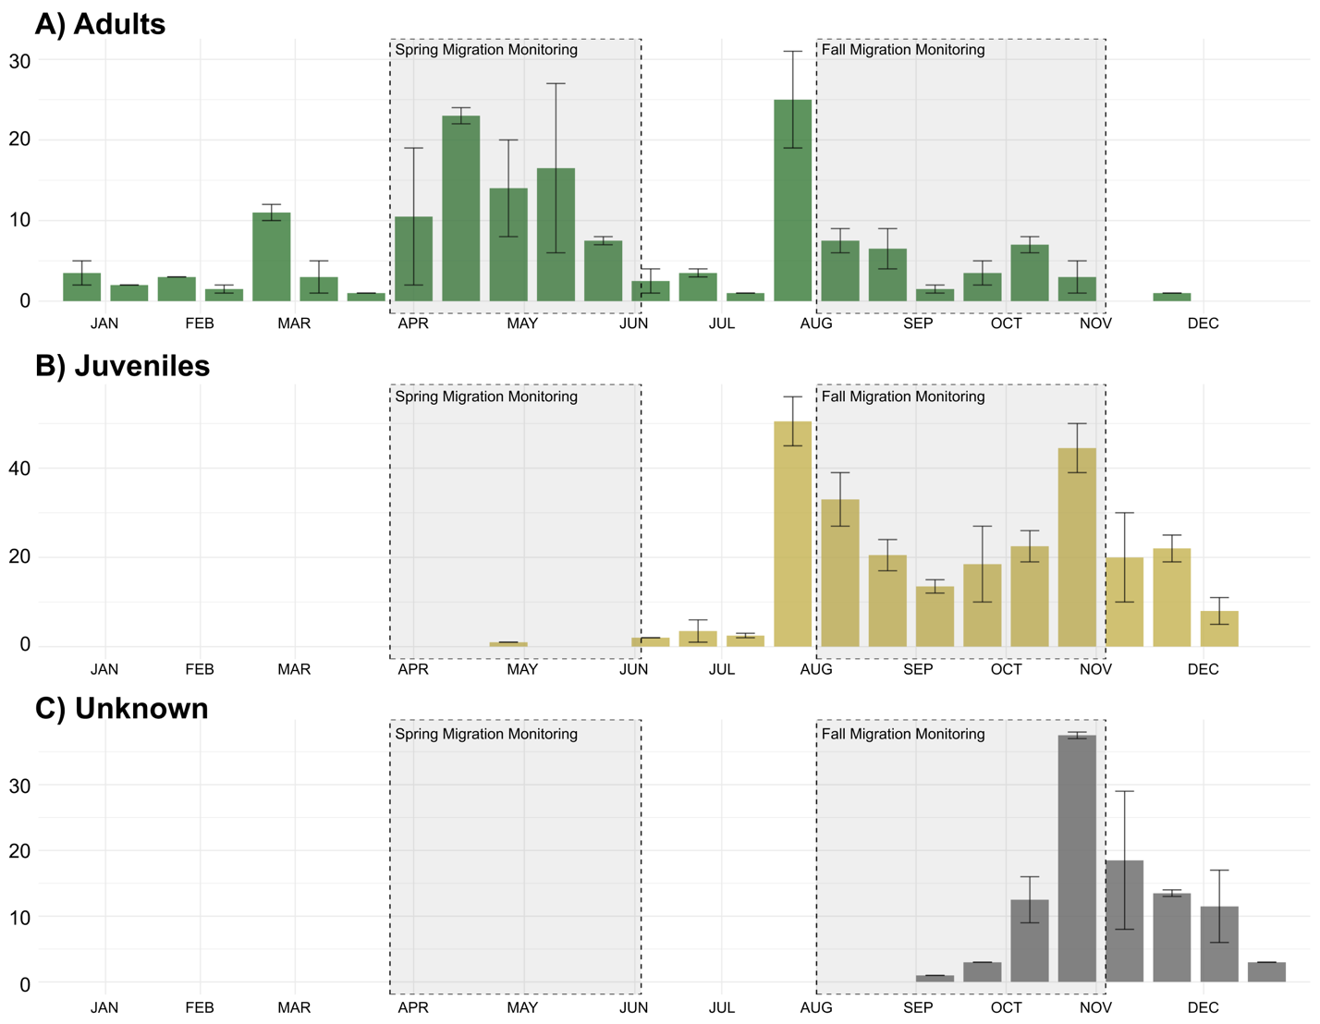Figure S1. Mean number of cardinals captured at the McGill Bird Observatory (peri-urban site) between 2004 and 2022 in Montreal, Quebec, Canada separated by age where A) shows adult birds, B) shows juvenile birds and C) shows unknown individuals.

Table S1. Model ranking using AICc of generalized linear mixed models (GLM) with a comparing scale-of-effect of landscape variables for resighting locations (n= 57) of cardinals tracked across three sites in Montreal, Quebec, Canada. The landscape variables include the mean vegetation height, the standard deviation of the vegetation height, the mean human population density, the road length and the distance to the nearest feeder.
Study site | Model | LL | Δ AICc | Wt
Peri-urban | 25 meters  50 meters  100 meters  200 meters | -722.48  -713.97  -735.69  -740.60 | 17.02  0.00  53.25  46.96 | 0.00  1.00  0.00  0.00
Suburban | 25 meters  50 meters  100 meters  200 meters | -296.05  -338.31  -344.25  -349.92 | 0.00  84.52  96.39  107.73 | 1.00  0.00  0.00  0.00
Urban | 25 meters  50 meters  100 meters  200 meters | -211.09  -225.64  -224.02  -228.79 | 0.00  29.11  25.85  35.40 | 1.00  0.00  0.00  0.00

Table S2. AIC values used to determine the best fitting model to explain cardinal’s habitat associations.
Study site |  | Model | Variables | AICc
Peri-urban |  | Full  Vegetation height  Vegetation sd  Human  Null | Mean vegetation height + sd vegetation height + mean population density + road length + distance to nearest feeder + (1|Winter) + (1|ID) + (1|Site)  Mean vegetation height+ (1|Winter) + (1|ID) + (1|Site)  Sd vegetation height+ (1|Winter) + (1|ID) + (1|Site)  Mean population density + road length + distance to nearest feeder+ (1|Winter) + (1|ID) + (1|Site)  (1|Winter) + (1|ID) + (1|Site) | 1443.696  1587.124  1596.077  1588.262  1616.101
Suburban | Full  Vegetation height  Vegetation sd  Human  Null |  | Mean vegetation height + sd vegetation height + mean population density + road length + distance to nearest feeder + (1|Winter) + (1|ID) + (1|Site)  Mean vegetation height+ (1|Winter) + (1|ID) + (1|Site)  Sd vegetation height+ (1|Winter) + (1|ID) + (1|Site)  Mean population density + road length + distance to nearest feeder+ (1|Winter) + (1|ID) + (1|Site)  (1|Winter) + (1|ID) + (1|Site) | 631.7501  728.0640  724.0187  632.1451  726.1005
Urban | Full  Vegetation height  Vegetation sd  Human  Null |  | Mean vegetation height + sd vegetation height + mean population density + road length + distance to nearest feeder + (1|Winter) + (1|ID) + (1|Site)  Mean vegetation height+ (1|Winter) + (1|ID) + (1|Site)  Sd vegetation height+ (1|Winter) + (1|ID) + (1|Site)  Mean population density + road length + distance to nearest feeder+ (1|Winter) + (1|ID) + (1|Site)  (1|Winter) + (1|ID) + (1|Site) | 444.7050  486.6402  485.2496  447.8691  484.8853

