Winter survival and urban green space use of the northern cardinal (Cardinalis cardinalis)

Anne-Marie Cousineau

Natural Resource Sciences
Agricultural and Environmental Sciences
McGill University, Montréal

August 2025

A thesis submitted to McGill University in partial fulfillment of the requirements of the degree of Master of Science in Renewable Resources

© Anne-Marie Cousineau, Montreal, Canada, 2025

DRAWING

Contribution of coauthors

I designed, conducted and analyzed all experiments of this thesis with the help of Dr. Kyle Elliott and Dr. Barbara Frei, except for the initial design and collection of northern cardinal tracking data by co-author Barbara Frei during the winter of 2022 and 2023, which served as a pilot project for the first chapter. Field technicians under my supervision and I collected all the GPS locations and tracking data for the northern cardinals between 2023 and 2025. We manually tracked cardinals using telemetry between October and May, approximately 3 to 4 times per week. All of the data collection occurred on the island of Montreal, more specifically on the west island and in the Notre-Dame-de-Grâce neighbourhood.

The coauthor of chapter two (Dr. Andrew Beauchamp from Western University of London – Ontario) contributed significantly by performing changepoint analyses on the data collected through the Motus receiver towers. I completed the statistical analyses and wrote both chapters with the help of coauthors. I wrote both chapters and the literature review with the help of Dr. Kyle Elliott and Dr. Barbara Frei.

Acknowledgements

First, I would like to thank my incredible supervisors, Kyle Elliott and Barbara Frei, for this opportunity. I am grateful for your unwavering support, encouragement, and guidance through this project. Having you as mentors allowed me to develop valuable skills for my future as a biologist.
I also want to thank the dedicated staff and volunteers at the McGill Bird Observatory, especially Shawna Sevigny, Ana Morales, and Barbara Frei, for banding the northern cardinals, installing Motus tags, assisting with translocations over both years, and teaching me bird banding and tag deployment. Tracking cardinals over eight months was a true team effort—thank you to Mackenzie Guest, Lauren Dobie, Nathanya Goudreau, Florence Piché-Lebel, Laurianne Fallu, Elliana Tomasso, and Mathilde Lefvert for your essential help in the field. Thanks to Jean and Richard Gregson for hosting a Motus tower in their backyard.
Thank you to Concordia University for partnering on the Loyola campus tower installation, and to my committee members, Christina Davy, Carly Ziter, and Marcel Gahbauer, for their valuable feedback. I’m also grateful to my Arctic Ecology Lab mates for their constant support and advice, and to McGill University and SSHRC for funding. Special thanks to Environment and Climate Change Canada for providing 80 nanotags across two field seasons!
Finally, thank you to my family—Patricia, Gilbert, and Xi Chen—for your encouragements and patience with all my cardinal adventures.
And of course, thanks to the northern cardinals for being the best (and most feisty) work companions; these bright red birds will always have a special place in my heart.
Table of Contents
Contribution of coauthors 3
Acknowledgements 4
Abstract 7
Résumé 9
List of tables 11
List of figures 12
Introduction 13
Literature review 15
Urbanization and its effects on birds 15
Habitat association and survival of songbirds in urban areas 18
Use of very high frequency (VHF) telemetry in bird research 20
Study species and study sites 24
Knowledge gaps and research objectives 27
Chapter 1: Larger winter home ranges in urban than peri-urban sites for a very short distance migrant, the northern cardinal (Cardinalis cardinalis) 29
Abstract 29
Introduction 30
Materials and methods 33
Study locations 33
Radio tagging, banding & translocation 35
Non-breeding season tracking and home range estimations 36
Scale of effect 38
Use-availability analysis 38
Results 39
Core areas and home ranges 43
Scale of association to habitat 44
Resource selection: used vs. available habitats 45
Discussion 49
Larger home ranges and supplemental feeding 51
Small scale of association to habitat regardless of urbanization level 52
Variation of preferred habitat factors across an urbanization gradient 53
Chapter 2: Northern cardinals (Cardinalis cardinalis) exhibit seasonal changes of onset and end of daily activities in urban areas 55
Abstract 55
Introduction 55
Materials and methods 58
Study site and Motus receiver stations 58
Radio tags deployment and Motus data download 60
Change point analysis 61
Cold temperature lag effect 63
Cold snaps effect 65
Effects of combined temperature variables 66
Results 67
Temperature lag and cold snap model selection 67
Effect of temperature lag and cold snap events on activity onset 69
Effect of temperature lag and cold snap events on activity end 70
Supplemental material 72
Literature cited 73

Abstract
Winter presents a season of challenges for resident bird species in temperate areas. With lower temperatures, reduced food availability and shorter days, non-migratory birds must adjust their behaviour and energy expenditures to survive this harsh season. Many species cope with harsh winter conditions by having flexible behaviour, such as changing roosting strategies and nighttime fasting. In urban environments, birds have both novel challenges and opportunities in winter. Urban areas provide microclimates that create refuges from harsh weather and reliable anthropogenic food sources, yet they also bring habitat fragmentation, artificial light pollution, and more. Learning more about the winter ecology of resident urban birds can provide us with valuable knowledge to design and improve urban green spaces in a way that benefits people and birds, year-round.
In my first thesis chapter, I examined fine-scale space use by northern cardinals (Cardinalis cardinalis) across three urban green spaces of varying levels of urbanization during the non-breeding season in Montreal, Canada. Using VHF telemetry, I tracked individual cardinals to evaluate how landscape structure and environmental conditions, such as road density, access to bird feeders and vegetation structure, influence movement patterns and habitat use. My findings show that cardinals select their habitats at a smaller scale (25 m radius) when human presence was more pronounced, compared to a larger scale in our less urbanized location (50 m radius). Birds spending winter in our most urban location had on average, home ranges about three times the size of the birds spending winter in less urbanized locations. Finally, cardinals selected for different habitat features, depending on the level of urbanization of the site they wintered at. These results underscore the importance of small-scale urban green space design and winter resource availability for supporting resident bird populations in urban settings.
In my second chapter, I tracked the daily activity of the same individuals in Chapter 1. To quantify activity, we used variability in the radio signal recorded by the Motus Wildlife Tracking System. All the study locations had receiver towers continuously recording the signal strength of the VHF tags we deployed for Chapter 1. A change point analysis was performed to precisely identify the time birds began their daily activities, along with the time they ended their daily activity. We used meteorological data to investigate how the cardinals adjust their winter foraging behaviour to temperature, snow on the ground, precipitation and consecutive days of cold weather. Across three years, cumulative effects of weather had a stronger explanatory power compared to same-day conditions. Precipitations had an important, non-linear effect on both the onset and end of the birds’ activities. The amount of snow on the ground had a strong and linear effect for the end of the bird’s activity period, with the birds ending their active period earlier as the amount of snow on the ground increases. Thus, several days of heavy snow reduced cardinal activity, perhaps because they were conserving energy during harsh conditions. These findings highlight the behavioural flexibility of northern cardinals towards harsh climatic conditions in winter, which may play a crucial role in its winter survival and thriving in urban areas. In summary, my thesis contributes to a growing understanding of how winter resident birds navigate the complex interactions between the urban landscape and the extreme seasonal variations in climate.

Résumé
L’hiver représente une saison de défis pour les espèces d’oiseaux résidents des régions tempérées. Avec des températures sous zéro, une disponibilité réduite de nourriture et une photopériode raccourcie, les oiseaux qui ne migrent pas doivent adapter leur comportement et dépenses énergétiques pour survivre à cette saison rigoureuse. Si plusieurs espèces comptent sur des stratégies d’agrégation, sur la flexibilité comportementale ou sur le jeûne nocturne, celles vivant en milieu urbain sont confrontées à la fois à de nouveaux défis et à certains avantages. Les milieux urbains offrent des microclimats plus cléments, pouvant servir de refuges et de source d’alimentation stable (via les humains), mais ils exposent aussi les oiseaux à la fragmentation d’habitat, à la pollution, à l’éclairage artificiel, etc. Certaines espèces s’en sortent mieux que d’autres, particulièrement en ville, et mieux comprendre leur écologie hivernale peut nous fournir des connaissances utiles pour concevoir et améliorer les espaces verts urbains afin de favoriser le bien-être des oiseaux, et celui des humains, toute l’année.
Dans le premier chapitre de ma thèse, j’ai examiné l’utilisation de l’espace à fine échelle par le cardinal rouge (Cardinalis cardinalis) dans trois sites aux niveaux d’urbanisation différents à Montréal. À l’aide de la télémétrie VHF, j’ai suivi plusieurs individus pour évaluer comment la structure du paysage et les conditions environnementales — telles que la densité routière, l’accès aux mangeoires et la structure verticale de la végétation — influencent leurs déplacements et l’utilisation de l’habitat. Mes résultats montrent que le cardinal sélectionne son habitat à une plus petite échelle spatiale (rayon de 25 m) dans les milieux plus urbanisés, comparativement à une échelle plus large (rayon de 50 m) dans les sites moins urbanisés. De plus, les oiseaux hivernant dans le site le plus urbanisé présentaient, en moyenne, des domaines vitaux trois fois plus grands que ceux des oiseaux en milieux moins urbanisés. Enfin, j’ai démontré que le cardinal sélectionne différentes composantes de son habitat selon le degré d’urbanisation. Ces résultats soulignent l’importance de la conception à petite échelle des espaces verts urbains et de la disponibilité des ressources hivernales pour soutenir les populations d’oiseaux urbains.
Dans le second chapitre, je me suis intéressée aux patrons d’activité journalière du cardinal rouge dans trois sites urbains de Montréal. J’ai suivi l’activité journalière des mêmes individus que dans le chapitre précédent, cette fois à l’aide du système automatisé Motus Wildlife Tracking System. Tous les sites étaient équipés de tours réceptrices enregistrant en continu la force du signal des émetteurs VHF installés au chapitre 1. Une analyse des points de changement a permis d’identifier les moments où les oiseaux débutaient et terminaient leurs activités quotidiennes. Des données météorologiques publiques ont été utilisées pour examiner comment le cardinal ajuste son comportement d’alimentation en hiver selon la température, la neige au sol, les précipitations et les jours consécutifs de froid. Nous avons constaté que les précipitations ont un effet important, mais non linéaire sur le début et la fin des activités, tandis que la neige influence de manière linéaire la fin de journée : les oiseaux terminent plus tôt quand la neige est abondante. Ces résultats mettent en valeur la flexibilité comportementale du cardinal face aux conditions climatiques hivernales, une adaptation qui pourrait jouer un rôle clé dans leur succès en milieu urbain. En résumé, ma thèse contribue à mieux comprendre les stratégies utilisées par les oiseaux résidents pour composer avec les interactions complexes entre le paysage urbain et les variations saisonnières du climat tempéré.

List of tables

Table 1.1.
Table 1.2.
Table 1.3.
Table 2.1
Table 2.2
Table 2.3.

List of figures

Figure 1.1.
Figure 1.2.
Figure 1.3.
Figure 1.4.
Figure 1.5.
Figure 1.6.
Figure 2.1.
Figure 2.2.
Figure 2.3.

Introduction
Humans living in urbanized areas derive many benefits from urban green spaces (UGS). Benefits include improved mental health, access to clean air from pollution removal by trees and cooling effects during heatwaves (Buxton et al., 2024; Cox et al., 2017; Jim & Chen, 2008; Skarbit et al., 2024). Access to UGS of high biodiversity brings greater restorative benefits for people than low biodiversity sites, regardless of socio-economic variables like age or ethnic background (Wood et al., 2018). While there are multiple benefits to greening cities, it is important to highlight the challenges faced by urban planners, such as the paradox between greening and gentrification. As efforts are deployed to increase access to urban green space to address health and environmental issues, neighbourhoods become healthier, more aesthetically pleasing, increasing property values and housing costs (Wolch et al., 2014). Urban greening is complex and involves trade-offs – including issues of gentrification, cost and ecological impact – but advancing knowledge in this area remains essential to move towards biodiversity-friendly green spaces that also support human well-being.
In Canada specifically, urban sprawl in major cities such as Montreal, Toronto and Vancouver expanded greatly in the past 100 years (Dupras & Alam, 2015; Filion et al., 2010; Furberg & Ban, 2008). Forest patch size tends to decrease as urbanization increases, leading to a reduction of the ecosystem services associated with those green spaces (Mitchell & Devisscher, 2022). For birds, this can increase cost to travel between patches, lower resource availability and reduce sheltering opportunities. In Canada, the areas with the most human modifications (urban and agricultural) are also occurring in our most biodiverse areas (Deguise & Kerr, 2006; Kraus & Hebb, 2020). These areas of high human influence also overlap with the four major North American bird migration flyways, further solidifying their ecological relevance (Fritts, 2022). The island of Montreal is located within the ecoregion of the St. Lawrence Lowlands, identified as a high biodiversity ecoregion with high threat, as less than 5% of the ecoregion is protected (Kraus & Hebb, 2020). In addition, resident birds in Canada experience prolonged cold weather in winter, adding significant energetic stress (Dawson et al., 1983; Swanson & Vézina, 2015). The importance of greening initiatives in heavily urbanized areas is not only crucial for the community experiencing the benefits of UGS, but also for the birds and the wildlife that depend on UGS to survive even the harsh winters of southern Canada. In the last few years, the city of Montreal has been a leader in its efforts towards urban greening initiatives. The city adopted its Climate Plan 2020-2030 which commits the city to plant, maintain and protect 500,000 trees, create new parks, green corridors and wetlands, restore shorelines and increase the size of protected areas so they cover 10% of the land within the city limits (City of Montreal, 2020). As of 2023, approximately 180,000 trees were planted, and 7.6% of the land is categorized as protected and contributing to preserving biodiversity (City of Montreal, 2024). While progress is being made, greening efforts need to ramp up in the next few years for the city to reach its goals, and there’s a need to build knowledge on efficient ways to create and restore UGS in ways that promote biodiversity in the city.

Literature review
STRUCTURE OF THE LIT REVIEW.

Urbanization and its effects on birds
Urbanization significantly alters the landscape and its composition. Songbirds can be particularly vulnerable to urban development, as urban development often reduces species richness while increasing the density of a few successful species (Seress & Liker, 2015). Nonetheless, cities can present both opportunities and challenges to avifauna (Isaksson, 2018). Urban locations can provide year-round food through bird feeders and human waste while simultaneously providing shelter against some predators that may not be as tolerant to human presence (Eötvös et al., 2018; Liker et al., 2008). Urbanization positively impacted some bird guilds, such as the granivorous and terrestrial species, whose richness increased in human-impacted habitats of Loja, Ecuador (Ordóñez-Delgado et al., 2022). On the other hand, significant challenges also arise for bird communities using urban areas. Habitat loss and fragmentation can negatively affect avian communities and genetic diversity (Palacio et al., 2018; Rodrigues et al., 2018; Shanahan et al., 2014). In South America, urbanization can act as a filter, favoring certain bird species with specific traits, leading to changes in both the birds community composition, but also in the genetic diversity within a single species (Palacio et al., 2024; Rodrigues et al., 2018).
Pollution in various forms in heavily urbanized areas, including chemical, light and noise pollution, can also affect avian health. Organic compounds can occur in high concentrations due to their use in housing, industrial processes and during the production of a wide range of goods (Kekkonen, 2017). Such compounds affect a multitude of organisms, including birds, which can suffer from reduced clutch sizes, hormonal disturbances, reduced active parenting behaviours and more (Kekkonen, 2017). One example is polybrominated diphenyl ethers (PBDEs), a brominated flame retardant widely used in many countries to reduce the flammability of consumer products (Chen & Hale, 2010). Because the use of PBDE is highly related to human goods, birds living in or around urbanized areas are often found to be highly contaminated with PBDEs (Elliott et al., 2005, 2015). Light pollution emanating from large urban centers affects migratory and resident bird species. Resident bird species residing in urban-core areas had smaller eyes than their urban-edge counterparts, most likely due to the intense brightness from urban centers (Jones et al., 2023). For long-distance migratory bird species, light pollution can have detrimental effects such as disorientation, disruption of circadian rhythm, changes in flight behaviours and more (Cabrera-Cruz et al., 2018).
When environmental conditions are changing (including via rapid human-induced changes), behavioural traits are often one of the first responses (Lane et al., 2023). For example, males of several songbird species were found to be more aggressive in urban habitats compared to their rural counterparts (Lane et al., 2023). Anthropogenic disturbances found in the city may also affect incubation behaviour, a critical life stage not only for the parents, but also for the success of the offspring (Hope et al., 2022; Lane et al., 2023). Urban great tits (Parus major) spent more time incubating, took shorter off-bouts and ended their last nest outing later during the day, compared to the females incubating in the forest (Hope et al., 2022). These differences in incubation time and off-bouts might be due to the easier access to specific food items in the city (i.e. seeds or food scraps) or due to territories being smaller in urban areas, hence the short amount of time spent away from the nest (Hope et al., 2022). Population dynamics and gene flow can also be affected by urbanization, as habitat fragmentation is a major side effect of humans’ increasing needs for land and resources (Brewer et al., 2020). Although these effects can negatively impact gene diversity in songbird populations (as movements are impeded by anthropogenic habitat changes), a threshold, as low-intensity urbanization (determined by using an urbanization index described in Davis et al. (2018)) does not have as strong an impact on the genetic diversity of song sparrows (Melospiza melodia) as initially anticipated (Brewer et al., 2020). These findings highlight the importance of greening in urban areas to counteract the effects of habitat fragmentation on avian genetic diversity. In Melbourne , Australia, habitat connectivity (here defined as areas with escape routes, protective cover, shrubs/trees/perchable infrastructures) is crucial for birds in urban parks trying to avoid humans and predators (Radvan et al., 2023). Birds flew farther when disturbed in areas where fewer trees occurred, suggesting that planting in urban parks may influence how well birds and people coexist in cities (Radvan et al., 2023). In Brisbane, Australia, connectivity can enhance the corridors that colonist species use to arrive in the city (thus increasing species richness), while have larger patch area allows for an increased abundance of birds by expanding the habitat available for the species that are already there (Shanahan et al., 2011).
Access to urban green spaces is often unevenly distributed in large cities, and being able to visit biodiverse spaces remains difficult for many urbanites. City structure can have an impact on both humans and birds, as urbanized areas where green spaces are more dispersed (defined as “land sharing”) often have greater avian diversity (especially in winter), compared to more isolated green patches (defined as “land sparing”) (Ibáñez-Álamo et al., 2020). Thus, whereas land-sparing (high density urban regions interspersed with large parks) usually increases overall biodiversity as even those species that need “pristine greenspaces are present, land-sharing (lower density regions with leafy streets, gold courses or small urban parks) can bring nature into backyards and closer to individual people for longer periods. In eastern North American cities, the charismatic and easily identifiable species that is the northern cardinal (Cardinalis cardinalis) can play an important role in this type of dynamic where the bird’s presence in even modest greenspaces can reflect the accessibility and quality of the connection between urban residents and nature.
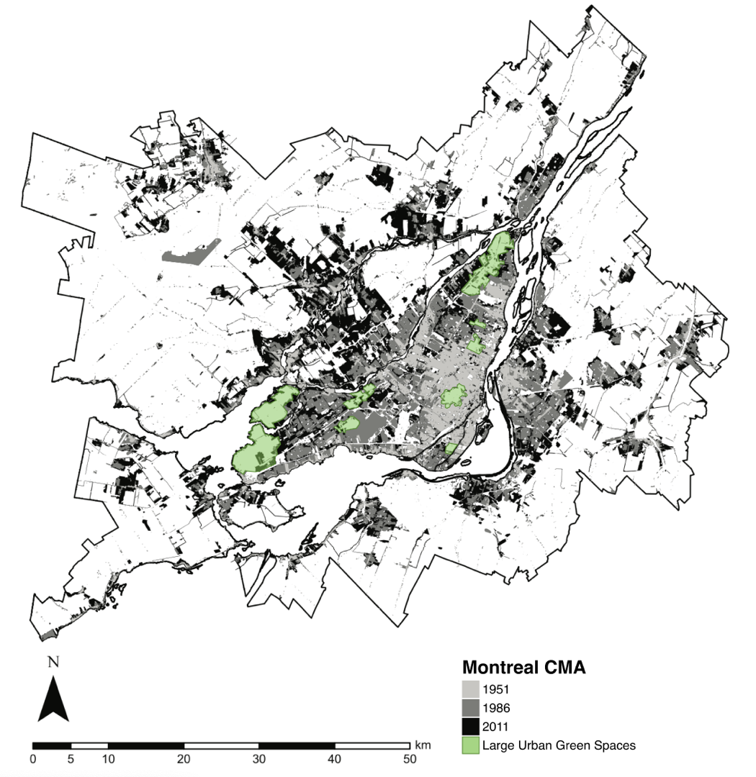
Figure 1. Built-up areas in the Montreal CMA (Census Metropolitan Area), in 1951, 1986 and 2011 (Nazarnia et al., 2016). In green are the few remaining large urban green spaces on the island of Montreal. This map was adapted from Nazarnia et al. (2016; Fig. 4).

Habitat association and survival of songbirds in urban areas
Habitat selection by songbirds in urban environments is influenced by a complex network of ecological and anthropogenic factors. Patch size and habitat fragmentation, which directly affect the availability and quality of resources for birds, are among the most widely studied variables. Vegetation composition—including plant species diversity and the physical vertical structure—also plays a significant role in determining habitat suitability, particularly for foraging, shelter and nesting. When creating and managing urban green spaces, stakeholders have to consider the area-heterogeneity trade-off (Chiron et al., 2024). This trade-off stems from increasing landscape heterogeneity inadvertently reducing patch sizes for individual habitat types, potentially disadvantaging specialist species (Chiron et al., 2024). Evidence from southern Ontario, Canada, confirmed that area (size) and natural vegetation (as opposed to horticulturally managed parks) within the urban landscape are of great importance to winter birds such as the northern cardinal (Cardinalis cardinalis), downy woodpecker (Dryobates pubescens), black-capped chickadee (Poecile atricapillus) and white-breasted nuthatch (Sitta carolinensis) northern cardinal(Smith, 2007). While it can be challenging to try and create new green corridors through a city, a New Zealand/Aotearoa study used a least-cost path analyses to integrate infrastructures, such as green roofs or walls, to show that increased connectivity between forest habitats can ease birds’ dispersal without resorting to major changes of the urban landscape (MacKinnon et al., 2023).
In addition to landscape structure, both resource availability and climate can significantly influence winter survival and habitat occupancy. Supplementary feeding in urban environments has been linked to non-adaptive behavioural strategies and reduced apparent survival in great tits (Parus major), highlighting the potential trade-offs of human-provided resources (Krama et al., 2023). Moreover, temperature dynamics are likely to affect winter distributions: northern cardinals were more likely to colonize sites that were warmer relative to the previous year, especially in forested areas (Latimer & Zuckerberg, 2021). Interestingly, while some other common urban species like the house sparrow (Passer domesticus) and the American goldfinch (Spinus tristis) show resilience to urban cold, others like the northern cardinal and the American tree sparrow demonstrate cold-driven colonization, colonizing cities rather than rural sites, suggesting species-specific thermal strategies (Latimer & Zuckerberg, 2021).
Winter represents a period of acute and chronic energetic stress for small passerines, particularly in northern latitudes, where during extreme cold periods birds must maintain a temperature difference from over 40˚C within the bird to under -40˚C outside the bird, with only one or two centimeters of insulation (feathers) to maintain that gradient. Birds must balance reduced food availability and shorter foraging windows, along with an increased thermoregulatory demand during longer, colder nights (Petit et al., 2017). Physiological adaptations, such as the elevated heart rate observed in Eurasian blackbirds (Turdus merula) during colder temperatures could help preserve heat by burning more energy (Linek et al., 2021). Small passerine birds spending winter at higher latitudes are required to display optimal energy management in a multifaceted way to survive through the harsh conditions (Andreev, 1999; Brodin, 2007; Petit et al., 2017). In addition, weather severity, including extreme wind events, has been linked to increased mortality in wintering seabirds (Louzao et al., 2019). This may also be especially relevant in urban settings, where wind tunnel effects created by buildings can amplify exposure to harsh microclimates (Kamei & Maruta, 1979).

Use of very high frequency (VHF) telemetry in bird research
Telemetry in wildlife research is defined as a group of techniques used to remotely acquire information (geographical, physiological, environmental, etc.) on animals equipped with various data-collecting devices (Rodgers, 2001; Thohari, 1989). Such devices include the use of VHF/UHF (Very High Frequency and Ultra High Frequency) units, store-on-board units, GPS (Global Positioning System) units and GSM (Global System for Mobile Communication) units, among others. At the present time, GPS-based tracking remains one of the most reliable and widely used method for monitoring animal movements, especially since the degradation of large-scale monitoring initiatives such as ICARUS (which was initially relying on the International Space Station’s partnership with the Russian Space Agency) (Müller & Avolio, 2023). Telemetry technologies have significantly improved recently, with higher success rates for satellite fixes (Hofman et al., 2019). Moreover, the size and weight of these devices has decreased substrantially over the past 40 years, as the technology around them improves (smaller batteries with longer runtime, increased memory storage, increased use of microcomputers, etc.), increasing the number of species that can be tracked, generating many possible applications in the field of wildlife conservation (Hofman et al., 2019).
The use of tracking devices to study birds can be traced back to at least the 1960s (REFERENCE). BANDING? During the 1970s and 1980s, VHF radio telemetry gained a strong interest from ornithologists (REFERENCE). Radio telemetry allowed researchers to acquire valuable information on birds’ movements, behaviours and physiology without the need to restrain the individuals (Harris & Fish, 1990). Radio telemetry is a useful tool to study birds’ migratory movements, stopover sites, breeding and non-breeding grounds, and local movements (Fuller et al., 2005). Those data can be extremely valuable when dealing with cases of avian disease affecting migratory birds and livestock (Fuller et al., 2005). Digital RFID systems such as Encounternet can also provide more detailed information that can be used to study birds’ behaviour (Mennill et al., 2012). The long-term use of portable receiver stations and RFID tags in systems such as Encounternet allows researchers to investigate birds’ social behaviours (such as social networks) and reproductive behaviours (such as lekking and parental care) (Mennill et al., 2012).
For my Master’s thesis, I relied on VHF radio-tracking devices for data collection. VHF radio-tracking tags are a particular type of logger that does not record any location data. As the name suggests, they emit a very high-frequency (VHF) radio signal that can be picked up by receiver stations or hand-held receiver devices. Researchers need to use an antenna and a receiver to get as close to the bird as possible before using a hand-held GPS device to record the location. A main disadvantage of using VHF radio tags is being labour-intensive as it requires the researchers to be within a certain range of the tagged bird to get a precise location (Iverson et al., 2023). Because these VHF receivers don’t include solar panels or need to connect with satellites (such as GPS loggers) or cell phone stations, transmitters can be extremely small. For example, Lotek’s Nanotags for birds and bats NTQB2-1 weighs only 0.28 grams with a maximum life expectancy of approximately 103 days (www.lotek.com). VHF radio tags are also generally less expensive than other loggers (~$200 CAD for the NTQB2-1), meaning researchers can have a greater sample size for the same budget. VHF telemetry has been used to reveal fine-scale movements of birds, such as habitat use and home range sizes (Brewer et al., 2023; Naguib et al., 2022; O’Connell et al., 2023). It is important to note that the success of using VHF radio telemetry at a fine scale is dependent on the presence of receiver within the vicinity of the marked individuals, and thus the researchers ' capacity to have access to the individuals in the field. Getting valuable fine-scale data on tracked birds is possible but highly labour-intensive as the researcher needs to get close enough to the bird to be able to pick up its signal. On the other hand, in areas where there’s an extensive network of receiver towers (such as the Motus Wildlife Tracking network in North America), the use of VHF radio telemetry can provide valuable information for long-distance monitoring, such as migration routes and stopover sites. Systems such as Motus can track birds across continents, and is, to some degree, replacing banding as a method for monitoring individual wildlife migration as Motus tags have a much higher detection rate than bands.
Although the use of telemetry devices can provide valuable physiological and ecological data on birds, telemetry devices can have negative impacts on organisms. Return rate of Swainson’s warblers (Limnothlypis swainsonii) with radio tags was not significantly different than return rates of the birds with only colour bands (Anich et al., 2009). However, although backpack-style tags on tree swallows (Tachycineta bicolor) had no short-term effects, the return rate of the tagged individuals was significantly lower compared to the individuals without tags, raising concerns about long-term effects (Gómez et al., 2014). An experimental study on homing pigeons (Columba livia) has also demonstrated that the birds equipped with a mass corresponding to 5% of their body weight (to simulate tag attachment) lost the corresponding amount of body mass over a 25-days period (Portugal & White, 2022). The authors emphasized that this loss of body mass equates to a loss of 1,140 kJ of energy, corresponding to approximately 32% of their daily energy budget (Portugal & White, 2022).While the effect of tagging on the return rate seems to vary greatly, a meta-analysis on the impact of biologging devices across multiple taxa stressed that there was a small, but significant negative impact of tagging on survival, parental care and reproduction of birds (Bodey et al., 2018). More recently Jones et al. (2024) called for radio-transmitters specifications to take in account colour and antenna length, and to avoid females and juveniles (which tend to have more inconspicuous plumages) being detected, and to reduce entanglement risks.
To our knowledge, this project is the first to install Motus radio tags on northern cardinals. We used a combination of tags and harnesses that were less than 3% of the average cardinal’s body mass to minimize the effects of the weight of the device on the birds’ energy budgets (especially since this research is happening in winter). During the first two years of experimentations, the radio tags used had a white “body” and a silver antenna which was quite visible through both males and females’ plumage. For the last year of experiment, we used all black radio tags (increased coating resistance) that were still below the 3% threshold but blended better through the cardinals’ plumage.

Study species and study sites
The northern cardinal (Cardinalis cardinalis) is a resident bird species that is abundant in many areas of eastern North America (Halkin et al., 2021). Cardinals be found year-round from southern Canada all the way to southern Mexico (Halkin et al., 2021). Northern cardinals have been expanding their range northward since the 1800s, and they can be characterized as urban-tolerant birds that thrive in inhabited areas (Halkin et al., 2021; Robert et al., 2019). The first reported sightings of northern cardinals in Quebec ca be traced back to 1862, when a bird was reportedly captured in Montreal (Robert et al., 2019). A few years later, in 1869, another specimen was caught in Quebec city (Robert et al., 2019). After that, it was 73 years before another northern cardinal was recorded in the region (in 1942) and another 14 years for two male cardinals to be spotted in Montreal again (Robert et al., 2019). Finally, 1956 will mark the official beginning of the establishment of the northern cardinals in Quebec, as they were observed every year from then in the Montreal area (Robert et al., 2019). In southern Quebec, the cardinals are strongly associated with urban and agricultural areas, along with mature deciduous forests, while being rarely found at elevations above 200 meters (Robert et al., 2019). Cardinals are 1.7 to 4 times more abundant in urban forests compared to rural ones (Leston & Rodewald, 2006). In Ohio, the researcher found that the apparent annual survival rate of adult northern cardinals ranges from 50.5% $±$ 10.3 SE to 78.3% $±$ 7.6 SE (Shustack, 2008). The principal causes of mortality for the cardinals are not well documented, with information on exposure to contaminants, disease and parasites, interspecific and intraspecific competition still fairly unknown (Halkin et al., 2021). Despite this lack of information, it’s possible to assume that predation by raptors, domestic cats and window collisions play an important role in the survival of the northern cardinal (Lopes et al., 2024; Panchana et al., 2025; Tryjanowski et al., 2024). In Tennessee and Iowa, breeding of cardinals can begin as early as April (and in some cases even if there is still snow on the ground), with nest building lasting approximately 2 to 3 weeks and first eggs laid at the end of April or beginning of May (Halkin et al., 2021; Robert et al., 2019). At the Lake Thoreau Environmental Center of the University of Southern Mississippi, nest predation for the northern cardinals is high in rural/forested areas, averaging 70% in the early season, with improving success as the breeding season progresses (DeVries & Jawor, 2013; Filliater et al., 1994; Linville et al., 1998). In Montreal cardinals had one of the lowest modelled nest survival estimates (Cull et al., 2025). For this reason, cardinals often have a second nest and brood later in the season, with reports of recently fledged young as late as August and September (Laskey, 1944). Cardinals in London, Ontario that exhibited nest failures, took on average 6 days to lay eggs in a new nest (with considerable individual variation in the time it takes the birds to renest after failure) (Scott et al., 1987).
The initial observation that sparked the development of my MSc thesis project, was the noticeable “pulse” of northern cardinals banded in late fall at the McGill Bird Observatory, that is curiously not observed during the spring banding operations. This seemed to indicate that while the cardinals are considered “resident”, they still exhibit seasonal movement, yet where and how they move around is still not well understood.
The three study sites in this project are located on the island of Montreal, the second largest city in Canada (Government of Canada, 2022a). The first study site is the McGill Bird Observatory (MBO), a migration monitoring banding station based in Sainte-Anne-de-Bellevue on the western tip of the island (45.43˚N, 73.94˚W). MBO occurs in the Stoneycroft Wildlife Area, part of the Macdonald campus at McGill University (Gahbauer et al., 2015). MBO was founded in 2004 by graduate students at McGill University and is now operated by the Migration Research Foundation (MRF) (Gahbauer et al., 2015). This banding station is the only one active in southwestern Quebec and also serves as a training facility for students who wish to enhance their skills in field ornithology (Gahbauer et al., 2015). The area covered by MBO is mainly composed of mature and immature forest, wetlands and agricultural fields (Poirier et al., 2024). This study site serves as a control location with minimal human presence. The second location used in this research is the Baie d’Urfé residential area, next to the Macdonald campus of McGill University. It’s located south of MBO near the Saint-Lawrence River (45.41˚N, 73.92˚W). This area was selected as an intermediate urbanized location, as human presence is more pronounced compared to MBO, while remaining one of the “greenest” neighbourhoods of Montreal. The final study site selected for this project is situated in Notre-Dame-de-Grâce, close to the Concordia University Loyola campus (45.46˚N, 73.64˚W). This site serves as the most urbanized location out of the three sites selected, with a higher average population density. This study was in part funded by the Environmental Damages Fund (EDF), which is a Government of Canada program (Government of Canada, 2018). The EDF receives money from fines, penalties and court orders for environmental violations, and the goal is to use this money to support projects (such as this one) that benefit Canada’s natural environment (Government of Canada, 2018).
These three study sites reflect different types of environments a bird may encounter in a large city. It has been shown that fragmentation, heat island effect, noise pollution and loss of habitats can constitute significant challenges for birds, and these may be even more challenging during the cold winter period. Understanding how a resident bird species can use, move, and survive across an urban gradient is crucial to inform greening efforts that are biodiversity-friendly.

Knowledge gaps and research objectives
Although a considerable body of research has explored the effects of urbanization on bird communities, significant knowledge gaps remain regarding fine-scale, winter-specific movement behaviours of urban-tolerant passerines like the northern cardinal. While urbanization has been linked to changes in behaviour, habitat selection, survival and gene flow, few studies examine how individual birds use urban green spaces during the whole non-breeding season at a fine spatial and temporal scale. Like most passerines, cardinals are studied more extensively during the breeding season or the migratory period. Most previous work has relied on coarse-resolution data or presence-absence metrics, limiting our understanding of how resident birds interact with habitats or anthropogenic features during periods of heightened energetic stress, such as winter. As iconic species in eastern North American cities, northern cardinals are great proxies to explore the questions surrounding year-round, biodiversity friendly greening efforts. As one of the only highly colourful birds to spend the winter in Montreal they are an important part of the nature people encounter in and around downtown. Countless times through fieldwork, I encountered residents sharing their love for the species and noticed houses or parks that would decorate their entrances with cardinal-themed ornaments.
In addition, while VHF telemetry has been widely used to monitor birds’ movements, its application has mostly focused on breeding or migratory periods. Studies investigating how resident passerines navigate through fragmented landscapes in winter using manual, ground-based VHF telemetry remain scarce, particularly in northern urban centers where winter conditions and urban microclimates can be quite harsh for the birds. Understanding these dynamics is crucial, especially as climate change and urban expansion continue to reshape winter conditions and resource availability in cities. Thus, the objective of this study is to use fine-scale VHF telemetry data to characterize the space use patterns and habitat preferences of the northern cardinal across three urban locations with varying levels of urbanization on the island of Montreal. By comparing movements with habitat use and proximity to anthropogenic features, this research aims to:
- Quantify winter home range sizes in relation to an urban gradient;
- Assess the influence of specific urban features (e.g., bird feeders, human population density, etc.) on habitat use;
- Examine potential differences in movement behaviour and space use across sites;
- Assess winter energy expenditure variations according to local climate;
- Inform future conservation planning for urban-tolerant resident birds.
This study seeks to bring novel insights into how individual birds behave within the urban ecosystem during a challenging life-history stage and to inform the planning, design and management of urban green spaces so as to support wintering bird populations. The northern cardinal is the ideal study species for this type of research as urbanites in Montreal have a strong connection to these birds.
CARDINAL PHOTOS

Chapter 1: Larger winter home ranges in urban than peri-urban sites for a very short distance migrant, the northern cardinal (Cardinalis cardinalis)

Abstract
Urban green spaces (UGS) are critical for maintaining biodiversity and supporting wildlife, especially in heavily urbanized environments. In temperate regions like southern Quebec, winter brings significant challenges for resident bird species, yet little is known about how birds respond to urbanization during the non-breeding season. This study investigates the fine-scale movements and habitat selection of northern cardinals (Cardinalis cardinalis) across three locations in Montreal, Canada, with varying degrees of urbanization. Using manual VHF telemetry, we quantified home range sizes, habitat selection scale and assessed habitat preferences across gradients of vegetation structure, road density, human population density, and proximity to bird feeders. Based on Christmas Bird Count data, cardinals arrived in Quebec in the 1960s and have increased continuously since then, mirroring changes in neighbouring American states and reflecting the rise in use of bird feeders. Although cardinals are considered year-round residents, there was a pulse in captures at a migration monitoring station during spring and fall showing that cardinals migrated from breeding sites in peri-urban green spaces to wintering sites at bird feeders each year. Cardinals in the most urbanized location had larger home ranges. Habitat selection occurred at very small scales (25-50 m) across all sites, but patterns varied across sites except that proximity to feeders was always an important variable. In less urbanized areas, birds selected for vertically complex vegetation while in more urbanized areas, birds select road length (a proxy for human density). Northern cardinals displayed behavioral plasticity in response to urbanization and highlight the importance of adapting conservation strategies to local urban contexts. As cities expand, understanding these fine-scale ecological responses will be key to designing biodiversity-friendly UGS that support both wildlife and human well-being throughout the year.

Introduction
Urbanization is accelerating worldwide (Elmqvist et al., 2013; Simkin et al., 2022; Wang et al., 2012), altering landscapes and bringing novel challenges to wildlife including habitat fragmentation, habitat loss and chronic pollution (Lowry et al., 2013; Murray et al., 2019; Seress & Liker, 2015; Vaz et al., 2023). Future global urban expansion could lead to an additional 11-33 million hectares of habitat loss by 2100, with a disproportionately large increase in habitat fragmentation (Li et al., 2022). This human-altered landscape can affect birds but also their habitat needs to survive, including home range and movement patterns. A meta-analysis showed that animals had generally smaller home ranges in urban areas (the same trend was observed for both birds and mammals when analyzed separately) and that urbanization restricts spatial movements for most animals (O’Donnell & delBarco-Trillo, 2020). During the breeding period, the communication distance of white-crowned sparrows (Zonotrichia leucophrys) in the San-Francisco Bay was highly predictive of its territory size, highlighting that in the urban landscape, noise pollution may drive songbirds into smaller home ranges in the breeding season (Simberloff et al., 2023). Birds in urban environments also tend to be central foragers, associated with a particular location, doing some back-and-forth between this central area and other foraging locations (Hahs et al., 2023). However, there are exceptions. House sparrows in urban locations in South Bohemia, Czech Republic, had larger foraging areas and flew greater distances to get food (Havlíček et al., 2022). House sparrows selected sites such as storage areas or poultry holding, which are both associated with easier food, of poor quality (Havlíček et al., 2022). Thus, natural food source for house sparrows are scarce and scattered in the urban landscape, driving the sparrows to forage in larger territories (Havlíček et al., 2022).

The effects of urbanization on birds may be reduced during the winter season, when natural resource are less available and weather is harsher. Urban areas can provide a more stable wintering environments for bird species that use bird feeders or that are generalists or omnivores (i.e. corvids), which exploit anthropogenic resources through the winter (Jokimäki et al., 2022). In other cases, cities can serve as refuge during periods of extreme weather, as local colonization of cities by birds increased during the colder conditions due to cities acting as heat islands (Latimer & Zuckerberg, 2021). Nonetheless, occupancy dynamics during winter are highly species-specific, with thermal tolerance playing an important role in determining which species would be able to persist in urban environments during this season. Moreover, energy demands for small resident passerines increase with latitude in winter, meaning that the birds spending their winter in regions such as southern Quebec or the northern United States, must consume significantly more energy to maintain their body temperatures than those wintering farther south—which is especially challenging given the scarcity of resources during the cold months (Fristoe, 2015). Despite these physiological and environmental challenges, along with the potential added effects of urbanization, winter remains an underrepresented season in experimental, ecological research (Dinh et al., 2023). This gap in knowledge highlights the importance of investigating how birds are occupying urban habitats in winter, particularly in temperate regions where winter survival is a major limiting factor for resident bird species.

To address this gap, we studied the northern cardinal (Cardinalis cardinalis). Cardinals are large songbirds (weighing between 40 to 45 grams), which allows for the deployment of radio tags capable of lasting almost the entirety of the non-breeding season. These birds are also very well adapted to urban life, able to thrive and persist across a wide range of urbanization gradients, from suburban neighbourhoods to densely populated areas of the city. They are resident in southern Quebec, a region of extreme cold and loss of natural seeds during the cold winter months. We tracked weekly movements of northern cardinals across an urbanization gradient in the city of Montreal, Quebec, Canada. This study has four objectives: (i) investigate how cardinal’s home range size varies across an urbanization gradient through the winter season, (ii) quantify the scale at which the cardinals are associated with certain factors of their habitat, (iii) analyse cardinals’ association to different habitat factors by comparing used and available habitats (iv) describe the spring transition from non-breeding to breeding grounds. We decided to work with the northern cardinal as they’re one of the most consistently banded species at the McGill Bird Observatory, particularly during the fall migration monitoring program (Gahbauer et al., 2021).
We predicted that wintering cardinals require larger home ranges (both core and total) and select habitats at larger scales when in dense urban locations due to food sources being more scattered (Havlíček et al., 2022). In addition, we predicted that the cardinals would have a higher probability of presence in locations with bird feeders, lower population density, and including a complex vertical vegetation structure (Carrasco et al., 2019; Rousseau et al., 2015). Finally, we predicted that the cardinals would transition from their breeding sites in forested/canopy covered areas towards residential areas in the fall to take advantage of bird feeders during winter, reversing the movement in spring.

Materials and methods

Study locations
The island of Montreal is in southern Quebec in Canada at the confluence of the Saint-Lawrence River and the Ottawa River. As of 2021, approximately 1.7 million people were estimated to live on the island itself, with a population density of 4833.5 people per square kilometers (Government of Canada, 2022b). The city of Montreal pledged to convert 10% of its territory into protected natural areas that contribute to the preservation of biodiversity by 2030, and is now reporting to have reached 7.6% (City of Montreal, 2024). The Montreal climate is divided in four distinct seasons, including cold winters with temperatures often reaching -10 ˚C, while the summers are usually hot and humid with temperatures around 23 ˚C (McGill University, 2025). This research was conducted in three study sites with varying levels of urbanization. Each site includes two release locations randomly assigned to the individuals. The first study site is at the McGill Bird Observatory (MBO), located on the western end of the island of Montreal (45˚25’51.4”N 73˚56’18.5”W). The MBO is our least urban site, being part of the 30 km² of the Grand parc de l’Ouest. The second study site is in the Town of Baie d’Urfé (BDU), serving as our suburban site (45˚24’39.2”N 73˚55’50.0”W). The final study site is in the Notre-Dame-de-Grâce neighbourhood, serving as our dense urban location (45˚27’35.7”N 73˚38’30.2”W). Because the northern cardinal can be found in all three sites, we assumed that the translocated birds would be able to survive and thrive at each location.
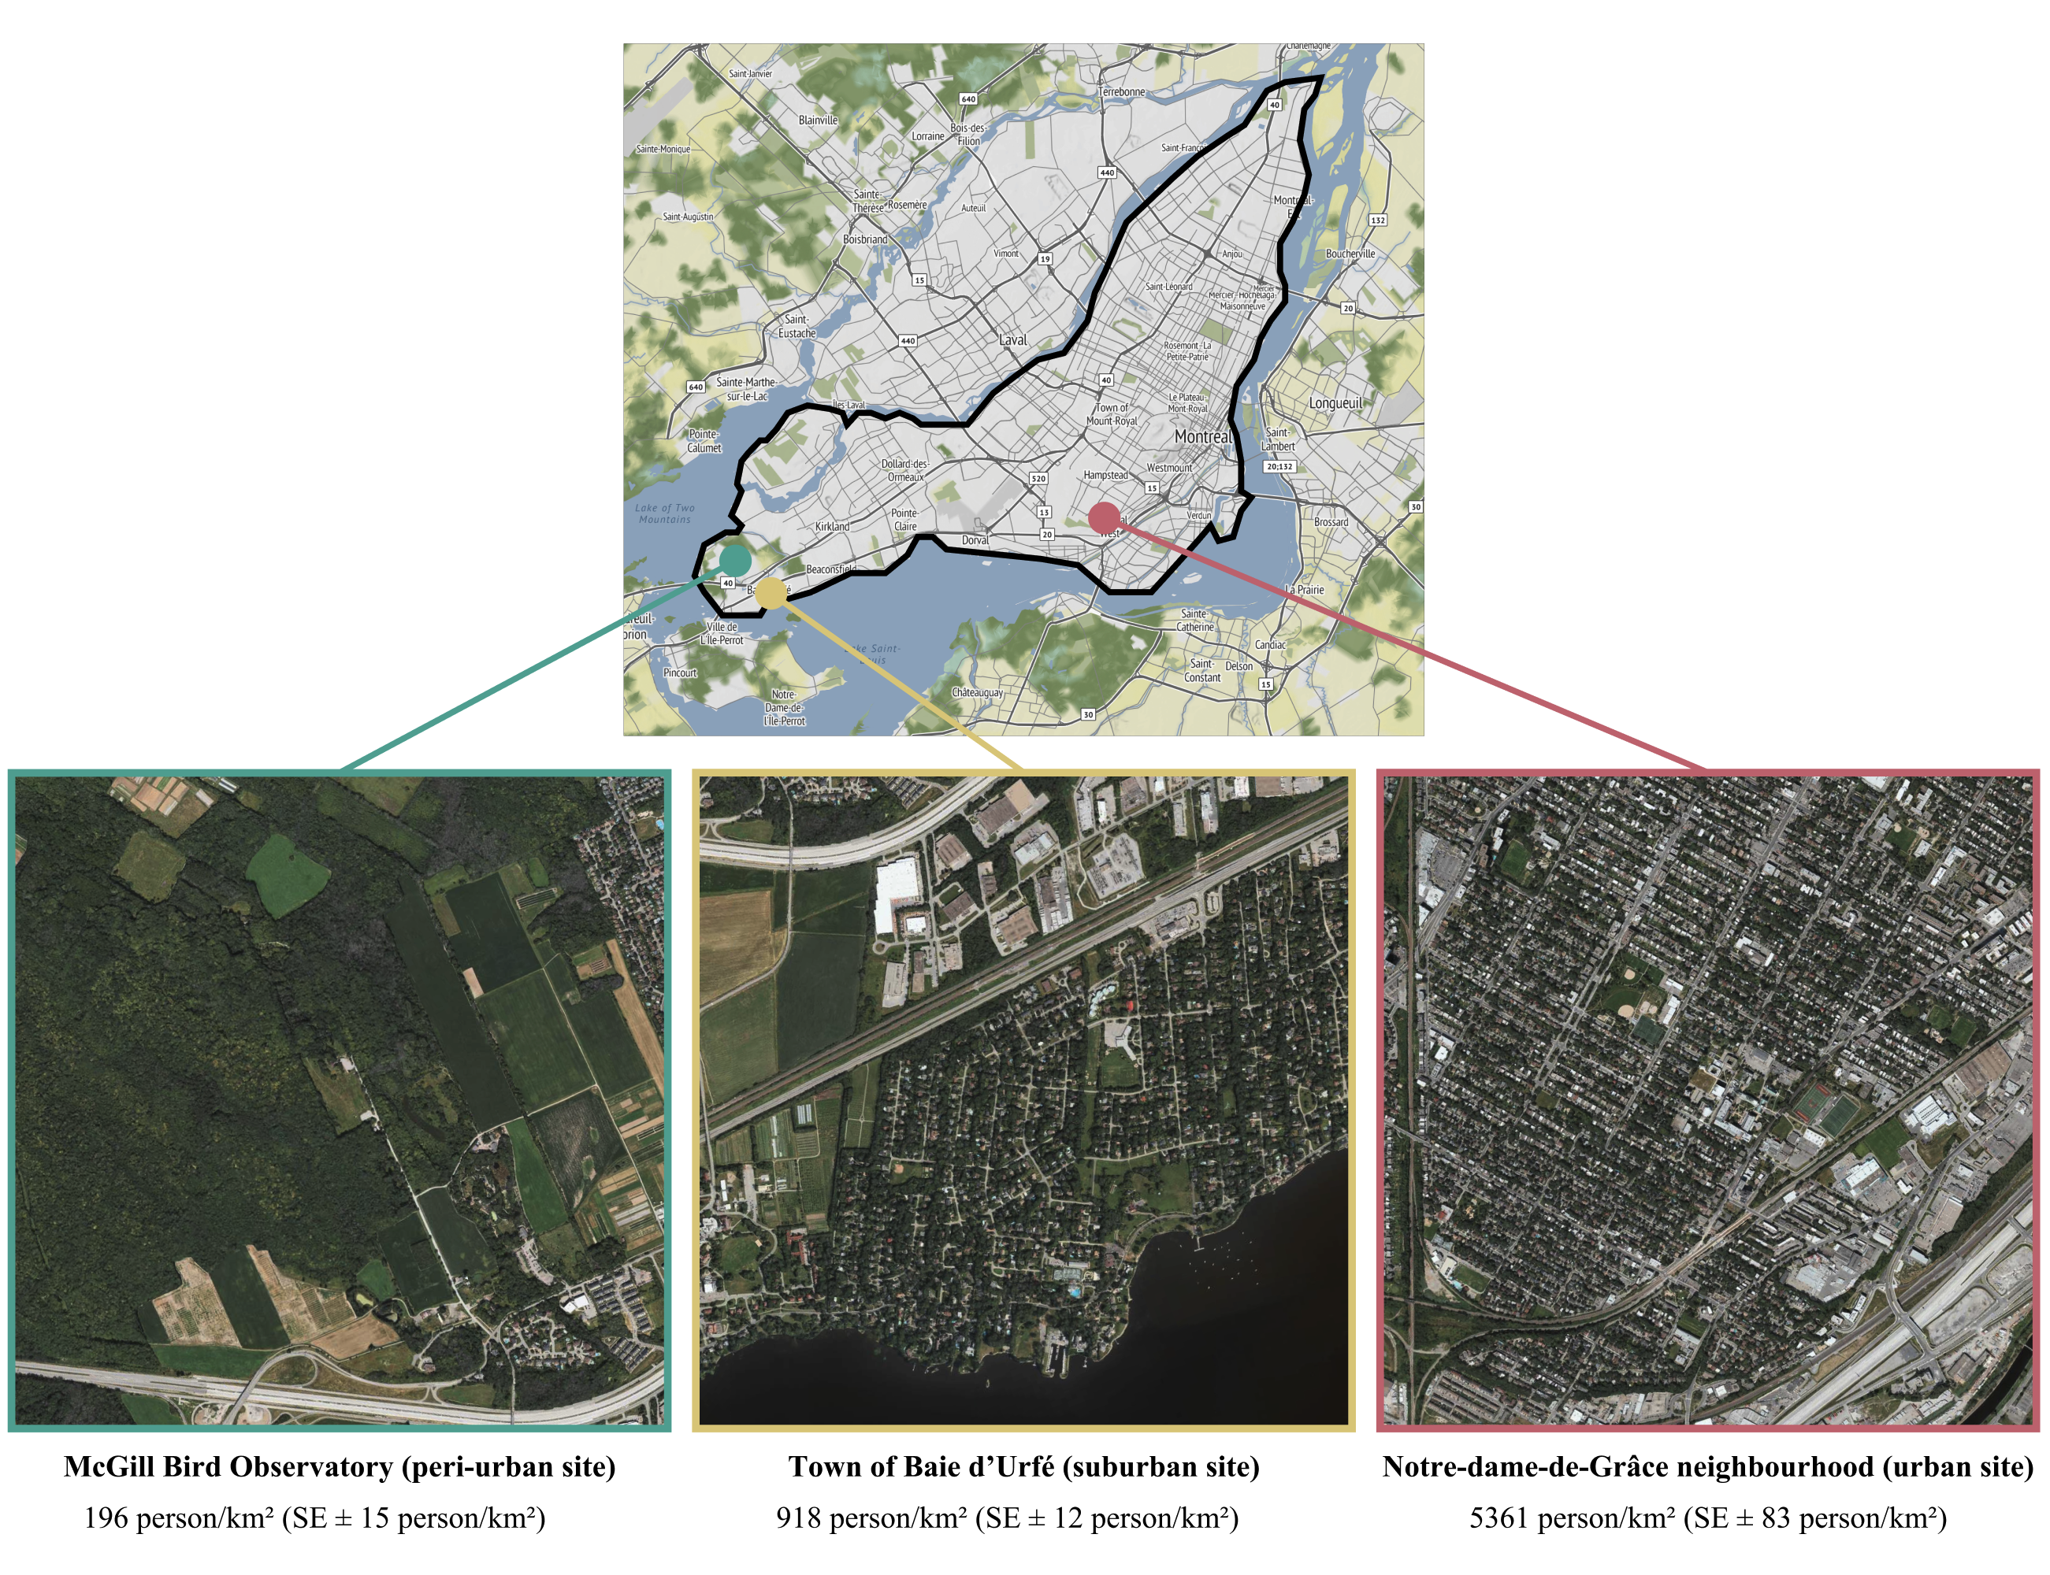
Figure 2. Study locations on the Island of Montreal A) The McGill Bird Observatory (MBO) served as the less urban location out of the three (2% of the area covered by streets and/or roads). It’s located in Sainte-Anne-de-Bellevue on the west side of the island. B) The residential area of Baie d’Urfé (BDU) served as an intermediately urbanized location (5% of the area covered by streets and/or roads). C) Concordia University (CON) in the Notre-Dame-de-Grâce neighbourhood served as the most urban location (13% of the area covered by streets and/or roads).
All translocation sites had a significantly different level of urbanization from one another (p < 0.001) based on population density data from the Cancensus packages, using census data from the Government of Canada for the year 2021. All three sites are characterized by relatively high levels of green space compared to the broader urban context of Montreal. As such, this gradient does not fully capture the extent of urbanization present across the entire city and should be interpreted as a localized urbanization gradient within predominantly green neighbourhoods, rather than a representative cross-section of the full urban-rural continuum.

Radio tagging, banding & translocation
We mist netted northern cardinals (males and females) at the MBO during October and November of the year 2022, 2023 and 2024. The birds were intercepted using 30 mm Japanese Nylon nets and placed in small cotton bags to reduce stress before handling. As part of the migration monitoring being done at the MBO, we banded the cardinals with a numbered aluminum band. The individuals were sexed, aged, weighed, and randomly assigned to one of the six possible release sites for translocation by car. In addition to the aluminum band, we fitted the cardinals with a set of heat-sealed coloured plastic bands, each with a unique combination of colours. This allowed visual identification of the individuals without having to resort to a radio tag receiver. Each bird was equipped with a Lotek NanoTag (NTQB-2) weighing 0.8 grams, using soft elastics in a figure 8 harness configuration (the total weight of the tag, harness, and glue was less than 3% of the cardinals’ body weight). All the radio-tags were registered as part of the Motus Wildlife Tracking System (Frei et al., 2024). Northern cardinals translocated to the MBO and BDU locations underwent a holding time of 45 minutes before release to standardize treatment amongst individuals. For the winter of the year 2022-2023 (winter 1), we were able to consistently track 20 birds at MBO, which served as a pilot winter to assess the feasibility of the project. During the winter of 2023-2024 (winter 2), a total of 45 birds were tagged and banded, with 15 individuals relocated to CON, 15 relocated to BDU and 15 relocated to MBO. In 2024-2025 (winter 3), a total of 42 birds were tagged and banded, with 5 individuals relocated to MBO, 16 individuals released in BDU and 21 individuals released at CON. Birds were banded under Animal Use Protocol 2007-5447 from McGill University and federal banding permits 10973, 10973B, 10973D issued by the Canadian Wildlife Service, and radio-tagged under Animal Use Protocol 22BF01 and 23BF01 from Environment and Climate Change Canada.

Non-breeding season tracking and home range estimations
During the first winter, only 2 automated receiver towers from the Motus network were deployed. The first tower is located at the MBO (4525’50.4”N 73˚56’18.6”W), while the second tower is located on top of a faculty building at McGill University’s Macdonald campus (45˚24’28.3”N 73˚56’20.3”W). For the second winter, those two towers were also used for continuous data location, with the addition of a third temporary receiver tower that we installed in BDU (45˚24’39.3”N 73˚55’48.3”W). Finally, during the third winter, a fourth, permanent Motus tower was installed on top of a building at Concordia University’s Loyola campus location (45˚27’32.6”N 73˚38’30.2”W).. We conducted manual radio tracking of each individual as often as possible (approximately once or twice a week) between the months of October and May using a set of portable receivers and antennae. Trackers would cover as much ground as possible at each study location with the goal of recording at least one GPS location for each individual per week using a Garmin ETREX 22x GPS. The portable receivers were either Lotek’s SRX800 or SRX1200. They were operated by setting the frequency to 166.380 MHz (Motus tags’ frequency for the Western hemisphere) and using both the gain and the signal strength to get as close as possible to the tagged individuals. The gain is a value between 0 and 100, representing the amplification of the received signal. By increasing it, the tracker increases how sensitive the receiver is to incoming radio signals. Higher gain values increase the ability to detect weaker signals but are also subject to background noise and interference. Using a lower gain reduces noise but may result in missing weak signals. In urbanized locations, the starting gain will rarely surpass 70-80 as the receiver picks up too much noise and interference. The signal is a value ranging from 0 to 200 for the SRX800 and 0 to 250 for the SRX1200. It represents the strength of the detected transmission from a radio tag, displayed in decibels (dB) on the receiver. A stronger signal indicates that the bird is closer; trackers use this information to estimate distance and direction. Trackers begin their tracking sessions with a gain of 80-70 to increase their chances of detecting nearby individuals. Once the receiver picks up a cardinal’s tag, the tracker moves toward the direction with the strongest signal. Once a threshold of 150 dB (SRX800) or 200 dB (SRX1200) is attained, the trackers then lower the gain by 10 and repeat this process until they reach the tagged individual. The trackers only record a GPS point if the signal strength is 150 or 200 dB, with a gain of 40 or less (the bird is considered close enough when those conditions are met). Once close enough to the bird, a few additional environmental measurements are collected.
For all three study sites, we calculated the average home range size using the Kernel Density Estimation (KDE), a non-parametric way to estimate the probability density function of a random variable based on a finite data sample (in the present case, the northern cardinal’s GPS location recorded in the field).
$$K\left(u\right)= \frac{1}{\sqrt{2π}}e^{-\frac{1}{2}u^{2}}$$
Where:
$K(u)$ is the kernel function evaluated at u, providing the weight assigned to a data point based on its distance to the target location.
$u= \frac{x-x_{i}}{h}$ is the standardized distance between the location x (where the density is being estimated) and the observed data point x_{i}, scaled by the bandwidth h.
h is the bandwidth parameter, which determines the smoothness of the resulting density estimate; smaller values of h lead to a rougher estimate, while larger values produce a smoother result.
$\frac{1}{\sqrt{2π}}$ is the normalization constant ensuring that the kernel integrates to one.
e is Euler’s number (approximately 2.718), the base of the natural logarithm.

Scale of effect
We first identified the scale of effect (i.e., the spatial extent at which landscape variables have the strongest relationship with a species’ response’) by extracting variables at four spatial scales (25, 50, 100, 200 meters; Martin & Fahrig, 2012). These spatial scales were chosen because they cover a wide range of possible scale of effect that are highly relevant in urban ecology, considering that habitat heterogeneity is scale-dependent. For each scale we ran generalized linear mixed models (GLMMs) at each study location using all five predictor variables as well as year, site, and individual ID as random effects. We ranked model using Akaike Information Criterion (AICc) values, which take into account small sample sizes (Burnham & Anderson, 2002). Once the scale of effect was determined for each location, we conducted a resource selection function.

Use-availability analysis
We compared ‘used’ vs. ‘available’ habitat using a resource selection function for northern cardinals during the non-breeding season and across an urban gradient. We used environmental and anthropogenic variables extracted from available spatial data as well that collected in the field. This included mean and standard deviation (SD) of vegetation height (1m resolution) from OpenForest (citation), distance to nearest bird feeder (collected through systematic field observations), population density data (census unit) using the Cancensus R package (vonBergmann & Jacobs, n.d.) and spatial data on the streets and road from the island of Montreal (VILLE DE MONTRÉAL, 2018). Unused locations were derived at a 1:1 ratio by creating random locations within 300 meters of the used location, at a random angle. For each study site, we ran a “Full model” (Used ~ Mean vegetation height + Sd vegetation height + Population density + Road length + Distance to nearest feeder + (1|Winter) + (1|Site) + (1|ID)), including all of the variables, plus the winter (years of sampling), relocation site and bird ID as random effects. The second model we ran was the “Vegetation height” model (Used ~ Mean vegetation height + (1|Winter) + (1|Site) + (1|ID)), assuming the vertical height of vegetation was a primary factor for decision making. The third model we ran was “Sd vegetation height” (Used ~ Sd vegetation height + (1|Winter) + (1|Site) + (1|ID)), in this case, we assume that the vertical composition was a more predominant decision-making factor compared to height on its own. The fourth model we ran was the “Human model” (Used ~ Population density + Road length + Distance to nearest feeders + (1|Winter) + (1|Site) + (1|ID)), which assumed that the cardinals would rely mostly on human-related cues to select a wintering habitat. The final model we ran was the “Null” model, including only the random effects variables (Used ~ + (1|Winter) + (1|Site) + (1|ID)). We then once again selected the best models according to the corrected Akaike Information Criterion (AICc). We used Variance Inflation Factor (VIF) to test for multicollinearity among predictor variables and Hosmer-Lemeshow as a goodness-of-fit test (Hosmer & Lemesbow, 1980). All statistical analysis were performed using Program R version 4.4.2 (R Core Team, 2024a).

Results
In 2022-2023, a total of 21 northern cardinals were released at MBO (peri-urban) with radio tags (including tags that were re-deployed upon retrieval following the death of individuals). In 2023-2024, 15 cardinals were released at MBO (peri-urban), 15 at BDU (suburban) and 15 at CON (dense urban) for a total of 45 northern cardinals across all three sites. In 2024-2025, 5 cardinals were released at MBO (peri-urban), 16 were released at BDU (suburban) and 21 were released at CON (dense urban) for a total of 42 birds across all three sites. Table X is detailing the number of cardinals we were able to track for each field season, along with the number of cardinals that died, and the potential causes for these deaths.

Table X Number of cardinals tracked 1 and 3 months after their initial release date, along with the number of individuals found dead and the most probable cause of death across three sites in Montreal, Quebec, Canada between 2022 and 2025.
Year | Site | Total number of cardinals | Number of cardinals tracked after 1 month | Number of cardinals tracked after 3 months | Number found dead | Probable cause of death
2022-2023 | MBO | 21 | 17 (81%) | 16 (76%) | 2 | Predation (n = 2)
2023-2024 | MBO | 15 | 13 (87%) | 9 (60%) | 3 | Predation (n = 2) Unknown (n = 1)
2023-2024 | BDU | 15 | 8 (53%) | 7 (47%) | 2 | Predation (n = 1)  Unknown (n = 1)
2023-2024 | CON | 15 | 4 (27%) | 2 (13%) | 1 | Window collision (n = 1)
2024-2025 | MBO | 5 | 4 (80%) | 3 (60%) | 1 | Unknown (n = 1)
2024-2025 | BDU | 16 | 11 (67%) | 11 (67%) | 2 | Disease (n = 1)  Predation (n = 1)
2024-2025 | CON | 21 | 7 (33%) | 4 (19%) | 2 | Predation (n = 1)  Window collision (n = 1)

Tracking of the cardinals was conducted 2 to 3 days per week by 3 people between October and May, for a total of ~288 days of tracking per winter. A total of 688 detections were recorded at MBO, 411 detections were recorded at BDU, and 265 detections were recorded at CON. The tracking team covered each time the maximum amount of ground possible during each outing, to record as many individuals as feasible. The total area covered at MBO is of approximately 4.75 km², the area covered at BDU is of approximately 5.94 km², and the area covered at CON is of approximately 18.35 km².

In southern Quebec, the northern cardinal population has seen a steep increase in abundance initiated around the 1970s. The same trends have been reported in southern Ontario, as shown in Figure X. This expansion of the northern distribution of the cardinal is largely attributed to the increase of people putting out bird feeders on their property, along with increasing winter temperatures, making it easier for the cardinals to remain in the northern part of their distribution range year-round.
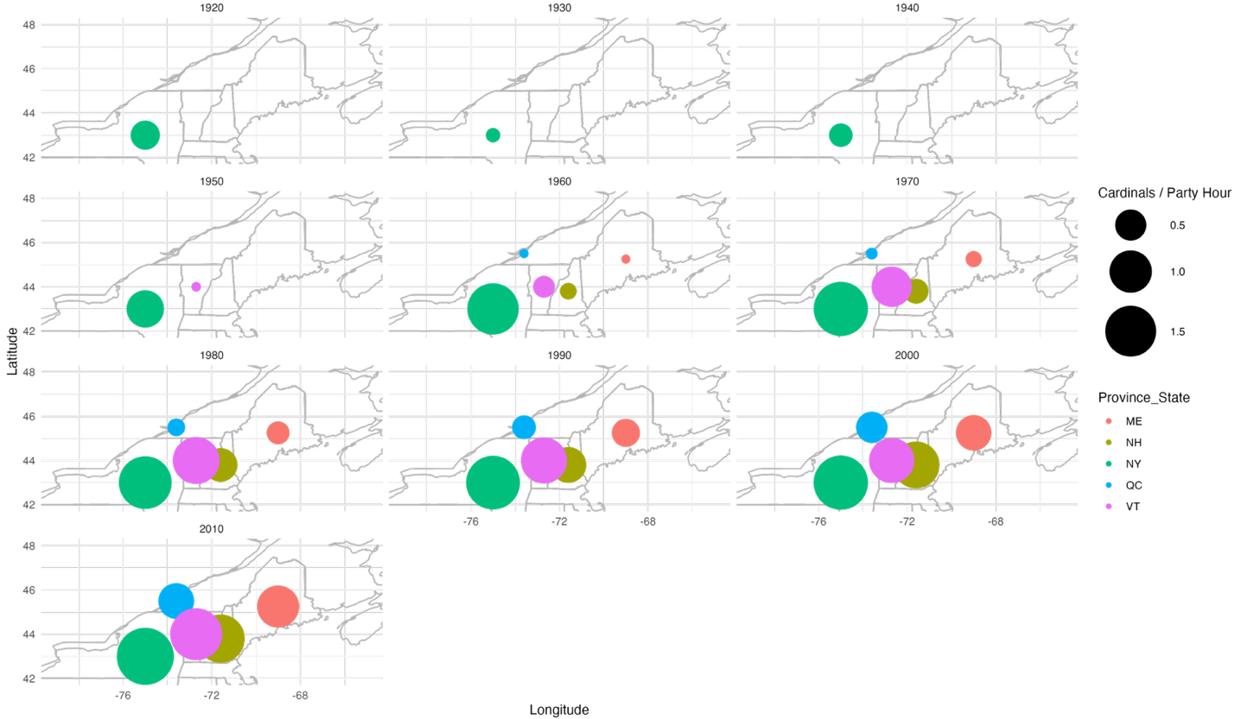Figure X. Number of northern cardinal observations per party hours between the 1920s and the 2010s according to state (United States of America) or province (Canada) as part of the Audubon Christmas Bird Count. As the years progress, we can see a steady increase in the number of cardinals reported in the United States and a propagation northward until it reaches southern Quebec in the 1960s. This figure highlights the steady increase of the cardinal’s northern distribution in Quebec during winter.
eBIRD FIGURE FOR WINTER VS SUMMER.
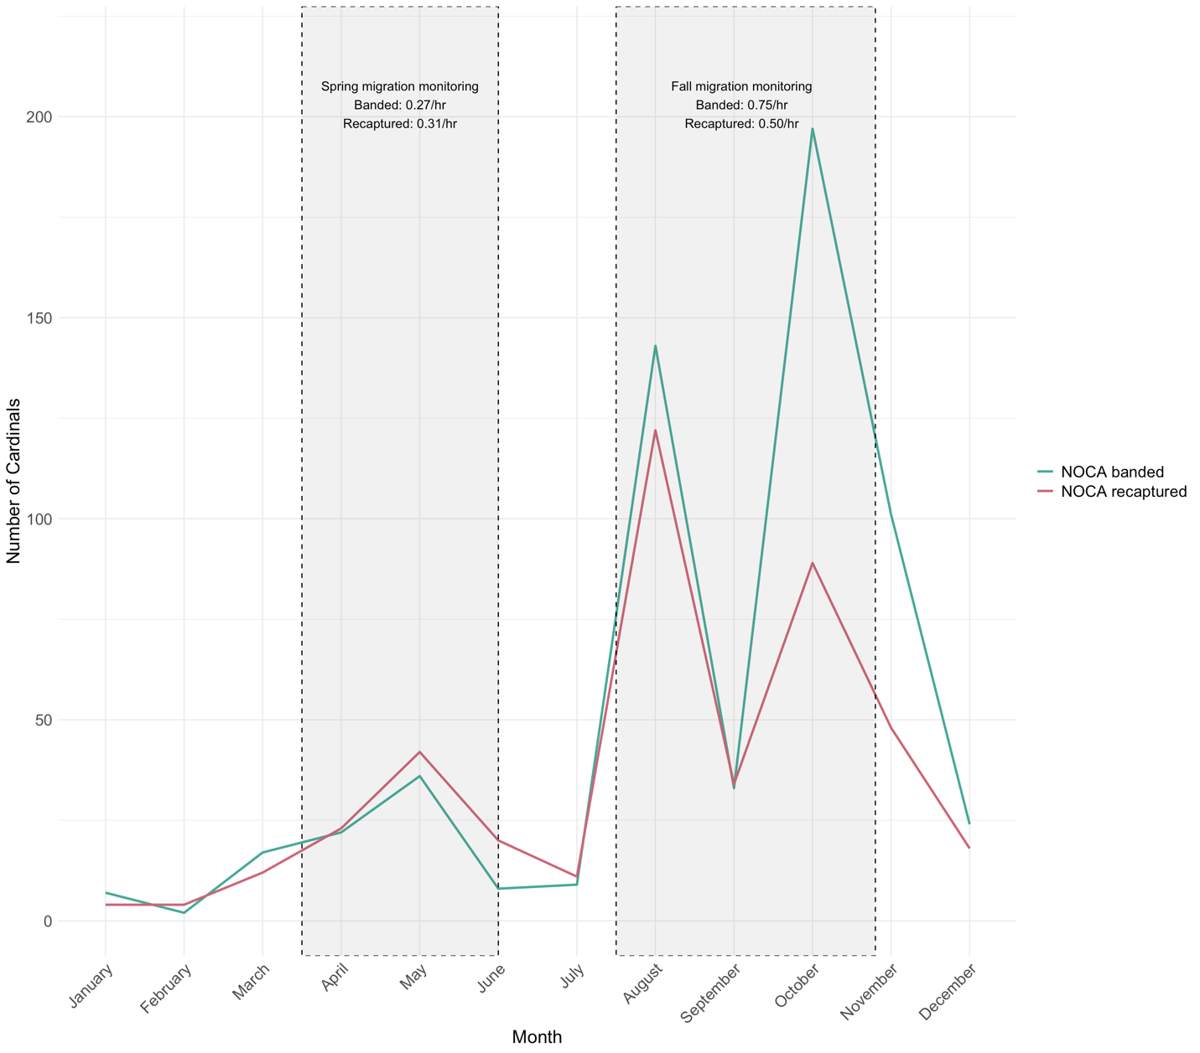
Figure X. Number of northern cardinal (NOCA) banded and recaptured at the McGill Bird Observatory between 2004 and 2022 in Montreal, Quebec, Canada. The grey boxes highlight both the spring and fall migration monitoring programs duration, along with the approximate number of cardinals banded and recaptured per hours of mist-net being opened during the season.

Core areas and home ranges
For all three locations, we calculated the KDE 50 % and 95 %, corresponding respectively to the core area where the bird spent most of its time, and to its total home range, including most of the areas visited in winter, excluding outliers (Figure 3). The cardinals wintering at MBO (least urbanized location, n = 35) had a core area (50 % KDE) averaging 0.15 ± 0.04 (SE) km², and total home ranges (95 % KDE) were on average 0.61 ± 0.13 km². Cardinals translocated to BDU (intermediate urbanization, n = 13) had on average, core areas of 0.08 ± 0.02 km² and total home ranges of 0.56 ± 0.11 km². Birds wintering at CON (most urban location, n = 9) had an average core area of 0.28 ± 0.11 km² while their total home ranges were 1.53 ± 0.52 km². Core and total home ranges sizes were not normally distributed (Shapiro-Wilk tests: core, W = 0.624, p < 0.001; total, W = 0.698, p < 0.001), so areas were transformed using a logarithm prior to analysis. After transformation, the data met assumptions of normality and variances were homogeneous. There was no significant difference in core home range size among sites, although the effect approached significance (ANOVA: F(2, 55) = 2.69, p = 0.077). Post-hoc comparisons show a trend towards the cardinals at our most urban location to have larger core home range sizes compared to the two other locations (Fig. X). There was a significant difference between sites regarding total home ranges (ANOVA: F(2, 55) = 3.45, p = 0.039). Post-hoc TukeyHSD comparisons showed that the only significant difference was between the total home ranges of cardinals at our most urban location being larger than those of the cardinals in our least urban location (mean difference = 1.24, 95% CI [0.09, 2.38], p = 0.031).
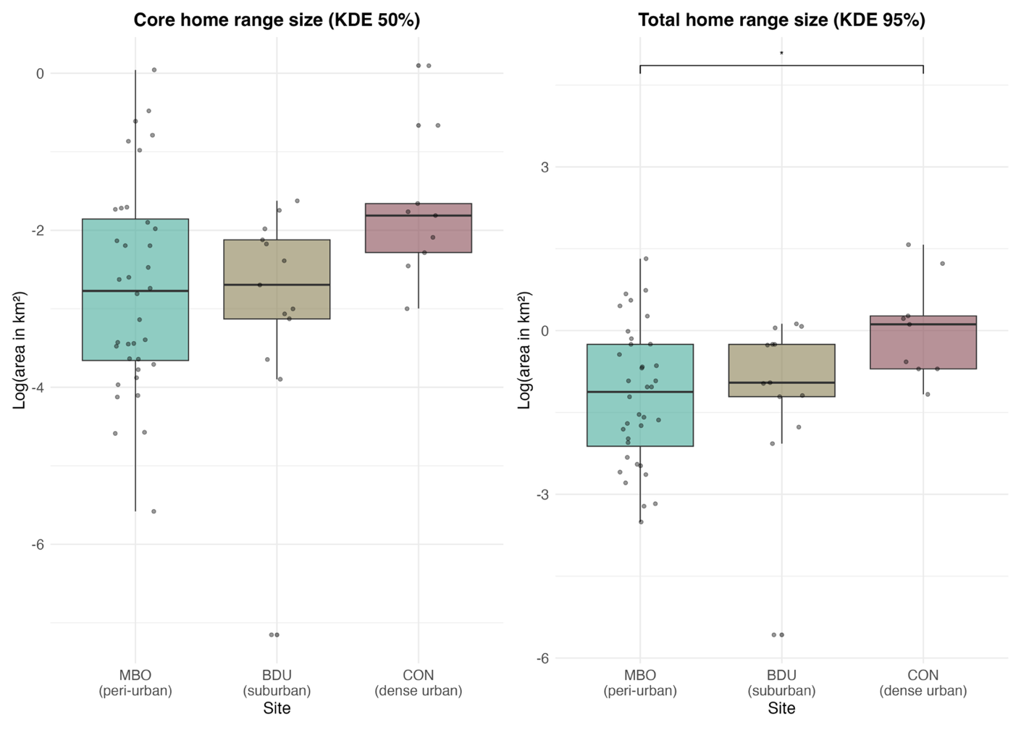
Figure X. Comparison of the core (KDE 50%) and total (KDE 95%) home ranges of northern cardinals in three study sites in Montreal, Quebec, Canada during winters between the years 2022 and 2025. The study sites are represented here as: McGill Bird Observatory – MBO, Town of Baie d’Urfé – BDU, Concordia University campus – CON. The area in km² was transformed using a logarithm.

Scale of association to habitat
The best model for the habitat selection scale of the cardinals relocated to MBO is the 50-meter model (> 10 Δ AICc values between all other models; Table X). For the birds translocated to BDU, the best model is the 25-meter one (> 10 Δ AICc values between all other models; Table 1a). Lastly, for the birds relocated at the most urban location (CON), the 25-meter model turned out to be the best (> 10 Δ AICc values among all other models; Table 1a).
Table X
Model ranking using AICc of generalized linear mixed models (GLM) with a comparing scale of effect of landscape variables for resighting locations (n= 57) the northern cardinals tracked across three sites in Montreal, Quebec, Canada.
Study site | Model | Variables | LL | Δ AICc | Wt
McGill Bird Observatory (peri-urban) | 25 meters  50 meters  100 meters  200 meters | Mean vegetation height + sd vegetation height + mean population density + road length + distance to nearest feeder | -722.48  -713.97  -735.69  -740.60 | 17.02  0.00  53.25  46.96 | 0.00  1.00  0.00  0.00
Town of Baie d’Urfé (suburban) | 25 meters  50 meters  100 meters  200 meters | Mean vegetation height + sd vegetation height + mean population density + road length + distance to nearest feeder | -296.05  -338.31  -344.25  -349.92 | 0.00  84.52  96.39  107.73 | 1.00  0.00  0.00  0.00
Concordia University (dense urban) | 25 meters  50 meters  100 meters  200 meters | Mean vegetation height + sd vegetation height + mean population density + road length + distance to nearest feeder | -211.09  -225.64  -224.02  -228.79 | 0.00  29.11  25.85  35.40 | 1.00  0.00  0.00  0.00

Resource selection: used vs. available habitats
Due to differences of urbanization level and scales of effect, resource selection function models were run separately for each study site. For the least urban site (MBO), the global model explained the most variation seen in the data (> 10 Δ AICc values between all other models, Table SX). For the suburban site (BDU), the top model was the human covariates model (human population and road density), with the next best model (full model) < 2AICc units from the top model (Table SX). Lastly for the dense urban site (CON), the full model was the top model, but again the next best (human covariates) was <1 AICc from the top model (Table SX).
Table X
Model parameters for the three resource selection models predicting the presence/absence of 56 northern cardinals within (25 or 50 m-radius) areas based on the average vegetation height (in meters) and its standard deviation, along with human-related environmental features such as population density (in people/km²), road length (in meters) and distance to the nearest bird feeder (in meters). The data was scaled and centered before running the models. The study site, year of sampling (Winter) and the individual’s identification (ID) are included as random effects in each model.
Study Site | Variable | Coefficient estimate | Standard error | z | p
McGill Bird Observatory (peri-urban) | Global model – 50 meters  Mean vegetation height (m)  Standard deviation of the mean vegetation height  Mean population density (person/km²)  Road length (m)  Distance to the nearest bird feeder (m) | -1.272  1.107  -0.095  0.023  -0.347 | 0.153  0.114  0.111  0.110  0.068 | -8.329  9.709  -0.858  0.207  -5.067 | <0.001  <0.001  0.391  0.836  <0.001
Town of Baie d’Urfé (suburban) | Human covariates model – 25 meters  Mean population density (person/km²)  Road length (m)  Distance to the nearest bird feeder (m) | -0.486  1.238  -0.427 | 0.135  0.136  0.128 | -3.603  9.138  -3.342 | <0.001  <0.001  <0.001
Concordia University (dense urban) | Global model – 25 meters  Mean vegetation height (m)  Standard deviation of the mean vegetation height  Mean population density (person/km²)  Road length (m)  Distance to the nearest bird feeder (m) | 0.252  -0.458  -0.212  0.736  -0.392 | 0.180  0.191  0.131  0.135  0.141 | 1.399  -2.405  -1.620  5.438  -2.772 | 0.162  0.016  0.105  <0.001  0.006

The prediction plots including only the significant fixed effects for the resource selection functions of each locations reveal that the presence of cardinals is associated with different urban and habitat features according to the site they spend their winter in (Fig. X). In the peri-urban site (MBO), the probability of presence of the cardinals decreases as the mean vegetation height increases (Fig. X, A), while the presence of the birds increases with greater variability in vegetation height (Fig. X, B). The probability of presence of the cardinals also seems to decrease as the distance to the nearest bird feeder increases (Fig. X, C). In our suburban location (BDU), the probability of presence of the cardinals shows little relationship with population density (Fig. X, D), but increases as the mean road length increases (Fig. X, E). Like our least urban site, the presence of the birds also decreases as the distance to the nearest feeder increases (Fig. X, F). In the dense urban site (CON), the cardinals’ probability of presence decreases with increasing vegetation height standard deviation, although uncertainty is high (Fig. X, G). The presence of the cardinals also increased with mean road length and decreased with the distance to the nearest feeders. Across sites, proximity to feeders and structural complexity of the infrastructures or the vegetation consistently influenced the probability of presence, yet specific relationships varied.
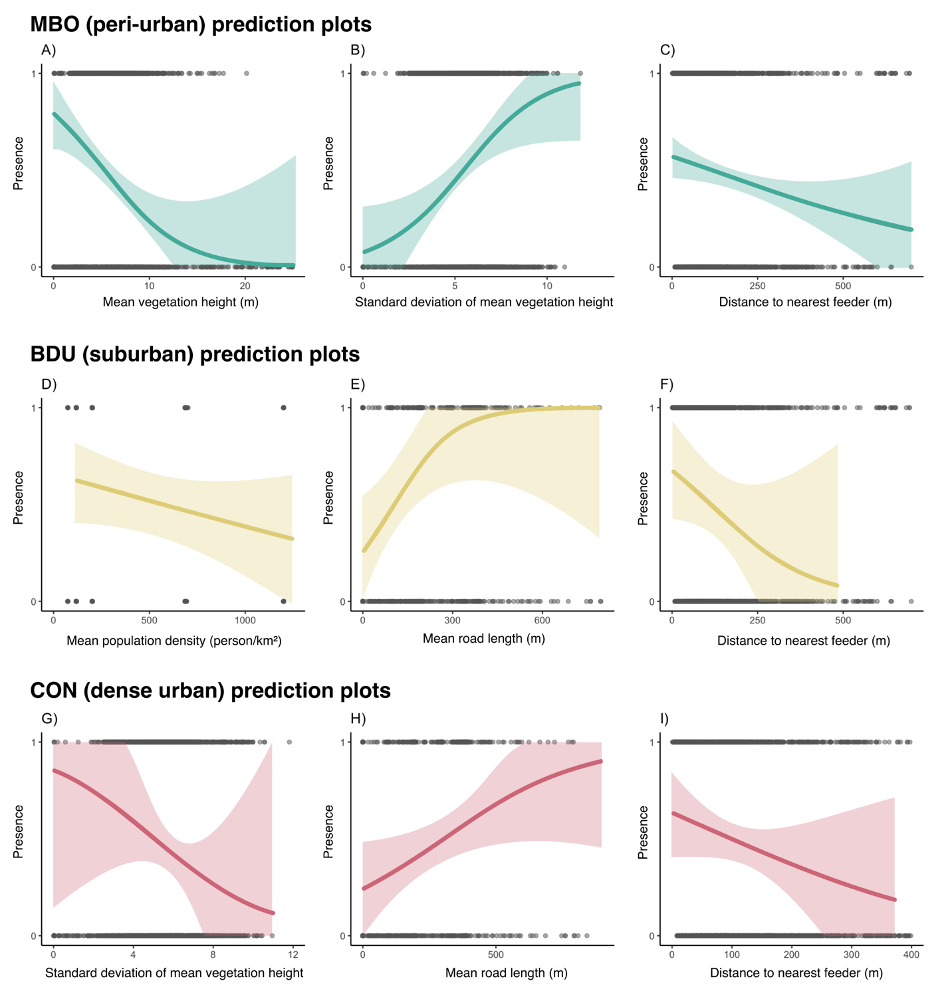
Figure X. Probability of presence of northern cardinals in a given radius area, as predicted by a generalized linear mixed effects model. Shaded areas represent 67% confidence intervals around the predicted probabilities. The model’s fixed effect variables are described in Table 1b, and for each model, random effects were sampling years, translocation site and bird ID.

Discussion
TO BE DELETED…
The variation in the cardinal’s home range size highlights the influence of urbanization on the birds’ use of space in winter. Individuals spending winter in our most urban location (CON) had substantially larger total and core home ranges (KDE 95% and 50%, respectively), compared to the birds that spent their winter in a less urbanized location (BDU) or a peri-urban location (MBO) (Fig. 3). This pattern suggests that the northern cardinals spending the winter in highly urbanized locations may need to traverse greater distances to meet their ecological and/or energetic needs. This could result from a more intense spatial fragmentation as urbanization increases (citation?). Conversely the smaller home ranges obtained at both MBO and BDU suggest that more continuous and resource-rich green spaces could enable the cardinals to fulfill their basic requirements with a more restricted area. Variability in home range size was lowest at the least urban site (MBO), suggesting a more consistent habitat use potentially reflecting an environment with reliable food sources and sheltering opportunities (citation?). These results align with broader urban ecology literature, suggesting that species thriving in urban areas may exhibit increased movement and space use plasticity to compensate for scattered resources in a fragmented landscape (ADD REFERENCES). Importantly, the larger home ranges in urban settings may come with energetic and survival costs, with implications for winter ecology and conservation strategies aimed at maintaining bird populations in increasingly urbanized landscapes.

At MBO, the cardinals showed a more pronounced positive association for areas with generally lower vegetation (A) and greater structural heterogeneity (B), as reflected by the negative association with mean vegetation height and its standard deviation. This preference could suggest that northern cardinals prefer to use habitats that are vertically complex, yet still mainly composed of shrubs, providing shelter and foraging opportunities. This is not surprising as cardinals are known to favour habitats corresponding to those criteria. In addition, the presence probability drops as the distance from the nearest feeder increases (C), emphasizing the role of supplementary feeding as a reliable food source in this less urbanized location. In contrast, selection patterns in the moderately urbanized BDU site seem to revolve mainly around human-related variables, and less so around the vegetation variables. Here, cardinals tended to avoid areas of high population density (D), while showing a preference for longer road lengths (E), a counterintuitive pattern. This might be reflecting an indirect association with edge habitats or corridors, often seen with suburban street planning. We considered the potential bias that could be induced by recording the GPS locations of the birds from the side of the streets. To assess this issue, the statistical analyses were run on both the unshifted location data and the shifted points, and the resulting model selection remains unchanged. This confirms the robustness of the method used to record cardinal location. The highly urbanized location of CON showed yet another distinct pattern of habitat use. Cardinals were less likely to occupy areas with strong vegetation vertical heterogeneity (G), a pattern opposite to what we’re seeing at MBO. This could indicate a certain avoidance of fragmented, or lower quality patches, in a context where vegetation is already scarce and patchily distributed through the landscape. In addition, the probability of selection increased with road length (H), suggesting that the limited access to vegetated habitats comes with the necessity to navigate along urban features such as roads. Finally, the presence of northern cardinals declined as the distance to the nearest bird feeder increased, highlighting the potential dependence on anthropogenic food resources in highly urbanized areas, where more natural foraging opportunities may be insufficient. Collectively, these findings highlight the context-dependent nature of habitat selection by northern cardinals, suggesting that behavioural flexibility may play a role in their persistence in urban environments through the winter. The varying importance of vegetation structure, anthropogenic disturbances and proximity to supplemental food indicates that conservation strategies for winter birds must be tailored to the local urban context. In less urbanized areas, maintaining large vegetation patches with a complex vertical structure is likely essential, while in urbanized locations, providing access to supplemental food and mitigating the negative impacts of fragmentation may be more critical for sustaining northern cardinals (and potentially other resident bird species) populations during the winter season.

NEW DISCUSSION
Using three years of telemetry tracking data of Northern Cardinals across an urban gradient during the non-breeding season, wefound evidence that cardinals in denser urban locations had significantly larger home ranges compared to those in suburban and peri-urban sites. Comparatively, the spatial scale of habitat use by cardinals was consistent across the urban gradient and occurred at a relatively at a fine scale (25-50 m). Significant vegetation and anthropogenic predictors of cardinal presence differed across the urban gradient, suggesting that ecological needs and drivers of winter survival by cardinals in human-modified landscapes may be context-dependent (peri-urban vs suburban vs urban. Apparent survival of cardinals during the harshest period of their annual cycle appears fairly similar between peri-urban and suburban sites, while mortality or relocation was threefold higher in the urban site. We found that cardinals in suburban and urban sites do not spend time in parks or other larger public green spaces during the non-breeding season, instead favouring the private urban green spaces such as private backyards and gardens, and are strongly associated with the presence of anthropogenic food resources (i.e., birdfeeders).s.

Larger home ranges and supplemental feeding
Although we did not find a significant difference in home range size when looking at core home ranges (KDE 50%), we did see a trend towards core home ranges being larger in our most urban location. However, we did see a significant difference when investigating total home ranges (KDE 95%), where the cardinals at our most urban location appeared to have larger home ranges compared to their peri-urban counterparts. These results oppose what has been previously found in house sparrows where individuals in urban landscapes occupied smaller home ranges compared to their rural counterparts (Vangestel et al., 2010). O’Donnell (2020) also suggested, that generally, birds in urban environments tend to have smaller home ranges. However, regarding cardinals specifically, research from 2008 focusing on extraterritorial movements of female cardinals, found that during the breeding period, females ventured out of their territory more often when they had supplemental feeding, compared to females that didn’t have access to supplemental food (Humbird & Neudorf, 2008). And while the authors did not find a statistically significant difference in the females’ home range sizes, they did see a trend towards supplemental fed females to have larger home ranges (Humbird & Neudorf, 2008). A similar process could be at play here, with the cardinals spending winter in urban areas, having access to supplemental feeding through bird feeders, are able to explore more and spend time outside of their habitual home range.
Across all our study sites, the cardinals were more likely to occupy a specific area with bird feeders were present. Research on the European turtle dove showed that the larger home ranges were more likely to contain see-rich habitats, potentially suggesting that they were willing to travel further to access high quality food sources (Dunn et al., 2021). The trends we’re seeing with the northern cardinals could support the idea that during the rough winter conditions, the birds are willing to move on greater distances to acquire high quality food items, mainly available through bird feeders.

Small scale of association to habitat regardless of urbanization level
We found that northern cardinals are associated with habitat features at different spatial scales depending on the level of urbanization of their wintering site: 50 meters in our least urban site, and 25 meters in both our suburban and dense urban locations. This pattern suggests that as soon as human presence is more pronounced in the landscape, cardinals rely more heavily on immediate habitat factors (possibly due to increased fragmentation and reduced availability of high-quality habitats at broader scales). This aligns with broader research on animal species, suggesting that the magnitude and direction of species’ responses to urbanization reflects landscape-scale differences within cities (Fidino et al., 2021). Moreover, recent work on migratory birds passing through urban areas via stopover sites highlighted the value of multiscale habitat assessment since different processes can come into play at different spatial resolution (Guo et al., 2023). Our findings showing that cardinals respond to finer spatial scales in more urbanized areas also support evidence that urban green space size and configuration matter—especially in cities where small patches may play a critical role to support bird populations (Dale, 2018). Thus, we want to underscore the importance of scale-sensitive, species-specific approaches when evaluating habitat use in urban areas and join other researchers in suggesting that conservation efforts in urbanized environments may need to focus on fine-scale habitat quality to support resident species year-round (Guo et al., 2023; Litteral & Shochat, 2017).

Variation of preferred habitat factors across an urbanization gradient
NEXT THING ON MY TO-DO LIST!
This study provides new insights into how a resident songbird species, the northern cardinal, adapts its movement and habitat selection patterns in response to varying levels of urbanization during the non-breeding season. By combining spatial movement analyses with fine-scale habitat selection models across three sites with varying levels of urbanization, we demonstrate that cardinals seem to exhibit both behavioural plasticity and context-dependent responses to urban landscape features. Larger home ranges in highly urbanized areas suggest increased energetic costs, likely driven by fragmented habitats and sparse natural resources. In contrast, smaller and more consistent home ranges in less urbanized environments reflect a more stable and resource-rich context for the cardinals. Habitat selection varied quite considerably across sites: in peri-urban areas, cardinals favoured structurally complex vegetation and proximity to feeders, while in urban areas, reliance on anthropogenic features was more evident. These findings highlight the importance of flexible behavioural strategies in enabling some species of birds to persist in human-modified environments. From a conservation perspective, we argue that this work emphasizes the importance, in urban environments, to tailor local management efforts to the context they’re in. As urban areas continue to expand globally, understanding such fine-scale responses will be critical for informing urban planning and ensuring a year-round support of our native bird species.

Chapter 2: Northern cardinals (Cardinalis cardinalis) exhibit seasonal changes of onset and end of daily activities in urban areas

Abstract

Introduction
Animal activity budgets are critical to their fitness. Foraging behaviour, predator avoidance and thermoregulation are all examples of daily activities an animal must balance to survive (Elliott et al., 2009; Majchrzak et al., 2022; Sumasgutner et al., 2023; Visscher et al., 2018). Both birds and mammals face the opportunity costs of behavioural thermoregulation (i.e. retreat to cooler microhabitats during a heat wave can limit access to profitable food patches) (Cunningham et al., 2021). Another example comes from wintering great tits (Parus major) in southern Sweden showing that the birds with access to predictable food were able to maintain lower body temperatures when subjected to an immune challenge (Watson et al., 2023). The same individuals were also able to revert back to their body temperature baseline in a shorter amount of time compared to great tits that didn’t have access to a predictable food source (Watson et al., 2023). In cities, species must adjust their daily activities in response to human-altered landscape, and activity budgets are an interesting metric to examine how wildlife respond to urbanization (Gumilyov et al., 2023; Tian et al., 2022). Efficient energy budget management can help counteract the negative effects of costly behaviours. An example of such is well illustrated by northern gannets (Morus bassanus) showing that the energetic benefits of foraging in the Gulf of Mexico during the winter, well outweighs any negative consequences of the longer-distance migration compared to conspecifics who opt for a different migratory route (Pelletier et al., 2020). Urban environments often result in animals having to change the timing of their activities in response to factors like noise, artificial lighting at night, human presence and landscape alterations. A striking example of the quick temporal scale at which those changes can occur comes from Spain following COVID-19 lockdown measures, when birds were more detectable (and thus more present) in urban areas, in the early morning (Gordo et al., 2021). This rapid change in behaviour could be driven by the quieter mornings in a usually crowded city (Gordo et al., 2021). In Europe, some early foragers advanced their onset of foraging time following exposition to artificial lighting (Silva et al., 2017). In Germany and Portugal, common woodpigeons (Columba palumbus) had varying time-budgets between seasons with less foraging time in winter compared to the breeding season (Masello et al., 2023). Yet interestingly, woodpigeons allocated more time to foraging in urban areas compared to their forest counterparts (Masello et al., 2023).

ADD PARAGRAPH TOPIC SENTENCE. Similarly, long-term phenomenon such as climate change are expected to have effects on animal behaviour, particularly in temperate regions in which seasonality plays a crucial role in daily activity patterns. Climate change is already affecting the North American winter season through warmer mean temperatures and warmer cold extremes (Blackport, 2024). It’s also leading to increasingly unpredictable weather conditions in a season that already requires a tight management of energetic resources of birds (Blackport, 2024). However, even if winter is considered to be a critical time for resident passerine species’ survival , this part of their life cycle tends to be understudied, and there are still a lot of unanswered questions surrounding winter ecology in temperate regions as a broader field (Studd et al., 2021; Sutton et al., 2021).

Fine-scale (every few seconds or minute) daily activity in free-ranging birds can be tracked via the Motus Wildlife Tracking System, an extensive network of automated VHF receiver stations deployed across North America and beyond (Birds Canada, 2025). Motus tags are ultra-lightweight radio transmitters (as low as ~0.3 g) attached to wild animals, with receiver stations that can continuously record tag IDs, timestamps and signal strength for each antenna whenever individuals are within range (approximately 15 km in ideal conditions). Variability in signal strength, indicates the onset and end of a bird’s daily movements (Beauchamp et al., 2020). Variation in Motus signal strength allows for continuous, precise monitoring of daily activity of songbirds, which is critical to understand how birds respond to environmental challenges.

Small, resident songbirds adjust their daily activities throughout winter to balance energy expenditure. Such adjustments may be particularly important in cities, where both climatic and anthropogenic pressures are rapidly changing. The northern cardinal (Cardinalis cardinalis) is a year-round resident throughout much of the eastern North America. Cardinals do not use torpor, but decrease body temperature slightly in winter, which could lead to a 10-16 % saving in daily energy expenditures (Schaeffer et al., 2015). Research on the northern shrike (Lanius borealis) showed that the resting metabolic rate (RMR) measured in winter was 50% higher than the RMRs gathered from summer shrikes (potentially the result of winter acclimatization) (Paruk et al., 2015). EXPAND ON HOW YOU THINK ACTIVITY BUDGETS CHANGE IN WINTER FOR CARDINALS
Here, we investigate how cardinals adjust the onset and end of their daily activities during winter. We studied cardinals across an urban gradient (Chapter 1) using Motus receiver stations. This study has three objectives: (i) investigate the effect of climate on the timing of onset and end of activity of the cardinals, (ii) characterize the influence of temperature lag on the onset and end of activity, (iii) investigate how cold snaps (sudden, marked temperature drops) affects the onset and end of activity of the birds.

We predicted that the cardinals would delay their daily onset of activities relative to sunrise as daily temperature decreases, reflecting a negative relationship between daily temperatures and the time cardinals begin their day. Moreover, we expect severe cold temperatures to have a lagging effect on both the onset and end of activity relative to sunrise and sunset, with cardinals starting their daily activities later, while ending their activities earlier for a few days following the cold temperature. Thus, we expect a negative correlation between the temperature lag and the duration of the daily activities of cardinals. Finally, we also expect the cardinals to have later onset and earlier end of activities on days when a cold snap occurs, such that cardinal activity will be negatively correlated with those sudden temperature declines.

Materials and methods

Study site and Motus receiver stations
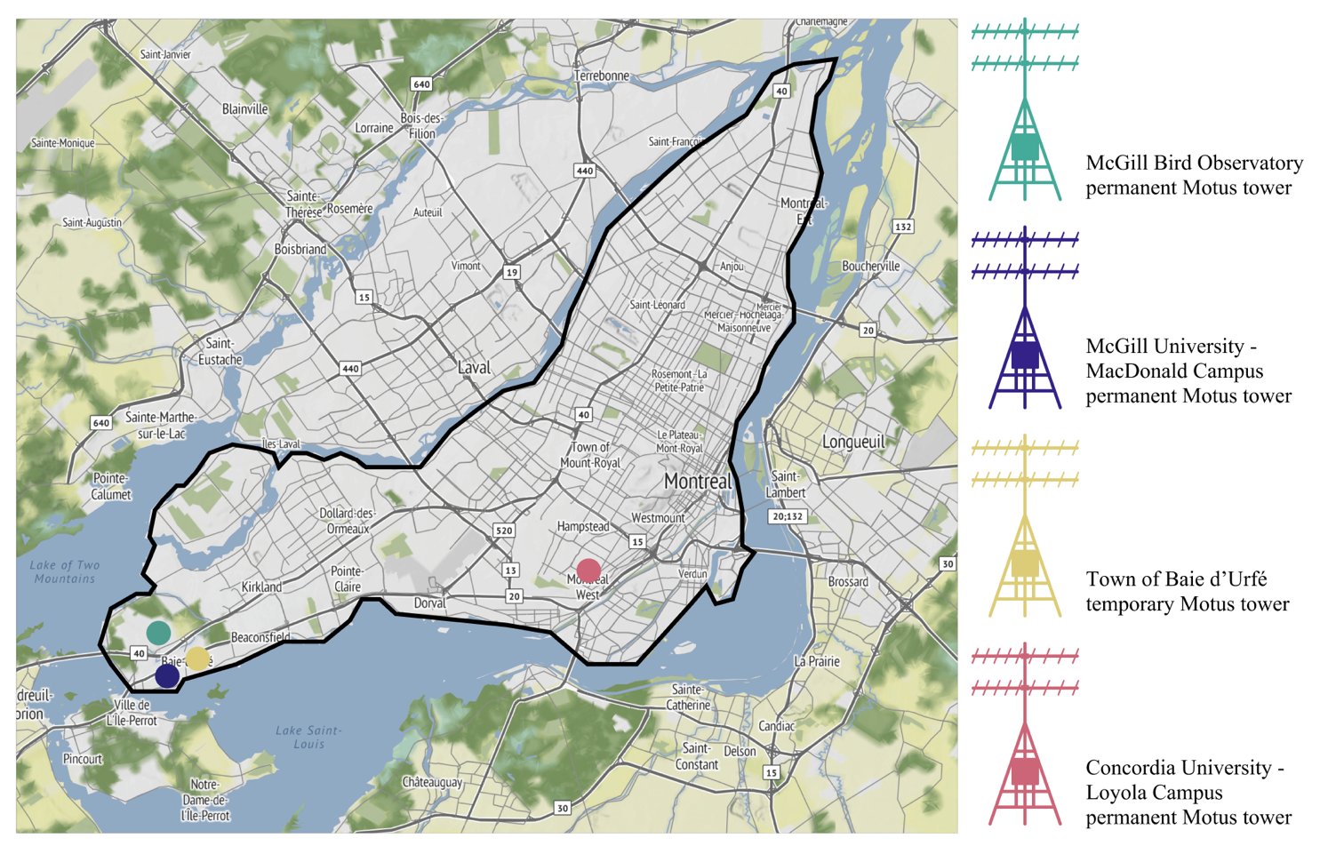
Like chapter 1, this project was done entirely on the island of Montreal, in three locations with varying levels of urbanization. Continuously monitoring the cardinals’ movement required the installation of portable and permanent Motus receiver stations. The first Motus tower that we used is located at the McGill Bird Observatory (MBO) and has been deployed in 2015 (45˚25’50.4”N 73˚56’18.6” W). This tower is permanently installed at the banding station and has continuously been collecting data since its installation (meaning it collected data across all three winters of data collection for this project, between 2022 and 2025). The second Motus tower used for this project is also a permanent one, installed on the roof of a building from the McGill University MacDonald campus, deployed in 2018 (45˚24’28.2”N 73˚56’20.3”W). This receiver station was also collecting data through the entirety of the project. The third tower is in the Town of Baie d’Urfé (BDU) in a residential backyard (45˚24’39.3”N 73˚55’48.3”W). This tower was deployed temporarily for the duration of this project only. Because the first winter served as a pilot project and cardinals were only tracked at MBO, the BDU tower was deployed in October 2023 and stayed active until May 2024, before being dismantled and re-deployed in October 2024 until May 2025. Finally, the last tower deployed for this project is located on the roof of a building at the Concordia University Loyola campus (45˚27’32.7”N 73˚38’30.2”W). This tower is permanently deployed, however the process of having such a device installed on a tall building in this urbanized part of Montreal was logistically challenging, which is why this tower was only deployed during the last winter of data collection, which started in October 2024.
Figure X. Location of the Motus towers deployed between 2015 and 2025 on the island of Montreal, Quebec, Canada.

Radio tags deployment and Motus data download
We mist netted northern cardinals (males and females) at the MBO during October and November of the year 2022, 2023 and 2024. The birds were intercepted using 30 mm Japanese Nylon nets and placed in small cotton bags to reduce stress before handling. The individuals were sexed, aged, weighed, banded and randomly assigned to one of the six possible release sites (two sites at MBO, two sites in the Town of Baie d’Urfé and two sites at the Concordia University) for translocation by car. Every cardinal was equipped with a Lotek NanoTag (NTQB-2) weighing 0.8 grams, using soft elastics in a figure 8 harness configuration (the total weight of the tag, harness, and glue was less than 3% of the cardinals’ body weight). All the radio-tags were registered as part of the Motus Wildlife Tracking System (Frei et al., 2024). The protocol used for the translocation of the birds, and the sample size at each location is described previously in chapter 1. Birds were banded under Animal Use Protocol 2007-5447 from McGill University and federal banding permits 10973, 10973B, 10973D issued by the Canadian Wildlife Service, and radio-tagged under Animal Use Protocol 22BF01 and 23BF01 from Environment and Climate Change Canada. Upon release, the data from all four Motus towers were regularly downloaded and uploaded to the Motus Wildlife Tracking System portal. The data collected through the three consecutive winters of cardinal tracking were used to determine change point times (onset and end of activity) for all the individuals successfully detected by the Motus receiver towers.

Change point analysis
The onset and end time of diel activity was determined using radio telemetry data collected by the Motus station deployed throughout the Montreal area. Proximity to receiving antenna, transmitter orientation, and environmental obstructions can affect received signal strength, causing high signal strength variation when a tagged individual is active and low signal strength variation during periods of inactivity. Changes in signal strength variation can then be used to determine when a bird becomes active in the morning and quiescent in the evening. Following Morbey et al. (2020), we applied change point analysis to extract the time of activity onset and end based on the characteristic increase and decrease of signal variation respectively. Change points in signal variation were determined using the package “changepoint” in R ver. 4.4.2 (R Core Team, 2024b), for the six-hour period centered on local sunrise for activity onset and sunset for activity end (Killick & Eckley, 2014). Sunrise and sunset times were determined for Montréal using the function getSunlightTimes in the package “suncalc” (Thieurmel & Elmarhraoui, 2022).

Unlike previous studies, we extracted activity change points using the combined dataset from multiple stations across the study region. As signals are received near-simultaneous on any stations within range, changes in the variability of received signal strength can be perceived across multiple stations in the same instance. Using the combined regional dataset allowed us to determine activity change points without needing birds to stay within detection range of single focal station or needing to analyse activity data from multiple stations separately. The study region was defined to include all station within the Montréal area, extending from latitudes 44.9655°N to 46.1320°N and longitudes -74.2796°E to -71.9254°E.

Change points were extracted for each day a bird was in the study area by first de-trending values of signal strength (sig) by taking the first differences (d_{i} = sig_{i} - sig_{i-1}, for observation i) for each antenna on each station included in the study area. Values of d among all unique antennas were then pooled and sorted by timestamp, after which the square-root of the absolute value of d (sqrt(|d|)) was calculated. This process reduces the major difference in sig among the receiver antennas as well as difference in signal strength from station proximity as birds move throughout the study region. Square root transformation emphasises the difference in the mean and variance of sig between activity states, further demarcating the change in activity pattern (Morbey et al., 2020).
Using separate automated process for the onset and end of activity, we first filtered any onset or end periods with fewer than 800 detections total to exclude periods with poor signal coverage. The function cpt.meanvar was then used to extract a single change point time (cpt) in the mean and variance of sqrt(|d|) within the six-hour period surrounding sunrise or sunset, specifying an asymptotic penalty value of 0.001 and a minimum segment length of 20. These parameters performed well to reliably identify the transition between activity states. For most change points, mean sqrt(|d|) was < 1 before the cpt and > 0.5 after the onset of activity, and mean sqrt(|d|) ranged between 0 and 2 before the cpt and < 1.5 after for the end of activity.

Post cpt extraction, filtering was conducted to exclude questionable change points, attributable primarily to gaps in the detection record. For activity onset change points, we removed any with a pre-cpt mean sqrt(|d|) > 1, post-cpt mean sqrt(|d|) < 0, a pre-cpt mean sqrt(|d|) > post-cpt mean sqrt(|d|), or a pre-cpt variance sqrt(|d|) > post-cpt variance sqrt(|d|). For activity end change points, we removed any with a pre-cpt mean sqrt(|d|) > 0.25, a post-cpt mean sqrt(|d|) > 1, a pre-cpt mean sqrt(|d|) < post-cpt mean sqrt(|d|), or a pre-cpt variance sqrt(|d|) < post-cpt variance sqrt(|d|).

Cold temperature lag effect
To investigate the effects of climate on the cardinal’s daily onset and end of activity, we pulled free and publicly available weather data from the Pierre-Eliott Trudeau Airport weather station (Environment and Climate Change Canada, 2022). All of the temperature data we have is in ˚C. We initially considered using the minimum temperature, the maximum temperature and the mean temperature as covariates, but since concurvity tests showed that all the temperature variables were highly correlated, we only used the minimum temperature recorded on a given day. The temperature lags were created by extracting the daily minimum temperature of either 1, 2, 3, 4 or 5 days before the current date’s temperature. We fitted a series of generalized additive models (GAMs) to investigate how temperature lag affects the cardinal’s onset and end of daily activity. The response variable, here “cpt.sr” corresponds to the onset time of activity relative to sunrise (meaning negative values are minutes before sunrise, and positive values are minutes after sunrise), and we included both environmental predictors and individual- and site-level random effects. Specifically, we modeled the effects of minimum daily temperatures (Min_temp), log-transformed precipitations (log_precip), snow accumulation on the ground (Snow_on_grnd), and maximum wind gust speed (Speed_max_gust_wind) using smooth terms. We also included random effect smooth terms for individuals (ID), the years from which the data were collected (Winter) and the study site (Site).
To assess the effects of delayed temperature, we also included smoothed lagged temperature predictors using the mean minimum temperature over the 1 to 5 previous days (Mean_lag1 to Mean_lag5), in addition to the current day’s minimum temperature. Each of these lag models were compared to a “no lag” model and a “null model” including only the random effects. Model selection and comparison were conducted using the Akaike Information Criterion (AICc) values (Burnham & Anderson, 2002). These previous modelling steps were also repeated to investigate the effect of temperature lag on the end of activity of cardinals, by simply replacing the response variable by “cpt.ss”, corresponding to the time of end of activity relative to sunset (meaning negative values are minutes before sunset, and positive values are minutes after sunset). After the most fitting temperature lag variable was established for both the onset and end of activity, we moved on to investigate the effect of cold snaps.

Cold snaps effect
We first define cold snaps as sudden drops in temperatures between two consecutive days. For each change point time, we determined the difference in daily minimum temperature by subtracting the previous day’s value from the current day’s value. We assigned a binary value to the result according to three different magnitudes of cold snaps. We then categorized these differences into binary variables, based on three thresholds of temperature drops: 5˚C, 7˚C and 10 ˚C. For each threshold, if the temperature drop is equal to, or greater than the specified magnitude, the data entry is assigned a value of 1 (indicating a cold snap). Otherwise, it’s assigned a value of 0 (indicating that the temperature drop wasn’t big enough to be considered a cold snap). This step was repeated for both the onset and end of activity of the cardinals.
Again, we used GAMs models to examine whether cold snaps were associated with changes in the onset and end of activity. Cold snaps were included in the models as binary fixed-effect predictors, based on the three threshold values described earlier. We fit different models for each threshold (cold_snap5, cold_snap7 and cold_snap10), alongside smoothed terms for the minimum daily temperature, log-transformed precipitations, snow accumulation on the ground, and maximum daily wind gust speed. Once again, site and individuals were included in the models as random effects using smooth terms. Because the cold snap variable is binary, we considered them as linear terms rather than smoothed. All the models were fitted using the mgcv package in R with restricted maximum likelihood (REML) method. Model selection and comparison were also conducted using AICc values (Burnham & Anderson, 2002). Once we selected the best model of the cold snaps, we moved on to investigate the combined effects of daily temperatures, temperature lag and cold snaps altogether.

Effects of combined temperature variables
Once we identified, for both the onset and end of activity, the best fitting model for the cold snaps and the temperature lag, we created models that investigate the combined effect of those variables on the activity of the cardinals. We also included all the previously mentioned weather variables and fitted a set of 5 different models. To ease reading, only the models for the onset of activity will be described, but the same models were also built for the end of activity. The first model is the “Full model” including all the variables possible (Change Point Sunrise ~ s(Minimum temperature) + s(log(Precipitations)) + s(Snow on the ground) + s(Mean temperature lag 5) + Cold snap 5 + s(Speed of maximum gust of wind) + s(Winter, bs = “re”) + s(ID, bs = “re”) + s(Site, bs = “re”)). The second model is a “Precipitation model” and focuses on both snow and rain (Change Point Sunrise ~ s(log(Precipitations)) + s(Snow on the ground) + s(Mean temperature lag 5) + Cold snap 5 + s(Winter, bs = “re”) + s(ID, bs = “re”) + s(Site, bs = “re”)). The third model we looked at is the “Temperature model”, containing only the temperature variables (Change Point Sunrise ~ s(Minimum temperature) + s(Mean temperature lag 5) + Cold snap 5 + s(Speed of maximum gust of wind) + s(Winter, bs = “re”) + s(ID, bs = “re”) + s(Site, bs = “re”)). The fourth model is the “Extreme temperature” one, including this time solely the temperature lag and cold snap variables (Change Point Sunrise ~ s(Mean temperature lag 5) + Cold snap 5 + s(Winter, bs = “re”) + s(ID, bs = “re”) + s(Site, bs = “re”)). Finally, the last model we looked into is the “Null model”, containing only the random effects variables (Change Point Sunrise ~ s(Winter, bs = “re”) + s(ID, bs = “re”) + s(Site, bs = “re”)). Once again, for both the onset and end of activity, we selected the best model using the lowest AICc value (Burnham & Anderson, 2002).

Results

Temperature lag and cold snap model selection
The best model for the onset of activity of the cardinals is the 5-day lag model, but it’s only marginally better (< 1 Δ AICc values among all other models; Table X). For the end of activity however, the best model is the 2-day lag one by far (> 10 Δ AICc values among all other models; Table X).Regarding the cold snaps, the best model for the onset of activity turned out to be the -5 ˚C model (> 5 Δ AICc values among all other models; Table X) and the best model for the end of activity was the -10 ˚C one (> 2 Δ AICc values among all other models; Table X).
Table X
Model ranking using AICc of generalized additive models (GAMs) with a comparing scale of effect of temperature lag for northern cardinals (n= 64) tracked across three sites in Montreal, Quebec, Canada between 2022 and 2025.
Activity period | Model | Variables | AIC | Δ AICc | Wt
Onset | No lag  1-day lag  2-day lag  3-day lag  4-day lag  5-day lag  Null | Minimum temperature + log(Precipitations) + Snow on the ground + Maximum speed of wind gust  Minimum temperature + Mean lag 1 + log(Precipitations) + Snow on the ground + Maximum speed of wind gust  Minimum temperature + Mean lag 2 + log(Precipitations) + Snow on the ground + Maximum speed of wind gust  Minimum temperature + Mean lag 3 + log(Precipitations) + Snow on the ground + Maximum speed of wind gust  Minimum temperature + Mean lag 4 + log(Precipitations) + Snow on the ground + Maximum speed of wind gust  Minimum temperature + Mean lag 5 + log(Precipitations) + Snow on the ground + Maximum speed of wind gust  Only random effects | 26753.43  26749.10  26741.93  26736.89  26734.24  26733.69  26867.95 | 19.74  15.41  8.24  3.20  0.55  0.00  134.26 | 0.00  0.00  0.00  0.00  0.00  1.00  0.00
End | No lag  1-day lag  2-day lag  3-day lag  4-day lag  5-day lag  Null | Minimum temperature + log(Precipitations) + Snow on the ground + Maximum speed of wind gust  Minimum temperature + Mean lag 1 + log(Precipitations) + Snow on the ground + Maximum speed of wind gust  Minimum temperature + Mean lag 2 + log(Precipitations) + Snow on the ground + Maximum speed of wind gust  Minimum temperature + Mean lag 3 + log(Precipitations) + Snow on the ground + Maximum speed of wind gust  Minimum temperature + Mean lag 4 + log(Precipitations) + Snow on the ground + Maximum speed of wind gust  Minimum temperature + Mean lag 5 + log(Precipitations) + Snow on the ground + Maximum speed of wind gust  Only random effects | 24024.54  24005.69  23965.94  24007.50  24018.26  24019.82  24090.85 | 58.60  39.76  0.00  41.57  52.33  53.89  124.92 | 0.00  0.00  1.00  0.00  0.00  0.00  0.00

Table X
Model ranking using AICc of generalized additive models (GAMs) with a comparing scale of effect of cold snap events for northern cardinals (n= 64) tracked across three sites in Montreal, Quebec, Canada between 2022 and 2025.
Activity period | Model | Variables | AIC | Δ AICc | Wt
Onset | No snap  -5˚C snap  -7˚C snap  -10˚C snap  Null | Minimum temperature + log(Precipitations) + Snow on the ground + Maximum speed of wind gust  Minimum temperature + log(Precipitations) + Snow on the ground + Maximum speed of wind gust + Cold snap -5  Minimum temperature + log(Precipitations) + Snow on the ground + Maximum speed of wind gust + Cold snap -7  Minimum temperature + log(Precipitations) + Snow on the ground + Maximum speed of wind gust + Cold snap -10  Only random effect variables | 26768.80  26761.39  26766.92  26770.65  26873.30 | 7.41  0.00  5.53  9.27  111.92 | 0.00  1.00  0.00  0.00  0.00
End | No snap  -5˚C snap  -7˚C snap  -10˚C snap  Null | Minimum temperature + log(Precipitations) + Snow on the ground + Maximum speed of wind gust  Minimum temperature + log(Precipitations) + Snow on the ground + Maximum speed of wind gust + Cold snap -5  Minimum temperature + log(Precipitations) + Snow on the ground + Maximum speed of wind gust + Cold snap -7  Minimum temperature + log(Precipitations) + Snow on the ground + Maximum speed of wind gust + Cold snap -10  Only random effect variables | 24095.99  24088.47  24097.29  24085.50  24106.95 | 10.49  2.97  11.80  0.00  21.46 | 0.00  0.00  0.00  1.00  0.00

Effect of temperature lag and cold snap events on activity onset
GAMs results revealed that multiple environmental variables significantly influenced the cardinals’ daily onset time of their activities relative to sunrise (Figure X). Minimum daily temperatures had a strong linear negative effect. As the temperature drops, the cardinals start to get active later after sunrise, while warmer temperatures are associated with earlier onset times relative to sunrise (Figure X, top left). Snow accumulation on the ground had a non-linear effect: onset time remains stable at low to moderate snow depths, but increased (i.e., onset is delayed) sharply at depths exceeding approximately 30 cm (Figure X, top middle). A similar, non-linear relationship is revealed for the 5-days mean temperature lag, with the earliest onset times occurring at intermediate lag values, while both lower and higher lag temperatures were associated with delayed onset of activity relative to sunrise (Figure X, top right).
Maximum wind gust speed showed a weak, non-linear relationship with a tendency for onset time to increase, but only at very high wind speeds (> 60 km/h; Figure X, bottom left). As for cold snap events (defined as a binary variable), it did not significantly affect the onset time, as indicated by the overlapping distributions and a non-significant result (Figure X, bottom middle).
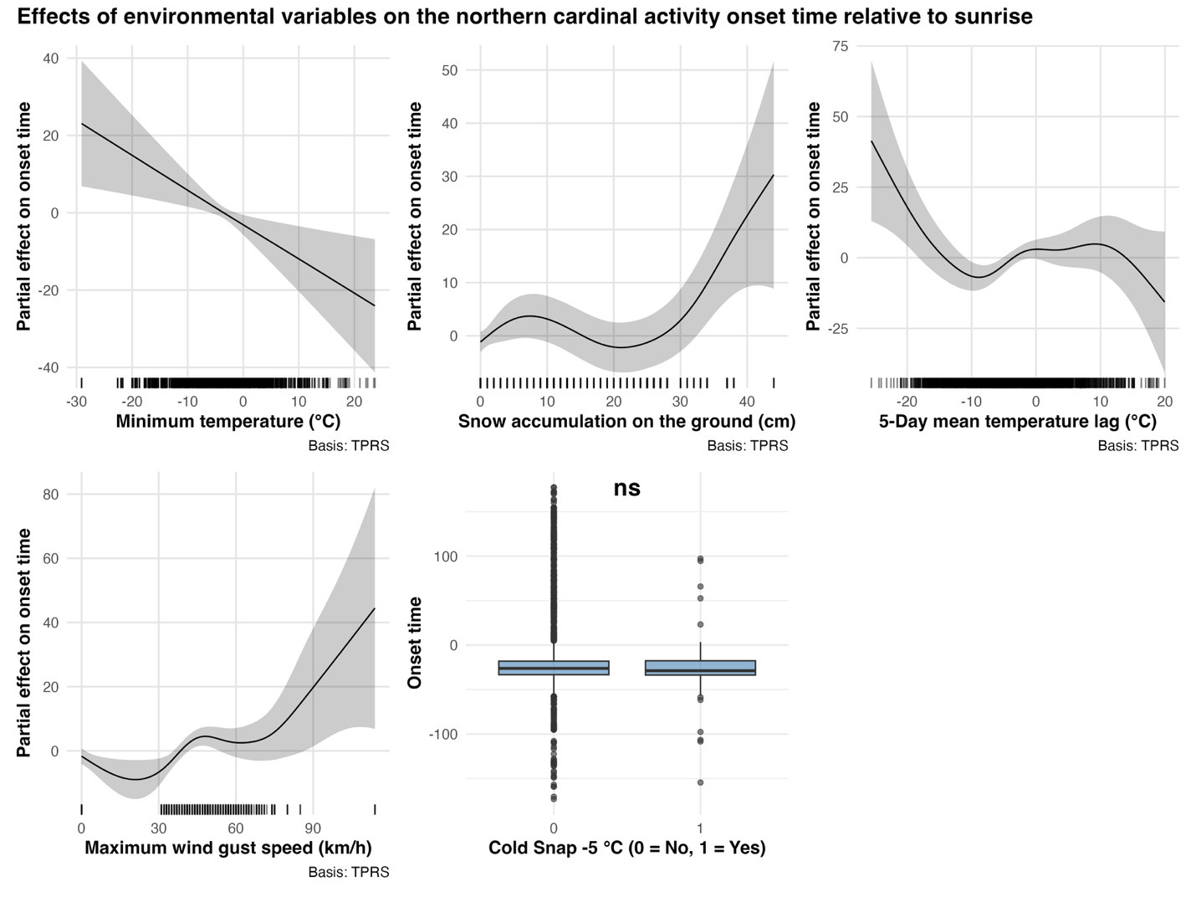
Figure X. Partial effect of 5 environmental variables on the northern cardinal’s daily activity onset time relative to sunrise for 64 individuals tracked in Montreal, Quebec, Canada between 2022 and 2025.

Effect of temperature lag and cold snap events on activity end
GAMs results revealed

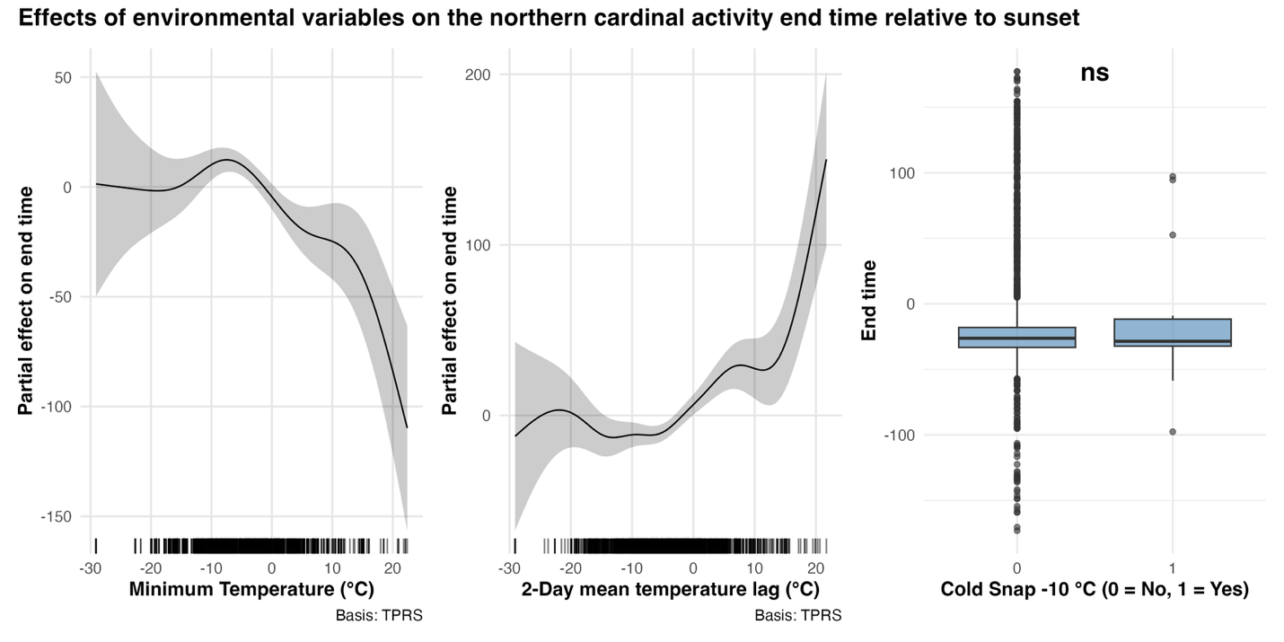Figure X. Partial effect of 3 environmental variables on the northern cardinal’s daily activity end time relative to sunset for 64 individuals tracked in Montreal, Quebec, Canada between 2022 and 2025.

Supplemental material
Study site | Model | Variables | AICc
McGill Bird Observatory (peri-urban) | Full  Vegetation height  Vegetation sd  Human  Null | Mean vegetation height + sd vegetation height + mean population density + road length + distance to nearest feeder + (1|Winter) + (1|ID) + (1|Site)  Mean vegetation height+ (1|Winter) + (1|ID) + (1|Site)  Sd vegetation height+ (1|Winter) + (1|ID) + (1|Site)  Mean population density + road length + distance to nearest feeder+ (1|Winter) + (1|ID) + (1|Site)  (1|Winter) + (1|ID) + (1|Site) | 1443.696  1587.124  1596.077  1588.262  1616.101
Town of Baie d’Urfé (suburban) | Full  Vegetation height  Vegetation sd  Human  Null | Mean vegetation height + sd vegetation height + mean population density + road length + distance to nearest feeder + (1|Winter) + (1|ID) + (1|Site)  Mean vegetation height+ (1|Winter) + (1|ID) + (1|Site)  Sd vegetation height+ (1|Winter) + (1|ID) + (1|Site)  Mean population density + road length + distance to nearest feeder+ (1|Winter) + (1|ID) + (1|Site)  (1|Winter) + (1|ID) + (1|Site) | 631.7501  728.0640  724.0187  632.1451  726.1005
Concordia University (dense urban) | Full  Vegetation height  Vegetation sd  Human  Null | Mean vegetation height + sd vegetation height + mean population density + road length + distance to nearest feeder + (1|Winter) + (1|ID) + (1|Site)  Mean vegetation height+ (1|Winter) + (1|ID) + (1|Site)  Sd vegetation height+ (1|Winter) + (1|ID) + (1|Site)  Mean population density + road length + distance to nearest feeder+ (1|Winter) + (1|ID) + (1|Site)  (1|Winter) + (1|ID) + (1|Site) | 444.7050  486.6402  485.2496  447.8691  484.8853
Table SX.

Literature cited

Andreev, A. V. (1999). Energetics and survival of birds in extreme environments. Ostrich, 70(1), 13–22. https://doi.org/10.1080/00306525.1999.9639745
Anich, N. M., Benson, T. J., & Bednarz, J. C. (2009). Effect of radio transmitters on return rates of Swainson’s Warblers. Journal of Field Ornithology, 80(2), 206–211. https://doi.org/10.1111/j.1557-9263.2009.00210.x
Beauchamp, A. T., Guglielmo, C. G., & Morbey, Y. E. (2020). Stopover refuelling, movement and departure decisions in the white-throated sparrow: The influence of intrinsic and extrinsic factors during spring migration. Journal of Animal Ecology, 89(11), 2553–2566. https://doi.org/10.1111/1365-2656.13315
Birds Canada. (2025). Motus Wildlife Tracking System. https://motus.org/
Blackport, R. (2024). Amplified warming of North American cold extremes linked to human-induced changes in temperature variability. 15(5864). https://doi.org/10.1038/s41467-024-49734-8
Bodey, T. W., Cleasby, I. R., Bell, F., Parr, N., Schultz, A., Votier, S. C., & Bearhop, S. (2018). A phylogenetically controlled meta-analysis of biologging device effects on birds: Deleterious effects and a call for more standardized reporting of study data. Methods in Ecology and Evolution, 9(4), 946–955. https://doi.org/10.1111/2041-210X.12934
Brewer, Gehring, T. M., Garcia, M. M., Shirkey, B. T., Simpson, J. W., & Fournier, A. M. V. (2023). King rail (Rallus elegans) home range and microhabitat characteristics in western Lake Erie coastal marshes. Ecology and Evolution, 13(4), 16. https://doi.org/10.1002/ece3.10043
Brewer, V., Lane, S. J., Sewall, K. B., & Mabry, K. E. (2020). Effects of low-density urbanization on genetic structure in the Song Sparrow. PLOS ONE, 15(6), e0234008. https://doi.org/10.1371/journal.pone.0234008
Brodin, A. (2007). Theoretical models of adaptive energy management in small wintering birds. Philosophical Transactions of the Royal Society B: Biological Sciences, 362(1486), 1857–1871. https://doi.org/10.1098/rstb.2006.1812
Burnham, K. P., & Anderson, D. R. (2002). Model Selection and Multimodel Inference (2nd ed.).
Buxton, R. T., Hudgins, E. J., Lavigne, E., Villeneuve, P. J., Prince, S. A., Pearson, A. L., Halsall, T., Robichaud, C., & Bennett, J. R. (2024). Mental health is positively associated with biodiversity in Canadian cities. Communications Earth & Environment, 5(1), 310. https://doi.org/10.1038/s43247-024-01482-9
Cabrera-Cruz, S. A., Smolinsky, J. A., & Buler, J. J. (2018). Light pollution is greatest within migration passage areas for nocturnally-migrating birds around the world. Scientific Reports, 8(1), 3261.
Carrasco, L., Giam, X., Papeş, M., & Sheldon, K. S. (2019). Metrics of Lidar-Derived 3D Vegetation Structure Reveal Contrasting Effects of Horizontal and Vertical Forest Heterogeneity on Bird Species Richness. Remote Sensing, 11(7), Article 7. https://doi.org/10.3390/rs11070743
Chen, D., & Hale, R. C. (2010). A global review of polybrominated diphenyl ether flame retardant contamination in birds. Environment International, 36(7), 800–811. https://doi.org/10.1016/j.envint.2010.05.013
Chiron, F., Lorrillière, R., Bessa-Gomes, C., Tryjanowski, P., Casanelles-Abella, J., Laanisto, L., Leal, A., Van Mensel, A., Moretti, M., Muyshondt, B., Niinemets, Ü., Ortí, M. A., Pinho, P., Samson, R., & Deguines, N. (2024). How do urban green space designs shape avian communities? Testing the area–heterogeneity trade-off. Landscape and Urban Planning, 242, 104954. https://doi.org/10.1016/j.landurbplan.2023.104954
City of Montreal. (2020). Climate Plan 2020-2030. City of Montreal. https://montreal.ca/en/articles/montreal-climate-plan-objective-carbon-neutral-2050-7613
City of Montreal. (2024). Plan climat 2020-2030 Ville de Montréal—État d’avancement avril 2024. City of Montreal. https://mtl.ged.montreal.ca/constellio/?collection=mtlca&portal=REPDOCVDM#!displayDocument/00000092918
Cox, D. T. C., Shanahan, D. F., Hudson, H. L., Plummer, K. E., Siriwardena, G. M., Fuller, R. A., Anderson, K., Hancock, S., & Gaston, K. J. (2017). Doses of Neighborhood Nature: The Benefits for Mental Health of Living with Nature. BioScience, 67(2), 147–155. https://doi.org/10.1093/biosci/biw173
Cull, C. A., Guest, M. J., Frei, B., & Ziter, C. D. (2025). Human recreational activity does not influence open cup avian nest survival in urban green spaces. Urban Ecosystems, 28(2), 24. https://doi.org/10.1007/s11252-024-01669-0
Cunningham, S. J., Gardner, J. L., & Martin, R. O. (2021). Opportunity costs and the response of birds and mammals to climate warming. Frontiers in Ecology and the Environment, 19(5), 300–307. https://doi.org/10.1002/fee.2324
Dale, S. (2018). Urban bird community composition influenced by size of urban green spaces, presence of native forest, and urbanization. Urban Ecosystems, 21(1), 1–14. https://doi.org/10.1007/s11252-017-0706-x
Davies, S., Beck, M. L., & Sewall, K. B. (2018). Territorial aggression in urban and rural Song Sparrows is correlated with corticosterone, but not testosterone. Hormones and Behavior, 98, 8–15. https://doi.org/10.1016/j.yhbeh.2017.11.010
Dawson, W. R., Marsh, R. L., & Yacoe, M. E. (1983). Metabolic adjustments of small passerine birds for migration and cold. 245(6), R755–R767. https://doi.org/10.1152/ajpregu.1983.245.6.R755
Deguise, I. E., & Kerr, J. T. (2006). Protected Areas and Prospects for Endangered Species Conservation in Canada. Conservation Biology, 20(1). https://conbio.onlinelibrary.wiley.com/doi/10.1111/j.1523-1739.2005.00274.x
DeVries, M. S., & Jawor, J. M. (2013). Natural variation in circulating testosterone does not predict nestling provisioning rates in the northern cardinal, Cardinalis cardinalis. Animal Behaviour, 85(5), 957–965. https://doi.org/10.1016/j.anbehav.2013.02.019
Dinh, K. V., Albini, D., Orr, J. A., Macaulay, S. J., Rillig, M. C., Borgå, K., & Jackson, M. C. (2023). Winter is coming: Interactions of multiple stressors in winter and implications for the natural world. Global Change Biology, 29(24), 6834–6845. https://doi.org/10.1111/gcb.16956
Dunn, J. C., Morris, A. J., Grice, P. V., & Peach, W. J. (2021). Effects of seed-rich habitat provision on territory density, home range and breeding performance of European Turtle Doves Streptopelia turtur. Bird Conservation International, 31(4), 620–639. https://doi.org/10.1017/S0959270920000635
Dupras, J., & Alam, M. (2015). Urban Sprawl and Ecosystem Services: A Half Century Perspective in the Montreal Area (Quebec, Canada). Journal of Environmental Policy & Planning, 17(2), 180–200. https://doi.org/10.1080/1523908X.2014.927755
Elliott, J., Brogan, J., Lee, S. L., Drouillard, K. G., & Elliott, K. H. (2015). PBDEs and other POPs in urban birds of prey partly explained by trophic level and carbon source. Science of The Total Environment, 524–525, 157–165. https://doi.org/10.1016/j.scitotenv.2015.04.008
Elliott, J., Wilson, L. K., & Wakeford, B. (2005). Polybrominated Diphenyl Ether Trends in Eggs of Marine and Freshwater Birds from British Columbia, Canada, 1979−2002. Environmental Science & Technology, 39(15), 5584–5591. https://doi.org/10.1021/es050496q
Elliott, Woo, K. J., & Benvenuti, S. (2009). Do activity costs determine foraging tactics for an arctic seabird? Marine Biology, 156(9), 1809–1816. https://doi.org/10.1007/s00227-009-1214-1
Elmqvist, T., Fragkias, M., Goodness, J., Güneralp, B., Marcotullio, P. J., McDonald, R. I., Parnell, S., Schewenius, M., Sendstad, M., & Seto, K. C. (2013). Urbanization, biodiversity and ecosystem services: Challenges and opportunities: A global assessment. Springer Nature.
Environment and Climate Change Canada. (2022). Daily Weather Data Report [Dataset]. https://climate.weather.gc.ca/climate_data/daily_data_e.html?hlyRange=2008-01-08%7C2025-07-22&dlyRange=2002-12-23%7C2025-07-22&mlyRange=%7C&StationID=30165&Prov=QC&urlExtension=_e.html&searchType=stnName&optLimit=specDate&StartYear=1840&EndYear=2025&selRowPerPage=25&Line=0&searchMethod=contains&Month=7&Day=16&txtStationName=Trudeau&timeframe=2&Year=2025
Eötvös, C. B., Magura, T., & Lövei, G. L. (2018). A meta-analysis indicates reduced predation pressure with increasing urbanization. Landscape and Urban Planning, 180, 54–59. https://doi.org/10.1016/j.landurbplan.2018.08.010
Fidino, M., Gallo, T., Lehrer, E. W., Murray, M. H., Kay, C. A. M., Sander, H. A., MacDougall, B., Salsbury, C. M., Ryan, T. J., Angstmann, J. L., Amy Belaire, J., Dugelby, B., Schell, C. J., Stankowich, T., Amaya, M., Drake, D., Hursh, S. H., Ahlers, A. A., Williamson, J., … Magle, S. B. (2021). Landscape‐scale differences among cities alter common species’ responses to urbanization. Ecological Applications, 31(2), e02253. https://doi.org/10.1002/eap.2253
Filion, P., Bunting, T., Pavlic, D., & Langlois, P. (2010). Intensification and Sprawl: Residential Density Trajectories in Canada’s Largest Metropolitan Regions. Urban Geography, 31(4), 541–569. https://doi.org/10.2747/0272-3638.31.4.541
Filliater, T. S., Breitwisch, R., & Nealen, P. M. (1994). Predation on Northern Cardinal Nests: Does Choice of Nest Site Matter? The Condor: Ornithological Applications, 96(3), 761–768. https://doi.org/10.2307/1369479
Frei, B., Morales, A., Cousineau, A.-M., & Beauchamp, A. (2024). Montreal Northern Cardinal Winter Movements (Project 882) [Dataset]. Motus Wildlife Tracking System, Birds Canada. https://motus.org/
Fristoe, T. S. (2015). Energy use by migrants and residents in North American breeding bird communities. Global Ecology and Biogeography, 24(4), 406–415. https://doi.org/10.1111/geb.12262
Fritts, R. (2022, May 16). Avian Superhighways: The Four Flyways of North America. American Bird Conservancy. https://abcbirds.org/blog/north-american-bird-flyways/
Fuller, M. R., Millspaugh, J. J., Church, K. E., & Kenward, R. E. (2005). Wildlife radiotelemetry. Techniques for Wildlife Investigations and Management. Sixth Edition. The Wildlife Society, Bethesda, Maryland, USA, 377–417.
Furberg, D., & Ban, Y. (2008). Satellite Monitoring of Urban Sprawl and Assessing the Impact of Land-Cover Changes in the Greater Toronto Area. The XXI Congress of ISPRS. Beijing, China. 3-11 July 2008.
Gahbauer, M. A., Duval, S., & Davey, D. (2015). McGill Bird Observatory Annual Program Report 2014.
Gahbauer, M. A., Duval, S., & Davey, D. (2021). McGill Bird Observatory 15-Year Report: 2005-2019 (p. 432). Migration Research Foundation.
Gómez, J., Michelson, C. I., Bradley, D. W., Ryan Norris, D., Berzins, L. L., Dawson, R. D., & Clark, R. G. (2014). Effects of geolocators on reproductive performance and annual return rates of a migratory songbird. Journal of Ornithology, 155(1), 37–44. https://doi.org/10.1007/s10336-013-0984-x
Gordo, O., Brotons, L., Herrando, S., & Gargallo, G. (2021). Rapid behavioural response of urban birds to COVID-19 lockdown. Proceedings of the Royal Society B: Biological Sciences, 288(1946), 20202513. https://doi.org/10.1098/rspb.2020.2513
Government of Canada. (2018, November 15). Environmental Damages Fund. https://www.canada.ca/en/environment-climate-change/services/environmental-funding/programs/environmental-damages-fund.html
Government of Canada, S. C. (2022a, February 9). Census Profile, 2021 Census of Population. https://www12.statcan.gc.ca/census-recensement/2021/dp-pd/prof/index.cfm?Lang=E
Government of Canada, S. C. (2022b, February 9). Profile table, Census Profile, 2021 Census of Population—Montréal, Ville (V) [Census subdivision], Quebec. https://www12.statcan.gc.ca/census-recensement/2021/dp-pd/prof/index.cfm?Lang=E
Gumilyov, L. N., Byulegenova, B. B., & Turemuratov, O. Zh. (2023). Urbanization as a global trend: Causes and consequences. 142(1), 37–42. https://doi.org/10.32523/2616-6887/2023-142-1-37-42
Guo, F., Buler, J. J., Smolinsky, J. A., & Wilcove, D. S. (2023). Autumn stopover hotspots and multiscale habitat associations of migratory landbirds in the eastern United States. Proceedings of the National Academy of Sciences, 120(3), e2203511120. https://doi.org/10.1073/pnas.2203511120
Hahs, A. K., Fournier, B., Aronson, M. F. J., Nilon, C. H., Herrera-Montes, A., Salisbury, A. B., Threlfall, C. G., Rega-Brodsky, C. C., Lepczyk, C. A., La Sorte, F. A., MacGregor-Fors, I., Scott MacIvor, J., Jung, K., Piana, M. R., Williams, N. S. G., Knapp, S., Vergnes, A., Acevedo, A. A., Gainsbury, A. M., … Moretti, M. (2023). Urbanisation generates multiple trait syndromes for terrestrial animal taxa worldwide. Nature Communications, 14(1), 4751. https://doi.org/10.1038/s41467-023-39746-1
Halkin, S. L., Shustack, D. P., DeVries, M. S., Jawor, J. M., & Linville, S. U. (2021). Northern Cardinal (Cardinalis cardinalis), version 2.0. Birds of the World. https://doi.org/10.2173/bow.norcar.02
Harris, R. B., & Fish, U. S. (1990). Tracking wildlife by satellite.
Havlíček, J., Riegert, J., & Fuchs, R. (2022). A comparison of foraging-range sizes, flight distances and foraging habitat preferences in urban and rural House Sparrow (Passer domesticus) populations. Ibis, 164(4), 1227–1242. https://doi.org/10.1111/ibi.13072
Hofman, M. P. G., Hayward, M. W., Heim, M., Marchand, P., Rolandsen, C. M., Mattisson, J., Urbano, F., Heurich, M., Mysterud, A., Melzheimer, J., Morellet, N., Voigt, U., Allen, B. L., Gehr, B., Rouco, C., Ullmann, W., Holand, Ø., Jørgensen, N. H., Steinheim, G., … Balkenhol, N. (2019). Right on track? Performance of satellite telemetry in terrestrial wildlife research. Plos One, 14(5), e0216223. https://doi.org/10.1371/journal.pone.0216223
Hope, S. F., Hopkins, W. A., & Angelier, F. (2022). Parenting in the city: Effects of urbanization on incubation behaviour and egg temperature in great tits, Parus major. Animal Behaviour, 194, 1–11. https://doi.org/10.1016/j.anbehav.2022.09.004
Hosmer, D. W., & Lemesbow, S. (1980). Goodness of fit tests for the multiple logistic regression model. Communications in Statistics - Theory and Methods, 9(10), 1043–1069. https://doi.org/10.1080/03610928008827941
Humbird, S. K., & Neudorf, D. L. H. (2008). THE EFFECTS OF FOOD SUPPLEMENTATION ON EXTRATERRITORIAL BEHAVIOR IN FEMALE NORTHERN CARDINALS. The Condor, 110(2), 392–395. https://doi.org/10.1525/cond.2008.8427
Ibáñez-Álamo, J. D., Morelli, F., Benedetti, Y., Rubio, E., Jokimäki, J., Pérez-Contreras, T., Sprau, P., Suhonen, J., Tryjanowski, P., Kaisanlahti-Jokimäki, M.-L., Møller, A. P., & Díaz, M. (2020). Biodiversity within the city: Effects of land sharing and land sparing urban development on avian diversity. Science of The Total Environment, 707, 135477. https://doi.org/10.1016/j.scitotenv.2019.135477
Isaksson, C. (2018). Impact of urbanization on birds. Bird Species, 235, 257.
Iverson, A. R., Schaefer, J. L., Skalos, S. M., & Hawkins, C. E. (2023). Global positioning system (GPS) and platform transmitter terminal (PTT) tags reveal fine-scale migratory movements of small birds: A review highlights further opportunities for hypothesis-driven research. Ornithological Applications, 125(3), duad014.
Jim, C. Y., & Chen, W. Y. (2008). Assessing the ecosystem service of air pollutant removal by urban trees in Guangzhou (China). Journal of Environmental Management, 88(4), 665–676. https://doi.org/10.1016/j.jenvman.2007.03.035
Jokimäki, J., Kaisanlahti-Jokimäki, M.-L., & Suhonen, J. (2022). Long-Term Winter Population Trends of Corvids in Relation to Urbanization and Climate at Northern Latitudes. Animals, 12(14), Article 14. https://doi.org/10.3390/ani12141820
Jones, T. M., Cooper, N. W., Haradon, H. A., Brunner, A. R., Dossman, B. C., Ward, M. P., Sillett, T. S., & Kaiser, S. A. (2024). Considerations for radio-transmitter specifications on songbirds: Color and antenna length matter too. Journal of Field Ornithology, 95(1). https://doi.org/10.5751/JFO-00426-950107
Jones, T. M., Llamas, A. P., & Phillips, J. N. (2023). Phenotypic signatures of urbanization? Resident, but not migratory, songbird eye size varies with urban‐associated light pollution levels. Global Change Biology, 29(23), 6635–6646.
Kamei, I., & Maruta, E. (1979). Study on wind environmental problems caused around buildings in Japan. Journal of Wind Engineering and Industrial Aerodynamics, 4(3), 307–331. https://doi.org/10.1016/0167-6105(79)90010-2
Kekkonen, J. (2017). Pollutants in urbanized areas: Direct and indirect effects on bird populations. Ecology and Conservation of Birds in Urban Environments, 227–250.
Killick, R., & Eckley, I. A. (2014). changepoint: An R Package for Changepoint Analysis. Journal of Statistical Software, 58, 1–19. https://doi.org/10.18637/jss.v058.i03
Krama, T., Krams, R., Popovs, S., Trakimas, G., Rantala, M. J., Freeberg, T. M., & Krams, I. A. (2023). Permanent Ad-lib Feeders Decrease the Survival of Wintering Great Tits (Parus major). Birds, 4(2), Article 2. https://doi.org/10.3390/birds4020019
Kraus, D., & Hebb, A. (2020). Southern Canada’s crisis ecoregions: Identifying the most significant and threatened places for biodiversity conservation. Biodiversity and Conservation, 29(13), 3573–3590. https://doi.org/10.1007/s10531-020-02038-x
Lane, S. J., VanDiest, I. J., Brewer, V. N., Linkous, C. R., Fossett, T. E., Goodchild, C. G., & Sewall, K. B. (2023). Indirect effects of urbanization: Consequences of increased aggression in an urban male songbird for mates and offspring. Frontiers in Ecology and Evolution, 11. https://doi.org/10.3389/fevo.2023.1234562
Laskey, A. R. (1944). A STUDY OF THE CARDINAL IN TENNESSEE. 56(1).
Latimer, C. E., & Zuckerberg, B. (2021). Habitat loss and thermal tolerances influence the sensitivity of resident bird populations to winter weather at regional scales. Journal of Animal Ecology, 90(2), 317–329. https://doi.org/10.1111/1365-2656.13332
Leston, L. F. V., & Rodewald, A. D. (2006). Are urban forests ecological traps for understory birds? An examination using Northern cardinals. Biological Conservation, 131(4), 566–574. https://doi.org/10.1016/j.biocon.2006.03.003
Li, G., Fang, C., Li, Y., Wang, Z., Sun, S., He, S., Qi, W., Bao, C., Ma, H., Fan, Y., Feng, Y., & Liu, X. (2022). Global impacts of future urban expansion on terrestrial vertebrate diversity. Nature Communications, 13(1), 1628. https://doi.org/10.1038/s41467-022-29324-2
Liker, A., Papp, Z., Bókony, V., & Lendvai, Á. Z. (2008). Lean birds in the city: Body size and condition of house sparrows along the urbanization gradient. Journal of Animal Ecology, 77(4), 789–795. https://doi.org/10.1111/j.1365-2656.2008.01402.x
Linek, N., Volkmer, T., Shipley, J. R., Twining, C. W., Zúñiga, D., Wikelski, M., & Partecke, J. (2021). A songbird adjusts its heart rate and body temperature in response to season and fluctuating daily conditions. Philosophical Transactions of the Royal Society B: Biological Sciences, 376(1830), 20200213. https://doi.org/10.1098/rstb.2020.0213
Linville, S. U., Breitwisch, R., & Schilling, A. J. (1998). Plumage brightness as an indicator of parental care in northern cardinals. Animal Behaviour, 55(1), 119–127. https://doi.org/10.1006/anbe.1997.0595
Litteral, J., & Shochat, E. (2017). The Role of Landscape-Scale Factors in Shaping Urban Bird Communities. In E. Murgui & M. Hedblom (Eds.), Ecology and Conservation of Birds in Urban Environments (pp. 135–159). Springer International Publishing. https://doi.org/10.1007/978-3-319-43314-1_8
Lopes, A. C., Rocha, G. O. C., de Oliveira Passos, M. F., Barçante, L., & de Azevedo, C. S. (2024). The Influence of Building Surroundings and Glass Cover in Bird Collisions. Birds, 5(4), Article 4. https://doi.org/10.3390/birds5040048
Louzao, M., Gallagher, R., García-Barón, I., Chust, G., Intxausti, I., Albisu, J., Brereton, T., & Fontán, A. (2019). Threshold responses in bird mortality driven by extreme wind events. Ecological Indicators, 99, 183–192. https://doi.org/10.1016/j.ecolind.2018.12.030
Lowry, H., Lill, A., & Wong, B. B. M. (2013). Behavioural responses of wildlife to urban environments. Biological Reviews, 88(3), 537–549. https://doi.org/10.1111/brv.12012
MacKinnon, M., Pedersen Zari, M., & Brown, D. K. (2023). Improving Urban Habitat Connectivity for Native Birds: Using Least-Cost Path Analyses to Design Urban Green Infrastructure Networks. Land, 12(7), Article 7. https://doi.org/10.3390/land12071456
Majchrzak, Y. N., Peers, M. J. L., Studd, E. K., Menzies, A. K., Walker, P. D., Shiratsuru, S., McCaw, L. K., Boonstra, R., Humphries, M., Jung, T. S., Kenney, A. J., Krebs, C. J., Murray, D. L., & Boutin, S. (2022). Balancing food acquisition and predation risk drives demographic changes in snowshoe hare population cycles. Ecology Letters, 25(4), 981–991. https://doi.org/10.1111/ele.13975
Martin, A. E., & Fahrig, L. (2012). Measuring and selecting scales of effect for landscape predictors in species–habitat models. Ecological Applications, 22(8), 2277–2292. https://doi.org/10.1890/11-2224.1
Masello, J. F., Rast, W., Schumm, Y. R., Metzger, B., & Quillfeldt, P. (2023). Year-round behavioural time budgets of common woodpigeons inferred from acceleration data using machine learning. Behavioral Ecology and Sociobiology, 77(4), 40. https://doi.org/10.1007/s00265-023-03306-w
McGill University. (2025). Climate. International Student Services. https://www.mcgill.ca/internationalstudents/once-here/pre-arrival/pre-arrival-information/about-montreal/climate
Mennill, D. J., Doucet, S. M., Ward, K.-A. A., Maynard, D. F., Otis, B., & Burt, J. M. (2012). A novel digital telemetry system for tracking wild animals: A field test for studying mate choice in a lekking tropical bird. Methods in Ecology and Evolution, 3(4), 663–672. https://doi.org/10.1111/j.2041-210X.2012.00206.x
Mitchell, M. G. E., & Devisscher, T. (2022). Strong relationships between urbanization, landscape structure, and ecosystem service multifunctionality in urban forest fragments. Landscape and Urban Planning, 228, 104548. https://doi.org/10.1016/j.landurbplan.2022.104548
Morbey, Y. E., Beauchamp, A. T., Bonner, S. J., & Mitchell, G. W. (2020). Evening locomotor activity during stopover differs on pre-departure and departure days in free-living songbirds. Journal of Avian Biology, 51(11). https://doi.org/10.1111/jav.02448
Müller, U., & Avolio, C. (2023, July 11). Icarus flies faster, further. Max-Planck-Gesellschaft. https://www.mpg.de/20614880/0711-ornr-icarus-flies-faster-further-987453-x
Murray, M. H., Sánchez, C. A., Becker, D. J., Byers, K. A., Worsley‐Tonks, K. E., & Craft, M. E. (2019). City sicker? A meta‐analysis of wildlife health and urbanization. Frontiers in Ecology and the Environment, 17(10), 575–583. https://doi.org/10.1002/fee.2126
Naguib, M., Titulaer, M., Waas, J. R., van Oers, K., Sprau, P., & Snijders, L. (2022). Prior territorial responses and home range size predict territory defense in radio-tagged great tits. Behavioral Ecology and Sociobiology, 76(3), 12. https://doi.org/10.1007/s00265-022-03143-3
Nazarnia, N., Schwick, C., & Jaeger, J. A. G. (2016). Accelerated urban sprawl in Montreal, Quebec City, and Zurich: Investigating the differences using time series 1951–2011. Ecological Indicators, 60, 1229–1251. https://doi.org/10.1016/j.ecolind.2015.09.020
O’Connell, M. J., Squirrell, F. I., & Greening, M. (2023). A preliminary study of the winter roosting behaviour of four woodland passerines. Bird Study, 70(4), 243–250. https://doi.org/10.1080/00063657.2023.2269329
O’Donnell, K., & delBarco-Trillo, J. (2020). Changes in the home range sizes of terrestrial vertebrates in response to urban disturbance: A meta-analysis. Journal of Urban Ecology, 6(1), juaa014. https://doi.org/10.1093/jue/juaa014
Ordóñez-Delgado, L., Iñiguez-Armijos, C., Díaz, M., Escudero, A., Gosselin, E., Waits, L. P., & Espinosa, C. I. (2022). The good, the bad, and the ugly of urbanization: Response of a bird community in the neotropical Andes. Frontiers in Ecology and Evolution, 10, 844944.
Palacio, F. X., Ibañez, L. M., Maragliano, R. E., & Montalti, D. (2018). Urbanization as a driver of taxonomic, functional, and phylogenetic diversity losses in bird communities. Canadian Journal of Zoology, 96(10), 1114–1121.
Palacio, F. X., Ibañez, L. M., Maragliano, R. E., & Montalti, D. (2024). (PDF) Urbanization as a driver of taxonomic, functional, and phylogenetic diversity losses in bird communities. ResearchGate. https://doi.org/10.1139/cjz-2018-0008
Panchana, K., Herrera, I., Vargas, A., Mella-Méndez, I., & Flores-Peredo, R. (2025). Whiskers in the city: Domestic cat predation in Ecuadorian coastal cities and associated factors. Urban Ecosystems, 28(1), 1–18. https://doi.org/10.1007/s11252-024-01628-9
Paruk, J., Cooper, S., Mangan, A., Brady, R., & Tucker, L. (2015). Resting Metabolic Rates of Adult Northern Shrikes (Lanius excubitor) Wintering in Northern Wisconsin. WILSON JOURNAL OF ORNITHOLOGY, 127(3), 510–514.
Pelletier, D., Seyer, Y., Garthe, S., Bonnefoi, S., Phillips, R. A., & Guillemette, M. (2020). So far, so good… Similar fitness consequences and overall energetic costs for short and long-distance migrants in a seabird. PLOS ONE, 15(3), e0230262. https://doi.org/10.1371/journal.pone.0230262
Petit, M., Clavijo-Baquet, S., & Vézina, F. (2017). Increasing Winter Maximal Metabolic Rate Improves Intrawinter Survival in Small Birds. Physiological and Biochemical Zoology, 90(2), 166–177. https://doi.org/10.1086/689274
Poirier, V., Elliott, K. H., & Frei, B. (2024). Peri-urban forest margins are important stopover sites for moult-migrating songbirds. Journal for Nature Conservation, 77, 126539. https://doi.org/10.1016/j.jnc.2023.126539
Portugal, S. J., & White, C. R. (2022). Externally attached biologgers cause compensatory body mass loss in birds. Methods in Ecology and Evolution, 13(2), 294–302. https://doi.org/10.1111/2041-210X.13754
R Core Team. (2024a). R: A Language and Environment for Statistical Computing [Computer software]. R Foundation for Statistical Computing. https://www.R-project.org/
R Core Team. (2024b). R: A Language and Environment for Statistical Computing (Version 4.4.2) [Computer software]. R Foundation for Statistical Computing. https://www.R-project.org/
Radvan, M., Rendall, A. R., & Weston, M. A. (2023). The habitat connectivity hypothesis of escape in urban woodland birds. Behavioral Ecology, 34(2), 297–305. https://doi.org/10.1093/beheco/arac127
Robert, M., Hachey, M.-H., Lepage, D., & Couturier, A. (2019). Second Atlas of the Breeding Birds of Southern Québec.
Rodgers, A. R. (2001). Chapter 4—Recent Telemetry Technology. In J. J. Millspaugh & J. M. Marzluff (Eds.), Radio Tracking and Animal Populations (pp. 79–121). Academic Press.
Rodrigues, A. G., Borges-Martins, M., & Zilio, F. (2018). Bird diversity in an urban ecosystem: The role of local habitats in understanding the effects of urbanization. Iheringia. Série Zoologia, 108, e2018017.
Rousseau, J. S., Savard, J.-P. L., & Titman, R. (2015). Shrub-nesting birds in urban habitats: Their abundance and association with vegetation. Urban Ecosystems, 18(3), 871–884. https://doi.org/10.1007/s11252-014-0434-4
Schaeffer, P., Komer, M. C., & Corder, K. (2015). Energy savings due to the use of shallow body temperature reduction in overwintering Northern Cardinals. ResearchGate, 3(1). https://doi.org/10.1186/s40317-015-0078-z
Scott, D. M., Lemon, R. E., & Darley, J. A. (1987). Relaying Interval After Nest Failure in Gray Catbirds and Northern Cardinals. Wilson Bulletin, 99.
Seress, G., & Liker, A. (2015). Habitat urbanization and its effects on birds. Acta Zoologica Academiae Scientiarum Hungaricae, 61(4), 373–408.
Shanahan, D. F., Miller, C., Possingham, H. P., & Fuller, R. A. (2011). The influence of patch area and connectivity on avian communities in urban revegetation. Biological Conservation, 144(2), 722–729. https://doi.org/10.1016/j.biocon.2010.10.014
Shanahan, D. F., Strohbach, M. W., Warren, P. S., & Fuller, R. A. (2014). The challenges of urban living. Avian Urban Ecology, 3–20.
Shustack, D. P. (2008). Reproductive Timing of Passerines in Urbanizing Landscapes [The Ohio State University]. http://rave.ohiolink.edu/etdc/view?acc_num=osu1217601092
Silva, A. D., Diez-Méndez, D., & Kempenaers, B. (2017). Effects of experimental night lighting on the daily timing of winter foraging in common European songbirds. Journal of Avian Biology, 48(6), 862–871. https://doi.org/10.1111/jav.01232
Simberloff, R. A., Phillips, J. N., Derryberry, G. E., Mahoney, M. C., & Derryberry, E. P. (2023). Communication distance predicts territory size: Implications for an urban songbird. Animal Behaviour, 203, 89–99. https://doi.org/10.1016/j.anbehav.2023.05.016
Simkin, R. D., Seto, K. C., McDonald, R. I., & Jetz, W. (2022). Biodiversity impacts and conservation implications of urban land expansion projected to 2050. Proceedings of the National Academy of Sciences, 119(12), e2117297119. https://doi.org/doi:10.1073/pnas.2117297119
Skarbit, N., Unger, J., & Gál, T. (2024). Evaluating the Impact of Heat Mitigation Strategies Using Added Urban Green Spaces during a Heatwave in a Medium-Sized City. Sustainability, 16(8), 17. https://doi.org/10.3390/su16083296
Smith, P. G. (2007). Characteristics of Urban Natural Areas Influencing Winter Bird Use in Southern Ontario, Canada. Environmental Management, 39(3), 338–352. https://doi.org/10.1007/s00267-005-0028-2
Studd, E. K., Bates, A. E., Bramburger, A. J., Hayden, B., Henry, H. A. L., Humphries, M. M., Martin, R., McMeans, B., Moise, E., O’Sullivan, A., Sharma, S., Sinclair, B., Sutton, A. O., Templer, P. H., & Cooke, S. J. (2021). Nine maxims for winter ecology. BioScience, 71(8), 820–830. https://doi.org/10.1093/biosci/biab032
Sumasgutner, P., Cunningham, S. J., Hegemann, A., Amar, A., Watson, H., Nilsson, J. F., Andersson, M. N., & Isaksson, C. (2023). Interactive effects of rising temperatures and urbanisation on birds across different climate zones: A mechanistic perspective. Global Change Biology, 29(9), 2399–2420. https://doi.org/10.1111/gcb.16645
Sutton, A. O., Studd, E. K., Fernandes, T., Bates, A. E., Bramburger, A. J., Cooke, S. J., Hayden, B., Henry, H. A. L., Humphries, M. M., Martin, R., McMeans, B., Moise, E., O’Sullivan, A. M., Sharma, S., & Templer, P. H. (2021). Frozen out: Unanswered questions about winter biology. Environmental Reviews, 29(4), 431–442. https://doi.org/10.1139/er-2020-0127
Swanson, D. L., & Vézina, F. (2015). Environmental, ecological and mechanistic drivers of avian seasonal metabolic flexibility in response to cold winters. Journal of Ornithology, 156(1), 377–388. https://doi.org/10.1007/s10336-015-1192-7
Thieurmel, B., & Elmarhraoui, A. (2022). suncalc: Compute Sun Position, Sunlight Phases, Moon Position and Lunar Phase (Version 0.5.1) [R packag]. https://CRAN.R-project.org/package=suncalc
Thohari, M. (1989). Wildlife Tracking by Telemetry.
Tian, Y., Tsendbazar, N.-E., van Leeuwen, E., Fensholt, R., & Herold, M. (2022). A global analysis of multifaceted urbanization patterns using Earth Observation data from 1975 to 2015. Landscape and Urban Planning, 219, 104316. https://doi.org/10.1016/j.landurbplan.2021.104316
Tryjanowski, P., Mikula, P., & Morelli, F. (2024). Dynamic interactions at birdfeeders: Attracting both prey and predators across urban and rural habitats. Basic and Applied Ecology, 79, 84–89. https://doi.org/10.1016/j.baae.2024.06.005
Vangestel, C., Braeckman, B. P., Matheve, H., & Lens, L. (2010). Constraints on home range behaviour affect nutritional condition in urban house sparrows (Passer domesticus): RANGING BEHAVIOUR IN URBAN HOUSE SPARROWS. Biological Journal of the Linnean Society, 101(1), 41–50. https://doi.org/10.1111/j.1095-8312.2010.01493.x
Vaz, S., Manes, S., Khattar, G., Mendes, M., Silveira, L., Mendes, E., De Morais Rodrigues, E., Gama-Maia, D., Lorini, M. L., Macedo, M., & Paiva, P. C. (2023). Global meta-analysis of urbanization stressors on insect abundance, richness, and traits. Science of The Total Environment, 903, 165967. https://doi.org/10.1016/j.scitotenv.2023.165967
VILLE DE MONTRÉAL. (2018). Chaussée agrégée et intersection (Base de données des actifs de voirie) (Jeu de données Nos. a2810949-7335-49e2-84af-1c5da4ff6342). Données Québec. https://www.donneesquebec.ca/recherche/dataset/vmtl-voirie-chaussee-intersection
Visscher, D. R., Unger, A., Grobbelaar, H., & DeWitt, P. D. (2018). Bird foraging is influenced by both risk and connectivity in urban parks. Journal of Urban Ecology, 4(1), juy020. https://doi.org/10.1093/jue/juy020
vonBergmann, J., & Jacobs, A. (n.d.). cancensus: Access, Retrieve, and Work with Canadian Census Data and Geography (Version 0.5.3) [Computer software]. Retrieved May 5, 2025, from https://CRAN.R-project.org/package=cancensus
Wang, H., He, Q., Liu, X., Zhuang, Y., & Hong, S. (2012). Global urbanization research from 1991 to 2009: A systematic research review. Landscape and Urban Planning, 104(3–4), 299–309.
Watson, H., Nilsson, J., & Nilsson, J. F. (2023). Thermoregulatory costs of the innate immune response are modulated by winter food availability in a small passerine. Journal of Animal Ecology, 92(5), 1065–1074. https://doi.org/10.1111/1365-2656.13914
Wolch, J. R., Byrne, J., & Newell, J. P. (2014). Urban green space, public health, and environmental justice: The challenge of making cities ‘just green enough.’ Landscape and Urban Planning, 125, 234–244. https://doi.org/10.1016/j.landurbplan.2014.01.017
Wood, E., Harsant, A., Dallimer, M., Cronin de Chavez, A., McEachan, R. R. C., & Hassall, C. (2018). Not All Green Space Is Created Equal: Biodiversity Predicts Psychological Restorative Benefits From Urban Green Space. Frontiers in Psychology, 9. https://doi.org/10.3389/fpsyg.2018.02320

