Title
Large winter home ranges in urban habitats for a very short distance migrant, the Northern Cardinal (Cardinalis cardinalis)
Authors
Cousineau, Anne-Marie¹; Frei, Barbara^{1,2}; Gahbauer, Marcel A.³ ; Elliott, Kyle H.¹
1: Department of natural Resource Sciences, McGill University, Ste. Anne de Bellevue, Québec, Canada
2: Science and Technology Branch, Environment and Climate Change Canada, Montreal, Québec, Canada
3: Canadian Wildlife Services, Environment and Climate Change Canada, Ottawa, Ontario, Canada
Corresponding author’s address
21111 Rue Lakeshore Ste Anne-de-Bellevue, H9X 3V9, QC, Canada
anne-marie.cousineau@mail.mcgill.ca

Acknowledgements
(1) I would like to thank all the dedicated staff and volunteers at the McGill Bird Observatory, especially Shawna Sevigny and Ana Morales for banding the Northern Cardinals, installing Motus tags, assisting with translocations over both years, and teaching me bird banding and tag deployment Tracking cardinals over eight months was a true team effort—thank you to Mackenzie Guest, Lauren Dobie, Nathanya Goudreau, Florence Piché-Lebel, Laurianne Fallu, Elliana Tomasso and Mathilde Lefvert for your essential help in the field. Special thanks to Jean and Richard Gregson for hosting a Motus tower in their backyard for this project.
(2) I also want to thank my reviewers for providing insightful feedback. I am grateful for McGill University and the Social Science and Humanities Research Council (SSHRC) for funding this project, along with Environment and Climate Change Canada for providing 80 Lotek NanoTags across two field seasons.
(3) All birds were banded under Animal Use Protocol 2007-5446 from McGill University and federal banding permits 10973, 10973B, 10973D issued by the Canadian Wildlife Service, and radio-tagged under Animal Use Protocol 22BF01 and 23BF01 from Environment and Climate Change Canada.
(4) I declare no conflicts of interest.
(5) Marcel Gahbauer, Anne-Marie Cousineau, Kyle Elliott and Barbara Frei conceived the idea, design and experiment. Anne-Marie Cousineau performed the experiments. Anne-Marie Cousineau wrote the paper, Kyle Elliott and Barbara Frei substantially edited the paper. Marcel Gahbauer provided valuable reviewing and editing input. Anne-Marie Cousineau, Barbara Frei and Kyle Elliott developed and designed the methods. Anne-Marie Cousineau analyzed the data.
(6) Analyses reported in this article can be reproduced using the data provided by Cousineau (2025).
Data from: Large winter home ranges in urban habitats for a very short distance migrant, the Northern Cardinal (Cardinalis cardinalis). Ornithology / Ornithological Applications. Data DOI will be added once data deposition completed.
Large winter home ranges in urban habitats for a very short distance migrant, the Northern Cardinal (Cardinalis cardinalis)

Abstract
Urban green spaces (UGS) are critical for maintaining biodiversity and supporting wildlife, especially in heavily urbanized environments. In temperate regions, winter brings significant challenges for resident bird species, which can be either compounded or alleviated in urban regions. We used VHF telemetry to quantify home range sizes, scale of habitat selection, and habitat associations in Cardinalis cardinalis (Northern Cardinal) translocated across an urban gradient in Montreal, Canada, over three winters. C. cardinalis populations increased across the northeastern United States and southeastern Canada in the past 100 years with most C. cardinalis restricted to cities, likely due to the presence of bird feeders. C. cardinalis in the most urbanized study site had larger home ranges compared to birds wintering in the suburban and peri-urban sites. Habitat selection occurred at the smallest scales measurable (25-50 m) across all sites (urban/suburban/peri-urban) implying very fine-scale selection. Habitat associations varied across the urban gradient, except for proximity to bird feeders which was consistently related to C. cardinalis habitat use. In less urbanized areas, birds selected for vertically complex vegetation, likely because C. cardinalis select shrubby, edge habitat. In more urbanized areas, birds were more likely to use areas with a greater density of roads, implying C. cardinalis select the most residential areas. C. cardinalis exhibited behavioral plasticity in response to urbanization, underscoring the need for locally tailored conservation strategies and fine-scale ecological understanding to design biodiversity-friendly UGS that support wildlife and human well-being year-round.
Keywords: behavioral plasticity, fine-scale movement, habitat association, home range size, manual VHF telemetry, Cardinalis cardinalis, urbanization gradient, winter
Lay summary
- Urban green spaces (UGS) can support wildlife in urbanized areas, yet little is known about birds’ use of UGS during winter in temperate regions.
- We used radio tags to track winter movements of Cardinalis cardinalis (Northern Cardinal) across an urban gradient.
- We quantified the area they used through the winter, the scale of habitat selection, and the association to variables related to nature and human presence.
- C. cardinalis had larger home ranges in the most urban site, habitat selection occurred at a small scale across all sites and association to human or natural variables varied depending on the urbanization level.
- C. cardinalis displayed behavioral plasticity, highlighting the importance of adapting conservation strategies to local urban contexts.

Introduction
Urbanization is accelerating worldwide (Wang et al. 2012; Elmqvist et al. 2013; Simkin et al. 2022), altering landscapes and bringing novel challenges to wildlife including habitat fragmentation, habitat loss, and chronic pollution (Lowry et al. 2013; Seress and Liker 2015; Murray et al. 2019; Vaz et al. 2023). Future global urban expansion could lead to an additional 11-33 million hectares of habitat loss by 2100, with a disproportionately large increase in habitat fragmentation (Li et al. 2022). This human-altered landscape can affect wildlife ecology including home range and movement patterns. A meta-analysis showed both birds and mammals had smaller home ranges in urban areas and that urbanization restricts spatial movements for most animals (O’Donnell and delBarco-Trillo 2020). During the breeding period, the communication distance of Zonotrichia leucophrys (White-crowned Sparrows) in the San-Francisco Bay was highly predictive of its territory size, highlighting that in the urban landscape, noise pollution may drive songbirds into smaller home ranges in the breeding season (Simberloff et al. 2023). Birds in urban environments also tend to be central foragers, associated with a particular location, doing some back-and-forth between this central area and other foraging locations (Hahs et al. 2023). We highlight that this applies for the breeding season, while research in avian urban ecology remains heavily biased towards studies conducted during this period. However, there are exceptions. Passer domesticus (House Sparrows) in urban locations in South Bohemia, Czech Republic, had larger foraging areas and flew greater distances to get food (Havlíček et al. 2022). P. domesticus selected sites such as storage areas or poultry holding, which are both associated with easier food, of poor quality (Havlíček et al. 2022). Thus, natural food source for sparrows are scarce and scattered in the urban landscape, driving the sparrows to forage in larger territories (Havlíček et al. 2022).
Habitat use in the city can differ significantly from that in rural environments, even within a single species. These differences can reflect hierarchical habitat selection (Johnson 1980), as animals select habitat at multiple spatial scales—from a geographic range (first order), to the home range of an individual (second order), to the selection of specific patches for daily activities (third and fourth orders). In the urban context those decisions are influenced by novel pressures such as human disturbances, artificial structures, and altered resource availability. Resource Selection Functions (RSFs) offer a quantitative method of assessing shifting habitat preferences along an urban gradient by modelling the probability of use of a specific habitat compared to habitat availability (Manly et al. 2002; Poirier et al. 2024). Birds adapt to urban habitats in response to challenges and opportunities, including increased predation pressures, heightened disturbances, novel anthropogenic resources, and human-made structures. To compensate for disturbances from noise, light and human activity, some birds may change their nesting behaviour—for example by nesting higher in the canopy (e.g., Pica pica (Eurasian Magpie); Šálek et al. 2020) or using off-ground artificial surfaces increasing fitness (e.g., Junco hyemalis (Dark-eyed Juncos); Bressler et al., 2020). Urban habitats can also provide foraging opportunities which can be exploited by some species like Falco peregrinus (Peregrine Falcons). F. peregrinus was shown to use buildings as perches and nesting sites, capitalizing on disoriented migratory birds wandering near lit glass structures (Kauffman et al. 2003; DeCandido and Allen 2006; Altwegg et al. 2014). Although some species can adapt and thrive in urban areas, urban tolerance varies across species and across annual cycles, with urban tolerance peaking during the winter months (potentially due to the urban heat island effect) (Callaghan et al. 2021).
Urban birds may outperform rural birds during the winter season, when natural resources are less available and weather is harsher. Cities can provide a more stable wintering environments for bird species that use bird feeders or that are generalists or omnivores (i.e., corvids), which exploit anthropogenic resources through the winter (Jokimäki et al. 2022). In other cases, cities can serve as refuge during periods of extreme weather, as local colonization of cities by birds increased during the colder conditions due to cities acting as heat islands (Latimer and Zuckerberg 2021). Nonetheless, occupancy dynamics in temperate regions during winter are highly species-specific, with thermal tolerance playing an important role in determining which species would be able to persist in urban environments during this season. Moreover, energy demands for small resident passerines increase with latitude in winter, meaning that the birds spending their winter in regions such as southern Quebec, must consume significantly more energy to maintain their body temperatures than those wintering farther south—which is especially challenging given the scarcity of resources during the cold months (Fristoe 2015). Despite these physiological and environmental challenges, along with the potential added effects of urbanization, winter remains an underrepresented season in experimental, ecological research (Dinh et al. 2023). This gap in knowledge highlights the importance of investigating how birds are occupying urban habitats in winter, particularly in temperate regions where winter survival is a major limiting factor for resident bird species.
To address this gap, we studied Cardinalis cardinalis (Northern Cardinal) across an urban gradient in one of Canada’s largest cities, Montreal, Quebec. C. cardinalis are large songbirds (weighing between 40 to 45 grams), which allows for the deployment of radio tags capable of lasting almost the entirety of the non-breeding season. These birds are also very well adapted to urban life, able to thrive and persist across a wide range of urbanization gradients, from suburban neighbourhoods to densely populated areas of the city. They are resident in southern Quebec, a region of extreme cold and loss of natural seeds during the cold winter months. In the last 100 years, C. cardinalis expanded their distribution range northwards, and have been anecdotally closely associated to urban and suburban landscapes in those areas (Beddall 1963; Smith et al. 2011; Robert et al. 2019). We tracked weekly movements of C. cardinalis across an urbanization gradient in the city of Montreal, Quebec, Canada. This study has four objectives: (i) investigate how C. cardinalis’ home range size varies across an urbanization gradient through the winter season, (ii) quantify the scale at which C. cardinalis are associated with certain factors of their habitat, (iii) analyse C. cardinalis’ association to different habitat factors by comparing used and available habitats , and (iv) document the spring movements from non-breeding to breeding grounds. We predicted that wintering C. cardinalis require larger home ranges (both core and total) and select habitats at larger scales when in dense urban locations due to food sources being more scattered (Havlíček et al., 2022). In addition, we predicted that C. cardinalis would have a higher probability of presence in locations with bird feeders, lower population density, and including a complex vertical vegetation structure (Rousseau et al. 2015; Carrasco et al. 2019). Finally, we predicted that C. cardinalis would transition from their breeding sites in forested/canopy covered areas towards residential areas in the fall to take advantage of bird feeders during winter, reversing the movement in spring.

Materials and methods

Study locations
The island of Montreal is located in southern Quebec, Canada, with a population of ~2 million people coupled with high population density. The city’s climate is comprised of four distinct seasons with cold winters (temperatures often reaching -20 ˚C) and warm summers (with temperatures sometimes exceeding 30 ˚C). This research was conducted in three study sites (Figure 1) with varying levels of urbanization. Each site includes two release locations randomly assigned to the individuals. The peri-urban site is located on the western end of the island of Montreal at the McGill Bird Observatory (MBO; 45˚25’51.4”N 73˚56’18.5”W). The MBO is part of the 30 km² of the Grand parc de l’Ouest. The suburban site is located in the Town of Baie d’Urfé (45˚24’39.2”N 73˚55’50.0”W). The urban study site is located in the Notre-Dame-de-Grâce neighbourhood of the city (45˚27’35.7”N 73˚38’30.2”W). Because C. cardinalis can be found in all three sites, we assumed that the translocated birds would be able to survive and thrive at each location.
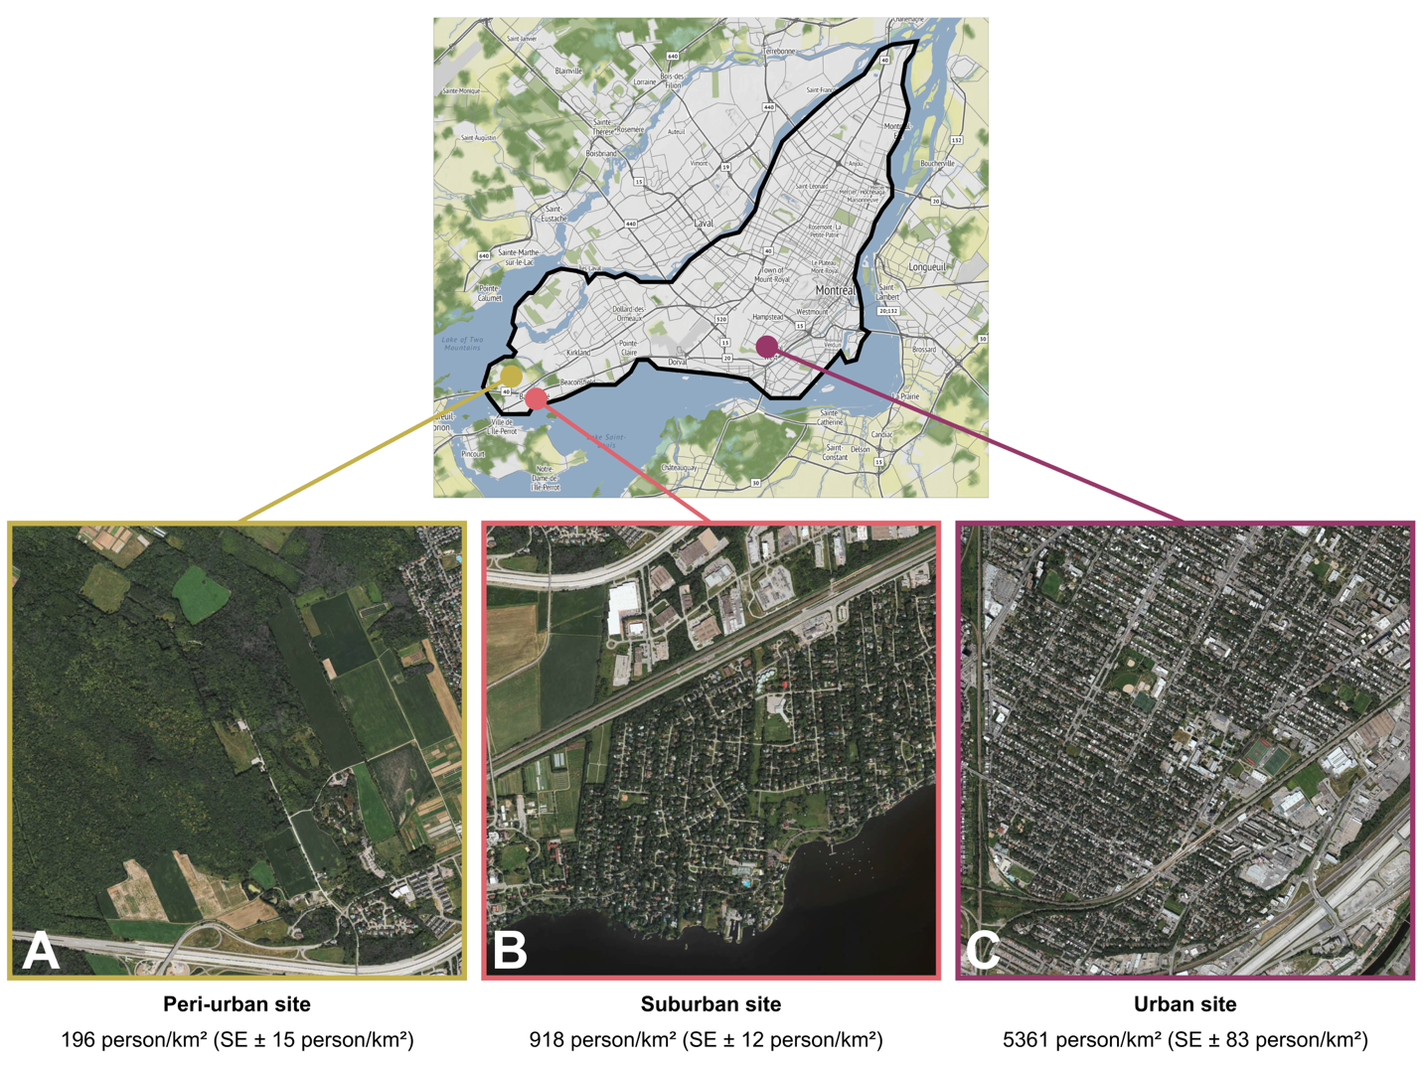Figure 1. Study locations on the Island of Montreal A) The peri-urban site is at the McGill Bird Observatory (2% of the area covered by streets and/or roads). B) The suburban site (5% of the area covered by streets and/or roads) is located in the residential Town of Baie d’Urfé. C) The urban site (13% of the area covered by streets and/or roads) is located in Notre-Dame-de-Grâce neighbourhood.

All translocation sites had a significantly different level of urbanization from one another following a Kruskal-Wallis test and a Bonferroni-corrected pairwise Wilcoxon test (p < 0.001) based on population density data from the Cancensus Program R package (von Bergmann et al. 2021), using census data from the Government of Canada for the year 2021. All three sites are characterized by relatively high levels of green space compared to the broader urban context of Montreal. The gradient used here ranges from the higher percentages of canopy covers in the peri-urban site to the median canopy cover for the Montreal area (~ 26%) (HealthyDesign.City 2021). As such, this gradient does not fully capture the extent of urbanization present across the entire city and should be interpreted as a localized urbanization gradient. We did try translocating C. cardinalis to areas with lower canopy cover early on, but due to two immediate mortalities we decided to omit this site.

Radio tagging, banding & translocation
All birds were caught during routine fall migration monitoring at MBO and were fitted with colour bands and Motus NanoTags following standard banding and morphological measurements (see Supplemental Information). C. cardinalis translocated to sites away from the peri-urban location (suburban and urban), as well as control birds held at the peri-urban site, underwent a holding time of 45 minutes before release to standardize treatment amongst individuals. For the winter of the year 2022-2023 (winter 1), we were able to consistently track 20 birds released as control at the peri-urban site, which served as a pilot winter to assess the feasibility of the project. During the winter of 2023-2024 (winter 2), a total of 45 birds were tagged and banded, with 15 individuals translocated to the urban site, 15 translocated to the suburban site and 15 released as controls at the peri-urban site. In 2024-2025 (winter 3), a total of 42 birds were tagged and banded, with 5 individuals released as controls at the peri-urban site, 16 individuals translocated at the suburban site and 21 individuals translocated at the urban site. During the reproductive season, C. cardinalis with tags (weighing 1.6 g [double the 0.8 g of our tags]) attached defended their nests less vigorously, but did not change their provisioning effects (Barron et al. 2013). C. cardinalis’ nests with tagged parents also had lower daily survival rates and were less likely to fledge offspring (Barron et al. 2013). However, these tag effects were relatively modest and observed across diverse habitats, making it improbable that they would only manifest in our dense urban site while remaining undetected in peri-urban and suburban locations. Birds were banded under Animal Use Protocol 2007-5447 from McGill University and federal banding permits 10973, 10973B, 10973D issued by the Canadian Wildlife Service, and radio-tagged under Animal Use Protocol 22BF01 and 23BF01 from Environment and Climate Change Canada.

C. cardinalis abundance and seasonal distribution
To investigate C. cardinalis’ historical abundance in Quebec, Canada, we used data from the Audubon Christmas Bird Count, more specifically we extracted the number of C. cardinalis recorded per party hours in the states of Maine, New York, New Hampshire and Vermont (United States), along with the data from Quebec (Canada) (National Audubon Society 2015).

Non-breeding season tracking and home range estimations
The birds were monitored using an array of automated Motus towers and handheld telemetry receivers. We conducted manual radio tracking of each individual two to three times per week between the months of October and May each year. The areas monitored were approximately 5 km² (500 ha) at the peri-urban site, 6 km² (600 ha) for the suburban site and 18 km² (1800 ha) for the urban site. The people tracking the birds by hand (trackers) would cover as much ground as possible at each study location with the goal of recording at least one GPS location for each individual per week using a Garmin ETREX 22x GPS. Details on the tracking method used and estimations of precision can be found in the Supplemental Information section.
For all three study sites, we calculated the average home range size using the Kernel Density Estimation (KDE), a non-parametric way to estimate the probability density function of a random variable based on a finite data sample (in the present case, the C. cardinalis GPS location recorded in the field) with the adehabitatHR: Home Range Estimation R package version 0.4.22 (Calenge 2024). We selected the 50% and 95% contours to investigate respectively the core area used within the home range of the birds and the broader home range excluding the most extreme locations (outliers). A minimum of 5 GPS locations were required to adequately run the function to calculate the KDEs meaning that individuals with fewer points than this threshold were excluded. Between 5 and 48 points per individual were used to estimate the KDEs, with the average number of points per bird being 17.
$$K\left(u\right)= \frac{1}{\sqrt{2π}}e^{-\frac{1}{2}u^{2}}$$
Where:
$K(u)$ is the kernel function evaluated at u, providing the weight assigned to a data point based on its distance to the target location.
$u= \frac{x-x_{i}}{h}$ is the standardized distance between the location x (where the density is being estimated) and the observed data point x_{i}, scaled by the bandwidth h.
h is the bandwidth parameter, which determines the smoothness of the resulting density estimate; smaller values of h lead to a rougher estimate, while larger values produce a smoother result.
$\frac{1}{\sqrt{2π}}$ is the normalization constant ensuring that the kernel integrates to one.
e is Euler’s number (approximately 2.718), the base of the natural logarithm.

Scale of effect
We first identified the scale of effect (i.e., the spatial extent at which landscape variables have the strongest relationship with a species’ response’) by extracting variables at four spatial scales (25, 50, 100, 200 meters; Martin & Fahrig, 2012). These spatial scales were chosen because they cover a wide range of possible scale of effect that are highly relevant in urban ecology, considering that habitat heterogeneity is scale-dependent. For each scale we ran generalized linear mixed models (GLMMs) at each study location using all five predictor variables as well as year, site, and individual ID as random effects. We ranked models using Akaike Information Criterion (AICc) values, which take into account small sample sizes (Burnham and Anderson 2002). The best model was identified as having the lowest AICc value. We also calculated the $∆$AICc to evaluate competing models following Burnham and Anderson (2002) (models with a $∆$AICc < 2 were considered to have substantial support, competing with the best model and models with a $∆$AICc > 10 were deemed to have no support, not competing with the best model). Once the scale of effect was determined for each location, we conducted a resource selection function.

Resource Selection Function
We compared ‘used’ vs. ‘available’ habitat using a resource selection function for C. cardinalis during the non-breeding season and across an urban gradient. We used environmental and anthropogenic variables extracted from available spatial data as well that collected in the field. This included mean and standard deviation (SD) of vegetation height (1m resolution) from OpenForest (Government and Municipalities of Quebec 2016), distance to nearest bird feeder (collected through systematic field observations), population density data (census unit) using the Cancensus R package (von Bergmann et al. 2021) and spatial data on the streets and road from the island of Montreal (Ville de Montréal 2018). Unused locations were derived at a 1:1 ratio by creating random locations within 300 meters of the used location, at a random angle. The average number of true observations for each individual ranges from 5 to 48 with an average number of points of 18. Having a ratio of 1:1, the same numbers apply for the random observations. For each study site, we ran a “Full model” (Used ~ Mean vegetation height + Sd vegetation height + Population density + Road length + Distance to nearest feeder + (1|Winter) + (1|Site) + (1|ID)), including all of the variables, plus the winter (years of sampling), relocation site and bird ID as random effects. The second model we ran was the “Vegetation height” model (Used ~ Mean vegetation height + (1|Winter) + (1|Site) + (1|ID)), assuming the vertical height of vegetation was a primary factor for decision making. The third model we ran was “Sd vegetation height” (Used ~ Sd vegetation height + (1|Winter) + (1|Site) + (1|ID)), in this case, we assume that the vertical composition was a more predominant decision-making factor compared to height on its own. The fourth model we ran was the “Human model” (Used ~ Population density + Road length + Distance to nearest feeders + (1|Winter) + (1|Site) + (1|ID)), which assumed that the C. cardinalis would rely mostly on human-related cues to select a wintering habitat. The final model we ran was the “Null” model, including only the random effects variables (Used ~ + (1|Winter) + (1|Site) + (1|ID)). We then once again selected the best models according to the corrected Akaike Information Criterion (AICc) following the method previously described by Burnham and Anderson (2002). We used Variance Inflation Factor (VIF) to test for multicollinearity (variables with VIF values > 10 were considered to have problematic collinearity and were removed) among predictor variables and Hosmer-Lemeshow as a goodness-of-fit test (Hosmer and Lemesbow 1980). All statistical analysis were performed using Program R version 4.4.2 (R Core Team 2024).

Results
Description of C. cardinalis trends across years and seasons
In southern Quebec, the C. cardinalis population has seen a steep increase in abundance since the 1970s (Fig. 2). As the years progress, the number of C. cardinalis reported in the northeastern United States increased as the species propagated northward, reaching southern Quebec in the 1960s (Fig. 2).
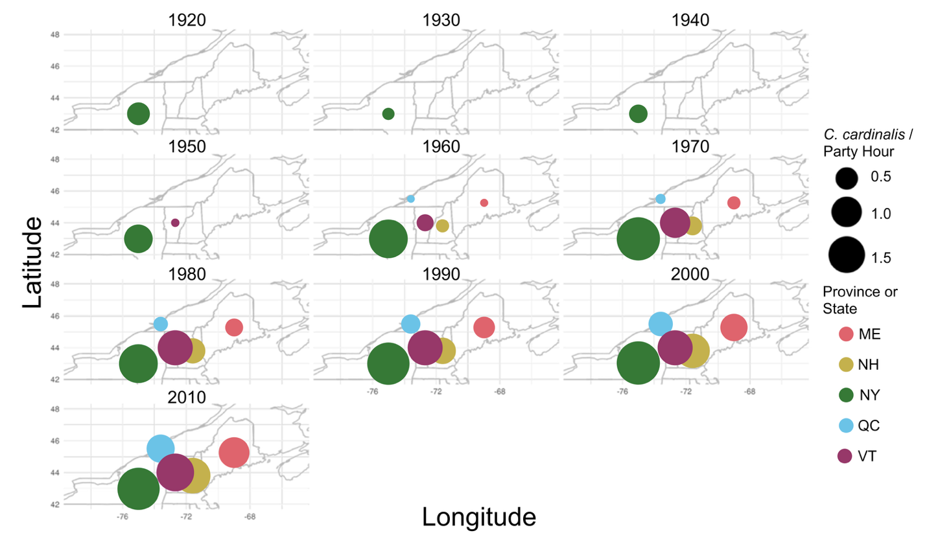Figure 2. Number of C. cardinalis observations per party hours between the 1920s and the 2010s according to state (United States of America) or province (Canada) as part of the Audubon Christmas Bird Count.
C. cardinalis captures at the McGill Bird Observatory over a 19-year period peak first in May (both banded and recaptured birds; Figure 3), approximately at the middle point of the spring migration monitoring program. During the entirety of the spring program, C. cardinalis are banded at a rate of ~ 0.27 individual per hour of mist-net opening and C. cardinalis are recaptured at a slightly higher rate of ~ 0.31 individual per hour of mist-net opening. When the fall migration monitoring program occurs, there is a steep increase in the number of C. cardinalis banded and recaptured. Banding rate goes up to ~ 0.75 individual per hour of mist-net opening (almost three times the banding rate during the spring), while recapture rate increases to 0.50 individual per hour of mist-net opening. Thus, there is an influx of unbanded birds in late fall. The individuals captured in the fall migration monitoring program are mostly aged as juveniles or unknowns (Supplementary Material Figure S1B, C). Despite this, we can still identify two distinct peaks of influx of adult C. cardinalis on site (specifically in mid-May and in late July, Supplementary Material Figure S1A) implying that this movement involved post-fledging dispersal and adult movement from breeding to non-breeding sites.
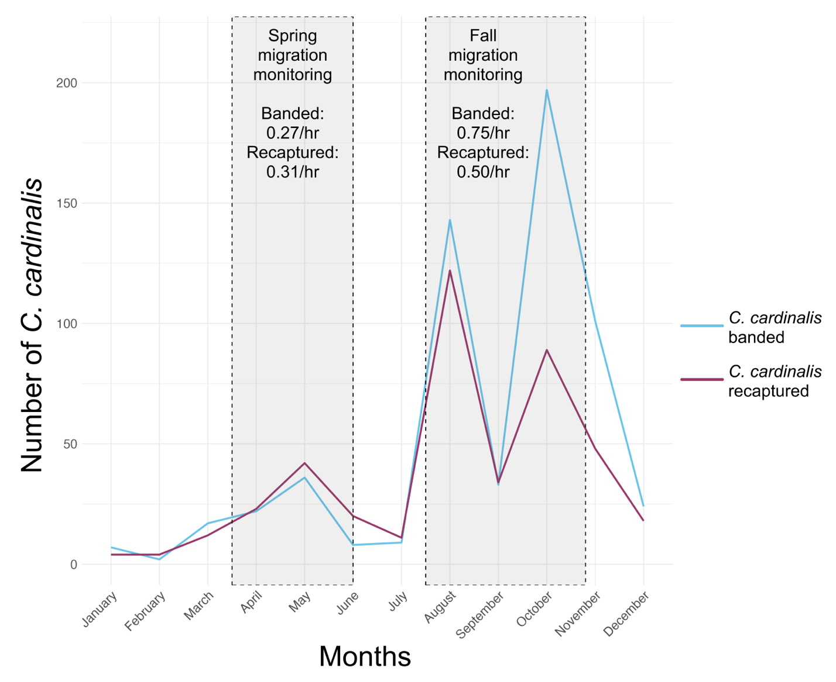Figure 3. Number of C. cardinalis banded and recaptured at the McGill Bird Observatory (peri-urban site) between 2004 and 2022 in Montreal, Quebec, Canada. The grey boxes highlight the duration of the spring and fall migration monitoring programs, along with the approximate number of C. cardinalis banded and recaptured per hours of mist-net being opened during the season.

Telemetry tracking of C. cardinalis across an urban gradient
Across three consecutive winters, we were able to track multiple individuals at all three sites and gather valuable information regarding C. cardinalis’ survival through the study. Table 1 details the number of C. cardinalis we were able to track for each field season, their apparent survival, along with the number of confirmed mortalities and the potential causes for these deaths.
Table 1. Number of C.cardinalis tracked 1 and 3 months after initial release, with apparent survival (48.15% average) and fated survival (including individuals presumed alive but outside the study area; 71% average), including known mortality events/probable causes across three sites in Montreal, Quebec, Canada between 2022 and 2025.
Site | Total number of C. cardinalis | # tracked 1 month (apparent survival) | # tracked 3 months (apparent survival) | Missing individuals after 3 months | Confirmed mortality events and probable cause of death | Survival of missing individuals (fated survival)
Peri-urban | 41 | 34 (83%) | 28 (68%) | 13 | 6  Predation (n = 4)  Unknown (n = 2) | 54%
Suburban | 31 | 19 (61%) | 18 (58%) | 13 | 4  Predation (n = 2)  Disease (n = 1)  Unknown (n = 1) | 69%
Urban | 36 | 11 (31%) | 6 (17%) | 30 | 3  Predation (n = 1)  Window collision (n = 2) | 90%

Telemetry tracking was conducted 2 to 3 days per week by three people between October and May 2022-2024, for a total of ~288 days of tracking per winter. A total of 688 unique detections were recorded at the peri-urban site, 411 at the suburban site, and 265 at the urban site. The tracking team covered the maximum amount of ground possible during each outing, to record as many individuals as feasible.

Core areas and home ranges of C. cardinalis across an urban gradient
We estimated core areas and home ranges for individuals with $≥$ 5 recorded GPS locations (35 individuals from the peri-urban site, 13 from the suburban site and 9 from the urban site; Figure 4). Among the 58 individuals with $≥$ 5 recorded GPS locations, core and total home range sizes were not normally distributed (Shapiro-Wilk tests: core, W = 0.624, p < 0.001; total, W = 0.698, p < 0.001), so areas were transformed using a logarithm prior to analysis (Figure 4; Table 2).
Site | Total number of C. cardinalis included in the analyses | Core area (km²) | SE of the core area (km²) | Home range (km²) | SE of the home range (km²)
Peri-urban | 36 | 0.15 | 0.04 | 0.61 | 0.13
Suburban | 13 | 0.08 | 0.02 | 0.56 | 0.11
Urban | 9 | 0.28 | 0.11 | 1.53 | 0.52
Table 2. Number of C. cardinalis that could be included in the analyses along with their respective core areas and home ranges including standard errors across three sites in Montreal, Quebec, Canada between 2022 and 2025.

After transformation, the data met assumptions of normality and variances were homogeneous. There was no significant difference in core home range size among sites, although the effect approached significance (ANOVA: F_{2, 55} = 2.69, p = 0.077). Post-hoc comparisons show a trend towards the C. cardinalis at our urban site to have larger core home range sizes compared to the suburban and peri-urban sites (Figure 4). There was a significant difference between the three study sites regarding total home ranges (ANOVA: F_{2, 55} = 3.45, p = 0.04). Post-hoc TukeyHSD comparisons showed that the only significant difference was between the total home ranges of C. cardinalis at our urban site being larger than C. cardinalis at the peri-urban site (mean difference = 1.24, 95% CI [0.09, 2.38], p = 0.03).
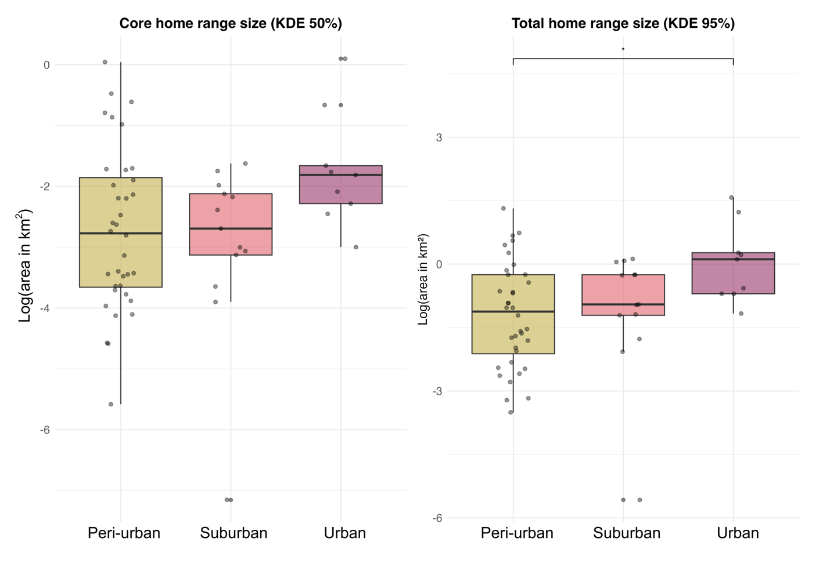Figure 4. Comparison of the core (KDE 50%) and total (KDE 95%) home ranges of C. cardinalis in three study sites (peri-urban, suburban and urban) in Montreal, Quebec, Canada during winters between the years 2022 and 2025. The area in km² was log transformed.

Scale of association to habitat
The spatial scale where habitat variables best predicted C. cardinalis habitat use (i.e., the scale of effect) on the smaller side for all three sites. At the peri-urban site, the 50-meter spatial-scale model explained the most variation seen in the data compared to the other spatial-scales (i.e., > 4 Δ AICc values between all other models; Figure 5A). For the birds at the suburban site and the urban site, the best model is the 25-meter one (> 10 Δ AICc values between all other models; Figure 5B). Lastly, for the urban site, the 25-meter model was the top model from the spatial scales investigated (> 10 Δ AICc values among all other models; Figure 5C).
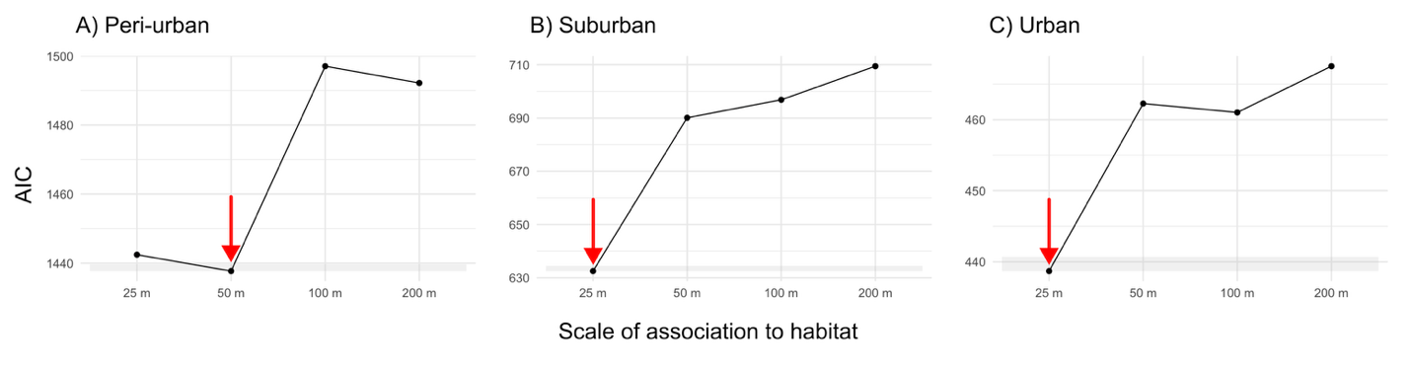Figure 5. Model ranking using AICc of generalized linear mixed models (GLM) with a comparing scale of effect of landscape variables for resighting locations (n= 57) of C. cardinalis tracked across three sites (A, B and C) in Montreal, Quebec, Canada. Arrows indicate the model with the lowest AIC value and the shaded area represent a two ∆AICc of 2 with the best model.

Resource selection: used vs. available habitats
Due to differences of urbanization level and scales of effect, resource selection function models were run separately for each study site. For the peri-urban site, the global model explained the most variation seen in the data (> 10 Δ AICc values between all other models, Supplementary Material Table S1). For the suburban site, the top model was the human covariates model (human population and road density), with the next best model (full model) < 2AICc units from the top model (Supplementary Material Table S1). Lastly for the urban site, the full model was the top model, but again the next best (human covariates) was <1 AICc from the top model (Supplementary Material Table S1). The best model for each study site was then used to generate prediction plots on the probability of presence of C. cardinalis according to the model variables (Table 3).
Table 3. Model parameters for the three resource selection models predicting the presence/absence of 56 C. cardinalis within (25 or 50 m-radius) areas based on the average vegetation height (in meters) and its standard deviation, along with human-related environmental features such as population density (in people/km²), road length (in meters) and distance to the nearest bird feeder (in meters). The data was scaled and centered before running the models. The study site, year of sampling (Winter) and the individual’s identification (ID) are included as
random effects in each model.
Study Site | Variable | Coefficient estimate | Standard error | z | p
Peri-Urban | Global model – 50 meters  Mean vegetation height (m)  Standard deviation of the mean vegetation height  Mean population density (person/km²)  Road length (m)  Distance to the nearest bird feeder (m) | -1.272  1.107  -0.095  0.023  -0.347 | 0.153  0.114  0.111  0.110  0.068 | -8.329  9.709  -0.858  0.207  -5.067 | <0.001  <0.001  0.391  0.836  <0.001
Suburban | Human covariates model – 25 meters  Mean population density (person/km²)  Road length (m)  Distance to the nearest bird feeder (m) | -0.486  1.238  -0.427 | 0.135  0.136  0.128 | -3.603  9.138  -3.342 | <0.001  <0.001  <0.001
Urban | Global model – 25 meters  Mean vegetation height (m)  Standard deviation of the mean vegetation height  Mean population density (person/km²)  Road length (m)  Distance to the nearest bird feeder (m) | 0.252  -0.458  -0.212  0.736  -0.392 | 0.180  0.191  0.131  0.135  0.141 | 1.399  -2.405  -1.620  5.438  -2.772 | 0.162  0.016  0.105  <0.001  0.006

The prediction plots including only the significant fixed effects for the resource selection functions of each locations reveal that the presence of C. cardinalis is associated with different urban and habitat features according to the site they spend their winter in (Figure 6). In the peri-urban site, the probability of presence of the C. cardinalis decreases as the mean vegetation height increases (Figure 6A), while the presence of the birds increases with greater variability in vegetation height (Figure 6B). The probability of presence of C. cardinalis also seems to decrease as the distance to the nearest bird feeder increases (Figure 6C). In our suburban site, the probability of presence of C. cardinalis shows little relationship with population density (Figure 6D), but increases as the mean road length increases (Figure 6E). Like our peri-urban site, the presence of the birds also decreases as the distance to the nearest feeder increases at the suburban site (Figure 6F). At the urban site, C. cardinalis’ probability of presence decreases with increasing vegetation height standard deviation, although uncertainty is high (Figure 6G). The presence of C. cardinalis also increased with mean road length and decreased with increasing distance to the nearest feeders. Across sites, proximity to feeders and structural complexity of the infrastructures or the vegetation consistently influenced the probability of presence, yet specific relationships varied.
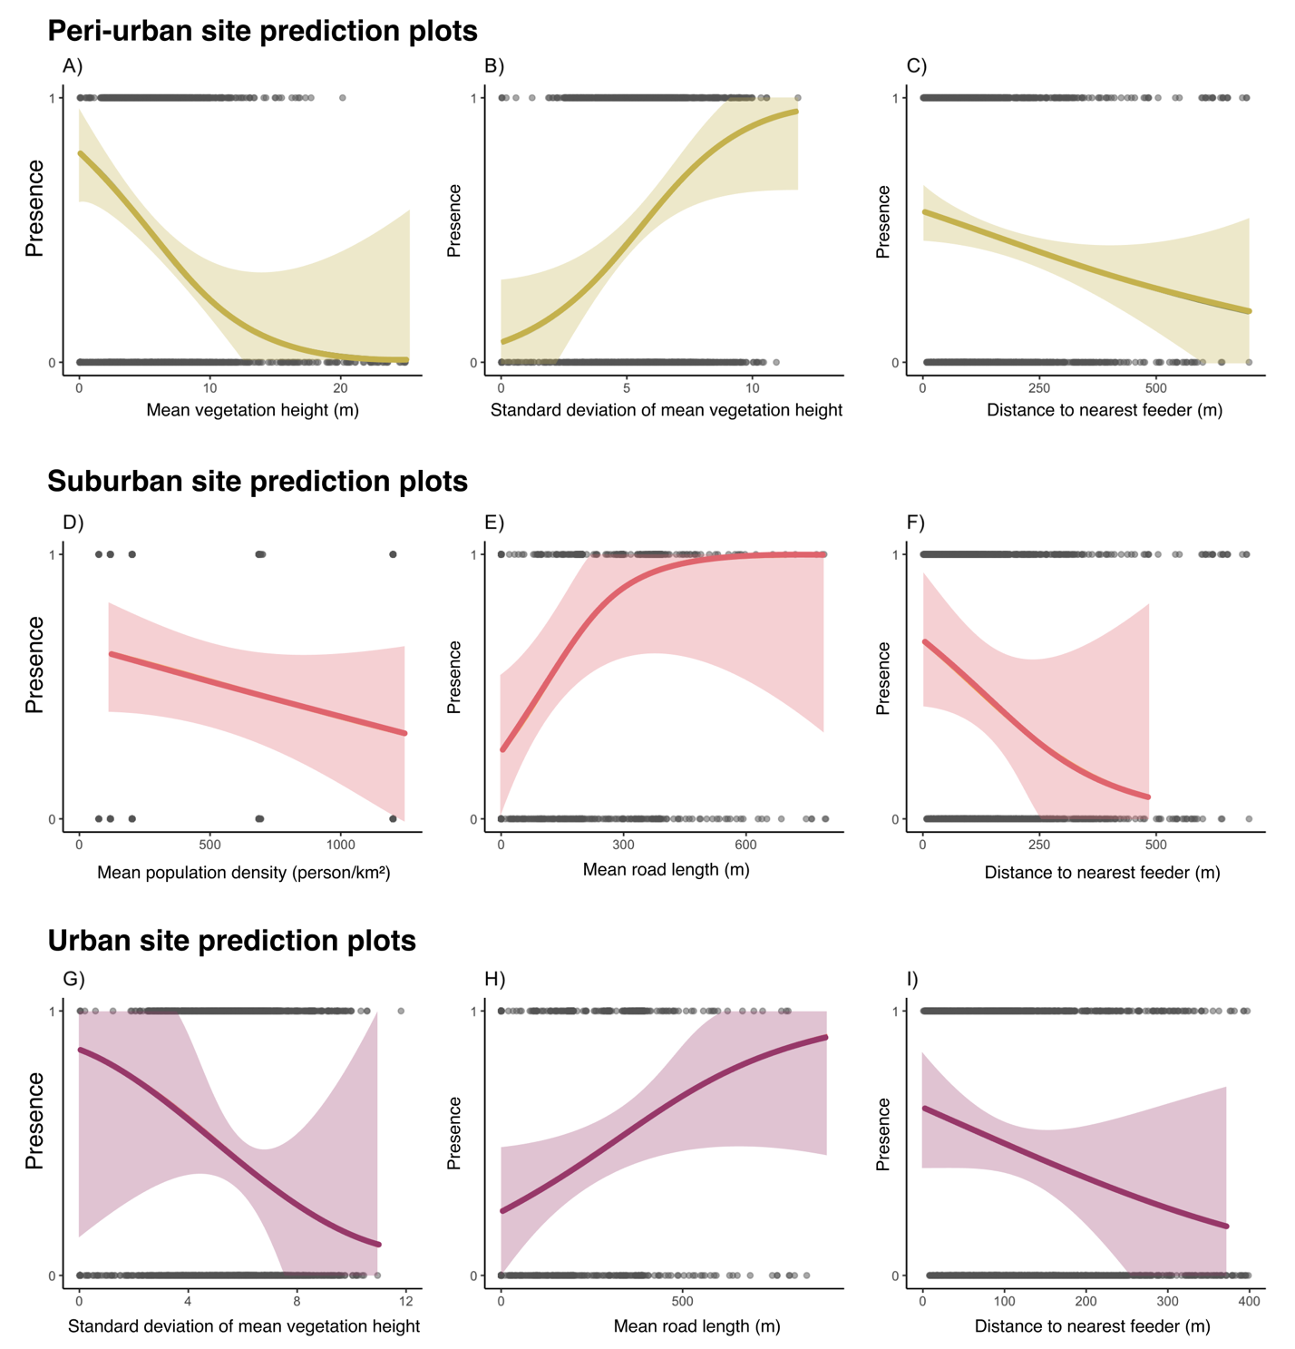Figure 6. Probability of presence of C. cardinalis in a given radius area, as predicted by a generalized linear mixed effects model. Shaded areas represent 67% confidence intervals around the predicted probabilities. The model’s fixed effect variables are described in Table 2, and for each model, random effects were sampling years, translocation site and bird ID.

Discussion
The northern range expansion of C. cardinalis is largely attributed to increasing winter temperatures along with an increase in bird-feeding, allowing C. cardinalis to remain in the northern part of their distribution range year-round (Robb et al. 2008; Robert et al. 2019; Halkin et al. 2021). The importance of bird-feeding along with parkland including varying vegetation structure was also apparent in our tracking data. Across three years of telemetry tracking data, C. cardinalis in urban locations had larger home ranges compared to those in suburban and peri-urban sites. Comparatively, the use of a fine spatial scale of habitat association (25-50 m) across the urban gradient shows that habitat use is localized in urbanized areas, highlighting the importance of having quality habitat at multiple spatial scale. What we have found on survival also indicates that urban areas are less suitable wintering locations compared to the peri-urban or suburban areas. C. cardinalis in suburban and urban sites do not spend time in parks or other larger public UGS during the non-breeding season, instead favouring the private UGS such as backyards and gardens and are strongly associated with the presence of anthropogenic food resources (i.e., birdfeeders). This highlights the often overlooked importance of private UGS in conservation, even though they are a dominant and highly diverse part of nature in cities (Goddard et al. 2010; Hutt-Taylor and Ziter 2022).

Lower apparent survival at urban site
While the apparent survival of C. cardinalis was quite similar between the peri-urban site (on average 65% after 3 months) and the suburban site (on average 57% after 3 months), it was much lower at the urban location (on average 16% after 3 months). Our apparent survival rates for the peri-urban and suburban locations are consistent with previously established annual survival in Ohio (50.5% ± 10.3 SE to 78.3% ± 7.6 SE) and in Washington D.C. (between 40 to 70%) in the United States (Shustack 2008; Evans et al. 2015). However, the very low survival rates that we are seeing in the urban location is well below what was previously found in urban habitats. C. cardinalis’ annual apparent survival was even greater as the amount of impervious surfaces (used as indicator of urbanization) increases from low to moderate (Evans et al. 2015). The lower survival in the urban environment is likely attributable to a higher concentration of anthropogenic threats; it was the only site with confirmed window collisions and indeed 67% of confirmed mortality were window collisions. Urban areas present multiple mortality risks for birds, including window collisions, strikes by vehicle and predation by domestic cats (Loss et al. 2014; Ibáñez-Álamo et al. 2020; Lopes et al. 2024). All of which can be found in both the suburban and urban site, but to a different degree. Specifically, our urban site had a far higher density of windows than our other sites, with many multi-level low-rise buildings (whereas none at other sites) that are especially dangerous for birds. An alternative explanation is that the individuals translocated to the urban site survived but moved further away from their release site and were beyond the area monitored (> 18 km²). Nevertheless, we suggest that the heightened mortality from the urban-specific threats is the primary driver of the reduced apparent survival we observed. We also cannot exclude the possibility that the C. cardinalis faced higher risks by moving in a larger area in the urban habitat, a matrix comprised of many threats like domestic cat predation in addition to window and vehicle collisions in comparison to the suburban and peri-urban areas.

Larger home ranges at urban site and the importance of bird feeders
Individuals at the urban site had the largest total (KDE 95%) home ranges (although we did not have a truly rural site, which may have also had a large home range). Because we couldn’t capture the full spectrum of urbanization, the relationship to territory size may not be linear (i.e., larger home ranges in rural and urban areas compared to smaller home ranges in peri-urban and suburban areas). P. domesticus in urban landscapes occupied smaller home ranges compared to their rural counterparts (Vangestel et al. 2010). O’Donnell (2020) also suggested that birds in urban environments generally tend to have smaller home ranges. However, female C. cardinalis venture out of their territory more often when they had supplemental feeding, compared to females that didn’t have access to supplemental food, leading to a trend towards larger home ranges (Humbird and Neudorf 2008). In our case, we found the opposite trend. By mapping the location of visible bird feeders, we determined the approximate feeder density at all sites: the peri-urban site had ~13 feeders/km², the suburban site had ~35 feeders/km² and the urban site had ~12 feeders/km². We can hypothesise that the poorer density of feeders at the urban site, along with a more dangerous matrix led C. cardinalis’s movements to be more convoluted and pushed them to travel further between these reliable resource points because of their scattered locations. On the contrary, in the suburban site (which has a feeder density over twice that of the urban site) we can hypothesise that the high feeder density allowed the birds to have access to reliable food sources coupled with simpler and shorter travel routes.

Small scale of association to habitat regardless of urbanization level
C. cardinalis are associated with habitat features at different spatial scales depending on the level of urbanization of their wintering site: 50 meters at the peri-urban site, and 25 meters in both our suburban and urban sites. This pattern suggests that as soon as human presence is more pronounced in the landscape, C. cardinalis rely more heavily on immediate habitat factors (possibly due to increased fragmentation and reduced availability of high-quality habitats at broader scales). This aligns with broader research suggesting that the magnitude and direction of species’ responses to urbanization reflects landscape-scale differences within cities (Fidino et al. 2021). Moreover, recent work on migratory birds passing through urban areas via stopover sites highlighted the value of multiscale habitat assessment since different processes can come into play at different spatial resolution (Guo et al. 2023). Our findings showing that C. cardinalis respond to finer spatial scales in more urbanized areas also support evidence that UGS size and configuration matter—especially in cities where small patches may play a critical role to support bird populations (Dale 2018). Nineteen years of banding data at the peri-urban site demonstrated that the proportion of unbanded to banded birds was similar over most of the year, implying a mostly resident population, yet there was a distinct peak of new birds in late fall (Fig. 3), suggesting a local, ‘very short-distance' migration (including post-fledging dispersal) for C. cardinalis. Our findings underscore the importance of scale-sensitive, species-specific approaches when evaluating habitat use in urban areas and join other researchers in suggesting that conservation efforts in urbanized environments may need to focus on fine-scale habitat quality to support resident species year-round (Litteral and Shochat 2017; Guo et al. 2023). In our case, bird feeders and vegetation structure had an important impact from the smallest scales (third order habitat selection) to the entire range (first order habitat selection).

Variation of preferred habitat factors across an urbanization gradient
C. cardinalis were associated with different environmental and anthropogenic habitat variables across an urban gradient, suggesting that ecological needs and drivers of winter survival by C. cardinalis in human-modified landscapes is context-dependent (peri-urban vs suburban vs urban. The one consistent association across study sites was the relationship between C. cardinalis’ presence and a shorter distance to the closest bird feeder—which is indeed apparent even at the scale of the entire range (Fig. 2; Robb et al. 2008). This is unsurprising as C. cardinalis is one of the most common species at bird feeders within its range, especially during autumn and winter (Horn et al. 2014). C. cardinalis were also more likely to be found in areas with more paved road cover (a potential proxy for residential density) in both the suburban and urban sites. Similarly, C. cardinalis had better survival odds during the breeding season (between May and August) in Washington D.C. in areas with high proportions of impervious surfaces (Evans et al. 2015). The association with the standard deviation of the vegetation height diverged among sites. At the urban site, C. cardinalis avoided the areas of highly contrasted vegetation structures, while at the peri-urban site they were more likely to occupy an area with an elevated standard deviation. These findings highlight the importance of vegetation structure in habitat association, and agrees with previous work showing that vegetation structure is a particularly important variable in urban areas, specifically for C. cardinalis (Duren et al. 2017). Postfledging C. cardinalis in urban areas strongly select for habitat with a complex understory vegetation (Ausprey and Rodewald 2011). C. cardinalis do not exhibit the same preference in the peri-urban site potentially because there was much more habitat available or the site was more homogenous. The importance of vegetation architecture and composition in birds’ habitat selection was most likely scale-dependent (Deppe and Rotenberry 2008). Indeed, C. cardinalis selected their wintering habitats at a larger scale at the peri-urban location, compared to the urban site. At a larger scale, the vegetation vertical structure may not be as important as say the species’ composition, while at a smaller scale, habitat selection relies more on the structure of the vegetation compared to its composition.

Implications
We highlight the importance of fine-scale habitat features and resource availability in shaping winter ecology of a resident songbird along an urban gradient. The context-dependent responses we observed underscore the need for tailored, scale-sensitive conservation strategies. In particular, the reliance on bird feeders and avoidance of large public UGS suggests that private UGS may play a disproportionately important role in supporting certain overwintering birds. As urban development intensifies, integrating biodiversity-friendly practices such as preserving vertically complex vegetation and enhancing connectivity between small habitat patches could help sustain resident birds’ populations. Taken together, our results highlight how habitat selection by a resident bird species is shaped by both landscape-level context and fine-scale resource availability. This multi-scale perspective demonstrates the importance on considering hierarchical habitat use in urban ecology and conservation. More broadly, our findings join a growing body of work emphasizing the ecological importance of urban landscape’s elements and highlight the need for inclusive UGS planning that includes both public and private green infrastructures.

Literature Cited
Altwegg R, Jenkins A, Abadi F (2014) Nestboxes and immigration drive the growth of an urban Peregrine Falcon Falco peregrinus population. Ibis 156:107–115. https://doi.org/10.1111/ibi.12125
Ausprey IJ, Rodewald AD (2011) Postfledging Survivorship and Habitat Selection Across A Rural-To-Urban Landscape Gradient. The Auk 128:293–302. https://doi.org/10.1525/auk.2011.10158
Barron DG, Weatherhead PJ, Brawn JD (2013) A Test of Radio-Transmitter Effects on Parental Investment and Productivity in the Northern Cardinal. The Condor 115:669–676. https://doi.org/10.1525/cond.2013.120149
Beddall B (1963) Range Expansion of the Cardinal and Other Birds in the Northeastern States. Wilson Bull 75:140–158
Bressler SA, Diamant ES, Tingley MW, Yeh PJ (2020) Nests in the cities: adaptive and non-adaptive phenotypic plasticity and convergence in an urban bird. Proc R Soc B Biol Sci 287:20202122. https://doi.org/10.1098/rspb.2020.2122
Burnham KP, Anderson DR (2002) Model Selection and Multimodel Inference, 2nd edn.
Calenge C (2024) adehabitatHR: Home Range Estimation
Callaghan CT, Cornwell WK, Poore AGB, et al (2021) Urban tolerance of birds changes throughout the full annual cycle. J Biogeogr 48:1503–1517. https://doi.org/10.1111/jbi.14093
Carrasco L, Giam X, Papeş M, Sheldon KS (2019) Metrics of Lidar-Derived 3D Vegetation Structure Reveal Contrasting Effects of Horizontal and Vertical Forest Heterogeneity on Bird Species Richness. Remote Sens 11:743. https://doi.org/10.3390/rs11070743
Dale S (2018) Urban bird community composition influenced by size of urban green spaces, presence of native forest, and urbanization. Urban Ecosyst 21:1–14. https://doi.org/10.1007/s11252-017-0706-x
DeCandido R, Allen D (2006) NOCTURNAL HUNTING BY PEREGRINE FALCONS AT THE EMPIRE STATE BUILDING, NEW YORK CITY. Wilson J Ornithol 118:53–58. https://doi.org/10.1676/1559-4491(2006)118%255B0053:NHBPFA%255D2.0.CO;2
Deppe JL, Rotenberry JT (2008) SCALE-DEPENDENT HABITAT USE BY FALL MIGRATORY BIRDS: VEGETATION STRUCTURE, FLORISTICS, AND GEOGRAPHY. Ecol Monogr 78:461–487. https://doi.org/10.1890/07-0163.1
Dinh KV, Albini D, Orr JA, et al (2023) Winter is coming: Interactions of multiple stressors in winter and implications for the natural world. Glob Change Biol 29:6834–6845. https://doi.org/10.1111/gcb.16956
Duren AM, Williams CK, D’amico V (2017) Microhabitat Factors Associated with Occupancy of Songbirds in Suburban Forest Fragments in the Eastern United States. Am Midl Nat 178:189–202. https://doi.org/10.1674/0003-0031-178.2.189
Elmqvist T, Fragkias M, Goodness J, et al (2013) Urbanization, biodiversity and ecosystem services: challenges and opportunities: a global assessment. Springer Nature
Evans BS, Ryder TB, Reitsma R, et al (2015) Characterizing avian survival along a rural‐to‐urban land use gradient. Ecology 96:1631–1640. https://doi.org/10.1890/14-0171.1
Fidino M, Gallo T, Lehrer EW, et al (2021) Landscape‐scale differences among cities alter common species’ responses to urbanization. Ecol Appl 31:e02253. https://doi.org/10.1002/eap.2253
Frei B, Morales A, Cousineau A-M, Beauchamp A (2024) Montreal Northern Cardinal Winter Movements (Project 882)
Fristoe TS (2015) Energy use by migrants and residents in North American breeding bird communities. Glob Ecol Biogeogr 24:406–415. https://doi.org/10.1111/geb.12262
Goddard MA, Dougill AJ, Benton TG (2010) Scaling up from gardens: biodiversity conservation in urban environments. Trends Ecol Evol 25:90–98. https://doi.org/10.1016/j.tree.2009.07.016
Government and Municipalities of Quebec (2016) Lidar - Digital models (terrain, canopy, slope, level curve) - Open Government Portal. https://open.canada.ca/data/en/dataset/5e5d2750-d129-4952-b9fc-f824c5e480b4. Accessed 17 Nov 2025
Guo F, Buler JJ, Smolinsky JA, Wilcove DS (2023) Autumn stopover hotspots and multiscale habitat associations of migratory landbirds in the eastern United States. Proc Natl Acad Sci 120:e2203511120. https://doi.org/10.1073/pnas.2203511120
Hahs AK, Fournier B, Aronson MFJ, et al (2023) Urbanisation generates multiple trait syndromes for terrestrial animal taxa worldwide. Nat Commun 14:4751. https://doi.org/10.1038/s41467-023-39746-1
Halkin SL, Shustack DP, DeVries MS, et al (2021) Northern Cardinal (Cardinalis cardinalis), version 2.0. Birds World. https://doi.org/10.2173/bow.norcar.02
Havlíček J, Riegert J, Fuchs R (2022) A comparison of foraging-range sizes, flight distances and foraging habitat preferences in urban and rural House Sparrow (Passer domesticus) populations. Ibis 164:1227–1242. https://doi.org/10.1111/ibi.13072
HealthyDesign.City (2021) HealthyPlan.City
Horn DJ, Johansen SM, Wilcoxen TE (2014) Seed and feeder use by birds in the United States and Canada. Wildl Soc Bull 38:18–25. https://doi.org/10.1002/wsb.365
Hosmer DW, Lemesbow S (1980) Goodness of fit tests for the multiple logistic regression model. Commun Stat - Theory Methods 9:1043–1069. https://doi.org/10.1080/03610928008827941
Humbird SK, Neudorf DLH (2008) THE EFFECTS OF FOOD SUPPLEMENTATION ON EXTRATERRITORIAL BEHAVIOR IN FEMALE NORTHERN CARDINALS. The Condor 110:392–395. https://doi.org/10.1525/cond.2008.8427
Hutt-Taylor K, Ziter CD (2022) Private trees contribute uniquely to urban forest diversity, structure and service-based traits. Urban For Urban Green 78:127760. https://doi.org/10.1016/j.ufug.2022.127760
Ibáñez-Álamo JD, Morelli F, Benedetti Y, et al (2020) Biodiversity within the city: Effects of land sharing and land sparing urban development on avian diversity. Sci Total Environ 707:135477. https://doi.org/10.1016/j.scitotenv.2019.135477
Johnson DH (1980) The Comparison of Usage and Availability Measurements for Evaluating Resource Preference. Ecology 61:65–71. https://doi.org/10.2307/1937156
Jokimäki J, Kaisanlahti-Jokimäki M-L, Suhonen J (2022) Long-Term Winter Population Trends of Corvids in Relation to Urbanization and Climate at Northern Latitudes. Animals 12:1820. https://doi.org/10.3390/ani12141820
Kauffman MJ, Frick WF, Linthicum J (2003) ESTIMATION OF HABITAT‐SPECIFIC DEMOGRAPHY AND POPULATION GROWTH FOR PEREGRINE FALCONS IN CALIFORNIA. Ecol Appl 13:1802–1816. https://doi.org/10.1890/01-5324
Latimer CE, Zuckerberg B (2021) Habitat loss and thermal tolerances influence the sensitivity of resident bird populations to winter weather at regional scales. J Anim Ecol 90:317–329. https://doi.org/10.1111/1365-2656.13332
Li G, Fang C, Li Y, et al (2022) Global impacts of future urban expansion on terrestrial vertebrate diversity. Nat Commun 13:1628. https://doi.org/10.1038/s41467-022-29324-2
Litteral J, Shochat E (2017) The Role of Landscape-Scale Factors in Shaping Urban Bird Communities. In: Murgui E, Hedblom M (eds) Ecology and Conservation of Birds in Urban Environments. Springer International Publishing, Cham, pp 135–159
Lopes AC, Rocha GOC, de Oliveira Passos MF, et al (2024) The Influence of Building Surroundings and Glass Cover in Bird Collisions. Birds 5:703–711. https://doi.org/10.3390/birds5040048
Loss SR, Will T, Marra PP (2014) Estimation of bird-vehicle collision mortality on U.S. roads. J Wildl Manag 78:763–771. https://doi.org/10.1002/jwmg.721
Lowry H, Lill A, Wong BBM (2013) Behavioural responses of wildlife to urban environments. Biol Rev 88:537–549. https://doi.org/10.1111/brv.12012
Manly BF, McDonald LL, Thomas DL, et al (2002) Resource selection by animals: statistical design and analysis for field studies. Springer
Martin AE, Fahrig L (2012) Measuring and selecting scales of effect for landscape predictors in species–habitat models. Ecol Appl 22:2277–2292. https://doi.org/10.1890/11-2224.1
Murray MH, Sánchez CA, Becker DJ, et al (2019) City sicker? A meta‐analysis of wildlife health and urbanization. Front Ecol Environ 17:575–583. https://doi.org/10.1002/fee.2126
National Audubon Society (2015) The Christmas Bird Count Historical Results
O’Donnell K, delBarco-Trillo J (2020) Changes in the home range sizes of terrestrial vertebrates in response to urban disturbance: a meta-analysis. J Urban Ecol 6:juaa014. https://doi.org/10.1093/jue/juaa014
Poirier V, Elliott KH, Frei B (2024) Peri-urban forest margins are important stopover sites for moult-migrating songbirds. J Nat Conserv 77:126539. https://doi.org/10.1016/j.jnc.2023.126539
R Core Team (2024) R: A Language and Environment for Statistical Computing
Robb GN, McDonald RA, Chamberlain DE, Bearhop S (2008) Food for thought: supplementary feeding as a driver of ecological change in avian populations. Front Ecol Environ 6:476–484. https://doi.org/10.1890/060152
Robert M, Hachey M-H, Lepage D, Couturier A (2019) Second Atlas of the Breeding Birds of Southern Québec
Rousseau JS, Savard J-PL, Titman R (2015) Shrub-nesting birds in urban habitats: their abundance and association with vegetation. Urban Ecosyst 18:871–884. https://doi.org/10.1007/s11252-014-0434-4
Šálek M, Grill S, Riegert J (2020) Nest-site selection of an avian urban exploiter, the Eurasian magpie Pica pica, across the urban-rural gradient. J Vertebr Biol 70:. https://doi.org/10.25225/jvb.20086
Seress G, Liker A (2015) Habitat urbanization and its effects on birds. Acta Zool Acad Sci Hung 61:373–408
Shustack DP (2008) Reproductive Timing of Passerines in Urbanizing Landscapes. The Ohio State University
Simberloff RA, Phillips JN, Derryberry GE, et al (2023) Communication distance predicts territory size: implications for an urban songbird. Anim Behav 203:89–99. https://doi.org/10.1016/j.anbehav.2023.05.016
Simkin RD, Seto KC, McDonald RI, Jetz W (2022) Biodiversity impacts and conservation implications of urban land expansion projected to 2050. Proc Natl Acad Sci 119:e2117297119. https://doi.org/doi:10.1073/pnas.2117297119
Smith BT, Escalante P, Hernández Baños BE, et al (2011) The role of historical and contemporary processes on phylogeographic structure and genetic diversity in the Northern Cardinal, Cardinalis cardinalis. BMC Evol Biol 11:136. https://doi.org/10.1186/1471-2148-11-136
Vangestel C, Braeckman BP, Matheve H, Lens L (2010) Constraints on home range behaviour affect nutritional condition in urban house sparrows (Passer domesticus): RANGING BEHAVIOUR IN URBAN HOUSE SPARROWS. Biol J Linn Soc 101:41–50. https://doi.org/10.1111/j.1095-8312.2010.01493.x
Vaz S, Manes S, Khattar G, et al (2023) Global meta-analysis of urbanization stressors on insect abundance, richness, and traits. Sci Total Environ 903:165967. https://doi.org/10.1016/j.scitotenv.2023.165967
Ville de Montréal (2018) Chaussée agrégée et intersection (Base de données des actifs de voirie)
von Bergmann J, Shkolnik D, Jacobs A (2021) cancensus: R package to access, retrieve, and work with Canadian Census data and geography
Wang H, He Q, Liu X, et al (2012) Global urbanization research from 1991 to 2009: A systematic research review. Landsc Urban Plan 104:299–309

Supplemental material
C. cardinalis tagging procedure
We mist netted C. cardinalis (males and females) at the McGill Bird Observatory (MBO) during October and November of the year 2022, 2023 and 2024. The birds were intercepted using 30 mm Japanese Nylon nets and placed in small cotton bags to reduce stress before handling. As part of the migration monitoring being done at the MBO, we banded all C. cardinalis with a numbered aluminum band issued by the Canadian Bird Banding Office. The individuals were sexed, aged, weighed, and randomly assigned to one of the six possible release sites consisting of translocation sites and control sites at the capture location. In addition to the aluminum band, we fitted all C. cardinalis with a set of heat-sealed coloured plastic bands, each with a unique combination of colours. This allowed visual identification of the individuals without having to resort to a radio tag receiver. Each bird was equipped with a Lotek NanoTag (NTQB-2) weighing 0.8 grams, using soft elastics in a figure 8 harness configuration (the total weight of the tag, harness, and glue was less than 3% of C. cardinalis’ body weight). All the radio-tags were registered as part of the Motus Wildlife Tracking System (Frei et al. 2024).
Motus tower locations
During the first winter, only 2 automated receiver towers from the Motus network were deployed. The first tower is located at the peri-urban site (4525’50.4”N 73˚56’18.6”W), while the second tower is located on top of a faculty building at McGill University’s Macdonald campus (45˚24’28.3”N 73˚56’20.3”W). For the second winter, those two towers were also used for continuous data location, with the addition of a third temporary receiver tower that we installed at the suburban site (45˚24’39.3”N 73˚55’48.3”W). Finally, during the third winter, a fourth, permanent Motus tower was installed on top of a building at Concordia University’s Loyola campus location at the urban site (45˚27’32.6”N 73˚38’30.2”W).

Detailed use of gain and signal strength when tracking
The gain is a value between 0 and 100, representing the amplification of the received signal. By increasing it, the tracker increases how sensitive the receiver is to incoming radio signals. Higher gain values increase the ability to detect weaker signals but are also subject to background noise and interference. Using a lower gain reduces noise but may result in missing weak signals. In urbanized locations, the starting gain will rarely surpass 70-80 as the receiver picks up too much noise and interference. The signal is a value ranging from 0 to 200 for the SRX800 and 0 to 250 for the SRX1200. It represents the strength of the detected transmission from a radio tag, displayed in decibels (dB) on the receiver. A stronger signal indicates that the bird is closer; trackers use this information to estimate distance and direction. Trackers begin their tracking sessions with a gain of 80-70 to increase their chances of detecting nearby individuals. Once the receiver picks up a C. cardinalis’ tag, the tracker moves toward the direction with the strongest signal. Once a threshold of 150 dB (SRX800) or 200 dB (SRX1200) is attained, the trackers then lower the gain by 10 and repeat this process until they reach the tagged individual. The trackers only record a GPS point if the signal strength is 150 or 200 dB, with a gain of 40 or less. While visual confirmation was difficult to achieve due to the nature of the release habitats (high density of private property), prior testing with radio tags showed that we could assume the bird to be within 10-15 meters when the gain was $≤$ 30 and the signal strength $≥$ 150 dB for the SRX800 receivers (or 200 db for the SRX1200). The handheld receivers were either Lotek’s SRX800 or SRX1200. They were operated by setting the frequency to 166.380 MHz (Motus tags’ frequency for the Western hemisphere) and using both the gain and the signal strength to get as close as possible to the tagged individuals. We were usually able to detect birds that were within 200 meters of our location, and on some rare occasions were even able to pick up signals of birds located as far as 800 meters away. We did encounter a significantly higher level of static noise when tracking at the urban location, yet it was not enough to prevent us from finding birds within the detection range. Another factor that could have complicated tracking efforts was the occasional aggregation of multiple birds, which can make it difficult to obtain precise location data. In most cases, no more than two birds were observed together. When larger groups were detected, the majority typically dispersed before we could approach close enough to record a GPS location. Overall, however, such aggregations were infrequent and are therefore unlikely to have significantly affected the accuracy of our tracking data.

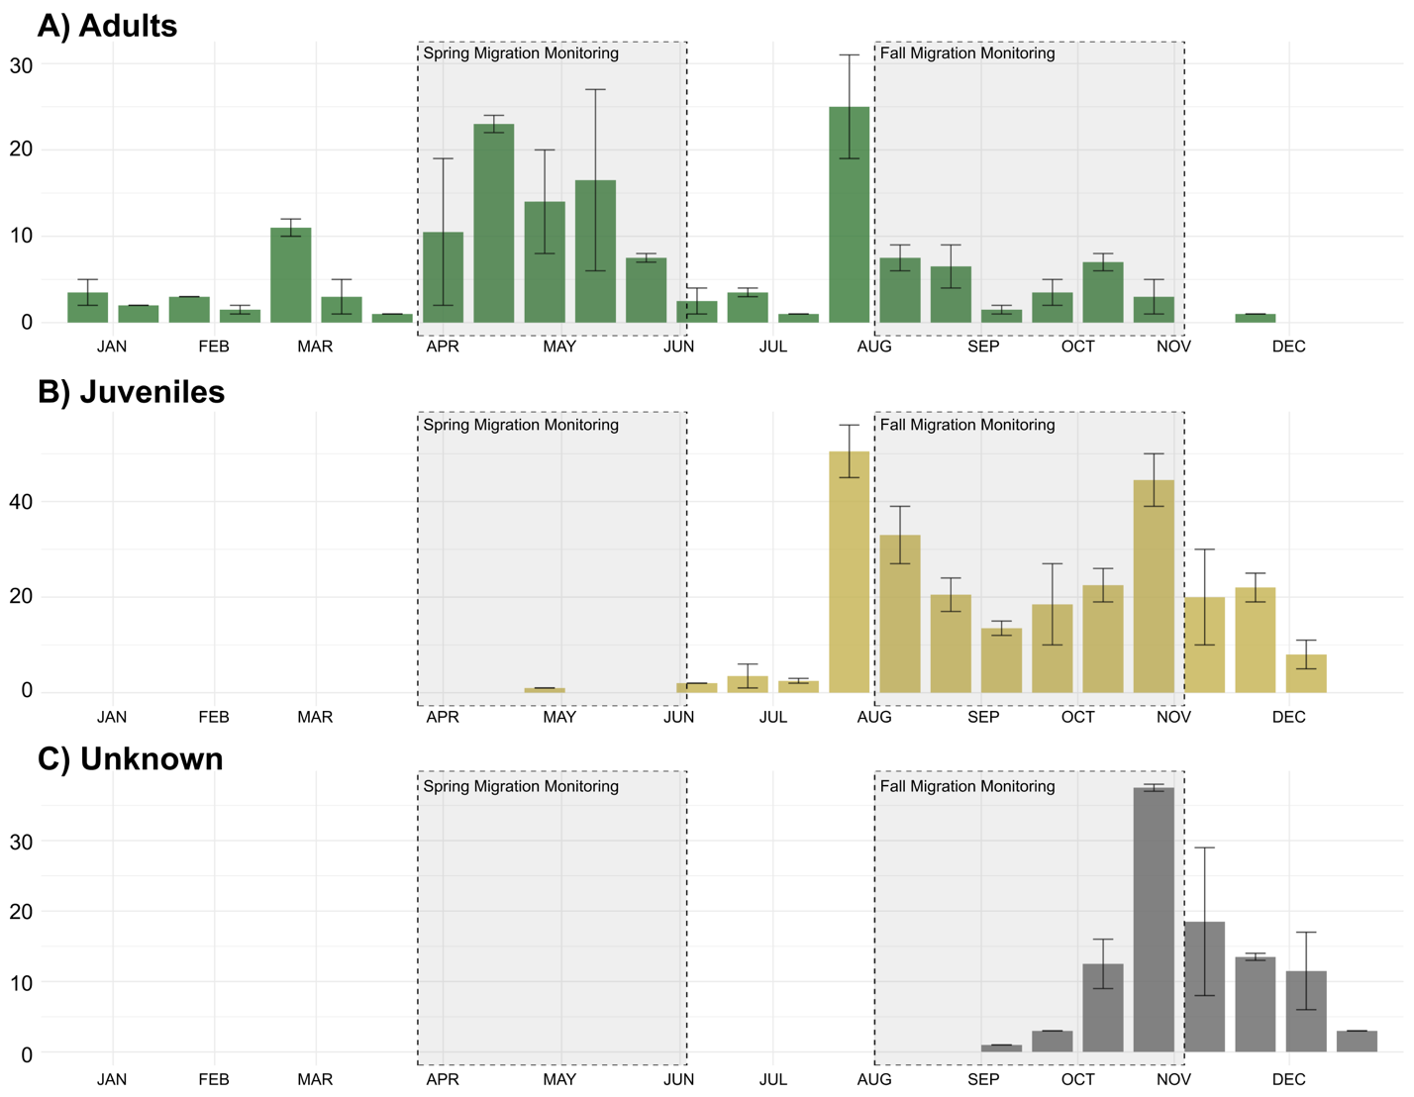Figure S1. Mean number of C. cardinalis captured at the McGill Bird Observatory (peri-urban site) between 2004 and 2022 in Montreal, Quebec, Canada separated by age where A) shows adult birds, B) shows juvenile birds and C) shows unknown individuals.

Table S1. Model ranking using AICc of generalized linear mixed models (GLM) with a comparing scale of effect of landscape variables for resighting locations (n= 57) of C. cardinalis tracked across three sites in Montreal, Quebec, Canada.
Study site | Model | Variables | LL | Δ AICc | Wt
Peri-urban | 25 meters  50 meters  100 meters  200 meters | Mean vegetation height + sd vegetation height + mean population density + road length + distance to nearest feeder | -722.48  -713.97  -735.69  -740.60 | 17.02  0.00  53.25  46.96 | 0.00  1.00  0.00  0.00
Suburban | 25 meters  50 meters  100 meters  200 meters | Mean vegetation height + sd vegetation height + mean population density + road length + distance to nearest feeder | -296.05  -338.31  -344.25  -349.92 | 0.00  84.52  96.39  107.73 | 1.00  0.00  0.00  0.00
Urban | 25 meters  50 meters  100 meters  200 meters | Mean vegetation height + sd vegetation height + mean population density + road length + distance to nearest feeder | -211.09  -225.64  -224.02  -228.79 | 0.00  29.11  25.85  35.40 | 1.00  0.00  0.00  0.00
Table S2. AIC values used to determine the best fitting model to explain C. cardinalis habitat associations.
Study site |  | Model | Variables | AICc
Peri-urban |  | Full  Vegetation height  Vegetation sd  Human  Null | Mean vegetation height + sd vegetation height + mean population density + road length + distance to nearest feeder + (1|Winter) + (1|ID) + (1|Site)  Mean vegetation height+ (1|Winter) + (1|ID) + (1|Site)  Sd vegetation height+ (1|Winter) + (1|ID) + (1|Site)  Mean population density + road length + distance to nearest feeder+ (1|Winter) + (1|ID) + (1|Site)  (1|Winter) + (1|ID) + (1|Site) | 1443.696  1587.124  1596.077  1588.262  1616.101
Suburban | Full  Vegetation height  Vegetation sd  Human  Null |  | Mean vegetation height + sd vegetation height + mean population density + road length + distance to nearest feeder + (1|Winter) + (1|ID) + (1|Site)  Mean vegetation height+ (1|Winter) + (1|ID) + (1|Site)  Sd vegetation height+ (1|Winter) + (1|ID) + (1|Site)  Mean population density + road length + distance to nearest feeder+ (1|Winter) + (1|ID) + (1|Site)  (1|Winter) + (1|ID) + (1|Site) | 631.7501  728.0640  724.0187  632.1451  726.1005
Urban | Full  Vegetation height  Vegetation sd  Human  Null |  | Mean vegetation height + sd vegetation height + mean population density + road length + distance to nearest feeder + (1|Winter) + (1|ID) + (1|Site)  Mean vegetation height+ (1|Winter) + (1|ID) + (1|Site)  Sd vegetation height+ (1|Winter) + (1|ID) + (1|Site)  Mean population density + road length + distance to nearest feeder+ (1|Winter) + (1|ID) + (1|Site)  (1|Winter) + (1|ID) + (1|Site) | 444.7050  486.6402  485.2496  447.8691  484.8853

