Winter survival and urban green space use of the Northern cardinal (Cardinalis cardinalis)

Anne-Marie Cousineau

Natural Resource Sciences
Agricultural and Environmental Sciences
McGill University, Montréal

August 2025

A thesis submitted to McGill University in partial fulfillment of the requirements of the degree of Master of Science in Renewable Resources

© Anne-Marie Cousineau, Montreal, Canada, 2025

Table of Contents
Preface 3
Contribution of coauthors 4
Acknowledgements 5
Abstract 6
Résumé 6
Introduction 6
Literature review 7
Research on urbanization’s effects on songbirds 7
Habitat selection and survival of songbirds in urban areas 8
Use of very high frequency (VHF) telemetry in bird research 10
Study species and study sites 12
Knowledge gaps and research objectives 14
Chapter 1: Fine-scale movements of the Northern Cardinal (Cardinalis cardinalis) across urban green spaces during the non-breeding period 16
Abstract 16
Introduction 16
Materials and methods 20
Study species 20
Study locations 22
Radio tagging, banding & translocation 24
VHF tracking & automated detections 25
Habitat characteristics from open-source datasets 26
Statistical analyses 27
Results 29
Study sites urbanization level 29
Core areas and home ranges 29
Habitat selection scale 31
Resource selection: used vs. available habitats 32
Discussion 34
Wintering home range sizes 34
Habitat selection preferences 36
Conclusion 38
Chapter 2: Seasonal variation in the activity level of the Northern cardinal (Cardinalis cardinalis) over the winter 39
Note on this chapter 39
Abstract 39
Introduction 39
Literature cited 41

Preface

This Master’s project was supervised by Dr. Kyle Elliott from the Macdonald campus of McGill University and by Dr. Barbara Frei from the Environment and Climate Change Canada – Science & Technologies Branch. The thesis’ purpose is to investigate how northern cardinals are using urban green spaces during the winter season, along with their survival and activity levels through the non-breeding season. Gathering knowledge on how green spaces support resident bird species, such as the northern cardinal, can guide future greening initiatives towards practices that support urban wildlife.

This article-based thesis is divided into two chapters. First,

Contribution of coauthors

I designed, conducted and analyzed all experiments of this thesis with the help of Dr. Kyle Elliott and Dr. Barbara Frei, except for the initial design and collection of Northern cardinal tracking data by co-author Barbara Frei during the winter of 2022 and 2023, which served as a pilot project for the first chapter. Field technicians and I collected all the GPS locations and tracking data for the Northern cardinals between 2023 and 2025.

The coauthor of chapter two (Andrew Beauchamp from Western University of London – Ontario) contributed significantly by performing changepoint analyses on the data collected through the Motus receiver towers. I completed the statistical analyses and wrote both chapters with the help of coauthors. I wrote both chapters and the literature review with the help of Dr. Kyle Elliott and Dr. Barbara Frei.

Acknowledgements

First, I would like to thank my incredible supervisors, Kyle Elliott and Barbara Frei, for this opportunity. I am grateful for your unwavering support, encouragement, and guidance through this project. Having you as mentors allowed me to develop valuable skills for my future as a biologist.
I also want to thank the dedicated staff and volunteers at the McGill Bird Observatory, especially Shawna Sevigny, Ana Morales, and Barbara Frei, for banding the Northern Cardinals, installing Motus tags, assisting with translocations over both years, and teaching me bird banding and tag deployment. Tracking cardinals over eight months was a true team effort—thank you to Mackenzie Guest, Lauren Dobie, Nathanya Goudreau, Florence Piché-Lebel, Laurianne Fallu, Elliana Tomasso, and Mathilde Lefevert for your essential help in the field. Thanks to Jean and Richard Gregson for hosting a Motus tower in their backyard.
Thank you to Concordia University for partnering on the Loyola campus tower installation, and to my committee members, Christina Davy, Carly Ziter, and Marcel Gahbauer, for their valuable feedback. I’m also grateful to my Arctic Ecology Lab mates for their constant support and advice, and to McGill University and SSHRC for funding. Special thanks to Environment and Climate Change Canada for providing 80 nanotags across two field seasons!
Finally, thank you to my family—Patricia, Gilbert, and Xi Chen—for your encouragement and patience with all my cardinal adventures.
And of course, thanks to the Northern Cardinals for being the best (and most feisty) work companions; these bright red birds will always have a special place in my heart.

Abstract

Résumé

Introduction

Literature review

Research on urbanization’s effects on songbirds
Urbanization significantly alters the landscape and its composition. Songbirds can be particularly vulnerable to urban development that often reduce species richness while increasing the density of only a few successful species (Seress & Liker, 2015). Nonetheless, cities can present both opportunities and challenges to the avifauna (Isaksson, 2018). Heavily urbanized areas can provide year-round food through bird feeders and human waste while simultaneously providing shelter against some predators that may not be as tolerant to human presence (Eötvös et al., 2018; Liker et al., 2008). Urbanization positively impacted some bird guilds, such as the granivorous and terrestrial species, whose richness increased in human-impacted habitats of Loja, Ecuador (Ordóñez-Delgado et al., 2022). On the other hand, significant challenges also arise for bird communities using urban areas. Habitat loss and fragmentation can negatively affect birds’ communities and genetic diversity (Palacio et al., 2018; Rodrigues et al., 2018; Shanahan et al., 2014). Pollution in various forms in heavily urbanized areas can also affect avian health. Organic compounds can occur in high concentrations due to their use in housing, industrial processes and during the production of a wide range of goods (Kekkonen, 2017). Such compounds affect a multitude of organisms, including birds, which can suffer from reduced clutch sizes, hormonal disturbances, reduced active parenting behaviours and more (Kekkonen, 2017). Light pollution emanating from large urban centers affects migratory and resident bird species. Resident bird species residing in urban-core areas had smaller eyes than their urban-edge counterparts, most likely due to the intense brightness from urban centers (Jones et al., 2023). For long-distance migratory bird species, light pollution can have detrimental effects such as disorientation, disruption of circadian rhythm, changes in flight behaviours and more (Cabrera-Cruz et al., 2018).
When environmental conditions are changing (including via rapid human-induced changes), behavioural traits are often one of the first displayed responses (Lane et al., 2023). For example, males of several songbird species show more aggression in urban habitats compared to their rural counterparts (Lane et al., 2023). Anthropogenic disturbances found in the city may also affect incubation behaviour, a critical life stage not only for the parents, but also for the success of the offspring (Hope et al., 2022; Lane et al., 2023). Urban great tits (Parus major) spent more time incubating, took shorter off-bouts and ended their last nest outing later during the day, compared to the females incubating in the forest (Hope et al., 2022). Population dynamics and gene flow can also be affected by urbanization, as habitat fragmentation is a major side effect of humans’ increasing needs for land and resources (V. N. Brewer et al., 2020). Although these effects can negatively impact gene diversity in songbirds’ populations, Brewer and her team showed that there seems to be an existing threshold, as low-intensity urbanization didn’t have as strong an impact on the genetic diversity of song sparrows as initially anticipated (V. N. Brewer et al., 2020). These findings highlight the importance of greening in urban areas to counteract the effects of habitat fragmentation on birds’ genetic diversity.

Habitat selection and survival of songbirds in urban areas
Habitat selection by songbirds in urban environments is influenced by a complex network of ecological and anthropogenic factors. Patch size and habitat fragmentation, which have been shown to directly affect the availability and quality of resources for birds, are among the most widely studied variables. Vegetation composition—including plant species diversity and the physical vertical structure—also plays a significant role in determining habitat suitability, particularly for foraging, shelter and nesting. When creating and managing urban green spaces, stakeholders have to consider the area-heterogeneity trade-off (Chiron et al., 2024). This trade-off stems from the fact that increasing landscape heterogeneity can inadvertently reduce patch sizes for individual habitat types, potentially disadvantaging specialist species (Chiron et al., 2024). Evidence from southern Ontario, Canada, confirmed that area (size) and natural vegetation (in opposition to horticulturally managed parks) within the urban landscape are of great importance for winter birds (i.e. Northern cardinal, Downy woodpecker, Black-capped chickadee, White-breasted nuthatch, etc.) (Smith, 2007). While it can be challenging to try and create new green corridors through a city, a New Zealand study revealed that the conversion of roofs in urban areas to green roofs supporting birds could improve native birds’ dispersal through the urban landscape (MacKinnon et al., 2023). In addition to landscape structure, resource availability, and climatic conditions can significantly influence winter survival and habitat occupancy. For instance, supplementary feeding in urban environments has been linked to non-adaptive behavioural strategies and reduced apparent survival in Great tits, highlighting the potential trade-offs of human-provided resources (Krama et al., 2023). Moreover, temperature dynamics are likely to affect winter distributions: Northern cardinals were more likely to colonize sites that were warmer relative to the previous year, especially in forested areas (Latimer & Zuckerberg, 2021). Interestingly, while some other common urban species like the House Sparrow and the American Goldfinch show resilience to urban cold, others like the Northern cardinal and the American tree sparrow demonstrate cold-driven colonization, suggesting species-specific thermal strategies (Latimer & Zuckerberg, 2021). Winter represents a period of acute and chronic energetic stress for small passerines, particularly in northern latitudes. Birds must balance reduced food availability and shorter foraging windows, along with an increased thermoregulatory demand during longer, colder nights (Petit et al., 2017). Physiological adaptations, such as the elevated heart rate observed in Eurasian blackbirds during colder temperatures could help preserve energy (Linek et al., 2021). Small passerine birds spending winter at higher latitudes are required to display optimal energy management in a multifaceted way to survive through the harsh conditions (Andreev, 1999; Brodin, 2007; Petit et al., 2017). In addition, weather severity, including extreme wind events, has been linked to increased mortality in wintering seabirds (Louzao et al., 2019). This may also be especially relevant in urban settings, where wind tunnel effects created by buildings can amplify exposure to harsh microclimates (Kamei & Maruta, 1979).

Use of very high frequency (VHF) telemetry in bird research
Telemetry tracking in wildlife research can be defined as a group of techniques used to remotely acquire information (geographical, physiological, environmental, etc.) on animals equipped with various data-collecting devices (Rodgers, 2001; Thohari, 1989). Such devices include the use of VHF/UHF (Very High Frequency and Ultra High Frequency) units, store-on-board units, GPS (Global Positioning System) units and GSM (Global System for Mobile Communication) units, among others. These technologies have significantly improved recently, particularly in satellite telemetry, where animal movements can be tracked with high success rates (Hofman et al., 2019). Moreover, the size and weight of these devices are continuously decreasing as the technology around them improves (smaller batteries with longer runtime, increased memory storage, increased use of microcomputers, etc.), generating many possible applications in the field of wildlife conservation (Hofman et al., 2019).
Some of the earliest published papers mentioning the use of tracking devices to study birds can be traced back to the 1960s. However, it was during the 1990s that telemetry tracking gained a strong interest from ornithologists. Using such devices allowed researchers to acquire valuable information on birds’ movements, behaviours and physiology without the need to restrain the individuals (Harris & Fish, 1990). Radio telemetry, for example, can provide helpful information on birds’ migratory movements, stopover sites, breeding and non-breeding grounds, and local movements (Fuller et al., 2005). This data can be extremely valuable when dealing with cases of avian disease affecting migratory birds and livestock (Fuller et al., 2005). Digital telemetry systems such as Encounternet can also provide more detailed information that can be used to study birds’ behaviour (Mennill et al., 2012). The long-term use of portable receiver stations and digital tags allows researchers to investigate birds’ social behaviours (such as social networks) and reproductive behaviours (such as Lekking and parental care) (Mennill et al., 2012).
This research project will rely heavily on VHF radio-tracking devices for data collection. VHF radio-tracking tags are a particular type of logger that does not record any location data. As the name suggests, they emit a very high-frequency radio signal that can be picked up by receiver stations or hand-held receiver devices. Researchers need to use an antenna and a receiver to get as close to the bird as possible before using a hand-held GPS device to record the location. This is probably the main disadvantage of using VHF radio tags: it’s labour-intensive as it requires the researchers to be within a certain range of the tagged bird to get a precise location (Iverson et al., 2023). Because this type of tag doesn’t include solar panels or devices to record GPS location, they can be extremely small. For example, Lotek’s Nanotags for birds and bats NTQB2-1 weighs only 0.28 grams with a maximum life expectancy of approximately 103 days (www.lotek.com). VHF radio tags are also generally less expensive than other loggers, meaning researchers can have a greater sample size for the same budget. Historically, VHF trackers have been successful at revealing fine-scale movements of birds, such as habitat use and home range sizes (D. E. Brewer et al., 2023; Naguib et al., 2022; O’Connell et al., 2023). It is important to note that the success of using VHF radio trackers at a small scale is dependent on the presence of receiver towers within the vicinity of the marked individuals, along with the researchers ' capacity to have access to the individuals in the field. Getting valuable fine-scale data on tracked birds is possible but highly labour-intensive as the researcher needs to get close enough to the bird to be able to pick up its signal. On the other hand, in areas of the world where there’s an extensive network of receiver towers (such as the Motus Wildlife Tracking network in North America), the use of VHF radio trackers can provide valuable information for long-distance monitoring, such as migration routes and stopover sites.

Study species and study sites
The Northern cardinal (Cardinalis cardinalis) is a resident bird species that is abundant in many areas of eastern North America (Halkin et al., 2021). It can be found year-round in southern Canada all the way to southern Mexico (Halkin et al., 2021). Northern cardinals have been expanding their range northward since the 1800s, and they can be characterized as urban-tolerant birds that thrive in inhabited areas (Halkin et al., 2021; Robert et al., 2019). In southern Quebec, the cardinals are strongly associated with urban and agricultural areas, along with mature deciduous forests, while being rarely found at elevations above 200 meters (Robert et al., 2019). Cardinals are 1.7 to 4 times more abundant in urban forests compared to rural ones (Leston & Rodewald, 2006). The apparent annual survival rate of adult Northern cardinals is estimated to range from 50.5% $±$ 10.3 SE to 78.3% $±$ 7.6 SE (Shustack, 2008). The principal causes of mortality for the cardinals are not well documented, with information on exposure to contaminants, disease and parasites, interspecific and intraspecific competition still fairly unknown (Halkin et al., 2021). Despite this lack of information, it’s possible to assume that predation by raptors, domestic cats and window collisions play an important role in the survival of the Northern cardinal (Lopes et al., 2024; Panchana et al., 2025; Tryjanowski et al., 2024). Breeding of cardinals can begin as early as April, with nest building lasting approximately 2 to 3 weeks and first eggs laid at the end of April or beginning of May (Halkin et al., 2021; Robert et al., 2019). Nest predation for the Northern cardinals tends to be quite high, averaging 70% in the early season, with improving success as the breeding season progresses (DeVries & Jawor, 2013; Filliater et al., 1994; Linville et al., 1998). For this reason, cardinals often have a second nest and brood later in the season, with reports of recently fledged young as late as August and September (Laskey, 1944).
The three study locations in this study are within the island of Montreal, the second largest city in Canada (Government of Canada, 2022). The first study site is the McGill Bird Observatory (MBO), a migration monitoring banding station based in Sainte-Anne-de-Bellevue on the western tip of the island (45.43˚N, 73.94˚W), more specifically in the Stoneycroft Wildlife Area, part of the MacDonald campus at McGill University (Gahbauer et al., 2015). MBO was founded in 2004 by graduate students at McGill University and is now operated by the Migration Research Foundation (MRF) (Gahbauer et al., 2015). This banding station is the only one active in southwestern Quebec and also serves as a training facility for students who wish to enhance their skills in field ornithology (Gahbauer et al., 2015). The area covered by MBO is mainly composed of mature and immature forest, wetlands and agricultural fields (Poirier et al., 2024). This study site serves as a control location with minimal human presence. The second location used in this research is the Baie d’Urfé residential area, next to the MacDonald campus of McGill University. It’s located south of MBO near the Saint-Lawrence River (45.41˚N, 73.92˚W). This area was selected as an intermediate urbanized location, as human presence is more pronounced compared to MBO, while remaining one of the greenest neighbourhoods of Montreal. The final study site selected for this project is situated in Notre-Dame-de-Grâce, close to the Concordia University Loyola campus (45.46˚N, 73.64˚W). This site serves as the most urbanized location out of the three sites selected, with a higher average population density.
These three study sites reflect different types of environments a bird may encounter in a large city. It has been shown that fragmentation, heat island effect, noise pollution and loss of habitats can constitute significant challenges for urban birds, and these may be even more challenging when the rough winter weather hits Montreal. Understanding how a resident bird species can use, move and survive across those different types of landscape is crucial to move towards greening efforts that are biodiversity-friendly.

Knowledge gaps and research objectives
Although a considerable body of research has explored the effects of urbanization on bird communities, significant knowledge gaps remain regarding fine-scale, winter-specific movement behaviours of urban-tolerant passerines like the Northern cardinal. While urbanization has been linked to changes in behaviour, habitat selection, survival and gene flow, there is a lack of detailed studies examining how individual birds use urban green spaces during the whole non-breeding season at a fine spatial and temporal scale. Most previous work has relied on coarse-resolution data or presence-absence metrics, limiting our understanding of how resident birds interact with habitats or anthropogenic features during periods of heightened energetic stress, such as winter.
In addition, while VHF telemetry has been widely used to monitor birds’ movements, its application has mostly focused on breeding or migratory periods. Studies investigating how resident passerines navigate through fragmented landscapes in winter using manual, ground-based VHF telemetry remain scarce, particularly in northern urban centers where winter conditions and urban microclimates can be quite harsh for the birds. Understanding these dynamics is crucial, especially as climate change and urban expansion continue to reshape winter conditions and resource availability in cities. Thus, the objective of this study is to use fine-scale VHF telemetry data to characterize the space use patterns and habitat preferences of the Northern cardinal across three urban locations with varying levels of urbanization on the island of Montreal. By comparing movements with habitat use and proximity to anthropogenic features, this research aims to:
- Quantify winter home range sizes in relation to urban gradient;
- Assess the influence of specific urban features (e.g., bird feeders, population density, etc.) on habitat use;
- Examine potential differences in movement behaviour and space use across sites;
- Assess winter energy expenditure variations according to local climate;
- Inform future conservation planning for urban-tolerant resident birds.
This study seeks to bring novel insights into how individual birds behave within the urban ecosystem during a challenging life-history stage and to inform the planning, design and management of urban green spaces that support wintering bird populations.

Chapter 1: Larger winter home ranges in urban than peri-urban sites for a very short distance migrant, the Northern Cardinal (Cardinalis cardinalis)

Note on this chapter

Abstract
It would really help me to have this written—what is the main message?

Introduction
Urbanization is a global phenomenon that keeps accelerating (Elmqvist et al., 2013; Simkin et al., 2022; Wang et al., 2012), dramatically altering landscapes and bringing novel challenges to wildlife (Lowry et al., 2013). Challenges include habitat fragmentation, habitat loss, chronic pollution, and more (Murray et al., 2019; Seress & Liker, 2015; Vaz et al., 2023). Future global urban expansion projections could lead to 11 to 33 million hectares of habitat loss by 2100, as well as cause a disproportionately large increase in habitat fragmentation (G. Li et al., 2022). This massive urban land conversion may lead to a 34% decline in local within-site species richness (G. Li et al., 2022). In recent years, international institutions and governments have recognized the value of creating and preserving urban green spaces (UGS). The 2022 Convention on Biological Diversity adopted the Kunming-Montreal Global Biodiversity Framework and introduced 23 global targets to be reached by the year 2030 (Stephens, 2023). Target 12 precisely touches on that matter by stating that there’s a need to “significantly increase the area and quality, and connectivity of, access to, and benefits from green and blue spaces in urban and densely populated areas” (Stephens, 2023, p. 880). Numerous studies have investigated the benefits that humans living in urbanized areas can get out of UGS. They include improved mental health, access to clean air from pollution removal by trees, cooling effects during heatwaves, and much more (Buxton et al., 2024; Cox et al., 2017; Jim & Chen, 2008; Skarbit et al., 2024). Access to UGS of high biodiversity brings greater restorative benefits for people, regardless of socio-economic variables like age or ethnic background (Wood et al., 2018). While there are multiple benefits to greening cities, it is important to highlight the challenges faced by urban planners, such as the paradox between greening and gentrification. As efforts are deployed to increase access to urban green space to address health and environmental issues, neighbourhoods become healthier, more aesthetically pleasing, increasing property values and housing costs (Wolch et al., 2014). Urban greening is complex and involves trade-offs – including issues of gentrification, cost and ecological impact – but advancing knowledge in this area remains essential to move towards biodiversity-friendly green spaces that also support human well-being.

UGS are crucial for the survival of urban wildlife. Urban forests can host shrub-nesting bird species during the reproduction season, while wintering birds rely on those UGS to survive through the harsh conditions of the non-breeding season (Kelly & Amanda, 2006; Rousseau et al., 2015). UGS also provide a wide range of benefits for the birds that find themselves in the middle of the complex urban landscape. Many urban bird species can be supported by interacting with 0.1-0.35 km² of continuous green space, while forest birds (“urban avoiders”) require larger areas (Chamberlain et al., 2007). What is interesting, however, is that adding just a little bit of additional green space to neighbourhood parks can considerably increase bird species richness. These smaller UGS are nonetheless important as they generate “stepping-stone” habitats that allow for highly mobile species like birds to navigate more easily through the urban matrix (DONNELLY & MARZLUFF, 2004).

Being mobile animals, birds are especially vulnerable to the challenges that urban areas impose. Over the past five decades, numerous bird species in Canada have experienced a significant decline in their populations (The State of Canada’s Birds Report, 2024). Amongst those groups, urbanization is often cited as a negative factor impacting bird populations (The State of Canada’s Birds Report, 2024). Indeed, numerous studies have highlighted the novel threats that birds are facing in the city: increased risk of collision with manmade structures (Chace & Walsh, 2006), acute predation by domestic cats (Seress & Liker, 2015), nesting disturbances (Bocz et al., 2017), and more. During the breeding period, UGS can provide birds with suitable nesting locations that are also food sources (Cull et al., 2025; Fernandez-Canero & Gonzalez-Redondo, 2010; K. Li et al., 2025). During the winter season, those same spaces can then provide shelter from the cold weather and potential predators (Marlès Magre et al., 2019; Šálek et al., 2024).

In Canada specifically, urban sprawl in major cities such as Montreal, Toronto and Vancouver is a phenomenon in constant expansion (Dupras & Alam, 2015; Filion et al., 2010; Furberg & Ban, 2008). Forest patch size tends to decrease as urbanization increases, leading to a reduction of the ecosystem services associated with those green spaces (Mitchell & Devisscher, 2022). For birds, this often results in an increased cost to travel between patches, lower resource availability and fewer sheltering opportunities. In addition, winters in Canada subject birds to prolonged cold weather periods, adding significant energetic stress for resident birds (Dawson et al., 1983; Swanson & Vézina, 2015). The importance of greening initiatives in heavily urbanized areas is not only crucial for the community experiencing the benefits of urban green spaces, but also for the birds and the wildlife that depend on it to survive even the harsh winters of southern Canada. In the last few years, the city of Montreal has been a leader in its efforts towards urban greening initiatives. The city adopted its Climate Plan 2020-2030 and through it is committing to plant, maintain and protect 500,000 trees, create new parks, green corridors and wetlands, restore shorelines and increase the size of protected areas so they cover 10% of the land within the city limits (City of Montreal, 2020). In the most recent progress report, the city states that as of 2023, approximately 180,000 trees were planted, and 7.6% of the land is categorized as protected and contributing to preserving biodiversity (City of Montreal, 2024). This highlights that while progress is being made, greening efforts need to ramp up in the next few years for the city to reach its goals, meaning that there’s a need to build knowledge on efficient ways to create and restore urban green spaces in a way that’ll promote biodiversity in the city.

While habitat use by breeding birds in urban environments has been well documented, much less is known about fine-scale movement patterns and habitat selection during the non-breeding season at higher latitudes, especially in relation to urbanization. There’s a lack of detailed understanding of how particular variables of the urban environment influence winter season survival and movement in resident bird species. This knowledge gap is especially relevant in temperate regions like southern Quebec, where winter poses extreme challenges for small passerines like the Northern cardinal.
We have identified three main hypotheses to investigate through this research:
- If Northern cardinals have less reliable food sources in urban areas, and their fine-scale movements are recorded through the winter in locations with varying levels of urbanization, then average home range size will correlate positively with urbanization level.
- If Northern cardinals spending the winter in urban areas have highly fragmented resources, and their fine-scale movements are recorded during the non-breeding season in sites with varying levels of urbanization, then the scale at which the birds are selecting their habitats will correlate positively with the urbanization level.
- If Northern cardinals selecting wintering grounds with a complex canopy stratification, and their fine-scale movements are tracked in areas with known vegetation vertical structure, then the probability of selection of the habitat will correlate positively with the complexity of the canopy stratification.

Materials and methods

Study species
We studied the Northern cardinal, a resident bird in southern Quebec. It’s also fairly large songbirds (weighing between 42 to 45 grams), which allows for the deployment of radio tags that are large enough to have a battery life that should span the whole duration of the non-breeding period. Northern cardinals are very well adapted to urban life. They should thus be able to survive and thrive across all of the selected study locations as part of this project. In southern Quebec, the Northern cardinal population has seen a steep increase in abundance initiated around the 1970s. The same trends have been reported in southern Ontario, as shown in Figure 1. This expansion of the northern distribution of the cardinal is largely attributed to the increase of people putting out bird feeders on their property, along with increasing winter temperatures, making it easier for the cardinals to remain in the northern part of their distribution range year-round.
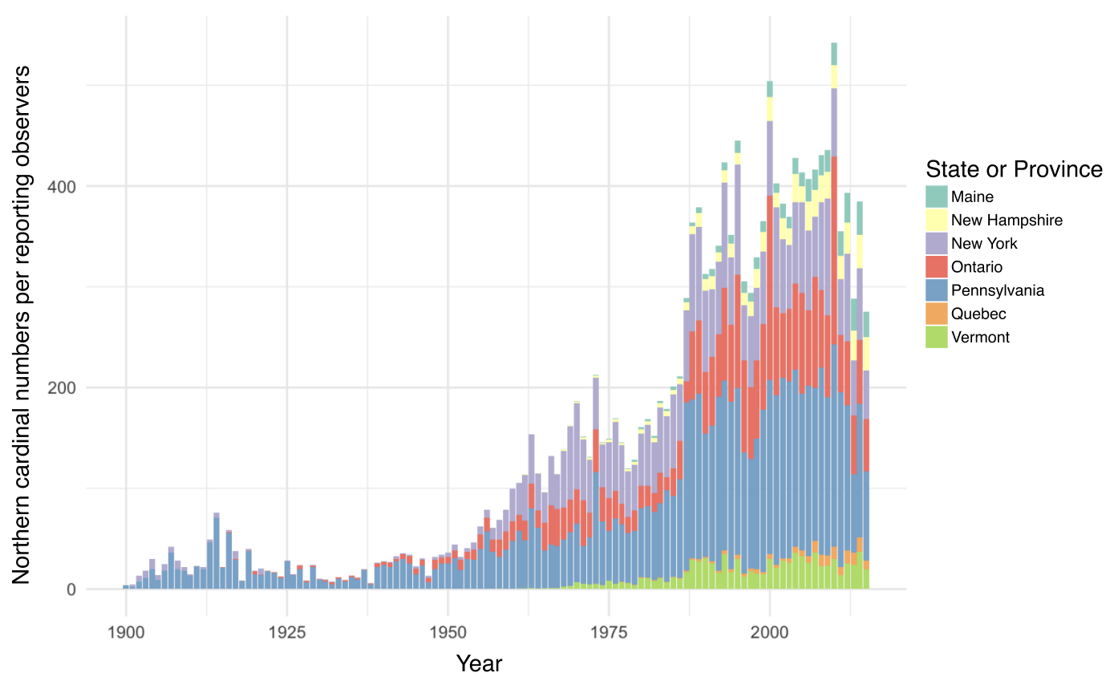
Figure 1. Number of Northern cardinal observations per reporting observers by year and state (United States of America) or province (Canada). This chart shows the number of Northern cardinals counted by year per observer from Audubon’s Christmas Bird Count. The state or province of the number of cardinals observed is also shown within each year using different colours. There is an overall increasing trend in the number of observations until approximately 2011, and the individual subnational regions mostly increase as well before that time. In Quebec specifically, early sightings can be seen after 1975 and steadily increase thereafter.

Study locations
This research was conducted in three study sites with varying levels of urbanization. Each study site includes two distinct release locations, which were randomly assigned to the individuals. The first study site is at the McGill Bird Observatory (MBO), located on the western end of the island of Montreal (45˚25’51.4”N 73˚56’18.5”W). The MBO site serves as our less urbanized location out of the three, being part of the 30 km² of the Grand parc de l’Ouest. The second study site is in the residential neighbourhood of Baie d’Urfé (BDU) has an intermediate level of urbanization (45˚24’39.2”N 73˚55’50.0”W). The final study site is in the Notre-Dame-de-Grâce neighbourhood in Montreal, close to Concordia University’s Loyola campus (45˚27’35.7”N 73˚38’30.2”W). This sector is the most urbanized of the three locations considered for this study. Since the Northern cardinal can be found in all three regions, we assumed that the translocated birds would be able to survive and thrive at each selected site.
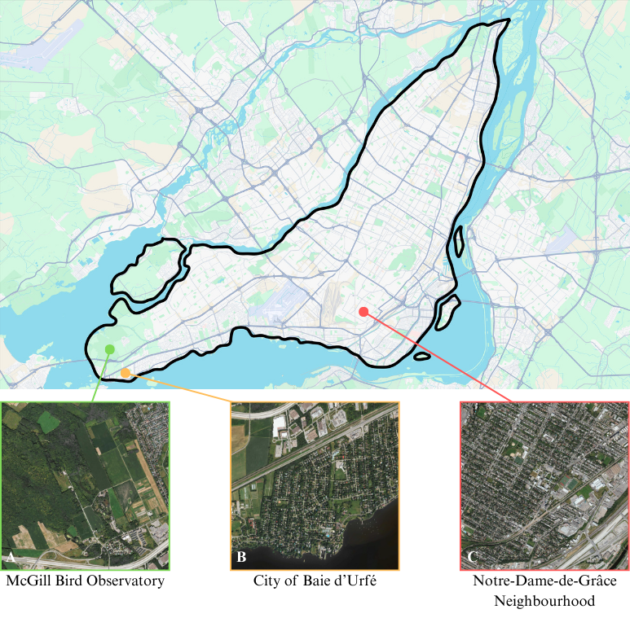
Figure 2. Study locations on the Island of Montreal A) The McGill Bird Observatory (MBO) served as the less urban location out of the three (2% of the area covered by streets and/or roads). It’s located in Sainte-Anne-de-Bellevue on the West side of the island. B) The residential area of Baie d’Urfé (BDU) served as an intermediately urbanized location (5% of the area covered by streets and/or roads). C) The last study site is near Concordia University (CON) in the Notre-Dame-de-Grâce neighbourhood and served as the most urban location (13% of the area covered by streets and/or roads).

Radio tagging, banding & translocation
We mistnetted Northern cardinals (males and females) at the MBO during October and November of the year 2022, 2023 and 2024. The birds were intercepted using 30 mm Japanese Nylon nets and placed in small cotton bags to reduce stress before handling. As part of the migration monitoring being done at the MBO, we banded the cardinals with a numbered aluminum band. The individuals were sexed, aged, weighed, and randomly assigned to one of the six possible release sites for translocation by car. In addition to the aluminum band, we fitted the cardinals with a set of coloured plastic bands, each with a unique combination of colours. This allowed visual identification of the individuals without having to resort to a radio tag receiver. Each bird was equipped with a Lotek NanoTag (NTQB-2) weighing 0.8 grams, using soft elastics in a figure 8 harness configuration (the total weight of the tag, harness, and glue was less than 3% of the cardinals’ body weight). All the radio-tags were registered as part of the Motus Wildlife Tracking System (CITATION). Northern cardinals translocated to the MBO and BDU locations underwent a holding time of 45 minutes before release to standardize treatment amongst individuals. For the winter of the year 2022-2023 (winter 1), we were able to consistently track 20 birds at MBO, which served as a pilot winter to assess the feasibility of the project. During the winter of 2023-2024 (winter 2), a total of 45 birds were tagged and banded, with 15 individuals relocated to CON, 15 relocated to BDU and 15 relocated to MBO. In 2024-2025 (winter 3), a total of 42 birds were tagged and banded, with 5 individuals relocated to MBO, 16 individuals released in BDU and 21 individuals released at CON. All birds were handled with appropriate permits (#####, Scientific permit to capture and band migratory birds 10973 D).

VHF tracking & automated detections
During the first winter, only 2 automated receiver towers from the Motus network were deployed. The first tower is located at the MBO (4525’50.4”N 73˚56’18.6”W), while the second tower is located on top of a faculty building at McGill University’s MacDonald campus (45˚24’28.3”N 73˚56’20.3”W). For the second winter, those two towers were also used for continuous data location, with the addition of a third temporary receiver tower that we installed in BDU (45˚24’39.3”N 73˚55’48.3”W). Finally, during the third winter, a fourth, permanent Motus tower was installed on top of a building at Concordia University’s Loyola campus location (45˚27’32.6”N 73˚38’30.2”W). While these automated receiver towers can detect the presence of the cardinals, they do not record precise GPS locations. We conducted manual radio tracking of each individual as often as possible (approximately once or twice a week) between the months of October and May using a set of portable receivers and antennae. Trackers would cover as much ground as possible at each study location with the goal of recording at least one GPS location for each individual per week using a Garmin ETREX 22x GPS. The portable receivers were either Lotek’s SRX800 or SRX1200. They were operated by setting the frequency to 166.380 MHz (Motus tags’ frequency for the Western hemisphere) and using both the gain and the signal strength to get as close as possible to the tagged individuals. The gain is a value between 0 and 100, representing the amplification of the received signal. By increasing it, the tracker increases how sensitive the receiver is to incoming radio signals. Higher gain values increase the ability to detect weaker signals but are also subject to background noise and interference. Using a lower gain reduces noise but may result in missing weak signals. In urbanized locations, the starting gain will rarely surpass 70-80 as the receiver picks up too much noise and interference. The signal is a value ranging from 0 to 200 for the SRX800 and 0 to 250 for the SRX1200. It represents the strength of the detected transmission from a radio tag, displayed in decibels (dB) on the receiver. A stronger signal indicates that the bird is closer; trackers use this information to estimate distance and direction. Trackers begin their tracking sessions with a gain of 80-70 to increase their chances of detecting nearby individuals. Once the receiver picks up a cardinal’s tag, the tracker moves toward the direction with the strongest signal. Once a threshold of 150 dB (SRX800) or 200 dB (SRX1200) is attained, the trackers then lower the gain by 10 and repeat this process until they reach the tagged individual. The trackers only record a GPS point if the signal strength is 150 or 200 dB, with a gain of 40 or less (the bird is considered close enough when those conditions are met). Once close enough to the bird, a few additional environmental measurements are collected. The wind speed (km/h), current temperature (˚C), along with the angle at which the antenna was pointing (˚) are all collected using free and publicly available smartphone applications. We assessed cloud coverage, with 100% meaning the clouds were completely covering the sky, and 0% meaning the sky was completely unobstructed by clouds. Finally, three snow measurements were taken at designated locations at each of the study sites. The amount of snow on the ground (cm), the snow hardness and the snow water content were estimated using the methods described in The International Classification for Seasonal Snow on the Ground (Fierz et al., 2009).

Habitat characteristics from open-source datasets
A variety of habitat characteristics were integrated in the later-described statistical analyses. We have also extracted a 1-meter resolution map of the vegetation height on the island of Montreal, from the OpenForest interactive platform from the Government and Municipalities of Quebec (Québec, n.d.). The LiDAR data extracted from OpenForest was collected in 2016 and is the most up-to-date version of this dataset. We have also collected locations of the bird feeders encountered during tracking, and the entire area of the Northern cardinals’ home ranges was covered by the field team. A GPS location was recorded using a Garmin ETREX 22x GPS for every bird feeder encountered, whether on private or public property. The population density data (population density per square kilometre) for all of the study sites were extracted in R using the Cancensus package (vonBergmann & Jacobs, n.d.). The last environmental metric sourced from open data is a polygon file of the streets and roads on the island of Montreal (VILLE DE MONTRÉAL, 2018).

Statistical analyses
To begin, we have assessed the urbanization level of each study location by calculating the mean population density, following a bounding box covering the study area. Because the data didn’t meet ANOVA assumptions, we used a non-parametric Kruskal-Wallis Test to assess site differences. This was followed by a Pairwise Wilcoxon Test to identify which specific pairs of relocation sites were different from one another.
We then assessed how the Northern cardinals were selecting their habitats using five variables, suspected of having an impact on the birds’ decision-making. Two vegetation-oriented variables were investigated: the mean height of the vegetation, along with the standard deviation of the mean vegetation height for each recorded location. Three human-oriented variables were also included in the models: the population density at all locations, the number of paved roads, and the proximity to the nearest recorded bird feeder. It is important to mention that to account for the bias that may arise from the fact that in urbanized locations, GPS coordinates were mostly recorded on the side of the streets, all of the GPS locations were corrected according to the gain and direction they were taken at, to reflect more accurately where the bird was located.
First, we ran a set of four generalized linear mixed models (GLMMs) for each study location with data extracted from four different radius areas (buffer zones), to assess the Northern cardinals’ habitat selection scale. For each model, we included all five of the previously mentioned variables. We evaluated the models using the corrected Akaike Information Criterion (AICc) values, which take into account small sample sizes. Once an optimal habitat selection scale was determined for each location, we conducted a use-availability analysis to investigate the Northern cardinals’ habitat preferences based on the five variables mentioned above. For each study site, we ran a “Full model” (Used ~ Mean vegetation height + Sd vegetation height + Population density + Road length + Distance to nearest feeder + (1|Winter) + (1|Site) + (1|ID)), including all of the variables, plus the winter (years of sampling), relocation site and bird ID as random effects. The second model we ran was the “Vegetation height” model (Used ~ Mean vegetation height + (1|Winter) + (1|Site) + (1|ID)), assuming the vertical height of vegetation was a primary factor for decision making. The third model we ran was “Sd vegetation height” (Used ~ Sd vegetation height + (1|Winter) + (1|Site) + (1|ID)), in this case, we assume that the vertical composition was a more predominant decision-making factor compared to height on its own. The fourth model we ran was the “Human model” (Used ~ Population density + Road length + Distance to nearest feeders + (1|Winter) + (1|Site) + (1|ID)), which assumed that the cardinals would rely mostly on human-related cues to select a wintering habitat. The final model we ran was the “Null” model, including only the random effects variables (Used ~ + (1|Winter) + (1|Site) + (1|ID)). We then once again selected the best models according to the corrected Akaike Information Criterion (AICc).
We used the Variance Inflation Factor (VIF) to quantify multicollinearity among the predictor variables of the models selected through the AICc process. VIF values of over 10 were considered very problematic, values between 5 and 10 were considered problematic, and values below or of 5 were considered acceptable. Finally, if the VIF scores are deemed satisfactory, we conducted a Hosmer-Lemeshow Goodness-of-Fit Test (H-L GOF) to evaluate how well the model’s predicted probabilities match the observed data. A high p-value (> 0.05) indicates no evidence of poor fit, meaning the model is likely adequate for the data. On the contrary, a low p-value (< 0.05) will indicate a lack of fit, meaning the model may be mis-specified for the data.

Results

Study sites urbanization level
All translocation sites had a significantly different level of urbanization from one another (p < 0.001). Here, urbanization level is determined using population density data from the Cancensus packages, using census data from the Government of Canada for the year 2021. The McGill Bird Observatory serving as the less urbanized location, has an average population density of 196 people/km² (SE ± 15 people/km²). The Town of Baie d’Urfé area, considered to be an intermediate urbanized location for this study, has an average population density of 918 people/km² (SE ± 12 people/km²). Finally, the Concordia University location serving as the most urbanized location out of the three has an average population density of 5361 ± 15 people/km² (SE ± 83 people/km²). Before moving forward, it is important to acknowledge that all three sites are characterized by relatively high levels of green space compared to the broader urban context of Montreal. As such, this gradient may not fully capture the extent of urbanization present across the entire city and should be interpreted as a localized urbanization gradient within predominantly green neighbourhoods, rather than a representative cross-section of the full urban-rural continuum.

Core areas and home ranges
For all three study sites, we calculated the average home range size using the Kernel Density Estimation (KDE), a non-parametric way to estimate the probability density function of a random variable based on a finite data sample (in the present case, the Northern cardinal’s GPS location recorded in the field).
$$K\left(u\right)= \frac{1}{\sqrt{2π}}e^{-\frac{1}{2}u^{2}}$$
Where:
$K(u)$ is the kernel function evaluated at u, providing the weight assigned to a data point based on its distance to the target location.
$u= \frac{x-x_{i}}{h}$ is the standardized distance between the location x (where the density is being estimated) and the observed data point x_{i}, scaled by the bandwidth h.
h is the bandwidth parameter, which determines the smoothness of the resulting density estimate; smaller values of h lead to a rougher estimate, while larger values produce a smoother result.
$\frac{1}{\sqrt{2π}}$ is the normalization constant ensuring that the kernel integrates to one.
e is Euler’s number (approximately 2.718), the base of the natural logarithm.

For all three locations, we calculated the KDE 50 % and 95 %, corresponding respectively to the core area where the bird spent most of its time, and to its total home range, including most of the areas visited in winter, excluding outliers (Figure 3). The cardinals wintering at MBO (least urbanized location) had a core area (50 % KDE) averaging 0.156 ± 0.038 (SE) km², and total home ranges (95 % KDE) were on average 0.631 ± 0.134 km². Cardinals translocated to BDU (intermediate urbanization) had, on average, core areas of 0.086 ± 0.021 km² and total home ranges of 0.572 ± 0.127 km². Birds wintering at CON (most urban location) had an average core area of 0.279 ± 0.117 km² while their total home ranges were 1.525 ± 0.532 km².

Habitat selection scale
The best model for the habitat selection scale of the cardinals relocated to MBO is the 50-meter model (> 10 Δ AICc values between all other models; Table 1a). For the birds translocated to BDU, the best model is the 25-meter one (> 10 Δ AICc values between all other models; Table 1a). Lastly, for the birds relocated at the most urban location (CON), the 25-meter model turned out to be the best (> 10 Δ AICc values among all other models; Table 1a).

Table 1a
AICc of 12 binomial generalized linear model (GLM) with a logit link function comparing habitat selection scales for the 56 Northern cardinals tracked at three study locations, based on vegetation vertical structure and anthropogenic variables.

Resource selection: used vs. available habitats
Because each translocation site has a different level of urbanization, model selection was conducted for each of them, at their corresponding habitat selection scale. For the McGill Bird Observatory, the global model, which extracted habitats and anthropogenic measurements from a 50-meter radius around used and available points, was significantly better than the models considering either only the vegetation variables, only the anthropogenic variables or the null model (> 10 Δ AICc values between all other models). For the birds relocated in the Town of Baie d’Urfé, the human covariates model, which extracted only anthropogenic measurements from a 25-meter radius around used and available points, was better than the other models, but with only less than a 2 AICc points difference between the human covariates model and the full model. For the Concordia University location, the full model, which also only extracted variables from a 25-meter radius around used and available points, was the best model, but by less than a 1 AICc point difference with the human covariates model.

Table 1b
Model parameters for the three resource selection models predicting the presence/absence of 56 Northern cardinals within (25 or 50 m-radius) areas based on the average vegetation height (in meters) and its standard deviation, along with human-related environmental features such as population density (in people/km²), road length (in meters) and distance to the nearest bird feeder (in meters). The study site, year of sampling (Winter) and the individual’s identification (ID) are included as random effects in each model.

Discussion
The main goal of this research was to provide novel insights regarding the fine-scale movement of a resident passerine species across urban green spaces, revealing how birds navigate and respond to varying degrees of urbanization. By comparing true and random point distributions across multiple landscape features—including vegetation cover, road length, population density and proximity to bird feeders—this work highlights how cardinals utilize human-modified environments during the non-breeding season. These findings contribute to a needed and growing body of work on avian ecology in urban areas, emphasizing the importance of maintaining and creating urban green spaces supporting wintering birds.

Wintering home range sizes
The variation in the cardinal’s home range size highlights the influence of urbanization on the birds’ use of space in winter. Individuals spending winter in our most urban location (CON) had substantially larger total and core home ranges (KDE 95% and 50%, respectively), compared to the birds that spent their winter in a less urbanized location (BDU) or a peri-urban location (MBO) (Fig. 3). This pattern suggests that the Northern cardinals spending the winter in highly urbanized locations may need to traverse greater distances to meet their ecological and/or energetic needs. This could result from a more intense spatial fragmentation as urbanization increases. In opposition to that, the smaller home ranges obtained at both MBO and BDU suggest that more continuous and resource-rich green spaces could enable the cardinals to fulfill their basic requirements with a more restricted area. The relatively low variability in home range estimates at MBO points towards more consistent habitat use, potentially reflecting an environment with reliable food sources and sheltering opportunities. These results align with broader urban ecology literature, suggesting that species thriving in urban areas often exhibit increased movement and space use plasticity as a way to compensate for scattered resources in a fragmented landscape (ADD REFERENCES). Importantly, the larger home ranges in urban settings may come with energetic and survival costs, with implications for winter ecology and conservation strategies aimed at maintaining bird populations in increasingly urbanized landscapes.
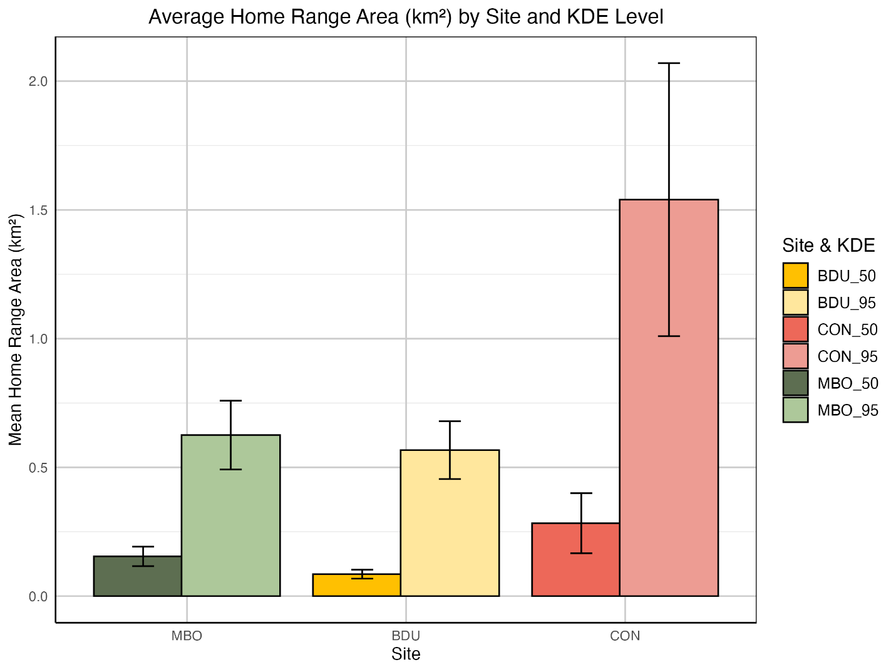
Figure 3. Mean home range areas of the cardinals at each translocation sites (McGill Bird Observatory – MBO, Town of Baie d’Urfé – BDU, Concordia University campus – CON) for both the KDE 50% (representing the core home range of the birds) and the KDE 95% (representing the total home range of the birds).

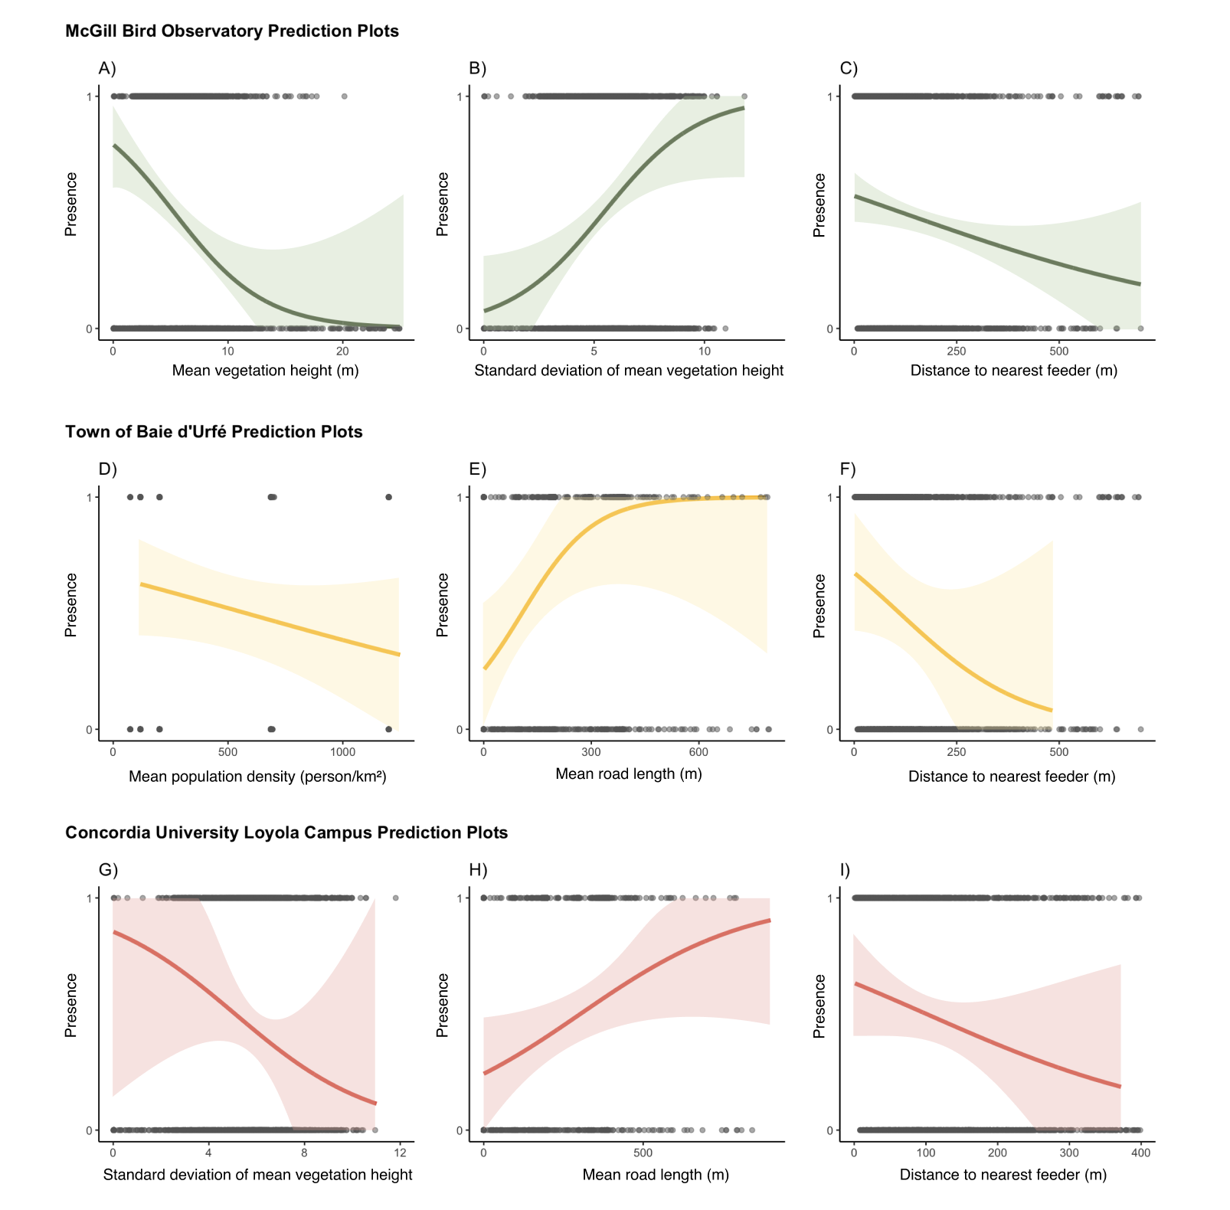
Habitat selection preferences
Figure 4. Probability of presence of Northern cardinals in a given radius area, as predicted by a generalized linear mixed effects model. Shaded areas represent 67% confidence intervals around the predicted probabilities. The model’s fixed effect variables are described in Table 1b, and for each model, random effects were sampling years, translocation site and bird ID.
Figure 4 shows the habitat selection preferences of Northern cardinals across three sites with varying levels of urbanization—McGill Bird Observatory (MBO), the Town of Baie d’Urfé (BDU), and Concordia University’s Loyola Campus (CON)—as predicted by generalized linear mixed-effects models. These prediction plots reveal distinct habitat use and demonstrate how cardinals select for different variables regarding both environmental and anthropogenic features. At MBO, the cardinals showed a more pronounced positive association for areas with generally lower vegetation (A) and greater structural heterogeneity (B), as reflected by the negative association with mean vegetation height and its standard deviation. This preference could suggest that Northern cardinals prefer to use habitats that are vertically complex, yet still mainly composed of shrubs, providing shelter and foraging opportunities. This is not surprising as cardinals are known to favour habitats corresponding to those criteria. In addition, the presence probability drops as the distance from the nearest feeder increases (C), emphasizing the role of supplementary feeding as a reliable food source in this less urbanized location. In contrast, selection patterns in the moderately urbanized BDU site seem to revolve mainly around human-related variables, and less so around the vegetation variables. Here, cardinals tended to avoid areas of high population density (D), while showing a preference for longer road lengths (E), a counterintuitive pattern. This might be reflecting an indirect association with edge habitats or corridors, often seen with suburban street planning. We considered the potential bias that could be induced by recording the GPS locations of the birds from the side of the streets. To assess this issue, the statistical analyses were run on both the unshifted location data and the shifted points, and the resulting model selection remains unchanged. This confirms the robustness of the method used to record cardinal location. The highly urbanized location of CON showed yet another distinct pattern of habitat use. Cardinals were less likely to occupy areas with strong vegetation vertical heterogeneity (G), a pattern opposite to what we’re seeing at MBO. This could indicate a certain avoidance of fragmented, or lower quality patches, in a context where vegetation is already scarce and patchily distributed through the landscape. In addition, the probability of selection increased with road length (H), suggesting that the limited access to vegetated habitats comes with the necessity to navigate along urban features such as roads. Finally, the presence of Northern cardinals declined as the distance to the nearest bird feeder increased, highlighting the potential dependence on anthropogenic food resources in highly urbanized areas, where more natural foraging opportunities may be insufficient. Collectively, these findings highlight the context-dependent nature of habitat selection by Northern cardinals, suggesting that behavioural flexibility may play a role in their persistence in urban environments through the winter. The varying importance of vegetation structure, anthropogenic disturbances and proximity to supplemental food indicates that conservation strategies for winter birds must be tailored to the local urban context. In less urbanized areas, maintaining large vegetation patches with a complex vertical structure is likely essential, while in urbanized locations, providing access to supplemental food and mitigating the negative impacts of fragmentation may be more critical for sustaining Northern cardinals (and potentially other resident bird species) populations during the winter season.

Conclusion
This study provides new insights into how a resident songbird species, the Northern cardinal, adapts its movement and habitat selection patterns in response to varying levels of urbanization during the non-breeding season. By combining spatial movement analyses with fine-scale habitat selection models across three sites with varying levels of urbanization, we demonstrate that cardinals seem to exhibit both behavioural plasticity and context-dependent responses to urban landscape features. Larger home ranges in highly urbanized areas suggest increased energetic costs, likely driven by fragmented habitats and sparse natural resources. In contrast, smaller and more consistent home ranges in less urbanized environments reflect a more stable and resource-rich context for the cardinals. Habitat selection varied quite considerably across sites: in peri-urban areas, cardinals favoured structurally complex vegetation and proximity to feeders, while in urban areas, reliance on anthropogenic features was more evident. These findings highlight the importance of flexible behavioural strategies in enabling some species of birds to persist in human-modified environments. From a conservation perspective, we argue that this work emphasizes the importance, in urban environments, to tailor local management efforts to the context they’re in. As urban areas continue to expand globally, understanding such fine-scale responses will be critical for informing urban planning and ensuring a year-round support of our native bird species.

Chapter 2: Seasonal variation in the activity level of the Northern cardinal (Cardinalis cardinalis) over the winter

Note on this chapter

Abstract

Introduction
- General background.
  - Importance of studying winter bird behaviour in temperate regions of the world.
  - Seasonal challenges (temperature, food, snow cover, etc.).
  - How urbanisation x climate can influence winter movement\activity
- Species of interest.
  - Cardinal doesn’t migrate.
  - Territoriality and vocalization in winter.
  - Adaptability to urban environments.
Previous work investigated the Northern cardinal’s ability to adapt its energy management to survive the winter. They found no evidence of the use of torpor, but did notice a slight decrease in body temperature in winter, which could potentially lead to a 10-16 % saving in daily energy expenditures (Schaeffer et al., 2015).
- Introduce Motus.
  - Fine-scale movement\activity.
  - Highlight benefits (passive + continuous).
  - Acknowledge limitations (radius, interference, coverage in city).
- Hypotheses.

Literature cited

Andreev, A. V. (1999). Energetics and survival of birds in extreme environments. Ostrich, 70(1), 13–22. https://doi.org/10.1080/00306525.1999.9639745
Bocz, R., Szép, D., Witz, D., Ronczyk, L., Kurucz, K., & Purger, J. J. (2017). Human disturbances and predation on artificial ground nests across an urban gradient. Animal Biodiversity and Conservation, 40(2).
Brewer, D. E., Gehring, T. M., Garcia, M. M., Shirkey, B. T., Simpson, J. W., & Fournier, A. M. V. (2023). King rail (Rallus elegans) home range and microhabitat characteristics in western Lake Erie coastal marshes. Ecology and Evolution, 13(4), 16. https://doi.org/10.1002/ece3.10043
Brewer, V. N., Lane, S. J., Sewall, K. B., & Mabry, K. E. (2020). Effects of low-density urbanization on genetic structure in the Song Sparrow. PLOS ONE, 15(6), e0234008. https://doi.org/10.1371/journal.pone.0234008
Brodin, A. (2007). Theoretical models of adaptive energy management in small wintering birds. Philosophical Transactions of the Royal Society B: Biological Sciences, 362(1486), 1857–1871. https://doi.org/10.1098/rstb.2006.1812
Buxton, R. T., Hudgins, E. J., Lavigne, E., Villeneuve, P. J., Prince, S. A., Pearson, A. L., Halsall, T., Robichaud, C., & Bennett, J. R. (2024). Mental health is positively associated with biodiversity in Canadian cities. Communications Earth & Environment, 5(1), 310. https://doi.org/10.1038/s43247-024-01482-9
Cabrera-Cruz, S. A., Smolinsky, J. A., & Buler, J. J. (2018). Light pollution is greatest within migration passage areas for nocturnally-migrating birds around the world. Scientific Reports, 8(1), 3261.
Chace, J. F., & Walsh, J. J. (2006). Urban effects on native avifauna: A review. Landscape and Urban Planning, 74(1), 46–69.
Chamberlain, D. E., Gough, S., Vaughan, H., Vickery, J. A., & Appleton, G. F. (2007). Determinants of bird species richness in public green spaces. Bird Study, 54(1), 87–97. https://doi.org/10.1080/00063650709461460
Chiron, F., Lorrillière, R., Bessa-Gomes, C., Tryjanowski, P., Casanelles-Abella, J., Laanisto, L., Leal, A., Van Mensel, A., Moretti, M., Muyshondt, B., Niinemets, Ü., Ortí, M. A., Pinho, P., Samson, R., & Deguines, N. (2024). How do urban green space designs shape avian communities? Testing the area–heterogeneity trade-off. Landscape and Urban Planning, 242, 104954. https://doi.org/10.1016/j.landurbplan.2023.104954
City of Montreal. (2020). Climate Plan 2020-2030. City of Montreal. https://montreal.ca/en/articles/montreal-climate-plan-objective-carbon-neutral-2050-7613
City of Montreal. (2024). Plan climat 2020-2030 Ville de Montréal—État d’avancement avril 2024. City of Montreal. https://mtl.ged.montreal.ca/constellio/?collection=mtlca&portal=REPDOCVDM#!displayDocument/00000092918
Cox, D. T. C., Shanahan, D. F., Hudson, H. L., Plummer, K. E., Siriwardena, G. M., Fuller, R. A., Anderson, K., Hancock, S., & Gaston, K. J. (2017). Doses of Neighborhood Nature: The Benefits for Mental Health of Living with Nature. BioScience, 67(2), 147–155. https://doi.org/10.1093/biosci/biw173
Cull, C. A., Guest, M. J., Frei, B., & Ziter, C. D. (2025). Human recreational activity does not influence open cup avian nest survival in urban green spaces. Urban Ecosystems, 28(2). https://doi.org/10.1007/s11252-024-01669-0
Dawson, W. R., Marsh, R. L., & Yacoe, M. E. (1983). Metabolic adjustments of small passerine birds for migration and cold. 245(6), R755–R767. https://doi.org/10.1152/ajpregu.1983.245.6.R755
DeVries, M. S., & Jawor, J. M. (2013). Natural variation in circulating testosterone does not predict nestling provisioning rates in the northern cardinal, Cardinalis cardinalis. Animal Behaviour, 85(5), 957–965. https://doi.org/10.1016/j.anbehav.2013.02.019
DONNELLY, R., & MARZLUFF, J. M. (2004). Importance of Reserve Size and Landscape Context to Urban Bird Conservation. Conservation Biology, 18(3), 733–745. https://doi.org/10.1111/j.1523-1739.2004.00032.x
Dupras, J., & Alam, M. (2015). Urban Sprawl and Ecosystem Services: A Half Century Perspective in the Montreal Area (Quebec, Canada). Journal of Environmental Policy & Planning, 17(2), 180–200. https://doi.org/10.1080/1523908X.2014.927755
Elmqvist, T., Fragkias, M., Goodness, J., Güneralp, B., Marcotullio, P. J., McDonald, R. I., Parnell, S., Schewenius, M., Sendstad, M., & Seto, K. C. (2013). Urbanization, biodiversity and ecosystem services: Challenges and opportunities: A global assessment. Springer Nature.
Eötvös, C. B., Magura, T., & Lövei, G. L. (2018). A meta-analysis indicates reduced predation pressure with increasing urbanization. Landscape and Urban Planning, 180, 54–59. https://doi.org/10.1016/j.landurbplan.2018.08.010
Fernandez-Canero, R., & Gonzalez-Redondo, P. (2010). Green Roofs as a Habitat for Birds: A Review. Journal of Animal and Veterinary Advances, 9(15), 2041–2052.
Fierz, C., Armstrong, R. L., Durand, Y., Etchevers, P., Greene, E., McClung, D. M., Nishimura, K., Satyawali, P. K., & Sokratov, S. A. (2009). The international classification for seasonal snow on the ground.
Filion, P., Bunting, T., Pavlic, D., & Langlois, P. (2010). Intensification and Sprawl: Residential Density Trajectories in Canada’s Largest Metropolitan Regions. Urban Geography, 31(4), 541–569. https://doi.org/10.2747/0272-3638.31.4.541
Filliater, T. S., Breitwisch, R., & Nealen, P. M. (1994). Predation on Northern Cardinal Nests: Does Choice of Nest Site Matter? The Condor: Ornithological Applications, 96(3), 761–768. https://doi.org/10.2307/1369479
Fuller, M. R., Millspaugh, J. J., Church, K. E., & Kenward, R. E. (2005). Wildlife radiotelemetry. Techniques for Wildlife Investigations and Management. Sixth Edition. The Wildlife Society, Bethesda, Maryland, USA, 377–417.
Furberg, D., & Ban, Y. (2008). Satellite Monitoring of Urban Sprawl and Assessing the Impact of Land-Cover Changes in the Greater Toronto Area. The XXI Congress of ISPRS. Beijing, China. 3-11 July 2008.
Gahbauer, M. A., Duval, S., & Davey, D. (2015). McGill Bird Observatory Annual Program Report 2014.
Government of Canada, S. C. (2022, February 9). Census Profile, 2021 Census of Population. https://www12.statcan.gc.ca/census-recensement/2021/dp-pd/prof/index.cfm?Lang=E
Halkin, S. L., Shustack, D. P., DeVries, M. S., Jawor, J. M., & Linville, S. U. (2021). Northern Cardinal (Cardinalis cardinalis), version 2.0. Birds of the World. https://doi.org/10.2173/bow.norcar.02
Harris, R. B., & Fish, U. S. (1990). Tracking wildlife by satellite.
Hofman, M. P. G., Hayward, M. W., Heim, M., Marchand, P., Rolandsen, C. M., Mattisson, J., Urbano, F., Heurich, M., Mysterud, A., Melzheimer, J., Morellet, N., Voigt, U., Allen, B. L., Gehr, B., Rouco, C., Ullmann, W., Holand, Ø., Jørgensen, N. H., Steinheim, G., … Balkenhol, N. (2019). Right on track? Performance of satellite telemetry in terrestrial wildlife research. Plos One, 14(5), e0216223. https://doi.org/10.1371/journal.pone.0216223
Hope, S. F., Hopkins, W. A., & Angelier, F. (2022). Parenting in the city: Effects of urbanization on incubation behaviour and egg temperature in great tits, Parus major. Animal Behaviour, 194, 1–11. https://doi.org/10.1016/j.anbehav.2022.09.004
Isaksson, C. (2018). Impact of urbanization on birds. Bird Species, 235, 257.
Iverson, A. R., Schaefer, J. L., Skalos, S. M., & Hawkins, C. E. (2023). Global positioning system (GPS) and platform transmitter terminal (PTT) tags reveal fine-scale migratory movements of small birds: A review highlights further opportunities for hypothesis-driven research. Ornithological Applications, 125(3), duad014.
Jim, C. Y., & Chen, W. Y. (2008). Assessing the ecosystem service of air pollutant removal by urban trees in Guangzhou (China). Journal of Environmental Management, 88(4), 665–676. https://doi.org/10.1016/j.jenvman.2007.03.035
Jones, T. M., Llamas, A. P., & Phillips, J. N. (2023). Phenotypic signatures of urbanization? Resident, but not migratory, songbird eye size varies with urban‐associated light pollution levels. Global Change Biology, 29(23), 6635–6646.
Kamei, I., & Maruta, E. (1979). Study on wind environmental problems caused around buildings in Japan. Journal of Wind Engineering and Industrial Aerodynamics, 4(3), 307–331. https://doi.org/10.1016/0167-6105(79)90010-2
Kekkonen, J. (2017). Pollutants in urbanized areas: Direct and indirect effects on bird populations. Ecology and Conservation of Birds in Urban Environments, 227–250.
Kelly, A. A., & Amanda, D. R. (2006). The Value of Urban Forests to Wintering Birds. Natural Areas Journal, 26(3), 280–288. https://doi.org/10.3375/0885-8608(2006)26[280:TVOUFT]2.0.CO;2
Krama, T., Krams, R., Popovs, S., Trakimas, G., Rantala, M. J., Freeberg, T. M., & Krams, I. A. (2023). Permanent Ad-lib Feeders Decrease the Survival of Wintering Great Tits (Parus major). Birds, 4(2), Article 2. https://doi.org/10.3390/birds4020019
Lane, S. J., VanDiest, I. J., Brewer, V. N., Linkous, C. R., Fossett, T. E., Goodchild, C. G., & Sewall, K. B. (2023). Indirect effects of urbanization: Consequences of increased aggression in an urban male songbird for mates and offspring. Frontiers in Ecology and Evolution, 11. https://doi.org/10.3389/fevo.2023.1234562
Laskey, A. R. (1944). A STUDY OF THE CARDINAL IN TENNESSEE. 56(1).
Latimer, C. E., & Zuckerberg, B. (2021). Habitat loss and thermal tolerances influence the sensitivity of resident bird populations to winter weather at regional scales. Journal of Animal Ecology, 90(2), 317–329. https://doi.org/10.1111/1365-2656.13332
Leston, L. F. V., & Rodewald, A. D. (2006). Are urban forests ecological traps for understory birds? An examination using Northern cardinals. Biological Conservation, 131(4), 566–574. https://doi.org/10.1016/j.biocon.2006.03.003
Li, G., Fang, C., Li, Y., Wang, Z., Sun, S., He, S., Qi, W., Bao, C., Ma, H., Fan, Y., Feng, Y., & Liu, X. (2022). Global impacts of future urban expansion on terrestrial vertebrate diversity. Nature Communications, 13(1), 1628. https://doi.org/10.1038/s41467-022-29324-2
Li, K., Hu, W. H., Chen, X., Zhang, M. Y., Ye, K. M., Zhu, H., & Zhao, H. B. (2025). More fruits, more birds? How plant traits attract birds feeding in urban green spaces during winter. Urban Forestry & Urban Greening, 107. https://doi.org/10.1016/j.ufug.2025.128748
Liker, A., Papp, Z., Bókony, V., & Lendvai, Á. Z. (2008). Lean birds in the city: Body size and condition of house sparrows along the urbanization gradient. Journal of Animal Ecology, 77(4), 789–795. https://doi.org/10.1111/j.1365-2656.2008.01402.x
Linek, N., Volkmer, T., Shipley, J. R., Twining, C. W., Zúñiga, D., Wikelski, M., & Partecke, J. (2021). A songbird adjusts its heart rate and body temperature in response to season and fluctuating daily conditions. Philosophical Transactions of the Royal Society B: Biological Sciences, 376(1830), 20200213. https://doi.org/10.1098/rstb.2020.0213
Linville, S. U., Breitwisch, R., & Schilling, A. J. (1998). Plumage brightness as an indicator of parental care in northern cardinals. Animal Behaviour, 55(1), 119–127. https://doi.org/10.1006/anbe.1997.0595
Lopes, A. C., Rocha, G. O. C., de Oliveira Passos, M. F., Barçante, L., & de Azevedo, C. S. (2024). The Influence of Building Surroundings and Glass Cover in Bird Collisions. Birds, 5(4), Article 4. https://doi.org/10.3390/birds5040048
Louzao, M., Gallagher, R., García-Barón, I., Chust, G., Intxausti, I., Albisu, J., Brereton, T., & Fontán, A. (2019). Threshold responses in bird mortality driven by extreme wind events. Ecological Indicators, 99, 183–192. https://doi.org/10.1016/j.ecolind.2018.12.030
Lowry, H., Lill, A., & Wong, B. B. (2013). Behavioural responses of wildlife to urban environments. Biological Reviews, 88(3), 537–549.
MacKinnon, M., Pedersen Zari, M., & Brown, D. K. (2023). Improving Urban Habitat Connectivity for Native Birds: Using Least-Cost Path Analyses to Design Urban Green Infrastructure Networks. Land, 12(7), Article 7. https://doi.org/10.3390/land12071456
Marlès Magre, J., Boada Juncà, M., Campanera, J. M., Bach Pagès, A., Ruiz Mallén, I., Maneja Zaragoza, R., Sánchez Mateo, S., Pallarès Barberà, M., & Barriocanal Lozano, C. (2019). How urban green management is influencing passerine birds’ nesting in the Mediterranean: A case study in a Catalan city. Urban Forestry & Urban Greening, 41, 221–229. https://doi.org/10.1016/j.ufug.2019.03.012
Mennill, D. J., Doucet, S. M., Ward, K.-A. A., Maynard, D. F., Otis, B., & Burt, J. M. (2012). A novel digital telemetry system for tracking wild animals: A field test for studying mate choice in a lekking tropical bird. Methods in Ecology and Evolution, 3(4), 663–672. https://doi.org/10.1111/j.2041-210X.2012.00206.x
Mitchell, M. G. E., & Devisscher, T. (2022). Strong relationships between urbanization, landscape structure, and ecosystem service multifunctionality in urban forest fragments. Landscape and Urban Planning, 228, 104548. https://doi.org/10.1016/j.landurbplan.2022.104548
Murray, M. H., Sánchez, C. A., Becker, D. J., Byers, K. A., Worsley‐Tonks, K. E., & Craft, M. E. (2019). City sicker? A meta‐analysis of wildlife health and urbanization. Frontiers in Ecology and the Environment, 17(10), 575–583.
Naguib, M., Titulaer, M., Waas, J. R., van Oers, K., Sprau, P., & Snijders, L. (2022). Prior territorial responses and home range size predict territory defense in radio-tagged great tits. Behavioral Ecology and Sociobiology, 76(3), 12. https://doi.org/10.1007/s00265-022-03143-3
O’Connell, M. J., Squirrell, F. I., & Greening, M. (2023). A preliminary study of the winter roosting behaviour of four woodland passerines. Bird Study, 70(4), 243–250. https://doi.org/10.1080/00063657.2023.2269329
Ordóñez-Delgado, L., Iñiguez-Armijos, C., Díaz, M., Escudero, A., Gosselin, E., Waits, L. P., & Espinosa, C. I. (2022). The good, the bad, and the ugly of urbanization: Response of a bird community in the neotropical Andes. Frontiers in Ecology and Evolution, 10, 844944.
Palacio, F. X., Ibañez, L. M., Maragliano, R. E., & Montalti, D. (2018). Urbanization as a driver of taxonomic, functional, and phylogenetic diversity losses in bird communities. Canadian Journal of Zoology, 96(10), 1114–1121.
Panchana, K., Herrera, I., Vargas, A., Mella-Méndez, I., & Flores-Peredo, R. (2025). Whiskers in the city: Domestic cat predation in Ecuadorian coastal cities and associated factors. Urban Ecosystems, 28(1), 1–18. https://doi.org/10.1007/s11252-024-01628-9
Petit, M., Clavijo-Baquet, S., & Vézina, F. (2017). Increasing Winter Maximal Metabolic Rate Improves Intrawinter Survival in Small Birds. Physiological and Biochemical Zoology, 90(2), 166–177. https://doi.org/10.1086/689274
Poirier, V., Elliott, K. H., & Frei, B. (2024). Peri-urban forest margins are important stopover sites for moult-migrating songbirds. Journal for Nature Conservation, 77, 126539. https://doi.org/10.1016/j.jnc.2023.126539
Québec, G. and M. of. (n.d.). Lidar—Digital models (terrain, canopy, slope, level curve)—Open Government Portal (Carte Interactive Nos. 1fb86026-791c-45d2-88d7-58754ecebd73) [HTML]. Retrieved May 5, 2025, from https://open.canada.ca/data/en/dataset/5e5d2750-d129-4952-b9fc-f824c5e480b4
Robert, M., Hachey, M.-H., Lepage, D., & Couturier, A. R. (Eds.). (2019). Second atlas of the breeding birds of Southern Québec. Regroupement QuébecOiseaux.
Rodgers, A. R. (2001). Chapter 4—Recent Telemetry Technology. In J. J. Millspaugh & J. M. Marzluff (Eds.), Radio Tracking and Animal Populations (pp. 79–121). Academic Press.
Rodrigues, A. G., Borges-Martins, M., & Zilio, F. (2018). Bird diversity in an urban ecosystem: The role of local habitats in understanding the effects of urbanization. Iheringia. Série Zoologia, 108, e2018017.
Rousseau, J. S., Savard, J.-P. L., & Titman, R. (2015). Shrub-nesting birds in urban habitats: Their abundance and association with vegetation. Urban Ecosystems, 18(3), 871–884. https://doi.org/10.1007/s11252-014-0434-4
Šálek, M., Bažant, M., Vrána, J., Grill, S., & Václav, R. (2024). Urban refuges in winter: The role of habitat characteristics and supplementary feeding in shaping bird occupancy and abundance. Urban Ecosystems, 28(1), 67. https://doi.org/10.1007/s11252-024-01632-z
Schaeffer, P., Komer, M. C., & Corder, K. (2015). Energy savings due to the use of shallow body temperature reduction in overwintering Northern Cardinals. ResearchGate, 3(1). https://doi.org/10.1186/s40317-015-0078-z
Seress, G., & Liker, A. (2015). Habitat urbanization and its effects on birds. Acta Zoologica Academiae Scientiarum Hungaricae, 61(4), 373–408.
Shanahan, D. F., Strohbach, M. W., Warren, P. S., & Fuller, R. A. (2014). The challenges of urban living. Avian Urban Ecology, 3–20.
Shustack, D. P. (2008). Reproductive Timing of Passerines in Urbanizing Landscapes [The Ohio State University]. http://rave.ohiolink.edu/etdc/view?acc_num=osu1217601092
Simkin, R. D., Seto, K. C., McDonald, R. I., & Jetz, W. (2022). Biodiversity impacts and conservation implications of urban land expansion projected to 2050. Proceedings of the National Academy of Sciences, 119(12), e2117297119. https://doi.org/doi:10.1073/pnas.2117297119
Skarbit, N., Unger, J., & Gál, T. (2024). Evaluating the Impact of Heat Mitigation Strategies Using Added Urban Green Spaces during a Heatwave in a Medium-Sized City. Sustainability, 16(8), 17. https://doi.org/10.3390/su16083296
Smith, P. G. (2007). Characteristics of Urban Natural Areas Influencing Winter Bird Use in Southern Ontario, Canada. Environmental Management, 39(3), 338–352. https://doi.org/10.1007/s00267-005-0028-2
Stephens, T. (2023). The Kunming–Montreal Global Biodiversity Framework. International Legal Materials, 62(5), 868–887. https://doi.org/10.1017/ilm.2023.16
Swanson, D. L., & Vézina, F. (2015). Environmental, ecological and mechanistic drivers of avian seasonal metabolic flexibility in response to cold winters. Journal of Ornithology, 156(1), 377–388. https://doi.org/10.1007/s10336-015-1192-7
The State of Canada’s Birds Report. (2024).
Thohari, M. (1989). Wildlife Tracking by Telemetry.
Tryjanowski, P., Mikula, P., & Morelli, F. (2024). Dynamic interactions at birdfeeders: Attracting both prey and predators across urban and rural habitats. Basic and Applied Ecology, 79, 84–89. https://doi.org/10.1016/j.baae.2024.06.005
Vaz, S., Manes, S., Khattar, G., Mendes, M., Silveira, L., Mendes, E., de Morais Rodrigues, E., Gama-Maia, D., Lorini, M. L., Macedo, M., & Paiva, P. C. (2023). Global meta-analysis of urbanization stressors on insect abundance, richness, and traits. Science of The Total Environment, 903, 165967. https://doi.org/10.1016/j.scitotenv.2023.165967
VILLE DE MONTRÉAL. (2018). Chaussée agrégée et intersection (Base de données des actifs de voirie) (Jeu de données Nos. a2810949-7335-49e2-84af-1c5da4ff6342). Données Québec. https://www.donneesquebec.ca/recherche/dataset/vmtl-voirie-chaussee-intersection
vonBergmann, J., & Jacobs, A. (n.d.). cancensus: Access, Retrieve, and Work with Canadian Census Data and Geography (Version 0.5.3) [Computer software]. Retrieved May 5, 2025, from https://CRAN.R-project.org/package=cancensus
Wang, H., He, Q., Liu, X., Zhuang, Y., & Hong, S. (2012). Global urbanization research from 1991 to 2009: A systematic research review. Landscape and Urban Planning, 104(3–4), 299–309.
Wolch, J. R., Byrne, J., & Newell, J. P. (2014). Urban green space, public health, and environmental justice: The challenge of making cities ‘just green enough.’ Landscape and Urban Planning, 125, 234–244. https://doi.org/10.1016/j.landurbplan.2014.01.017
Wood, E., Harsant, A., Dallimer, M., Cronin de Chavez, A., McEachan, R. R. C., & Hassall, C. (2018). Not All Green Space Is Created Equal: Biodiversity Predicts Psychological Restorative Benefits From Urban Green Space. Frontiers in Psychology, 9. https://doi.org/10.3389/fpsyg.2018.02320

