Chapter 1: Winter home ranges size increases across an urbanization gradient for a very short distance migrant, the Northern Cardinal (Cardinalis cardinalis)

Authors: Cousineau, Anne-Marie¹; Elliott, Kyle H.¹; Frei, Barbara²
1: Department of Natural Resource Sciences, McGill University, Ste. Anne de Bellevue, Québec, Canada
2: Science and Technology Branch, Environment and Climate Change Canada, Montreal, Québec, Canada
Corresponding author: Anne-Marie Cousineau; 370 rue Armstrong, Rosemère, J7A1V9, QC, Canada; anne-marie.cousineau@mail.mcgill.ca
Acknowledgements:
This work wouldn’t have been possible without the generous work of the volunteers and staff at the McGill Bird Observatory. Shawna Sevigny, Ana Morales and Barbara Frei helped greatly with the banding and tagging of the cardinals. We also want to thank everyone who took part in the relentless tracking of the cardinals through the harsh winters of Montreal: Mackenzie Guest, Lauren Dobie, Nathanya Goudreau, Mathilde Lefvert, Florence Piché-Lebel, Laurianne Fallu and Elliana Tomasso.
Funding statement:
Funding was provided by many sources: the Environmental Damages Fund (EDF, 2024)
Data availability:

Abstract
Urban green spaces (UGS) are critical for maintaining biodiversity and supporting wildlife, especially in heavily urbanized environments. In temperate regions like southern Quebec, winter brings significant challenges for resident bird species, yet little is known about how birds respond to urbanization during the non-breeding season. This study investigates the fine-scale movements and habitat selection of Cardinalis cardinalis across three locations in Montreal, Canada, with varying degrees of urbanization. Using manual VHF telemetry, we quantified home range sizes, scale of habitat selection, and assessed habitat associations with natural and anthropogenic variables across an urban gradient. Across three winters, cardinals in the most urbanized study site had significantly larger home ranges compared to the suburban and peri-urban sites. Habitat selection occurred at the smallest scales measurable (25-50 m) across all sites (urban/suburban/peri-urban). Habitat associations with natural and anthropogenic landscape features varied across the urban gradient, except for proximity to bird feeders which was consistently related to cardinal habitat use. In less urbanized areas, birds selected for vertically complex vegetation while in more urbanized areas, birds select were more likely to use areas with a greater presence of roads. Cardinalis cardinalis displayed behavioral plasticity in response to urbanization and highlight the importance of adapting conservation strategies to local urban contexts. As cities expand, understanding these fine-scale ecological responses will be key to designing biodiversity-friendly UGS that support both wildlife and human well-being throughout the year.
Keywords: Habitat association; Home range; Scale of association; Urban green spaces; Urbanization gradient; VHF telemetry
Lay summary
- We studied Cardinalis cardinalis (Northern Cardinal) winter habitat use in Montreal, Canada, across three years at sites with varying levels of urbanization (peri-urban, suburban, urban), measured home range sizes, and analyzed habitat association patterns.
- We used hand-held VHF radio telemetry to accurately track fine-scale movements of C. cardinalis.
- Survival rates varied across sites with only ~16% of C. cardinalis surviving after three months in the urban site compared to ~57% in the suburban site and ~65% in the peri-urban location.
- C. cardinalis in the most urban site had significantly larger winter home ranges compared to their suburban and peri-urban counterparts, requiring them to travel further to find scattered resources like bird feeders.
- Bird feeders were the most significant predictor of C. cardinalis’ association to a specific location across all urbanization levels, while habitat association with vegetation structures and proximity to roads varied depending on the level of urbanization.
- This research shows that urban wildlife conservation strategies must be context-dependent rather than one-size-fits-all, as the variation in habitat association of C. cardinalis across the urban gradient highlights the importance of small urban green spaces and accessible resources for winter survival.
Introduction
Urbanization is accelerating worldwide (Elmqvist et al., 2013; Simkin et al., 2022; Wang et al., 2012), altering landscapes and bringing novel challenges to wildlife including habitat fragmentation, habitat loss and chronic pollution (Lowry et al., 2013; Murray et al., 2019; Seress & Liker, 2015; Vaz et al., 2023). Future global urban expansion could lead to an additional 11-33 million hectares of habitat loss by 2100, with a disproportionately large increase in habitat fragmentation (Li et al., 2022). This human-altered landscape can affect bird’s ecology including home range and movement patterns. A meta-analysis showed that animals had generally smaller home ranges in urban areas (the same trend was observed for both birds and mammals when analyzed separately) and that urbanization restricts spatial movements for most animals (O’Donnell & delBarco-Trillo, 2020). During the breeding period, the communication distance of white-crowned sparrows (Zonotrichia leucophrys) in the San-Francisco Bay was highly predictive of its territory size, highlighting that in the urban landscape, noise pollution may drive songbirds into smaller home ranges in the breeding season (Simberloff et al., 2023). Birds in urban environments also tend to be central foragers, associated with a particular location, doing some back-and-forth between this central area and other foraging locations (Hahs et al., 2023). However, there are exceptions. House sparrows (Passer domesticus) in urban locations in South Bohemia, Czech Republic, had larger foraging areas and flew greater distances to get food (Havlíček et al., 2022). House sparrows selected sites such as storage areas or poultry holding, which are both associated with easier food, of poor quality (Havlíček et al., 2022). Thus, natural food source for house sparrows are scarce and scattered in the urban landscape, driving the sparrows to forage in larger territories (Havlíček et al., 2022).
Habitat use in the city can differ significantly from that in rural environments, even within a single species. These differences can reflect the hierarchical habitat selection, introduced by Johnson (1980), where he suggests animals can select their habitat at multiple spatial scales—from a geographic range (first order), to the home range of an individual within an area (second order), all the way to the selection of specific patches for daily activities (third and fourth orders). In the urban context part of those decisions are influenced by novel pressures such as human disturbances, artificial structures and altered resource availability. Resource Selection Functions (RSFs) offer a quantitative method of assessing habitat preferences by modelling the probability of use of a specific habitat compared to what habitat is available. This approach allows researchers to detect shifts in preference along an urbanization gradient. For instance, research across an urban-rural gradient in Czech Republic showed that Eurasian magpies (Pica pica) tend to nest higher in the tree canopy in the city centre, compared to counterparts nesting in a more rural setting (Šálek et al., 2020). Higher nesting locations may be a way for the magpies to counteract urban-related disturbances such as noise or lights (Šálek et al., 2020). In a study comparing nesting behaviour of dark-eyed juncos (Junco hyemalis) in Los Angeles and San-Diego (United States), juncos that placed their nests in an ecologically novel location (off-ground and on artificial surfaces) were shown to have increased fitness (Bressler et al., 2020). Another example is how peregrine falcons (Falco peregrinus) in urban areas prefer different habitats compared to rural conspecifics, for example by nesting in human-made nest boxes or selecting buildings as perches or nesting site (Altwegg et al., 2014; Kauffman et al., 2003). In one striking case, peregrine falcons were shown to be significantly more likely to be present at the Empire State building (New York, United States) in autumn nights when migratory birds were flying over (DeCandido & Allen, 2006). The falcons took advantage of the artificial perches the building offered, along with the migratory birds’ confusion due to the intense artificial lighting emanating from the building (DeCandido & Allen, 2006). Although some species can adapt and thrive in urban habitats, urban tolerance varies across species and across the annual cycle, with urban tolerance peaking during the winter months (potentially as a result of the urban heat island effect) (Callaghan et al., 2021).
Urban birds may outperform rural birds during the winter season, when natural resource are less available and weather is harsher. Urban areas can provide a more stable wintering environments for bird species that use bird feeders or that are generalists or omnivores (i.e., corvids), which exploit anthropogenic resources through the winter (Jokimäki et al., 2022). In other cases, cities can serve as refuge during periods of extreme weather, as local colonization of cities by birds increased during the colder conditions due to cities acting as heat islands (Latimer & Zuckerberg, 2021). Nonetheless, occupancy dynamics during winter are highly species-specific, with thermal tolerance playing an important role in determining which species would be able to persist in urban environments during this season. Moreover, energy demands for small resident passerines increase with latitude in winter, meaning that the birds spending their winter in regions such as southern Quebec or the northern United States, must consume significantly more energy to maintain their body temperatures than those wintering farther south—which is especially challenging given the scarcity of resources during the cold months (Fristoe, 2015). Despite these physiological and environmental challenges, along with the potential added effects of urbanization, winter remains an underrepresented season in experimental, ecological research (Dinh et al., 2023). This gap in knowledge highlights the importance of investigating how birds are occupying urban habitats in winter, particularly in temperate regions where winter survival is a major limiting factor for resident bird species.
To address this gap, we studied Cardinalis cardinalis (Northern Cardinal) across an urban gradient in one of Canada’s largest cities, Montreal, Quebec. Cardinals are large songbirds (weighing between 40 to 45 grams), which allows for the deployment of radio tags capable of lasting almost the entirety of the non-breeding season. These birds are also very well adapted to urban life, able to thrive and persist across a wide range of urbanization gradients, from suburban neighbourhoods to densely populated areas of the city. They are resident in southern Quebec, a region of extreme cold and loss of natural seeds during the cold winter months. In the last 100 years, cardinals expanded their distribution range northwards, and have been anecdotally closely associated to urban and suburban landscapes in those areas (Beddall, 1963; Robert et al., 2019; Smith et al., 2011). We tracked weekly movements of C. cardinalis across an urbanization gradient in the city of Montreal, Quebec, Canada. This study has four objectives: (i) investigate how cardinal’s home range size varies across an urbanization gradient through the winter season, (ii) quantify the scale at which the cardinals are associated with certain factors of their habitat, (iii) analyse C. cardinalis’ association to different habitat factors by comparing used and available habitats (iv) document the spring movements from non-breeding to breeding grounds. We predicted that wintering C. cardinalis require larger home ranges (both core and total) and select habitats at larger scales when in dense urban locations due to food sources being more scattered (Havlíček et al., 2022). In addition, we predicted that the C. cardinalis would have a higher probability of presence in locations with bird feeders, lower population density, and including a complex vertical vegetation structure (Carrasco et al., 2019; Rousseau et al., 2015). Finally, we predicted that C. cardinalis would transition from their breeding sites in forested/canopy covered areas towards residential areas in the fall to take advantage of bird feeders during winter, reversing the movement in spring.

Materials and methods

Study locations
The island of Montreal is in southern Quebec, Canada at the confluence of the Saint-Lawrence River and the Ottawa River. As of 2021, approximately 1.7 million people were estimated to live on the island itself, with a population density of 4833.5 people per square kilometers (Government of Canada, 2022). The city of Montreal pledged to convert 10% of its territory into protected natural areas that contribute to the preservation of biodiversity by 2030, and is now reporting to have reached 7.6% (City of Montreal, 2024). The Montreal climate is divided in four distinct seasons, including cold winters with temperatures often reaching -20 ˚C and colder, while the summers are usually hot and humid with temperatures sometimes exceeding 35 ˚C (McGill University, 2025). This research was conducted in three study sites (figure 1.1.) with varying levels of urbanization. Each site includes two release locations randomly assigned to the individuals. The first study site is at the McGill Bird Observatory (MBO), located on the western end of the island of Montreal (45˚25’51.4”N 73˚56’18.5”W). The MBO is our least urban site, being part of the 30 km² of the Grand parc de l’Ouest. The second study site is in the Town of Baie d’Urfé (BDU), serving as our suburban site (45˚24’39.2”N 73˚55’50.0”W). The final study site is in the Notre-Dame-de-Grâce neighbourhood, serving as our dense urban location (45˚27’35.7”N 73˚38’30.2”W). Because C. cardinalis can be found in all three sites, we assumed that the translocated birds would be able to survive and thrive at each location.
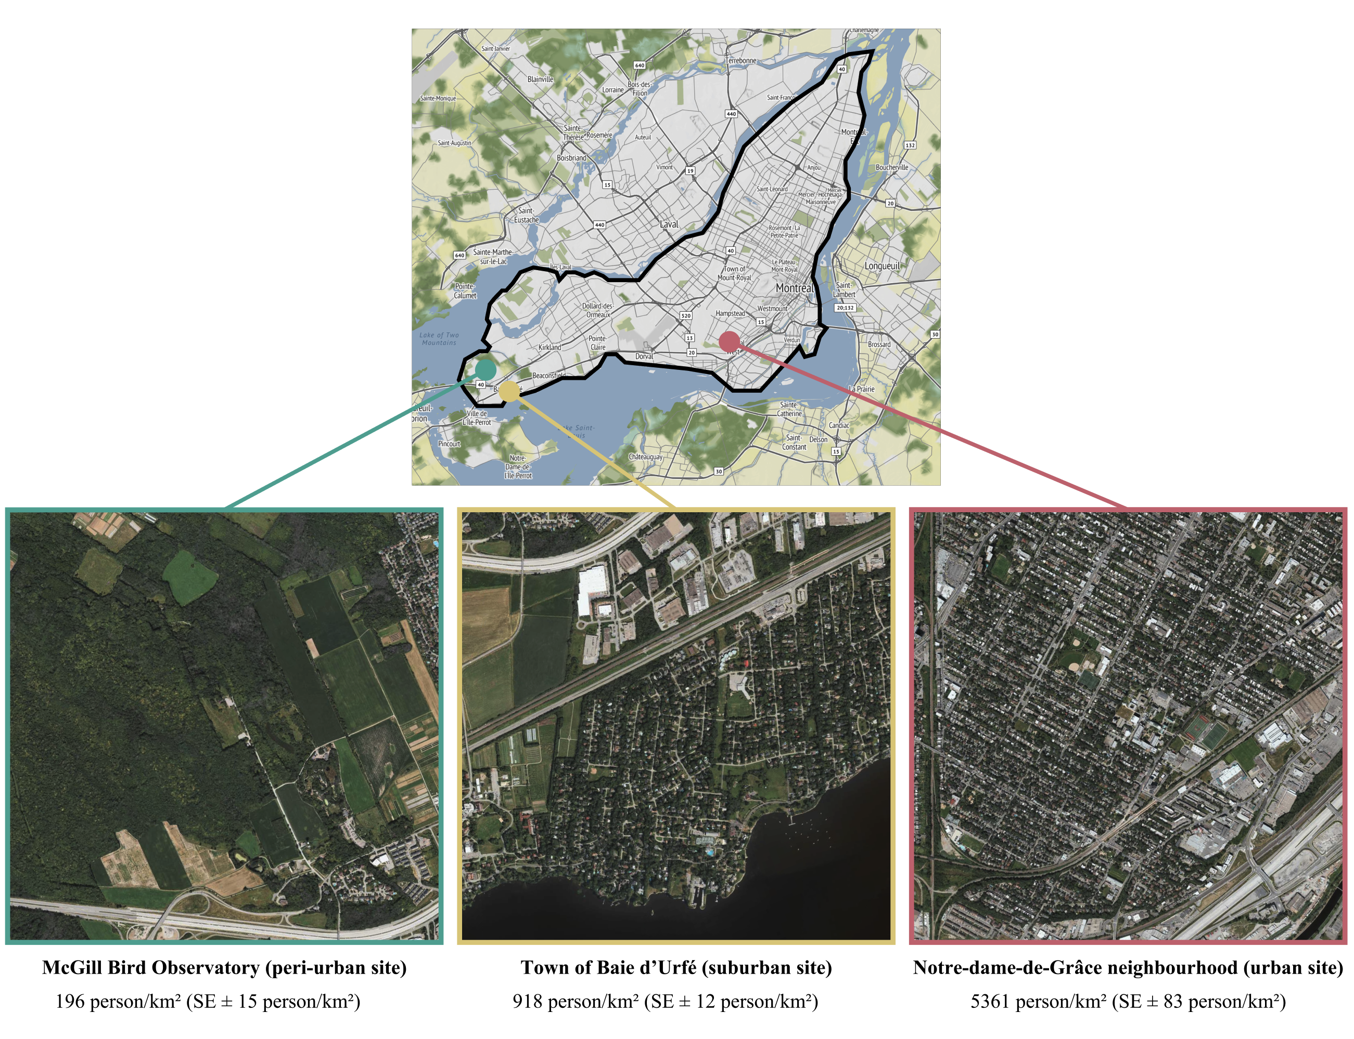
Figure 1.1. Study locations on the Island of Montreal A) The McGill Bird Observatory (MBO) served as the less urban location out of the three (2% of the area covered by streets and/or roads). It’s located in Sainte-Anne-de-Bellevue on the west side of the island. B) The residential area of Baie d’Urfé (BDU) served as an intermediately urbanized location (5% of the area covered by streets and/or roads). C) Concordia University (CON) in the Notre-Dame-de-Grâce neighbourhood served as the most urban location (13% of the area covered by streets and/or roads).
All translocation sites had a significantly different level of urbanization from one another (p < 0.001) based on population density data from the Cancensus packages, using census data from the Government of Canada for the year 2021. All three sites are characterized by relatively high levels of green space compared to the broader urban context of Montreal. As such, this gradient does not fully capture the extent of urbanization present across the entire city and should be interpreted as a localized urbanization gradient within predominantly green neighbourhoods, rather than a representative cross-section of the full urban-rural continuum.

Radio tagging, banding & translocation
We mist netted C. cardinalis (males and females) at the MBO during October and November of the year 2022, 2023 and 2024. The birds were intercepted using 30 mm Japanese Nylon nets and placed in small cotton bags to reduce stress before handling. As part of the migration monitoring being done at the MBO, we banded the cardinals with a numbered aluminum band. The individuals were sexed, aged, weighed, and randomly assigned to one of the six possible release sites for translocation by car. In addition to the aluminum band, we fitted the cardinals with a set of heat-sealed coloured plastic bands, each with a unique combination of colours. This allowed visual identification of the individuals without having to resort to a radio tag receiver. Each bird was equipped with a Lotek NanoTag (NTQB-2) weighing 0.8 grams, using soft elastics in a figure 8 harness configuration (the total weight of the tag, harness, and glue was less than 3% of the cardinals’ body weight). All the radio-tags were registered as part of the Motus Wildlife Tracking System (Frei et al., 2024). C. cardinalis translocated to the MBO and BDU locations underwent a holding time of 45 minutes before release to standardize treatment amongst individuals. For the winter of the year 2022-2023 (winter 1), we were able to consistently track 20 birds at MBO, which served as a pilot winter to assess the feasibility of the project. During the winter of 2023-2024 (winter 2), a total of 45 birds were tagged and banded, with 15 individuals relocated to CON, 15 relocated to BDU and 15 relocated to MBO. In 2024-2025 (winter 3), a total of 42 birds were tagged and banded, with 5 individuals relocated to MBO, 16 individuals released in BDU and 21 individuals released at CON. Birds were banded under Animal Use Protocol 2007-5447 from McGill University and federal banding permits 10973, 10973B, 10973D issued by the Canadian Wildlife Service, and radio-tagged under Animal Use Protocol 22BF01 and 23BF01 from Environment and Climate Change Canada.

Cardinal abundance and seasonal distribution
To investigate the C. cardinalis’ historical abundance in Quebec, Canada, we used data from the Audubon Christmas Bird Count, more specifically we extracted the number of cardinals recorded per party hours in the states of Maine, New York, New Hampshire and Vermont (United States), along with the data from Quebec (Canada) (National Audubon Society, 2015). To examine seasonal variations in C. cardinalis’ distribution, we used weekly abundance estimates from eBird data collected between 2009 and 2023, to generate a map of the birds’ distribution in summer (week of July 5th) and winter (week of December 27th) (Fink et al., 2025).

Non-breeding season tracking and home range estimations
During the first winter, only 2 automated receiver towers from the Motus network were deployed. The first tower is located at the MBO (4525’50.4”N 73˚56’18.6”W), while the second tower is located on top of a faculty building at McGill University’s Macdonald campus (45˚24’28.3”N 73˚56’20.3”W). For the second winter, those two towers were also used for continuous data location, with the addition of a third temporary receiver tower that we installed in BDU (45˚24’39.3”N 73˚55’48.3”W). Finally, during the third winter, a fourth, permanent Motus tower was installed on top of a building at Concordia University’s Loyola campus location (45˚27’32.6”N 73˚38’30.2”W). We conducted manual radio tracking of each individual as often as possible (approximately once or twice a week) between the months of October and May using a set of portable receivers and antennae. Trackers would cover as much ground as possible at each study location with the goal of recording at least one GPS location for each individual per week using a Garmin ETREX 22x GPS. The portable receivers were either Lotek’s SRX800 or SRX1200. They were operated by setting the frequency to 166.380 MHz (Motus tags’ frequency for the Western hemisphere) and using both the gain and the signal strength to get as close as possible to the tagged individuals. The gain is a value between 0 and 100, representing the amplification of the received signal. By increasing it, the tracker increases how sensitive the receiver is to incoming radio signals. Higher gain values increase the ability to detect weaker signals but are also subject to background noise and interference. Using a lower gain reduces noise but may result in missing weak signals. In urbanized locations, the starting gain will rarely surpass 70-80 as the receiver picks up too much noise and interference. The signal is a value ranging from 0 to 200 for the SRX800 and 0 to 250 for the SRX1200. It represents the strength of the detected transmission from a radio tag, displayed in decibels (dB) on the receiver. A stronger signal indicates that the bird is closer; trackers use this information to estimate distance and direction. Trackers begin their tracking sessions with a gain of 80-70 to increase their chances of detecting nearby individuals. Once the receiver picks up a cardinal’s tag, the tracker moves toward the direction with the strongest signal. Once a threshold of 150 dB (SRX800) or 200 dB (SRX1200) is attained, the trackers then lower the gain by 10 and repeat this process until they reach the tagged individual. The trackers only record a GPS point if the signal strength is 150 or 200 dB, with a gain of 40 or less (the bird is considered close enough when those conditions are met).
For all three study sites, we calculated the average home range size using the Kernel Density Estimation (KDE), a non-parametric way to estimate the probability density function of a random variable based on a finite data sample (in the present case, C. cardinalis GPS location recorded in the field) (Calenge, 2024).
$$K\left(u\right)= \frac{1}{\sqrt{2π}}e^{-\frac{1}{2}u^{2}}$$
Where:
$K(u)$ is the kernel function evaluated at u, providing the weight assigned to a data point based on its distance to the target location.
$u= \frac{x-x_{i}}{h}$ is the standardized distance between the location x (where the density is being estimated) and the observed data point x_{i}, scaled by the bandwidth h.
h is the bandwidth parameter, which determines the smoothness of the resulting density estimate; smaller values of h lead to a rougher estimate, while larger values produce a smoother result.
$\frac{1}{\sqrt{2π}}$ is the normalization constant ensuring that the kernel integrates to one.
e is Euler’s number (approximately 2.718), the base of the natural logarithm.

Scale of effect
We first identified the scale of effect (i.e., the spatial extent at which landscape variables have the strongest relationship with a species’ response’) by extracting variables at four spatial scales (25, 50, 100, 200 meters; Martin & Fahrig, 2012). These spatial scales were chosen because they cover a wide range of possible scale of effect that are highly relevant in urban ecology, considering that habitat heterogeneity is scale-dependent. For each scale we ran generalized linear mixed models (GLMMs) at each study location using all five predictor variables as well as year, site, and individual ID as random effects. We ranked model using Akaike Information Criterion (AICc) values, which take into account small sample sizes (Burnham & Anderson, 2002). Once the scale of effect was determined for each location, we conducted a resource selection function.

Resource Selection Function
We compared ‘used’ vs. ‘available’ habitat using a resource selection function for C. cardinalis during the non-breeding season and across an urban gradient. We used environmental and anthropogenic variables extracted from available spatial data as well that collected in the field. This included mean and standard deviation (SD) of vegetation height (1m resolution) from OpenForest (citation), distance to nearest bird feeder (collected through systematic field observations), population density data (census unit) using the Cancensus R package (vonBergmann & Jacobs, n.d.) and spatial data on the streets and road from the island of Montreal (VILLE DE MONTRÉAL, 2018). Unused locations were derived at a 1:1 ratio by creating random locations within 300 meters of the used location, at a random angle. For each study site, we ran a “Full model” (Used ~ Mean vegetation height + Sd vegetation height + Population density + Road length + Distance to nearest feeder + (1|Winter) + (1|Site) + (1|ID)), including all of the variables, plus the winter (years of sampling), relocation site and bird ID as random effects. The second model we ran was the “Vegetation height” model (Used ~ Mean vegetation height + (1|Winter) + (1|Site) + (1|ID)), assuming the vertical height of vegetation was a primary factor for decision making. The third model we ran was “Sd vegetation height” (Used ~ Sd vegetation height + (1|Winter) + (1|Site) + (1|ID)), in this case, we assume that the vertical composition was a more predominant decision-making factor compared to height on its own. The fourth model we ran was the “Human model” (Used ~ Population density + Road length + Distance to nearest feeders + (1|Winter) + (1|Site) + (1|ID)), which assumed that the cardinals would rely mostly on human-related cues to select a wintering habitat. The final model we ran was the “Null” model, including only the random effects variables (Used ~ + (1|Winter) + (1|Site) + (1|ID)). We then once again selected the best models according to the corrected Akaike Information Criterion (AICc). We used Variance Inflation Factor (VIF) to test for multicollinearity among predictor variables and Hosmer-Lemeshow as a goodness-of-fit test (Hosmer & Lemesbow, 1980). All statistical analysis were performed using Program R version 4.4.2 (R Core Team, 2024).

Results

Description of C. cardinalis trends from Christmas Bird Count, eBird, and bird banding data
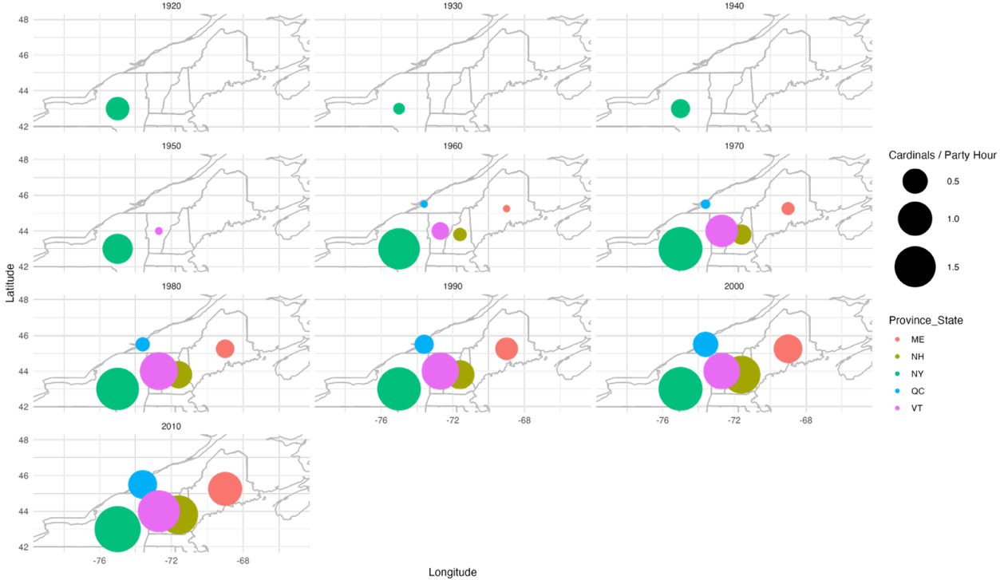
In southern Quebec, C. cardinalis’ population has seen a steep increase in abundance initiated around the 1970s. The same trends have been reported in southern Ontario, as shown in figure 1.2. (i.e. as the years progress, we can see a steady increase in the number of cardinals reported in the United States and a propagation northward until it reaches southern Quebec in the 1960s). This expansion of the northern distribution of C. cardinalis is largely attributed to the increase of people putting out bird feeders on their property, along with increasing winter temperatures, making it easier for the cardinals to remain in the northern part of their distribution range year-round (Halkin et al., 2021; Robert et al., 2019).
Figure 1.2. Number of C. cardinalis observations per party hours between the 1920s and the 2010s according to state (United States of America) or province (Canada) as part of the Audubon Christmas Bird Count.
C. cardinalis are associated to anthropogenic environments (figure 1.3.), which is especially pronounced during the winter period (Fink et al., 2025). The eBird data suggests that the Montreal area has on average ~1-2 C. cardinalis reported on a weekly basis on July 5th, while this number goes up to ~3-4 cardinals reported on December 27th (Fink et al., 2025).
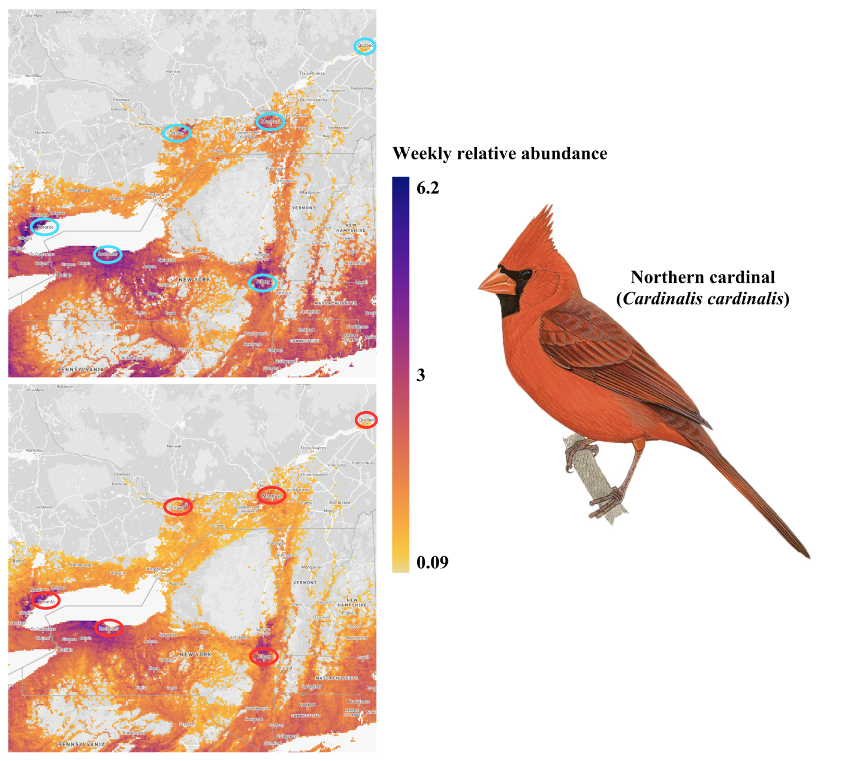Figure 1.3. Weekly reported abundance of C. cardinalis on eBird during the winter (top, December 27th) and the summer (bottom, July 5th) (Fink et al., 2025). Encircled in blue (winter) and red (summer) are the major cities, including Quebec (Canada), Montreal (Canada), Toronto (Canada), Rochester (United States) and Albany (United States) (Illustration credit: Brian Small).
C. cardinalis captures at MBO peak first in May (both banded and recaptured birds; figure 1.4.), approximately at the middle point of the spring migration monitoring program. During the entirety of the spring program, C. cardinalis are banded at a rate of ~ 0.27 individual per hour of mist-net opening and cardinals are recaptured at a slightly higher rate of ~ 0.31 individual per hour of mist-net opening. When the fall migration monitoring program occurs, there is a steep increase in the number of C. cardinalis banded and recaptured. Banding rate goes up to ~ 0.75 individual per hour of mist-net opening (almost three times the banding rate during the spring), while recapture rate increases to 0.50 individual per hour of mist-net opening. The high numbers of C. cardinalis captured during the fall migration monitoring program are mainly juveniles, most probably from pairs breeding on site.
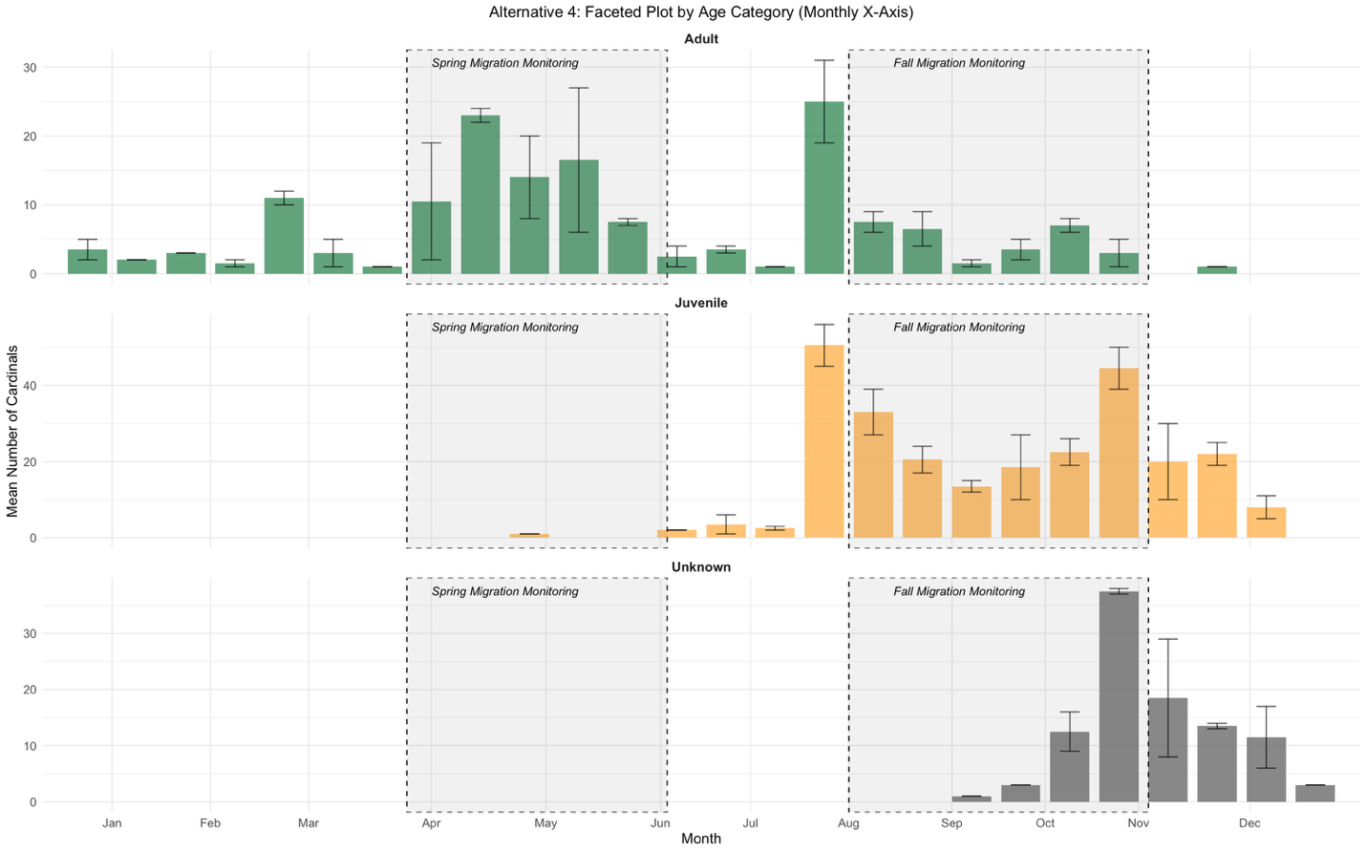Figure 1.4. Mean number of adults (top), juveniles (middle) and unknown (bottom) C. cardinalis banded on a bi-weekly basis at the McGill Bird Observatory between 2004 and 2022 in Montreal, Quebec, Canada. The grey boxes highlight both the spring and fall migration monitoring programs duration.

Telemetry tracking of C. cardinalis across an urban gradient
In the fall and winter of 2022-2023, a total of 21 C. cardinalis were released at MBO (peri-urban) with radio tags (including tags that were re-deployed due to mortalities shortly after release). In 2023-2024, 15 C. cardinalis were released at MBO (peri-urban), 15 at BDU (suburban) and 15 at CON (urban) for a total of 45 C. cardinalis across all three sites. In 2024-2025, 5 C. cardinalis were released at MBO (peri-urban), 16 were released at BDU (suburban) and 21 were released at CON (urban) for a total of 42 birds across all three sites. Table 1.1. is detailing the number of C. cardinalis we were able to track for each field season, their apparent survival, along with the number of confirmed mortalities and the potential causes for these deaths.
Table 1.1. Number of C. cardinalis tracked 1 and 3 months after initial release, with apparent survival (48.15%) and known mortality events/probable causes across three sites in Montreal, Quebec, Canada between 2022 and 2025.
Year | Site | Total number of C. cardinalis | # tracked 1 month (apparent survival) | # tracked 3 months (apparent survival) | Known mortality events | Probable cause of death
2022-2023 | MBO | 21 | 17 (81%) | 16 (76%) | 2 | Predation (n = 2)
2023-2024 | MBO | 15 | 13 (87%) | 9 (60%) | 3 | Predation (n = 2) Unknown (n = 1)
2023-2024 | BDU | 15 | 8 (53%) | 7 (47%) | 2 | Predation (n = 1)  Unknown (n = 1)
2023-2024 | CON | 15 | 4 (27%) | 2 (13%) | 1 | Window collision (n = 1)
2024-2025 | MBO | 5 | 4 (80%) | 3 (60%) | 1 | Unknown (n = 1)
2024-2025 | BDU | 16 | 11 (67%) | 11 (67%) | 2 | Disease (n = 1)  Predation (n = 1)
2024-2025 | CON | 21 | 7 (33%) | 4 (19%) | 2 | Predation (n = 1)  Window collision (n = 1)

Telemetry tracking was conducted 2 to 3 days per week by three people between October and May, for a total of ~288 days of tracking per winter. A total of 688 unique detections were recorded at MBO, 411 detections were recorded at BDU, and 265 detections were recorded at CON. The tracking team covered each time the maximum amount of ground possible during each outing, to record as many individuals as feasible. The total area covered at MBO is of approximately 4.75 km², the area covered at BDU is of approximately 5.94 km², and the area covered at CON is of approximately 18.35 km². The larger coverage at the CON site was due to the highest rate of disappearance of birds from the site and the higher need to ensure that the lack of detection was not simply due to the birds leaving the immediate study area.

Core areas and home ranges of C. cardinalis across an urban gradient
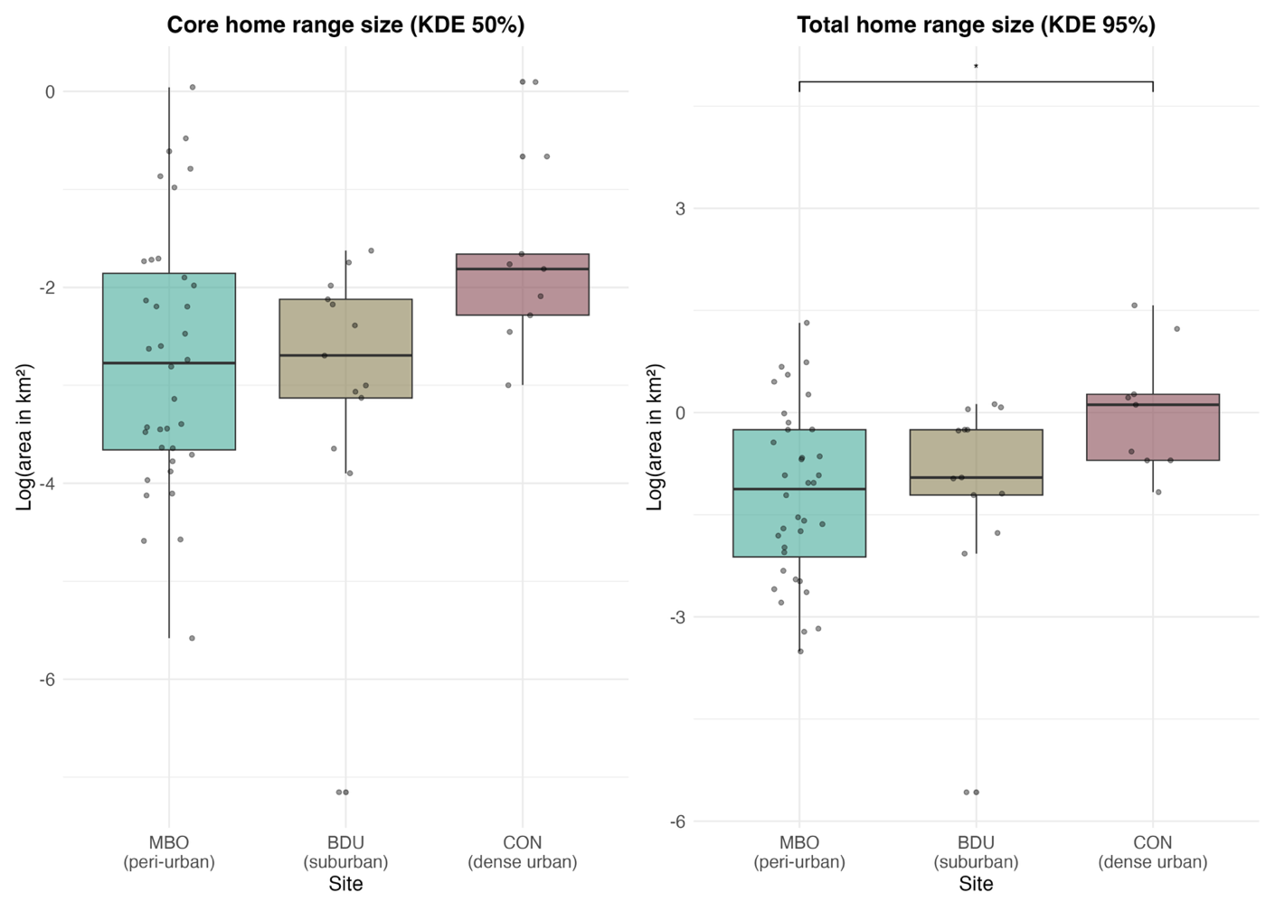
For all three locations, we calculated the KDE 50 % and 95 %, corresponding respectively to the core area where the bird spent most of its time, and to its total home range, including most of the areas visited in winter, excluding outliers (Figure 3). To be included in the KDE estimations, individuals needed to have a minimum of 5 recorded GPS locations. For this reason, we included 36 individuals from the peri-urban site, 13 individuals from the suburban site and 9 individuals at the urban site. C. cardinalis wintering at MBO (peri-urban site, n = 35) had a core area (50 % KDE) averaging 0.15 ± 0.04 (SE) km², and total home ranges (95 % KDE) were on average 0.61 ± 0.13 km². C. cardinalis translocated to BDU (suburban sites, n = 13) had on average, core areas of 0.08 ± 0.02 km² and total home ranges of 0.56 ± 0.11 km². Birds wintering at CON (urban site, n = 9) had an average core area of 0.28 ± 0.11 km² while their total home ranges were 1.53 ± 0.52 km². Core and total home ranges sizes were not normally distributed (Shapiro-Wilk tests: core, W = 0.62, p < 0.001; total, W = 0.70, p < 0.001), so areas were transformed using a logarithm prior to analysis. After transformation, the data met assumptions of normality and variances were homogeneous. There was no significant difference in core home range size among sites, although the effect approached significance (ANOVA: F(2, 55) = 2.69, p = 0.08). Post-hoc comparisons show a trend towards C. cardinalis at our urban site to have larger core home range sizes compared to the suburban and peri-urban sites (figure 1.5.). There was a significant difference between the three study sites regarding total home ranges (ANOVA: F(2, 55) = 3.45, p = 0.04). Post-hoc TukeyHSD comparisons showed that the only significant difference was between the total home ranges of C. cardinalis at our urban site being larger than C. cardinalis at the peri-urban site (mean difference = 1.24, 95% CI [0.09, 2.38], p = 0.03).
Figure 1.5. Comparison of the core (KDE 50%) and total (KDE 95%) home ranges of C. cardinalis in three study sites in Montreal, Quebec, Canada during winters between the years 2022 and 2025. The study sites are represented here as: McGill Bird Observatory – MBO, Town of Baie d’Urfé – BDU, Concordia University campus – CON. The area in km² was log transformed.

Scale of association to habitat
Using information-theoretics (AICc) we found the spatial scale where habitat variables best predicted C. cardinalis habitat use (i.e., the scale of effect) was fairly consistent across the three sites. At the peri-urban site (MBO) the 50-meter spatial-scale model explained the most variation seen in the data compared to the other spatial-scales (i.e., > 4 Δ AICc values between all other models; figure 1.6., A). For the birds at the suburban site (BDU) and the urban site (CON), the best model is the 25-meter one (> 10 Δ AICc values between all other models; figure 1.6., B). Lastly, for the urban CON site, the 25-meter model was the top model from the spatial scales investigated (> 10 Δ AICc values among all other models; figure 1.6., C).
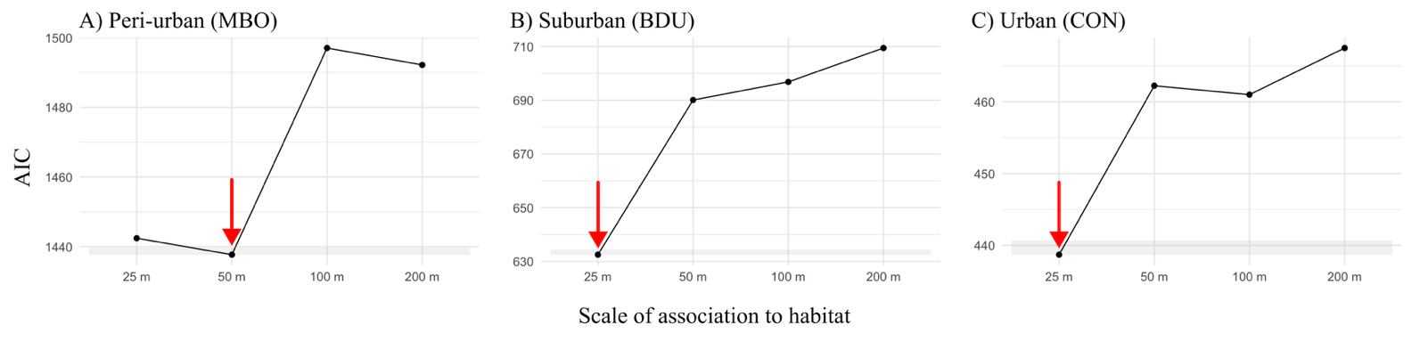
Figure 1.6. Model ranking using AICc of generalized linear mixed models (GLM) with a comparing scale of effect of landscape variables for resighting locations (n= 57) of the C. cardinalis tracked across three sites (A, B and C) in Montreal, Quebec, Canada. Arrows indicate the model with the lowest AIC value and the shaded area represent a two ∆AICc of 2 with the best model.

Resource selection: used vs. available habitats
Due to differences of urbanization level and scales of effect, resource selection function models were run separately for each study site. For the peri-urban site (MBO), the global model explained the most variation seen in the data (> 10 Δ AICc values between all other models, Table S1). For the suburban site (BDU), the top model was the human covariates model (human population and road density), with the next best model (full model) < 2AICc units from the top model (Table S1). Lastly for the urban site (CON), the full model was the top model, but again the next best (human covariates) was <1 AICc from the top model (Table S1). The best model for each study site was then used to generate prediction plots on the probability of presence of C. cardinalis according to the model variables (table 1.2.).
Study Site | Variable | Coefficient estimate | Standard error | z | p
McGill Bird Observatory (peri-urban) | Global model – 50 meters  Mean vegetation height (m)  Standard deviation of the mean vegetation height  Mean population density (person/km²)  Road length (m)  Distance to the nearest bird feeder (m) | -1.272  1.107  -0.095  0.023  -0.347 | 0.153  0.114  0.111  0.110  0.068 | -8.329  9.709  -0.858  0.207  -5.067 | <0.001  <0.001  0.391  0.836  <0.001
Town of Baie d’Urfé (suburban) | Human covariates model – 25 meters  Mean population density (person/km²)  Road length (m)  Distance to the nearest bird feeder (m) | -0.486  1.238  -0.427 | 0.135  0.136  0.128 | -3.603  9.138  -3.342 | <0.001  <0.001  <0.001
Concordia University (dense urban) | Global model – 25 meters  Mean vegetation height (m)  Standard deviation of the mean vegetation height  Mean population density (person/km²)  Road length (m)  Distance to the nearest bird feeder (m) | 0.252  -0.458  -0.212  0.736  -0.392 | 0.180  0.191  0.131  0.135  0.141 | 1.399  -2.405  -1.620  5.438  -2.772 | 0.162  0.016  0.105  <0.001  0.006
Table 1.2. Model parameters for the three resource selection models predicting the presence/absence of 56 C. cardinalis within (25 or 50 m-radius) areas based on the average vegetation height (in meters) and its standard deviation, along with human-related environmental features such as population density (in people/km²), road length (in meters) and distance to the nearest bird feeder (in meters). The data was scaled and centered before running the models. The study site, year of sampling (Winter) and the individual’s identification (ID) are included as random effects in each model.

The prediction plots including only the significant fixed effects for the resource selection functions of each locations reveal that the presence of C. cardinalis is associated with different urban and habitat features according to the site they spend their winter in (figure 1.7.). In the peri-urban site (MBO), the probability of presence of the C. cardinalis decreases as the mean vegetation height increases (figure 1.7., A), while the presence of the birds increases with greater variability in vegetation height (figure 1.7., B). The probability of presence of the C. cardinalis also seems to decrease as the distance to the nearest bird feeder increases (figure 1.7., C). In our suburban site (BDU), the probability of presence of the C. cardinalis shows little relationship with population density (figure 1.7., D), but increases as the mean road length increases (figure 1.7., E). Like our peri-urban site, the presence of the birds also decreases as the distance to the nearest feeder increases at the suburban site (figure 1.7., F). At the urban site (CON), the C. cardinalis’ probability of presence decreases with increasing vegetation height standard deviation, although uncertainty is high (figure 1.7., G). The presence of C. cardinalis also increased with mean road length and decreased with the distance to the nearest feeders. Across sites, proximity to feeders and structural complexity of the infrastructures or the vegetation consistently influenced the probability of presence, yet specific relationships varied.
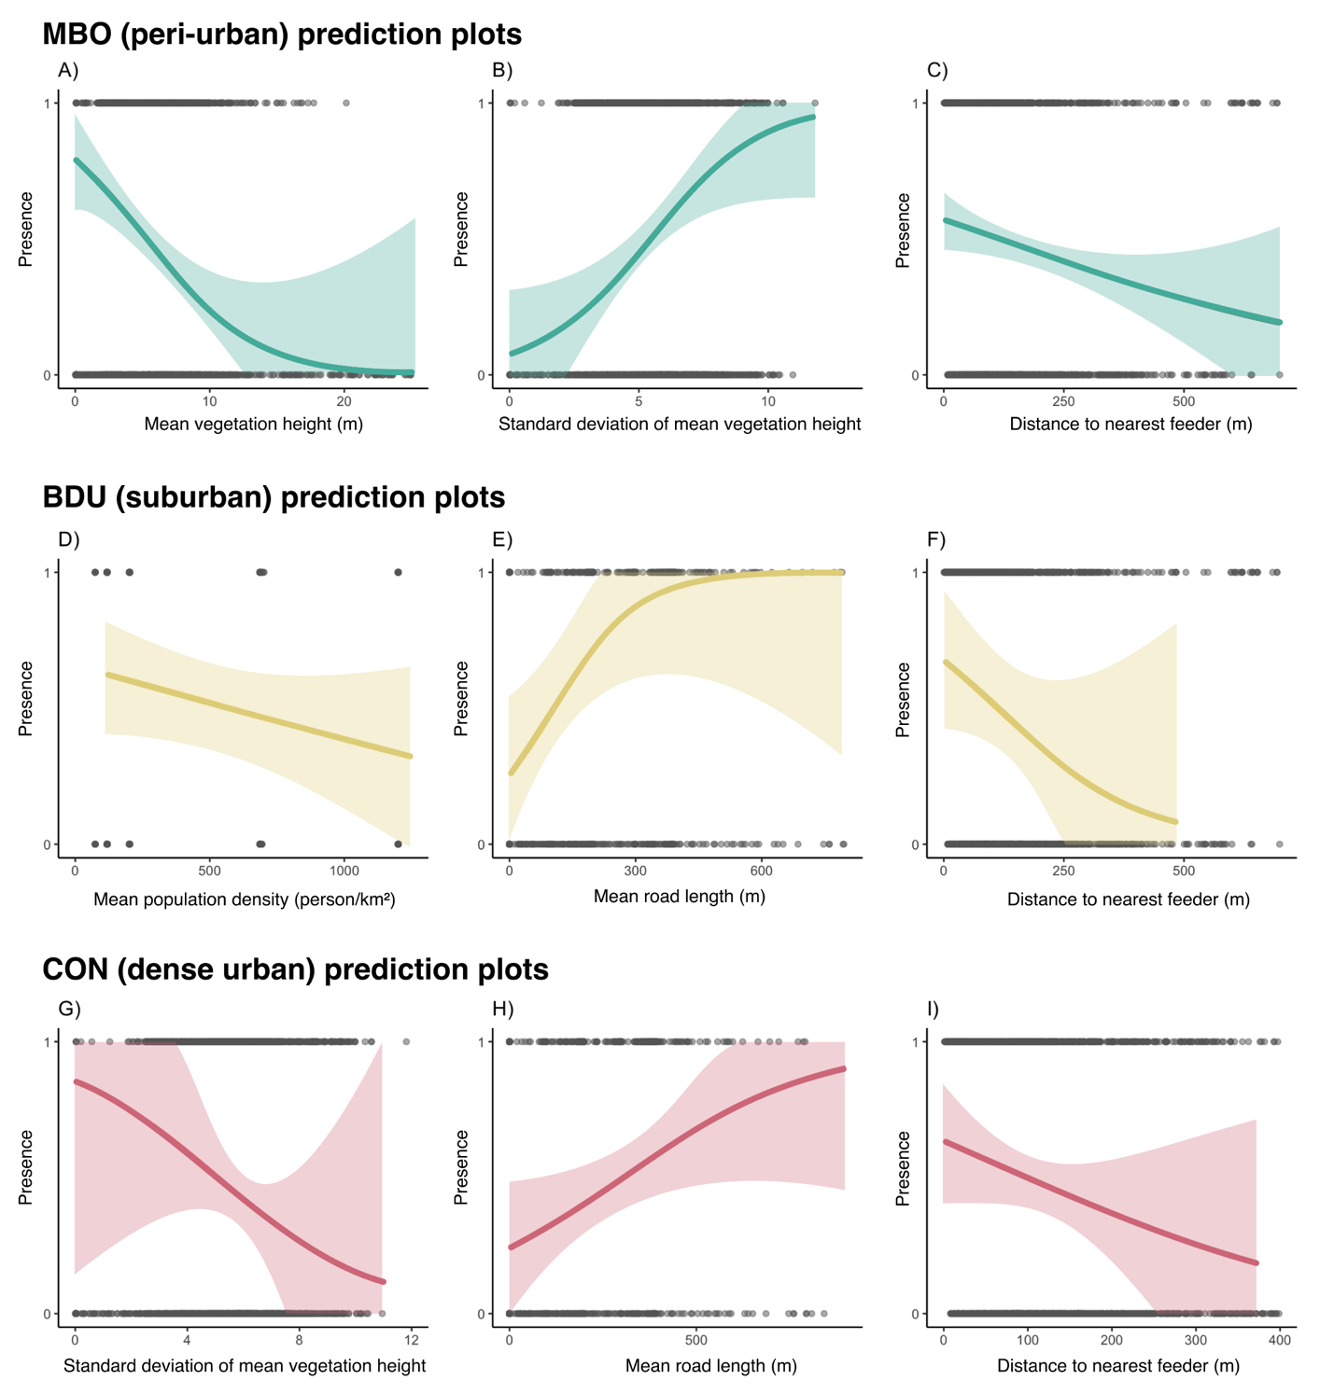
Figure 1.7. Probability of presence of C. cardinalis in a given radius area, as predicted by a generalized linear mixed effects model. Shaded areas represent 67% confidence intervals around the predicted probabilities. The model’s fixed effect variables are described in Table 1b, and for each model, random effects were sampling years, translocation site and bird ID.

Discussion
Using three years of telemetry tracking data of C. cardinalis across an urban gradient during the non-breeding season, we found evidence that C. cardinalis in urban locations had significantly larger home ranges compared to those in suburban and peri-urban sites. Comparatively, the spatial scale of habitat use by C. cardinalis was consistent across the urban gradient and occurred at a relatively at a fine scale (25-50 m). Significant vegetation and anthropogenic predictors of C. cardinalis presence differed across the urban gradient, suggesting that ecological needs and drivers of winter survival by C. cardinalis in human-modified landscapes may be context-dependent (peri-urban vs suburban vs urban). Apparent survival of C. cardinalis during the harshest period of their annual cycle appears fairly similar between peri-urban and suburban sites, while mortality or relocation was threefold higher in the urban site. C. cardinalis in suburban and urban sites do not spend time in parks or other larger public green spaces during the non-breeding season, instead favouring the private urban green spaces such as private backyards and gardens and are strongly associated with the presence of anthropogenic food resources (i.e., birdfeeders).

Lower apparent survival at urban site
While the apparent survival of C. cardinalis was quite similar between the peri-urban site (on average 65% after 3 months) and the suburban site (on average 57% after 3 months), it was much lower at the dense urban location (on average 16% after 3 months). Our apparent survival rates for the peri-urban and suburban locations are consistent with previously established annual survival in Ohio (50.5% ± 10.3 SE to 78.3% ± 7.6 SE) and in Washington D.C. (between 40 to 70%) in the United States (Evans et al., 2015; Shustack, 2008). However, the very low survival rates that we are seeing in the dense urban location is well below what was previously found in urban habitats. C. cardinalis’ annual apparent survival was even shown to increase as the amount of impervious surfaces (used as indicator of urbanization) increases (Shustack, 2008). We also cannot exclude the possibility that the tags had detrimental effects on the survival of C. cardinalis in the most urban location. During the reproductive season, C. cardinalis with tags (weighing 1.6 g) attached defended their nests less vigorously, but did not change their provisioning effects (Barron et al., 2013). C. cardinalis nests with tagged parents also had lower daily survival rates and were less likely to fledge offspring (Barron et al., 2013). It’s possible that the tags had a detrimental effect on survival, which wasn’t perceptible in the peri-urban and suburban study sites but was noticeable in the dense urban location. Likewise, despite covering a large area surrounding the urban release sites (>16 km²), there is a possibility that urban tagged and translocated individuals survived but moved far away from their release site and were beyond detection.

Larger home ranges and the importance of bird feeders
There is a significant difference between total home ranges (KDE 95%) sizes across an urban gradient, where the individuals at the urban site having the largest total home ranges. These results oppose what has been previously found in other studies, where house sparrows in urban landscapes occupied smaller home ranges compared to their rural counterparts (Vangestel et al., 2010). O’Donnell (2020) also suggested, that generally, birds in urban environments tend to have smaller home ranges. However, regarding C. cardinalis specifically, research from 2008 focusing on extraterritorial movements of female C. cardinalis, found that during the breeding period, females ventured out of their territory more often when they had supplemental feeding, compared to females that didn’t have access to supplemental food (Humbird & Neudorf, 2008). And while the authors did not find a statistically significant difference in the females’ home range sizes, they did see a trend towards supplemental fed females to have larger home ranges (Humbird & Neudorf, 2008). Yet, what we have found doesn’t exactly align with this idea that C. cardinalis with access to supplemental food would have larger home ranges. By mapping the location of visible bird feeders, we determined the approximate feeder density at all sites: the peri-urban site had ~13 feeders/km², the suburban site had ~35 feeders/km² and the urban site had ~12 feeders/km². We can hypothesise that the poorer density of feeders at the urban site led C. cardinalis to travel further between these reliable resource points because of their scattered locations. On the contrary, in the suburban site (which has a feeder density over twice that of the urban site) we can hypothesise that the high feeder density allowed the birds to have access to reliable food sources without the need to travel further away.
Across all our study sites, the C. cardinalis were more likely to occupy a specific area with bird feeders were present. Research on the European turtle doves (Streptopelia turtur) found that the larger home ranges were more likely to contain seed-rich habitats, potentially suggesting that they were willing to travel further to access high quality food sources (Dunn et al., 2021). Likewise in an urban system, birds may employ higher movement rates and larger home ranges size during the challenging winter months to visit well stocked bird feeders for quality food resources.

Small scale of association to habitat regardless of urbanization level
C. cardinalis are associated with habitat features at different spatial scales depending on the level of urbanization of their wintering site: 50 meters in our least urban site, and 25 meters in both our suburban and dense urban locations. This pattern suggests that as soon as human presence is more pronounced in the landscape, C. cardinalis rely more heavily on immediate habitat factors (possibly due to increased fragmentation and reduced availability of high-quality habitats at broader scales). This aligns with broader research on animal species, suggesting that the magnitude and direction of species’ responses to urbanization reflects landscape-scale differences within cities (Fidino et al., 2021). Moreover, recent work on migratory birds passing through urban areas via stopover sites highlighted the value of multiscale habitat assessment since different processes can come into play at different spatial resolution (Guo et al., 2023). Our findings showing that C. cardinalis respond to finer spatial scales in more urbanized areas also support evidence that urban green space size and configuration matter—especially in cities where small patches may play a critical role to support bird populations (Dale, 2018). Thus, we want to underscore the importance of scale-sensitive, species-specific approaches when evaluating habitat use in urban areas and join other researchers in suggesting that conservation efforts in urbanized environments may need to focus on fine-scale habitat quality to support resident species year-round (Guo et al., 2023; Litteral & Shochat, 2017).

Variation of preferred habitat factors across an urbanization gradient
C. cardinalis were associated with different environmental and anthropogenic habitat variables across an urban gradient. The one consistent association across study sites was the relationship between C. cardinalis presence and a shorter distance to the closest bird feeder. This finding is in alignment with previous work, that showed C. cardinalis are one of the most common species of birds to frequent bird feeders across the United States and Canada, and that their abundance at feeders is more pronounced during the autumn and winter season (Horn et al., 2014). Supplementary feeding in urban areas is suspected to be one of the main drivers of C. cardinalis expanding their northern distribution, thus it is unsurprising that bird feeders were found to be a significant predictor of their presence (Robb et al., 2008). C. cardinalis were also more likely to be found in areas with more paved road cover in both the suburban and urban sites. Our finding is similar to a study in Washington D.C. (United States) that found that C. cardinalis had better survival odds during the breeding season (between May and August) when in areas with high proportions of impervious surfaces (Evans et al. 2015). In the urban landscape, roads may offer similar habitat features to edge habitats that they are known to be fond of, which would explain their close association to this variable in the suburban and urban location (Rousseau et al., 2015). We have also found diverging trends with regards to the association with the standard deviation of the vegetation height. At the urban site, C. cardinalis avoided the areas of highly contrasted vegetation structures, while at the peri-urban site they were more likely to occupy an area with an elevated standard deviation. These findings highlight the importance of vegetation structure in habitat association, and agrees with previous work showing that vegetation structure is a particularly important variable in urban areas, specifically for C. cardinalis (Duren et al., 2017). Postfledging C. cardinalis in urban areas were also found to strongly select for habitat with a complex understory vegetation (Ausprey & Rodewald, 2011). C. cardinalis do not exhibit the same preference in the peri-urban site potentially because there was much more habitat available or the site was more homogenous. Research in Yucatan, Mexico, found that the importance of vegetation architecture and composition in birds’ habitat selection was most likely scale-dependent (Deppe & Rotenberry, 2008). We did find that C. cardinalis were selecting their wintering habitats at a larger scale at the peri-urban location, compared to the urban site. At a larger scale, the vegetation vertical structure may not be as important as say the species’ composition, while at a smaller scale, habitat selection relies more on the structure of the vegetation compared to its composition.

Implications
Our results highlight the importance of fine-scale habitat features and resource availability in shaping winter ecology of a resident songbird along an urban gradient. The context-dependent responses we observed underscore the need for tailored, scale-sensitive conservation strategies. In particular, the reliance on bird feeders and avoidance of large public green spaces suggests that private residential habitats may play a disproportionately important role in supporting overwintering birds. As urban development intensifies, integrating biodiversity-friendly practices such as preserving vertically complex vegetation and enhancing connectivity between small habitat patches could help sustain resident birds’ populations. More broadly, our findings join a growing body of work emphasizing the ecological importance of urban landscape’s elements and highlight the need for inclusive conservation planning that includes both public and private green infrastructures.

Literature cited
Altwegg, R., Jenkins, A., & Abadi, F. (2014). Nestboxes and immigration drive the growth of an urban Peregrine Falcon Falco peregrinus population. Ibis, 156(1), 107–115. https://doi.org/10.1111/ibi.12125
Ausprey, I. J., & Rodewald, A. D. (2011). Postfledging Survivorship and Habitat Selection Across A Rural-To-Urban Landscape Gradient. The Auk, 128(2), 293–302. https://doi.org/10.1525/auk.2011.10158
Barron, D. G., Weatherhead, P. J., & Brawn, J. D. (2013). A Test of Radio-Transmitter Effects on Parental Investment and Productivity in the Northern Cardinal. The Condor, 115(3), 669–676. https://doi.org/10.1525/cond.2013.120149
Beddall, B. (1963). Range Expansion of the Cardinal and Other Birds in the Northeastern States. The Wilson Bulletin, 75(2), 140–158.
Bressler, S. A., Diamant, E. S., Tingley, M. W., & Yeh, P. J. (2020). Nests in the cities: Adaptive and non-adaptive phenotypic plasticity and convergence in an urban bird. Proceedings of the Royal Society B: Biological Sciences, 287(1941), 20202122. https://doi.org/10.1098/rspb.2020.2122
Burnham, K. P., & Anderson, D. R. (2002). Model Selection and Multimodel Inference (2nd ed.).
Calenge, C. (2024). adehabitatHR: Home Range Estimation [Computer software].
Callaghan, C. T., Cornwell, W. K., Poore, A. G. B., Benedetti, Y., & Morelli, F. (2021). Urban tolerance of birds changes throughout the full annual cycle. Journal of Biogeography, 48(6), 1503–1517. https://doi.org/10.1111/jbi.14093
Carrasco, L., Giam, X., Papeş, M., & Sheldon, K. S. (2019). Metrics of Lidar-Derived 3D Vegetation Structure Reveal Contrasting Effects of Horizontal and Vertical Forest Heterogeneity on Bird Species Richness. Remote Sensing, 11(7), Article 7. https://doi.org/10.3390/rs11070743
City of Montreal. (2024). Plan climat 2020-2030 Ville de Montréal—État d’avancement avril 2024. City of Montreal. https://mtl.ged.montreal.ca/constellio/?collection=mtlca&portal=REPDOCVDM#!displayDocument/00000092918
Dale, S. (2018). Urban bird community composition influenced by size of urban green spaces, presence of native forest, and urbanization. Urban Ecosystems, 21(1), 1–14. https://doi.org/10.1007/s11252-017-0706-x
DeCandido, R., & Allen, D. (2006). NOCTURNAL HUNTING BY PEREGRINE FALCONS AT THE EMPIRE STATE BUILDING, NEW YORK CITY. The Wilson Journal of Ornithology, 118(1), 53–58. https://doi.org/10.1676/1559-4491(2006)118[0053:NHBPFA]2.0.CO;2
Deppe, J. L., & Rotenberry, J. T. (2008). SCALE-DEPENDENT HABITAT USE BY FALL MIGRATORY BIRDS: VEGETATION STRUCTURE, FLORISTICS, AND GEOGRAPHY. Ecological Monographs, 78(3), 461–487. https://doi.org/10.1890/07-0163.1
Dinh, K. V., Albini, D., Orr, J. A., Macaulay, S. J., Rillig, M. C., Borgå, K., & Jackson, M. C. (2023). Winter is coming: Interactions of multiple stressors in winter and implications for the natural world. Global Change Biology, 29(24), 6834–6845. https://doi.org/10.1111/gcb.16956
Dunn, J. C., Morris, A. J., Grice, P. V., & Peach, W. J. (2021). Effects of seed-rich habitat provision on territory density, home range and breeding performance of European Turtle Doves Streptopelia turtur. Bird Conservation International, 31(4), 620–639. https://doi.org/10.1017/S0959270920000635
Duren, A. M., Williams, C. K., & D’amico, V. (2017). Microhabitat Factors Associated with Occupancy of Songbirds in Suburban Forest Fragments in the Eastern United States. The American Midland Naturalist, 178(2), 189–202. https://doi.org/10.1674/0003-0031-178.2.189
Elmqvist, T., Fragkias, M., Goodness, J., Güneralp, B., Marcotullio, P. J., McDonald, R. I., Parnell, S., Schewenius, M., Sendstad, M., & Seto, K. C. (2013). Urbanization, biodiversity and ecosystem services: Challenges and opportunities: A global assessment. Springer Nature.
Evans, B. S., Ryder, T. B., Reitsma, R., Hurlbert, A. H., & Marra, P. P. (2015). Characterizing avian survival along a rural‐to‐urban land use gradient. Ecology, 96(6), 1631–1640. https://doi.org/10.1890/14-0171.1
Fidino, M., Gallo, T., Lehrer, E. W., Murray, M. H., Kay, C. A. M., Sander, H. A., MacDougall, B., Salsbury, C. M., Ryan, T. J., Angstmann, J. L., Amy Belaire, J., Dugelby, B., Schell, C. J., Stankowich, T., Amaya, M., Drake, D., Hursh, S. H., Ahlers, A. A., Williamson, J., … Magle, S. B. (2021). Landscape‐scale differences among cities alter common species’ responses to urbanization. Ecological Applications, 31(2), e02253. https://doi.org/10.1002/eap.2253
Fink, D., Auer, T., Johnston, A., Strimas-Mackey, M., Ligocki, S., Robinson, O., Hochachka, W., Jaromczyk, L., Crowley, C., Dunham, K., Stillman, A., Davis, C., Stokowski, M., Ruiz-Gutierrez, V., Wood, C., & Rodewald, A. (2025). eBird Status and Trends, Data Version 2023 [Dataset]. Cornell Lab of Ornithology. https://doi.org/10.2173/WZTW8903
Frei, B., Morales, A., Cousineau, A.-M., & Beauchamp, A. (2024). Montreal Northern Cardinal Winter Movements (Project 882) [Dataset]. Motus Wildlife Tracking System, Birds Canada. https://motus.org/
Fristoe, T. S. (2015). Energy use by migrants and residents in North American breeding bird communities. Global Ecology and Biogeography, 24(4), 406–415. https://doi.org/10.1111/geb.12262
Government of Canada, S. C. (2022, February 9). Profile table, Census Profile, 2021 Census of Population—Montréal, Ville (V) [Census subdivision], Quebec. https://www12.statcan.gc.ca/census-recensement/2021/dp-pd/prof/index.cfm?Lang=E
Guo, F., Buler, J. J., Smolinsky, J. A., & Wilcove, D. S. (2023). Autumn stopover hotspots and multiscale habitat associations of migratory landbirds in the eastern United States. Proceedings of the National Academy of Sciences, 120(3), e2203511120. https://doi.org/10.1073/pnas.2203511120
Hahs, A. K., Fournier, B., Aronson, M. F. J., Nilon, C. H., Herrera-Montes, A., Salisbury, A. B., Threlfall, C. G., Rega-Brodsky, C. C., Lepczyk, C. A., La Sorte, F. A., MacGregor-Fors, I., Scott MacIvor, J., Jung, K., Piana, M. R., Williams, N. S. G., Knapp, S., Vergnes, A., Acevedo, A. A., Gainsbury, A. M., … Moretti, M. (2023). Urbanisation generates multiple trait syndromes for terrestrial animal taxa worldwide. Nature Communications, 14(1), 4751. https://doi.org/10.1038/s41467-023-39746-1
Halkin, S. L., Shustack, D. P., DeVries, M. S., Jawor, J. M., & Linville, S. U. (2021). Northern Cardinal (Cardinalis cardinalis), version 2.0. Birds of the World. https://doi.org/10.2173/bow.norcar.02
Havlíček, J., Riegert, J., & Fuchs, R. (2022). A comparison of foraging-range sizes, flight distances and foraging habitat preferences in urban and rural House Sparrow (Passer domesticus) populations. Ibis, 164(4), 1227–1242. https://doi.org/10.1111/ibi.13072
Horn, D. J., Johansen, S. M., & Wilcoxen, T. E. (2014). Seed and feeder use by birds in the United States and Canada. Wildlife Society Bulletin, 38(1), 18–25. https://doi.org/10.1002/wsb.365
Hosmer, D. W., & Lemesbow, S. (1980). Goodness of fit tests for the multiple logistic regression model. Communications in Statistics - Theory and Methods, 9(10), 1043–1069. https://doi.org/10.1080/03610928008827941
Humbird, S. K., & Neudorf, D. L. H. (2008). THE EFFECTS OF FOOD SUPPLEMENTATION ON EXTRATERRITORIAL BEHAVIOR IN FEMALE NORTHERN CARDINALS. The Condor, 110(2), 392–395. https://doi.org/10.1525/cond.2008.8427
Johnson, D. H. (1980). The Comparison of Usage and Availability Measurements for Evaluating Resource Preference. Ecology, 61(1), 65–71. https://doi.org/10.2307/1937156
Jokimäki, J., Kaisanlahti-Jokimäki, M.-L., & Suhonen, J. (2022). Long-Term Winter Population Trends of Corvids in Relation to Urbanization and Climate at Northern Latitudes. Animals, 12(14), Article 14. https://doi.org/10.3390/ani12141820
Kauffman, M. J., Frick, W. F., & Linthicum, J. (2003). ESTIMATION OF HABITAT‐SPECIFIC DEMOGRAPHY AND POPULATION GROWTH FOR PEREGRINE FALCONS IN CALIFORNIA. Ecological Applications, 13(6), 1802–1816. https://doi.org/10.1890/01-5324
Latimer, C. E., & Zuckerberg, B. (2021). Habitat loss and thermal tolerances influence the sensitivity of resident bird populations to winter weather at regional scales. Journal of Animal Ecology, 90(2), 317–329. https://doi.org/10.1111/1365-2656.13332
Li, G., Fang, C., Li, Y., Wang, Z., Sun, S., He, S., Qi, W., Bao, C., Ma, H., Fan, Y., Feng, Y., & Liu, X. (2022). Global impacts of future urban expansion on terrestrial vertebrate diversity. Nature Communications, 13(1), 1628. https://doi.org/10.1038/s41467-022-29324-2
Litteral, J., & Shochat, E. (2017). The Role of Landscape-Scale Factors in Shaping Urban Bird Communities. In E. Murgui & M. Hedblom (Eds.), Ecology and Conservation of Birds in Urban Environments (pp. 135–159). Springer International Publishing. https://doi.org/10.1007/978-3-319-43314-1_8
Lowry, H., Lill, A., & Wong, B. B. M. (2013). Behavioural responses of wildlife to urban environments. Biological Reviews, 88(3), 537–549. https://doi.org/10.1111/brv.12012
Martin, A. E., & Fahrig, L. (2012). Measuring and selecting scales of effect for landscape predictors in species–habitat models. Ecological Applications, 22(8), 2277–2292. https://doi.org/10.1890/11-2224.1
McGill University. (2025). Climate. International Student Services. https://www.mcgill.ca/internationalstudents/once-here/pre-arrival/pre-arrival-information/about-montreal/climate
Murray, M. H., Sánchez, C. A., Becker, D. J., Byers, K. A., Worsley‐Tonks, K. E., & Craft, M. E. (2019). City sicker? A meta‐analysis of wildlife health and urbanization. Frontiers in Ecology and the Environment, 17(10), 575–583. https://doi.org/10.1002/fee.2126
National Audubon Society. (2015). The Christmas Bird Count Historical Results [Dataset]. https://www.audubon.org/community-science/christmas-bird-count
O’Donnell, K., & delBarco-Trillo, J. (2020). Changes in the home range sizes of terrestrial vertebrates in response to urban disturbance: A meta-analysis. Journal of Urban Ecology, 6(1), juaa014. https://doi.org/10.1093/jue/juaa014
R Core Team. (2024). R: A Language and Environment for Statistical Computing [Computer software]. R Foundation for Statistical Computing. https://www.R-project.org/
Robb, G. N., McDonald, R. A., Chamberlain, D. E., & Bearhop, S. (2008). Food for thought: Supplementary feeding as a driver of ecological change in avian populations. Frontiers in Ecology and the Environment, 6(9), 476–484. https://doi.org/10.1890/060152
Robert, M., Hachey, M.-H., Lepage, D., & Couturier, A. (2019). Second Atlas of the Breeding Birds of Southern Québec.
Rousseau, J. S., Savard, J.-P. L., & Titman, R. (2015). Shrub-nesting birds in urban habitats: Their abundance and association with vegetation. Urban Ecosystems, 18(3), 871–884. https://doi.org/10.1007/s11252-014-0434-4
Šálek, M., Grill, S., & Riegert, J. (2020). Nest-site selection of an avian urban exploiter, the Eurasian magpie Pica pica, across the urban-rural gradient. Journal of Vertebrate Biology, 70(1). https://doi.org/10.25225/jvb.20086
Seress, G., & Liker, A. (2015). Habitat urbanization and its effects on birds. Acta Zoologica Academiae Scientiarum Hungaricae, 61(4), 373–408.
Shustack, D. P. (2008). Reproductive Timing of Passerines in Urbanizing Landscapes [The Ohio State University]. http://rave.ohiolink.edu/etdc/view?acc_num=osu1217601092
Simberloff, R. A., Phillips, J. N., Derryberry, G. E., Mahoney, M. C., & Derryberry, E. P. (2023). Communication distance predicts territory size: Implications for an urban songbird. Animal Behaviour, 203, 89–99. https://doi.org/10.1016/j.anbehav.2023.05.016
Simkin, R. D., Seto, K. C., McDonald, R. I., & Jetz, W. (2022). Biodiversity impacts and conservation implications of urban land expansion projected to 2050. Proceedings of the National Academy of Sciences, 119(12), e2117297119. https://doi.org/doi:10.1073/pnas.2117297119
Smith, B. T., Escalante, P., Hernández Baños, B. E., Navarro-Sigüenza, A. G., Rohwer, S., & Klicka, J. (2011). The role of historical and contemporary processes on phylogeographic structure and genetic diversity in the Northern Cardinal, Cardinalis cardinalis. BMC Evolutionary Biology, 11(1), 136. https://doi.org/10.1186/1471-2148-11-136
Vangestel, C., Braeckman, B. P., Matheve, H., & Lens, L. (2010). Constraints on home range behaviour affect nutritional condition in urban house sparrows (Passer domesticus): RANGING BEHAVIOUR IN URBAN HOUSE SPARROWS. Biological Journal of the Linnean Society, 101(1), 41–50. https://doi.org/10.1111/j.1095-8312.2010.01493.x
Vaz, S., Manes, S., Khattar, G., Mendes, M., Silveira, L., Mendes, E., De Morais Rodrigues, E., Gama-Maia, D., Lorini, M. L., Macedo, M., & Paiva, P. C. (2023). Global meta-analysis of urbanization stressors on insect abundance, richness, and traits. Science of The Total Environment, 903, 165967. https://doi.org/10.1016/j.scitotenv.2023.165967
VILLE DE MONTRÉAL. (2018). Chaussée agrégée et intersection (Base de données des actifs de voirie) (Jeu de données Nos. a2810949-7335-49e2-84af-1c5da4ff6342). Données Québec. https://www.donneesquebec.ca/recherche/dataset/vmtl-voirie-chaussee-intersection
vonBergmann, J., & Jacobs, A. (n.d.). cancensus: Access, Retrieve, and Work with Canadian Census Data and Geography (Version 0.5.3) [Computer software]. Retrieved May 5, 2025, from https://CRAN.R-project.org/package=cancensus
Wang, H., He, Q., Liu, X., Zhuang, Y., & Hong, S. (2012). Global urbanization research from 1991 to 2009: A systematic research review. Landscape and Urban Planning, 104(3–4), 299–309.

