Winter survival and urban green space use of the northern cardinal (Cardinalis cardinalis)

Anne-Marie Cousineau

Natural Resource Sciences
Agricultural and Environmental Sciences
McGill University, Montréal

August 2025

A thesis submitted to McGill University in partial fulfillment of the requirements of the degree of Master of Science in Renewable Resources

© Anne-Marie Cousineau, Montréal, Canada, 2025
Table of Contents
Abstract 4
Résumé 6
Acknowledgements 8
Contribution of coauthors 9
List of figures 10
List of tables 13
Introduction 14
Literature review 16
Urbanization and its effects on birds 16
Habitat selection scale 20
Habitat use and survival of songbirds in urban areas 21
Use of very high frequency (VHF) telemetry in bird research 23
Study species and study sites 27
Knowledge gaps and research objectives 30
Chapter 1: Winter home ranges size increases across an urbanization gradient for a very short distance migrant, the northern cardinal (Cardinalis cardinalis) 33
Abstract 33
Introduction 34
Materials and methods 37
Study locations 37
Radio tagging, banding & translocation 39
Cardinal abundance and seasonal distribution 40
Non-breeding season tracking and home range estimations 40
Scale of effect 42
Resource Selection Function 42
Telemetry tracking of northern cardinals across an urban gradient 46
Core areas and home ranges of northern cardinals across an urban gradient 47
Scale of association to habitat 49
Resource selection: used vs. available habitats 50
Discussion 53
Lower apparent survival at urban site 53
Larger home ranges and the importance of bird feeders 54
Small scale of association to habitat regardless of urbanization level 55
Variation of preferred habitat factors across an urbanization gradient 56
Implications 57
References 58
Connecting statement 78
Chapter 2: Northern cardinals (Cardinalis cardinalis) exhibit seasonal changes of onset and end of daily activities in urban areas 79
Abstract 79
Introduction 80
Materials and methods 83
Study site and Motus receiver stations 83
Radio tags deployment and Motus data download 84
Change point analysis 85
Weather data extraction 87
Scale of effect of dynamic temporal variables 88
Modelling the effects of weather conditions and dynamic temporal variables on the onset and end of northern cardinal’s daily activities 90
Results 90
Dynamic temporal variables model selection 90
Modelling the effect of weather conditions and dynamic temporal variables on cardinal’s daily activities 91
Discussion 97
Varying scale of effect of dynamic temporal variables 98
Colder temperatures are linked to earlier morning activity in northern cardinals 99
Cardinals only end their day earlier if subjected to extreme cold 101
Implications 102
References 103
General discussion 123
Chapter summaries 124
Limitations, methods and future directions 126
Thesis conclusion 130
Supplemental material 131
References 134

Abstract
Winter presents a season of challenges for resident bird species in temperate areas. With lower temperatures, reduced food availability and shorter days, non-migratory birds must adjust their behaviour and energy expenditures to survive this harsh season. Many species cope with harsh winter conditions by having flexible behaviour, such as changing roosting strategies and reduced metabolism at night. In urban environments, birds have both novel challenges and opportunities in winter. Urban areas provide microclimates that create refuges from harsh weather and reliable anthropogenic food sources, yet they also bring habitat fragmentation and artificial light pollution. Learning more about the winter ecology of resident urban birds can provide us with valuable knowledge to design and improve urban green spaces in a way that benefits people and birds, year-round.
In my first thesis chapter, I examined fine-scale space use by northern cardinals (Cardinalis cardinalis) across three urban green spaces of varying levels of urbanization during the non-breeding season in Montreal, Canada. Using VHF telemetry, I tracked individual cardinals to evaluate how landscape structure and environmental conditions, such as road density, access to bird feeders and vegetation structure, influence movement patterns and habitat use. Cardinals selected their habitats at a smaller scale (25 m radius) when human presence was more pronounced, compared to a larger scale in our less urbanized location (50 m radius). Birds wintering at our urban site had larger total home ranges, compared to their conspecific spending the winter in our peri-urban site. Finally, cardinals selected for different habitat features (vegetation vertical structure, amount of paved roads and proximity to bird feeders), depending on the level of urbanization of the site they wintered at. These results underscore the importance of small-scale urban green space design and winter resource availability for supporting resident bird populations in urban settings.
In my second chapter, I investigated how dynamic temporal weather variables and weather conditions influence the daily onset and end of activity in northern cardinals wintering in Montreal, Canada. I extracted detection recordings from the Motus Wildlife Tracking System, for 64 cardinals (the same individuals tagged in chapter 1), tracked during three consecutive winters. A change point analysis was performed to precisely identify the time birds began their daily activities, along with the time they ended their daily activity. We used meteorological data to investigate how the cardinals adjust their winter foraging behaviour to temperature, snow on the ground, precipitation, temperature lag and cold snap events. I found that the onset of cardinal’s daily activities was mostly delayed by cold conditions, yet on days of cold snap events below -5 ˚C, cardinals actually advanced their morning activities. Cardinals only advanced the cessation of their activities in extreme cold snap events (temperature drops of at least -10 ˚C). These findings highlight the behavioural flexibility of northern cardinals towards harsh climatic conditions in winter, which may play a crucial role in its winter survival and thriving in urban areas. In summary, my thesis contributes to a growing understanding of how winter resident birds navigate the complex interactions between the urban landscape and the extreme local winter conditions.

Résumé
L'hiver est une saison exigeante pour les espèces d'oiseaux résidant dans les régions tempérées. Avec des températures sous zéro, une disponibilité alimentaire réduite et des journées plus courtes, les oiseaux qui ne migrent pas doivent adapter leur comportement et leurs dépenses énergétiques pour survivre à cette saison rigoureuse. De nombreuses espèces font face aux conditions hivernales en adoptant un comportement flexible comme changer leurs routines journalières et réduire leur métabolisme la nuit. L’hiver, en milieu urbain, les oiseaux sont confrontés à la fois à de nouveaux défis et à de nouvelles opportunités. Les zones urbaines offrent des microclimats constituant des refuges contre les intempéries et des sources d’alimentation plus fiables, mais elles apportent également une fragmentation de l'habitat et de la pollution lumineuse. En savoir plus sur l'écologie hivernale des oiseaux urbains résidents peut nous fournir des connaissances clés pour concevoir et améliorer les espaces verts urbains de manière à ce qu’ils profitent autant aux humains, qu’aux oiseaux, et ce à travers les saisons.
Dans le premier chapitre de ma thèse, j'ai examiné l'utilisation à fine échelle de l’espace par les cardinaux rouges (Cardinalis cardinalis) dans trois sites d’étude le long d’un gradient d’urbanisation, pendant l’hiver à Montréal, au Canada. À l'aide de la télémétrie VHF, j'ai suivi plusieurs individus afin d'évaluer comment la structure du paysage et les conditions environnementales, telles que la densité routière, l'accès aux mangeoires et la structure verticale de la végétation, influencent les schémas de déplacement et l'utilisation de l'habitat. Les cardinaux sélectionnent leur habitat à une échelle plus petite (rayon de 25 m) lorsque la présence humaine est plus prononcée, comparativement à une échelle plus grande dans notre site le moins urbanisé (rayon de 50 m). Les oiseaux passant l'hiver dans le site le plus urbanisé avaient en moyenne un territoire global environ trois fois plus grand que les oiseaux passant l'hiver dans des sites moins urbanisés. Enfin, les cardinaux étaient associés à différents types d'habitats (structure verticale de la végétation, nombre de routes pavées et proximité des mangeoires) en fonction du niveau d'urbanisation du site d’hivernage. Ces résultats soulignent l'importance de la conception d'espaces verts urbains à petite échelle et de la disponibilité des ressources hivernales pour soutenir les populations d'oiseaux résidents en milieu urbain.
Dans mon deuxième chapitre, j'ai étudié comment certaines variables météorologiques temporelles dynamiques et les conditions météorologiques influencent le début et la fin de l'activité journalière du cardinal rouge hivernant à Montréal, au Canada. J'ai extrait les enregistrements de détection du Système Motus pour 64 cardinaux (les mêmes individus que dans le chapitre 1), suivis pendant trois hivers consécutifs. Une analyse des points de changement a été effectuée pour identifier précisément l'heure à laquelle les oiseaux commençaient leurs activités quotidiennes, ainsi que l'heure à laquelle ils les terminaient. Nous avons utilisé des données météorologiques pour étudier comment les cardinaux adaptent leur comportement d’alimentation hivernal à la température, à l’accumulation de neige au sol, aux précipitations, au l’effet décalé de la température et aux événements de froid soudains. J'ai constaté que le début des activités quotidiennes des cardinaux était principalement retardé par le froid, mais que lors des vagues de froid sous les -5 °C, les cardinaux devançaient leurs activités matinales. Les cardinaux ne devançaient la fin de leurs activités que lors de vagues de froid extrêmes (chutes de température d'au moins -10 °C). Ces résultats soulignent la flexibilité des cardinaux face aux conditions climatiques difficiles de l'hiver, qui peut jouer un rôle crucial dans leur survie hivernale et leur prospérité dans les zones urbaines. Pour conclure, ma thèse contribue à une meilleure compréhension de la manière dont les oiseaux résidents hivernaux réagissent aux interactions complexes entre le paysage urbain et les conditions hivernales locales extrêmes.

Acknowledgements

First, I would like to thank my incredible supervisors, Kyle Elliott and Barbara Frei, for this opportunity. I am grateful for your unwavering support, encouragement, and guidance through this project. Having you as mentors allowed me to develop valuable skills for my future as a biologist.
I also want to thank the dedicated staff and volunteers at the McGill Bird Observatory, especially Shawna Sevigny, Ana Morales, and Barbara Frei, for banding the northern cardinals, installing Motus tags, assisting with translocations over both years, and teaching me bird banding and tag deployment. Tracking cardinals over eight months was a true team effort—thank you to Mackenzie Guest, Lauren Dobie, Nathanya Goudreau, Florence Piché-Lebel, Laurianne Fallu, Elliana Tomasso, and Mathilde Lefvert for your essential help in the field. Thanks to Jean and Richard Gregson for hosting a Motus tower in their backyard.
Thank you to Concordia University for partnering on the Loyola campus tower installation, and to my committee members, Christina Davy, Carly Ziter, and Marcel Gahbauer, for their valuable feedback. I’m also grateful to my Arctic Ecology Lab mates for their constant support and advice, and to McGill University and SSHRC for funding. Special thanks to Environment and Climate Change Canada for providing 80 nanotags across two field seasons!
Finally, thank you to my family—Patricia, Gilbert, and Xi Chen—for your encouragements, support and patience with all my cardinal adventures.
And of course, thanks to the northern cardinals for being the best (and most feisty) work companions; these bright red birds will always have a special place in my heart.

Contribution of coauthors

I designed, conducted and analyzed all experiments of this thesis with the help of Dr. Kyle Elliott and Dr. Barbara Frei, except for the initial design and collection of northern cardinal tracking data by co-author Barbara Frei during the winter of 2022 and 2023, which served as a pilot project for the first chapter. Field technicians under my supervision and I collected all the GPS locations and tracking data for the northern cardinals between 2023 and 2025. We manually tracked cardinals using telemetry between October and May, approximately 3 to 4 times per week. All of the data collection occurred on the island of Montreal, more specifically on the west island and in the Notre-Dame-de-Grâce neighbourhood.

The coauthor of chapter two (Dr. Andrew Beauchamp from Western University of London – Ontario) contributed significantly by performing changepoint analyses on the data collected through the Motus receiver towers. I completed the statistical analyses and wrote both chapters with the help of coauthors. I wrote both chapters and the literature review with the help of Dr. Kyle Elliott and Dr. Barbara Frei.

List of figures

Figure 1. Built-up areas in the Montreal CMA (Census Metropolitan Area), in 1951, 1986 and 2011 (Nazarnia et al., 2016). In green are the few remaining large urban green spaces on the island of Montreal. This map was adapted from Nazarnia et al. (2016; Fig 4). ………………………….19

Figure 2. Examples of the different orders of habitat selection suggested by Johnson in 1980. The first order corresponds to the distribution range of the northern cardinal, the second order corresponds to the home ranges of a group of cardinal, the third order shows the core and total home range of a single cardinal and the fourth order shows the various food items that cardinals may forage on at specific locations. …………………………………………………..…………20

Figure 3. Examples of Lotek Motus tags on both male (left, photo taken by Émile Brisson-Curadeau) and female northern cardinals (right, photo taken by Shawna Sevigny) at the McGill Bird Observatory in Montreal, Quebec, Canada. ……………………………………………..…26

Figure 4. Male (left) and female (right) cardinal at the Montreal Botanical Gardens, Quebec, Canada in 2024 (Photo credit: Anne-Marie Cousineau). …………………………………………26

Figure 5. Banded and tagged northern cardinal at the McGill Bird Observatory during the 2023 field season in Montreal, Quebec, Canada (Photo credit: Ron Rind). ……………………………26

Figure 1.1. Study locations on the Island of Montreal A) The McGill Bird Observatory (MBO) served as the less urban location out of the three (2% of the area covered by streets and/or roads). It’s located in Sainte-Anne-de-Bellevue on the west side of the island. B) The residential area of Baie d’Urfé (BDU) served as an intermediately urbanized location (5% of the area covered by streets and/or roads). C) Concordia University (CON) in the Notre-Dame-de-Grâce neighbourhood served as the most urban location (13% of the area covered by streets and/or roads). ……………37

Figure 1.2. Number of northern cardinal observations per party hours between the 1920s and the 2010s according to state (United States of America) or province (Canada) as part of the Audubon Christmas Bird Count. As the years progress, we can see a steady increase in the number of cardinals reported in the United States and a propagation northward until it reaches southern Quebec in the 1960s. This figure highlights the steady increase of the cardinal’s northern distribution in Quebec during winter. …………………………………………………………….43

Figure 1.3. Weekly reported abundance of northern cardinals on eBird during the winter (top, December 27th) and the summer (bottom, July 5th) (Fink et al., 2025). Encircled in blue (winter) and red (summer) are the major cities, including Quebec (Canada), Montreal (Canada), Toronto (Canada), Rochester (United States) and Albany (United States) (Illustration credit: Brian Small).………………………………………………………………………………...………….44

Figure 1.4. Number of northern cardinal (NOCA) banded and recaptured at the McGill Bird Observatory between 2004 and 2022 in Montreal, Quebec, Canada. The grey boxes highlight both the spring and fall migration monitoring programs duration, along with the approximate number of cardinals banded and recaptured per hours of mist-net being opened during the season. ……45

Figure 1.5. Comparison of the core (KDE 50%) and total (KDE 95%) home ranges of northern cardinals in three study sites in Montreal, Quebec, Canada during winters between the years 2022 and 2025. The study sites are represented here as: McGill Bird Observatory – MBO, Town of Baie d’Urfé – BDU, Concordia University campus – CON. The area in km² was log transformed. …48

Figure 1.6. Model ranking using AICc of generalized linear mixed models (GLM) with a comparing scale of effect of landscape variables for resighting locations (n= 57) of the northern cardinals tracked across three sites (A, B and C) in Montreal, Quebec, Canada. Arrows indicate the model with the lowest AIC value and the shaded area represent a two ∆AICc of 2 with the best model. ……………………………………………………………………………………………49

Figure 1.7. Probability of presence of northern cardinals in a given radius area, as predicted by a generalized linear mixed effects model. Shaded areas represent 67% confidence intervals around the predicted probabilities. The model’s fixed effect variables are described in Table 1b, and for each model, random effects were sampling years, translocation site and bird ID. ………………..51

Figure 2.1. Location of the Motus towers deployed between 2015 and 2025 on the island of Montreal, Quebec, Canada. ………………………………………………………………….…..83

Figure 2.2. Example of the change point times identified for a single bird’s detections in Montreal, Canada. The bottom graph represents all the detections recorded for an individual between the months of November 2024 to April 2025, while the top graph is a zoomed in view of the daily detections recorded by a single tower. The solid black lines represent the onset and end times identified, while the red dotted lines are change point times that were excluded in the initial post-filtering. The grey areas represent nighttime………………………………………………….....86

Figure 2.3. Model ranking using AICc of generalized additive models (GAMs) with a comparing scale of effect of mean temperature lag (A, C) and cold snap events (B, D) on the change point timing relative to both sunrise (A, B) and sunset (C, D) of northern cardinals (n = 64) tracked in Montreal, Quebec, Canada between 2022 and 2025. The arrow indicates the best model (lowest AIC value) and the shaded area represents a ∆AICc of 2 points. ………………………………..90

Figure 2.4. Comparison of the candidate models for the onset of activity of the birds using ∆ AIC, where a lower score indicates a better model fit. …………………………………………………91

Figure 2.5. Partial effect of 5 environmental variables on the northern cardinal’s daily activity onset time relative to sunrise for 64 individuals tracked in Montreal, Quebec, Canada between 2022 and 2025. …………………………………………………………………………………..93

Figure 2.6. Comparison of the candidate models for the end of activity of the birds using ∆ AIC, where a lower score indicates a better model fit. ………………………………………………..94

Figure 2.7. Partial effect of three significant environmental variables on the northern cardinal’s daily activity end time relative to sunset for 64 individuals tracked in Montreal, Quebec, Canada between 2022 and 2025. …………………………………………………………………………96
Figure 6. Summary of the methods and findings in both chapter of this thesis. Cardinal illustration credit: Brian Small. ………………………………………………...…………………………..123

Figure 7. Physical effect of radio tags fitted using a figure eight harness method on two male cardinals (A. NOCA 104 tagged in October 2023 and recaptured in May 2024; B. NOCA 627 tagged in October 2024 and recaptured in August 2025). Photo credit: A. Anne-Marie Cousineau; B. Shawna Sevigny. ……………………………………………………….…………………....126

List of tables

Table 1.1. Number of northern cardinals tracked 1 and 3 months after initial release, with apparent survival (48.15%) and known mortality events/probable causes across three sites in Montreal, Quebec, Canada between 2022 and 2025. ………………………………………………………46

Table 1.2. Model parameters for the three resource selection models predicting the presence/absence of 56 northern cardinals within (25 or 50 m-radius) areas based on the average vegetation height (in meters) and its standard deviation, along with human-related environmental features such as population density (in people/km²), road length (in meters) and distance to the nearest bird feeder (in meters). The data was scaled and centered before running the models. The study site, year of sampling (Winter) and the individual’s identification (ID) are included as random effects in each model. ……………………………………………………………………49

Table 2.1. Summary of GAM results (full model) predicting the effects of weather conditions on the onset of activity of northern cardinals. ……………………………………………………….93

Table 2.2. Summary of GAM results (extreme temperature model) predicting the effects of weather conditions on the end of activity of northern cardinals. ……………………………...….95

Table S1. Model ranking using AICc of generalized linear mixed models (GLM) with a comparing scale of effect of landscape variables for resighting locations (n= 57) the northern cardinals tracked across three sites in Montreal, Quebec, Canada. ……………………………………………….130
Table S2. Model ranking using AICc of generalized linear mixed models (GLM) used to determine the best fitting model to explain cardinal’s habitat associations. ………………………………130
Table S3. Model ranking using AICc of generalized additive models (GAMs) with a comparing scale of effect of temperature lag for northern cardinals (n= 64) tracked across three sites in Montreal, Quebec, Canada between 2022 and 2025. …………………………………………...131

Table S4. Model ranking using AICc of generalized additive models (GAMs) with a comparing scale of effect of cold snap events for northern cardinals (n= 64) tracked across three sites in Montreal, Quebec, Canada between 2022 and 2025. …………………………………………..131

Introduction
Humans living in urbanized areas derive many benefits from urban green spaces (UGS) (Buxton et al., 2024; Cox et al., 2017; Jim & Chen, 2008; Skarbit et al., 2024). Benefits include improved mental health, access to clean air from pollution removal by trees and cooling effects during heatwaves (Buxton et al., 2024; Cox et al., 2017; Jim & Chen, 2008; Skarbit et al., 2024). There is currently a wave of funding and support for urban greening under “Nature-based Solutions” with an interest to understand the relationship between the ecological benefits and social aspects of greening (Government of Canada, 2020; United Nations Environment Program, 2024). While there are multiple benefits to greening cities, it is important to highlight the challenges faced by urban planners, such as the paradox between greening and gentrification. As efforts are deployed to increase access to UGS to address health and environmental issues, neighbourhoods become healthier, more aesthetically pleasing, increasing property values and housing costs (Wolch et al., 2014). The notion of ecosystem disservices (EDS) can also come into play, with some people reporting discomfort because of allergies, a feeling of insecurity because of the lack of lighting in parks, fear of animals carrying disease and concerns about the costs required to maintain green spaces (Von Döhren & Haase, 2015). Urban greening is complex and involves trade-offs – including issues of gentrification, cost and ecological impact – but advancing knowledge in this area remains essential to move towards biodiversity-friendly green spaces that also support human well-being.

In Canada specifically, urban sprawl surrounding major cities such as Montreal, Toronto and Vancouver expanded greatly in the past 100 years (Dupras & Alam, 2015; Filion et al., 2010; Furberg & Ban, 2008). Forest patch size tends to decrease as urbanization increases, leading to a reduction of the ecosystem services associated with those green spaces (Mitchell & Devisscher, 2022). For birds, this can increase cost to travel between patches, lower resource availability and reduce sheltering opportunities. In Canada, the areas with the most human modifications (urban and agricultural) are also occurring in our most biodiverse areas (Deguise & Kerr, 2006; Kraus & Hebb, 2020). These areas of high human influence also overlap with the four major North American bird migration flyways, further solidifying their ecological relevance (Fritts, 2022). The island of Montreal is located within the ecoregion of the St. Lawrence Lowlands, identified as a high biodiversity ecoregion with high threat, as less than 5% of the ecoregion is protected (Kraus & Hebb, 2020). In cities, birds are exposed to multiple stressors including noise, artificial light, pollution and reduced access to high-quality habitat (Cabrera-Cruz et al., 2018a; Guigueno & Fernie, 2017; Havlíček et al., 2022; Jones et al., 2023a, p. 20; Swanson & Vézina, 2015). Despite these pressures, many species, including year-round residents, persist by relying on UGS such as parks, gardens, and canopy corridors (Šálek et al., 2020; Shanahan et al., 2011). In addition, resident birds in Canada experience prolonged cold weather in winter, adding significant energetic stress (Dawson et al., 1983; Swanson & Vézina, 2015). The importance of greening initiatives in heavily urbanized areas is not only crucial for the community experiencing the benefits of UGS, but also for the birds and the wildlife that depend on UGS to survive even the harsh winters of southern Canada.

This thesis examines how a common resident species, the northern cardinal (Cardinalis cardinalis), uses UGS during the non-breeding period in Montreal, Quebec, Canada. The first chapter will investigate habitat association at multiple spatial scale along with home range size along an urbanization gradient. I hypothesized that cardinals would have bigger home ranges in urban areas, and that habitat association would vary in scale and preferences across the urban gradient. In the second chapter, I investigated the effects of winter weather conditions on the cardinals’ onset and end of daily activities. I used automated radio telemetry detections to pinpoint the timing at which cardinals begin and end their day [stop roosting/sleeping] during the non-breeding season. Together, these two chapters reveal how cardinals use UGS during winter and how their behaviour is shaped by both habitat configuration and weather. My project demonstrates that birds (or at least cardinals) are responsive and dynamic users of UGS, and that if we want to genuinely support biodiversity through greening efforts, we need to account for when and how wildlife interacts with such spaces, especially under seasonal stress.

Literature review
This literature review will be divided into 4 main sections. The first part will focus on the effects of urbanization on songbirds, highlighting both the opportunities and the challenges birds face in this novel environment. The second section is dedicated to what is known of birds’ habitat selection and survival in the context of urban areas, with special attention to the winter season. The third part will provide a bird’s eye view of the use of VHF telemetry to study avian ecology, and the progress tracking devices underwent in the past decades, all while acknowledging the potential downsides of using such technologies on wildlife. Finally, the last section of this review will address knowledge gaps and detail the main objectives of this Master’s thesis.

Urbanization and its effects on birds
Urbanization significantly alters the landscape and its composition. Songbirds can be particularly vulnerable to urban development, as urban development often reduces species richness while increasing the density of a few successful species (Seress & Liker, 2015). Nonetheless, cities can present both opportunities and challenges to avifauna (Isaksson, 2018). Urban locations can provide year-round food through bird feeders and human waste while simultaneously providing shelter against some predators that may not be as tolerant to human presence (Eötvös et al., 2018; Liker et al., 2008). Urbanization positively impacted some bird guilds, such as the granivorous and terrestrial species, whose richness increased in human-impacted habitats of Loja, Ecuador (Ordóñez-Delgado et al., 2022). On the other hand, significant challenges also arise for bird communities using urban areas. Habitat loss and fragmentation can negatively affect avian communities and genetic diversity (Palacio et al., 2018; Rodrigues et al., 2018; Shanahan et al., 2014). In South America, urbanization can act as a filter, favoring certain bird species with specific traits, leading to changes in both the birds community composition, but also in the genetic diversity within a single species (Palacio et al., 2024; Rodrigues et al., 2018).

Pollution in various forms in heavily urbanized areas, including chemical, light and noise pollution, can also affect avian health. Organic compounds can occur in high concentrations due to their use in housing, industrial processes and during the production of a wide range of goods (Guigueno & Fernie, 2017; Kekkonen, 2017). Such compounds affect a multitude of organisms, including birds, which can suffer from reduced clutch sizes, hormonal disturbances, reduced active parenting behaviours and more (Kekkonen, 2017). One example is polybrominated diphenyl ethers (PBDEs), a brominated flame retardant widely used in many countries to reduce the flammability of consumer products (Chen & Hale, 2010). Because the use of PBDE is highly related to human goods, birds living in or around urbanized areas are often found to be highly contaminated with PBDEs, such as Cooper’s hawks in Greater Vancouver (Elliott et al., 2005, 2015). Light pollution emanating from large urban centers affects migratory and resident bird species. Carolina wrens (Thryothorus ludovicianus) and northern cardinals (Cardinalis cardinalis) residing in urban-core areas of San Antonio in Texas, United States had smaller eyes than their urban-edge counterparts, most likely due to the intense brightness from urban centers (Jones et al., 2023a). For long-distance migratory bird species, light pollution can have detrimental effects such as disorientation, disruption of circadian rhythm, changes in flight behaviours and more (Cabrera-Cruz et al., 2018b).

When environmental conditions are changing (including via rapid human-induced changes), behavioural traits are often one of the first responses (Lane et al., 2023). For example, males of several songbird species were found to be more aggressive in urban habitats compared to their rural counterparts (Lane et al., 2023). Anthropogenic disturbances found in the city may also affect incubation behaviour, a critical life stage not only for the parents, but also for the success of the offspring (Hope et al., 2022; Lane et al., 2023). Urban great tits (Parus major) spent more time incubating, took shorter off-bouts and ended their last nest outing later during the day, compared to the females incubating in the forest (Hope et al., 2022). These differences in incubation time and off-bouts might be due to the easier access to specific food items in the city (i.e. seeds or food scraps) or due to territories being smaller in urban areas, hence the short amount of time spent away from the nest (Hope et al., 2022). Population dynamics and gene flow can also be affected by urbanization, as habitat fragmentation is a major side effect of humans’ increasing needs for land and resources (Brewer et al., 2020). Although these effects can negatively impact gene diversity in songbird populations (as movements are impeded by anthropogenic habitat changes), a threshold, as low-intensity urbanization (determined by using an urbanization index described in Davis et al. (2018)) does not have as strong an impact on the genetic diversity of song sparrows (Melospiza melodia) as initially anticipated (Brewer et al., 2020). These findings highlight the importance of greening in urban areas to counteract the effects of habitat fragmentation on avian genetic diversity. In Melbourne, Australia, habitat connectivity (here defined as areas with escape routes, protective cover, shrubs/trees/perchable infrastructures) is crucial for birds in urban parks trying to avoid humans and predators (Radvan et al., 2023). Noisy miner (Manorina melanocephala), red wattlebird (Anthochaera carunculate), common myna (Acridotheres tristis), spotted dove (Spilopelia chinensis) and New Holland honeyeater (Phylidonyris novaehollandiae) all flew farther when disturbed in areas where fewer trees occurred, suggesting that planting in urban parks may influence how well birds and people coexist in cities (Radvan et al., 2023). In Brisbane, Australia, connectivity strengthens the corridors used by colonist species to enter the city, thereby increasing species richness. At the same time, larger patch areas support greater bird abundance by expanding the available habitat for species already present (Shanahan et al., 2011).

Access to urban green spaces is often unevenly distributed (see figure 1) in large cities, and being able to visit biodiverse spaces remains difficult for many urbanites. City structure can have an impact on both humans and birds, as urbanized areas where green spaces are more dispersed (defined as “land sharing”) often have greater avian diversity (especially in winter), compared to more isolated green patches (defined as “land sparing”) (Ibáñez-Álamo et al., 2020). Thus, whereas land-sparing (high density urban regions interspersed with large parks) usually increases overall biodiversity as even those species that need “pristine” greenspaces are present, land-sharing (lower density regions with leafy streets, gold courses or small urban parks) can bring nature into backyards and closer to individual people for longer periods. In eastern North American cities, the charismatic and easily identifiable species that is the northern cardinal (Cardinalis cardinalis) can play an important role in this type of dynamic where the bird’s presence in even modest greenspaces can reflect the accessibility and quality of the connection between urban residents and nature.
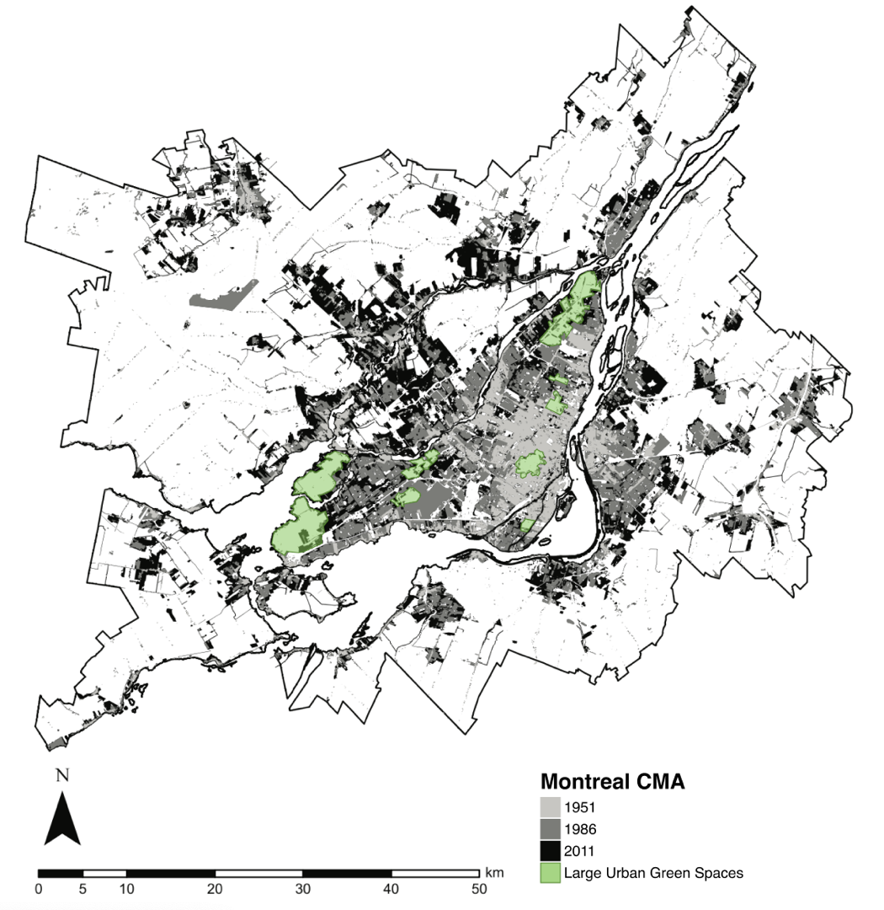Figure 1. Built-up areas in the Montreal CMA (Census Metropolitan Area), in 1951, 1986 and 2011 (Nazarnia et al., 2016). In green are the few remaining large urban green spaces on the island of Montreal. This map was adapted from Nazarnia et al. (2016; Fig. 4).

Habitat selection scale
Habitat selection can be defined as the process whereby individuals preferentially use or occupy a non-random set of available habitats (Morris, 2003). Animals can select their habitat at different orders of magnitudes, often represented as different scales. In 1980, Douglas H. Johnson suggested to categorize habitat selection according to 4 distinct orders, which are still widely use in ecology to this day (Johnson, 1980). As shown in figure 2, the first order corresponds to the entire distribution range of a species, the second order is the home range of an individual or a group of animals, the third order corresponds to the resource or habitat use within an individual or a group of animal’s home range and the fourth order corresponds to the specific procurement of resources (Johnson, 1980; McGarigal et al., 2016). Here, scale refers to the spatial resolution at which ecological processes are studied, and it can be divided into two principal components: grain (smallest unit of space used to collect or analyze data) and extent (overall size of the area studied) (Thompson & McGarigal, 2002). Being aware of these metrics can lead to a better understanding of animal’s responses to their environment at multiple spatial scales, ensuring that crucial patterns aren’t missed by either focusing too narrowly or too broadly. For instance, in the context of studying the northern cardinal in a city, we may ask ourselves if they prefer areas with shrubs within 25 meters (fine grain), or whether their movements are more influenced by large urban green spaces (broad extent).

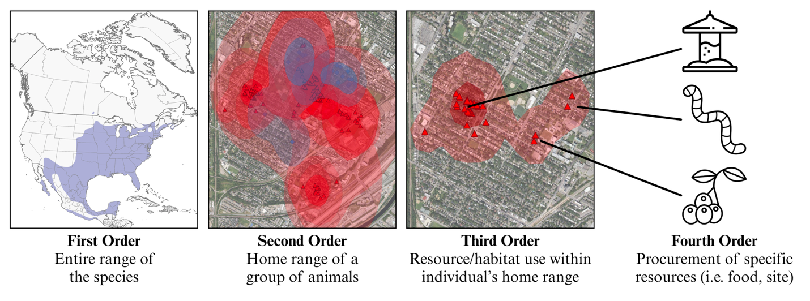Figure 2. Examples of the different orders of habitat selection suggested by Johnson in 1980. The first order corresponds to the distribution range of the northern cardinal, the second order corresponds to the home ranges of a group of cardinal, the third order shows the core and total home range of a single cardinal and the fourth order shows the various food items that cardinals may forage on at specific locations.

As of 2016, McGarigal’s review showed that only 5% of published papers on habitat ecology conduct scale optimization before modelling. To demonstrate the importance of considering multiple scale of habitat selection when modelling, a study on the Mexican spotted owl (Strix occidentalis lucida) nest and roosting habitat selection compared multi-scale habitat modelling to single-scale modelling (Timm et al., 2016). They have found that multi-scale models were consistently better in terms of the proportion of deviance explained and predictive performance, compared to single-scale analogous models (Timm et al., 2016). In south-eastern Australia, multi-scale habitat selection studies on the critically endangered plains-wanderer (Pedionomus torquatus) revealed that this cryptic bird’s habitat use is primarily driven by patch and fine-scale vegetation structure, rather than broad landscape-level features, using a range of grassland types previously thought unsuitable for the species (Nugent et al., 2022). In this case, considering multi-scale habitat selection helped re-orient conservation efforts (which initially focused on uniform, open grasslands) towards promoting structural heterogeneity within the home ranges of these birds (Nugent et al., 2022).

It’s important to note that while some researchers use the terms “habitat selection” and “habitat use” interchangeably, others suggests that “habitat selection” refers to the understanding of a hierarchical process of complex behaviours and environmental processes, while “habitat use” doesn’t imply that these processes are understood (Jones, 2001). This thesis is leaning more towards gaining knowledge on habitat use and association, rather than trying to understand the underlying behavioural processes of active, habitat selection.

Habitat use and survival of songbirds in urban areas
Habitat use by songbirds in urban environments is influenced by a complex network of ecological and anthropogenic factors. Patch size and habitat fragmentation, which directly affect the availability and quality of resources for birds, are among the most widely studied variables. Vegetation composition—including plant species diversity and the physical vertical structure—also plays a significant role in determining habitat suitability, particularly for foraging, shelter and nesting. When creating and managing urban green spaces, stakeholders should consider the area-heterogeneity trade-off (Chiron et al., 2024). This trade-off stems from increasing landscape heterogeneity inadvertently reducing patch sizes for individual habitat types, potentially disadvantaging specialist species (Chiron et al., 2024). Evidence from southern Ontario, Canada, confirmed that area (size) and natural vegetation (as opposed to horticulturally managed parks) within the urban landscape are of great importance to winter birds such as the northern cardinal (Cardinalis cardinalis), downy woodpecker (Dryobates pubescens), black-capped chickadee (Poecile atricapillus) and white-breasted nuthatch (Sitta carolinensis) northern cardinal (P. G. Smith, 2007). While it can be challenging to try and create new green corridors through a city, a New Zealand/Aotearoa study used a least-cost path analyses to integrate infrastructures, such as green roofs or walls, to show that increased connectivity between forest habitats can ease birds’ dispersal without resorting to major changes of the urban landscape (MacKinnon et al., 2023).

In addition to landscape structure, both resource availability and climate can significantly influence winter survival and habitat occupancy. Supplementary feeding in urban environments has been linked to non-adaptive behavioural strategies and reduced apparent survival in great tits (Parus major), highlighting the potential trade-offs of human-provided resources (Krama et al., 2023). Moreover, temperature dynamics are likely to affect winter distributions: northern cardinals were more likely to colonize sites that were warmer relative to the previous year, especially in forested areas (Latimer & Zuckerberg, 2021). Interestingly, while some other common urban species like the house sparrow (Passer domesticus) and the American goldfinch (Spinus tristis) appear unaffected by winter conditions and occupy cities regardless of temperature, others like the northern cardinal and the American tree sparrow demonstrate cold-driven colonization, colonizing cities rather than rural sites, suggesting species-specific thermal strategies (Latimer & Zuckerberg, 2021).

Winter represents a period of acute and chronic energetic stress for small passerines, particularly in northern latitudes, where during extreme cold periods birds must maintain a temperature difference from over 40˚C within the bird to under -40˚C outside the bird, with only one or two centimeters of insulation (feathers) to maintain that gradient. Birds must balance reduced food availability and shorter foraging windows, along with an increased thermoregulatory demand during longer, colder nights (Petit et al., 2017). Physiological adaptations, such as the elevated heart rate observed in Eurasian blackbirds (Turdus merula) during colder temperatures could help maintain core body temperatures by burning more energy (Linek et al., 2021). Small passerine birds spending winter at higher latitudes are required to display optimal energy management in a multifaceted way to survive through the harsh conditions (Andreev, 1999; Brodin, 2007; Petit et al., 2017). In addition, weather severity, including extreme wind events, has been linked to increased mortality in wintering seabirds (Louzao et al., 2019). This may also be especially relevant in urban settings, where wind tunnel effects created by buildings can increase convective heat loss (wind), amplifying exposure to harsh microclimates (Kamei & Maruta, 1979).

Use of very high frequency (VHF) telemetry in bird research
Telemetry in wildlife research is defined as a group of techniques used to remotely acquire information (geographical, physiological, environmental, etc.) on animals equipped with various data-collecting devices (Rodgers, 2001; Thohari, 1989). Such devices include the use of VHF/UHF (Very High Frequency and Ultra High Frequency) units, store-on-board units, GPS (Global Positioning System) units and GSM (Global System for Mobile Communication) units, among others. At the present time, GPS-based tracking remains one of the most reliable and widely used method for monitoring animal movements, while global scale monitoring initiatives such as ICARUS (which is now relying on independent, small satellite to continue operations since the bilateral collaboration between Germany and Russia ended in 2022) are also successfully used in research projects across Europe (Müller & Avolio, 2023; Universität Konstanz, 2023). Telemetry technologies have significantly improved recently, with higher success rates for satellite transmitter fixes (Hofman et al., 2019). Moreover, the size and weight of these devices has decreased substantially over the past 40 years, as the technology around them improves (smaller batteries with longer runtime, increased memory storage, smaller and faster microcomputers, etc.), increasing the number of species that can be tracked, generating many possible applications in the field of wildlife conservation (Hofman et al., 2019).

Before the development of electronic tracking devices, bird banding was one of the foundational methods to gather information on birds’ movements. When a bird wearing a metal band including a unique identifier number is recaptured, ornithologists can get definitive information on the birds’ movements (Whitney, 2021). In the United States, bird banding started around the 1920s. Since then, bird banders (often volunteers) have generated a large amount of data, banding millions of birds (Benson, 2017). In Canada, bird banding has been ongoing since the 1900s and on average 340 000 birds are banded every year (Environment and Climate Change Canada, 2016). However, bird banding has significant limitations, notably the extremely low recapture rates (~10% for game birds banded and ~1% for songbirds) that are biased towards areas where encounter rates are high, an issue the electronic tracking devices can overcome (Environment and Climate Change Canada, 2016). The use of electronic tracking devices to study birds can be traced back to at least the 1960s (EVANS, 1966; McEwen & Brown, 1966). During the 1970s and 1980s, VHF radio telemetry gained a strong interest from ornithologists (Craighead & Dunstan, 1976; Ferns et al., 1980; Smith & Bolen, 1980). Radio telemetry allowed researchers to acquire valuable information on birds’ movements, behaviours and physiology without the need to restrain the individuals (Harris & Fish, 1990). Radio telemetry is a useful tool to study birds’ migratory movements, stopover sites, breeding and non-breeding grounds, and local movements (Fuller et al., 2005). Those data can be extremely valuable when dealing with cases of avian disease affecting migratory birds and livestock (Fuller et al., 2005). Digital RFID systems such as Encounternet can also provide more detailed information that can be used to study birds’ behaviour (Mennill et al., 2012). The long-term use of portable receiver stations and RFID tags in systems such as Encounternet allows researchers to investigate birds’ social behaviours (such as social networks) and reproductive behaviours (such as lekking and parental care) (Mennill et al., 2012).

For my Master’s thesis, I relied on VHF radio-tracking devices for data collection. VHF radio-tracking tags are a particular type of logger that does not record any location data. As the name suggests, they emit a very high-frequency (VHF) radio signal that can be picked up by receiver stations or hand-held receiver devices. Researchers need to use an antenna and a receiver to get as close to the bird as possible before using a hand-held GPS device to record the location. A main disadvantage of using VHF radio tags is being labour-intensive as it requires the researchers to be within a certain range of the tagged bird to get a precise location (Iverson et al., 2023). Because these VHF receivers don’t include solar panels or need to connect with satellites (such as GPS loggers) or cell phone stations, transmitters can be extremely small. For example, Lotek’s Nanotags for birds and bats NTQB2-1 weighs only 0.28 grams with a maximum life expectancy of approximately 103 days (www.lotek.com). VHF radio tags are also generally less expensive than other loggers (~$200 CAD for the NTQB2-1), meaning researchers can have a greater sample size for the same budget (compared to ~$2000 CAD for some versions of the Lotek Pinpoint GPS loggers, from the same company). VHF telemetry has been used to reveal fine-scale movements of birds, such as habitat use and home range sizes (Brewer et al., 2023; Naguib et al., 2022; O’Connell et al., 2023). It is important to note that the success of using VHF radio telemetry at a fine scale is dependent on the presence of receiver within the vicinity of the marked individuals, and thus the researchers ' capacity to have access to the individuals in the field. Getting valuable fine-scale data on tracked birds is possible but highly labour-intensive as the researcher needs to get close enough to the bird to be able to pick up its signal. On the other hand, in areas where there’s an extensive network of receiver towers (such as the Motus Wildlife Tracking network in North America), the use of VHF radio telemetry can provide valuable information for long-distance monitoring, such as migration routes and stopover sites. Systems such as Motus can track birds across continents, and is, to some degree, replacing banding as a method for monitoring individual wildlife migration as Motus tags have a much higher detection rate than bands.

Although the use of telemetry devices can provide valuable physiological and ecological data on birds, telemetry devices can have negative impacts on organisms. Return rate of Swainson’s warblers (Limnothlypis swainsonii) with radio tags was not significantly different than return rates of the birds with only colour bands (Anich et al., 2009). However, although backpack-style tags on tree swallows (Tachycineta bicolor) had no short-term effects, the return rate of the tagged individuals was significantly lower compared to the individuals without tags, raising concerns about long-term effects (Gómez et al., 2014). An experimental study on homing pigeons (Columba livia) has also demonstrated that the birds equipped with a mass corresponding to 5% of their body weight (to simulate tag attachment) lost the corresponding amount of body mass over a 25-days period (Portugal & White, 2022). The authors emphasized that this loss of body mass equates to a loss of 1,140 kJ of energy, corresponding to approximately 32% of their daily energy budget (Portugal & White, 2022).While the effect of tagging on the return rate seems to vary greatly, a meta-analysis on the impact of biologging devices across multiple taxa stressed that there was a small, but significant negative impact of tagging on survival, parental care and reproduction of birds (Bodey et al., 2018). More recently Jones et al. (2024) called for radio-transmitters specifications to take in account colour and antenna length, and to avoid females and juveniles (which tend to have more inconspicuous plumages) being detected, and to reduce entanglement risks.

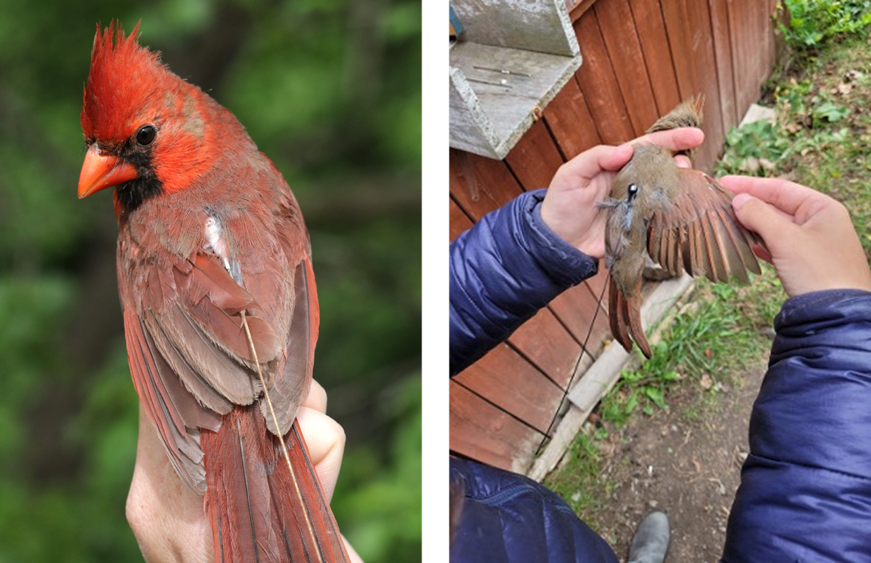
To our knowledge, this project is the first to install Motus radio tags on northern cardinals. We used a combination of tags and harnesses that were less than 3% of the average cardinal’s body mass to minimize the effects of the weight of the device on the birds’ energy budgets (especially since this research is happening in winter). During the first two years of experimentations, the radio tags used had a white “body” and a silver antenna (figure 3, left) which was quite visible through both males and females’ plumage. For the last year of experiment, we used all black radio tags (increased coating resistance) that were still below the 3% threshold but blended better through the cardinals’ plumage (figure 3, right).
Figure 3. Examples of Lotek Motus tags on both male (left, photo taken by Émile Brisson-Curadeau) and female northern cardinals (right, photo taken by Shawna Sevigny) at the McGill Bird Observatory in Montreal, Quebec, Canada.

Study species and study sites
The northern cardinal (Cardinalis cardinalis) is a resident bird species that is abundant in many areas of eastern North America (Halkin et al., 2021). Cardinals can be found year-round from southern Canada all the way to southern Mexico (Halkin et al., 2021). Northern cardinals have been expanding their range northward since the 1800s, and may be characterized as urban-tolerant birds that thrive in inhabited areas (Halkin et al., 2021; Robert et al., 2019). The first reported sightings of northern cardinals in Quebec can be traced back to 1862, when a bird was reportedly captured in Montreal (Robert et al., 2019). A few years later, in 1869, another specimen was caught in Quebec City (Robert et al., 2019). After that, it was 73 years before another northern cardinal was recorded in the region (in 1942) and another 14 years for two male cardinals to be spotted in Montreal again (Robert et al., 2019). Finally, 1956 marked the official beginning of the establishment of the northern cardinals in Quebec, as they were observed every year from then in the Montreal area (Robert et al., 2019). In southern Quebec, the cardinals are strongly associated with urban and agricultural areas, along with mature deciduous forests, while being rarely found at elevations above 200 meters (Robert et al., 2019). Cardinals are 1.7 to 4 times more abundant in urban forests compared to rural ones (Leston & Rodewald, 2006). In Ohio the reported apparent annual survival rate of adult northern cardinals ranges from 50.5% $±$ 10.3 SE to 78.3% $±$ 7.6 SE (Shustack, 2008). The principal causes of mortality for the cardinals are not well documented, with information on exposure to contaminants, disease and parasites, interspecific and intraspecific competition still fairly unknown (Halkin et al., 2021). Despite this lack of information, it’s possible to assume that predation and window collisions play an important role in the survival of the northern cardinal (Lopes et al., 2024; Panchana et al., 2025; Tryjanowski et al., 2024). In Tennessee and Iowa, breeding of cardinals can begin as early as April (and in some cases even if there is still snow on the ground), with nest building lasting approximately 2 to 3 weeks and first eggs laid at the end of April or beginning of May (Halkin et al., 2021; Robert et al., 2019). At the Lake Thoreau Environmental Center of the University of Southern Mississippi, nest predation for the northern cardinals is high in rural/forested areas, averaging 70% in the early season, with improving success as the breeding season progresses (DeVries & Jawor, 2013; Filliater et al., 1994; Linville et al., 1998). In Montreal, Quebec cardinals had one of the lowest modelled nest survival estimates out of four cup-nesting passerines in urban forests (Cull et al., 2025). For this reason, cardinals often have a second nest and brood later in the season, with reports of recently fledged young as late as August and September (Laskey, 1944). Cardinals in London, Ontario that exhibited nest failures, took on average 6 days to lay eggs in a new nest (with considerable individual variation in the time it takes the birds to renest after failure) (Scott et al., 1987).

The initial observation that sparked the development of my MSc thesis project, was the noticeable “pulse” of northern cardinals banded in late fall at the McGill Bird Observatory, that is curiously not observed during the spring banding operations. This seemed to indicate that while the cardinals are considered “resident”, they still exhibit seasonal movement, yet where and how they move around is still not well understood.

The three study sites in this project are located on the island of Montreal, the second largest city in Canada (Government of Canada, 2022a). The first study site is the McGill Bird Observatory (MBO), a migration monitoring banding station based in Sainte-Anne-de-Bellevue on the western tip of the island (45.43˚N, 73.94˚W). MBO occurs in the Stoneycroft Wildlife Area, part of the Macdonald campus at McGill University (Gahbauer et al., 2015). MBO was founded in 2004 by graduate students at McGill University and is now operated by the Migration Research Foundation (MRF) (Gahbauer et al., 2015). This banding station is the only one active in southwestern Quebec and also serves as a training facility for students who wish to enhance their skills in field ornithology (Gahbauer et al., 2015). The area covered by MBO is mainly composed of mature and immature forest, wetlands and agricultural fields (Poirier et al., 2024). This study site serves as a control location with minimal human presence. The second location used in this research is the Baie d’Urfé residential area, next to the Macdonald campus of McGill University. It’s located south of MBO near the Saint-Lawrence River (45.41˚N, 73.92˚W). This area was selected as an intermediate urbanized location, as human presence is more pronounced compared to MBO, while remaining one of the “greenest” neighbourhoods of Montreal. The final study site selected for this project is situated in Notre-Dame-de-Grâce, close to the Concordia University Loyola campus (45.46˚N, 73.64˚W). This site serves as the most urbanized location out of the three sites selected, with a higher average population density. This study was in part funded by the Environmental Damages Fund (EDF), which is a Government of Canada program (Government of Canada, 2018). The EDF receives money from fines, penalties and court orders for environmental violations, and the goal is to use this money to support projects (such as this one) that benefit Canada’s natural environment (Government of Canada, 2018).

These three study sites reflect different types of environments a bird may encounter in a large city. Resident birds in urban areas are exposed to multiple anthropogenic pressures (e.g. noise, artificial lights, habitat fragmentation, pollution) year-round, including during the difficult season that is winter (Swanson & Vézina, 2015). Bird responses to an urbanization gradient can vary greatly, with differences in movement patterns, foraging behaviour and survival (Clergeau et al., 2006; Møller, 2009). Not only that but different bird species have different habitat preferences, as such generalized greening efforts may not support bird species equally (Chong et al., 2014). Studying a representative, urban resident species such as the northern cardinal could help tailor greening strategies that meet the specific needs of similar species. Thus, understanding how a resident bird navigates, use and survive across an urban gradient is crucial to manage and generate urban green spaces that are both functional and biodiversity-friendly.

Knowledge gaps and research objectives
Although a considerable body of research has explored the effects of urbanization on bird communities, there remains significant knowledge gaps regarding fine-scale, winter-specific movement behaviours of urban-tolerant passerines like the northern cardinal. While urbanization has been linked to changes in behaviour, habitat selection, survival and gene flow, few studies examine how individual birds use urban green spaces during the whole non-breeding season at a fine spatial and temporal scale. Like most passerines, cardinals are studied more extensively during the breeding season. Most previous work has relied on coarse-resolution data or presence-absence metrics, limiting our understanding of how resident birds interact with habitats or anthropogenic features during periods of heightened energetic stress, such as winter. As iconic species in eastern North American cities, northern cardinals are great proxies to explore the questions surrounding year-round, biodiversity friendly greening efforts. As one of the only highly colourful birds to spend the winter in Montreal, they are an important part of the nature people encounter in and around downtown. Countless times through fieldwork, I encountered residents sharing their love for the species and noticed houses or parks that would decorate their entrances with cardinal-themed ornaments.

In addition, while VHF telemetry has been widely used to monitor birds’ movements, its application has mostly focused on the breeding or migratory periods. Studies investigating how resident passerines navigate through fragmented landscapes during winter using manual, ground-based VHF telemetry remain scarce, particularly in northern urban centers where winter conditions and urban microclimates can be quite harsh for the birds. Understanding these dynamics is crucial, especially as climate change and urban expansion continue to reshape winter conditions and resource availability in cities. Thus, the objective of this study is to use fine-scale VHF telemetry data to characterize the space use patterns and habitat preferences of the northern cardinal across three urban locations with varying levels of urbanization on the island of Montreal. By comparing movements with habitat use and proximity to anthropogenic features, this research aims to:
- Quantify winter home range sizes in relation to an urban gradient;
- Assess the influence of specific urban features (e.g., bird feeders, human population density, etc.) on habitat use;
- Examine potential differences in movement behaviour and space use across sites;
- Assess winter energy expenditure variations according to local climate;
- Inform future conservation planning for urban-tolerant resident birds.

This study seeks to bring novel insights into how individual birds behave within the urban ecosystem during a challenging life-history stage and to inform the planning, design and management of urban green spaces so as to support wintering bird populations. The northern cardinal is the ideal study species for this type of research as urbanites in Montreal have a strong connection to these birds.
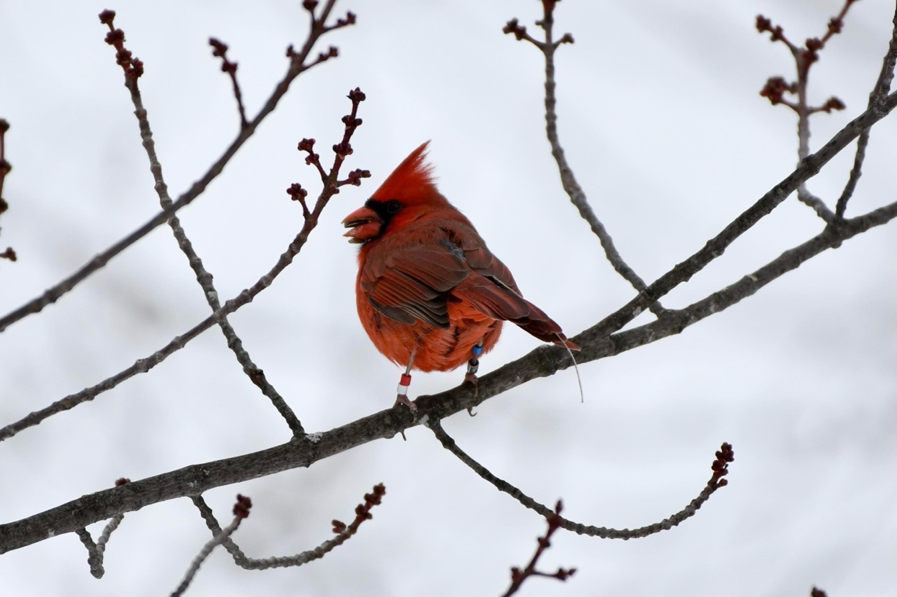
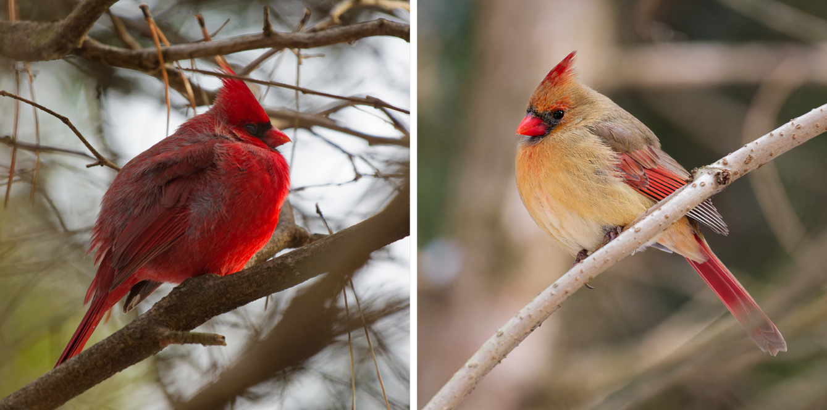
Figure 4. Male (left) and female (right) cardinal at the Montreal Botanical Gardens, Quebec, Canada in 2024 (Photo credit: Anne-Marie Cousineau).
Figure 5. Banded and tagged northern cardinal at the McGill Bird Observatory during the 2023 field season in Montreal, Quebec, Canada (Photo credit: Ron Rind).

Chapter 1: Winter home ranges size increases across an urbanization gradient for a very short distance migrant, the northern cardinal (Cardinalis cardinalis)

Authors: Cousineau, Anne-Marie¹; Elliott, Kyle H.¹; Frei, Barbara²
1: Department of natural Resource Sciences, McGill University, Ste. Anne de Bellevue, Québec, Canada
2: Science and Technology Branch, Environment and Climate Change Canada, Montreal, Québec, Canada

Abstract
Urban green spaces (UGS) are critical for maintaining biodiversity and supporting wildlife, especially in heavily urbanized environments. In temperate regions like southern Quebec, winter brings significant challenges for resident bird species, yet little is known about how birds respond to urbanization during the non-breeding season. This study investigates the fine-scale movements and habitat selection of northern cardinals (Cardinalis cardinalis) across three locations in Montreal, Canada, with varying degrees of urbanization. Using manual VHF telemetry, we quantified home range sizes, scale of habitat selection, and assessed habitat associations with natural and anthropogenic variables across an urban gradient. Across three winters, cardinals in the most urbanized study site had significantly larger home ranges compared to the suburban and peri-urban sites. Habitat selection occurred at the smallest scales measurable (25-50 m) across all sites (urban/suburban/peri-urban). Habitat associations with natural and anthropogenic landscape features varied across the urban gradient, except for proximity to bird feeders which was consistently related to cardinal habitat use. In less urbanized areas, birds selected for vertically complex vegetation while in more urbanized areas, birds select were more likely to use areas with a greater presence of roads. Northern cardinals displayed behavioral plasticity in response to urbanization and highlight the importance of adapting conservation strategies to local urban contexts. As cities expand, understanding these fine-scale ecological responses will be key to designing biodiversity-friendly UGS that support both wildlife and human well-being throughout the year.

Introduction
Urbanization is accelerating worldwide (Elmqvist et al., 2013; Simkin et al., 2022; Wang et al., 2012), altering landscapes and bringing novel challenges to wildlife including habitat fragmentation, habitat loss and chronic pollution (Lowry et al., 2013; Murray et al., 2019; Seress & Liker, 2015; Vaz et al., 2023). Future global urban expansion could lead to an additional 11-33 million hectares of habitat loss by 2100, with a disproportionately large increase in habitat fragmentation (Li et al., 2022). This human-altered landscape can affect bird’s ecology including home range and movement patterns. A meta-analysis showed that animals had generally smaller home ranges in urban areas (the same trend was observed for both birds and mammals when analyzed separately) and that urbanization restricts spatial movements for most animals (O’Donnell & delBarco-Trillo, 2020). During the breeding period, the communication distance of white-crowned sparrows (Zonotrichia leucophrys) in the San-Francisco Bay was highly predictive of its territory size, highlighting that in the urban landscape, noise pollution may drive songbirds into smaller home ranges in the breeding season (Simberloff et al., 2023). Birds in urban environments also tend to be central foragers, associated with a particular location, doing some back-and-forth between this central area and other foraging locations (Hahs et al., 2023). However, there are exceptions. House sparrows (Passer domesticus) in urban locations in South Bohemia, Czech Republic, had larger foraging areas and flew greater distances to get food (Havlíček et al., 2022). House sparrows selected sites such as storage areas or poultry holding, which are both associated with easier food, of poor quality (Havlíček et al., 2022). Thus, natural food source for house sparrows are scarce and scattered in the urban landscape, driving the sparrows to forage in larger territories (Havlíček et al., 2022).

Habitat use in the city can differ significantly from that in rural environments, even within a single species. These differences can reflect the hierarchical habitat selection, introduced by Johnson (1980), where he suggests animals can select their habitat at multiple spatial scales—from a geographic range (first order), to the home range of an individual within an area (second order), all the way to the selection of specific patches for daily activities (third and fourth orders). In the urban context part of those decisions are influenced by novel pressures such as human disturbances, artificial structures and altered resource availability. Resource Selection Functions (RSFs) offer a quantitative method of assessing habitat preferences by modelling the probability of use of a specific habitat compared to what habitat is available. This approach allows researchers to detect shifts in preference along an urbanization gradient. For instance, research across an urban-rural gradient in Czech Republic showed that Eurasian magpies (Pica pica) tend to nest higher in the tree canopy in the city centre, compared to counterparts nesting in a more rural setting (Šálek et al., 2020). Higher nesting locations may be a way for the magpies to counteract urban-related disturbances such as noise or lights (Šálek et al., 2020). In a study comparing nesting behaviour of dark-eyed juncos (Junco hyemalis) in Los Angeles and San-Diego (United States), juncos that placed their nests in an ecologically novel location (off-ground and on artificial surfaces) were shown to have increased fitness (Bressler et al., 2020). Another example is how peregrine falcons (Falco peregrinus) in urban areas prefer different habitats compared to rural conspecifics, for example by nesting in human-made nest boxes or selecting buildings as perches or nesting site (Altwegg et al., 2014; Kauffman et al., 2003). In one striking case, peregrine falcons were shown to be significantly more likely to be present at the Empire State building (New York, United States) in autumn nights when migratory birds were flying over (DeCandido & Allen, 2006). The falcons took advantage of the artificial perches the building offered, along with the migratory birds’ confusion due to the intense artificial lighting emanating from the building (DeCandido & Allen, 2006). Although some species can adapt and thrive in urban habitats, urban tolerance varies across species and across the annual cycle, with urban tolerance peaking during the winter months (potentially as a result of the urban heat island effect) (Callaghan et al., 2021).

Urban birds may outperform rural birds during the winter season, when natural resource are less available and weather is harsher. Urban areas can provide a more stable wintering environments for bird species that use bird feeders or that are generalists or omnivores (i.e., corvids), which exploit anthropogenic resources through the winter (Jokimäki et al., 2022). In other cases, cities can serve as refuge during periods of extreme weather, as local colonization of cities by birds increased during the colder conditions due to cities acting as heat islands (Latimer & Zuckerberg, 2021). Nonetheless, occupancy dynamics during winter are highly species-specific, with thermal tolerance playing an important role in determining which species would be able to persist in urban environments during this season. Moreover, energy demands for small resident passerines increase with latitude in winter, meaning that the birds spending their winter in regions such as southern Quebec or the northern United States, must consume significantly more energy to maintain their body temperatures than those wintering farther south—which is especially challenging given the scarcity of resources during the cold months (Fristoe, 2015). Despite these physiological and environmental challenges, along with the potential added effects of urbanization, winter remains an underrepresented season in experimental, ecological research (Dinh et al., 2023). This gap in knowledge highlights the importance of investigating how birds are occupying urban habitats in winter, particularly in temperate regions where winter survival is a major limiting factor for resident bird species.

To address this gap, we studied the northern cardinal (Cardinalis cardinalis) across an urban gradient in one of Canada’s largest cities, Montreal, Quebec. Cardinals are large songbirds (weighing between 40 to 45 grams), which allows for the deployment of radio tags capable of lasting almost the entirety of the non-breeding season. These birds are also very well adapted to urban life, able to thrive and persist across a wide range of urbanization gradients, from suburban neighbourhoods to densely populated areas of the city. They are resident in southern Quebec, a region of extreme cold and loss of natural seeds during the cold winter months. In the last 100 years, cardinals expanded their distribution range northwards, and have been anecdotally closely associated to urban and suburban landscapes in those areas (Beddall, 1963; Robert et al., 2019; B. T. Smith et al., 2011). We tracked weekly movements of northern cardinals across an urbanization gradient in the city of Montreal, Quebec, Canada. This study has four objectives: (i) investigate how cardinal’s home range size varies across an urbanization gradient through the winter season, (ii) quantify the scale at which the cardinals are associated with certain factors of their habitat, (iii) analyse cardinals’ association to different habitat factors by comparing used and available habitats (iv) document the spring movements from non-breeding to breeding grounds. We predicted that wintering cardinals require larger home ranges (both core and total) and select habitats at larger scales when in dense urban locations due to food sources being more scattered (Havlíček et al., 2022). In addition, we predicted that the cardinals would have a higher probability of presence in locations with bird feeders, lower population density, and including a complex vertical vegetation structure (Carrasco et al., 2019; Rousseau et al., 2015). Finally, we predicted that the cardinals would transition from their breeding sites in forested/canopy covered areas towards residential areas in the fall to take advantage of bird feeders during winter, reversing the movement in spring.

Materials and methods

Study locations
The island of Montreal is in southern Quebec, Canada at the confluence of the Saint-Lawrence River and the Ottawa River. As of 2021, approximately 1.7 million people were estimated to live on the island itself, with a population density of 4833.5 people per square kilometers (Government of Canada, 2022b). The city of Montreal pledged to convert 10% of its territory into protected natural areas that contribute to the preservation of biodiversity by 2030, and is now reporting to have reached 7.6% (City of Montreal, 2024). The Montreal climate is divided in four distinct seasons, including cold winters with temperatures often reaching -20 ˚C and colder, while the summers are usually hot and humid with temperatures sometimes exceeding 35 ˚C (McGill University, 2025). This research was conducted in three study sites (figure 1.1.) with varying levels of urbanization. Each site includes two release locations randomly assigned to the individuals. The first study site is at the McGill Bird Observatory (MBO), located on the western end of the island of Montreal (45˚25’51.4”N 73˚56’18.5”W). The MBO is our least urban site, being part of the 30 km² of the Grand parc de l’Ouest. The second study site is in the Town of Baie d’Urfé (BDU), serving as our suburban site (45˚24’39.2”N 73˚55’50.0”W). The final study site is in the Notre-Dame-de-Grâce neighbourhood, serving as our dense urban location (45˚27’35.7”N 73˚38’30.2”W). Because the northern cardinal can be found in all three sites, we assumed that the translocated birds would be able to survive and thrive at each location.
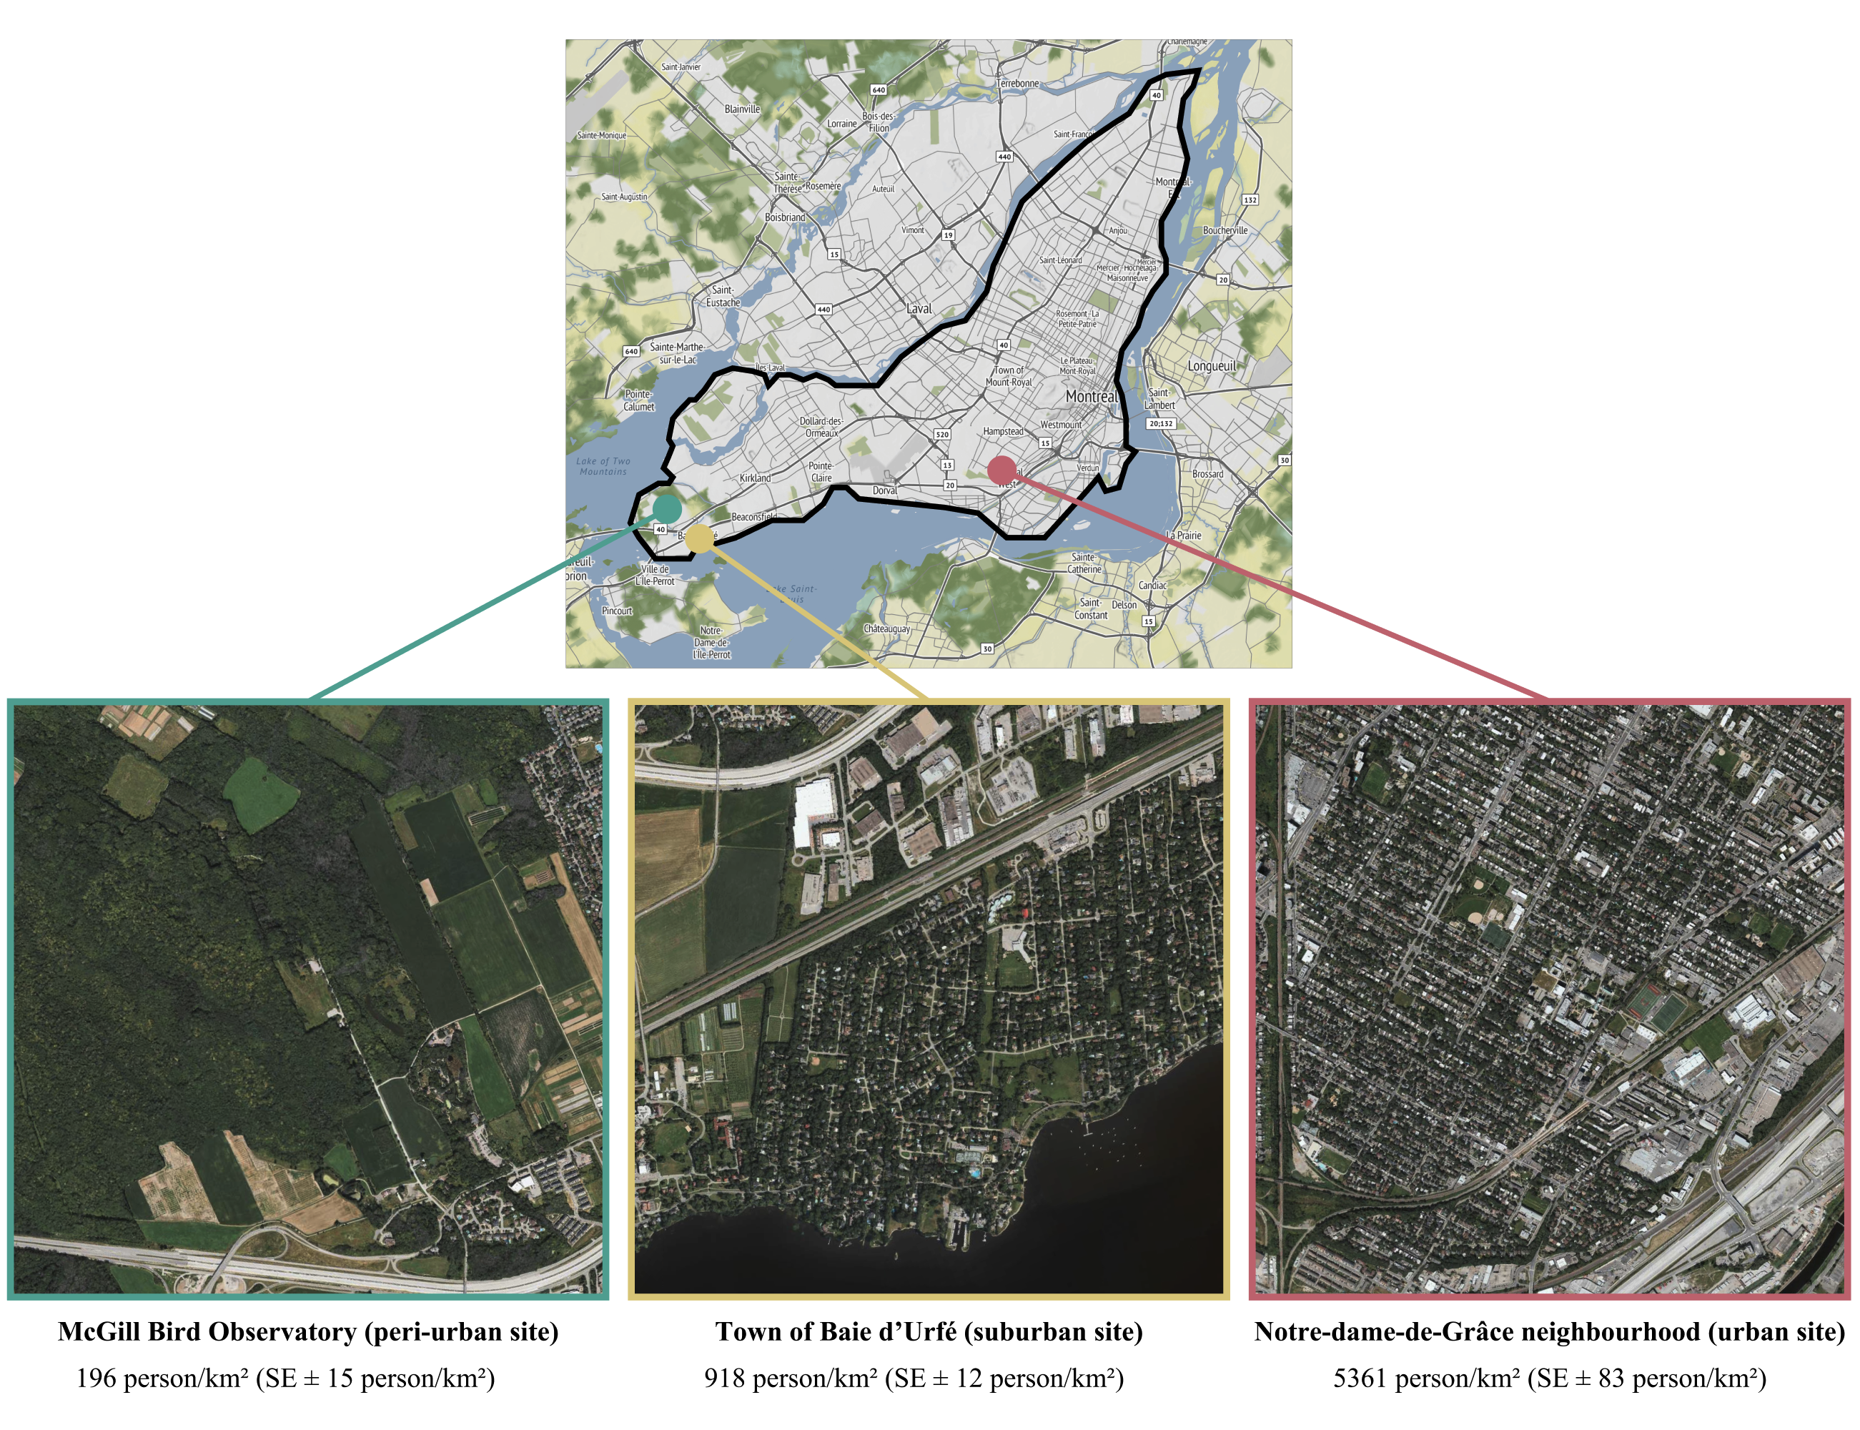
Figure 1.1. Study locations on the Island of Montreal A) The McGill Bird Observatory (MBO) served as the less urban location out of the three (2% of the area covered by streets and/or roads). It’s located in Sainte-Anne-de-Bellevue on the west side of the island. B) The residential area of Baie d’Urfé (BDU) served as an intermediately urbanized location (5% of the area covered by streets and/or roads). C) Concordia University (CON) in the Notre-Dame-de-Grâce neighbourhood served as the most urban location (13% of the area covered by streets and/or roads).

All translocation sites had a significantly different level of urbanization from one another (p < 0.001) based on population density data from the Cancensus packages, using census data from the Government of Canada for the year 2021. All three sites are characterized by relatively high levels of green space compared to the broader urban context of Montreal. As such, this gradient does not fully capture the extent of urbanization present across the entire city and should be interpreted as a localized urbanization gradient within predominantly green neighbourhoods, rather than a representative cross-section of the full urban-rural continuum.

Radio tagging, banding & translocation
We mist netted northern cardinals (males and females) at the MBO during October and November of the year 2022, 2023 and 2024. The birds were intercepted using 30 mm Japanese Nylon nets and placed in small cotton bags to reduce stress before handling. As part of the migration monitoring being done at the MBO, we banded the cardinals with a numbered aluminum band issued by the Canadian Bird Banding Office. The individuals were sexed, aged, weighed, and randomly assigned to one of the six possible release sites consisting of translocation sites and control sites at the capture location. In addition to the aluminum band, we fitted the cardinals with a set of heat-sealed coloured plastic bands, each with a unique combination of colours. This allowed visual identification of the individuals without having to resort to a radio tag receiver. Each bird was equipped with a Lotek NanoTag (NTQB-2) weighing 0.8 grams, using soft elastics in a figure 8 harness configuration (the total weight of the tag, harness, and glue was less than 3% of the cardinals’ body weight). All the radio-tags were registered as part of the Motus Wildlife Tracking System (Frei et al., 2024). Northern cardinals translocated to sites away from MBO (BDU and CON), as well as control birds held at MBO, underwent a holding time of 45 minutes before release to standardize treatment amongst individuals. For the winter of the year 2022-2023 (winter 1), we were able to consistently track 20 birds released as control at MBO, which served as a pilot winter to assess the feasibility of the project. During the winter of 2023-2024 (winter 2), a total of 45 birds were tagged and banded, with 15 individuals translocated to CON, 15 translocated to BDU and 15 released as controls at MBO. In 2024-2025 (winter 3), a total of 42 birds were tagged and banded, with 5 individuals released as controls at MBO, 16 individuals translocated at BDU and 21 individuals translocated at CON. Birds were banded under Animal Use Protocol 2007-5447 from McGill University and federal banding permits 10973, 10973B, 10973D issued by the Canadian Wildlife Service, and radio-tagged under Animal Use Protocol 22BF01 and 23BF01 from Environment and Climate Change Canada.

Cardinal abundance and seasonal distribution
To investigate the northern cardinals’ historical abundance in Quebec, Canada, we used data from the Audubon Christmas Bird Count, more specifically we extracted the number of cardinals recorded per party hours in the states of Maine, New York, New Hampshire and Vermont (United States), along with the data from Quebec (Canada) (National Audubon Society, 2015). To examine seasonal variations in northern cardinals’ distribution, we used weekly abundance estimates from eBird data collected between 2009 and 2023, to generate a map of the birds’ distribution in summer (week of July 5th) and winter (week of December 27th) (Fink et al., 2025).

Non-breeding season tracking and home range estimations
During the first winter, only 2 automated receiver towers from the Motus network were deployed. The first tower is located at the MBO (4525’50.4”N 73˚56’18.6”W), while the second tower is located on top of a faculty building at McGill University’s Macdonald campus (45˚24’28.3”N 73˚56’20.3”W). For the second winter, those two towers were also used for continuous data location, with the addition of a third temporary receiver tower that we installed in BDU (45˚24’39.3”N 73˚55’48.3”W). Finally, during the third winter, a fourth, permanent Motus tower was installed on top of a building at Concordia University’s Loyola campus location (45˚27’32.6”N 73˚38’30.2”W). We conducted manual radio tracking of each individual as often as possible (approximately once or twice a week) between the months of October and May using a set of handheld receivers and antennae. The people tracking the cardinals by hand (trackers) would cover as much ground as possible at each study location with the goal of recording at least one GPS location for each individual per week using a Garmin ETREX 22x GPS. The handheld receivers were either Lotek’s SRX800 or SRX1200. They were operated by setting the frequency to 166.380 MHz (Motus tags’ frequency for the Western hemisphere) and using both the gain and the signal strength to get as close as possible to the tagged individuals. The gain is a value between 0 and 100, representing the amplification of the received signal. By increasing it, the tracker increases how sensitive the receiver is to incoming radio signals. Higher gain values increase the ability to detect weaker signals but are also subject to background noise and interference. Using a lower gain reduces noise but may result in missing weak signals. In urbanized locations, the starting gain will rarely surpass 70-80 as the receiver picks up too much noise and interference. The signal is a value ranging from 0 to 200 for the SRX800 and 0 to 250 for the SRX1200. It represents the strength of the detected transmission from a radio tag, displayed in decibels (dB) on the receiver. A stronger signal indicates that the bird is closer; trackers use this information to estimate distance and direction. Trackers begin their tracking sessions with a gain of 80-70 to increase their chances of detecting nearby individuals. Once the receiver picks up a cardinal’s tag, the tracker moves toward the direction with the strongest signal. Once a threshold of 150 dB (SRX800) or 200 dB (SRX1200) is attained, the trackers then lower the gain by 10 and repeat this process until they reach the tagged individual. The trackers only record a GPS point if the signal strength is 150 or 200 dB, with a gain of 40 or less (the bird is considered close enough when those conditions are met).

For all three study sites, we calculated the average home range size using the Kernel Density Estimation (KDE), a non-parametric way to estimate the probability density function of a random variable based on a finite data sample (in the present case, the northern cardinal’s GPS location recorded in the field) (Calenge, 2024). We selected the 50% and 95% contours to investigate respectively the core area used within the home range of the birds and the broader home range excluding the most extreme locations (outliers). Between 5 and 48 points per individual were used to estimate the KDEs, with the average number of points per bird being 17.
$$K\left(u\right)= \frac{1}{\sqrt{2π}}e^{-\frac{1}{2}u^{2}}$$
Where:
$K(u)$ is the kernel function evaluated at u, providing the weight assigned to a data point based on its distance to the target location.
$u= \frac{x-x_{i}}{h}$ is the standardized distance between the location x (where the density is being estimated) and the observed data point x_{i}, scaled by the bandwidth h.
h is the bandwidth parameter, which determines the smoothness of the resulting density estimate; smaller values of h lead to a rougher estimate, while larger values produce a smoother result.
$\frac{1}{\sqrt{2π}}$ is the normalization constant ensuring that the kernel integrates to one.
e is Euler’s number (approximately 2.718), the base of the natural logarithm.

Scale of effect
We first identified the scale of effect (i.e., the spatial extent at which landscape variables have the strongest relationship with a species’ response’) by extracting variables at four spatial scales (25, 50, 100, 200 meters; Martin & Fahrig, 2012). These spatial scales were chosen because they cover a wide range of possible scale of effect that are highly relevant in urban ecology, considering that habitat heterogeneity is scale-dependent. For each scale we ran generalized linear mixed models (GLMMs) at each study location using all five predictor variables as well as year, site, and individual ID as random effects. We ranked model using Akaike Information Criterion (AICc) values, which take into account small sample sizes (Burnham & Anderson, 2002). The best model was identified as having the lowest AICc value. We also calculated the $∆$AICc to evaluate competing models following Burnham and Anderson (2002) (models with a $∆$AICc < 2 were considered to have substantial support, competing with the best model and models with a $∆$AICc > 10 were deemed to have no support, not competing with the best model). Once the scale of effect was determined for each location, we conducted a resource selection function.

Resource Selection Function
We compared ‘used’ vs. ‘available’ habitat using a resource selection function for northern cardinals during the non-breeding season and across an urban gradient. We used environmental and anthropogenic variables extracted from available spatial data as well that collected in the field. This included mean and standard deviation (SD) of vegetation height (1m resolution) from OpenForest (citation), distance to nearest bird feeder (collected through systematic field observations), population density data (census unit) using the Cancensus R package (vonBergmann & Jacobs, n.d.) and spatial data on the streets and road from the island of Montreal (VILLE DE MONTRÉAL, 2018). Unused locations were derived at a 1:1 ratio by creating random locations within 300 meters of the used location, at a random angle. The average number of true observations for each individual ranges from 5 to 48 with an average number of points of 18. Having a ratio of 1:1, the same numbers apply for the random observations. For each study site, we ran a “Full model” (Used ~ Mean vegetation height + Sd vegetation height + Population density + Road length + Distance to nearest feeder + (1|Winter) + (1|Site) + (1|ID)), including all of the variables, plus the winter (years of sampling), relocation site and bird ID as random effects. The second model we ran was the “Vegetation height” model (Used ~ Mean vegetation height + (1|Winter) + (1|Site) + (1|ID)), assuming the vertical height of vegetation was a primary factor for decision making. The third model we ran was “Sd vegetation height” (Used ~ Sd vegetation height + (1|Winter) + (1|Site) + (1|ID)), in this case, we assume that the vertical composition was a more predominant decision-making factor compared to height on its own. The fourth model we ran was the “Human model” (Used ~ Population density + Road length + Distance to nearest feeders + (1|Winter) + (1|Site) + (1|ID)), which assumed that the cardinals would rely mostly on human-related cues to select a wintering habitat. The final model we ran was the “Null” model, including only the random effects variables (Used ~ + (1|Winter) + (1|Site) + (1|ID)). We then once again selected the best models according to the corrected Akaike Information Criterion (AICc) following the method previously described by Burnham and Anderson (2002). We used Variance Inflation Factor (VIF) to test for multicollinearity (variables with VIF values > 10 were considered to have problematic collinearity and were removed) among predictor variables and Hosmer-Lemeshow as a goodness-of-fit test (Hosmer & Lemesbow, 1980). All statistical analysis were performed using Program R version 4.4.2 (R Core Team, 2024a).

Results
Description of northern cardinal trends from Christmas Bird Count, eBird, and bird banding data
In southern Quebec, the northern cardinal population has seen a steep increase in abundance initiated around the 1970s. The same trends have been reported in southern Ontario, as shown in figure 1.2. (i.e. as the years progress, we can see a steady increase in the number of cardinals reported in the United States and a propagation northward until it reaches southern Quebec in the 1960s). This expansion of the northern distribution of the cardinal is largely attributed to the increase of people putting out bird feeders on their property, along with increasing winter temperatures, making it easier for the cardinals to remain in the northern part of their distribution range year-round (Halkin et al., 2021; Robert et al., 2019).
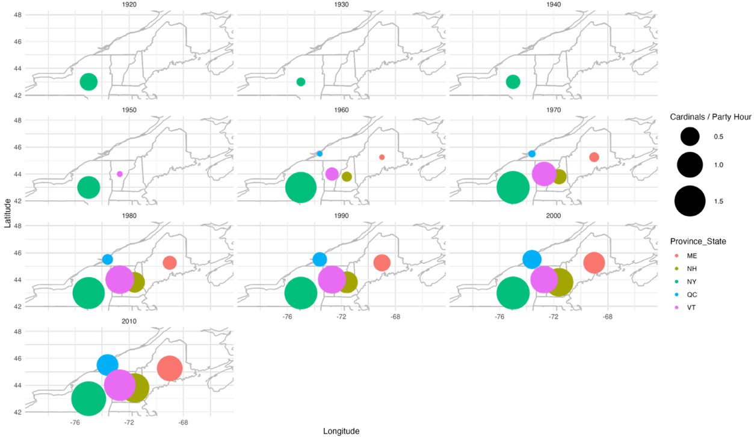Figure 1.2. Number of northern cardinal observations per party hours between the 1920s and the 2010s according to state (United States of America) or province (Canada) as part of the Audubon Christmas Bird Count.
Cardinals are associated to anthropogenic environments (figure 1.3.), which is especially pronounced during the winter period (Fink et al., 2025). The eBird data suggests that the Montreal area has on average ~1-2 cardinals reported on a weekly basis on July 5th, while this number goes up to ~3-4 cardinals reported on December 27th (Fink et al., 2025).
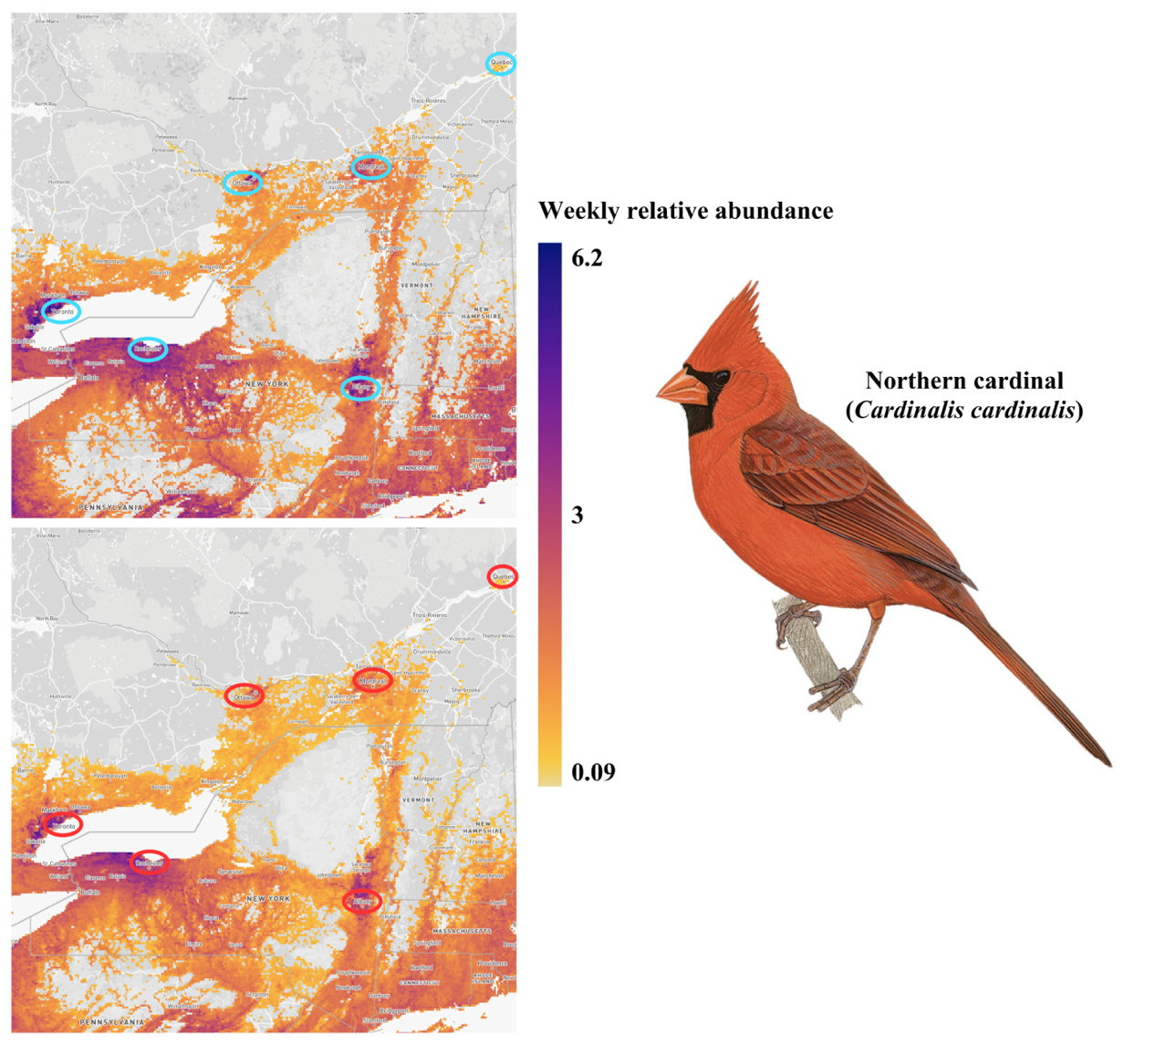Figure 1.3. Weekly reported abundance of northern cardinals on eBird during the winter (top, December 27th) and the summer (bottom, July 5th) (Fink et al., 2025). Encircled in blue (winter) and red (summer) are the major cities, including Quebec (Canada), Montreal (Canada), Toronto (Canada), Rochester (United States) and Albany (United States) (Illustration credit: Brian Small).
Cardinals captures at MBO peak first in May (both banded and recaptured birds; figure 1.4.), approximately at the middle point of the spring migration monitoring program. During the entirety of the spring program, cardinals are banded at a rate of ~ 0.27 individual per hour of mist-net opening and cardinals are recaptured at a slightly higher rate of ~ 0.31 individual per hour of mist-net opening. When the fall migration monitoring program occurs, there is a steep increase in the number of cardinals banded and recaptured. Banding rate goes up to ~ 0.75 individual per hour of mist-net opening (almost three times the banding rate during the spring), while recapture rate increases to 0.50 individual per hour of mist-net opening.
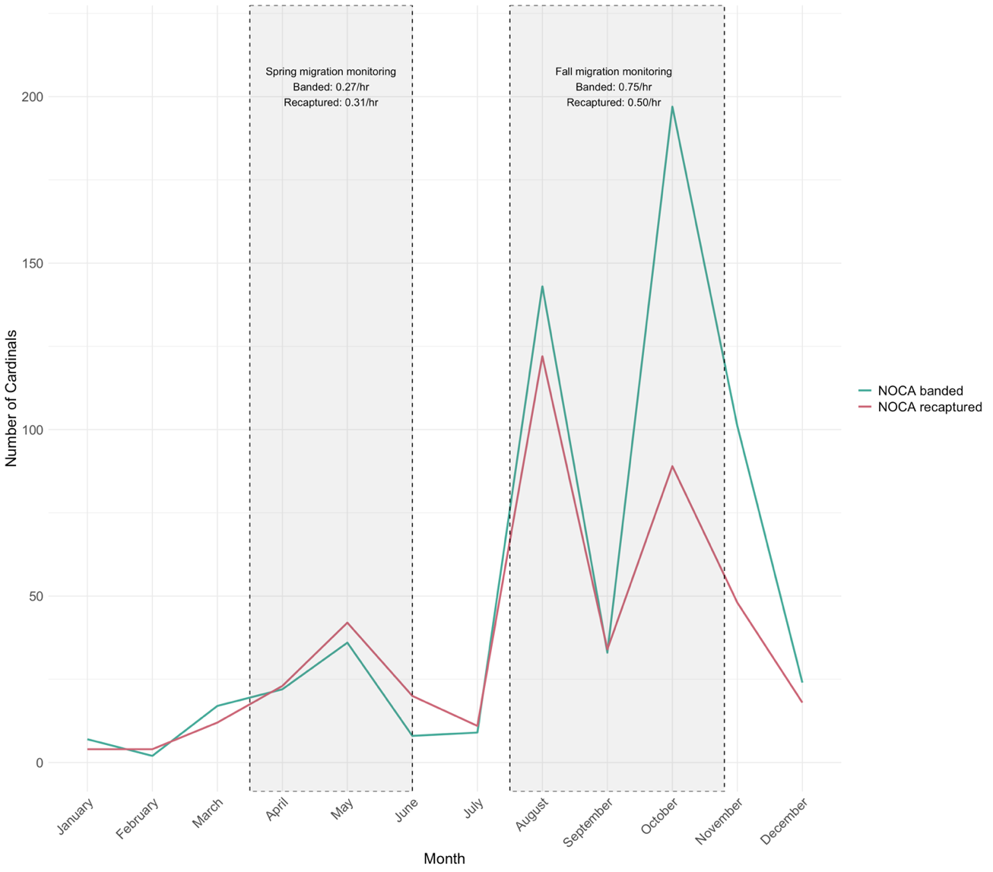
Figure 1.4. Number of northern cardinal (NOCA) banded and recaptured at the McGill Bird Observatory between 2004 and 2022 in Montreal, Quebec, Canada. The grey boxes highlight both the spring and fall migration monitoring programs duration, along with the approximate number of cardinals banded and recaptured per hours of mist-net being opened during the season.

Telemetry tracking of northern cardinals across an urban gradient
In the fall and winter of 2022-2023, a total of 21 northern cardinals were released at MBO (peri-urban) with radio tags (including tags that were re-deployed due to mortalities shortly after release). In 2023-2024, 15 cardinals were released at MBO (peri-urban), 15 at BDU (suburban) and 15 at CON (urban) for a total of 45 northern cardinals across all three sites. In 2024-2025, 5 cardinals were released at MBO (peri-urban), 16 were released at BDU (suburban) and 21 were released at CON (urban) for a total of 42 birds across all three sites. Table 1.1. is detailing the number of cardinals we were able to track for each field season, their apparent survival, along with the number of confirmed mortalities and the potential causes for these deaths.

Table 1.1. Number of northern cardinals tracked 1 and 3 months after initial release, with apparent survival (48.15%) and known mortality events/probable causes across three sites in Montreal, Quebec, Canada between 2022 and 2025.
Year | Site | Total number of cardinals | # tracked 1 month (apparent survival) | # tracked 3 months (apparent survival) | Known mortality events | Probable cause of death
2022-2023 | MBO | 21 | 17 (81%) | 16 (76%) | 2 | Predation (n = 2)
2023-2024 | MBO | 15 | 13 (87%) | 9 (60%) | 3 | Predation (n = 2) Unknown (n = 1)
2023-2024 | BDU | 15 | 8 (53%) | 7 (47%) | 2 | Predation (n = 1)  Unknown (n = 1)
2023-2024 | CON | 15 | 4 (27%) | 2 (13%) | 1 | Window collision (n = 1)
2024-2025 | MBO | 5 | 4 (80%) | 3 (60%) | 1 | Unknown (n = 1)
2024-2025 | BDU | 16 | 11 (67%) | 11 (67%) | 2 | Disease (n = 1)  Predation (n = 1)
2024-2025 | CON | 21 | 7 (33%) | 4 (19%) | 2 | Predation (n = 1)  Window collision (n = 1)

Telemetry tracking was conducted 2 to 3 days per week by three people between October and May, for a total of ~288 days of tracking per winter. A total of 688 unique detections were recorded at MBO, 411 detections were recorded at BDU, and 265 detections were recorded at CON. The tracking team covered each time the maximum amount of ground possible during each outing, to record as many individuals as feasible. The total area covered at MBO is of approximately 4.75 km², the area covered at BDU is of approximately 5.94 km², and the area covered at CON is of approximately 18.35 km². The larger coverage at the CON site was due to the highest rate of disappearance of birds from the site and the higher need to ensure that the lack of detection was not simply due to the birds leaving the immediate study area.

Core areas and home ranges of northern cardinals across an urban gradient
For all three locations, we calculated the KDE 50 % and 95 %, corresponding respectively to the core area where the bird spent most of its time, and to its total home range, including most of the areas visited in winter, excluding outliers (Figure 3). To be included in the KDE estimations, individuals needed to have a minimum of 5 recorded GPS locations. For this reason, we included 36 individuals from the peri-urban site, 13 individuals from the suburban site and 9 individuals at the urban site. Cardinals wintering at MBO (peri-urban site, n = 35) had a core area (50 % KDE) averaging 0.15 ± 0.04 (SE) km², and total home ranges (95 % KDE) were on average 0.61 ± 0.13 km². Cardinals translocated to BDU (suburban sites, n = 13) had on average, core areas of 0.08 ± 0.02 km² and total home ranges of 0.56 ± 0.11 km². Birds wintering at CON (urban site, n = 9) had an average core area of 0.28 ± 0.11 km² while their total home ranges were 1.53 ± 0.52 km². Core and total home ranges sizes were not normally distributed (Shapiro-Wilk tests: core, W = 0.624, p < 0.001; total, W = 0.698, p < 0.001), so areas were transformed using a logarithm prior to analysis. After transformation, the data met assumptions of normality and variances were homogeneous. There was no significant difference in core home range size among sites, although the effect approached significance (ANOVA: F(2, 55) = 2.69, p = 0.077). Post-hoc comparisons show a trend towards the cardinals at our urban site to have larger core home range sizes compared to the suburban and peri-urban sites (figure 1.5.). There was a significant difference between the three study sites regarding total home ranges (ANOVA: F(2, 55) = 3.45, p = 0.039). Post-hoc TukeyHSD comparisons showed that the only significant difference was between the total home ranges of cardinals at our urban site being larger than cardinals at the peri-urban site (mean difference = 1.24, 95% CI [0.09, 2.38], p = 0.031).
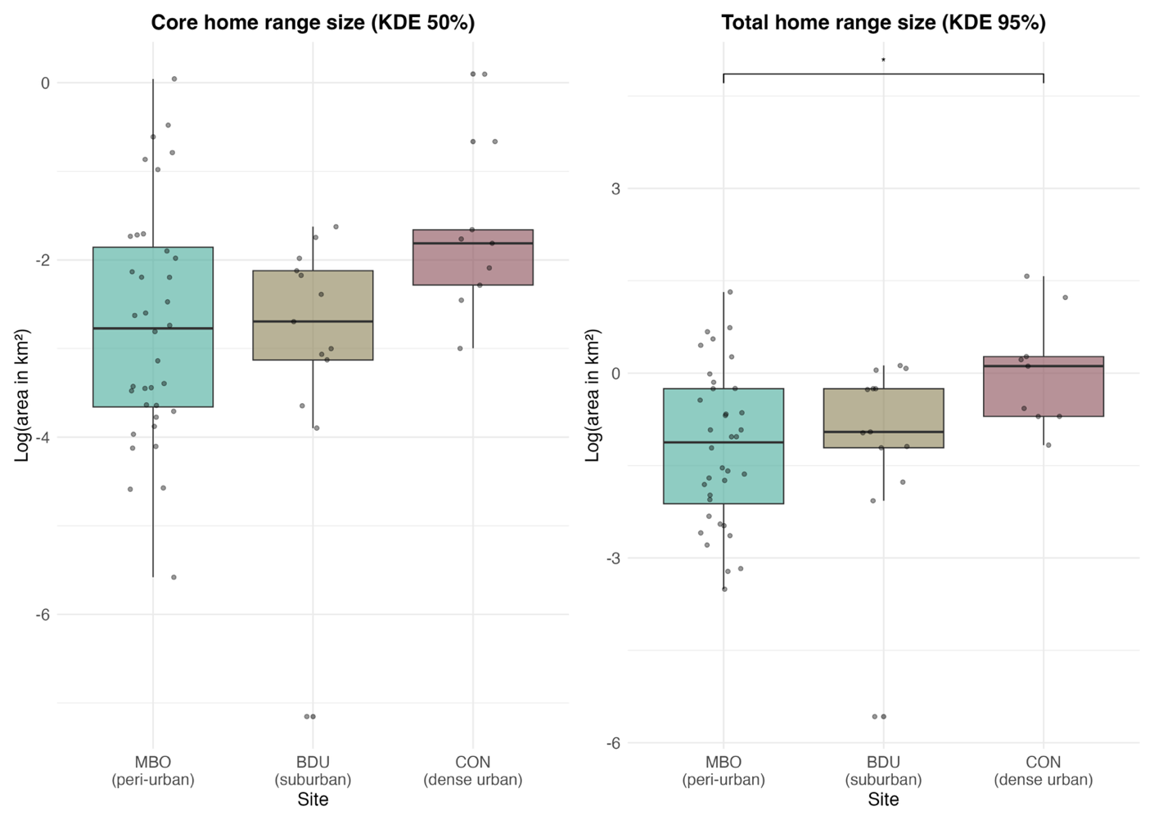Figure 1.5. Comparison of the core (KDE 50%) and total (KDE 95%) home ranges of northern cardinals in three study sites in Montreal, Quebec, Canada during winters between the years 2022 and 2025. The study sites are represented here as: McGill Bird Observatory – MBO, Town of Baie d’Urfé – BDU, Concordia University campus – CON. The area in km² was log transformed.

Scale of association to habitat
Using information-theoretics (AICc) we found the spatial scale where habitat variables best predicted northern cardinal habitat use (i.e., the scale of effect) was fairly consistent across the three sites. At the peri-urban site (MBO) the 50-meter spatial-scale model explained the most variation seen in the data compared to the other spatial-scales (i.e., > 4 Δ AICc values between all other models; figure 1.6., A). For the birds at the suburban site (BDU) and the urban site (CON), the best model is the 25-meter one (> 10 Δ AICc values between all other models; figure 1.6., B). Lastly, for the urban CON site, the 25-meter model was the top model from the spatial scales investigated (> 10 Δ AICc values among all other models; figure 1.6., C).
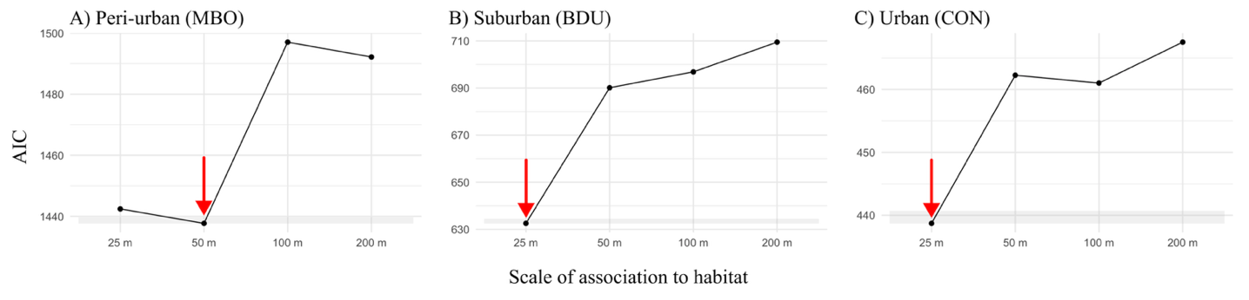
Figure 1.6. Model ranking using AICc of generalized linear mixed models (GLM) with a comparing scale of effect of landscape variables for resighting locations (n= 57) of the northern cardinals tracked across three sites (A, B and C) in Montreal, Quebec, Canada. Arrows indicate the model with the lowest AIC value and the shaded area represent a two ∆AICc of 2 with the best model.

Resource selection: used vs. available habitats
Due to differences of urbanization level and scales of effect, resource selection function models were run separately for each study site. For the peri-urban site (MBO), the global model explained the most variation seen in the data (> 10 Δ AICc values between all other models, Table S1). For the suburban site (BDU), the top model was the human covariates model (human population and road density), with the next best model (full model) < 2AICc units from the top model (Table S1). Lastly for the urban site (CON), the full model was the top model, but again the next best (human covariates) was <1 AICc from the top model (Table S1). The best model for each study site was then used to generate prediction plots on the probability of presence of northern cardinals according to the model variables (table 1.2.).

Table 1.2. Model parameters for the three resource selection models predicting the presence/absence of 56 northern cardinals within (25 or 50 m-radius) areas based on the average vegetation height (in meters) and its standard deviation, along with human-related environmental features such as population density (in people/km²), road length (in meters) and distance to the nearest bird feeder (in meters). The data was scaled and centered before running the models. The study site, year of sampling (Winter) and the individual’s identification (ID) are included as random effects in each model.
Study Site | Variable | Coefficient estimate | Standard error | z | p
McGill Bird Observatory (peri-urban) | Global model – 50 meters  Mean vegetation height (m)  Standard deviation of the mean vegetation height  Mean population density (person/km²)  Road length (m)  Distance to the nearest bird feeder (m) | -1.272  1.107  -0.095  0.023  -0.347 | 0.153  0.114  0.111  0.110  0.068 | -8.329  9.709  -0.858  0.207  -5.067 | <0.001  <0.001  0.391  0.836  <0.001
Town of Baie d’Urfé (suburban) | Human covariates model – 25 meters  Mean population density (person/km²)  Road length (m)  Distance to the nearest bird feeder (m) | -0.486  1.238  -0.427 | 0.135  0.136  0.128 | -3.603  9.138  -3.342 | <0.001  <0.001  <0.001
Concordia University (dense urban) | Global model – 25 meters  Mean vegetation height (m)  Standard deviation of the mean vegetation height  Mean population density (person/km²)  Road length (m)  Distance to the nearest bird feeder (m) | 0.252  -0.458  -0.212  0.736  -0.392 | 0.180  0.191  0.131  0.135  0.141 | 1.399  -2.405  -1.620  5.438  -2.772 | 0.162  0.016  0.105  <0.001  0.006

The prediction plots including only the significant fixed effects for the resource selection functions of each locations reveal that the presence of cardinals is associated with different urban and habitat features according to the site they spend their winter in (figure 1.7.). In the peri-urban site (MBO), the probability of presence of the cardinals decreases as the mean vegetation height increases (figure 1.7., A), while the presence of the birds increases with greater variability in vegetation height (figure 1.7., B). The probability of presence of the cardinals also seems to decrease as the distance to the nearest bird feeder increases (figure 1.7., C). In our suburban site (BDU), the probability of presence of the cardinals shows little relationship with population density (figure 1.7., D), but increases as the mean road length increases (figure 1.7., E). Like our peri-urban site, the presence of the birds also decreases as the distance to the nearest feeder increases at the suburban site (figure 1.7., F). At the urban site (CON), the cardinals’ probability of presence decreases with increasing vegetation height standard deviation, although uncertainty is high (figure 1.7., G). The presence of the cardinals also increased with mean road length and decreased with the distance to the nearest feeders. Across sites, proximity to feeders and structural complexity of the infrastructures or the vegetation consistently influenced the probability of presence, yet specific relationships varied.
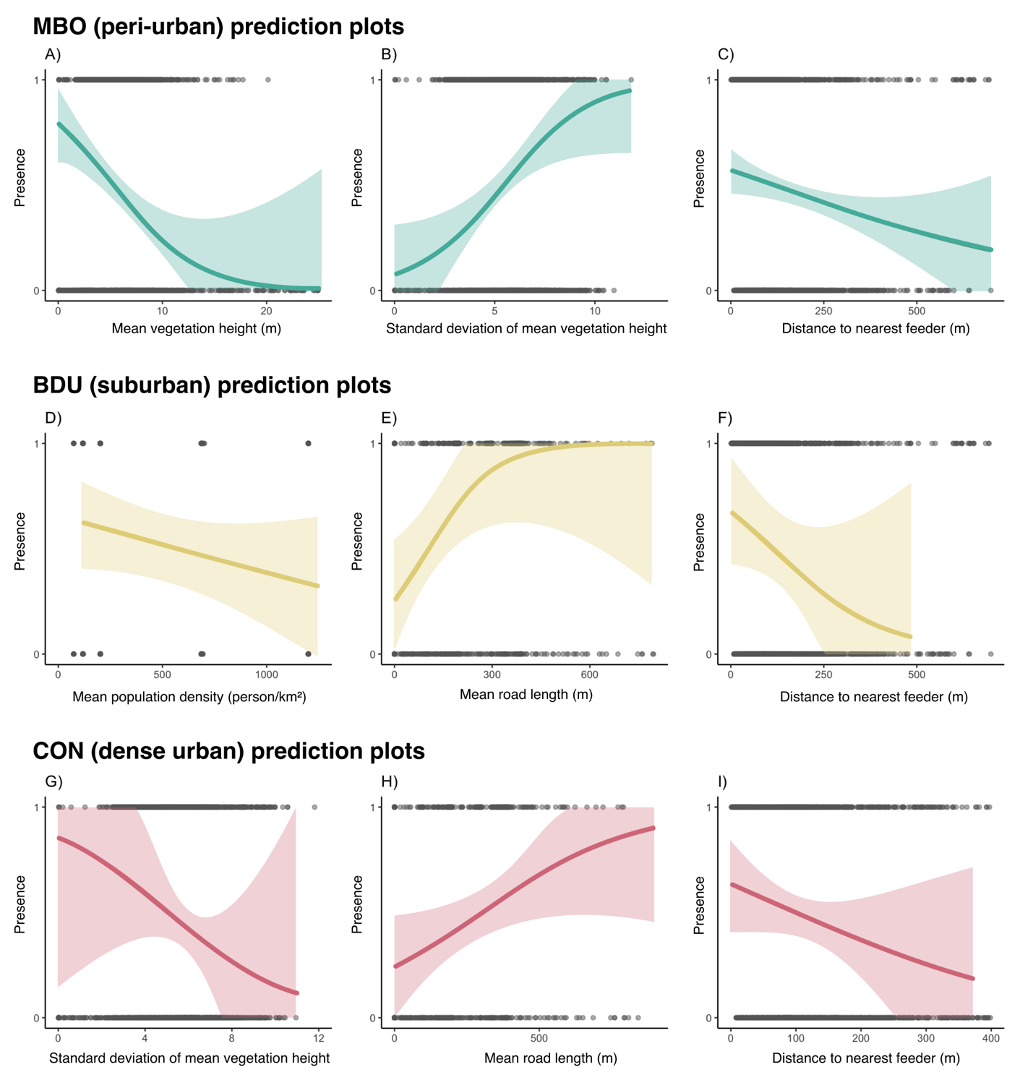
Figure 1.7. Probability of presence of northern cardinals in a given radius area, as predicted by a generalized linear mixed effects model. Shaded areas represent 67% confidence intervals around the predicted probabilities. The model’s fixed effect variables are described in Table 1b, and for each model, random effects were sampling years, translocation site and bird ID.

Discussion
Using three years of telemetry tracking data of northern cardinals across an urban gradient during the non-breeding season, we found evidence that cardinals in urban locations had significantly larger home ranges compared to those in suburban and peri-urban sites. Comparatively, the spatial scale of habitat use by cardinals was consistent across the urban gradient and occurred at a relatively at a fine scale (25-50 m). Significant vegetation and anthropogenic predictors of cardinal presence differed across the urban gradient, suggesting that ecological needs and drivers of winter survival by cardinals in human-modified landscapes may be context-dependent (peri-urban vs suburban vs urban). Apparent survival of cardinals during the harshest period of their annual cycle appears fairly similar between peri-urban and suburban sites, while mortality or relocation was threefold higher in the urban site. Cardinals in suburban and urban sites do not spend time in parks or other larger public green spaces during the non-breeding season, instead favouring the private urban green spaces such as private backyards and gardens and are strongly associated with the presence of anthropogenic food resources (i.e., birdfeeders).

Lower apparent survival at urban site
While the apparent survival of the cardinals was quite similar between the peri-urban site (on average 65% after 3 months) and the suburban site (on average 57% after 3 months), it was much lower at the dense urban location (on average 16% after 3 months). Our apparent survival rates for the peri-urban and suburban locations are consistent with previously established annual survival in Ohio (50.5% ± 10.3 SE to 78.3% ± 7.6 SE) and in Washington D.C. (between 40 to 70%) in the United States (B. S. Evans et al., 2015; Shustack, 2008). However, the very low survival rates that we are seeing in the dense urban location is well below what was previously found in urban habitats. Cardinals’ annual apparent survival was even shown to increase as the amount of impervious surfaces (used as indicator of urbanization) increases (Shustack, 2008). The lower survival in the dense urban environment is likely attributable to the greater concentration of anthropogenic threats. Urban areas present multiple mortality risks for birds, including window collisions, strikes by vehicle and predation by domestic cats (Ibáñez-Álamo et al., 2020; Lopes et al., 2024; Loss et al., 2014). While we cannot entirely rule out the possibility that tags had detrimental effects on cardinal survival in the most urban location, this is unlikely able to fully explain our findings. During the reproductive season, cardinals with tags (weighing 1.6 g) attached defended their nests less vigorously, but did not change their provisioning effects (Barron et al., 2013). Cardinal nests with tagged parents also had lower daily survival rates and were less likely to fledge offspring (Barron et al., 2013). However, these tag effects were relatively modest and observed across diverse habitats, making it improbable that they would only manifest in our dense urban site while remaining undetected in peri-urban and suburban locations. An alternative explanation is that the individuals translocated to the urban site survived but moved further away from their release site and were beyond detection range (> 16 km²). Nevertheless, we suggest that the heightened mortality from the urban-specific threats is the primary driver of the reduced apparent survival we observed.

Larger home ranges and the importance of bird feeders
There is a significant difference between total home ranges (KDE 95%) sizes across an urban gradient, where the individuals at the urban site having the largest total home ranges. These results oppose what has been previously found in other studies, where house sparrows in urban landscapes occupied smaller home ranges compared to their rural counterparts (Vangestel et al., 2010). O’Donnell (2020) also suggested, that generally, birds in urban environments tend to have smaller home ranges. However, regarding cardinals specifically, research from 2008 focusing on extraterritorial movements of female cardinals, found that during the breeding period, females ventured out of their territory more often when they had supplemental feeding, compared to females that didn’t have access to supplemental food (Humbird & Neudorf, 2008). And while the authors did not find a statistically significant difference in the females’ home range sizes, they did see a trend towards supplemental fed females to have larger home ranges (Humbird & Neudorf, 2008). Yet, what we have found doesn’t exactly align with this idea that cardinals with access to supplemental food would have larger home ranges. By mapping the location of visible bird feeders, we determined the approximate feeder density at all sites: the peri-urban site had ~13 feeders/km², the suburban site had ~35 feeders/km² and the urban site had ~12 feeders/km². We can hypothesise that the poorer density of feeders at the urban site led cardinals to travel further between these reliable resource points because of their scattered locations. On the contrary, in the suburban site (which has a feeder density over twice that of the urban site) we can hypothesise that the high feeder density allowed the birds to have access to reliable food sources without the need to travel further away.

Across all our study sites, the cardinals were more likely to occupy a specific area with bird feeders were present. Research on the European turtle doves (Streptopelia turtur) found that the larger home ranges were more likely to contain seed-rich habitats, potentially suggesting that they were willing to travel further to access high quality food sources (Dunn et al., 2021). Likewise in an urban system, birds may employ higher movement rates and larger home ranges size during the challenging winter months to visit well stocked bird feeders for quality food resources.

Small scale of association to habitat regardless of urbanization level
Northern cardinals are associated with habitat features at different spatial scales depending on the level of urbanization of their wintering site: 50 meters in our least urban site, and 25 meters in both our suburban and dense urban locations. This pattern suggests that as soon as human presence is more pronounced in the landscape, cardinals rely more heavily on immediate habitat factors (possibly due to increased fragmentation and reduced availability of high-quality habitats at broader scales). This aligns with broader research on animal species, suggesting that the magnitude and direction of species’ responses to urbanization reflects landscape-scale differences within cities (Fidino et al., 2021). Moreover, recent work on migratory birds passing through urban areas via stopover sites highlighted the value of multiscale habitat assessment since different processes can come into play at different spatial resolution (Guo et al., 2023). Our findings showing that cardinals respond to finer spatial scales in more urbanized areas also support evidence that urban green space size and configuration matter—especially in cities where small patches may play a critical role to support bird populations (Dale, 2018). Thus, we want to underscore the importance of scale-sensitive, species-specific approaches when evaluating habitat use in urban areas and join other researchers in suggesting that conservation efforts in urbanized environments may need to focus on fine-scale habitat quality to support resident species year-round (Guo et al., 2023; Litteral & Shochat, 2017).

Variation of preferred habitat factors across an urbanization gradient
Cardinals were associated with different environmental and anthropogenic habitat variables across an urban gradient. The one consistent association across study sites was the relationship between cardinal presence and a shorter distance to the closest bird feeder. This finding is in alignment with previous work, that showed northern cardinals are one of the most common species of birds to frequent bird feeders across the United States and Canada, and that their abundance at feeders Is more pronounced during the autumn and winter season (Horn et al., 2014). Supplementary feeding in urban areas is suspected to be one of the main drivers of the northern cardinals expanding their northern distribution, thus it is unsurprising that bird feeders were found to be a significant predictor of their presence (Robb et al., 2008). Cardinals were also more likely to be found in areas with more paved road cover in both the suburban and urban sites. Our finding is similar to a study in Washington D.C. (United States) that found that cardinals had better survival odds during the breeding season (between May and August) when in areas with high proportions of impervious surfaces (Evans et al. 2015). In the urban landscape, roads may offer similar habitat features to edge habitats that they are known to be fond of, which would explain their close association to this variable in the suburban and urban location (Rousseau et al., 2015). We have also found diverging trends with regards to the association with the standard deviation of the vegetation height. At the urban site, cardinals avoided the areas of highly contrasted vegetation structures, while at the peri-urban site they were more likely to occupy an area with an elevated standard deviation.

These findings highlight the importance of vegetation structure in habitat association, and agrees with previous work showing that vegetation structure is a particularly important variable in urban areas, specifically for northern cardinals (Duren et al., 2017). Postfledging cardinals in urban areas were also found to strongly select for habitat with a complex understory vegetation (Ausprey & Rodewald, 2011). Cardinals do not exhibit the same preference in the peri-urban site potentially because there was much more habitat available or the site was more homogenous. Research in Yucatan, Mexico, found that the importance of vegetation architecture and composition in birds’ habitat selection was most likely scale-dependent (Deppe & Rotenberry, 2008). We did find that the cardinals were selecting their wintering habitats at a larger scale at the peri-urban location, compared to the urban site. At a larger scale, the vegetation vertical structure may not be as important as say the species’ composition, while at a smaller scale, habitat selection relies more on the structure of the vegetation compared to its composition.

Implications
Our results highlight the importance of fine-scale habitat features and resource availability in shaping winter ecology of a resident songbird along an urban gradient. The context-dependent responses we observed underscore the need for tailored, scale-sensitive conservation strategies. In particular, the reliance on bird feeders and avoidance of large public green spaces suggests that private residential habitats may play a disproportionately important role in supporting overwintering birds. As urban development intensifies, integrating biodiversity-friendly practices such as preserving vertically complex vegetation and enhancing connectivity between small habitat patches could help sustain resident birds’ populations. More broadly, our findings join a growing body of work emphasizing the ecological importance of urban landscape’s elements and highlight the need for inclusive conservation planning that includes both public and private green infrastructures.

References
Adam, M., Musilová, Z., Musil, P., Zouhar, J., & Romportl, D. (2015). Long-Term Changes in Habitat Selection of Wintering Waterbirds: High Importance of Cold Weather Refuge Sites. Acta Ornithologica, 50(2), 127–138. https://doi.org/10.3161/00016454AO2015.50.2.001
Altwegg, R., Jenkins, A., & Abadi, F. (2014). Nestboxes and immigration drive the growth of an urban Peregrine Falcon Falco peregrinus population. Ibis, 156(1), 107–115. https://doi.org/10.1111/ibi.12125
Andreev, A. V. (1999). Energetics and survival of birds in extreme environments. Ostrich, 70(1), 13–22. https://doi.org/10.1080/00306525.1999.9639745
Anich, N. M., Benson, T. J., & Bednarz, J. C. (2009). Effect of radio transmitters on return rates of Swainson’s Warblers. Journal of Field Ornithology, 80(2), 206–211. https://doi.org/10.1111/j.1557-9263.2009.00210.x
Ausprey, I. J., & Rodewald, A. D. (2011). Postfledging Survivorship and Habitat Selection Across A Rural-To-Urban Landscape Gradient. The Auk, 128(2), 293–302. https://doi.org/10.1525/auk.2011.10158
Barron, D. G., Weatherhead, P. J., & Brawn, J. D. (2013). A Test of Radio-Transmitter Effects on Parental Investment and Productivity in the Northern Cardinal. The Condor, 115(3), 669–676. https://doi.org/10.1525/cond.2013.120149
Beauchamp, A. T., Guglielmo, C. G., & Morbey, Y. E. (2020). Stopover refuelling, movement and departure decisions in the white-throated sparrow: The influence of intrinsic and extrinsic factors during spring migration. Journal of Animal Ecology, 89(11), 2553–2566. https://doi.org/10.1111/1365-2656.13315
Beddall, B. (1963). Range Expansion of the Cardinal and Other Birds in the Northeastern States. The Wilson Bulletin, 75(2), 140–158.
Bednekoff, P. A., & Houston, A. I. (1994). Optimizing Fat Reserves over the Entire Winter: A Dynamic Model. Oikos, 71(3), 408. https://doi.org/10.2307/3545828
Benson, E. S. (2017). A Centrifuge of Calculation: Managing Data and Enthusiasm in Early Twentieth-Century Bird Banding. Osiris, 32(1), 286–306. https://doi.org/10.1086/694172
Bissonette, J. A. (1978). The Influence of Extremes of Temperature on Activity Patterns of Peccaries. The Southwestern Naturalist, 23(3), 339. https://doi.org/10.2307/3670240
Blackport, R. (2024). Amplified warming of North American cold extremes linked to human-induced changes in temperature variability. 15(5864). https://doi.org/10.1038/s41467-024-49734-8
Blem, C. R. (1975). GEOGRAPHIC VARIATION IN WING-LOADING OF THE HOUSE SPARROW. The Wilson Bulletin, 87(4).
Blondin, A. L., Drever, M. C., Flemming, S. A., Easton, W. E., Maftei, M., Zharikov, Y., Warnock, N., & Nol, E. (2025). Lengths of Stay and Stopover Strategies of Western Sandpipers During Migration at Two Sites in British Columbia, Canada. Ecology and Evolution, 15(1), e70739. https://doi.org/10.1002/ece3.70739
Bodey, T. W., Cleasby, I. R., Bell, F., Parr, N., Schultz, A., Votier, S. C., & Bearhop, S. (2018). A phylogenetically controlled meta-analysis of biologging device effects on birds: Deleterious effects and a call for more standardized reporting of study data. Methods in Ecology and Evolution, 9(4), 946–955. https://doi.org/10.1111/2041-210X.12934
Bonter, D. N., Zuckerberg, B., Sedgwick, C. W., & Hochachka, W. M. (2013). Daily foraging patterns in free-living birds: Exploring the predation–starvation trade-off. Proceedings of the Royal Society B: Biological Sciences, 280(1760), 20123087. https://doi.org/10.1098/rspb.2012.3087
Bosco, L., Otterbeck, A., Fransson, T., Lindén, A., Piha, M., & Lehikoinen, A. (2023). Increasing winter temperatures explain body size decrease in wintering bird populations of Northern Europe—But response patterns vary along the spatioclimatic gradient. Global Ecology and Biogeography, 32(12), 2100–2110. https://doi.org/10.1111/geb.13754
Boyd, B. P., Hayes, S. M., Migotto, A. A., & Stutchbury, B. J. M. (2025). Age-related differences in fall migration timing and performance of juvenile and adult Wood Thrushes departing from a breeding site. Movement Ecology, 13(1), 32. https://doi.org/10.1186/s40462-025-00556-3
Bressler, S. A., Diamant, E. S., Tingley, M. W., & Yeh, P. J. (2020). Nests in the cities: Adaptive and non-adaptive phenotypic plasticity and convergence in an urban bird. Proceedings of the Royal Society B: Biological Sciences, 287(1941), 20202122. https://doi.org/10.1098/rspb.2020.2122
Brewer, Gehring, T. M., Garcia, M. M., Shirkey, B. T., Simpson, J. W., & Fournier, A. M. V. (2023). King rail (Rallus elegans) home range and microhabitat characteristics in western Lake Erie coastal marshes. Ecology and Evolution, 13(4), 16. https://doi.org/10.1002/ece3.10043
Brewer, V., Lane, S. J., Sewall, K. B., & Mabry, K. E. (2020). Effects of low-density urbanization on genetic structure in the Song Sparrow. PLOS ONE, 15(6), e0234008. https://doi.org/10.1371/journal.pone.0234008
Brodin, A. (2007). Theoretical models of adaptive energy management in small wintering birds. Philosophical Transactions of the Royal Society B: Biological Sciences, 362(1486), 1857–1871. https://doi.org/10.1098/rstb.2006.1812
Brodin, A., Nilsson, J.-Å., & Nord, A. (2017). Adaptive temperature regulation in the little bird in winter: Predictions from a stochastic dynamic programming model. Oecologia, 185(1), 43–54. https://doi.org/10.1007/s00442-017-3923-3
Broggi, J., Hohtola, E., Koivula, K., Orell, M., Thomson, R. L., & Nilsson, J. ‐Å. (2007). Sources of variation in winter basal metabolic rate in the great tit. Functional Ecology, 21(3), 528–533. https://doi.org/10.1111/j.1365-2435.2007.01255.x
Burger, C., & Both, C. (2011). Translocation as a Novel Approach to Study Effects of a New Breeding Habitat on Reproductive Output in Wild Birds. PLoS ONE, 6(3), e18143. https://doi.org/10.1371/journal.pone.0018143
Burnham, K. P., & Anderson, D. R. (2002). Model Selection and Multimodel Inference (2nd ed.).
Buron, R., Hostetler, M. E., & Andreu, M. (2022). Urban forest fragments vs residential neighborhoods: Urban habitat preference of migratory birds. Landscape and Urban Planning, 227, 104538. https://doi.org/10.1016/j.landurbplan.2022.104538
Buxton, R. T., Hudgins, E. J., Lavigne, E., Villeneuve, P. J., Prince, S. A., Pearson, A. L., Halsall, T., Robichaud, C., & Bennett, J. R. (2024). Mental health is positively associated with biodiversity in Canadian cities. Communications Earth & Environment, 5(1), 310. https://doi.org/10.1038/s43247-024-01482-9
Cabrera-Cruz, S. A., Smolinsky, J. A., & Buler, J. J. (2018a). Light pollution is greatest within migration passage areas for nocturnally-migrating birds around the world. Scientific Reports, 8(1), 3261. https://doi.org/10.1038/s41598-018-21577-6
Cabrera-Cruz, S. A., Smolinsky, J. A., & Buler, J. J. (2018b). Light pollution is greatest within migration passage areas for nocturnally-migrating birds around the world. Scientific Reports, 8(1), 3261.
Calenge, C. (2024). adehabitatHR: Home Range Estimation [Computer software].
Callaghan, C. T., Cornwell, W. K., Poore, A. G. B., Benedetti, Y., & Morelli, F. (2021). Urban tolerance of birds changes throughout the full annual cycle. Journal of Biogeography, 48(6), 1503–1517. https://doi.org/10.1111/jbi.14093
Carrasco, L., Giam, X., Papeş, M., & Sheldon, K. S. (2019). Metrics of Lidar-Derived 3D Vegetation Structure Reveal Contrasting Effects of Horizontal and Vertical Forest Heterogeneity on Bird Species Richness. Remote Sensing, 11(7), Article 7. https://doi.org/10.3390/rs11070743
Chen, D., & Hale, R. C. (2010). A global review of polybrominated diphenyl ether flame retardant contamination in birds. Environment International, 36(7), 800–811. https://doi.org/10.1016/j.envint.2010.05.013
Chiron, F., Lorrillière, R., Bessa-Gomes, C., Tryjanowski, P., Casanelles-Abella, J., Laanisto, L., Leal, A., Van Mensel, A., Moretti, M., Muyshondt, B., Niinemets, Ü., Ortí, M. A., Pinho, P., Samson, R., & Deguines, N. (2024). How do urban green space designs shape avian communities? Testing the area–heterogeneity trade-off. Landscape and Urban Planning, 242, 104954. https://doi.org/10.1016/j.landurbplan.2023.104954
Chong, K. Y., Teo, S., Kurukulasuriya, B., Chung, Y. F., Rajathurai, S., & Tan, H. T. W. (2014). Not all green is as good: Different effects of the natural and cultivated components of urban vegetation on bird and butterfly diversity. Biological Conservation, 171, 299–309. https://doi.org/10.1016/j.biocon.2014.01.037
Christian, H.-M. (2023). The Main Drivers of Biodiversity Loss: A Brief Overview. Journal of Ecology & Natural Resources, 7(3). https://doi.org/10.23880/jenr-16000346
City of Montreal. (2024). Plan climat 2020-2030 Ville de Montréal—État d’avancement avril 2024. City of Montreal. https://mtl.ged.montreal.ca/constellio/?collection=mtlca&portal=REPDOCVDM#!displayDocument/00000092918
Clergeau, P., Croci, S., Jokimäki, J., Kaisanlahti-Jokimäki, M.-L., & Dinetti, M. (2006). Avifauna homogenisation by urbanisation: Analysis at different European latitudes. Biological Conservation, 127(3), 336–344. https://doi.org/10.1016/j.biocon.2005.06.035
Cox, D. T. C., Shanahan, D. F., Hudson, H. L., Plummer, K. E., Siriwardena, G. M., Fuller, R. A., Anderson, K., Hancock, S., & Gaston, K. J. (2017). Doses of Neighborhood Nature: The Benefits for Mental Health of Living with Nature. BioScience, 67(2), 147–155. https://doi.org/10.1093/biosci/biw173
Craighead, F., & Dunstan, T. (1976). Progress Toward Tracking Migrating Raptors by Satellite. 10(4), 112–119.
Cull, C. A., Guest, M. J., Frei, B., & Ziter, C. D. (2025). Human recreational activity does not influence open cup avian nest survival in urban green spaces. Urban Ecosystems, 28(2), 24. https://doi.org/10.1007/s11252-024-01669-0
Cunningham, S. J., Gardner, J. L., & Martin, R. O. (2021). Opportunity costs and the response of birds and mammals to climate warming. Frontiers in Ecology and the Environment, 19(5), 300–307. https://doi.org/10.1002/fee.2324
Dale, S. (2018). Urban bird community composition influenced by size of urban green spaces, presence of native forest, and urbanization. Urban Ecosystems, 21(1), 1–14. https://doi.org/10.1007/s11252-017-0706-x
Davies, S., Beck, M. L., & Sewall, K. B. (2018). Territorial aggression in urban and rural Song Sparrows is correlated with corticosterone, but not testosterone. Hormones and Behavior, 98, 8–15. https://doi.org/10.1016/j.yhbeh.2017.11.010
Dawson, W. R., Marsh, R. L., & Yacoe, M. E. (1983). Metabolic adjustments of small passerine birds for migration and cold. 245(6), R755–R767. https://doi.org/10.1152/ajpregu.1983.245.6.R755
DeCandido, R., & Allen, D. (2006). NOCTURNAL HUNTING BY PEREGRINE FALCONS AT THE EMPIRE STATE BUILDING, NEW YORK CITY. The Wilson Journal of Ornithology, 118(1), 53–58. https://doi.org/10.1676/1559-4491(2006)118%255B0053:NHBPFA%255D2.0.CO;2
Deguise, I. E., & Kerr, J. T. (2006). Protected Areas and Prospects for Endangered Species Conservation in Canada. Conservation Biology, 20(1). https://conbio.onlinelibrary.wiley.com/doi/10.1111/j.1523-1739.2005.00274.x
Deppe, J. L., & Rotenberry, J. T. (2008). SCALE-DEPENDENT HABITAT USE BY FALL MIGRATORY BIRDS: VEGETATION STRUCTURE, FLORISTICS, AND GEOGRAPHY. Ecological Monographs, 78(3), 461–487. https://doi.org/10.1890/07-0163.1
Deshpande, P., Lehikoinen, P., Thorogood, R., & Lehikoinen, A. (2022). Snow depth drives habitat selection by overwintering birds in built‐up areas, farmlands and forests. Journal of Biogeography, 49(4), 630–639. https://doi.org/10.1111/jbi.14326
DeVries, M. S., & Jawor, J. M. (2013). Natural variation in circulating testosterone does not predict nestling provisioning rates in the northern cardinal, Cardinalis cardinalis. Animal Behaviour, 85(5), 957–965. https://doi.org/10.1016/j.anbehav.2013.02.019
Dinh, K. V., Albini, D., Orr, J. A., Macaulay, S. J., Rillig, M. C., Borgå, K., & Jackson, M. C. (2023). Winter is coming: Interactions of multiple stressors in winter and implications for the natural world. Global Change Biology, 29(24), 6834–6845. https://doi.org/10.1111/gcb.16956
Dunn, J. C., Morris, A. J., Grice, P. V., & Peach, W. J. (2021). Effects of seed-rich habitat provision on territory density, home range and breeding performance of European Turtle Doves Streptopelia turtur. Bird Conservation International, 31(4), 620–639. https://doi.org/10.1017/S0959270920000635
Dupras, J., & Alam, M. (2015). Urban Sprawl and Ecosystem Services: A Half Century Perspective in the Montreal Area (Quebec, Canada). Journal of Environmental Policy & Planning, 17(2), 180–200. https://doi.org/10.1080/1523908X.2014.927755
Duren, A. M., Williams, C. K., & D’amico, V. (2017). Microhabitat Factors Associated with Occupancy of Songbirds in Suburban Forest Fragments in the Eastern United States. The American Midland Naturalist, 178(2), 189–202. https://doi.org/10.1674/0003-0031-178.2.189
Elliott, J., Brogan, J., Lee, S. L., Drouillard, K. G., & Elliott, K. H. (2015). PBDEs and other POPs in urban birds of prey partly explained by trophic level and carbon source. Science of The Total Environment, 524–525, 157–165. https://doi.org/10.1016/j.scitotenv.2015.04.008
Elliott, J., Wilson, L. K., & Wakeford, B. (2005). Polybrominated Diphenyl Ether Trends in Eggs of Marine and Freshwater Birds from British Columbia, Canada, 1979−2002. Environmental Science & Technology, 39(15), 5584–5591. https://doi.org/10.1021/es050496q
Elliott, Woo, K. J., & Benvenuti, S. (2009). Do activity costs determine foraging tactics for an arctic seabird? Marine Biology, 156(9), 1809–1816. https://doi.org/10.1007/s00227-009-1214-1
Elmqvist, T., Fragkias, M., Goodness, J., Güneralp, B., Marcotullio, P. J., McDonald, R. I., Parnell, S., Schewenius, M., Sendstad, M., & Seto, K. C. (2013). Urbanization, biodiversity and ecosystem services: Challenges and opportunities: A global assessment. Springer Nature.
Environment and Climate Change Canada. (2016, December 9). Bird banding program overview [Contact us]. https://www.canada.ca/en/environment-climate-change/services/bird-banding/program-overview-contact-information.html
Environment and Climate Change Canada. (2022). Daily Weather Data Report [Dataset]. https://climate.weather.gc.ca/climate_data/daily_data_e.html?hlyRange=2008-01-08%7C2025-07-22&dlyRange=2002-12-23%7C2025-07-22&mlyRange=%7C&StationID=30165&Prov=QC&urlExtension=_e.html&searchType=stnName&optLimit=specDate&StartYear=1840&EndYear=2025&selRowPerPage=25&Line=0&searchMethod=contains&Month=7&Day=16&txtStationName=Trudeau&timeframe=2&Year=2025
Eötvös, C. B., Magura, T., & Lövei, G. L. (2018). A meta-analysis indicates reduced predation pressure with increasing urbanization. Landscape and Urban Planning, 180, 54–59. https://doi.org/10.1016/j.landurbplan.2018.08.010
Evans, B. S., Ryder, T. B., Reitsma, R., Hurlbert, A. H., & Marra, P. P. (2015). Characterizing avian survival along a rural‐to‐urban land use gradient. Ecology, 96(6), 1631–1640. https://doi.org/10.1890/14-0171.1
EVANS, P. (1966). MIGRATION AND ORIENTATION OF PASSERINE NIGHT MIGRANTS IN NORTHEAST ENGLAND. JOURNAL OF ZOOLOGY, 150, 319-+.
Evans, P. R. (1969). Winter Fat Deposition and Overnight Survival of Yellow Buntings (Emberiza citrinella L.). The Journal of Animal Ecology, 38(2), 415. https://doi.org/10.2307/2781
Ferns, P. N., Macalpine-Leny, I. H., & Goss-Custard, J. D. (1980). Telemetry of Heart Rate as a Possible Method of Estimating Energy Expenditure in the Redshank Tringa totanus (L.). In A Handbook on Biotelemetry and Radio Tracking (pp. 595–601). Elsevier. https://doi.org/10.1016/B978-0-08-024928-5.50077-4
Fidino, M., Gallo, T., Lehrer, E. W., Murray, M. H., Kay, C. A. M., Sander, H. A., MacDougall, B., Salsbury, C. M., Ryan, T. J., Angstmann, J. L., Amy Belaire, J., Dugelby, B., Schell, C. J., Stankowich, T., Amaya, M., Drake, D., Hursh, S. H., Ahlers, A. A., Williamson, J., … Magle, S. B. (2021). Landscape‐scale differences among cities alter common species’ responses to urbanization. Ecological Applications, 31(2), e02253. https://doi.org/10.1002/eap.2253
Filion, P., Bunting, T., Pavlic, D., & Langlois, P. (2010). Intensification and Sprawl: Residential Density Trajectories in Canada’s Largest Metropolitan Regions. Urban Geography, 31(4), 541–569. https://doi.org/10.2747/0272-3638.31.4.541
Filliater, T. S., Breitwisch, R., & Nealen, P. M. (1994). Predation on Northern Cardinal Nests: Does Choice of Nest Site Matter? The Condor: Ornithological Applications, 96(3), 761–768. https://doi.org/10.2307/1369479
Fink, D., Auer, T., Johnston, A., Strimas-Mackey, M., Ligocki, S., Robinson, O., Hochachka, W., Jaromczyk, L., Crowley, C., Dunham, K., Stillman, A., Davis, C., Stokowski, M., Ruiz-Gutierrez, V., Wood, C., & Rodewald, A. (2025). eBird Status and Trends, Data Version 2023 [Dataset]. Cornell Lab of Ornithology. https://doi.org/10.2173/WZTW8903
Frei, B., Morales, A., Cousineau, A.-M., & Beauchamp, A. (2024). Montreal Northern Cardinal Winter Movements (Project 882) [Dataset]. Motus Wildlife Tracking System, Birds Canada. https://motus.org/
Fristoe, T. S. (2015). Energy use by migrants and residents in North American breeding bird communities. Global Ecology and Biogeography, 24(4), 406–415. https://doi.org/10.1111/geb.12262
Fritts, R. (2022, May 16). Avian Superhighways: The Four Flyways of North America. American Bird Conservancy. https://abcbirds.org/blog/north-american-bird-flyways/
Fuller, M. R., Millspaugh, J. J., Church, K. E., & Kenward, R. E. (2005). Wildlife radiotelemetry. Techniques for Wildlife Investigations and Management. Sixth Edition. The Wildlife Society, Bethesda, Maryland, USA, 377–417.
Furberg, D., & Ban, Y. (2008). Satellite Monitoring of Urban Sprawl and Assessing the Impact of Land-Cover Changes in the Greater Toronto Area. The XXI Congress of ISPRS. Beijing, China. 3-11 July 2008.
Gahbauer, M. A., Duval, S., & Davey, D. (2015). McGill Bird Observatory Annual Program Report 2014.
Gjerde, I., & Wegge, P. (1987). Activity patterns of Capercaillie, Tetrao urogallus, during winter. Ecography, 10(4), 286–293. https://doi.org/10.1111/j.1600-0587.1987.tb00770.x
Gómez, J., Michelson, C. I., Bradley, D. W., Ryan Norris, D., Berzins, L. L., Dawson, R. D., & Clark, R. G. (2014). Effects of geolocators on reproductive performance and annual return rates of a migratory songbird. Journal of Ornithology, 155(1), 37–44. https://doi.org/10.1007/s10336-013-0984-x
Gonnerman, M., Shea, S. A., Sullivan, K., Kamath, P., Overturf, K., & Blomberg, E. (2023). Dynamic winter weather moderates movement and resource selection of wild turkeys at high‐latitude range limits. Ecological Applications, 33(1), e2734. https://doi.org/10.1002/eap.2734
Gordo, O., Brotons, L., Herrando, S., & Gargallo, G. (2021). Rapid behavioural response of urban birds to COVID-19 lockdown. Proceedings of the Royal Society B: Biological Sciences, 288(1946), 20202513. https://doi.org/10.1098/rspb.2020.2513
Government of Canada. (2018, November 15). Environmental Damages Fund. https://www.canada.ca/en/environment-climate-change/services/environmental-funding/programs/environmental-damages-fund.html
Government of Canada. (2020). Nature Based Climate Solutions Toolkit. Nature Canada. https://naturecanada.ca/defend-nature/how-you-help-us-take-action/nature-based-climate-solutions/toolkit/
Government of Canada, S. C. (2022a, February 9). Census Profile, 2021 Census of Population. https://www12.statcan.gc.ca/census-recensement/2021/dp-pd/prof/index.cfm?Lang=E
Government of Canada, S. C. (2022b, February 9). Profile table, Census Profile, 2021 Census of Population—Montréal, Ville (V) [Census subdivision], Quebec. https://www12.statcan.gc.ca/census-recensement/2021/dp-pd/prof/index.cfm?Lang=E
Griffin, A. S., Gapes, C., Williams, L. A., Taylor, M., Kyte, R., Little, G., & Little, J. (2025). Using motus automated telemetry to quantify habitat use and movement in a Far Eastern Curlew within the Hunter Estuary, NSW, Australia.
Grimm, N. B., Faeth, S. H., Golubiewski, N. E., Redman, C. L., Wu, J., Bai, X., & Briggs, J. M. (2008). Global Change and the Ecology of Cities. Science, 319(5864), 756–760. https://doi.org/10.1126/science.1150195
Guiden, P. W., & Orrock, J. L. (2020). Seasonal shifts in activity timing reduce heat loss of small mammals during winter. Animal Behaviour, 164, 181–192. https://doi.org/10.1016/j.anbehav.2020.04.014
Guigueno, M. F., & Fernie, K. J. (2017). Birds and flame retardants: A review of the toxic effects on birds of historical and novel flame retardants. Environmental Research, 154, 398–424. https://doi.org/10.1016/j.envres.2016.12.033
Gumilyov, L. N., Byulegenova, B. B., & Turemuratov, O. Zh. (2023). Urbanization as a global trend: Causes and consequences. 142(1), 37–42. https://doi.org/10.32523/2616-6887/2023-142-1-37-42
Guo, F., Buler, J. J., Smolinsky, J. A., & Wilcove, D. S. (2023). Autumn stopover hotspots and multiscale habitat associations of migratory landbirds in the eastern United States. Proceedings of the National Academy of Sciences, 120(3), e2203511120. https://doi.org/10.1073/pnas.2203511120
Hahs, A. K., Fournier, B., Aronson, M. F. J., Nilon, C. H., Herrera-Montes, A., Salisbury, A. B., Threlfall, C. G., Rega-Brodsky, C. C., Lepczyk, C. A., La Sorte, F. A., MacGregor-Fors, I., Scott MacIvor, J., Jung, K., Piana, M. R., Williams, N. S. G., Knapp, S., Vergnes, A., Acevedo, A. A., Gainsbury, A. M., … Moretti, M. (2023). Urbanisation generates multiple trait syndromes for terrestrial animal taxa worldwide. Nature Communications, 14(1), 4751. https://doi.org/10.1038/s41467-023-39746-1
Halkin, S. L., Shustack, D. P., DeVries, M. S., Jawor, J. M., & Linville, S. U. (2021). Northern Cardinal (Cardinalis cardinalis), version 2.0. Birds of the World. https://doi.org/10.2173/bow.norcar.02
Harris, R. B., & Fish, U. S. (1990). Tracking wildlife by satellite.
Havlíček, J., Riegert, J., & Fuchs, R. (2022). A comparison of foraging-range sizes, flight distances and foraging habitat preferences in urban and rural House Sparrow (Passer domesticus) populations. Ibis, 164(4), 1227–1242. https://doi.org/10.1111/ibi.13072
Hofman, M. P. G., Hayward, M. W., Heim, M., Marchand, P., Rolandsen, C. M., Mattisson, J., Urbano, F., Heurich, M., Mysterud, A., Melzheimer, J., Morellet, N., Voigt, U., Allen, B. L., Gehr, B., Rouco, C., Ullmann, W., Holand, Ø., Jørgensen, N. H., Steinheim, G., … Balkenhol, N. (2019). Right on track? Performance of satellite telemetry in terrestrial wildlife research. Plos One, 14(5), e0216223. https://doi.org/10.1371/journal.pone.0216223
Hope, S. F., Hopkins, W. A., & Angelier, F. (2022). Parenting in the city: Effects of urbanization on incubation behaviour and egg temperature in great tits, Parus major. Animal Behaviour, 194, 1–11. https://doi.org/10.1016/j.anbehav.2022.09.004
Horn, D. J., Johansen, S. M., & Wilcoxen, T. E. (2014). Seed and feeder use by birds in the United States and Canada. Wildlife Society Bulletin, 38(1), 18–25. https://doi.org/10.1002/wsb.365
Hosmer, D. W., & Lemesbow, S. (1980). Goodness of fit tests for the multiple logistic regression model. Communications in Statistics - Theory and Methods, 9(10), 1043–1069. https://doi.org/10.1080/03610928008827941
Humbird, S. K., & Neudorf, D. L. H. (2008). THE EFFECTS OF FOOD SUPPLEMENTATION ON EXTRATERRITORIAL BEHAVIOR IN FEMALE NORTHERN CARDINALS. The Condor, 110(2), 392–395. https://doi.org/10.1525/cond.2008.8427
Ibáñez-Álamo, J. D., Morelli, F., Benedetti, Y., Rubio, E., Jokimäki, J., Pérez-Contreras, T., Sprau, P., Suhonen, J., Tryjanowski, P., Kaisanlahti-Jokimäki, M.-L., Møller, A. P., & Díaz, M. (2020). Biodiversity within the city: Effects of land sharing and land sparing urban development on avian diversity. Science of The Total Environment, 707, 135477. https://doi.org/10.1016/j.scitotenv.2019.135477
Isaksson, C. (2018). Impact of urbanization on birds. Bird Species, 235, 257.
Iverson, A. R., Schaefer, J. L., Skalos, S. M., & Hawkins, C. E. (2023). Global positioning system (GPS) and platform transmitter terminal (PTT) tags reveal fine-scale migratory movements of small birds: A review highlights further opportunities for hypothesis-driven research. Ornithological Applications, 125(3), duad014.
Jim, C. Y., & Chen, W. Y. (2008). Assessing the ecosystem service of air pollutant removal by urban trees in Guangzhou (China). Journal of Environmental Management, 88(4), 665–676. https://doi.org/10.1016/j.jenvman.2007.03.035
Johnson, D. H. (1980). The Comparison of Usage and Availability Measurements for Evaluating Resource Preference. Ecology, 61(1), 65–71. https://doi.org/10.2307/1937156
Jokimäki, J., Kaisanlahti-Jokimäki, M.-L., & Suhonen, J. (2022). Long-Term Winter Population Trends of Corvids in Relation to Urbanization and Climate at Northern Latitudes. Animals, 12(14), Article 14. https://doi.org/10.3390/ani12141820
Jones. (2001). Habitat Selection Studies in Avian Ecology: A Critical Review. The Auk, 118(2), 557–562. https://doi.org/10.1093/auk/118.2.557
Jones, T. M., Cooper, N. W., Haradon, H. A., Brunner, A. R., Dossman, B. C., Ward, M. P., Sillett, T. S., & Kaiser, S. A. (2024). Considerations for radio-transmitter specifications on songbirds: Color and antenna length matter too. Journal of Field Ornithology, 95(1). https://doi.org/10.5751/JFO-00426-950107
Jones, T. M., Llamas, A. P., & Phillips, J. N. (2023a). Phenotypic signatures of urbanization? Resident, but not migratory, songbird eye size varies with urban‐associated light pollution levels. Global Change Biology, 29(23), 6635–6646.
Jones, T. M., Llamas, A. P., & Phillips, J. N. (2023b). Phenotypic signatures of urbanization? Resident, but not migratory, songbird eye size varies with urban-associated light pollution levels. Global Change Biology, 29(23), 6635–6646. https://doi.org/10.1111/gcb.16935
Jorde, D. G., Krapu, G. L., Crawford, R. D., & Hay, M. A. (1984). Effects of Weather on Habitat Selection and Behavior of Mallards Wintering in Nebraska. The Condor, 86(3), 258. https://doi.org/10.2307/1366993
Kamei, I., & Maruta, E. (1979). Study on wind environmental problems caused around buildings in Japan. Journal of Wind Engineering and Industrial Aerodynamics, 4(3), 307–331. https://doi.org/10.1016/0167-6105(79)90010-2
Kauffman, M. J., Frick, W. F., & Linthicum, J. (2003). ESTIMATION OF HABITAT‐SPECIFIC DEMOGRAPHY AND POPULATION GROWTH FOR PEREGRINE FALCONS IN CALIFORNIA. Ecological Applications, 13(6), 1802–1816. https://doi.org/10.1890/01-5324
Kekkonen, J. (2017). Pollutants in Urbanized Areas: Direct and Indirect Effects on Bird Populations. In ResearchGate. https://doi.org/10.1007/978-3-319-43314-1_12
Killick, R., & Eckley, I. A. (2014). changepoint: An R Package for Changepoint Analysis. Journal of Statistical Software, 58, 1–19. https://doi.org/10.18637/jss.v058.i03
Korpi, Z. O., Matthews, S. N., Shumar, M. B., McDermott, M. E., Russell, D., DeGroote, L. W., Jacob, R., Shieldcastle, M., & Tonra, C. M. (2025). Spatial and species-specific variation in lake-crossing behavior in the Great Lakes region influences collision risk with offshore wind development. Ornithological Applications, 127(2), duaf019. https://doi.org/10.1093/ornithapp/duaf019
Krama, T., Krams, R., Popovs, S., Trakimas, G., Rantala, M. J., Freeberg, T. M., & Krams, I. A. (2023). Permanent Ad-lib Feeders Decrease the Survival of Wintering Great Tits (Parus major). Birds, 4(2), Article 2. https://doi.org/10.3390/birds4020019
Kraus, D., & Hebb, A. (2020). Southern Canada’s crisis ecoregions: Identifying the most significant and threatened places for biodiversity conservation. Biodiversity and Conservation, 29(13), 3573–3590. https://doi.org/10.1007/s10531-020-02038-x
Kristan, W. B., Johnson, M. D., & Rotenberry, J. T. (2007). Choices and Consequences of Habitat Selection for Birds. The Condor, 109(3), 485–488. https://doi.org/10.1093/condor/109.3.485
Lane, S. J., VanDiest, I. J., Brewer, V. N., Linkous, C. R., Fossett, T. E., Goodchild, C. G., & Sewall, K. B. (2023). Indirect effects of urbanization: Consequences of increased aggression in an urban male songbird for mates and offspring. Frontiers in Ecology and Evolution, 11. https://doi.org/10.3389/fevo.2023.1234562
Laskey, A. R. (1944). A STUDY OF THE CARDINAL IN TENNESSEE. 56(1).
Latimer, C. E., & Zuckerberg, B. (2021). Habitat loss and thermal tolerances influence the sensitivity of resident bird populations to winter weather at regional scales. Journal of Animal Ecology, 90(2), 317–329. https://doi.org/10.1111/1365-2656.13332
Leston, L. F. V., & Rodewald, A. D. (2006). Are urban forests ecological traps for understory birds? An examination using Northern cardinals. Biological Conservation, 131(4), 566–574. https://doi.org/10.1016/j.biocon.2006.03.003
Li, G., Fang, C., Li, Y., Wang, Z., Sun, S., He, S., Qi, W., Bao, C., Ma, H., Fan, Y., Feng, Y., & Liu, X. (2022). Global impacts of future urban expansion on terrestrial vertebrate diversity. Nature Communications, 13(1), 1628. https://doi.org/10.1038/s41467-022-29324-2
Liker, A., Papp, Z., Bókony, V., & Lendvai, Á. Z. (2008). Lean birds in the city: Body size and condition of house sparrows along the urbanization gradient. Journal of Animal Ecology, 77(4), 789–795. https://doi.org/10.1111/j.1365-2656.2008.01402.x
Linek, N., Volkmer, T., Shipley, J. R., Twining, C. W., Zúñiga, D., Wikelski, M., & Partecke, J. (2021). A songbird adjusts its heart rate and body temperature in response to season and fluctuating daily conditions. Philosophical Transactions of the Royal Society B: Biological Sciences, 376(1830), 20200213. https://doi.org/10.1098/rstb.2020.0213
Linville, S. U., Breitwisch, R., & Schilling, A. J. (1998). Plumage brightness as an indicator of parental care in northern cardinals. Animal Behaviour, 55(1), 119–127. https://doi.org/10.1006/anbe.1997.0595
Litteral, J., & Shochat, E. (2017). The Role of Landscape-Scale Factors in Shaping Urban Bird Communities. In E. Murgui & M. Hedblom (Eds.), Ecology and Conservation of Birds in Urban Environments (pp. 135–159). Springer International Publishing. https://doi.org/10.1007/978-3-319-43314-1_8
Lopes, A. C., Rocha, G. O. C., de Oliveira Passos, M. F., Barçante, L., & de Azevedo, C. S. (2024). The Influence of Building Surroundings and Glass Cover in Bird Collisions. Birds, 5(4), Article 4. https://doi.org/10.3390/birds5040048
Loss, S. R., Will, T., & Marra, P. P. (2014). Estimation of bird-vehicle collision mortality on U.S. roads. The Journal of Wildlife Management, 78(5), 763–771. https://doi.org/10.1002/jwmg.721
Louzao, M., Gallagher, R., García-Barón, I., Chust, G., Intxausti, I., Albisu, J., Brereton, T., & Fontán, A. (2019). Threshold responses in bird mortality driven by extreme wind events. Ecological Indicators, 99, 183–192. https://doi.org/10.1016/j.ecolind.2018.12.030
Lowry, H., Lill, A., & Wong, B. B. M. (2013). Behavioural responses of wildlife to urban environments. Biological Reviews, 88(3), 537–549. https://doi.org/10.1111/brv.12012
Maccarone, A. D. (1987). Effect of Snow Cover on Starling Activity and Foraging Patterns. The Wilson Bulletin, 99(1), 94–97.
MacKinnon, M., Pedersen Zari, M., & Brown, D. K. (2023). Improving Urban Habitat Connectivity for Native Birds: Using Least-Cost Path Analyses to Design Urban Green Infrastructure Networks. Land, 12(7), Article 7. https://doi.org/10.3390/land12071456
Madsen, A. E., Vander Meiden, L. N., & Shizuka, D. (2021). Social partners and temperature jointly affect morning foraging activity of small birds in winter. Behavioral Ecology, 32(3), 407–415. https://doi.org/10.1093/beheco/araa134
Mainwaring, M. C., Nord, A., & Sharp, S. P. (2021). Editorial: The Impact of Weather on the Behavior and Ecology of Birds. Frontiers in Ecology and Evolution, 9, 777478. https://doi.org/10.3389/fevo.2021.777478
Majchrzak, Y. N., Peers, M. J. L., Studd, E. K., Menzies, A. K., Walker, P. D., Shiratsuru, S., McCaw, L. K., Boonstra, R., Humphries, M., Jung, T. S., Kenney, A. J., Krebs, C. J., Murray, D. L., & Boutin, S. (2022). Balancing food acquisition and predation risk drives demographic changes in snowshoe hare population cycles. Ecology Letters, 25(4), 981–991. https://doi.org/10.1111/ele.13975
Martin, A. E., & Fahrig, L. (2012). Measuring and selecting scales of effect for landscape predictors in species–habitat models. Ecological Applications, 22(8), 2277–2292. https://doi.org/10.1890/11-2224.1
Martinez, C. (2000). Daily activity patterns of Great Bustards Otis tarda. Ardeola, 47(1), 57–68.
Marzluff, J. M., Withey, J. C., Whittaker, K. A., David Oleyar, M., Unfried, T. M., Rullman, S., & Delap, J. (2007). Consequences of Habitat Utilization by Nest Predators and Breeding Songbirds Across Multiple Scales in an Urbanizing Landscape. The Condor, 109(3), 516–534. https://doi.org/10.1093/condor/109.3.516
Masello, J. F., Rast, W., Schumm, Y. R., Metzger, B., & Quillfeldt, P. (2023). Year-round behavioural time budgets of common woodpigeons inferred from acceleration data using machine learning. Behavioral Ecology and Sociobiology, 77(4), 40. https://doi.org/10.1007/s00265-023-03306-w
McEwen, L. C., & Brown, R. L. (1966). Acute Toxicity of Dieldrin and Malathion to Wild Sharp-Tailed Grouse. The Journal of Wildlife Management, 30(3), 604. https://doi.org/10.2307/3798755
McGarigal, K., Wan, H. Y., Zeller, K. A., Timm, B. C., & Cushman, S. A. (2016). Multi-scale habitat selection modeling: A review and outlook. Landscape Ecology, 31(6), 1161–1175. https://doi.org/10.1007/s10980-016-0374-x
McGill University. (2025). Climate. International Student Services. https://www.mcgill.ca/internationalstudents/once-here/pre-arrival/pre-arrival-information/about-montreal/climate
Mckinnon, E. A., Laplante, M.-P., Love, O. P., Fraser, K. C., Mackenzie, S., & Vézina, F. (2019). Tracking Landscape-Scale Movements of Snow Buntings and Weather-Driven Changes in Flock Composition During the Temperate Winter. Frontiers in Ecology and Evolution, 7, 329. https://doi.org/10.3389/fevo.2019.00329
McNamara, J. M., Houston, A. I., & Lima, S. L. (1994). Foraging Routines of Small Birds in Winter: A Theoretical Investigation. Journal of Avian Biology, 25(4), 287. https://doi.org/10.2307/3677276
Mennill, D. J., Doucet, S. M., Ward, K.-A. A., Maynard, D. F., Otis, B., & Burt, J. M. (2012). A novel digital telemetry system for tracking wild animals: A field test for studying mate choice in a lekking tropical bird. Methods in Ecology and Evolution, 3(4), 663–672. https://doi.org/10.1111/j.2041-210X.2012.00206.x
Mitchell, M. G. E., & Devisscher, T. (2022). Strong relationships between urbanization, landscape structure, and ecosystem service multifunctionality in urban forest fragments. Landscape and Urban Planning, 228, 104548. https://doi.org/10.1016/j.landurbplan.2022.104548
Møller, A. P. (2009). Successful city dwellers: A comparative study of the ecological characteristics of urban birds in the Western Palearctic. Oecologia, 159(4), 849–858. https://doi.org/10.1007/s00442-008-1259-8
Morales, A., Frei, B., Mitchell, G. W., Bégin-Marchand, C., & Elliott, K. H. (2022). Reduced diurnal activity and increased stopover duration by molting Swainson’s Thrushes. Ornithology, 139(2), ukab083. https://doi.org/10.1093/ornithology/ukab083
Morbey, Y. E., Beauchamp, A. T., Bonner, S. J., & Mitchell, G. W. (2020). Evening locomotor activity during stopover differs on pre-departure and departure days in free-living songbirds. Journal of Avian Biology, 51(11). https://doi.org/10.1111/jav.02448
Morris, D. W. (2003). Toward an ecological synthesis: A case for habitat selection. Oecologia, 136(1), 1–13. https://doi.org/10.1007/s00442-003-1241-4
Müller, U., & Avolio, C. (2023, July 11). Icarus flies faster, further. Max-Planck-Gesellschaft. https://www.mpg.de/20614880/0711-ornr-icarus-flies-faster-further-987453-x
Murray, M. H., Sánchez, C. A., Becker, D. J., Byers, K. A., Worsley‐Tonks, K. E., & Craft, M. E. (2019). City sicker? A meta‐analysis of wildlife health and urbanization. Frontiers in Ecology and the Environment, 17(10), 575–583. https://doi.org/10.1002/fee.2126
Naguib, M., Titulaer, M., Waas, J. R., van Oers, K., Sprau, P., & Snijders, L. (2022). Prior territorial responses and home range size predict territory defense in radio-tagged great tits. Behavioral Ecology and Sociobiology, 76(3), 12. https://doi.org/10.1007/s00265-022-03143-3
National Audubon Society. (2015). The Christmas Bird Count Historical Results [Dataset]. https://www.audubon.org/community-science/christmas-bird-count
Nazarnia, N., Schwick, C., & Jaeger, J. A. G. (2016). Accelerated urban sprawl in Montreal, Quebec City, and Zurich: Investigating the differences using time series 1951–2011. Ecological Indicators, 60, 1229–1251. https://doi.org/10.1016/j.ecolind.2015.09.020
Nugent, D. T., Baker‐Gabb, D. J., Green, P., Ostendorf, B., Dawlings, F., Clarke, R. H., & Morgan, J. W. (2022). Multi‐scale habitat selection by a cryptic, critically endangered grassland bird—The Plains‐wanderer ( Pedionomus torquatus ): Implications for habitat management and conservation. Austral Ecology, 47(3), 698–712. https://doi.org/10.1111/aec.13157
O’Connell, M. J., Squirrell, F. I., & Greening, M. (2023). A preliminary study of the winter roosting behaviour of four woodland passerines. Bird Study, 70(4), 243–250. https://doi.org/10.1080/00063657.2023.2269329
O’Donnell, K., & delBarco-Trillo, J. (2020). Changes in the home range sizes of terrestrial vertebrates in response to urban disturbance: A meta-analysis. Journal of Urban Ecology, 6(1), juaa014. https://doi.org/10.1093/jue/juaa014
Ordóñez-Delgado, L., Iñiguez-Armijos, C., Díaz, M., Escudero, A., Gosselin, E., Waits, L. P., & Espinosa, C. I. (2022). The good, the bad, and the ugly of urbanization: Response of a bird community in the neotropical Andes. Frontiers in Ecology and Evolution, 10, 844944.
Palacio, F. X., Ibañez, L. M., Maragliano, R. E., & Montalti, D. (2018). Urbanization as a driver of taxonomic, functional, and phylogenetic diversity losses in bird communities. Canadian Journal of Zoology, 96(10), 1114–1121.
Palacio, F. X., Ibañez, L. M., Maragliano, R. E., & Montalti, D. (2024). (PDF) Urbanization as a driver of taxonomic, functional, and phylogenetic diversity losses in bird communities. ResearchGate. https://doi.org/10.1139/cjz-2018-0008
Panchana, K., Herrera, I., Vargas, A., Mella-Méndez, I., & Flores-Peredo, R. (2025). Whiskers in the city: Domestic cat predation in Ecuadorian coastal cities and associated factors. Urban Ecosystems, 28(1), 1–18. https://doi.org/10.1007/s11252-024-01628-9
Paruk, J., Cooper, S., Mangan, A., Brady, R., & Tucker, L. (2015). Resting Metabolic Rates of Adult Northern Shrikes (Lanius excubitor) Wintering in Northern Wisconsin. WILSON JOURNAL OF ORNITHOLOGY, 127(3), 510–514.
Pearce‐Higgins, J. W., Eglington, S. M., Martay, B., & Chamberlain, D. E. (2015). Drivers of climate change impacts on bird communities. Journal of Animal Ecology, 84(4), 943–954. https://doi.org/10.1111/1365-2656.12364
Petit, M., Clavijo-Baquet, S., & Vézina, F. (2017). Increasing Winter Maximal Metabolic Rate Improves Intrawinter Survival in Small Birds. Physiological and Biochemical Zoology, 90(2), 166–177. https://doi.org/10.1086/689274
Poirier, V., Elliott, K. H., & Frei, B. (2024). Peri-urban forest margins are important stopover sites for moult-migrating songbirds. Journal for Nature Conservation, 77, 126539. https://doi.org/10.1016/j.jnc.2023.126539
Polansky, L., Douglas-Hamilton, I., & Wittemyer, G. (2013). Using diel movement behavior to infer foraging strategies related to ecological and social factors in elephants. Movement Ecology, 1(1), 13. https://doi.org/10.1186/2051-3933-1-13
Portugal, S. J., & White, C. R. (2022). Externally attached biologgers cause compensatory body mass loss in birds. Methods in Ecology and Evolution, 13(2), 294–302. https://doi.org/10.1111/2041-210X.13754
Prather, R. M., Dalton, R. M., Barr, B., Blumstein, D. T., Boggs, C. L., Brody, A. K., Inouye, D. W., Irwin, R. E., Martin, J. G. A., Smith, R. J., Van Vuren, D. H., Wells, C. P., Whiteman, H. H., Inouye, B. D., & Underwood, N. (2023). Current and lagged climate affects phenology across diverse taxonomic groups. Proceedings of the Royal Society B: Biological Sciences, 290(1990), 20222181. https://doi.org/10.1098/rspb.2022.2181
Pruitt, W. O., & Lucier, C. V. (1958). Winter Activity of Red Squirrels in Interior Alaska. Journal of Mammalogy, 39(3), 443. https://doi.org/10.2307/1376165
R Core Team. (2024a). R: A Language and Environment for Statistical Computing [Computer software]. R Foundation for Statistical Computing. https://www.R-project.org/
R Core Team. (2024b). R: A Language and Environment for Statistical Computing (Version 4.4.2) [Computer software]. R Foundation for Statistical Computing. https://www.R-project.org/
Radvan, M., Rendall, A. R., & Weston, M. A. (2023). The habitat connectivity hypothesis of escape in urban woodland birds. Behavioral Ecology, 34(2), 297–305. https://doi.org/10.1093/beheco/arac127
Robb, G. N., McDonald, R. A., Chamberlain, D. E., & Bearhop, S. (2008). Food for thought: Supplementary feeding as a driver of ecological change in avian populations. Frontiers in Ecology and the Environment, 6(9), 476–484. https://doi.org/10.1890/060152
Robert, M., Hachey, M.-H., Lepage, D., & Couturier, A. (2019). Second Atlas of the Breeding Birds of Southern Québec.
Rodgers, A. R. (2001). Chapter 4—Recent Telemetry Technology. In J. J. Millspaugh & J. M. Marzluff (Eds.), Radio Tracking and Animal Populations (pp. 79–121). Academic Press.
Rodrigues, A. G., Borges-Martins, M., & Zilio, F. (2018). Bird diversity in an urban ecosystem: The role of local habitats in understanding the effects of urbanization. Iheringia. Série Zoologia, 108, e2018017.
Rousseau, J. S., Savard, J.-P. L., & Titman, R. (2015). Shrub-nesting birds in urban habitats: Their abundance and association with vegetation. Urban Ecosystems, 18(3), 871–884. https://doi.org/10.1007/s11252-014-0434-4
Rowcliffe, J. M., Kays, R., Kranstauber, B., Carbone, C., & Jansen, P. A. (2014). Quantifying levels of animal activity using camera trap data. Methods in Ecology and Evolution, 5(11), 1170–1179. https://doi.org/10.1111/2041-210X.12278
Šálek, M., Grill, S., & Riegert, J. (2020). Nest-site selection of an avian urban exploiter, the Eurasian magpie Pica pica, across the urban-rural gradient. Journal of Vertebrate Biology, 70(1). https://doi.org/10.25225/jvb.20086
Schaeffer, P., Komer, M. C., & Corder, K. (2015). Energy savings due to the use of shallow body temperature reduction in overwintering Northern Cardinals. ResearchGate, 3(1). https://doi.org/10.1186/s40317-015-0078-z
Schweiger, B. R., & Frey, J. K. (2021). Weather determines daily activity pattern of an endemic chipmunk with predictions for climate change. Climate Change Ecology, 2, 100027. https://doi.org/10.1016/j.ecochg.2021.100027
Scott, D. M., Lemon, R. E., & Darley, J. A. (1987). Relaying Interval After Nest Failure in Gray Catbirds and Northern Cardinals. Wilson Bulletin, 99.
Seress, G., & Liker, A. (2015). Habitat urbanization and its effects on birds. Acta Zoologica Academiae Scientiarum Hungaricae, 61(4), 373–408.
Shanahan, D. F., Miller, C., Possingham, H. P., & Fuller, R. A. (2011). The influence of patch area and connectivity on avian communities in urban revegetation. Biological Conservation, 144(2), 722–729. https://doi.org/10.1016/j.biocon.2010.10.014
Shanahan, D. F., Strohbach, M. W., Warren, P. S., & Fuller, R. A. (2014). The challenges of urban living. Avian Urban Ecology, 3–20.
Shustack, D. P. (2008). Reproductive Timing of Passerines in Urbanizing Landscapes [The Ohio State University]. http://rave.ohiolink.edu/etdc/view?acc_num=osu1217601092
Silva, A. D., Diez-Méndez, D., & Kempenaers, B. (2017). Effects of experimental night lighting on the daily timing of winter foraging in common European songbirds. Journal of Avian Biology, 48(6), 862–871. https://doi.org/10.1111/jav.01232
Simberloff, R. A., Phillips, J. N., Derryberry, G. E., Mahoney, M. C., & Derryberry, E. P. (2023). Communication distance predicts territory size: Implications for an urban songbird. Animal Behaviour, 203, 89–99. https://doi.org/10.1016/j.anbehav.2023.05.016
Simkin, R. D., Seto, K. C., McDonald, R. I., & Jetz, W. (2022). Biodiversity impacts and conservation implications of urban land expansion projected to 2050. Proceedings of the National Academy of Sciences, 119(12), e2117297119. https://doi.org/doi:10.1073/pnas.2117297119
Skarbit, N., Unger, J., & Gál, T. (2024). Evaluating the Impact of Heat Mitigation Strategies Using Added Urban Green Spaces during a Heatwave in a Medium-Sized City. Sustainability, 16(8), 17. https://doi.org/10.3390/su16083296
Smith, B. T., Escalante, P., Hernández Baños, B. E., Navarro-Sigüenza, A. G., Rohwer, S., & Klicka, J. (2011). The role of historical and contemporary processes on phylogeographic structure and genetic diversity in the Northern Cardinal, Cardinalis cardinalis. BMC Evolutionary Biology, 11(1), 136. https://doi.org/10.1186/1471-2148-11-136
Smith, & Bolen. (1980). Automatic Monitoring of Nest Attentiveness in Incubating Birds. In A Handbook on Biotelemetry and Radio Tracking (pp. 339–344). Elsevier. https://doi.org/10.1016/B978-0-08-024928-5.50045-2
Smith, P. G. (2007). Characteristics of Urban Natural Areas Influencing Winter Bird Use in Southern Ontario, Canada. Environmental Management, 39(3), 338–352. https://doi.org/10.1007/s00267-005-0028-2
Studd, E. K., Bates, A. E., Bramburger, A. J., Hayden, B., Henry, H. A. L., Humphries, M. M., Martin, R., McMeans, B., Moise, E., O’Sullivan, A., Sharma, S., Sinclair, B., Sutton, A. O., Templer, P. H., & Cooke, S. J. (2021). Nine maxims for winter ecology. BioScience, 71(8), 820–830. https://doi.org/10.1093/biosci/biab032
Sumasgutner, P., Cunningham, S. J., Hegemann, A., Amar, A., Watson, H., Nilsson, J. F., Andersson, M. N., & Isaksson, C. (2023). Interactive effects of rising temperatures and urbanisation on birds across different climate zones: A mechanistic perspective. Global Change Biology, 29(9), 2399–2420. https://doi.org/10.1111/gcb.16645
Sutton, A. O., Studd, E. K., Fernandes, T., Bates, A. E., Bramburger, A. J., Cooke, S. J., Hayden, B., Henry, H. A. L., Humphries, M. M., Martin, R., McMeans, B., Moise, E., O’Sullivan, A. M., Sharma, S., & Templer, P. H. (2021). Frozen out: Unanswered questions about winter biology. Environmental Reviews, 29(4), 431–442. https://doi.org/10.1139/er-2020-0127
Swanson, D. L., & Vézina, F. (2015). Environmental, ecological and mechanistic drivers of avian seasonal metabolic flexibility in response to cold winters. Journal of Ornithology, 156(1), 377–388. https://doi.org/10.1007/s10336-015-1192-7
Taff, C. C., & Shipley, J. Ryan. (2023). Inconsistent shifts in warming and temperature variability are linked to reduced avian fitness. Nature Communications, 14(1), 7400. https://doi.org/10.1038/s41467-023-43071-y
Taylor, P. D., Crewe, T. L., Mackenzie, S. A., Lepage, D., Aubry, Y., Crysler, Z., Finney, G., Francis, C. M., Guglielmo, C. G., Hamilton, D. J., Holberton, R. L., Loring, P. H., Mitchell, G. W., Norris, D. R., Paquet, J., Ronconi, R. A., Smetzer, J. R., Smith, P. A., Welch, L. J., & Woodworth, B. K. (2017). The Motus Wildlife Tracking System: A collaborative research network to enhance the understanding of wildlife movement. Avian Conservation and Ecology, 12(1), art8. https://doi.org/10.5751/ACE-00953-120108
Terhune, T. M., Sisson, D. C., Stribling, H. L., & Carroll, J. P. (2006). Home range, movement, and site fidelity of translocated northern bobwhite (Colinus virginianus) in southwest Georgia, USA. European Journal of Wildlife Research, 52(2), 119–124. https://doi.org/10.1007/s10344-005-0015-1
Thieurmel, B., & Elmarhraoui, A. (2022). suncalc: Compute Sun Position, Sunlight Phases, Moon Position and Lunar Phase (Version 0.5.1) [R packag]. https://CRAN.R-project.org/package=suncalc
Thohari, M. (1989). Wildlife Tracking by Telemetry.
Thompson, C. M., & McGarigal, K. (2002). The influence of research scale on bald eagle habitat selection along the lower Hudson River, New York (USA). Landscape Ecology, 17(6), 569–586. https://doi.org/10.1023/A:1021501231182
Tian, Y., Tsendbazar, N.-E., van Leeuwen, E., Fensholt, R., & Herold, M. (2022). A global analysis of multifaceted urbanization patterns using Earth Observation data from 1975 to 2015. Landscape and Urban Planning, 219, 104316. https://doi.org/10.1016/j.landurbplan.2021.104316
Timm, B. C., McGarigal, K., Cushman, S. A., & Ganey, J. L. (2016). Multi-scale Mexican spotted owl (Strix occidentalis lucida) nest/roost habitat selection in Arizona and a comparison with single-scale modeling results. Landscape Ecology, 31(6), 1209–1225. https://doi.org/10.1007/s10980-016-0371-0
Tryjanowski, P., Mikula, P., & Morelli, F. (2024). Dynamic interactions at birdfeeders: Attracting both prey and predators across urban and rural habitats. Basic and Applied Ecology, 79, 84–89. https://doi.org/10.1016/j.baae.2024.06.005
United Nations Environment Program. (2024). Nature-based Solutions. Nature-Based Solutions. https://www.unepfi.org/nature/nature/nature-based-solutions/
Universität Konstanz. (2023). ICARUS - Tracking animals from space | Topics of focus | News and media | University | University of Konstanz. https://www.uni-konstanz.de/en/university/news-and-media/topics-of-focus/icarus-tracking-animals-from-space/
Vangestel, C., Braeckman, B. P., Matheve, H., & Lens, L. (2010). Constraints on home range behaviour affect nutritional condition in urban house sparrows (Passer domesticus): RANGING BEHAVIOUR IN URBAN HOUSE SPARROWS. Biological Journal of the Linnean Society, 101(1), 41–50. https://doi.org/10.1111/j.1095-8312.2010.01493.x
Vaz, S., Manes, S., Khattar, G., Mendes, M., Silveira, L., Mendes, E., De Morais Rodrigues, E., Gama-Maia, D., Lorini, M. L., Macedo, M., & Paiva, P. C. (2023). Global meta-analysis of urbanization stressors on insect abundance, richness, and traits. Science of The Total Environment, 903, 165967. https://doi.org/10.1016/j.scitotenv.2023.165967
VILLE DE MONTRÉAL. (2018). Chaussée agrégée et intersection (Base de données des actifs de voirie) (Jeu de données Nos. a2810949-7335-49e2-84af-1c5da4ff6342). Données Québec. https://www.donneesquebec.ca/recherche/dataset/vmtl-voirie-chaussee-intersection
Visscher, D. R., Unger, A., Grobbelaar, H., & DeWitt, P. D. (2018). Bird foraging is influenced by both risk and connectivity in urban parks. Journal of Urban Ecology, 4(1), juy020. https://doi.org/10.1093/jue/juy020
Von Döhren, P., & Haase, D. (2015). Ecosystem disservices research: A review of the state of the art with a focus on cities. Ecological Indicators, 52, 490–497. https://doi.org/10.1016/j.ecolind.2014.12.027
vonBergmann, J., & Jacobs, A. (n.d.). cancensus: Access, Retrieve, and Work with Canadian Census Data and Geography (Version 0.5.3) [Computer software]. Retrieved May 5, 2025, from https://CRAN.R-project.org/package=cancensus
Walsberg, G. E. (1986). Thermal Consequences of Roost-site Selection: The Relative Importance of Three Modes of Heat Conservation. The Auk, 103(1), 1–7. https://doi.org/10.1093/auk/103.1.1
Wang, H., He, Q., Liu, X., Zhuang, Y., & Hong, S. (2012). Global urbanization research from 1991 to 2009: A systematic research review. Landscape and Urban Planning, 104(3–4), 299–309.
Watson, H., Nilsson, J., & Nilsson, J. F. (2023). Thermoregulatory costs of the innate immune response are modulated by winter food availability in a small passerine. Journal of Animal Ecology, 92(5), 1065–1074. https://doi.org/10.1111/1365-2656.13914
Weathers, W. W., & Sullivan, K. A. (1993). Seasonal Patterns of Time and Energy Allocation by Birds. Physiological Zoology, 66(4), 511–536. https://doi.org/10.1086/physzool.66.4.30163806
Whitney, K. (2021). Bird Banding and the Environmental Humanities. Environmental Humanities, 13(1), 113–135. https://doi.org/10.1215/22011919-8867230
Wolch, J. R., Byrne, J., & Newell, J. P. (2014). Urban green space, public health, and environmental justice: The challenge of making cities ‘just green enough.’ Landscape and Urban Planning, 125, 234–244. https://doi.org/10.1016/j.landurbplan.2014.01.017
Zhou, R., Hua, R., Tang, Z., & Hua, L. (2023). Daily and Seasonal Activity Patterns of Plateau Pikas (Ochotona curzoniae) on the Qinghai–Tibet Plateau, China, and Their Relationship with Weather Condition. Animals, 13(10), 1689. https://doi.org/10.3390/ani13101689

Connecting statement
In chapter 1, I studied the apparent survival of the northern cardinals, along with variations in their home range sizes and habitat use along an urbanization gradient in Montreal, Quebec, Canada. We successfully used manual radio tracking of several tagged individuals for a long period of time (around eight months) and generated a valuable fine-scale movement dataset. We were able to get insights on the cardinals’ first and second order of habitat selection (selection of resource items and selection of wintering home range) by using a multi-scale modelling approach. Cardinals had lower survival rates at the urban site and displayed bigger home ranges, potentially in response to more scattered reliable food resources. Habitat selection occurred at a fine spatial scale across the urban gradient and cardinals were strongly associated to bird feeders at all three sites. Cardinals avoided areas with contrasted vertical vegetation structure at the urban site but showed the opposite preference at the peri-urban site. Those results can inform greening efforts in Montreal so present and future green spaces can support birds during their full annual cycle.

In chapter 2, we decided to explore how the weather conditions during the non-breeding season affected the daily onset and end of activity of the cardinals. When deploying the radio tags for chapter 1, we simultaneously deployed automated Motus receiver stations to continuously monitor signal variations of the radio tags. We were able to precisely identify when birds start to get active in the morning, and when they stop during the evening via a change point analysis. By pairing our results with publicly available weather data for the Montreal area, we can investigate what are the effects of temperature, wind, snow accumulation and precipitations affect the cardinals’ daily activities. We hope to better understand how resident bird species wintering in urban areas manage their energy expenditures during prolonged exposition to harsh weather.

Chapter 2: Northern cardinals (Cardinalis cardinalis) exhibit seasonal changes of onset and end of daily activities in urban areas

Authors: Cousineau, Anne-Marie¹; Frei, Barbara²; Beauchamp, Andrew T.³; Elliott, Kyle H.¹
1: Department of natural Resource Sciences, McGill University, Ste. Anne de Bellevue, Québec, Canada
2: Science and Technology Branch, Environment and Climate Change Canada, Montreal, Québec, Canada
3: Department of Biology, Advanced Facility for Avian Research, University of Western Ontario, London, Ontario, Canada

Abstract
In winter, small endotherms, such as songbirds, face the challenge of maintaining high core body temperature during both acute and chronic cold. They can adjust their behaviour to either spend less time active (indirect energy from activity to heating) or more time active (foraging for energy for heat). To test those ideas, we investigates the effect of two temperature-related dynamic temporal variables (mean lagged temperatures and single-day cold snap events) and other weather-related variables (minimum daily temperatures, maximum daily wind gust speed, precipitations and snow accumulation on the ground), on the winter timing of onset and end of the northern cardinals (Cardinalis cardinalis) daily activities relative to, respectively, sunrise and sunset in Montreal, Canada. Using automated VHF telemetry detections’ signal strength, we identified change point times corresponding to the onset and end of activity for cardinals and assessed the effect of weather and temperatures on activity timing using publicly available weather station measurements. The onset of cardinals’ activity was mostly delayed by chronic cold conditions, but surprisingly, on days of cold snap event ( $≤$ -5 ˚C temperature drop) cardinals advanced the onset of activity by ~14 minutes relative to the baseline, suggesting that they compensate increased energy demands during nighttime by “waking up” 14 minutes earlier, at the cost of being active during the coldest part of the day. Cardinals ended their daily activities earlier during acute cold snap events ( $≤$ -10 ˚C temperature drop) but delayed cessation of activity on warm days, suggesting cardinals restrict their activity on colder days to preserve energy, while exploiting milder conditions to “catch-up” on deficits. Northern cardinals overwintering in urban environments see their daily activities’ timing affected by both climatic and dynamic temporal variables. As urban habitats will most likely face increasingly frequent weather anomalies due to climate change, our results advocate for the need to consider both acute and lagged effects of weather conditions on birds.

Introduction
Animal activity budgets are critical to their fitness. Foraging behaviour, predator avoidance and thermoregulation are all examples of daily activities an animal must balance to survive (Elliott et al., 2009; Majchrzak et al., 2022; Sumasgutner et al., 2023; Visscher et al., 2018). These trade-offs are often intensified when in thermally stressful environments. Both birds and mammals face the opportunity and costs of behavioural thermoregulation (e.g., retreat to cooler microhabitats during a heat wave can limit access to profitable food patches or mating opportunities) (Cunningham et al., 2021).

Fine-scale temporal changes in temperature—such as brief cold snaps or other daily fluctuations—can have important energetic consequences, particularly for small animals with high surface-area-to-volume ratios (Pruitt & Lucier, 1958). For example, research on wintering great tits (Parus major) in southern Sweden showed that the birds with access to predictable food maintained lower body temperatures when subjected to an immune challenge (Watson et al., 2023). The same individuals were also able to revert back to their body temperature baseline in a shorter amount of time compared to great tits that didn’t have access to a predictable food source (Watson et al., 2023). These results suggest that energy availability can mediate thermoregulatory flexibility (Watson et al., 2023). These physiological trade-offs may result in behavioural shifts such as delayed emergence or reduced activity under harsh conditions. However, the degree to which fine-scale temporal temperature variation and recent thermal history—temperature lag—shape such behavioural responses in wild birds remains poorly understood (Schweiger & Frey, 2021).

In cities, species must adjust their daily activities in response to human-altered landscape and everything that comes with it (noise, artificial light at night, altered food availability) (Gumilyov et al., 2023; Silva et al., 2017; Tian et al., 2022). Activity budgets are an interesting metric to examine how wildlife respond to urbanization (Gumilyov et al., 2023; Tian et al., 2022). A striking example of the quick temporal scale at which those changes can occur comes from Spain following COVID-19 lockdown measures, when birds were more detectable (and thus more present) in urban areas, in the early morning (Gordo et al., 2021). This rapid change in behaviour could be driven by the quieter mornings in a usually crowded city (Gordo et al., 2021). In Europe, some early foragers advanced their onset of foraging time following exposition to artificial lighting (Silva et al., 2017). In Germany and Portugal, common woodpigeons (Columba palumbus) had varying time-budgets between seasons with less foraging time in winter compared to the breeding season (Masello et al., 2023). Yet interestingly, woodpigeons allocated more time to foraging in urban areas compared to their forest counterparts, showing that urban habitats can modify the time allocation across seasons (Masello et al., 2023). Such plasticity may interact with environmental stressors such as temperature, especially in winter when thermoregulation is costly and daylight hours are limited.

Similarly, long-term phenomena such as climate change are expected to have effects on animal behaviour. In temperate regions, animals rely on photoperiod and seasonal temperature to regulate behaviour, and climate change has resulted in warmer winters, decreased snow cover and more frequent extreme weather events like sudden cold snaps (Blackport, 2024). These changes impose complex energetic challenges for resident birds that must remain active through shifting and unpredictable conditions. Still, winter ecology remains understudied for many passerine species, especially in urban context where anthropogenic and climatic challenges may interact in non-additive ways (Studd et al., 2021; Sutton et al., 2021).

Small, resident songbirds adjust their daily activities throughout winter to balance energy expenditure. The northern cardinal (Cardinalis cardinalis) is a year-round resident throughout much of the eastern North America does not use torpor, but slightly decrease body temperature in winter, which could lead to a 10-16 % saving in daily energy savings (Schaeffer et al., 2015). This small decrease can potentially have big repercussions on survival, as predictive models indicate that for small wintering birds, a 15% energy saving could increase survival by 33.5% (Brodin et al., 2017). Research on the northern shrike (Lanius borealis) showed that the resting metabolic rate (RMR) measured in winter was 50% higher than the RMRs gathered from summer shrikes (potentially the result of winter acclimatization) (Paruk et al., 2015). In Norway, studies on the activity patterns of the western capercaillie (Tetrao urogallus) showed that birds’ activity was initially restricted to the light hours of the day, with activity peaks near sunset and one in the morning (Gjerde & Wegge, 1987). However, the morning peak of activity almost completely disappears in midwinter as ambient temperature seems to be a more important factor than the photoperiod(Gjerde & Wegge, 1987). By delaying the onset of their daily activities, the capercaillie may avoid unnecessary energy expenditures (Gjerde & Wegge, 1987). In central Maine, United States, turkeys were more likely to remain stationary when temperatures decreased and snow depth increased (Gonnerman et al., 2023). Considering this, we might expect cardinals to delay the onset of their daily activities as ambient temperatures get too cold, to avoid the high energy demand of thermoregulation.

Despite the large body of work on behavioural thermoregulation, few studies have specifically tested how fine-scale temperature variability—including temperature lag and cold snap events—influences the timing of daily activities in free-ranging, resident songbirds in urban areas. Here, we investigate how cardinals adjust the onset and end of their daily activities during winter. We tracked daily activities of cardinals across an urban gradient in Montreal, Quebec, Canada, using automated Motus receiver stations. To investigate how birds manage fine-scale behavioural responses to winter’s variable conditions, automated tracking system such as the Motus Wildlife Tracking System offer unique opportunities (Mckinnon et al., 2019). Motus uses sub-gram radio transmitters to monitor movements of free-ranging birds (Griffin et al., 2025; Mckinnon et al., 2019). Variability in signal strength can reliably indicate the onset and end of daily activities in small songbirds, allowing for detailed examination of daily rhythms in response to weather conditions (Beauchamp et al., 2020; Morales et al., 2022).This study has three objectives: (i) identify temporal scales of effect of cold temperature on northern cardinals, (ii) characterize “cold snap” thresholds where a sudden dip in minimum daily temperature leads to a change in daily activity, and (iii) investigate patterns of climate variables to the daily onset and end of northern cardinal winter activity.

To avoid the thermoregulatory costs of being active during the coldest part of the day, we predict that the cardinals delay their daily onset of activities relative to sunrise as daily temperature decreases (Gonnerman et al., 2023). Moreover, we expect severe cold temperatures to have a lagging effect on both the onset and end of activity relative to sunrise and sunset, with cardinals starting their daily activities later, while ending their activities earlier for a few days in response to prolonged cold temperatures (Guiden & Orrock, 2020; Martinez, 2000; Prather et al., 2023; Schweiger & Frey, 2021). Finally, we also expect the cardinals to have later onset and earlier end of activities on days when a cold snap occurs, such that cardinal activity will be negatively correlated with those sudden temperature declines (Bissonette, 1978; Zhou et al., 2023).

Materials and methods

Study site and Motus receiver stations
Like chapter 1, this project was done entirely on the island of Montreal, in three locations with varying levels of urbanization (figure 2.1.). Continuously monitoring the cardinals’ movement required the installation of portable and permanent Motus receiver stations. The first Motus tower that we used is located at the McGill Bird Observatory (MBO) and has been deployed in 2015 (45˚25’50.4”N 73˚56’18.6” W). This tower is permanently installed at the banding station and has continuously been collecting data since its installation (meaning it collected data across all three winters of data collection for this project, between 2022 and 2025). The second Motus tower used for this project is also a permanent one, installed on the roof of a building from the McGill University MacDonald campus, deployed in 2018 (45˚24’28.2”N 73˚56’20.3”W). This receiver station was also collecting data through the entirety of the project. The third tower is in the Town of Baie d’Urfé (BDU) in a residential backyard (45˚24’39.3”N 73˚55’48.3”W). This tower was deployed temporarily for the duration of this project only. Because the first winter served as a pilot project and cardinals were only tracked at MBO, the BDU tower was deployed in October 2023 and stayed active until May 2024, before being dismantled and re-deployed in October 2024 until May 2025. Finally, the last tower deployed for this project is located on the roof of a building at the Concordia University Loyola campus (45˚27’32.7”N 73˚38’30.2”W).
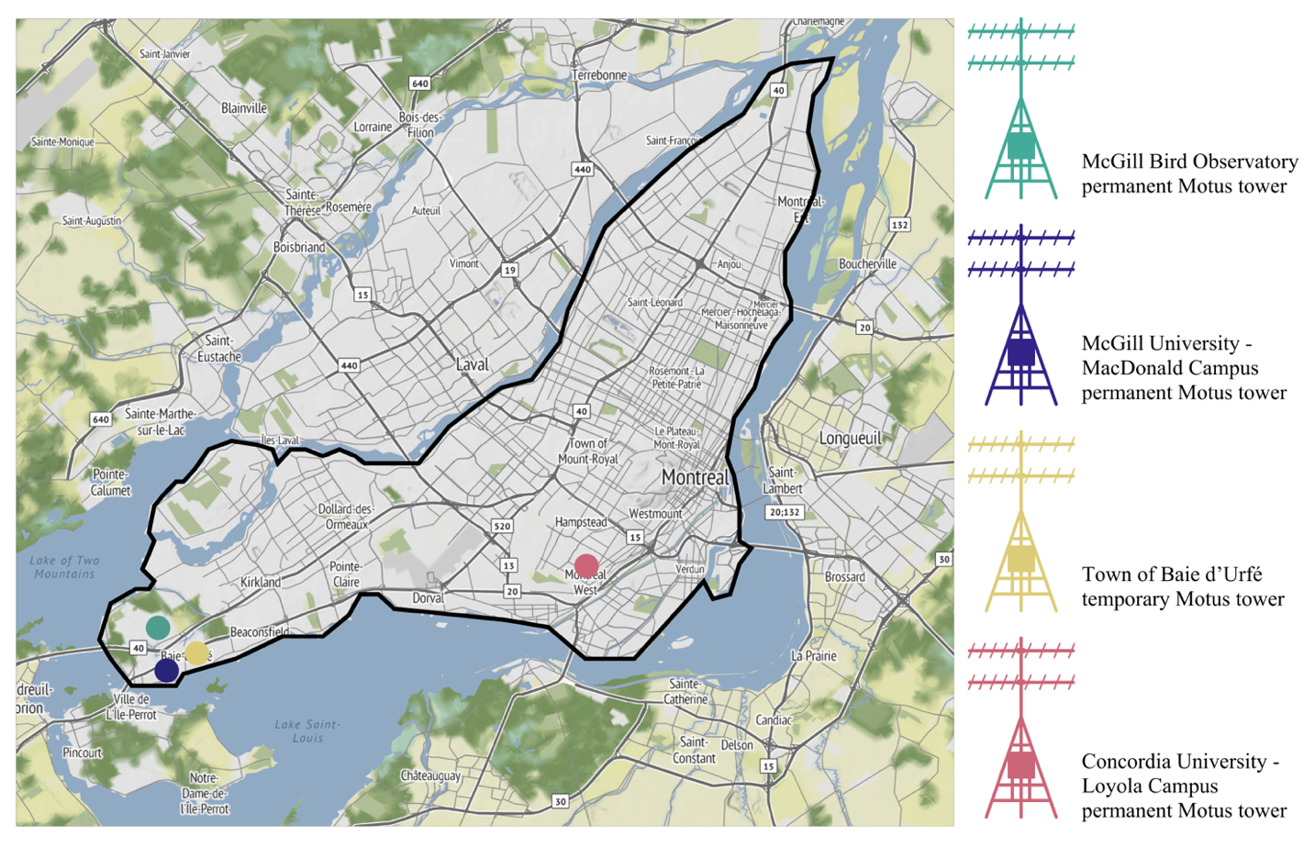Figure 2.1. Location of the Motus towers deployed between 2015 and 2025 on the island of Montreal, Quebec, Canada.

Radio tags deployment and Motus data download
We mist netted northern cardinals (males and females) at the MBO during October and November of the year 2022, 2023 and 2024. The birds were intercepted using 30 mm Japanese Nylon nets and placed in small cotton bags to reduce stress before handling. The individuals were sexed, aged, weighed, banded and randomly assigned to one of the six possible release sites (two sites at MBO, two sites in the Town of Baie d’Urfé and two sites at the Concordia University) for translocation by car. Every cardinal was equipped with a Lotek NanoTag (NTQB-2) weighing 0.8 grams, using soft elastics in a figure 8 harness configuration (the total weight of the tag, harness, and glue was less than 3% of the cardinals’ body weight). All the radio-tags were registered as part of the Motus Wildlife Tracking System (Frei et al., 2024). The birds relocated to the MBO and BDU underwent a holding time of 45 minutes before release to standardize treatment across individuals. During the winter of 2022-2023, 20 individuals fitted with trackers were released. In the following winter (2023-2024), a total of 45 birds were tagged, with 15 individuals relocated to CON, 15 relocated to BDU and 15 relocated to MBO. Finally in 2024-2025, we relocated a total of 42 birds with radio tags, including 5 individuals relocated to MBO, 16 individuals relocated to BDU, and 21 individuals relocated at CON. Birds were banded under Animal Use Protocol 2007-5447 from McGill University and federal banding permits 10973, 10973B, 10973D issued by the Canadian Wildlife Service, and radio-tagged under Animal Use Protocol 22BF01 and 23BF01 from Environment and Climate Change Canada. Upon release, the data from all four Motus towers were regularly downloaded and uploaded to the Motus Wildlife Tracking System portal. The data collected through the three consecutive winters of cardinal tracking were used to determine change point times (onset and end of activity) for all the individuals successfully detected by the Motus receiver towers.

Change point analysis
The onset and end time of diel activity was determined using radio telemetry data collected by the Motus station deployed throughout the Montreal area. Proximity to receiving antenna, transmitter orientation, and environmental obstructions can affect received signal strength, causing high signal strength variation when a tagged individual is active and low signal strength variation during periods of inactivity. Changes in signal strength variation can then be used to determine when a bird becomes active in the morning and quiescent in the evening. Following Morbey et al. (2020), we applied change point analysis to extract the time of activity onset and end based on the characteristic increase and decrease of signal variation respectively. Change points in signal variation were determined using the package “changepoint” in R ver. 4.4.2 (R Core Team, 2024b), for the six-hour period centered on local sunrise for activity onset and sunset for activity end (Killick & Eckley, 2014). Sunrise and sunset times were determined for Montréal using the function getSunlightTimes in the package “suncalc” (Thieurmel & Elmarhraoui, 2022).

Unlike previous studies, we extracted activity change points using the combined dataset from multiple stations across the study region. As signals are received near-simultaneous on any stations within range, changes in the variability of received signal strength can be perceived across multiple stations in the same instance. Using the combined regional dataset allowed us to determine activity change points without needing birds to stay within detection range of single focal station or needing to analyse activity data from multiple stations separately. The study region was defined to include all station within the Montréal area, extending from latitudes 44.9655°N to 46.1320°N and longitudes -74.2796°E to -71.9254°E.

Change points were extracted for each day a bird was in the study area by first de-trending values of signal strength (sig) by taking the first differences (d_{i} = sig_{i} - sig_{i-1}, for observation i) for each antenna on each station included in the study area (i.e. figure 2.2.). Values of d among all unique antennas were then pooled and sorted by timestamp, after which the square-root of the absolute value of d (sqrt(|d|)) was calculated. This process reduces the major difference in sig among the receiver antennas as well as difference in signal strength from station proximity as birds move throughout the study region. Square root transformation emphasises the difference in the mean and variance of sig between activity states, further demarcating the change in activity pattern (Morbey et al., 2020).

Using separate automated process for the onset and end of activity, we first filtered any onset or end periods with fewer than 800 detections total to exclude periods with poor signal coverage. The function cpt.meanvar was then used to extract a single change point time (cpt) in the mean and variance of sqrt(|d|) within the six-hour period surrounding sunrise or sunset, specifying an asymptotic penalty value of 0.001 and a minimum segment length of 20. These parameters performed well to reliably identify the transition between activity states. For most change points, mean sqrt(|d|) was < 1 before the cpt and > 0.5 after the onset of activity, and mean sqrt(|d|) ranged between 0 and 2 before the cpt and < 1.5 after for the end of activity.

Post cpt extraction, filtering was conducted to exclude questionable change points, attributable primarily to gaps in the detection record. For activity onset change points, we removed any with a pre-cpt mean sqrt(|d|) > 1, post-cpt mean sqrt(|d|) < 0, a pre-cpt mean sqrt(|d|) > post-cpt mean sqrt(|d|), or a pre-cpt variance sqrt(|d|) > post-cpt variance sqrt(|d|). For activity end change points, we removed any with a pre-cpt mean sqrt(|d|) > 0.25, a post-cpt mean sqrt(|d|) > 1, a pre-cpt mean sqrt(|d|) < post-cpt mean sqrt(|d|), or a pre-cpt variance sqrt(|d|) < post-cpt variance sqrt(|d|).

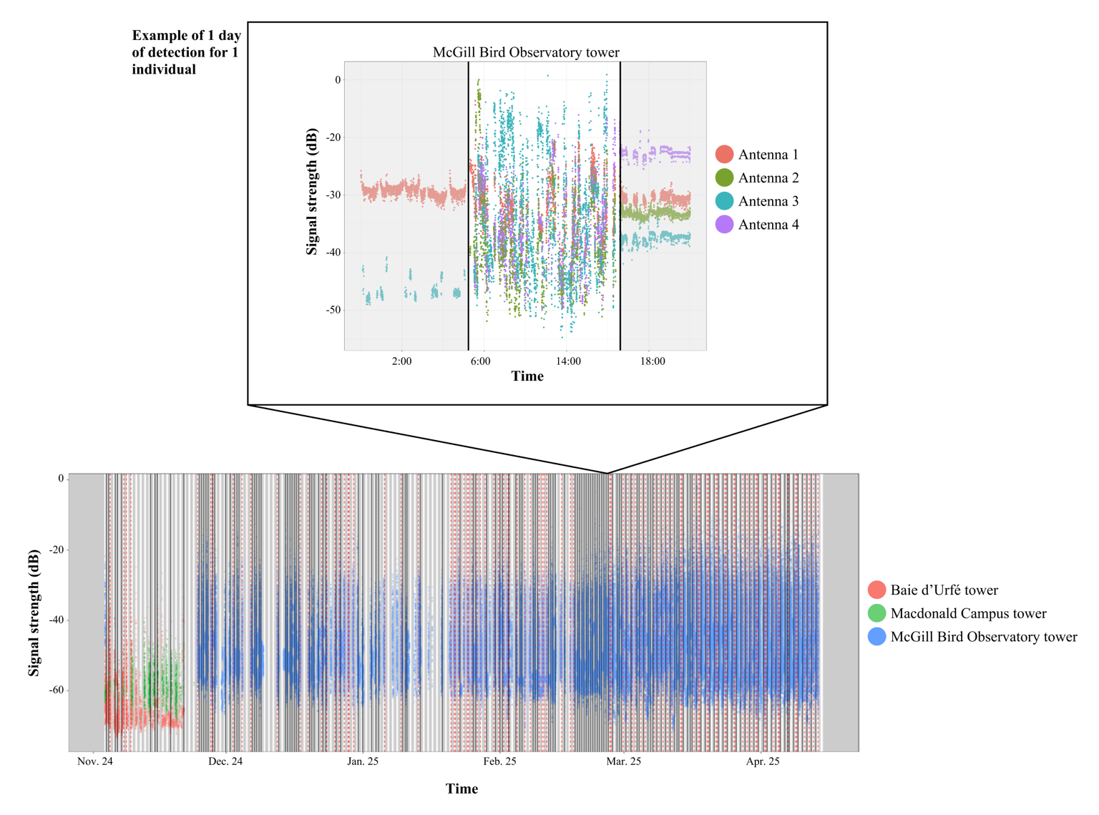Figure 2.2. Example of the change point times identified for a single bird’s detections in Montreal, Canada. The bottom graph represents all the detections recorded for an individual between the months of November 2024 to April 2025, while the top graph is a zoomed in view of the daily detections recorded by a single tower. The solid black lines represent the onset and end times identified, while the red dotted lines are change point times that were excluded in the initial post-filtering. The grey areas represent nighttime.

Weather data extraction
To investigate the effects of climate on the cardinal’s daily onset and end of activity, we got free and publicly available weather data from the Pierre-Eliott Trudeau Airport weather station (Environment and Climate Change Canada, 2022). Regarding temperature, we were able to extract data on the minimum daily temperatures (˚C), maximum daily temperatures (˚C) and the average daily temperature (˚C). We initially considered using all three temperature variables as covariates, but since concurvity tests showed that all the temperature variables were highly correlated, we only used the minimum daily temperature moving forward. We were also able to extract the daily precipitations (mm), the amount of snow accumulation on the ground (cm) and the speed of the maximum gust of wind during the day (km/h).

We then assigned the weather data from the newly created dataset to the corresponding dates in two distinct datasets for the onset and end of activity of the birds. We created two dynamic temporal variables: temperature lag and cold snap events. The temperature lags were created by extracting the daily minimum temperature 1 to 5 days before the current date’s temperature, for both the onset and end of activity. Here, we define cold snaps as sudden drops in temperatures between two consecutive days. For each change point time, we determined the difference in daily minimum temperature by subtracting the previous day’s value from the current day’s value. We assigned a binary value to the result according to three different magnitudes of cold snaps. We then categorized these differences into binary variables, based on three thresholds of temperature drops: 5˚C, 7˚C and 10 ˚C. For each threshold, if the temperature drop is equal to, or greater than the specified magnitude, the data entry is assigned a value of 1 (indicating a cold snap event happened). Otherwise, it’s assigned a value of 0 (indicating that the temperature drop wasn’t big enough to be considered a cold snap event). This step was repeated for both the onset and end of activity of the cardinals.

Scale of effect of dynamic temporal variables
The first step was to determine the scale of effect of both dynamic temporal variables, to identify which temperature lag (1 to 5 days) and which cold snap events (-5 ˚C, -7 ˚C or -10 ˚C) have the biggest impact on cardinal’s onset and end of activity. Thus, we fitted a series of generalized additive models (GAMs). The response variable, here “cpt.sr” corresponds to the onset time of activity relative to sunrise (meaning negative values are minutes before sunrise, and positive values are minutes after sunrise), and we included both environmental predictors and individual- and site-level random effects. Specifically, we modeled the effects of minimum daily temperatures (Min_temp), log-transformed precipitations (log_precip), snow accumulation on the ground (Snow_on_grnd), and maximum wind gust speed (Speed_max_gust_wind) using smooth terms. We also included random effect smooth terms for individuals (ID), the years from which the data were collected (Winter) and the study site (Site).

To assess the effects of delayed temperature, we also included smoothed lagged temperature predictors using the mean minimum temperature over the 1 to 5 previous days (Mean_lag1 to Mean_lag5), in addition to the current day’s minimum temperature. Each of these lag models were compared to a “no lag” model and a “null model” including only the random effects. Model selection and comparison were conducted using the Akaike Information Criterion (AICc) values (Burnham & Anderson, 2002). The best model was identified as having the lowest AICc value. We also calculated the $∆$AICc to evaluate competing models following Burnham and Anderson (2002) (models with a $∆$AICc < 2 were considered to have substantial support, competing with the best model and models with a $∆$AICc > 10 were deemed to have no support, not competing with the best model). These previous modelling steps were also repeated to investigate the effect of temperature lag on the end of activity of cardinals, by simply replacing the response variable by “cpt.ss”, corresponding to the time of end of activity relative to sunset (meaning negative values are minutes before sunset, and positive values are minutes after sunset). After the most fitting temperature lag variable was established for both the onset and end of activity, we moved on to investigate the effect of cold snaps.

Again, we used GAMs models to examine whether cold snaps were associated with changes in the onset and end of activity. Cold snaps were included in the models as binary fixed-effect predictors, based on the three threshold values described earlier. We fit different models for each threshold (cold_snap5, cold_snap7 and cold_snap10), alongside smoothed terms for the minimum daily temperature, log-transformed precipitations, snow accumulation on the ground, and maximum daily wind gust speed. Once again, site and individuals were included in the models as random effects using smooth terms. Because the cold snap variable is binary, we considered them as linear terms rather than smoothed. All the models were fitted using the mgcv package in R with restricted maximum likelihood (REML) method. Model selection and comparison were also conducted using AICc values and following Burnham and Anderson’s guidelines (2002). Once we selected the best model of the cold snaps, we moved on to investigate the combined effects of daily temperatures, temperature lag and cold snaps altogether.

Modelling the effects of weather conditions and dynamic temporal variables on the onset and end of northern cardinal’s daily activities
Once we identified, for both the onset and end of activity, the best fitting model for the cold snaps and the temperature lag, we created models that investigate the combined effect of those variables on the activity of the cardinals. We also included all the previously mentioned weather variables and fitted a set of 5 different models. To ease reading, only the models for the onset of activity will be described, but the same models were also built for the end of activity. The first model is the “Full model” including all the variables possible (Change Point Sunrise ~ s(Minimum temperature) + s(log(Precipitations)) + s(Snow on the ground) + s(Mean temperature lag 5) + Cold snap 5 + s(Speed of maximum gust of wind) + s(Winter, bs = “re”) + s(ID, bs = “re”) + s(Site, bs = “re”)). The second model is a “Precipitation model” and focuses on both snow and rain (Change Point Sunrise ~ s(log(Precipitations)) + s(Snow on the ground) + s(Mean temperature lag 5) + Cold snap 5 + s(Winter, bs = “re”) + s(ID, bs = “re”) + s(Site, bs = “re”)). The third model we looked at is the “Temperature model”, containing only the temperature variables (Change Point Sunrise ~ s(Minimum temperature) + s(Mean temperature lag 5) + Cold snap 5 + s(Speed of maximum gust of wind) + s(Winter, bs = “re”) + s(ID, bs = “re”) + s(Site, bs = “re”)). The fourth model is the “Extreme temperature” one, including this time solely the temperature lag and cold snap variables (Change Point Sunrise ~ s(Mean temperature lag 5) + Cold snap 5 + s(Winter, bs = “re”) + s(ID, bs = “re”) + s(Site, bs = “re”)). Finally, the last model we looked into is the “Null model”, containing only the random effects variables (Change Point Sunrise ~ s(Winter, bs = “re”) + s(ID, bs = “re”) + s(Site, bs = “re”)). Once again, for both the onset and end of activity, we selected the best model using the lowest AICc value (Burnham & Anderson, 2002).

Results

Dynamic temporal variables model selection
The best model for the onset of activity of the cardinals is the 5-day lag model, but it’s only marginally better (< 1 Δ AICc values among all other models; figure 2.3., A). 5-day lag is defined here as the mean temperature over the previous 5 days relative to the current day of onset/end of daily activities. For the end of activity however, the best model is the 2-day lag one by far (> 10 Δ AICc values among all other models; figure 2.3., C). Regarding the cold snaps, the best model for the onset of activity turned out to be the -5 ˚C model (> 5 Δ AICc values among all other models; figure 2.3., B) and the best model for the end of activity was the -10 ˚C one (> 2 Δ AICc values among all other models; figure 2.3., D).
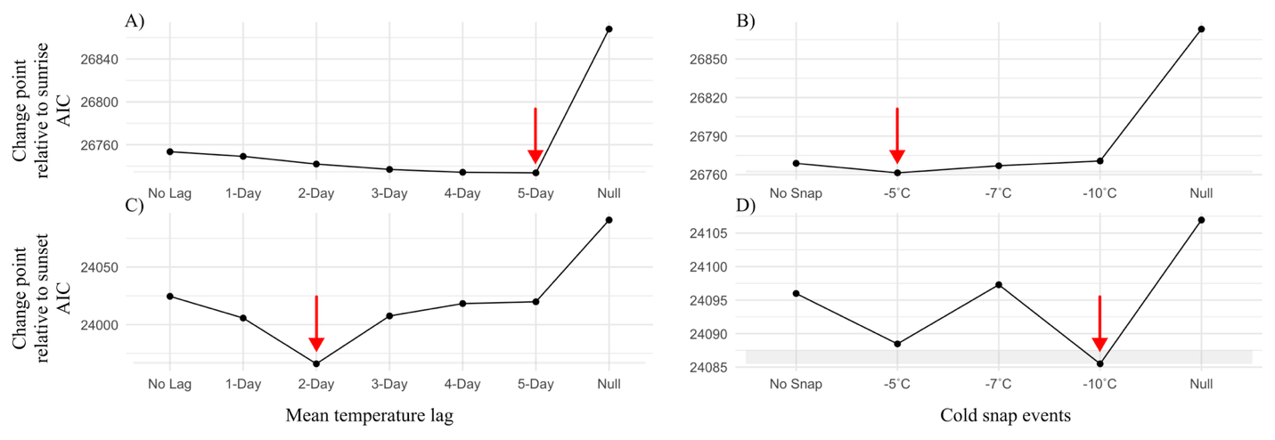
Figure 2.3. Model ranking using AICc of generalized additive models (GAMs) with a comparing scale of effect of mean temperature lag (A, C) and cold snap events (B, D) on the change point timing relative to both sunrise (A, B) and sunset (C, D) of northern cardinals (n = 64) tracked in Montreal, Quebec, Canada between 2022 and 2025. The arrow indicates the best model (lowest AIC value) and the shaded area represents a ∆AICc of 2 points.

Modelling the effect of weather conditions and dynamic temporal variables on cardinal’s daily activities
The best candidate GAM model for the onset of activity of the cardinals was the full model. The full model has a ∆ AIC value of 0 and a 22.5 AIC point difference with the next best model (precipitation model; figure 2.4.). Thus, the full model (Change Point Sunrise ~ s(Minimum temperature) + s(log(Precipitations)) + s(Snow on the ground) + s(Mean temperature lag 5) + Cold snap 5 + s(Speed of maximum gust of wind) + s(Winter, bs = “re”) + s(ID, bs = “re”) + s(Site, bs = “re”)) was selected to move forward with the analyses.
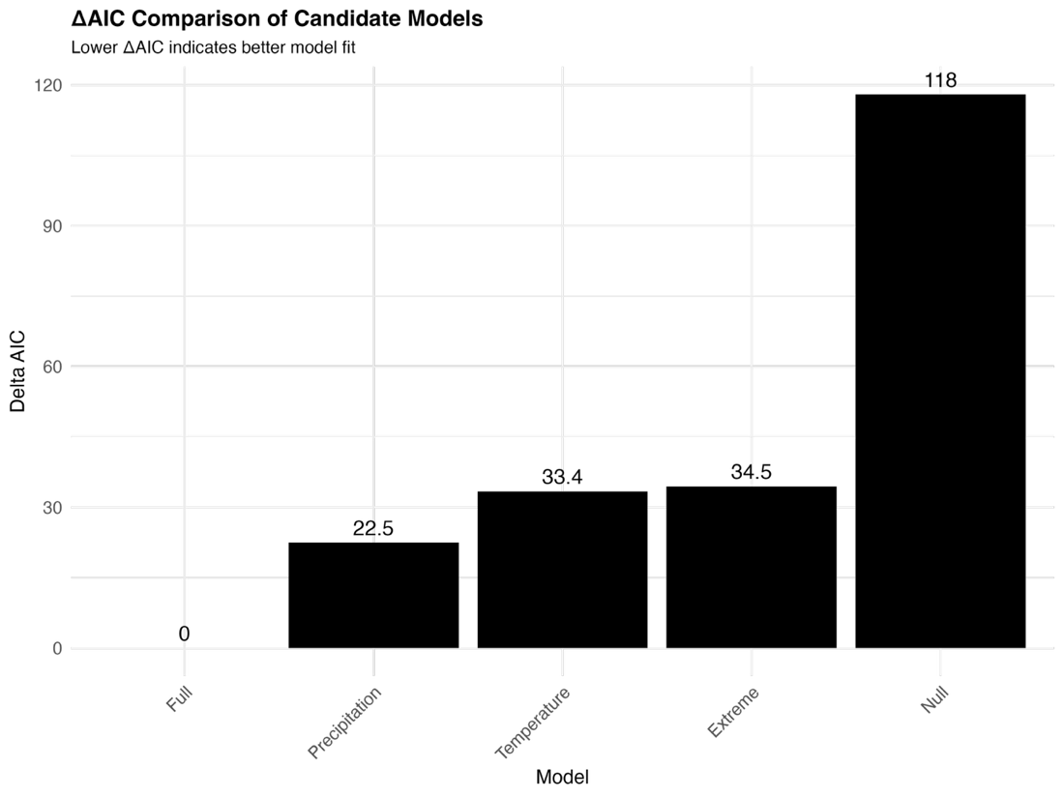
Figure 2.4. Comparison of the candidate models for the onset of activity of the birds using ∆ AIC, where a lower score indicates a better model fit.

The intercept of the parametric coefficients has a value of -12.456, meaning that the baseline onset time of activity of the cardinals would be ~ 12 minutes before sunrise, when all predictors are at reference levels (table 2.1.). It’s highly significant, meaning this baseline level is indeed meaningful (table 2.1.). The cold snap -5 ˚C has an estimate value of -14.814, meaning that during cold snap events of at least -5 ˚C, cardinals become active ~ 15 minutes before the baseline (~ 27 minutes before sunrise; table 2.1.).

Out of all the variables explored, minimum daily temperatures, snow accumulation on the ground, 5-day mean temperature lag, maximum daily wind gust speed, birds’ ID and cold snap events of -5 ˚C and below, all had a significant effect on the onset of activity. Minimum temperature has an edf value of ~ 1 and is significant (p = 0.006), showing a linear relationship with the onset of activity (table 2.1.). Snow on the ground has a significant (p = 0.007), non-linear effect (edf = 3.820), indicating that the effect of snow depth has a more complex influence on the onset of activity of the birds (table 2.1.). Mean temperature lag also shows a strong, complex (edf = 5.772) and highly significant (p < 0.001) effect on the cardinal’s onset of activity (table 2.1.). Finally, the speed of maximum gust of wind has a significant (p < 0.001) and non-linear (edf = 4.600) relationship with onset of activity (table 2.1.). On a last note, looking at random effects, we notice that the ID (individual birds) is highly significant (p < 0.001), highlighting large differences among individuals in the onset of their daily activities (table 2.1.). The model explains 14.4% of the deviance, with an adjusted R² of 0.124.

GAMs results revealed that multiple environmental variables significantly influenced the cardinals’ daily onset time of their activities relative to sunrise (figure 2.5.). Minimum daily temperatures had a strong linear negative effect. As the temperature drops, the cardinals start to get active later after sunrise, while warmer temperatures are associated with earlier onset times relative to sunrise (figure 2.5., top left). Snow accumulation on the ground had a non-linear effect: onset time remains stable at low to moderate snow depths, but increased (i.e., onset is delayed) sharply at depths exceeding approximately 30 cm (figure 2.5., top middle). A similar, non-linear relationship is revealed for the 5-days mean temperature lag, with the earliest onset times occurring at intermediate lag values, while both lower and higher lag temperatures were associated with delayed onset of activity relative to sunrise (figure 2.5., top right).

Maximum wind gust speed showed a weak, non-linear relationship with a tendency for onset time to increase, but only at very high wind speeds (> 60 km/h; figure 2.5., bottom left). As for cold snap events (defined as a binary variable), birds did start their days ~ 27 minutes earlier relative to sunrise when cold snap events colder or equal to a -5 ˚C temperature drop (figure 2.5., bottom middle).

Table 2.1. Summary of GAM results (full model) predicting the effects of weather conditions on the onset of activity of northern cardinals.
Parametric coefficients
Terms | Estimate | Standard Error | t value | Pr(>|t|) | Significance
Intercept | -12.456 | 3.316 | -3.756 | < 0.001 | ***
Cold snap -5˚C | -14.814 | 5.121 | -2.893 | 0.004 | **
Smooth terms
Terms | edf | Ref.df | F | p-value | Significance
Minimum temperature | 1.050 | 1.096 | 7.155 | 0.006 | **
log(Precipitations) | 1.011 | 1.023 | 0.698 | 0.402
Snow on the ground | 3.820 | 4.717 | 3.287 | 0.007 | **
Mean temperature lag 5 days | 5.722 | 6.919 | 5.891 | < 0.001 | ***
Speed of maximum gust of wind | 4.600 | 5.464 | 4.634 | < 0.001 | ***
Winter (random effect) | 1.274 | 2.000 | 33.380 | 0.071
ID (random effect) | 41.533 | 63.000 | 3.345 | < 0.001 | ***
Site (random effect) | 0.005 | 2.000 | 0.001 | 0.556
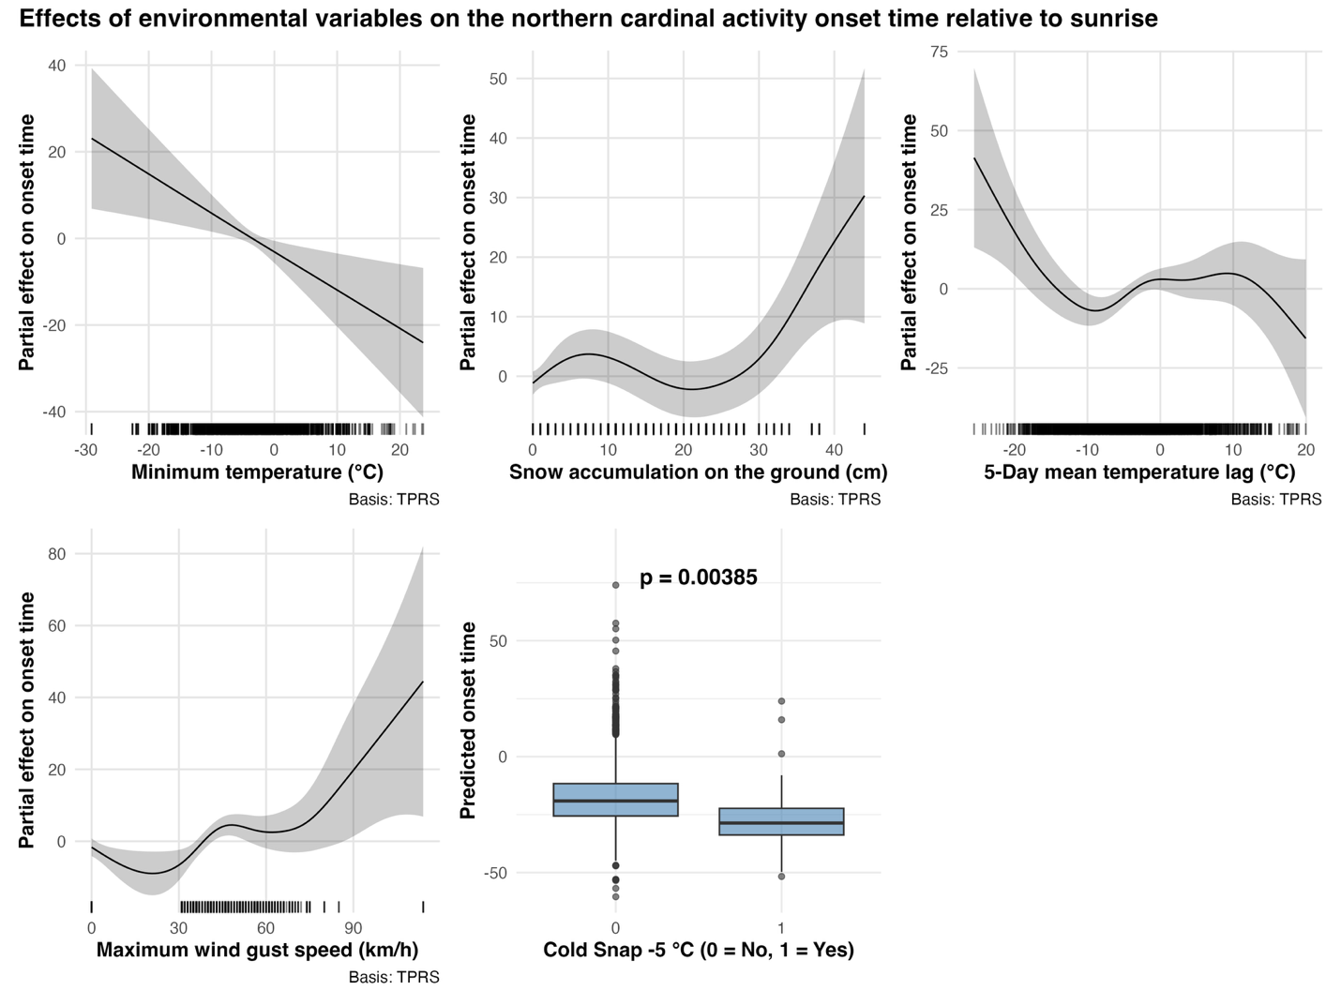Figure 2.5. Partial effect of 5 environmental variables on the northern cardinal’s daily activity onset time relative to sunrise for 64 individuals tracked in Montreal, Quebec, Canada between 2022 and 2025.
The best candidate GAM model for the end of activity of the cardinals turned out to be the temperature model. As shown in figure 2.6., the temperature model has a ∆ AIC value of 0 and a 2.6 AIC point difference with the next best model (full model). Thus, the temperature model (Change Point sunset ~ s(Minimum temperature) + s(Mean temperature lag 2) + Cold snap 10 + s(Speed of maximum gust of wind) + s(Winter, bs = “re”) + s(ID, bs = “re”) + s(Site, bs = “re”)) was selected to move forward with the analyses.

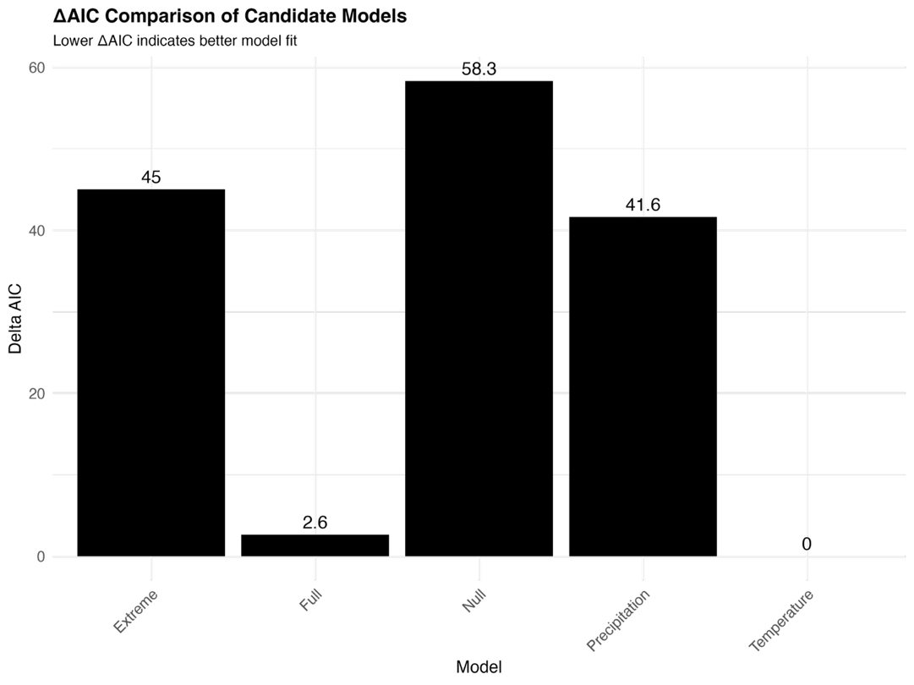
Figure 2.6. Comparison of the candidate models for the end of activity of the birds using ∆ AIC, where a lower score indicates a better model fit.

The intercept of the parametric coefficients has a value of 10.465, meaning that the baseline end time of activity of the cardinals would be ~ 10 minutes after sunset, when all predictors are at reference levels (table 2.2.). It’s highly significant, meaning this baseline level is meaningful (table 2.2.). The cold snap -10 ˚C has an estimate value of -42.144, meaning that during cold snap events of at least -10 ˚C, cardinals end their daily activities ~ 42 minutes before the baseline (~ 32 minutes before sunset; table 2.2.).

Among the smooth terms, the speed of maximum gust of wind, the winter and the study site were non-significant (table 2.2.). Minimum temperature shows a strong, significant (p < 0.001) non-linear (edf = 6.371) effect, indicating that end-of-day activity is influenced in a complex way by minimum daily temperatures (table 2.2.). Mean temperature lag also shows a highly significant (p < 0.001) non-linear (edf = 7.901) effect on the cardinal’s end of activity (table 2.2.). Here as well, we notice that the ID (individual birds) is highly significant (p < 0.001), indicating individual variability (table 2.2.). The model explains 7.95% of the deviance, with an adjusted R² of 0.063.

GAMs results demonstrate multiple environmental variables are significantly related to northern cardinal’s end of activity relative to sunset (figure 2.7.). Minimum daily temperatures had a strong non-linear effect. As the temperature drops below zero, the cardinals end their daily activities later after sunset, but once -10 ˚C is reached, the cardinals go back to ending their daily activities closer to the baseline (figure 2.7., left). A non-linear relationship is also revealed for the 2-days mean temperature lag, with cardinals ending their daily activities earlier than sunset when temperatures are colder and ending their day later after sunset when the mean temperature lag of 2 days gets warmer (figure 2.7., middle). As for cold snap events of at least -10 ˚C, birds ended their day approximately half an hour before sunset on days when cold snap events happened, compared to days without cold snap events (figure 2.7., right).

Table 2.2. Summary of GAM results (extreme temperature model) predicting the effects of weather conditions on the end of activity of northern cardinals.
Parametric coefficients
Terms | Estimate | Standard Error | t value | Pr(>|t|) | Significance
Intercept | 10.465 | 1.356 | 7.719 | < 0.001 | ***
Cold snap -10˚C | -42.144 | 10.211 | -4.127 | < 0.001 | ***
Smooth terms
Terms | edf | Ref.df | F | p-value | Significance
Minimum temperature | 6.371 | 7.565 | 5.173 | < 0.001 | ***
Mean temperature lag 2 days | 7.901 | 8.580 | 6.547 | < 0.001 | ***
Speed of maximum gust of wind | 1.002 | 1.005 | 0.201 | 0.655
Winter (random effect) | 0.720 | 2.000 | 1.800 | 0.169
ID (random effect) | 26.099 | 63.000 | 0.966 | < 0.001 | ***
Site (random effect) | 0.007 | 2.000 | 0.002 | 0.436
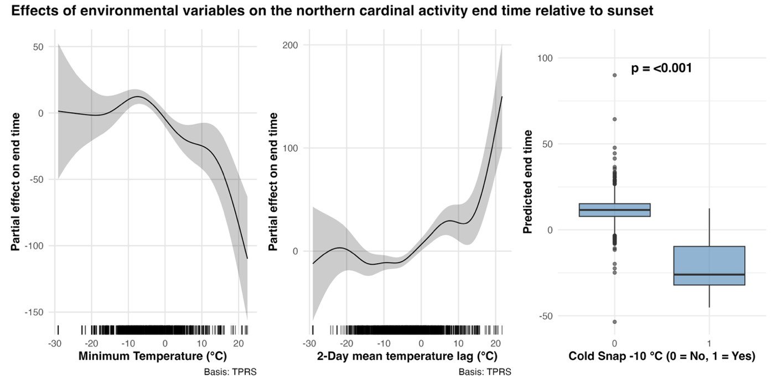
Figure 2.7. Partial effect of three significant environmental variables on the northern cardinal’s daily activity end time relative to sunset for 64 individuals tracked in Montreal, Quebec, Canada between 2022 and 2025.

Discussion
In response to chronic, inclement weather (cold temperatures, high winds, high snow accumulation), cardinals started to be active later in the day, suggesting that they conserve energy. However, during cold snap events (drops in temperature of -5 ˚C day-over-day), they start their daily activities earlier, suggesting that they were actively foraging to cope with the acute thermoregulatory stress imposed by the previous night. Cardinals’ end timing of daily activity responded more to acute cold snap events (drops in temperature of -10 ˚C day-over-day) and shorter-term inclement weather, leading the birds to end their day earlier, suggesting that in those conditions, the thermoregulatory costs to keep foraging is not worth the energetic gains. Together, these results highlight the behavioural flexibility of cardinals regarding thermoregulation strategies when wintering in urban environments.

Varying scale of effect of dynamic temporal variables
Both dynamic temporal variables (temperature lag and cold snap events) had a different scale of effect whether looking at the onset or end of the cardinal’s daily activities. Our model selection showed that a temperature lag of five days was best explanatory of the onset time of the cardinals’ activity, while a two-day temperature lag was better at explaining the end time of daily activities. These findings suggest that cardinals respond to temperature cues at distinct timescales, with short-term conditions being more relevant in determining when to begin activity in the morning, and long-term conditions guiding energetic needs related to the cessation of daily activities. Previous research, on larger spatial (across a country) and temporal (annual cycle) scales have demonstrated that there is a lag effect of temperatures on 59 breeding birds of England (Pearce‐Higgins et al., 2015). A negative lagged correlation was found between hot, dry summer weather and birds’ population growth (Pearce‐Higgins et al., 2015). Resident birds’ populations appeared to increase following wet autumn months, and populations of long-distance migrants were negatively affected by May temperatures, reflecting the potential effects of a phenological mismatch in the breeding season (Pearce‐Higgins et al., 2015). More recent work in Sweden and Finland on 24 bird species showed that temperature anomalies from previous winters (lagged effect) had a negative effect on bird's body size (Bosco et al., 2023). Wing length was negatively correlated to temperature anomalies of the previous years, potentially suggesting carry-over effects related survival or dispersal (Bosco et al., 2023). Birds’ body mass was also negatively related to temperature anomalies of the same winter, suggesting this time some more immediate effects, potentially related to reduced fat reserves during the mild winters (Bosco et al., 2023). Bosco’s findings contradict Bergmann’s rule, as they found the birds in southernmost areas were heavier, suggesting that living at higher and colder latitudes cost birds more energy, depleting their fat reserves (thus leading to lighter birds). Our results are broadly aligned with prior work showing that temperature lag can affect different aspect of birds’ life cycle (e.g., Pearce-Higgins et al., 2015; Bosco et al., 2023), yet these studies mostly relied on very large spatial and temporal scales (e.g., multiple years and months, datasets spanning an entire country), whereas we tested for temperature lags over only a few days at a time and over a smaller spatial scale (the city of Montreal, Canada). Other researchers have recognized that there are very few studies investigating the lag effect of temperature on birds’ full life cycle, including both the breeding and non-breeding season (Mainwaring et al., 2021).
Regarding cold snaps events, the model including drops of at least -5 ˚C was best explanatory of the onset time of the birds’ daily activities, while the model including drops of at least -10 ˚C was best to predict the timing of cessation of activity. Our results suggests that more subtle changes in minimum temperatures are enough to have an effect on the timing at which the cardinals begin their days, and conversely the timing at which they end their daily activities depends on more drastic temperature drops. Recent work on 24 North American bird species with historical temperature data showed that during the breeding season, relative fitness was reduced following heatwaves and cold snaps in 11 and 16 of the species studied, respectively (Taff & Shipley, 2023). Taff and Shipley (2023) suggested that species were most vulnerable to extreme temperatures at range limits, which may contribute to shifts in species distribution. For example, eastern bluebirds (Sialia sialis) were vulnerable to heatwaves over most of their distribution range, especially during provisioning, but were only sensitive to cold snaps near their northern range limit (Taff & Shipley, 2023). Our results on the varying scale of effect of cold snap events for daily activities of northern cardinals seem to align with previous findings suggesting that extreme temperature events (specifically cold events) can impact bird to varying degrees and at different stages of their life history.

Colder temperatures are linked to earlier morning activity in northern cardinals
Northern cardinal’s onset of activity varies according to minimum daily temperatures, snow accumulation on the ground, a 5-day mean temperature lag, maximum daily wind gust speed and cold snaps events of -5 ˚C. As minimum daily temperatures drop, cardinals’ onset of activity begins later, and as those temperatures increase, cardinals begin their days earlier. This pattern suggests that cardinals are responsive to immediate thermal cost of activity: colder daily temperatures may push them to delay the onset of activity, potentially to preserve energy. This would be consistent with behavioural thermoregulation seen in other wintering birds (e.g., Gjerde & Wegge, 1987; Gonnerman et al., 2023). Snow accumulation on the ground had a non-linear, yet somewhat similar effect on the onset of activity. It seems that snow depths below 30 cm are not eliciting a strong response from cardinals, but past this apparent threshold, we notice a steep increase of the onset time of activity relative to sunrise (meaning the birds start to get active later when snow cover reaches a certain depth). This could reflect reduced mobility or foraging opportunities as deeper snow can encumbers ground foraging birds such as the northern cardinal (Maccarone, 1987). Heavy snow conditions could potentially increase the cost-benefit ratio of early activity. Maximum daily wind gust speed also has an apparent threshold. Below 60 km/h, there’s seemingly no effect of wind gust speed on the bird’s onset of activity, yet when wind gust speed surpasses 60 km/h, the birds are once again delaying the onset of their daily activities. Our results suggest that cardinals have a window of tolerance for lower wind gust speed. Wind was shown to increase heat loss through convection, increasing thermoregulatory demands, which may drive birds to delay the onset of their morning activities (Walsberg, 1986).

When investigating the effect of 5-day mean temperature lag, we see that when mean temperature of the last 5 days are between -10 ˚C and 10 ˚C, there is no apparent effect on the onset of activity. However, when the 5-day mean temperatures go below -10 ˚C, cardinals start their morning activities later after sunrise, and when 5-day mean temperatures go above 10 ˚C, cardinals begin their mornings before sunrise. This pattern may reflect cardinals “catching up” on foraging during milder conditions (starting activity before sunrise) or avoid additional resource depletion during cold spell by delaying the onset of activity. These lag effects of temperatures are consistent with findings in other species, where recent thermal conditions shapes short-term behavioural decisions (Schweiger & Frey, 2021). Interestingly, the effect of cold snap events below or equal to -5 ˚C had a highly significant and unexpected effect on the cardinals’ onset of activities. The birds started their mornings ~15 minutes earlier than the baseline (~12 minutes before sunrise) during cold snaps events, making it a total of ~27 minutes earlier than sunrise. This result contrasts with broader patterns of later onset of activity during harsh conditions and may point to a distinct behavioural strategy (Gjerde & Wegge, 1987; Gonnerman et al., 2023; Taff & Shipley, 2023). One possibility is that the cardinals increase their foraging efforts whenever cold snaps happen in anticipation of higher energy demands due to ambient minimum temperatures going well below zero. On the opposite, this could indicate that the increased energy requirements to keep warm overnight were too steep (despite falling into torpor) meaning the cardinals had to forage earlier the following morning to stay warm and replenish energy, at the cost of being active in the coldest part of the day (Bednekoff & Houston, 1994; Broggi et al., 2007; P. R. Evans, 1969; Madsen et al., 2021). Our findings would suggest that cardinals are able to adjust their behaviour not only to preserve energy, but also to proactively meet energetic challenges to come.

Cardinals only end their day earlier if subjected to extreme cold
While we expected colder temperatures to constrain activity duration, our results show that warmer minimum temperatures were associated with an earlier end to daily activities. This could reflect a compensatory response where cardinals reduce their activity duration on warmer days, due to reduced foraging urgence when thermoregulatory costs are lower. These results partially contrasts with other findings in different species such as the common woodpigeon, which showed increased foraging activity in urban areas during winter (Masello et al., 2023). Our results also align with the notion that birds are subjected to the forces of both starvation and predation, and that combined these forces influence daily foraging routines (Bonter et al., 2013; McNamara et al., 1994). Our results may indicate that once cardinals meet their caloric need (usually way before sunset), they tend to end daily activities earlier to avoid predation risk (Bonter et al., 2013; McNamara et al., 1994). There was also a non-linear effect of a 2-day mean temperature lag. Birds initially ended their days earlier following moderately cold temperatures, but this effect decreased as 2-day mean lag temperature reached -20 ˚C, suggesting that feeding was potentially not making up for the energy savings of entering torpor or dropping body temperatures. Such lagged responses could indicate cumulative energetic costs or shifts in foraging strategies to adjust to short-term cold spells. This aligns with similar findings in other songbirds, where cold exposure on multiple days influences behaviour differently compared to single-day exposure (Schweiger & Frey, 2021).

Interestingly, we also see that warmer 2-day mean temperatures were associated with later end times. This asymmetry may indicate that while cardinals end their daily routines earlier during cold phases to preserve energy, the also exploit warmer days to extend their daily activities to compensate previous deficits. Finally, the effect of -10 ˚C cold snap events was highly significant and meant that birds would end their daily activities ~42 minutes before the baseline (which is ~ 10 minutes after sunset). This behavioural shift underscores the acute impact of extreme temperature events, seemingly triggering early activity cessation. This pattern is consistent with prior research showing that birds reduce movement and remain more stationary during extreme cold and snow conditions (Gonnerman et al., 2023; Prather et al., 2023). We could also hypothesise that cardinals end their foraging earlier as the energy gain from feeding in extreme cold would not be worth compared to the energy savings of entering torpor earlier. Blem (1975) also suggested that birds may avoid accumulating unnecessary fat reserves during winter (which can lead to increased energetic demands to fly, and thus reduce agility against predators; Blem, 1975) mainly because of predation pressures. Together, these results reveal a complex, asymmetric response of northern cardinals’ activity cessation relative to temperature cues, where short-term (2-day mean temperature lag) and acute cold snap events (-10 ˚C) both affecting the end of daily activities.

Implications
Our findings have shown that northern cardinals in urban environments adjust both the onset and end of their daily activities in response to dynamic temporal variables and climatic conditions. This behavioural plasticity could help counteract acute energy deficits during extreme cold events but may also make them sensitive to the intensity and frequency of such events. As urban environments will most likely experience increasingly frequent weather anomalies due to climate change, our results support the need to consider both acute and lagged effects of weather conditions when investigating winter survival, daily activities and resource use. In addition, understanding fine-scale responses of resident bird species could inform urban stakeholders who wish to maintain accessible foraging resources and thermal refuges to support overwintering bird populations.

References
Adam, M., Musilová, Z., Musil, P., Zouhar, J., & Romportl, D. (2015). Long-Term Changes in Habitat Selection of Wintering Waterbirds: High Importance of Cold Weather Refuge Sites. Acta Ornithologica, 50(2), 127–138. https://doi.org/10.3161/00016454AO2015.50.2.001
Altwegg, R., Jenkins, A., & Abadi, F. (2014). Nestboxes and immigration drive the growth of an urban Peregrine Falcon Falco peregrinus population. Ibis, 156(1), 107–115. https://doi.org/10.1111/ibi.12125
Andreev, A. V. (1999). Energetics and survival of birds in extreme environments. Ostrich, 70(1), 13–22. https://doi.org/10.1080/00306525.1999.9639745
Anich, N. M., Benson, T. J., & Bednarz, J. C. (2009). Effect of radio transmitters on return rates of Swainson’s Warblers. Journal of Field Ornithology, 80(2), 206–211. https://doi.org/10.1111/j.1557-9263.2009.00210.x
Ausprey, I. J., & Rodewald, A. D. (2011). Postfledging Survivorship and Habitat Selection Across A Rural-To-Urban Landscape Gradient. The Auk, 128(2), 293–302. https://doi.org/10.1525/auk.2011.10158
Barron, D. G., Weatherhead, P. J., & Brawn, J. D. (2013). A Test of Radio-Transmitter Effects on Parental Investment and Productivity in the Northern Cardinal. The Condor, 115(3), 669–676. https://doi.org/10.1525/cond.2013.120149
Beauchamp, A. T., Guglielmo, C. G., & Morbey, Y. E. (2020). Stopover refuelling, movement and departure decisions in the white-throated sparrow: The influence of intrinsic and extrinsic factors during spring migration. Journal of Animal Ecology, 89(11), 2553–2566. https://doi.org/10.1111/1365-2656.13315
Beddall, B. (1963). Range Expansion of the Cardinal and Other Birds in the Northeastern States. The Wilson Bulletin, 75(2), 140–158.
Bednekoff, P. A., & Houston, A. I. (1994). Optimizing Fat Reserves over the Entire Winter: A Dynamic Model. Oikos, 71(3), 408. https://doi.org/10.2307/3545828
Benson, E. S. (2017). A Centrifuge of Calculation: Managing Data and Enthusiasm in Early Twentieth-Century Bird Banding. Osiris, 32(1), 286–306. https://doi.org/10.1086/694172
Bissonette, J. A. (1978). The Influence of Extremes of Temperature on Activity Patterns of Peccaries. The Southwestern Naturalist, 23(3), 339. https://doi.org/10.2307/3670240
Blackport, R. (2024). Amplified warming of North American cold extremes linked to human-induced changes in temperature variability. 15(5864). https://doi.org/10.1038/s41467-024-49734-8
Blem, C. R. (1975). GEOGRAPHIC VARIATION IN WING-LOADING OF THE HOUSE SPARROW. The Wilson Bulletin, 87(4).
Blondin, A. L., Drever, M. C., Flemming, S. A., Easton, W. E., Maftei, M., Zharikov, Y., Warnock, N., & Nol, E. (2025). Lengths of Stay and Stopover Strategies of Western Sandpipers During Migration at Two Sites in British Columbia, Canada. Ecology and Evolution, 15(1), e70739. https://doi.org/10.1002/ece3.70739
Bodey, T. W., Cleasby, I. R., Bell, F., Parr, N., Schultz, A., Votier, S. C., & Bearhop, S. (2018). A phylogenetically controlled meta-analysis of biologging device effects on birds: Deleterious effects and a call for more standardized reporting of study data. Methods in Ecology and Evolution, 9(4), 946–955. https://doi.org/10.1111/2041-210X.12934
Bonter, D. N., Zuckerberg, B., Sedgwick, C. W., & Hochachka, W. M. (2013). Daily foraging patterns in free-living birds: Exploring the predation–starvation trade-off. Proceedings of the Royal Society B: Biological Sciences, 280(1760), 20123087. https://doi.org/10.1098/rspb.2012.3087
Bosco, L., Otterbeck, A., Fransson, T., Lindén, A., Piha, M., & Lehikoinen, A. (2023). Increasing winter temperatures explain body size decrease in wintering bird populations of Northern Europe—But response patterns vary along the spatioclimatic gradient. Global Ecology and Biogeography, 32(12), 2100–2110. https://doi.org/10.1111/geb.13754
Boyd, B. P., Hayes, S. M., Migotto, A. A., & Stutchbury, B. J. M. (2025). Age-related differences in fall migration timing and performance of juvenile and adult Wood Thrushes departing from a breeding site. Movement Ecology, 13(1), 32. https://doi.org/10.1186/s40462-025-00556-3
Bressler, S. A., Diamant, E. S., Tingley, M. W., & Yeh, P. J. (2020). Nests in the cities: Adaptive and non-adaptive phenotypic plasticity and convergence in an urban bird. Proceedings of the Royal Society B: Biological Sciences, 287(1941), 20202122. https://doi.org/10.1098/rspb.2020.2122
Brewer, Gehring, T. M., Garcia, M. M., Shirkey, B. T., Simpson, J. W., & Fournier, A. M. V. (2023). King rail (Rallus elegans) home range and microhabitat characteristics in western Lake Erie coastal marshes. Ecology and Evolution, 13(4), 16. https://doi.org/10.1002/ece3.10043
Brewer, V., Lane, S. J., Sewall, K. B., & Mabry, K. E. (2020). Effects of low-density urbanization on genetic structure in the Song Sparrow. PLOS ONE, 15(6), e0234008. https://doi.org/10.1371/journal.pone.0234008
Brodin, A. (2007). Theoretical models of adaptive energy management in small wintering birds. Philosophical Transactions of the Royal Society B: Biological Sciences, 362(1486), 1857–1871. https://doi.org/10.1098/rstb.2006.1812
Brodin, A., Nilsson, J.-Å., & Nord, A. (2017). Adaptive temperature regulation in the little bird in winter: Predictions from a stochastic dynamic programming model. Oecologia, 185(1), 43–54. https://doi.org/10.1007/s00442-017-3923-3
Broggi, J., Hohtola, E., Koivula, K., Orell, M., Thomson, R. L., & Nilsson, J. ‐Å. (2007). Sources of variation in winter basal metabolic rate in the great tit. Functional Ecology, 21(3), 528–533. https://doi.org/10.1111/j.1365-2435.2007.01255.x
Burger, C., & Both, C. (2011). Translocation as a Novel Approach to Study Effects of a New Breeding Habitat on Reproductive Output in Wild Birds. PLoS ONE, 6(3), e18143. https://doi.org/10.1371/journal.pone.0018143
Burnham, K. P., & Anderson, D. R. (2002). Model Selection and Multimodel Inference (2nd ed.).
Buron, R., Hostetler, M. E., & Andreu, M. (2022). Urban forest fragments vs residential neighborhoods: Urban habitat preference of migratory birds. Landscape and Urban Planning, 227, 104538. https://doi.org/10.1016/j.landurbplan.2022.104538
Buxton, R. T., Hudgins, E. J., Lavigne, E., Villeneuve, P. J., Prince, S. A., Pearson, A. L., Halsall, T., Robichaud, C., & Bennett, J. R. (2024). Mental health is positively associated with biodiversity in Canadian cities. Communications Earth & Environment, 5(1), 310. https://doi.org/10.1038/s43247-024-01482-9
Cabrera-Cruz, S. A., Smolinsky, J. A., & Buler, J. J. (2018a). Light pollution is greatest within migration passage areas for nocturnally-migrating birds around the world. Scientific Reports, 8(1), 3261. https://doi.org/10.1038/s41598-018-21577-6
Cabrera-Cruz, S. A., Smolinsky, J. A., & Buler, J. J. (2018b). Light pollution is greatest within migration passage areas for nocturnally-migrating birds around the world. Scientific Reports, 8(1), 3261.
Calenge, C. (2024). adehabitatHR: Home Range Estimation [Computer software].
Callaghan, C. T., Cornwell, W. K., Poore, A. G. B., Benedetti, Y., & Morelli, F. (2021). Urban tolerance of birds changes throughout the full annual cycle. Journal of Biogeography, 48(6), 1503–1517. https://doi.org/10.1111/jbi.14093
Carrasco, L., Giam, X., Papeş, M., & Sheldon, K. S. (2019). Metrics of Lidar-Derived 3D Vegetation Structure Reveal Contrasting Effects of Horizontal and Vertical Forest Heterogeneity on Bird Species Richness. Remote Sensing, 11(7), Article 7. https://doi.org/10.3390/rs11070743
Chen, D., & Hale, R. C. (2010). A global review of polybrominated diphenyl ether flame retardant contamination in birds. Environment International, 36(7), 800–811. https://doi.org/10.1016/j.envint.2010.05.013
Chiron, F., Lorrillière, R., Bessa-Gomes, C., Tryjanowski, P., Casanelles-Abella, J., Laanisto, L., Leal, A., Van Mensel, A., Moretti, M., Muyshondt, B., Niinemets, Ü., Ortí, M. A., Pinho, P., Samson, R., & Deguines, N. (2024). How do urban green space designs shape avian communities? Testing the area–heterogeneity trade-off. Landscape and Urban Planning, 242, 104954. https://doi.org/10.1016/j.landurbplan.2023.104954
Chong, K. Y., Teo, S., Kurukulasuriya, B., Chung, Y. F., Rajathurai, S., & Tan, H. T. W. (2014). Not all green is as good: Different effects of the natural and cultivated components of urban vegetation on bird and butterfly diversity. Biological Conservation, 171, 299–309. https://doi.org/10.1016/j.biocon.2014.01.037
Christian, H.-M. (2023). The Main Drivers of Biodiversity Loss: A Brief Overview. Journal of Ecology & Natural Resources, 7(3). https://doi.org/10.23880/jenr-16000346
City of Montreal. (2024). Plan climat 2020-2030 Ville de Montréal—État d’avancement avril 2024. City of Montreal. https://mtl.ged.montreal.ca/constellio/?collection=mtlca&portal=REPDOCVDM#!displayDocument/00000092918
Clergeau, P., Croci, S., Jokimäki, J., Kaisanlahti-Jokimäki, M.-L., & Dinetti, M. (2006). Avifauna homogenisation by urbanisation: Analysis at different European latitudes. Biological Conservation, 127(3), 336–344. https://doi.org/10.1016/j.biocon.2005.06.035
Cox, D. T. C., Shanahan, D. F., Hudson, H. L., Plummer, K. E., Siriwardena, G. M., Fuller, R. A., Anderson, K., Hancock, S., & Gaston, K. J. (2017). Doses of Neighborhood Nature: The Benefits for Mental Health of Living with Nature. BioScience, 67(2), 147–155. https://doi.org/10.1093/biosci/biw173
Craighead, F., & Dunstan, T. (1976). Progress Toward Tracking Migrating Raptors by Satellite. 10(4), 112–119.
Cull, C. A., Guest, M. J., Frei, B., & Ziter, C. D. (2025). Human recreational activity does not influence open cup avian nest survival in urban green spaces. Urban Ecosystems, 28(2), 24. https://doi.org/10.1007/s11252-024-01669-0
Cunningham, S. J., Gardner, J. L., & Martin, R. O. (2021). Opportunity costs and the response of birds and mammals to climate warming. Frontiers in Ecology and the Environment, 19(5), 300–307. https://doi.org/10.1002/fee.2324
Dale, S. (2018). Urban bird community composition influenced by size of urban green spaces, presence of native forest, and urbanization. Urban Ecosystems, 21(1), 1–14. https://doi.org/10.1007/s11252-017-0706-x
Davies, S., Beck, M. L., & Sewall, K. B. (2018). Territorial aggression in urban and rural Song Sparrows is correlated with corticosterone, but not testosterone. Hormones and Behavior, 98, 8–15. https://doi.org/10.1016/j.yhbeh.2017.11.010
Dawson, W. R., Marsh, R. L., & Yacoe, M. E. (1983). Metabolic adjustments of small passerine birds for migration and cold. 245(6), R755–R767. https://doi.org/10.1152/ajpregu.1983.245.6.R755
DeCandido, R., & Allen, D. (2006). NOCTURNAL HUNTING BY PEREGRINE FALCONS AT THE EMPIRE STATE BUILDING, NEW YORK CITY. The Wilson Journal of Ornithology, 118(1), 53–58. https://doi.org/10.1676/1559-4491(2006)118%255B0053:NHBPFA%255D2.0.CO;2
Deguise, I. E., & Kerr, J. T. (2006). Protected Areas and Prospects for Endangered Species Conservation in Canada. Conservation Biology, 20(1). https://conbio.onlinelibrary.wiley.com/doi/10.1111/j.1523-1739.2005.00274.x
Deppe, J. L., & Rotenberry, J. T. (2008). SCALE-DEPENDENT HABITAT USE BY FALL MIGRATORY BIRDS: VEGETATION STRUCTURE, FLORISTICS, AND GEOGRAPHY. Ecological Monographs, 78(3), 461–487. https://doi.org/10.1890/07-0163.1
Deshpande, P., Lehikoinen, P., Thorogood, R., & Lehikoinen, A. (2022). Snow depth drives habitat selection by overwintering birds in built‐up areas, farmlands and forests. Journal of Biogeography, 49(4), 630–639. https://doi.org/10.1111/jbi.14326
DeVries, M. S., & Jawor, J. M. (2013). Natural variation in circulating testosterone does not predict nestling provisioning rates in the northern cardinal, Cardinalis cardinalis. Animal Behaviour, 85(5), 957–965. https://doi.org/10.1016/j.anbehav.2013.02.019
Dinh, K. V., Albini, D., Orr, J. A., Macaulay, S. J., Rillig, M. C., Borgå, K., & Jackson, M. C. (2023). Winter is coming: Interactions of multiple stressors in winter and implications for the natural world. Global Change Biology, 29(24), 6834–6845. https://doi.org/10.1111/gcb.16956
Dunn, J. C., Morris, A. J., Grice, P. V., & Peach, W. J. (2021). Effects of seed-rich habitat provision on territory density, home range and breeding performance of European Turtle Doves Streptopelia turtur. Bird Conservation International, 31(4), 620–639. https://doi.org/10.1017/S0959270920000635
Dupras, J., & Alam, M. (2015). Urban Sprawl and Ecosystem Services: A Half Century Perspective in the Montreal Area (Quebec, Canada). Journal of Environmental Policy & Planning, 17(2), 180–200. https://doi.org/10.1080/1523908X.2014.927755
Duren, A. M., Williams, C. K., & D’amico, V. (2017). Microhabitat Factors Associated with Occupancy of Songbirds in Suburban Forest Fragments in the Eastern United States. The American Midland Naturalist, 178(2), 189–202. https://doi.org/10.1674/0003-0031-178.2.189
Elliott, J., Brogan, J., Lee, S. L., Drouillard, K. G., & Elliott, K. H. (2015). PBDEs and other POPs in urban birds of prey partly explained by trophic level and carbon source. Science of The Total Environment, 524–525, 157–165. https://doi.org/10.1016/j.scitotenv.2015.04.008
Elliott, J., Wilson, L. K., & Wakeford, B. (2005). Polybrominated Diphenyl Ether Trends in Eggs of Marine and Freshwater Birds from British Columbia, Canada, 1979−2002. Environmental Science & Technology, 39(15), 5584–5591. https://doi.org/10.1021/es050496q
Elliott, Woo, K. J., & Benvenuti, S. (2009). Do activity costs determine foraging tactics for an arctic seabird? Marine Biology, 156(9), 1809–1816. https://doi.org/10.1007/s00227-009-1214-1
Elmqvist, T., Fragkias, M., Goodness, J., Güneralp, B., Marcotullio, P. J., McDonald, R. I., Parnell, S., Schewenius, M., Sendstad, M., & Seto, K. C. (2013). Urbanization, biodiversity and ecosystem services: Challenges and opportunities: A global assessment. Springer Nature.
Environment and Climate Change Canada. (2016, December 9). Bird banding program overview [Contact us]. https://www.canada.ca/en/environment-climate-change/services/bird-banding/program-overview-contact-information.html
Environment and Climate Change Canada. (2022). Daily Weather Data Report [Dataset]. https://climate.weather.gc.ca/climate_data/daily_data_e.html?hlyRange=2008-01-08%7C2025-07-22&dlyRange=2002-12-23%7C2025-07-22&mlyRange=%7C&StationID=30165&Prov=QC&urlExtension=_e.html&searchType=stnName&optLimit=specDate&StartYear=1840&EndYear=2025&selRowPerPage=25&Line=0&searchMethod=contains&Month=7&Day=16&txtStationName=Trudeau&timeframe=2&Year=2025
Eötvös, C. B., Magura, T., & Lövei, G. L. (2018). A meta-analysis indicates reduced predation pressure with increasing urbanization. Landscape and Urban Planning, 180, 54–59. https://doi.org/10.1016/j.landurbplan.2018.08.010
Evans, B. S., Ryder, T. B., Reitsma, R., Hurlbert, A. H., & Marra, P. P. (2015). Characterizing avian survival along a rural‐to‐urban land use gradient. Ecology, 96(6), 1631–1640. https://doi.org/10.1890/14-0171.1
EVANS, P. (1966). MIGRATION AND ORIENTATION OF PASSERINE NIGHT MIGRANTS IN NORTHEAST ENGLAND. JOURNAL OF ZOOLOGY, 150, 319-+.
Evans, P. R. (1969). Winter Fat Deposition and Overnight Survival of Yellow Buntings (Emberiza citrinella L.). The Journal of Animal Ecology, 38(2), 415. https://doi.org/10.2307/2781
Ferns, P. N., Macalpine-Leny, I. H., & Goss-Custard, J. D. (1980). Telemetry of Heart Rate as a Possible Method of Estimating Energy Expenditure in the Redshank Tringa totanus (L.). In A Handbook on Biotelemetry and Radio Tracking (pp. 595–601). Elsevier. https://doi.org/10.1016/B978-0-08-024928-5.50077-4
Fidino, M., Gallo, T., Lehrer, E. W., Murray, M. H., Kay, C. A. M., Sander, H. A., MacDougall, B., Salsbury, C. M., Ryan, T. J., Angstmann, J. L., Amy Belaire, J., Dugelby, B., Schell, C. J., Stankowich, T., Amaya, M., Drake, D., Hursh, S. H., Ahlers, A. A., Williamson, J., … Magle, S. B. (2021). Landscape‐scale differences among cities alter common species’ responses to urbanization. Ecological Applications, 31(2), e02253. https://doi.org/10.1002/eap.2253
Filion, P., Bunting, T., Pavlic, D., & Langlois, P. (2010). Intensification and Sprawl: Residential Density Trajectories in Canada’s Largest Metropolitan Regions. Urban Geography, 31(4), 541–569. https://doi.org/10.2747/0272-3638.31.4.541
Filliater, T. S., Breitwisch, R., & Nealen, P. M. (1994). Predation on Northern Cardinal Nests: Does Choice of Nest Site Matter? The Condor: Ornithological Applications, 96(3), 761–768. https://doi.org/10.2307/1369479
Fink, D., Auer, T., Johnston, A., Strimas-Mackey, M., Ligocki, S., Robinson, O., Hochachka, W., Jaromczyk, L., Crowley, C., Dunham, K., Stillman, A., Davis, C., Stokowski, M., Ruiz-Gutierrez, V., Wood, C., & Rodewald, A. (2025). eBird Status and Trends, Data Version 2023 [Dataset]. Cornell Lab of Ornithology. https://doi.org/10.2173/WZTW8903
Frei, B., Morales, A., Cousineau, A.-M., & Beauchamp, A. (2024). Montreal Northern Cardinal Winter Movements (Project 882) [Dataset]. Motus Wildlife Tracking System, Birds Canada. https://motus.org/
Fristoe, T. S. (2015). Energy use by migrants and residents in North American breeding bird communities. Global Ecology and Biogeography, 24(4), 406–415. https://doi.org/10.1111/geb.12262
Fritts, R. (2022, May 16). Avian Superhighways: The Four Flyways of North America. American Bird Conservancy. https://abcbirds.org/blog/north-american-bird-flyways/
Fuller, M. R., Millspaugh, J. J., Church, K. E., & Kenward, R. E. (2005). Wildlife radiotelemetry. Techniques for Wildlife Investigations and Management. Sixth Edition. The Wildlife Society, Bethesda, Maryland, USA, 377–417.
Furberg, D., & Ban, Y. (2008). Satellite Monitoring of Urban Sprawl and Assessing the Impact of Land-Cover Changes in the Greater Toronto Area. The XXI Congress of ISPRS. Beijing, China. 3-11 July 2008.
Gahbauer, M. A., Duval, S., & Davey, D. (2015). McGill Bird Observatory Annual Program Report 2014.
Gjerde, I., & Wegge, P. (1987). Activity patterns of Capercaillie, Tetrao urogallus, during winter. Ecography, 10(4), 286–293. https://doi.org/10.1111/j.1600-0587.1987.tb00770.x
Gómez, J., Michelson, C. I., Bradley, D. W., Ryan Norris, D., Berzins, L. L., Dawson, R. D., & Clark, R. G. (2014). Effects of geolocators on reproductive performance and annual return rates of a migratory songbird. Journal of Ornithology, 155(1), 37–44. https://doi.org/10.1007/s10336-013-0984-x
Gonnerman, M., Shea, S. A., Sullivan, K., Kamath, P., Overturf, K., & Blomberg, E. (2023). Dynamic winter weather moderates movement and resource selection of wild turkeys at high‐latitude range limits. Ecological Applications, 33(1), e2734. https://doi.org/10.1002/eap.2734
Gordo, O., Brotons, L., Herrando, S., & Gargallo, G. (2021). Rapid behavioural response of urban birds to COVID-19 lockdown. Proceedings of the Royal Society B: Biological Sciences, 288(1946), 20202513. https://doi.org/10.1098/rspb.2020.2513
Government of Canada. (2018, November 15). Environmental Damages Fund. https://www.canada.ca/en/environment-climate-change/services/environmental-funding/programs/environmental-damages-fund.html
Government of Canada. (2020). Nature Based Climate Solutions Toolkit. Nature Canada. https://naturecanada.ca/defend-nature/how-you-help-us-take-action/nature-based-climate-solutions/toolkit/
Government of Canada, S. C. (2022a, February 9). Census Profile, 2021 Census of Population. https://www12.statcan.gc.ca/census-recensement/2021/dp-pd/prof/index.cfm?Lang=E
Government of Canada, S. C. (2022b, February 9). Profile table, Census Profile, 2021 Census of Population—Montréal, Ville (V) [Census subdivision], Quebec. https://www12.statcan.gc.ca/census-recensement/2021/dp-pd/prof/index.cfm?Lang=E
Griffin, A. S., Gapes, C., Williams, L. A., Taylor, M., Kyte, R., Little, G., & Little, J. (2025). Using motus automated telemetry to quantify habitat use and movement in a Far Eastern Curlew within the Hunter Estuary, NSW, Australia.
Grimm, N. B., Faeth, S. H., Golubiewski, N. E., Redman, C. L., Wu, J., Bai, X., & Briggs, J. M. (2008). Global Change and the Ecology of Cities. Science, 319(5864), 756–760. https://doi.org/10.1126/science.1150195
Guiden, P. W., & Orrock, J. L. (2020). Seasonal shifts in activity timing reduce heat loss of small mammals during winter. Animal Behaviour, 164, 181–192. https://doi.org/10.1016/j.anbehav.2020.04.014
Guigueno, M. F., & Fernie, K. J. (2017). Birds and flame retardants: A review of the toxic effects on birds of historical and novel flame retardants. Environmental Research, 154, 398–424. https://doi.org/10.1016/j.envres.2016.12.033
Gumilyov, L. N., Byulegenova, B. B., & Turemuratov, O. Zh. (2023). Urbanization as a global trend: Causes and consequences. 142(1), 37–42. https://doi.org/10.32523/2616-6887/2023-142-1-37-42
Guo, F., Buler, J. J., Smolinsky, J. A., & Wilcove, D. S. (2023). Autumn stopover hotspots and multiscale habitat associations of migratory landbirds in the eastern United States. Proceedings of the National Academy of Sciences, 120(3), e2203511120. https://doi.org/10.1073/pnas.2203511120
Hahs, A. K., Fournier, B., Aronson, M. F. J., Nilon, C. H., Herrera-Montes, A., Salisbury, A. B., Threlfall, C. G., Rega-Brodsky, C. C., Lepczyk, C. A., La Sorte, F. A., MacGregor-Fors, I., Scott MacIvor, J., Jung, K., Piana, M. R., Williams, N. S. G., Knapp, S., Vergnes, A., Acevedo, A. A., Gainsbury, A. M., … Moretti, M. (2023). Urbanisation generates multiple trait syndromes for terrestrial animal taxa worldwide. Nature Communications, 14(1), 4751. https://doi.org/10.1038/s41467-023-39746-1
Halkin, S. L., Shustack, D. P., DeVries, M. S., Jawor, J. M., & Linville, S. U. (2021). Northern Cardinal (Cardinalis cardinalis), version 2.0. Birds of the World. https://doi.org/10.2173/bow.norcar.02
Harris, R. B., & Fish, U. S. (1990). Tracking wildlife by satellite.
Havlíček, J., Riegert, J., & Fuchs, R. (2022). A comparison of foraging-range sizes, flight distances and foraging habitat preferences in urban and rural House Sparrow (Passer domesticus) populations. Ibis, 164(4), 1227–1242. https://doi.org/10.1111/ibi.13072
Hofman, M. P. G., Hayward, M. W., Heim, M., Marchand, P., Rolandsen, C. M., Mattisson, J., Urbano, F., Heurich, M., Mysterud, A., Melzheimer, J., Morellet, N., Voigt, U., Allen, B. L., Gehr, B., Rouco, C., Ullmann, W., Holand, Ø., Jørgensen, N. H., Steinheim, G., … Balkenhol, N. (2019). Right on track? Performance of satellite telemetry in terrestrial wildlife research. Plos One, 14(5), e0216223. https://doi.org/10.1371/journal.pone.0216223
Hope, S. F., Hopkins, W. A., & Angelier, F. (2022). Parenting in the city: Effects of urbanization on incubation behaviour and egg temperature in great tits, Parus major. Animal Behaviour, 194, 1–11. https://doi.org/10.1016/j.anbehav.2022.09.004
Horn, D. J., Johansen, S. M., & Wilcoxen, T. E. (2014). Seed and feeder use by birds in the United States and Canada. Wildlife Society Bulletin, 38(1), 18–25. https://doi.org/10.1002/wsb.365
Hosmer, D. W., & Lemesbow, S. (1980). Goodness of fit tests for the multiple logistic regression model. Communications in Statistics - Theory and Methods, 9(10), 1043–1069. https://doi.org/10.1080/03610928008827941
Humbird, S. K., & Neudorf, D. L. H. (2008). THE EFFECTS OF FOOD SUPPLEMENTATION ON EXTRATERRITORIAL BEHAVIOR IN FEMALE NORTHERN CARDINALS. The Condor, 110(2), 392–395. https://doi.org/10.1525/cond.2008.8427
Ibáñez-Álamo, J. D., Morelli, F., Benedetti, Y., Rubio, E., Jokimäki, J., Pérez-Contreras, T., Sprau, P., Suhonen, J., Tryjanowski, P., Kaisanlahti-Jokimäki, M.-L., Møller, A. P., & Díaz, M. (2020). Biodiversity within the city: Effects of land sharing and land sparing urban development on avian diversity. Science of The Total Environment, 707, 135477. https://doi.org/10.1016/j.scitotenv.2019.135477
Isaksson, C. (2018). Impact of urbanization on birds. Bird Species, 235, 257.
Iverson, A. R., Schaefer, J. L., Skalos, S. M., & Hawkins, C. E. (2023). Global positioning system (GPS) and platform transmitter terminal (PTT) tags reveal fine-scale migratory movements of small birds: A review highlights further opportunities for hypothesis-driven research. Ornithological Applications, 125(3), duad014.
Jim, C. Y., & Chen, W. Y. (2008). Assessing the ecosystem service of air pollutant removal by urban trees in Guangzhou (China). Journal of Environmental Management, 88(4), 665–676. https://doi.org/10.1016/j.jenvman.2007.03.035
Johnson, D. H. (1980). The Comparison of Usage and Availability Measurements for Evaluating Resource Preference. Ecology, 61(1), 65–71. https://doi.org/10.2307/1937156
Jokimäki, J., Kaisanlahti-Jokimäki, M.-L., & Suhonen, J. (2022). Long-Term Winter Population Trends of Corvids in Relation to Urbanization and Climate at Northern Latitudes. Animals, 12(14), Article 14. https://doi.org/10.3390/ani12141820
Jones. (2001). Habitat Selection Studies in Avian Ecology: A Critical Review. The Auk, 118(2), 557–562. https://doi.org/10.1093/auk/118.2.557
Jones, T. M., Cooper, N. W., Haradon, H. A., Brunner, A. R., Dossman, B. C., Ward, M. P., Sillett, T. S., & Kaiser, S. A. (2024). Considerations for radio-transmitter specifications on songbirds: Color and antenna length matter too. Journal of Field Ornithology, 95(1). https://doi.org/10.5751/JFO-00426-950107
Jones, T. M., Llamas, A. P., & Phillips, J. N. (2023a). Phenotypic signatures of urbanization? Resident, but not migratory, songbird eye size varies with urban‐associated light pollution levels. Global Change Biology, 29(23), 6635–6646.
Jones, T. M., Llamas, A. P., & Phillips, J. N. (2023b). Phenotypic signatures of urbanization? Resident, but not migratory, songbird eye size varies with urban-associated light pollution levels. Global Change Biology, 29(23), 6635–6646. https://doi.org/10.1111/gcb.16935
Jorde, D. G., Krapu, G. L., Crawford, R. D., & Hay, M. A. (1984). Effects of Weather on Habitat Selection and Behavior of Mallards Wintering in Nebraska. The Condor, 86(3), 258. https://doi.org/10.2307/1366993
Kamei, I., & Maruta, E. (1979). Study on wind environmental problems caused around buildings in Japan. Journal of Wind Engineering and Industrial Aerodynamics, 4(3), 307–331. https://doi.org/10.1016/0167-6105(79)90010-2
Kauffman, M. J., Frick, W. F., & Linthicum, J. (2003). ESTIMATION OF HABITAT‐SPECIFIC DEMOGRAPHY AND POPULATION GROWTH FOR PEREGRINE FALCONS IN CALIFORNIA. Ecological Applications, 13(6), 1802–1816. https://doi.org/10.1890/01-5324
Kekkonen, J. (2017). Pollutants in Urbanized Areas: Direct and Indirect Effects on Bird Populations. In ResearchGate. https://doi.org/10.1007/978-3-319-43314-1_12
Killick, R., & Eckley, I. A. (2014). changepoint: An R Package for Changepoint Analysis. Journal of Statistical Software, 58, 1–19. https://doi.org/10.18637/jss.v058.i03
Korpi, Z. O., Matthews, S. N., Shumar, M. B., McDermott, M. E., Russell, D., DeGroote, L. W., Jacob, R., Shieldcastle, M., & Tonra, C. M. (2025). Spatial and species-specific variation in lake-crossing behavior in the Great Lakes region influences collision risk with offshore wind development. Ornithological Applications, 127(2), duaf019. https://doi.org/10.1093/ornithapp/duaf019
Krama, T., Krams, R., Popovs, S., Trakimas, G., Rantala, M. J., Freeberg, T. M., & Krams, I. A. (2023). Permanent Ad-lib Feeders Decrease the Survival of Wintering Great Tits (Parus major). Birds, 4(2), Article 2. https://doi.org/10.3390/birds4020019
Kraus, D., & Hebb, A. (2020). Southern Canada’s crisis ecoregions: Identifying the most significant and threatened places for biodiversity conservation. Biodiversity and Conservation, 29(13), 3573–3590. https://doi.org/10.1007/s10531-020-02038-x
Kristan, W. B., Johnson, M. D., & Rotenberry, J. T. (2007). Choices and Consequences of Habitat Selection for Birds. The Condor, 109(3), 485–488. https://doi.org/10.1093/condor/109.3.485
Lane, S. J., VanDiest, I. J., Brewer, V. N., Linkous, C. R., Fossett, T. E., Goodchild, C. G., & Sewall, K. B. (2023). Indirect effects of urbanization: Consequences of increased aggression in an urban male songbird for mates and offspring. Frontiers in Ecology and Evolution, 11. https://doi.org/10.3389/fevo.2023.1234562
Laskey, A. R. (1944). A STUDY OF THE CARDINAL IN TENNESSEE. 56(1).
Latimer, C. E., & Zuckerberg, B. (2021). Habitat loss and thermal tolerances influence the sensitivity of resident bird populations to winter weather at regional scales. Journal of Animal Ecology, 90(2), 317–329. https://doi.org/10.1111/1365-2656.13332
Leston, L. F. V., & Rodewald, A. D. (2006). Are urban forests ecological traps for understory birds? An examination using Northern cardinals. Biological Conservation, 131(4), 566–574. https://doi.org/10.1016/j.biocon.2006.03.003
Li, G., Fang, C., Li, Y., Wang, Z., Sun, S., He, S., Qi, W., Bao, C., Ma, H., Fan, Y., Feng, Y., & Liu, X. (2022). Global impacts of future urban expansion on terrestrial vertebrate diversity. Nature Communications, 13(1), 1628. https://doi.org/10.1038/s41467-022-29324-2
Liker, A., Papp, Z., Bókony, V., & Lendvai, Á. Z. (2008). Lean birds in the city: Body size and condition of house sparrows along the urbanization gradient. Journal of Animal Ecology, 77(4), 789–795. https://doi.org/10.1111/j.1365-2656.2008.01402.x
Linek, N., Volkmer, T., Shipley, J. R., Twining, C. W., Zúñiga, D., Wikelski, M., & Partecke, J. (2021). A songbird adjusts its heart rate and body temperature in response to season and fluctuating daily conditions. Philosophical Transactions of the Royal Society B: Biological Sciences, 376(1830), 20200213. https://doi.org/10.1098/rstb.2020.0213
Linville, S. U., Breitwisch, R., & Schilling, A. J. (1998). Plumage brightness as an indicator of parental care in northern cardinals. Animal Behaviour, 55(1), 119–127. https://doi.org/10.1006/anbe.1997.0595
Litteral, J., & Shochat, E. (2017). The Role of Landscape-Scale Factors in Shaping Urban Bird Communities. In E. Murgui & M. Hedblom (Eds.), Ecology and Conservation of Birds in Urban Environments (pp. 135–159). Springer International Publishing. https://doi.org/10.1007/978-3-319-43314-1_8
Lopes, A. C., Rocha, G. O. C., de Oliveira Passos, M. F., Barçante, L., & de Azevedo, C. S. (2024). The Influence of Building Surroundings and Glass Cover in Bird Collisions. Birds, 5(4), Article 4. https://doi.org/10.3390/birds5040048
Loss, S. R., Will, T., & Marra, P. P. (2014). Estimation of bird-vehicle collision mortality on U.S. roads. The Journal of Wildlife Management, 78(5), 763–771. https://doi.org/10.1002/jwmg.721
Louzao, M., Gallagher, R., García-Barón, I., Chust, G., Intxausti, I., Albisu, J., Brereton, T., & Fontán, A. (2019). Threshold responses in bird mortality driven by extreme wind events. Ecological Indicators, 99, 183–192. https://doi.org/10.1016/j.ecolind.2018.12.030
Lowry, H., Lill, A., & Wong, B. B. M. (2013). Behavioural responses of wildlife to urban environments. Biological Reviews, 88(3), 537–549. https://doi.org/10.1111/brv.12012
Maccarone, A. D. (1987). Effect of Snow Cover on Starling Activity and Foraging Patterns. The Wilson Bulletin, 99(1), 94–97.
MacKinnon, M., Pedersen Zari, M., & Brown, D. K. (2023). Improving Urban Habitat Connectivity for Native Birds: Using Least-Cost Path Analyses to Design Urban Green Infrastructure Networks. Land, 12(7), Article 7. https://doi.org/10.3390/land12071456
Madsen, A. E., Vander Meiden, L. N., & Shizuka, D. (2021). Social partners and temperature jointly affect morning foraging activity of small birds in winter. Behavioral Ecology, 32(3), 407–415. https://doi.org/10.1093/beheco/araa134
Mainwaring, M. C., Nord, A., & Sharp, S. P. (2021). Editorial: The Impact of Weather on the Behavior and Ecology of Birds. Frontiers in Ecology and Evolution, 9, 777478. https://doi.org/10.3389/fevo.2021.777478
Majchrzak, Y. N., Peers, M. J. L., Studd, E. K., Menzies, A. K., Walker, P. D., Shiratsuru, S., McCaw, L. K., Boonstra, R., Humphries, M., Jung, T. S., Kenney, A. J., Krebs, C. J., Murray, D. L., & Boutin, S. (2022). Balancing food acquisition and predation risk drives demographic changes in snowshoe hare population cycles. Ecology Letters, 25(4), 981–991. https://doi.org/10.1111/ele.13975
Martin, A. E., & Fahrig, L. (2012). Measuring and selecting scales of effect for landscape predictors in species–habitat models. Ecological Applications, 22(8), 2277–2292. https://doi.org/10.1890/11-2224.1
Martinez, C. (2000). Daily activity patterns of Great Bustards Otis tarda. Ardeola, 47(1), 57–68.
Marzluff, J. M., Withey, J. C., Whittaker, K. A., David Oleyar, M., Unfried, T. M., Rullman, S., & Delap, J. (2007). Consequences of Habitat Utilization by Nest Predators and Breeding Songbirds Across Multiple Scales in an Urbanizing Landscape. The Condor, 109(3), 516–534. https://doi.org/10.1093/condor/109.3.516
Masello, J. F., Rast, W., Schumm, Y. R., Metzger, B., & Quillfeldt, P. (2023). Year-round behavioural time budgets of common woodpigeons inferred from acceleration data using machine learning. Behavioral Ecology and Sociobiology, 77(4), 40. https://doi.org/10.1007/s00265-023-03306-w
McEwen, L. C., & Brown, R. L. (1966). Acute Toxicity of Dieldrin and Malathion to Wild Sharp-Tailed Grouse. The Journal of Wildlife Management, 30(3), 604. https://doi.org/10.2307/3798755
McGarigal, K., Wan, H. Y., Zeller, K. A., Timm, B. C., & Cushman, S. A. (2016). Multi-scale habitat selection modeling: A review and outlook. Landscape Ecology, 31(6), 1161–1175. https://doi.org/10.1007/s10980-016-0374-x
McGill University. (2025). Climate. International Student Services. https://www.mcgill.ca/internationalstudents/once-here/pre-arrival/pre-arrival-information/about-montreal/climate
Mckinnon, E. A., Laplante, M.-P., Love, O. P., Fraser, K. C., Mackenzie, S., & Vézina, F. (2019). Tracking Landscape-Scale Movements of Snow Buntings and Weather-Driven Changes in Flock Composition During the Temperate Winter. Frontiers in Ecology and Evolution, 7, 329. https://doi.org/10.3389/fevo.2019.00329
McNamara, J. M., Houston, A. I., & Lima, S. L. (1994). Foraging Routines of Small Birds in Winter: A Theoretical Investigation. Journal of Avian Biology, 25(4), 287. https://doi.org/10.2307/3677276
Mennill, D. J., Doucet, S. M., Ward, K.-A. A., Maynard, D. F., Otis, B., & Burt, J. M. (2012). A novel digital telemetry system for tracking wild animals: A field test for studying mate choice in a lekking tropical bird. Methods in Ecology and Evolution, 3(4), 663–672. https://doi.org/10.1111/j.2041-210X.2012.00206.x
Mitchell, M. G. E., & Devisscher, T. (2022). Strong relationships between urbanization, landscape structure, and ecosystem service multifunctionality in urban forest fragments. Landscape and Urban Planning, 228, 104548. https://doi.org/10.1016/j.landurbplan.2022.104548
Møller, A. P. (2009). Successful city dwellers: A comparative study of the ecological characteristics of urban birds in the Western Palearctic. Oecologia, 159(4), 849–858. https://doi.org/10.1007/s00442-008-1259-8
Morales, A., Frei, B., Mitchell, G. W., Bégin-Marchand, C., & Elliott, K. H. (2022). Reduced diurnal activity and increased stopover duration by molting Swainson’s Thrushes. Ornithology, 139(2), ukab083. https://doi.org/10.1093/ornithology/ukab083
Morbey, Y. E., Beauchamp, A. T., Bonner, S. J., & Mitchell, G. W. (2020). Evening locomotor activity during stopover differs on pre-departure and departure days in free-living songbirds. Journal of Avian Biology, 51(11). https://doi.org/10.1111/jav.02448
Morris, D. W. (2003). Toward an ecological synthesis: A case for habitat selection. Oecologia, 136(1), 1–13. https://doi.org/10.1007/s00442-003-1241-4
Müller, U., & Avolio, C. (2023, July 11). Icarus flies faster, further. Max-Planck-Gesellschaft. https://www.mpg.de/20614880/0711-ornr-icarus-flies-faster-further-987453-x
Murray, M. H., Sánchez, C. A., Becker, D. J., Byers, K. A., Worsley‐Tonks, K. E., & Craft, M. E. (2019). City sicker? A meta‐analysis of wildlife health and urbanization. Frontiers in Ecology and the Environment, 17(10), 575–583. https://doi.org/10.1002/fee.2126
Naguib, M., Titulaer, M., Waas, J. R., van Oers, K., Sprau, P., & Snijders, L. (2022). Prior territorial responses and home range size predict territory defense in radio-tagged great tits. Behavioral Ecology and Sociobiology, 76(3), 12. https://doi.org/10.1007/s00265-022-03143-3
National Audubon Society. (2015). The Christmas Bird Count Historical Results [Dataset]. https://www.audubon.org/community-science/christmas-bird-count
Nazarnia, N., Schwick, C., & Jaeger, J. A. G. (2016). Accelerated urban sprawl in Montreal, Quebec City, and Zurich: Investigating the differences using time series 1951–2011. Ecological Indicators, 60, 1229–1251. https://doi.org/10.1016/j.ecolind.2015.09.020
Nugent, D. T., Baker‐Gabb, D. J., Green, P., Ostendorf, B., Dawlings, F., Clarke, R. H., & Morgan, J. W. (2022). Multi‐scale habitat selection by a cryptic, critically endangered grassland bird—The Plains‐wanderer ( Pedionomus torquatus ): Implications for habitat management and conservation. Austral Ecology, 47(3), 698–712. https://doi.org/10.1111/aec.13157
O’Connell, M. J., Squirrell, F. I., & Greening, M. (2023). A preliminary study of the winter roosting behaviour of four woodland passerines. Bird Study, 70(4), 243–250. https://doi.org/10.1080/00063657.2023.2269329
O’Donnell, K., & delBarco-Trillo, J. (2020). Changes in the home range sizes of terrestrial vertebrates in response to urban disturbance: A meta-analysis. Journal of Urban Ecology, 6(1), juaa014. https://doi.org/10.1093/jue/juaa014
Ordóñez-Delgado, L., Iñiguez-Armijos, C., Díaz, M., Escudero, A., Gosselin, E., Waits, L. P., & Espinosa, C. I. (2022). The good, the bad, and the ugly of urbanization: Response of a bird community in the neotropical Andes. Frontiers in Ecology and Evolution, 10, 844944.
Palacio, F. X., Ibañez, L. M., Maragliano, R. E., & Montalti, D. (2018). Urbanization as a driver of taxonomic, functional, and phylogenetic diversity losses in bird communities. Canadian Journal of Zoology, 96(10), 1114–1121.
Palacio, F. X., Ibañez, L. M., Maragliano, R. E., & Montalti, D. (2024). (PDF) Urbanization as a driver of taxonomic, functional, and phylogenetic diversity losses in bird communities. ResearchGate. https://doi.org/10.1139/cjz-2018-0008
Panchana, K., Herrera, I., Vargas, A., Mella-Méndez, I., & Flores-Peredo, R. (2025). Whiskers in the city: Domestic cat predation in Ecuadorian coastal cities and associated factors. Urban Ecosystems, 28(1), 1–18. https://doi.org/10.1007/s11252-024-01628-9
Paruk, J., Cooper, S., Mangan, A., Brady, R., & Tucker, L. (2015). Resting Metabolic Rates of Adult Northern Shrikes (Lanius excubitor) Wintering in Northern Wisconsin. WILSON JOURNAL OF ORNITHOLOGY, 127(3), 510–514.
Pearce‐Higgins, J. W., Eglington, S. M., Martay, B., & Chamberlain, D. E. (2015). Drivers of climate change impacts on bird communities. Journal of Animal Ecology, 84(4), 943–954. https://doi.org/10.1111/1365-2656.12364
Petit, M., Clavijo-Baquet, S., & Vézina, F. (2017). Increasing Winter Maximal Metabolic Rate Improves Intrawinter Survival in Small Birds. Physiological and Biochemical Zoology, 90(2), 166–177. https://doi.org/10.1086/689274
Poirier, V., Elliott, K. H., & Frei, B. (2024). Peri-urban forest margins are important stopover sites for moult-migrating songbirds. Journal for Nature Conservation, 77, 126539. https://doi.org/10.1016/j.jnc.2023.126539
Polansky, L., Douglas-Hamilton, I., & Wittemyer, G. (2013). Using diel movement behavior to infer foraging strategies related to ecological and social factors in elephants. Movement Ecology, 1(1), 13. https://doi.org/10.1186/2051-3933-1-13
Portugal, S. J., & White, C. R. (2022). Externally attached biologgers cause compensatory body mass loss in birds. Methods in Ecology and Evolution, 13(2), 294–302. https://doi.org/10.1111/2041-210X.13754
Prather, R. M., Dalton, R. M., Barr, B., Blumstein, D. T., Boggs, C. L., Brody, A. K., Inouye, D. W., Irwin, R. E., Martin, J. G. A., Smith, R. J., Van Vuren, D. H., Wells, C. P., Whiteman, H. H., Inouye, B. D., & Underwood, N. (2023). Current and lagged climate affects phenology across diverse taxonomic groups. Proceedings of the Royal Society B: Biological Sciences, 290(1990), 20222181. https://doi.org/10.1098/rspb.2022.2181
Pruitt, W. O., & Lucier, C. V. (1958). Winter Activity of Red Squirrels in Interior Alaska. Journal of Mammalogy, 39(3), 443. https://doi.org/10.2307/1376165
R Core Team. (2024a). R: A Language and Environment for Statistical Computing [Computer software]. R Foundation for Statistical Computing. https://www.R-project.org/
R Core Team. (2024b). R: A Language and Environment for Statistical Computing (Version 4.4.2) [Computer software]. R Foundation for Statistical Computing. https://www.R-project.org/
Radvan, M., Rendall, A. R., & Weston, M. A. (2023). The habitat connectivity hypothesis of escape in urban woodland birds. Behavioral Ecology, 34(2), 297–305. https://doi.org/10.1093/beheco/arac127
Robb, G. N., McDonald, R. A., Chamberlain, D. E., & Bearhop, S. (2008). Food for thought: Supplementary feeding as a driver of ecological change in avian populations. Frontiers in Ecology and the Environment, 6(9), 476–484. https://doi.org/10.1890/060152
Robert, M., Hachey, M.-H., Lepage, D., & Couturier, A. (2019). Second Atlas of the Breeding Birds of Southern Québec.
Rodgers, A. R. (2001). Chapter 4—Recent Telemetry Technology. In J. J. Millspaugh & J. M. Marzluff (Eds.), Radio Tracking and Animal Populations (pp. 79–121). Academic Press.
Rodrigues, A. G., Borges-Martins, M., & Zilio, F. (2018). Bird diversity in an urban ecosystem: The role of local habitats in understanding the effects of urbanization. Iheringia. Série Zoologia, 108, e2018017.
Rousseau, J. S., Savard, J.-P. L., & Titman, R. (2015). Shrub-nesting birds in urban habitats: Their abundance and association with vegetation. Urban Ecosystems, 18(3), 871–884. https://doi.org/10.1007/s11252-014-0434-4
Rowcliffe, J. M., Kays, R., Kranstauber, B., Carbone, C., & Jansen, P. A. (2014). Quantifying levels of animal activity using camera trap data. Methods in Ecology and Evolution, 5(11), 1170–1179. https://doi.org/10.1111/2041-210X.12278
Šálek, M., Grill, S., & Riegert, J. (2020). Nest-site selection of an avian urban exploiter, the Eurasian magpie Pica pica, across the urban-rural gradient. Journal of Vertebrate Biology, 70(1). https://doi.org/10.25225/jvb.20086
Schaeffer, P., Komer, M. C., & Corder, K. (2015). Energy savings due to the use of shallow body temperature reduction in overwintering Northern Cardinals. ResearchGate, 3(1). https://doi.org/10.1186/s40317-015-0078-z
Schweiger, B. R., & Frey, J. K. (2021). Weather determines daily activity pattern of an endemic chipmunk with predictions for climate change. Climate Change Ecology, 2, 100027. https://doi.org/10.1016/j.ecochg.2021.100027
Scott, D. M., Lemon, R. E., & Darley, J. A. (1987). Relaying Interval After Nest Failure in Gray Catbirds and Northern Cardinals. Wilson Bulletin, 99.
Seress, G., & Liker, A. (2015). Habitat urbanization and its effects on birds. Acta Zoologica Academiae Scientiarum Hungaricae, 61(4), 373–408.
Shanahan, D. F., Miller, C., Possingham, H. P., & Fuller, R. A. (2011). The influence of patch area and connectivity on avian communities in urban revegetation. Biological Conservation, 144(2), 722–729. https://doi.org/10.1016/j.biocon.2010.10.014
Shanahan, D. F., Strohbach, M. W., Warren, P. S., & Fuller, R. A. (2014). The challenges of urban living. Avian Urban Ecology, 3–20.
Shustack, D. P. (2008). Reproductive Timing of Passerines in Urbanizing Landscapes [The Ohio State University]. http://rave.ohiolink.edu/etdc/view?acc_num=osu1217601092
Silva, A. D., Diez-Méndez, D., & Kempenaers, B. (2017). Effects of experimental night lighting on the daily timing of winter foraging in common European songbirds. Journal of Avian Biology, 48(6), 862–871. https://doi.org/10.1111/jav.01232
Simberloff, R. A., Phillips, J. N., Derryberry, G. E., Mahoney, M. C., & Derryberry, E. P. (2023). Communication distance predicts territory size: Implications for an urban songbird. Animal Behaviour, 203, 89–99. https://doi.org/10.1016/j.anbehav.2023.05.016
Simkin, R. D., Seto, K. C., McDonald, R. I., & Jetz, W. (2022). Biodiversity impacts and conservation implications of urban land expansion projected to 2050. Proceedings of the National Academy of Sciences, 119(12), e2117297119. https://doi.org/doi:10.1073/pnas.2117297119
Skarbit, N., Unger, J., & Gál, T. (2024). Evaluating the Impact of Heat Mitigation Strategies Using Added Urban Green Spaces during a Heatwave in a Medium-Sized City. Sustainability, 16(8), 17. https://doi.org/10.3390/su16083296
Smith, B. T., Escalante, P., Hernández Baños, B. E., Navarro-Sigüenza, A. G., Rohwer, S., & Klicka, J. (2011). The role of historical and contemporary processes on phylogeographic structure and genetic diversity in the Northern Cardinal, Cardinalis cardinalis. BMC Evolutionary Biology, 11(1), 136. https://doi.org/10.1186/1471-2148-11-136
Smith, & Bolen. (1980). Automatic Monitoring of Nest Attentiveness in Incubating Birds. In A Handbook on Biotelemetry and Radio Tracking (pp. 339–344). Elsevier. https://doi.org/10.1016/B978-0-08-024928-5.50045-2
Smith, P. G. (2007). Characteristics of Urban Natural Areas Influencing Winter Bird Use in Southern Ontario, Canada. Environmental Management, 39(3), 338–352. https://doi.org/10.1007/s00267-005-0028-2
Studd, E. K., Bates, A. E., Bramburger, A. J., Hayden, B., Henry, H. A. L., Humphries, M. M., Martin, R., McMeans, B., Moise, E., O’Sullivan, A., Sharma, S., Sinclair, B., Sutton, A. O., Templer, P. H., & Cooke, S. J. (2021). Nine maxims for winter ecology. BioScience, 71(8), 820–830. https://doi.org/10.1093/biosci/biab032
Sumasgutner, P., Cunningham, S. J., Hegemann, A., Amar, A., Watson, H., Nilsson, J. F., Andersson, M. N., & Isaksson, C. (2023). Interactive effects of rising temperatures and urbanisation on birds across different climate zones: A mechanistic perspective. Global Change Biology, 29(9), 2399–2420. https://doi.org/10.1111/gcb.16645
Sutton, A. O., Studd, E. K., Fernandes, T., Bates, A. E., Bramburger, A. J., Cooke, S. J., Hayden, B., Henry, H. A. L., Humphries, M. M., Martin, R., McMeans, B., Moise, E., O’Sullivan, A. M., Sharma, S., & Templer, P. H. (2021). Frozen out: Unanswered questions about winter biology. Environmental Reviews, 29(4), 431–442. https://doi.org/10.1139/er-2020-0127
Swanson, D. L., & Vézina, F. (2015). Environmental, ecological and mechanistic drivers of avian seasonal metabolic flexibility in response to cold winters. Journal of Ornithology, 156(1), 377–388. https://doi.org/10.1007/s10336-015-1192-7
Taff, C. C., & Shipley, J. Ryan. (2023). Inconsistent shifts in warming and temperature variability are linked to reduced avian fitness. Nature Communications, 14(1), 7400. https://doi.org/10.1038/s41467-023-43071-y
Taylor, P. D., Crewe, T. L., Mackenzie, S. A., Lepage, D., Aubry, Y., Crysler, Z., Finney, G., Francis, C. M., Guglielmo, C. G., Hamilton, D. J., Holberton, R. L., Loring, P. H., Mitchell, G. W., Norris, D. R., Paquet, J., Ronconi, R. A., Smetzer, J. R., Smith, P. A., Welch, L. J., & Woodworth, B. K. (2017). The Motus Wildlife Tracking System: A collaborative research network to enhance the understanding of wildlife movement. Avian Conservation and Ecology, 12(1), art8. https://doi.org/10.5751/ACE-00953-120108
Terhune, T. M., Sisson, D. C., Stribling, H. L., & Carroll, J. P. (2006). Home range, movement, and site fidelity of translocated northern bobwhite (Colinus virginianus) in southwest Georgia, USA. European Journal of Wildlife Research, 52(2), 119–124. https://doi.org/10.1007/s10344-005-0015-1
Thieurmel, B., & Elmarhraoui, A. (2022). suncalc: Compute Sun Position, Sunlight Phases, Moon Position and Lunar Phase (Version 0.5.1) [R packag]. https://CRAN.R-project.org/package=suncalc
Thohari, M. (1989). Wildlife Tracking by Telemetry.
Thompson, C. M., & McGarigal, K. (2002). The influence of research scale on bald eagle habitat selection along the lower Hudson River, New York (USA). Landscape Ecology, 17(6), 569–586. https://doi.org/10.1023/A:1021501231182
Tian, Y., Tsendbazar, N.-E., van Leeuwen, E., Fensholt, R., & Herold, M. (2022). A global analysis of multifaceted urbanization patterns using Earth Observation data from 1975 to 2015. Landscape and Urban Planning, 219, 104316. https://doi.org/10.1016/j.landurbplan.2021.104316
Timm, B. C., McGarigal, K., Cushman, S. A., & Ganey, J. L. (2016). Multi-scale Mexican spotted owl (Strix occidentalis lucida) nest/roost habitat selection in Arizona and a comparison with single-scale modeling results. Landscape Ecology, 31(6), 1209–1225. https://doi.org/10.1007/s10980-016-0371-0
Tryjanowski, P., Mikula, P., & Morelli, F. (2024). Dynamic interactions at birdfeeders: Attracting both prey and predators across urban and rural habitats. Basic and Applied Ecology, 79, 84–89. https://doi.org/10.1016/j.baae.2024.06.005
United Nations Environment Program. (2024). Nature-based Solutions. Nature-Based Solutions. https://www.unepfi.org/nature/nature/nature-based-solutions/
Universität Konstanz. (2023). ICARUS - Tracking animals from space | Topics of focus | News and media | University | University of Konstanz. https://www.uni-konstanz.de/en/university/news-and-media/topics-of-focus/icarus-tracking-animals-from-space/
Vangestel, C., Braeckman, B. P., Matheve, H., & Lens, L. (2010). Constraints on home range behaviour affect nutritional condition in urban house sparrows (Passer domesticus): RANGING BEHAVIOUR IN URBAN HOUSE SPARROWS. Biological Journal of the Linnean Society, 101(1), 41–50. https://doi.org/10.1111/j.1095-8312.2010.01493.x
Vaz, S., Manes, S., Khattar, G., Mendes, M., Silveira, L., Mendes, E., De Morais Rodrigues, E., Gama-Maia, D., Lorini, M. L., Macedo, M., & Paiva, P. C. (2023). Global meta-analysis of urbanization stressors on insect abundance, richness, and traits. Science of The Total Environment, 903, 165967. https://doi.org/10.1016/j.scitotenv.2023.165967
VILLE DE MONTRÉAL. (2018). Chaussée agrégée et intersection (Base de données des actifs de voirie) (Jeu de données Nos. a2810949-7335-49e2-84af-1c5da4ff6342). Données Québec. https://www.donneesquebec.ca/recherche/dataset/vmtl-voirie-chaussee-intersection
Visscher, D. R., Unger, A., Grobbelaar, H., & DeWitt, P. D. (2018). Bird foraging is influenced by both risk and connectivity in urban parks. Journal of Urban Ecology, 4(1), juy020. https://doi.org/10.1093/jue/juy020
Von Döhren, P., & Haase, D. (2015). Ecosystem disservices research: A review of the state of the art with a focus on cities. Ecological Indicators, 52, 490–497. https://doi.org/10.1016/j.ecolind.2014.12.027
vonBergmann, J., & Jacobs, A. (n.d.). cancensus: Access, Retrieve, and Work with Canadian Census Data and Geography (Version 0.5.3) [Computer software]. Retrieved May 5, 2025, from https://CRAN.R-project.org/package=cancensus
Walsberg, G. E. (1986). Thermal Consequences of Roost-site Selection: The Relative Importance of Three Modes of Heat Conservation. The Auk, 103(1), 1–7. https://doi.org/10.1093/auk/103.1.1
Wang, H., He, Q., Liu, X., Zhuang, Y., & Hong, S. (2012). Global urbanization research from 1991 to 2009: A systematic research review. Landscape and Urban Planning, 104(3–4), 299–309.
Watson, H., Nilsson, J., & Nilsson, J. F. (2023). Thermoregulatory costs of the innate immune response are modulated by winter food availability in a small passerine. Journal of Animal Ecology, 92(5), 1065–1074. https://doi.org/10.1111/1365-2656.13914
Weathers, W. W., & Sullivan, K. A. (1993). Seasonal Patterns of Time and Energy Allocation by Birds. Physiological Zoology, 66(4), 511–536. https://doi.org/10.1086/physzool.66.4.30163806
Whitney, K. (2021). Bird Banding and the Environmental Humanities. Environmental Humanities, 13(1), 113–135. https://doi.org/10.1215/22011919-8867230
Wolch, J. R., Byrne, J., & Newell, J. P. (2014). Urban green space, public health, and environmental justice: The challenge of making cities ‘just green enough.’ Landscape and Urban Planning, 125, 234–244. https://doi.org/10.1016/j.landurbplan.2014.01.017
Zhou, R., Hua, R., Tang, Z., & Hua, L. (2023). Daily and Seasonal Activity Patterns of Plateau Pikas (Ochotona curzoniae) on the Qinghai–Tibet Plateau, China, and Their Relationship with Weather Condition. Animals, 13(10), 1689. https://doi.org/10.3390/ani13101689

General discussion
Northern cardinals wintering in urban areas are influenced by multiple factors such as habitat fragmentation (e.g., urban expansion reduces habitat connectivity; Ibáñez-Álamo et al., 2020; Shanahan et al., 2011), anthropogenic disturbances (e.g., noise, artificial lighting at night and window collisions; Jones et al., 2023b; Lopes et al., 2024; Simberloff et al., 2023) and pollution (e.g., contamination with flame retardants; Chen & Hale, 2010; Elliott et al., 2005; Guigueno & Fernie, 2017). Understanding the key habitat features supporting resident bird species through the winter, along with their responses to increasingly frequent extreme weather conditions is crucial to design functional urban green spaces (MacKinnon et al., 2023; Taff & Shipley, 2023). Habitat association must, therefore, be assessed at both fine-scale spatial gradient (e.g., urban-rural interface; B. S. Evans et al., 2015; Havlíček et al., 2022) and temporal scales (e.g., daily activities and seasonal shifts; Mckinnon et al., 2019; Pruitt & Lucier, 1958; Taff & Shipley, 2023). This thesis examined habitat association of the northern cardinal and its daily winter activity patterns in response to urbanisation and weather, using a multi-scale spatiotemporal approach (figure 6).

Chapter summaries
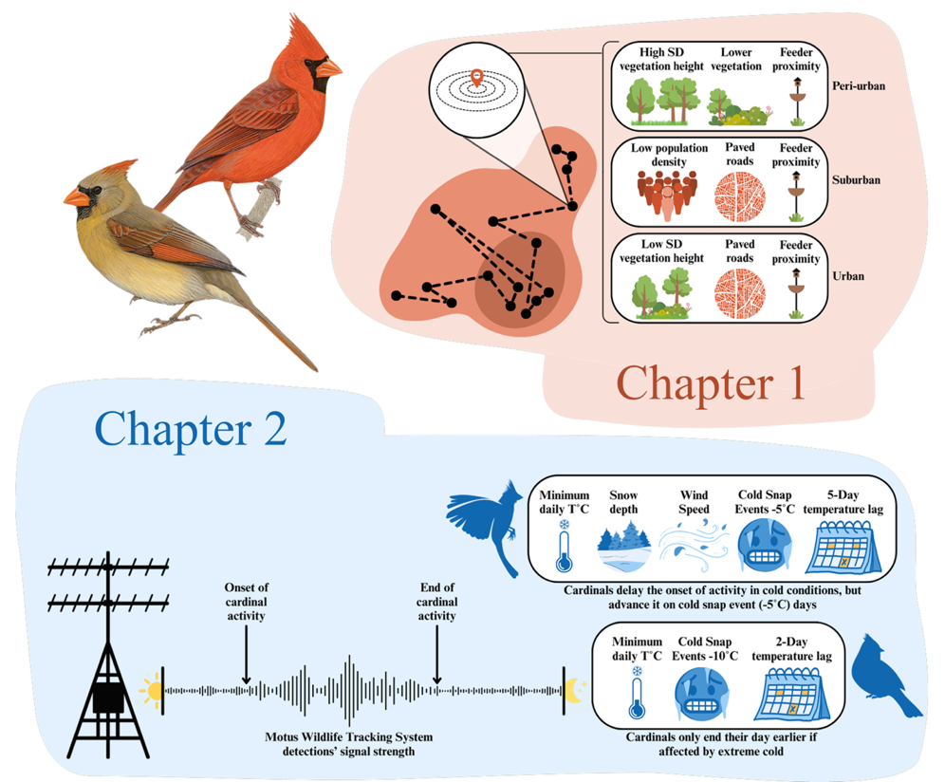
Figure 6. Summary of the methods and findings for both chapter of this thesis. Cardinal illustration credit: Brian Small.

In chapter 1, I studied how northern cardinals use urban green spaces during the winter season, using manual VHF telemetry tracking, across an urbanization gradient during three consecutive years. I paired recorded GPS locations with open source, remote sensing datasets to determine which habitat variables were the cardinals associated to the most at each study site, along with the scale at which this association was made. In the peri-urban site, cardinals were associated to their habitat at a 50 meters scale, while at the suburban and urban site this association occurred at a 25 meters scale. Cardinals spending the winter in the urban site also showed larger total home ranges compared to cardinals staying at the peri-urban site. In terms of habitat association, cardinals at the peri-urban site were more likely to be found in areas with overall lover vegetation with a high vertical contrast and near bird feeders. The cardinals at both the suburban and urban site were more likely to be present in areas with roads and bird feeders, and while the cardinals in the suburban site avoided densely populated areas, the birds at the urban site avoided highly contrasted vertical vegetation areas.

In chapter 2, I focused on the effect of temperature and weather conditions on the cardinals’ onset and end of daily activities, using automated receiver stations continuously recording the signal strength of the same radio tags (and thus individuals) I deployed in chapter 1. Northern cardinals’ onset timing was delayed in colder conditions, except on days when cold snap events of at least -5 ˚C occur (resulting in an unexpected advance of their daily activity onset). In contrast, cardinals’ cessation of activity only significantly advanced when extreme cold snap events of at least -10 ˚C occurred.

Both of my thesis chapter are connected by the role that temperature and urban structure play in influencing daily activities and space use of cardinals in winter (Adam et al., 2015; Deshpande et al., 2022; Jorde et al., 1984). I have demonstrated that cardinals essentially preferred using green spaces offering lower vegetation cover and proximity to bird feeders. I have also shown that cardinals in urban areas present larger total home ranges, compared to peri-urban counterparts which aligns with other research that found larger home ranges for birds in urban areas (Dunn et al., 2021; Humbird & Neudorf, 2008), but is in opposition with others that found smaller home ranges (O’Donnell & delBarco-Trillo, 2020; Vangestel et al., 2010). When examining the timing of daily activity, specifically the onset and end patterns, I demonstrated that cold temperatures delayed the onset of activity, but that the cessation of activity would only be delayed under extremely cold conditions. Numerous studies have established that, in general, animals tend to delay the onset of daily activities when subjected to cold temperatures, or sudden temperature drops, mainly to avoid the costs of being active during the coldest period of the day (just before sunrise) (Gjerde & Wegge, 1987; Gonnerman et al., 2023; Taff & Shipley, 2023). However, I demonstrated in chapter 2 that cardinals actually advanced the onset of their daily activities during cold snap events of -5 ˚C or below, which would align with other research suggesting that overnight conditions may sometimes force animals to forage early in the morning, despite the increased exposure to cold (Bednekoff & Houston, 1994; Broggi et al., 2007; P. R. Evans, 1969; Madsen et al., 2021). I recognize, however, that the results I produced through both of these chapters only represents a small portion of the multitude of variables that may interact to influence cardinal’s survival and habitat association across the urban landscape (Buron et al., 2022; Jokimäki et al., 2022; Kristan et al., 2007; Marzluff et al., 2007). I also acknowledge that both chapters focus on a limited sample size (although covering almost 21 months of fieldwork), and that observed habitat association and weather effect cannot be generalized to the entire species. Future research could investigate cardinals’ movement and habitat use on a broader urbanization gradient to help confirm if the associations and daily activity’s timing are consistent, and clarify the impact of local habitat conditions

Limitations, methods and future directions
An important limitation that should be address relates to the translocation of the cardinals to their new wintering sites. Some studies report effects of translocation on birds (e.g. translocated breeding pairs of pied flycatchers (Ficedula hypoleuca) resulted in an extension of four days between the arrival and egg laying; Burger & Both, 2011), while others haven’t found effects on the birds’ movements upon release (e.g. translocated norther bobwhites did not impact their home ranges, mean daily movements or distance moved from the trap upon release; Terhune et al., 2006). Although the duration of the tracking period (approximately eight months) likely reduced the effects of novelty from translocation, I recognize that we cannot exclude the possibility that short-term behavioural adjustments made early on in the study (specifically for in chapter 1), may have influenced movement data collected during this unknown adjustment period. It’s important to also acknowledge that in chapter 2, thermoregulatory strategies were inferred from the timing of daily activities (onset and end), rather than through direct physiological measurements (e.g. body temperature, metabolic rate or fat reserves). Given the fragility of small songbirds—particularly in winter—we opted for this indirect approach to minimize stress on the animals, and to avoid the logistical challenges that would have been associated with collecting physiological variables in cold conditions. Previous studies support this principle, showing that activity can serve as a proxy to investigate energy management strategies (Polansky et al., 2013; Rowcliffe et al., 2014; Weathers & Sullivan, 1993).

In the context of our study, a deeper investigation of effects of tagging on the cardinals was logistically difficult. However, we were able to gather some information through birds that ended up being recaptured at our peri-urban site (McGill Bird Observatory banding station). On the few occasions that winter banding was conducted, we noted ~4 recaptured individuals that showed no apparent effect of the radio tags (the devices were still well placed, no apparent feather loss, no skin irritation or physical markings). However, we did notice that two recaptured cardinals showed feather loss around the leg elastic loops and on their backs (Figure 7). One individual recaptured in May 2024 (tagged in October 2023; Figure 7a showed what seemed to be an accumulation of oil and dirt on the inside of the birds’ thighs on the elastic loops (Figure 7a). The bird did not have any open wounds from the tag or the accumulated oil, but did show signs of skin irritations. Another individual recaptured in August 2025 (tagged in October 2024; figure 7, B) did not present these oily aggregations, but we did see potential early signs of those accumulations forming, along with significant feather absence on its back and around both thighs (figure 7, B). The bander in charge also noted that the elastic loops were extremely loose (most probably due to normal wear), and the bird was able to “flip” the tag on its back and peck at it, which is probably what caused the feather loss. Again, this individual did not present any open wounds, but in both cases, the absence of feathers around the radio tag harness may be of concern if the birds are not able to grow back feathers in time before the winter season (indicating potential insulation and thermoregulatory issues). Future studies could investigate the effects of tags mounted using figure eight harnesses on resident birds through both the winter and summer time, to reveal any season-specific effects.

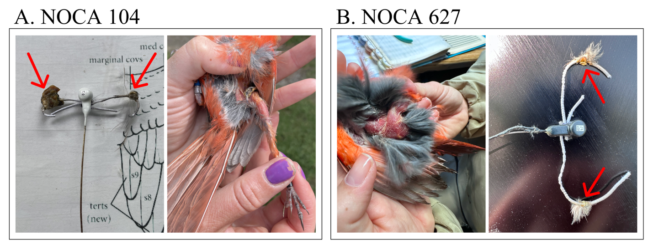Figure 7. Physical effect of radio tags fitted using a figure eight harness method on two male cardinals (A. NOCA 104 tagged in October 2023 and recaptured in May 2024; B. NOCA 627 tagged in October 2024 and recaptured in August 2025). Arrows are pointing the oily accumulations on the elastic loops of the tags’ harness. Photo credit: A. Anne-Marie Cousineau; B. Shawna Sevigny.

Working with the Motus Wildlife Tracking System provides substantial advantages for studying both fine- and large-scale movements of small birds, allowing for remote, automated detections or precise manual tracking across extended spatial and temporal scales without needing to recapture individuals (Blondin et al., 2025; Boyd et al., 2025; Korpi et al., 2025). This is especially handy in urban environments, where birds are most likely in private properties’ backyards, making recapture logistically challenging. Signal interference from buildings, vehicles and electronic devices can reduce the detection range and reliability of automated receiver stations and handheld receiver devices, although to different degree (Taylor et al., 2017). When conducting manual tracking using the hand-held receiver, we were able to avoid most of the issues with interference by simply moving to another location or adjusting the gain however, permanent receiver stations cannot be moved around to avoid interference, making it harder to avoid especially in the urban setting. In our study, some individuals appeared to “vanish” from the network, sometime as soon as the day of their release, sometimes a few months after release. In this context, it’s very difficult to determine if the absence of a signal was the result of tag failure, mortality or movement beyond the covered range. Nonetheless, through my research I have shown that using radio telemetry as a mean to generate quality, fine-scale data on songbirds’ movements in the city over extensive periods of time is possible (but still requiring a significant investment in time and energy from the researcher). Moreover, due to restricted access in many areas, we were often constrained to recording GPS locations along roads or sidewalks. To minimize potential habitat association bias from these constraints, I shifted the position of all the recorded detections using the gain setting at which the point was recorded (indicator of distance) and the antenna orientation (between 0˚ and 360˚) so that every detection was at its “true” position before running all the analyses. I am confident that these precautions helped reduce potential spatial bias, although they also underscore the complexity of using both automated and hand-held tracking devices in urban areas.

My thesis brings new insights into how northern cardinals use urban green spaces in winter and adjust their daily activity in response to temperature variation, but it also highlights key limitations and unanswered questions. Building on this foundation, several promising avenues for future research could deepen our knowledge of urban winter ecology and improve the effectiveness of conservation efforts in urban areas.
- Expand tracking across seasons to understand year-round behavioural strategies.
  - Investigating movements of cardinals across their entire annual cycle could allow us to investigate how winter energy management strategies differ from summertime, or how it correlates with breeding behaviour, territorial fidelity and survival. Multi-season tracking could provide answers as to how cardinals shift their strategies according to environmental demands.
- Address signal loss and detection interference with the Motus Wildlife Tracking System in urban areas.
  - In our study, we did face some challenges with deployed tags “vanishing” and strong interference areas potentially preventing us from detecting radio tags in the vicinity. To improve data reliability and reduce the proportion of these unexplained “disappearances” future studies could try to quantify thresholds of interference where tags are no longer detected, along with realistic ranges of detections in urban areas and compare that to what can be measured in a city.
- Investigate individual- and site-level variation in behaviour.
  - Our study did look into variation across site in chapter 1 but didn’t get to go deeper into individual differences. On the opposite, in chapter 2, we showed that there are significant individual differences in the way cardinals adjust their daily activities, but we did not investigate site differences. Future studies could assess repeatability of onset and end timing across winters for the same individuals, or explore whether individuals exhibit consistent thermoregulatory “types”

Thesis conclusion
Urbanization was, and is still, one of the key drivers of biodiversity loss, through habitat fragmentation and destruction, pollution of local ecosystems and disturbances like noise and artificial lighting at night (Christian, 2023; Grimm et al., 2008). Canada’s most biodiverse regions are also the most built-up and as such, understanding how birds’ use and move across urban green spaces in the demanding winter season is a key step to move towards biodiversity-friendly nature management practices (Deguise & Kerr, 2006; Kraus & Hebb, 2020). In my thesis, I used VHF telemetry to investigate the movements and association to urban green spaces’ features by northern cardinals at different spatial scales along an urbanization gradient. I demonstrated that cardinals spending winter in the urban site had larger total home ranges compared to their peri-urban counterparts, and that cardinals are associated to habitat features at different spatial scale in a peri-urban site (50 m radius) compared to urbanized sites (suburban and urban: 25 m radius). I also showed that cardinals are associated to different habitat variables according to the urbanization level of the site they’re wintering in, with a strong association to bird feeders across all three study sites. As for winter daily activities, I demonstrated that northern cardinal’s timing of both the onset and end of activity is influenced by both climatic conditions and extreme weather events (onset: 5-day mean temperature lag and -5˚C cold snap events; end: 2-day mean temperature lag and -10 ˚C cold snap events) also affected their daily activities. To complement this thesis, investigating how cardinals use urban green spaces during the summer, could provide a valuable addition to our knowledge of resident bird species’ full annual cycle, and how urban green spaces may provide different benefits or resources at different times of the year.

Supplemental material
Table S1. Model ranking using AICc of generalized linear mixed models (GLM) with a comparing scale of effect of landscape variables for resighting locations (n= 57) the northern cardinals tracked across three sites in Montreal, Quebec, Canada.
Study site | Model | Variables | LL | Δ AICc | Wt
McGill Bird Observatory (peri-urban) | 25 meters  50 meters  100 meters  200 meters | Mean vegetation height + sd vegetation height + mean population density + road length + distance to nearest feeder | -722.48  -713.97  -735.69  -740.60 | 17.02  0.00  53.25  46.96 | 0.00  1.00  0.00  0.00
Town of Baie d’Urfé (suburban) | 25 meters  50 meters  100 meters  200 meters | Mean vegetation height + sd vegetation height + mean population density + road length + distance to nearest feeder | -296.05  -338.31  -344.25  -349.92 | 0.00  84.52  96.39  107.73 | 1.00  0.00  0.00  0.00
Concordia University (dense urban) | 25 meters  50 meters  100 meters  200 meters | Mean vegetation height + sd vegetation height + mean population density + road length + distance to nearest feeder | -211.09  -225.64  -224.02  -228.79 | 0.00  29.11  25.85  35.40 | 1.00  0.00  0.00  0.00
Study site | Model | Variables | AICc
McGill Bird Observatory (peri-urban) | Full  Vegetation height  Vegetation sd  Human  Null | Mean vegetation height + sd vegetation height + mean population density + road length + distance to nearest feeder + (1|Winter) + (1|ID) + (1|Site)  Mean vegetation height+ (1|Winter) + (1|ID) + (1|Site)  Sd vegetation height+ (1|Winter) + (1|ID) + (1|Site)  Mean population density + road length + distance to nearest feeder+ (1|Winter) + (1|ID) + (1|Site)  (1|Winter) + (1|ID) + (1|Site) | 1443.696  1587.124  1596.077  1588.262  1616.101
Town of Baie d’Urfé (suburban) | Full  Vegetation height  Vegetation sd  Human  Null | Mean vegetation height + sd vegetation height + mean population density + road length + distance to nearest feeder + (1|Winter) + (1|ID) + (1|Site)  Mean vegetation height+ (1|Winter) + (1|ID) + (1|Site)  Sd vegetation height+ (1|Winter) + (1|ID) + (1|Site)  Mean population density + road length + distance to nearest feeder+ (1|Winter) + (1|ID) + (1|Site)  (1|Winter) + (1|ID) + (1|Site) | 631.7501  728.0640  724.0187  632.1451  726.1005
Concordia University (dense urban) | Full  Vegetation height  Vegetation sd  Human  Null | Mean vegetation height + sd vegetation height + mean population density + road length + distance to nearest feeder + (1|Winter) + (1|ID) + (1|Site)  Mean vegetation height+ (1|Winter) + (1|ID) + (1|Site)  Sd vegetation height+ (1|Winter) + (1|ID) + (1|Site)  Mean population density + road length + distance to nearest feeder+ (1|Winter) + (1|ID) + (1|Site)  (1|Winter) + (1|ID) + (1|Site) | 444.7050  486.6402  485.2496  447.8691  484.8853
Table S2. AIC values used to determine the best fitting model to explain cardinal’s habitat associations.
Table S3. Model ranking using AICc of generalized additive models (GAMs) with a comparing scale of effect of temperature lag for northern cardinals (n= 64) tracked across three sites in Montreal, Quebec, Canada between 2022 and 2025.
Activity period | Model | Variables | AIC | Δ AICc | Wt
Onset | No lag  1-day lag  2-day lag  3-day lag  4-day lag  5-day lag  Null | Minimum temperature + log(Precipitations) + Snow on the ground + Maximum speed of wind gust  Minimum temperature + Mean lag 1 + log(Precipitations) + Snow on the ground + Maximum speed of wind gust  Minimum temperature + Mean lag 2 + log(Precipitations) + Snow on the ground + Maximum speed of wind gust  Minimum temperature + Mean lag 3 + log(Precipitations) + Snow on the ground + Maximum speed of wind gust  Minimum temperature + Mean lag 4 + log(Precipitations) + Snow on the ground + Maximum speed of wind gust  Minimum temperature + Mean lag 5 + log(Precipitations) + Snow on the ground + Maximum speed of wind gust  Only random effects | 26753.43  26749.10  26741.93  26736.89  26734.24  26733.69  26867.95 | 19.74  15.41  8.24  3.20  0.55  0.00  134.26 | 0.00  0.00  0.00  0.00  0.00  1.00  0.00
End | No lag  1-day lag  2-day lag  3-day lag  4-day lag  5-day lag  Null | Minimum temperature + log(Precipitations) + Snow on the ground + Maximum speed of wind gust  Minimum temperature + Mean lag 1 + log(Precipitations) + Snow on the ground + Maximum speed of wind gust  Minimum temperature + Mean lag 2 + log(Precipitations) + Snow on the ground + Maximum speed of wind gust  Minimum temperature + Mean lag 3 + log(Precipitations) + Snow on the ground + Maximum speed of wind gust  Minimum temperature + Mean lag 4 + log(Precipitations) + Snow on the ground + Maximum speed of wind gust  Minimum temperature + Mean lag 5 + log(Precipitations) + Snow on the ground + Maximum speed of wind gust  Only random effects | 24024.54  24005.69  23965.94  24007.50  24018.26  24019.82  24090.85 | 58.60  39.76  0.00  41.57  52.33  53.89  124.92 | 0.00  0.00  1.00  0.00  0.00  0.00  0.00

Table S4. Model ranking using AICc of generalized additive models (GAMs) with a comparing scale of effect of cold snap events for northern cardinals (n= 64) tracked across three sites in Montreal, Quebec, Canada between 2022 and 2025.
Activity period | Model | Variables | AIC | Δ AICc | Wt
Onset | No snap  -5˚C snap  -7˚C snap  -10˚C snap  Null | Minimum temperature + log(Precipitations) + Snow on the ground + Maximum speed of wind gust  Minimum temperature + log(Precipitations) + Snow on the ground + Maximum speed of wind gust + Cold snap -5  Minimum temperature + log(Precipitations) + Snow on the ground + Maximum speed of wind gust + Cold snap -7  Minimum temperature + log(Precipitations) + Snow on the ground + Maximum speed of wind gust + Cold snap -10  Only random effect variables | 26768.80  26761.39  26766.92  26770.65  26873.30 | 7.41  0.00  5.53  9.27  111.92 | 0.00  1.00  0.00  0.00  0.00
End | No snap  -5˚C snap  -7˚C snap  -10˚C snap  Null | Minimum temperature + log(Precipitations) + Snow on the ground + Maximum speed of wind gust  Minimum temperature + log(Precipitations) + Snow on the ground + Maximum speed of wind gust + Cold snap -5  Minimum temperature + log(Precipitations) + Snow on the ground + Maximum speed of wind gust + Cold snap -7  Minimum temperature + log(Precipitations) + Snow on the ground + Maximum speed of wind gust + Cold snap -10  Only random effect variables | 24095.99  24088.47  24097.29  24085.50  24106.95 | 10.49  2.97  11.80  0.00  21.46 | 0.00  0.00  0.00  1.00  0.00

References

Adam, M., Musilová, Z., Musil, P., Zouhar, J., & Romportl, D. (2015). Long-Term Changes in Habitat Selection of Wintering Waterbirds: High Importance of Cold Weather Refuge Sites. Acta Ornithologica, 50(2), 127–138. https://doi.org/10.3161/00016454AO2015.50.2.001
Altwegg, R., Jenkins, A., & Abadi, F. (2014). Nestboxes and immigration drive the growth of an urban Peregrine Falcon Falco peregrinus population. Ibis, 156(1), 107–115. https://doi.org/10.1111/ibi.12125
Andreev, A. V. (1999). Energetics and survival of birds in extreme environments. Ostrich, 70(1), 13–22. https://doi.org/10.1080/00306525.1999.9639745
Anich, N. M., Benson, T. J., & Bednarz, J. C. (2009). Effect of radio transmitters on return rates of Swainson’s Warblers. Journal of Field Ornithology, 80(2), 206–211. https://doi.org/10.1111/j.1557-9263.2009.00210.x
Ausprey, I. J., & Rodewald, A. D. (2011). Postfledging Survivorship and Habitat Selection Across A Rural-To-Urban Landscape Gradient. The Auk, 128(2), 293–302. https://doi.org/10.1525/auk.2011.10158
Barron, D. G., Weatherhead, P. J., & Brawn, J. D. (2013). A Test of Radio-Transmitter Effects on Parental Investment and Productivity in the Northern Cardinal. The Condor, 115(3), 669–676. https://doi.org/10.1525/cond.2013.120149
Beauchamp, A. T., Guglielmo, C. G., & Morbey, Y. E. (2020). Stopover refuelling, movement and departure decisions in the white-throated sparrow: The influence of intrinsic and extrinsic factors during spring migration. Journal of Animal Ecology, 89(11), 2553–2566. https://doi.org/10.1111/1365-2656.13315
Beddall, B. (1963). Range Expansion of the Cardinal and Other Birds in the Northeastern States. The Wilson Bulletin, 75(2), 140–158.
Bednekoff, P. A., & Houston, A. I. (1994). Optimizing Fat Reserves over the Entire Winter: A Dynamic Model. Oikos, 71(3), 408. https://doi.org/10.2307/3545828
Benson, E. S. (2017). A Centrifuge of Calculation: Managing Data and Enthusiasm in Early Twentieth-Century Bird Banding. Osiris, 32(1), 286–306. https://doi.org/10.1086/694172
Bissonette, J. A. (1978). The Influence of Extremes of Temperature on Activity Patterns of Peccaries. The Southwestern Naturalist, 23(3), 339. https://doi.org/10.2307/3670240
Blackport, R. (2024). Amplified warming of North American cold extremes linked to human-induced changes in temperature variability. 15(5864). https://doi.org/10.1038/s41467-024-49734-8
Blem, C. R. (1975). GEOGRAPHIC VARIATION IN WING-LOADING OF THE HOUSE SPARROW. The Wilson Bulletin, 87(4).
Blondin, A. L., Drever, M. C., Flemming, S. A., Easton, W. E., Maftei, M., Zharikov, Y., Warnock, N., & Nol, E. (2025). Lengths of Stay and Stopover Strategies of Western Sandpipers During Migration at Two Sites in British Columbia, Canada. Ecology and Evolution, 15(1), e70739. https://doi.org/10.1002/ece3.70739
Bodey, T. W., Cleasby, I. R., Bell, F., Parr, N., Schultz, A., Votier, S. C., & Bearhop, S. (2018). A phylogenetically controlled meta-analysis of biologging device effects on birds: Deleterious effects and a call for more standardized reporting of study data. Methods in Ecology and Evolution, 9(4), 946–955. https://doi.org/10.1111/2041-210X.12934
Bonter, D. N., Zuckerberg, B., Sedgwick, C. W., & Hochachka, W. M. (2013). Daily foraging patterns in free-living birds: Exploring the predation–starvation trade-off. Proceedings of the Royal Society B: Biological Sciences, 280(1760), 20123087. https://doi.org/10.1098/rspb.2012.3087
Bosco, L., Otterbeck, A., Fransson, T., Lindén, A., Piha, M., & Lehikoinen, A. (2023). Increasing winter temperatures explain body size decrease in wintering bird populations of Northern Europe—But response patterns vary along the spatioclimatic gradient. Global Ecology and Biogeography, 32(12), 2100–2110. https://doi.org/10.1111/geb.13754
Boyd, B. P., Hayes, S. M., Migotto, A. A., & Stutchbury, B. J. M. (2025). Age-related differences in fall migration timing and performance of juvenile and adult Wood Thrushes departing from a breeding site. Movement Ecology, 13(1), 32. https://doi.org/10.1186/s40462-025-00556-3
Bressler, S. A., Diamant, E. S., Tingley, M. W., & Yeh, P. J. (2020). Nests in the cities: Adaptive and non-adaptive phenotypic plasticity and convergence in an urban bird. Proceedings of the Royal Society B: Biological Sciences, 287(1941), 20202122. https://doi.org/10.1098/rspb.2020.2122
Brewer, Gehring, T. M., Garcia, M. M., Shirkey, B. T., Simpson, J. W., & Fournier, A. M. V. (2023). King rail (Rallus elegans) home range and microhabitat characteristics in western Lake Erie coastal marshes. Ecology and Evolution, 13(4), 16. https://doi.org/10.1002/ece3.10043
Brewer, V., Lane, S. J., Sewall, K. B., & Mabry, K. E. (2020). Effects of low-density urbanization on genetic structure in the Song Sparrow. PLOS ONE, 15(6), e0234008. https://doi.org/10.1371/journal.pone.0234008
Brodin, A. (2007). Theoretical models of adaptive energy management in small wintering birds. Philosophical Transactions of the Royal Society B: Biological Sciences, 362(1486), 1857–1871. https://doi.org/10.1098/rstb.2006.1812
Brodin, A., Nilsson, J.-Å., & Nord, A. (2017). Adaptive temperature regulation in the little bird in winter: Predictions from a stochastic dynamic programming model. Oecologia, 185(1), 43–54. https://doi.org/10.1007/s00442-017-3923-3
Broggi, J., Hohtola, E., Koivula, K., Orell, M., Thomson, R. L., & Nilsson, J. ‐Å. (2007). Sources of variation in winter basal metabolic rate in the great tit. Functional Ecology, 21(3), 528–533. https://doi.org/10.1111/j.1365-2435.2007.01255.x
Burger, C., & Both, C. (2011). Translocation as a Novel Approach to Study Effects of a New Breeding Habitat on Reproductive Output in Wild Birds. PLoS ONE, 6(3), e18143. https://doi.org/10.1371/journal.pone.0018143
Burnham, K. P., & Anderson, D. R. (2002). Model Selection and Multimodel Inference (2nd ed.).
Buron, R., Hostetler, M. E., & Andreu, M. (2022). Urban forest fragments vs residential neighborhoods: Urban habitat preference of migratory birds. Landscape and Urban Planning, 227, 104538. https://doi.org/10.1016/j.landurbplan.2022.104538
Buxton, R. T., Hudgins, E. J., Lavigne, E., Villeneuve, P. J., Prince, S. A., Pearson, A. L., Halsall, T., Robichaud, C., & Bennett, J. R. (2024). Mental health is positively associated with biodiversity in Canadian cities. Communications Earth & Environment, 5(1), 310. https://doi.org/10.1038/s43247-024-01482-9
Cabrera-Cruz, S. A., Smolinsky, J. A., & Buler, J. J. (2018a). Light pollution is greatest within migration passage areas for nocturnally-migrating birds around the world. Scientific Reports, 8(1), 3261. https://doi.org/10.1038/s41598-018-21577-6
Cabrera-Cruz, S. A., Smolinsky, J. A., & Buler, J. J. (2018b). Light pollution is greatest within migration passage areas for nocturnally-migrating birds around the world. Scientific Reports, 8(1), 3261.
Calenge, C. (2024). adehabitatHR: Home Range Estimation [Computer software].
Callaghan, C. T., Cornwell, W. K., Poore, A. G. B., Benedetti, Y., & Morelli, F. (2021). Urban tolerance of birds changes throughout the full annual cycle. Journal of Biogeography, 48(6), 1503–1517. https://doi.org/10.1111/jbi.14093
Carrasco, L., Giam, X., Papeş, M., & Sheldon, K. S. (2019). Metrics of Lidar-Derived 3D Vegetation Structure Reveal Contrasting Effects of Horizontal and Vertical Forest Heterogeneity on Bird Species Richness. Remote Sensing, 11(7), Article 7. https://doi.org/10.3390/rs11070743
Chen, D., & Hale, R. C. (2010). A global review of polybrominated diphenyl ether flame retardant contamination in birds. Environment International, 36(7), 800–811. https://doi.org/10.1016/j.envint.2010.05.013
Chiron, F., Lorrillière, R., Bessa-Gomes, C., Tryjanowski, P., Casanelles-Abella, J., Laanisto, L., Leal, A., Van Mensel, A., Moretti, M., Muyshondt, B., Niinemets, Ü., Ortí, M. A., Pinho, P., Samson, R., & Deguines, N. (2024). How do urban green space designs shape avian communities? Testing the area–heterogeneity trade-off. Landscape and Urban Planning, 242, 104954. https://doi.org/10.1016/j.landurbplan.2023.104954
Chong, K. Y., Teo, S., Kurukulasuriya, B., Chung, Y. F., Rajathurai, S., & Tan, H. T. W. (2014). Not all green is as good: Different effects of the natural and cultivated components of urban vegetation on bird and butterfly diversity. Biological Conservation, 171, 299–309. https://doi.org/10.1016/j.biocon.2014.01.037
Christian, H.-M. (2023). The Main Drivers of Biodiversity Loss: A Brief Overview. Journal of Ecology & Natural Resources, 7(3). https://doi.org/10.23880/jenr-16000346
City of Montreal. (2024). Plan climat 2020-2030 Ville de Montréal—État d’avancement avril 2024. City of Montreal. https://mtl.ged.montreal.ca/constellio/?collection=mtlca&portal=REPDOCVDM#!displayDocument/00000092918
Clergeau, P., Croci, S., Jokimäki, J., Kaisanlahti-Jokimäki, M.-L., & Dinetti, M. (2006). Avifauna homogenisation by urbanisation: Analysis at different European latitudes. Biological Conservation, 127(3), 336–344. https://doi.org/10.1016/j.biocon.2005.06.035
Cox, D. T. C., Shanahan, D. F., Hudson, H. L., Plummer, K. E., Siriwardena, G. M., Fuller, R. A., Anderson, K., Hancock, S., & Gaston, K. J. (2017). Doses of Neighborhood Nature: The Benefits for Mental Health of Living with Nature. BioScience, 67(2), 147–155. https://doi.org/10.1093/biosci/biw173
Craighead, F., & Dunstan, T. (1976). Progress Toward Tracking Migrating Raptors by Satellite. 10(4), 112–119.
Cull, C. A., Guest, M. J., Frei, B., & Ziter, C. D. (2025). Human recreational activity does not influence open cup avian nest survival in urban green spaces. Urban Ecosystems, 28(2), 24. https://doi.org/10.1007/s11252-024-01669-0
Cunningham, S. J., Gardner, J. L., & Martin, R. O. (2021). Opportunity costs and the response of birds and mammals to climate warming. Frontiers in Ecology and the Environment, 19(5), 300–307. https://doi.org/10.1002/fee.2324
Dale, S. (2018). Urban bird community composition influenced by size of urban green spaces, presence of native forest, and urbanization. Urban Ecosystems, 21(1), 1–14. https://doi.org/10.1007/s11252-017-0706-x
Davies, S., Beck, M. L., & Sewall, K. B. (2018). Territorial aggression in urban and rural Song Sparrows is correlated with corticosterone, but not testosterone. Hormones and Behavior, 98, 8–15. https://doi.org/10.1016/j.yhbeh.2017.11.010
Dawson, W. R., Marsh, R. L., & Yacoe, M. E. (1983). Metabolic adjustments of small passerine birds for migration and cold. 245(6), R755–R767. https://doi.org/10.1152/ajpregu.1983.245.6.R755
DeCandido, R., & Allen, D. (2006). NOCTURNAL HUNTING BY PEREGRINE FALCONS AT THE EMPIRE STATE BUILDING, NEW YORK CITY. The Wilson Journal of Ornithology, 118(1), 53–58. https://doi.org/10.1676/1559-4491(2006)118%255B0053:NHBPFA%255D2.0.CO;2
Deguise, I. E., & Kerr, J. T. (2006). Protected Areas and Prospects for Endangered Species Conservation in Canada. Conservation Biology, 20(1). https://conbio.onlinelibrary.wiley.com/doi/10.1111/j.1523-1739.2005.00274.x
Deppe, J. L., & Rotenberry, J. T. (2008). SCALE-DEPENDENT HABITAT USE BY FALL MIGRATORY BIRDS: VEGETATION STRUCTURE, FLORISTICS, AND GEOGRAPHY. Ecological Monographs, 78(3), 461–487. https://doi.org/10.1890/07-0163.1
Deshpande, P., Lehikoinen, P., Thorogood, R., & Lehikoinen, A. (2022). Snow depth drives habitat selection by overwintering birds in built‐up areas, farmlands and forests. Journal of Biogeography, 49(4), 630–639. https://doi.org/10.1111/jbi.14326
DeVries, M. S., & Jawor, J. M. (2013). Natural variation in circulating testosterone does not predict nestling provisioning rates in the northern cardinal, Cardinalis cardinalis. Animal Behaviour, 85(5), 957–965. https://doi.org/10.1016/j.anbehav.2013.02.019
Dinh, K. V., Albini, D., Orr, J. A., Macaulay, S. J., Rillig, M. C., Borgå, K., & Jackson, M. C. (2023). Winter is coming: Interactions of multiple stressors in winter and implications for the natural world. Global Change Biology, 29(24), 6834–6845. https://doi.org/10.1111/gcb.16956
Dunn, J. C., Morris, A. J., Grice, P. V., & Peach, W. J. (2021). Effects of seed-rich habitat provision on territory density, home range and breeding performance of European Turtle Doves Streptopelia turtur. Bird Conservation International, 31(4), 620–639. https://doi.org/10.1017/S0959270920000635
Dupras, J., & Alam, M. (2015). Urban Sprawl and Ecosystem Services: A Half Century Perspective in the Montreal Area (Quebec, Canada). Journal of Environmental Policy & Planning, 17(2), 180–200. https://doi.org/10.1080/1523908X.2014.927755
Duren, A. M., Williams, C. K., & D’amico, V. (2017). Microhabitat Factors Associated with Occupancy of Songbirds in Suburban Forest Fragments in the Eastern United States. The American Midland Naturalist, 178(2), 189–202. https://doi.org/10.1674/0003-0031-178.2.189
Elliott, J., Brogan, J., Lee, S. L., Drouillard, K. G., & Elliott, K. H. (2015). PBDEs and other POPs in urban birds of prey partly explained by trophic level and carbon source. Science of The Total Environment, 524–525, 157–165. https://doi.org/10.1016/j.scitotenv.2015.04.008
Elliott, J., Wilson, L. K., & Wakeford, B. (2005). Polybrominated Diphenyl Ether Trends in Eggs of Marine and Freshwater Birds from British Columbia, Canada, 1979−2002. Environmental Science & Technology, 39(15), 5584–5591. https://doi.org/10.1021/es050496q
Elliott, Woo, K. J., & Benvenuti, S. (2009). Do activity costs determine foraging tactics for an arctic seabird? Marine Biology, 156(9), 1809–1816. https://doi.org/10.1007/s00227-009-1214-1
Elmqvist, T., Fragkias, M., Goodness, J., Güneralp, B., Marcotullio, P. J., McDonald, R. I., Parnell, S., Schewenius, M., Sendstad, M., & Seto, K. C. (2013). Urbanization, biodiversity and ecosystem services: Challenges and opportunities: A global assessment. Springer Nature.
Environment and Climate Change Canada. (2016, December 9). Bird banding program overview [Contact us]. https://www.canada.ca/en/environment-climate-change/services/bird-banding/program-overview-contact-information.html
Environment and Climate Change Canada. (2022). Daily Weather Data Report [Dataset]. https://climate.weather.gc.ca/climate_data/daily_data_e.html?hlyRange=2008-01-08%7C2025-07-22&dlyRange=2002-12-23%7C2025-07-22&mlyRange=%7C&StationID=30165&Prov=QC&urlExtension=_e.html&searchType=stnName&optLimit=specDate&StartYear=1840&EndYear=2025&selRowPerPage=25&Line=0&searchMethod=contains&Month=7&Day=16&txtStationName=Trudeau&timeframe=2&Year=2025
Eötvös, C. B., Magura, T., & Lövei, G. L. (2018). A meta-analysis indicates reduced predation pressure with increasing urbanization. Landscape and Urban Planning, 180, 54–59. https://doi.org/10.1016/j.landurbplan.2018.08.010
Evans, B. S., Ryder, T. B., Reitsma, R., Hurlbert, A. H., & Marra, P. P. (2015). Characterizing avian survival along a rural‐to‐urban land use gradient. Ecology, 96(6), 1631–1640. https://doi.org/10.1890/14-0171.1
EVANS, P. (1966). MIGRATION AND ORIENTATION OF PASSERINE NIGHT MIGRANTS IN NORTHEAST ENGLAND. JOURNAL OF ZOOLOGY, 150, 319-+.
Evans, P. R. (1969). Winter Fat Deposition and Overnight Survival of Yellow Buntings (Emberiza citrinella L.). The Journal of Animal Ecology, 38(2), 415. https://doi.org/10.2307/2781
Ferns, P. N., Macalpine-Leny, I. H., & Goss-Custard, J. D. (1980). Telemetry of Heart Rate as a Possible Method of Estimating Energy Expenditure in the Redshank Tringa totanus (L.). In A Handbook on Biotelemetry and Radio Tracking (pp. 595–601). Elsevier. https://doi.org/10.1016/B978-0-08-024928-5.50077-4
Fidino, M., Gallo, T., Lehrer, E. W., Murray, M. H., Kay, C. A. M., Sander, H. A., MacDougall, B., Salsbury, C. M., Ryan, T. J., Angstmann, J. L., Amy Belaire, J., Dugelby, B., Schell, C. J., Stankowich, T., Amaya, M., Drake, D., Hursh, S. H., Ahlers, A. A., Williamson, J., … Magle, S. B. (2021). Landscape‐scale differences among cities alter common species’ responses to urbanization. Ecological Applications, 31(2), e02253. https://doi.org/10.1002/eap.2253
Filion, P., Bunting, T., Pavlic, D., & Langlois, P. (2010). Intensification and Sprawl: Residential Density Trajectories in Canada’s Largest Metropolitan Regions. Urban Geography, 31(4), 541–569. https://doi.org/10.2747/0272-3638.31.4.541
Filliater, T. S., Breitwisch, R., & Nealen, P. M. (1994). Predation on Northern Cardinal Nests: Does Choice of Nest Site Matter? The Condor: Ornithological Applications, 96(3), 761–768. https://doi.org/10.2307/1369479
Fink, D., Auer, T., Johnston, A., Strimas-Mackey, M., Ligocki, S., Robinson, O., Hochachka, W., Jaromczyk, L., Crowley, C., Dunham, K., Stillman, A., Davis, C., Stokowski, M., Ruiz-Gutierrez, V., Wood, C., & Rodewald, A. (2025). eBird Status and Trends, Data Version 2023 [Dataset]. Cornell Lab of Ornithology. https://doi.org/10.2173/WZTW8903
Frei, B., Morales, A., Cousineau, A.-M., & Beauchamp, A. (2024). Montreal Northern Cardinal Winter Movements (Project 882) [Dataset]. Motus Wildlife Tracking System, Birds Canada. https://motus.org/
Fristoe, T. S. (2015). Energy use by migrants and residents in North American breeding bird communities. Global Ecology and Biogeography, 24(4), 406–415. https://doi.org/10.1111/geb.12262
Fritts, R. (2022, May 16). Avian Superhighways: The Four Flyways of North America. American Bird Conservancy. https://abcbirds.org/blog/north-american-bird-flyways/
Fuller, M. R., Millspaugh, J. J., Church, K. E., & Kenward, R. E. (2005). Wildlife radiotelemetry. Techniques for Wildlife Investigations and Management. Sixth Edition. The Wildlife Society, Bethesda, Maryland, USA, 377–417.
Furberg, D., & Ban, Y. (2008). Satellite Monitoring of Urban Sprawl and Assessing the Impact of Land-Cover Changes in the Greater Toronto Area. The XXI Congress of ISPRS. Beijing, China. 3-11 July 2008.
Gahbauer, M. A., Duval, S., & Davey, D. (2015). McGill Bird Observatory Annual Program Report 2014.
Gjerde, I., & Wegge, P. (1987). Activity patterns of Capercaillie, Tetrao urogallus, during winter. Ecography, 10(4), 286–293. https://doi.org/10.1111/j.1600-0587.1987.tb00770.x
Gómez, J., Michelson, C. I., Bradley, D. W., Ryan Norris, D., Berzins, L. L., Dawson, R. D., & Clark, R. G. (2014). Effects of geolocators on reproductive performance and annual return rates of a migratory songbird. Journal of Ornithology, 155(1), 37–44. https://doi.org/10.1007/s10336-013-0984-x
Gonnerman, M., Shea, S. A., Sullivan, K., Kamath, P., Overturf, K., & Blomberg, E. (2023). Dynamic winter weather moderates movement and resource selection of wild turkeys at high‐latitude range limits. Ecological Applications, 33(1), e2734. https://doi.org/10.1002/eap.2734
Gordo, O., Brotons, L., Herrando, S., & Gargallo, G. (2021). Rapid behavioural response of urban birds to COVID-19 lockdown. Proceedings of the Royal Society B: Biological Sciences, 288(1946), 20202513. https://doi.org/10.1098/rspb.2020.2513
Government of Canada. (2018, November 15). Environmental Damages Fund. https://www.canada.ca/en/environment-climate-change/services/environmental-funding/programs/environmental-damages-fund.html
Government of Canada. (2020). Nature Based Climate Solutions Toolkit. Nature Canada. https://naturecanada.ca/defend-nature/how-you-help-us-take-action/nature-based-climate-solutions/toolkit/
Government of Canada, S. C. (2022a, February 9). Census Profile, 2021 Census of Population. https://www12.statcan.gc.ca/census-recensement/2021/dp-pd/prof/index.cfm?Lang=E
Government of Canada, S. C. (2022b, February 9). Profile table, Census Profile, 2021 Census of Population—Montréal, Ville (V) [Census subdivision], Quebec. https://www12.statcan.gc.ca/census-recensement/2021/dp-pd/prof/index.cfm?Lang=E
Griffin, A. S., Gapes, C., Williams, L. A., Taylor, M., Kyte, R., Little, G., & Little, J. (2025). Using motus automated telemetry to quantify habitat use and movement in a Far Eastern Curlew within the Hunter Estuary, NSW, Australia.
Grimm, N. B., Faeth, S. H., Golubiewski, N. E., Redman, C. L., Wu, J., Bai, X., & Briggs, J. M. (2008). Global Change and the Ecology of Cities. Science, 319(5864), 756–760. https://doi.org/10.1126/science.1150195
Guiden, P. W., & Orrock, J. L. (2020). Seasonal shifts in activity timing reduce heat loss of small mammals during winter. Animal Behaviour, 164, 181–192. https://doi.org/10.1016/j.anbehav.2020.04.014
Guigueno, M. F., & Fernie, K. J. (2017). Birds and flame retardants: A review of the toxic effects on birds of historical and novel flame retardants. Environmental Research, 154, 398–424. https://doi.org/10.1016/j.envres.2016.12.033
Gumilyov, L. N., Byulegenova, B. B., & Turemuratov, O. Zh. (2023). Urbanization as a global trend: Causes and consequences. 142(1), 37–42. https://doi.org/10.32523/2616-6887/2023-142-1-37-42
Guo, F., Buler, J. J., Smolinsky, J. A., & Wilcove, D. S. (2023). Autumn stopover hotspots and multiscale habitat associations of migratory landbirds in the eastern United States. Proceedings of the National Academy of Sciences, 120(3), e2203511120. https://doi.org/10.1073/pnas.2203511120
Hahs, A. K., Fournier, B., Aronson, M. F. J., Nilon, C. H., Herrera-Montes, A., Salisbury, A. B., Threlfall, C. G., Rega-Brodsky, C. C., Lepczyk, C. A., La Sorte, F. A., MacGregor-Fors, I., Scott MacIvor, J., Jung, K., Piana, M. R., Williams, N. S. G., Knapp, S., Vergnes, A., Acevedo, A. A., Gainsbury, A. M., … Moretti, M. (2023). Urbanisation generates multiple trait syndromes for terrestrial animal taxa worldwide. Nature Communications, 14(1), 4751. https://doi.org/10.1038/s41467-023-39746-1
Halkin, S. L., Shustack, D. P., DeVries, M. S., Jawor, J. M., & Linville, S. U. (2021). Northern Cardinal (Cardinalis cardinalis), version 2.0. Birds of the World. https://doi.org/10.2173/bow.norcar.02
Harris, R. B., & Fish, U. S. (1990). Tracking wildlife by satellite.
Havlíček, J., Riegert, J., & Fuchs, R. (2022). A comparison of foraging-range sizes, flight distances and foraging habitat preferences in urban and rural House Sparrow (Passer domesticus) populations. Ibis, 164(4), 1227–1242. https://doi.org/10.1111/ibi.13072
Hofman, M. P. G., Hayward, M. W., Heim, M., Marchand, P., Rolandsen, C. M., Mattisson, J., Urbano, F., Heurich, M., Mysterud, A., Melzheimer, J., Morellet, N., Voigt, U., Allen, B. L., Gehr, B., Rouco, C., Ullmann, W., Holand, Ø., Jørgensen, N. H., Steinheim, G., … Balkenhol, N. (2019). Right on track? Performance of satellite telemetry in terrestrial wildlife research. Plos One, 14(5), e0216223. https://doi.org/10.1371/journal.pone.0216223
Hope, S. F., Hopkins, W. A., & Angelier, F. (2022). Parenting in the city: Effects of urbanization on incubation behaviour and egg temperature in great tits, Parus major. Animal Behaviour, 194, 1–11. https://doi.org/10.1016/j.anbehav.2022.09.004
Horn, D. J., Johansen, S. M., & Wilcoxen, T. E. (2014). Seed and feeder use by birds in the United States and Canada. Wildlife Society Bulletin, 38(1), 18–25. https://doi.org/10.1002/wsb.365
Hosmer, D. W., & Lemesbow, S. (1980). Goodness of fit tests for the multiple logistic regression model. Communications in Statistics - Theory and Methods, 9(10), 1043–1069. https://doi.org/10.1080/03610928008827941
Humbird, S. K., & Neudorf, D. L. H. (2008). THE EFFECTS OF FOOD SUPPLEMENTATION ON EXTRATERRITORIAL BEHAVIOR IN FEMALE NORTHERN CARDINALS. The Condor, 110(2), 392–395. https://doi.org/10.1525/cond.2008.8427
Ibáñez-Álamo, J. D., Morelli, F., Benedetti, Y., Rubio, E., Jokimäki, J., Pérez-Contreras, T., Sprau, P., Suhonen, J., Tryjanowski, P., Kaisanlahti-Jokimäki, M.-L., Møller, A. P., & Díaz, M. (2020). Biodiversity within the city: Effects of land sharing and land sparing urban development on avian diversity. Science of The Total Environment, 707, 135477. https://doi.org/10.1016/j.scitotenv.2019.135477
Isaksson, C. (2018). Impact of urbanization on birds. Bird Species, 235, 257.
Iverson, A. R., Schaefer, J. L., Skalos, S. M., & Hawkins, C. E. (2023). Global positioning system (GPS) and platform transmitter terminal (PTT) tags reveal fine-scale migratory movements of small birds: A review highlights further opportunities for hypothesis-driven research. Ornithological Applications, 125(3), duad014.
Jim, C. Y., & Chen, W. Y. (2008). Assessing the ecosystem service of air pollutant removal by urban trees in Guangzhou (China). Journal of Environmental Management, 88(4), 665–676. https://doi.org/10.1016/j.jenvman.2007.03.035
Johnson, D. H. (1980). The Comparison of Usage and Availability Measurements for Evaluating Resource Preference. Ecology, 61(1), 65–71. https://doi.org/10.2307/1937156
Jokimäki, J., Kaisanlahti-Jokimäki, M.-L., & Suhonen, J. (2022). Long-Term Winter Population Trends of Corvids in Relation to Urbanization and Climate at Northern Latitudes. Animals, 12(14), Article 14. https://doi.org/10.3390/ani12141820
Jones. (2001). Habitat Selection Studies in Avian Ecology: A Critical Review. The Auk, 118(2), 557–562. https://doi.org/10.1093/auk/118.2.557
Jones, T. M., Cooper, N. W., Haradon, H. A., Brunner, A. R., Dossman, B. C., Ward, M. P., Sillett, T. S., & Kaiser, S. A. (2024). Considerations for radio-transmitter specifications on songbirds: Color and antenna length matter too. Journal of Field Ornithology, 95(1). https://doi.org/10.5751/JFO-00426-950107
Jones, T. M., Llamas, A. P., & Phillips, J. N. (2023a). Phenotypic signatures of urbanization? Resident, but not migratory, songbird eye size varies with urban‐associated light pollution levels. Global Change Biology, 29(23), 6635–6646.
Jones, T. M., Llamas, A. P., & Phillips, J. N. (2023b). Phenotypic signatures of urbanization? Resident, but not migratory, songbird eye size varies with urban-associated light pollution levels. Global Change Biology, 29(23), 6635–6646. https://doi.org/10.1111/gcb.16935
Jorde, D. G., Krapu, G. L., Crawford, R. D., & Hay, M. A. (1984). Effects of Weather on Habitat Selection and Behavior of Mallards Wintering in Nebraska. The Condor, 86(3), 258. https://doi.org/10.2307/1366993
Kamei, I., & Maruta, E. (1979). Study on wind environmental problems caused around buildings in Japan. Journal of Wind Engineering and Industrial Aerodynamics, 4(3), 307–331. https://doi.org/10.1016/0167-6105(79)90010-2
Kauffman, M. J., Frick, W. F., & Linthicum, J. (2003). ESTIMATION OF HABITAT‐SPECIFIC DEMOGRAPHY AND POPULATION GROWTH FOR PEREGRINE FALCONS IN CALIFORNIA. Ecological Applications, 13(6), 1802–1816. https://doi.org/10.1890/01-5324
Kekkonen, J. (2017). Pollutants in Urbanized Areas: Direct and Indirect Effects on Bird Populations. In ResearchGate. https://doi.org/10.1007/978-3-319-43314-1_12
Killick, R., & Eckley, I. A. (2014). changepoint: An R Package for Changepoint Analysis. Journal of Statistical Software, 58, 1–19. https://doi.org/10.18637/jss.v058.i03
Korpi, Z. O., Matthews, S. N., Shumar, M. B., McDermott, M. E., Russell, D., DeGroote, L. W., Jacob, R., Shieldcastle, M., & Tonra, C. M. (2025). Spatial and species-specific variation in lake-crossing behavior in the Great Lakes region influences collision risk with offshore wind development. Ornithological Applications, 127(2), duaf019. https://doi.org/10.1093/ornithapp/duaf019
Krama, T., Krams, R., Popovs, S., Trakimas, G., Rantala, M. J., Freeberg, T. M., & Krams, I. A. (2023). Permanent Ad-lib Feeders Decrease the Survival of Wintering Great Tits (Parus major). Birds, 4(2), Article 2. https://doi.org/10.3390/birds4020019
Kraus, D., & Hebb, A. (2020). Southern Canada’s crisis ecoregions: Identifying the most significant and threatened places for biodiversity conservation. Biodiversity and Conservation, 29(13), 3573–3590. https://doi.org/10.1007/s10531-020-02038-x
Kristan, W. B., Johnson, M. D., & Rotenberry, J. T. (2007). Choices and Consequences of Habitat Selection for Birds. The Condor, 109(3), 485–488. https://doi.org/10.1093/condor/109.3.485
Lane, S. J., VanDiest, I. J., Brewer, V. N., Linkous, C. R., Fossett, T. E., Goodchild, C. G., & Sewall, K. B. (2023). Indirect effects of urbanization: Consequences of increased aggression in an urban male songbird for mates and offspring. Frontiers in Ecology and Evolution, 11. https://doi.org/10.3389/fevo.2023.1234562
Laskey, A. R. (1944). A STUDY OF THE CARDINAL IN TENNESSEE. 56(1).
Latimer, C. E., & Zuckerberg, B. (2021). Habitat loss and thermal tolerances influence the sensitivity of resident bird populations to winter weather at regional scales. Journal of Animal Ecology, 90(2), 317–329. https://doi.org/10.1111/1365-2656.13332
Leston, L. F. V., & Rodewald, A. D. (2006). Are urban forests ecological traps for understory birds? An examination using Northern cardinals. Biological Conservation, 131(4), 566–574. https://doi.org/10.1016/j.biocon.2006.03.003
Li, G., Fang, C., Li, Y., Wang, Z., Sun, S., He, S., Qi, W., Bao, C., Ma, H., Fan, Y., Feng, Y., & Liu, X. (2022). Global impacts of future urban expansion on terrestrial vertebrate diversity. Nature Communications, 13(1), 1628. https://doi.org/10.1038/s41467-022-29324-2
Liker, A., Papp, Z., Bókony, V., & Lendvai, Á. Z. (2008). Lean birds in the city: Body size and condition of house sparrows along the urbanization gradient. Journal of Animal Ecology, 77(4), 789–795. https://doi.org/10.1111/j.1365-2656.2008.01402.x
Linek, N., Volkmer, T., Shipley, J. R., Twining, C. W., Zúñiga, D., Wikelski, M., & Partecke, J. (2021). A songbird adjusts its heart rate and body temperature in response to season and fluctuating daily conditions. Philosophical Transactions of the Royal Society B: Biological Sciences, 376(1830), 20200213. https://doi.org/10.1098/rstb.2020.0213
Linville, S. U., Breitwisch, R., & Schilling, A. J. (1998). Plumage brightness as an indicator of parental care in northern cardinals. Animal Behaviour, 55(1), 119–127. https://doi.org/10.1006/anbe.1997.0595
Litteral, J., & Shochat, E. (2017). The Role of Landscape-Scale Factors in Shaping Urban Bird Communities. In E. Murgui & M. Hedblom (Eds.), Ecology and Conservation of Birds in Urban Environments (pp. 135–159). Springer International Publishing. https://doi.org/10.1007/978-3-319-43314-1_8
Lopes, A. C., Rocha, G. O. C., de Oliveira Passos, M. F., Barçante, L., & de Azevedo, C. S. (2024). The Influence of Building Surroundings and Glass Cover in Bird Collisions. Birds, 5(4), Article 4. https://doi.org/10.3390/birds5040048
Loss, S. R., Will, T., & Marra, P. P. (2014). Estimation of bird-vehicle collision mortality on U.S. roads. The Journal of Wildlife Management, 78(5), 763–771. https://doi.org/10.1002/jwmg.721
Louzao, M., Gallagher, R., García-Barón, I., Chust, G., Intxausti, I., Albisu, J., Brereton, T., & Fontán, A. (2019). Threshold responses in bird mortality driven by extreme wind events. Ecological Indicators, 99, 183–192. https://doi.org/10.1016/j.ecolind.2018.12.030
Lowry, H., Lill, A., & Wong, B. B. M. (2013). Behavioural responses of wildlife to urban environments. Biological Reviews, 88(3), 537–549. https://doi.org/10.1111/brv.12012
Maccarone, A. D. (1987). Effect of Snow Cover on Starling Activity and Foraging Patterns. The Wilson Bulletin, 99(1), 94–97.
MacKinnon, M., Pedersen Zari, M., & Brown, D. K. (2023). Improving Urban Habitat Connectivity for Native Birds: Using Least-Cost Path Analyses to Design Urban Green Infrastructure Networks. Land, 12(7), Article 7. https://doi.org/10.3390/land12071456
Madsen, A. E., Vander Meiden, L. N., & Shizuka, D. (2021). Social partners and temperature jointly affect morning foraging activity of small birds in winter. Behavioral Ecology, 32(3), 407–415. https://doi.org/10.1093/beheco/araa134
Mainwaring, M. C., Nord, A., & Sharp, S. P. (2021). Editorial: The Impact of Weather on the Behavior and Ecology of Birds. Frontiers in Ecology and Evolution, 9, 777478. https://doi.org/10.3389/fevo.2021.777478
Majchrzak, Y. N., Peers, M. J. L., Studd, E. K., Menzies, A. K., Walker, P. D., Shiratsuru, S., McCaw, L. K., Boonstra, R., Humphries, M., Jung, T. S., Kenney, A. J., Krebs, C. J., Murray, D. L., & Boutin, S. (2022). Balancing food acquisition and predation risk drives demographic changes in snowshoe hare population cycles. Ecology Letters, 25(4), 981–991. https://doi.org/10.1111/ele.13975
Martin, A. E., & Fahrig, L. (2012). Measuring and selecting scales of effect for landscape predictors in species–habitat models. Ecological Applications, 22(8), 2277–2292. https://doi.org/10.1890/11-2224.1
Martinez, C. (2000). Daily activity patterns of Great Bustards Otis tarda. Ardeola, 47(1), 57–68.
Marzluff, J. M., Withey, J. C., Whittaker, K. A., David Oleyar, M., Unfried, T. M., Rullman, S., & Delap, J. (2007). Consequences of Habitat Utilization by Nest Predators and Breeding Songbirds Across Multiple Scales in an Urbanizing Landscape. The Condor, 109(3), 516–534. https://doi.org/10.1093/condor/109.3.516
Masello, J. F., Rast, W., Schumm, Y. R., Metzger, B., & Quillfeldt, P. (2023). Year-round behavioural time budgets of common woodpigeons inferred from acceleration data using machine learning. Behavioral Ecology and Sociobiology, 77(4), 40. https://doi.org/10.1007/s00265-023-03306-w
McEwen, L. C., & Brown, R. L. (1966). Acute Toxicity of Dieldrin and Malathion to Wild Sharp-Tailed Grouse. The Journal of Wildlife Management, 30(3), 604. https://doi.org/10.2307/3798755
McGarigal, K., Wan, H. Y., Zeller, K. A., Timm, B. C., & Cushman, S. A. (2016). Multi-scale habitat selection modeling: A review and outlook. Landscape Ecology, 31(6), 1161–1175. https://doi.org/10.1007/s10980-016-0374-x
McGill University. (2025). Climate. International Student Services. https://www.mcgill.ca/internationalstudents/once-here/pre-arrival/pre-arrival-information/about-montreal/climate
Mckinnon, E. A., Laplante, M.-P., Love, O. P., Fraser, K. C., Mackenzie, S., & Vézina, F. (2019). Tracking Landscape-Scale Movements of Snow Buntings and Weather-Driven Changes in Flock Composition During the Temperate Winter. Frontiers in Ecology and Evolution, 7, 329. https://doi.org/10.3389/fevo.2019.00329
McNamara, J. M., Houston, A. I., & Lima, S. L. (1994). Foraging Routines of Small Birds in Winter: A Theoretical Investigation. Journal of Avian Biology, 25(4), 287. https://doi.org/10.2307/3677276
Mennill, D. J., Doucet, S. M., Ward, K.-A. A., Maynard, D. F., Otis, B., & Burt, J. M. (2012). A novel digital telemetry system for tracking wild animals: A field test for studying mate choice in a lekking tropical bird. Methods in Ecology and Evolution, 3(4), 663–672. https://doi.org/10.1111/j.2041-210X.2012.00206.x
Mitchell, M. G. E., & Devisscher, T. (2022). Strong relationships between urbanization, landscape structure, and ecosystem service multifunctionality in urban forest fragments. Landscape and Urban Planning, 228, 104548. https://doi.org/10.1016/j.landurbplan.2022.104548
Møller, A. P. (2009). Successful city dwellers: A comparative study of the ecological characteristics of urban birds in the Western Palearctic. Oecologia, 159(4), 849–858. https://doi.org/10.1007/s00442-008-1259-8
Morales, A., Frei, B., Mitchell, G. W., Bégin-Marchand, C., & Elliott, K. H. (2022). Reduced diurnal activity and increased stopover duration by molting Swainson’s Thrushes. Ornithology, 139(2), ukab083. https://doi.org/10.1093/ornithology/ukab083
Morbey, Y. E., Beauchamp, A. T., Bonner, S. J., & Mitchell, G. W. (2020). Evening locomotor activity during stopover differs on pre-departure and departure days in free-living songbirds. Journal of Avian Biology, 51(11). https://doi.org/10.1111/jav.02448
Morris, D. W. (2003). Toward an ecological synthesis: A case for habitat selection. Oecologia, 136(1), 1–13. https://doi.org/10.1007/s00442-003-1241-4
Müller, U., & Avolio, C. (2023, July 11). Icarus flies faster, further. Max-Planck-Gesellschaft. https://www.mpg.de/20614880/0711-ornr-icarus-flies-faster-further-987453-x
Murray, M. H., Sánchez, C. A., Becker, D. J., Byers, K. A., Worsley‐Tonks, K. E., & Craft, M. E. (2019). City sicker? A meta‐analysis of wildlife health and urbanization. Frontiers in Ecology and the Environment, 17(10), 575–583. https://doi.org/10.1002/fee.2126
Naguib, M., Titulaer, M., Waas, J. R., van Oers, K., Sprau, P., & Snijders, L. (2022). Prior territorial responses and home range size predict territory defense in radio-tagged great tits. Behavioral Ecology and Sociobiology, 76(3), 12. https://doi.org/10.1007/s00265-022-03143-3
National Audubon Society. (2015). The Christmas Bird Count Historical Results [Dataset]. https://www.audubon.org/community-science/christmas-bird-count
Nazarnia, N., Schwick, C., & Jaeger, J. A. G. (2016). Accelerated urban sprawl in Montreal, Quebec City, and Zurich: Investigating the differences using time series 1951–2011. Ecological Indicators, 60, 1229–1251. https://doi.org/10.1016/j.ecolind.2015.09.020
Nugent, D. T., Baker‐Gabb, D. J., Green, P., Ostendorf, B., Dawlings, F., Clarke, R. H., & Morgan, J. W. (2022). Multi‐scale habitat selection by a cryptic, critically endangered grassland bird—The Plains‐wanderer ( Pedionomus torquatus ): Implications for habitat management and conservation. Austral Ecology, 47(3), 698–712. https://doi.org/10.1111/aec.13157
O’Connell, M. J., Squirrell, F. I., & Greening, M. (2023). A preliminary study of the winter roosting behaviour of four woodland passerines. Bird Study, 70(4), 243–250. https://doi.org/10.1080/00063657.2023.2269329
O’Donnell, K., & delBarco-Trillo, J. (2020). Changes in the home range sizes of terrestrial vertebrates in response to urban disturbance: A meta-analysis. Journal of Urban Ecology, 6(1), juaa014. https://doi.org/10.1093/jue/juaa014
Ordóñez-Delgado, L., Iñiguez-Armijos, C., Díaz, M., Escudero, A., Gosselin, E., Waits, L. P., & Espinosa, C. I. (2022). The good, the bad, and the ugly of urbanization: Response of a bird community in the neotropical Andes. Frontiers in Ecology and Evolution, 10, 844944.
Palacio, F. X., Ibañez, L. M., Maragliano, R. E., & Montalti, D. (2018). Urbanization as a driver of taxonomic, functional, and phylogenetic diversity losses in bird communities. Canadian Journal of Zoology, 96(10), 1114–1121.
Palacio, F. X., Ibañez, L. M., Maragliano, R. E., & Montalti, D. (2024). (PDF) Urbanization as a driver of taxonomic, functional, and phylogenetic diversity losses in bird communities. ResearchGate. https://doi.org/10.1139/cjz-2018-0008
Panchana, K., Herrera, I., Vargas, A., Mella-Méndez, I., & Flores-Peredo, R. (2025). Whiskers in the city: Domestic cat predation in Ecuadorian coastal cities and associated factors. Urban Ecosystems, 28(1), 1–18. https://doi.org/10.1007/s11252-024-01628-9
Paruk, J., Cooper, S., Mangan, A., Brady, R., & Tucker, L. (2015). Resting Metabolic Rates of Adult Northern Shrikes (Lanius excubitor) Wintering in Northern Wisconsin. WILSON JOURNAL OF ORNITHOLOGY, 127(3), 510–514.
Pearce‐Higgins, J. W., Eglington, S. M., Martay, B., & Chamberlain, D. E. (2015). Drivers of climate change impacts on bird communities. Journal of Animal Ecology, 84(4), 943–954. https://doi.org/10.1111/1365-2656.12364
Petit, M., Clavijo-Baquet, S., & Vézina, F. (2017). Increasing Winter Maximal Metabolic Rate Improves Intrawinter Survival in Small Birds. Physiological and Biochemical Zoology, 90(2), 166–177. https://doi.org/10.1086/689274
Poirier, V., Elliott, K. H., & Frei, B. (2024). Peri-urban forest margins are important stopover sites for moult-migrating songbirds. Journal for Nature Conservation, 77, 126539. https://doi.org/10.1016/j.jnc.2023.126539
Polansky, L., Douglas-Hamilton, I., & Wittemyer, G. (2013). Using diel movement behavior to infer foraging strategies related to ecological and social factors in elephants. Movement Ecology, 1(1), 13. https://doi.org/10.1186/2051-3933-1-13
Portugal, S. J., & White, C. R. (2022). Externally attached biologgers cause compensatory body mass loss in birds. Methods in Ecology and Evolution, 13(2), 294–302. https://doi.org/10.1111/2041-210X.13754
Prather, R. M., Dalton, R. M., Barr, B., Blumstein, D. T., Boggs, C. L., Brody, A. K., Inouye, D. W., Irwin, R. E., Martin, J. G. A., Smith, R. J., Van Vuren, D. H., Wells, C. P., Whiteman, H. H., Inouye, B. D., & Underwood, N. (2023). Current and lagged climate affects phenology across diverse taxonomic groups. Proceedings of the Royal Society B: Biological Sciences, 290(1990), 20222181. https://doi.org/10.1098/rspb.2022.2181
Pruitt, W. O., & Lucier, C. V. (1958). Winter Activity of Red Squirrels in Interior Alaska. Journal of Mammalogy, 39(3), 443. https://doi.org/10.2307/1376165
R Core Team. (2024a). R: A Language and Environment for Statistical Computing [Computer software]. R Foundation for Statistical Computing. https://www.R-project.org/
R Core Team. (2024b). R: A Language and Environment for Statistical Computing (Version 4.4.2) [Computer software]. R Foundation for Statistical Computing. https://www.R-project.org/
Radvan, M., Rendall, A. R., & Weston, M. A. (2023). The habitat connectivity hypothesis of escape in urban woodland birds. Behavioral Ecology, 34(2), 297–305. https://doi.org/10.1093/beheco/arac127
Robb, G. N., McDonald, R. A., Chamberlain, D. E., & Bearhop, S. (2008). Food for thought: Supplementary feeding as a driver of ecological change in avian populations. Frontiers in Ecology and the Environment, 6(9), 476–484. https://doi.org/10.1890/060152
Robert, M., Hachey, M.-H., Lepage, D., & Couturier, A. (2019). Second Atlas of the Breeding Birds of Southern Québec.
Rodgers, A. R. (2001). Chapter 4—Recent Telemetry Technology. In J. J. Millspaugh & J. M. Marzluff (Eds.), Radio Tracking and Animal Populations (pp. 79–121). Academic Press.
Rodrigues, A. G., Borges-Martins, M., & Zilio, F. (2018). Bird diversity in an urban ecosystem: The role of local habitats in understanding the effects of urbanization. Iheringia. Série Zoologia, 108, e2018017.
Rousseau, J. S., Savard, J.-P. L., & Titman, R. (2015). Shrub-nesting birds in urban habitats: Their abundance and association with vegetation. Urban Ecosystems, 18(3), 871–884. https://doi.org/10.1007/s11252-014-0434-4
Rowcliffe, J. M., Kays, R., Kranstauber, B., Carbone, C., & Jansen, P. A. (2014). Quantifying levels of animal activity using camera trap data. Methods in Ecology and Evolution, 5(11), 1170–1179. https://doi.org/10.1111/2041-210X.12278
Šálek, M., Grill, S., & Riegert, J. (2020). Nest-site selection of an avian urban exploiter, the Eurasian magpie Pica pica, across the urban-rural gradient. Journal of Vertebrate Biology, 70(1). https://doi.org/10.25225/jvb.20086
Schaeffer, P., Komer, M. C., & Corder, K. (2015). Energy savings due to the use of shallow body temperature reduction in overwintering Northern Cardinals. ResearchGate, 3(1). https://doi.org/10.1186/s40317-015-0078-z
Schweiger, B. R., & Frey, J. K. (2021). Weather determines daily activity pattern of an endemic chipmunk with predictions for climate change. Climate Change Ecology, 2, 100027. https://doi.org/10.1016/j.ecochg.2021.100027
Scott, D. M., Lemon, R. E., & Darley, J. A. (1987). Relaying Interval After Nest Failure in Gray Catbirds and Northern Cardinals. Wilson Bulletin, 99.
Seress, G., & Liker, A. (2015). Habitat urbanization and its effects on birds. Acta Zoologica Academiae Scientiarum Hungaricae, 61(4), 373–408.
Shanahan, D. F., Miller, C., Possingham, H. P., & Fuller, R. A. (2011). The influence of patch area and connectivity on avian communities in urban revegetation. Biological Conservation, 144(2), 722–729. https://doi.org/10.1016/j.biocon.2010.10.014
Shanahan, D. F., Strohbach, M. W., Warren, P. S., & Fuller, R. A. (2014). The challenges of urban living. Avian Urban Ecology, 3–20.
Shustack, D. P. (2008). Reproductive Timing of Passerines in Urbanizing Landscapes [The Ohio State University]. http://rave.ohiolink.edu/etdc/view?acc_num=osu1217601092
Silva, A. D., Diez-Méndez, D., & Kempenaers, B. (2017). Effects of experimental night lighting on the daily timing of winter foraging in common European songbirds. Journal of Avian Biology, 48(6), 862–871. https://doi.org/10.1111/jav.01232
Simberloff, R. A., Phillips, J. N., Derryberry, G. E., Mahoney, M. C., & Derryberry, E. P. (2023). Communication distance predicts territory size: Implications for an urban songbird. Animal Behaviour, 203, 89–99. https://doi.org/10.1016/j.anbehav.2023.05.016
Simkin, R. D., Seto, K. C., McDonald, R. I., & Jetz, W. (2022). Biodiversity impacts and conservation implications of urban land expansion projected to 2050. Proceedings of the National Academy of Sciences, 119(12), e2117297119. https://doi.org/doi:10.1073/pnas.2117297119
Skarbit, N., Unger, J., & Gál, T. (2024). Evaluating the Impact of Heat Mitigation Strategies Using Added Urban Green Spaces during a Heatwave in a Medium-Sized City. Sustainability, 16(8), 17. https://doi.org/10.3390/su16083296
Smith, B. T., Escalante, P., Hernández Baños, B. E., Navarro-Sigüenza, A. G., Rohwer, S., & Klicka, J. (2011). The role of historical and contemporary processes on phylogeographic structure and genetic diversity in the Northern Cardinal, Cardinalis cardinalis. BMC Evolutionary Biology, 11(1), 136. https://doi.org/10.1186/1471-2148-11-136
Smith, & Bolen. (1980). Automatic Monitoring of Nest Attentiveness in Incubating Birds. In A Handbook on Biotelemetry and Radio Tracking (pp. 339–344). Elsevier. https://doi.org/10.1016/B978-0-08-024928-5.50045-2
Smith, P. G. (2007). Characteristics of Urban Natural Areas Influencing Winter Bird Use in Southern Ontario, Canada. Environmental Management, 39(3), 338–352. https://doi.org/10.1007/s00267-005-0028-2
Studd, E. K., Bates, A. E., Bramburger, A. J., Hayden, B., Henry, H. A. L., Humphries, M. M., Martin, R., McMeans, B., Moise, E., O’Sullivan, A., Sharma, S., Sinclair, B., Sutton, A. O., Templer, P. H., & Cooke, S. J. (2021). Nine maxims for winter ecology. BioScience, 71(8), 820–830. https://doi.org/10.1093/biosci/biab032
Sumasgutner, P., Cunningham, S. J., Hegemann, A., Amar, A., Watson, H., Nilsson, J. F., Andersson, M. N., & Isaksson, C. (2023). Interactive effects of rising temperatures and urbanisation on birds across different climate zones: A mechanistic perspective. Global Change Biology, 29(9), 2399–2420. https://doi.org/10.1111/gcb.16645
Sutton, A. O., Studd, E. K., Fernandes, T., Bates, A. E., Bramburger, A. J., Cooke, S. J., Hayden, B., Henry, H. A. L., Humphries, M. M., Martin, R., McMeans, B., Moise, E., O’Sullivan, A. M., Sharma, S., & Templer, P. H. (2021). Frozen out: Unanswered questions about winter biology. Environmental Reviews, 29(4), 431–442. https://doi.org/10.1139/er-2020-0127
Swanson, D. L., & Vézina, F. (2015). Environmental, ecological and mechanistic drivers of avian seasonal metabolic flexibility in response to cold winters. Journal of Ornithology, 156(1), 377–388. https://doi.org/10.1007/s10336-015-1192-7
Taff, C. C., & Shipley, J. Ryan. (2023). Inconsistent shifts in warming and temperature variability are linked to reduced avian fitness. Nature Communications, 14(1), 7400. https://doi.org/10.1038/s41467-023-43071-y
Taylor, P. D., Crewe, T. L., Mackenzie, S. A., Lepage, D., Aubry, Y., Crysler, Z., Finney, G., Francis, C. M., Guglielmo, C. G., Hamilton, D. J., Holberton, R. L., Loring, P. H., Mitchell, G. W., Norris, D. R., Paquet, J., Ronconi, R. A., Smetzer, J. R., Smith, P. A., Welch, L. J., & Woodworth, B. K. (2017). The Motus Wildlife Tracking System: A collaborative research network to enhance the understanding of wildlife movement. Avian Conservation and Ecology, 12(1), art8. https://doi.org/10.5751/ACE-00953-120108
Terhune, T. M., Sisson, D. C., Stribling, H. L., & Carroll, J. P. (2006). Home range, movement, and site fidelity of translocated northern bobwhite (Colinus virginianus) in southwest Georgia, USA. European Journal of Wildlife Research, 52(2), 119–124. https://doi.org/10.1007/s10344-005-0015-1
Thieurmel, B., & Elmarhraoui, A. (2022). suncalc: Compute Sun Position, Sunlight Phases, Moon Position and Lunar Phase (Version 0.5.1) [R packag]. https://CRAN.R-project.org/package=suncalc
Thohari, M. (1989). Wildlife Tracking by Telemetry.
Thompson, C. M., & McGarigal, K. (2002). The influence of research scale on bald eagle habitat selection along the lower Hudson River, New York (USA). Landscape Ecology, 17(6), 569–586. https://doi.org/10.1023/A:1021501231182
Tian, Y., Tsendbazar, N.-E., van Leeuwen, E., Fensholt, R., & Herold, M. (2022). A global analysis of multifaceted urbanization patterns using Earth Observation data from 1975 to 2015. Landscape and Urban Planning, 219, 104316. https://doi.org/10.1016/j.landurbplan.2021.104316
Timm, B. C., McGarigal, K., Cushman, S. A., & Ganey, J. L. (2016). Multi-scale Mexican spotted owl (Strix occidentalis lucida) nest/roost habitat selection in Arizona and a comparison with single-scale modeling results. Landscape Ecology, 31(6), 1209–1225. https://doi.org/10.1007/s10980-016-0371-0
Tryjanowski, P., Mikula, P., & Morelli, F. (2024). Dynamic interactions at birdfeeders: Attracting both prey and predators across urban and rural habitats. Basic and Applied Ecology, 79, 84–89. https://doi.org/10.1016/j.baae.2024.06.005
United Nations Environment Program. (2024). Nature-based Solutions. Nature-Based Solutions. https://www.unepfi.org/nature/nature/nature-based-solutions/
Universität Konstanz. (2023). ICARUS - Tracking animals from space | Topics of focus | News and media | University | University of Konstanz. https://www.uni-konstanz.de/en/university/news-and-media/topics-of-focus/icarus-tracking-animals-from-space/
Vangestel, C., Braeckman, B. P., Matheve, H., & Lens, L. (2010). Constraints on home range behaviour affect nutritional condition in urban house sparrows (Passer domesticus): RANGING BEHAVIOUR IN URBAN HOUSE SPARROWS. Biological Journal of the Linnean Society, 101(1), 41–50. https://doi.org/10.1111/j.1095-8312.2010.01493.x
Vaz, S., Manes, S., Khattar, G., Mendes, M., Silveira, L., Mendes, E., De Morais Rodrigues, E., Gama-Maia, D., Lorini, M. L., Macedo, M., & Paiva, P. C. (2023). Global meta-analysis of urbanization stressors on insect abundance, richness, and traits. Science of The Total Environment, 903, 165967. https://doi.org/10.1016/j.scitotenv.2023.165967
VILLE DE MONTRÉAL. (2018). Chaussée agrégée et intersection (Base de données des actifs de voirie) (Jeu de données Nos. a2810949-7335-49e2-84af-1c5da4ff6342). Données Québec. https://www.donneesquebec.ca/recherche/dataset/vmtl-voirie-chaussee-intersection
Visscher, D. R., Unger, A., Grobbelaar, H., & DeWitt, P. D. (2018). Bird foraging is influenced by both risk and connectivity in urban parks. Journal of Urban Ecology, 4(1), juy020. https://doi.org/10.1093/jue/juy020
Von Döhren, P., & Haase, D. (2015). Ecosystem disservices research: A review of the state of the art with a focus on cities. Ecological Indicators, 52, 490–497. https://doi.org/10.1016/j.ecolind.2014.12.027
vonBergmann, J., & Jacobs, A. (n.d.). cancensus: Access, Retrieve, and Work with Canadian Census Data and Geography (Version 0.5.3) [Computer software]. Retrieved May 5, 2025, from https://CRAN.R-project.org/package=cancensus
Walsberg, G. E. (1986). Thermal Consequences of Roost-site Selection: The Relative Importance of Three Modes of Heat Conservation. The Auk, 103(1), 1–7. https://doi.org/10.1093/auk/103.1.1
Wang, H., He, Q., Liu, X., Zhuang, Y., & Hong, S. (2012). Global urbanization research from 1991 to 2009: A systematic research review. Landscape and Urban Planning, 104(3–4), 299–309.
Watson, H., Nilsson, J., & Nilsson, J. F. (2023). Thermoregulatory costs of the innate immune response are modulated by winter food availability in a small passerine. Journal of Animal Ecology, 92(5), 1065–1074. https://doi.org/10.1111/1365-2656.13914
Weathers, W. W., & Sullivan, K. A. (1993). Seasonal Patterns of Time and Energy Allocation by Birds. Physiological Zoology, 66(4), 511–536. https://doi.org/10.1086/physzool.66.4.30163806
Whitney, K. (2021). Bird Banding and the Environmental Humanities. Environmental Humanities, 13(1), 113–135. https://doi.org/10.1215/22011919-8867230
Wolch, J. R., Byrne, J., & Newell, J. P. (2014). Urban green space, public health, and environmental justice: The challenge of making cities ‘just green enough.’ Landscape and Urban Planning, 125, 234–244. https://doi.org/10.1016/j.landurbplan.2014.01.017
Zhou, R., Hua, R., Tang, Z., & Hua, L. (2023). Daily and Seasonal Activity Patterns of Plateau Pikas (Ochotona curzoniae) on the Qinghai–Tibet Plateau, China, and Their Relationship with Weather Condition. Animals, 13(10), 1689. https://doi.org/10.3390/ani13101689

