Title
Large winter home ranges in urban habitats for a very short-distance migrant, the Northern Cardinal (Cardinalis cardinalis)
Authors
Cousineau, Anne-Marie¹; Frei, Barbara^{1,2}; Gahbauer, Marcel A.³ ; Elliott, Kyle H.¹
1: Department of Natural Resource Sciences, McGill University, Ste. Anne de Bellevue, Québec, Canada
2: Science and Technology Branch, Environment and Climate Change Canada, Montreal, Québec, Canada
3: Canadian Wildlife Service, Environment and Climate Change Canada, Ottawa, Ontario, Canada
Corresponding author’s address
21111 Rue Lakeshore Ste Anne-de-Bellevue, H9X 3V9, QC, Canada
kyle.elliott@mgcill.ca

Acknowledgements
(1) We would like to thank all the dedicated staff and volunteers at the McGill Bird Observatory, especially Shawna Sevigny and Ana Morales for banding the Northern Cardinals, installing Motus tags, assisting with translocations over both years, and teaching me bird banding and tag deployment. Tracking cardinals over eight months was a true team effort—thank you to Mackenzie Guest, Lauren Dobie, Nathanya Goudreau, Florence Piché-Lebel, Laurianne Fallu, Elliana Tomasso, and Mathilde Lefvert for your essential help in the field. Special thanks to Jean and Richard Gregson for hosting a Motus tower in their backyard for this project.
(2) We also want to thank our reviewers for providing insightful feedback. We are grateful to McGill University and the Social Sciences and Humanities Research Council (SSHRC) for funding this project, along with Environment and Climate Change Canada for providing 80 Lotek NanoTags across two field seasons.
(3) All birds were banded under Animal Use Protocol 2007-5446 from McGill University and federal banding permits 10973, 10973B, 10973D issued by the Canadian Wildlife Service, and radio-tagged under Animal Use Protocol 22BF01 and 23BF01 from Environment and Climate Change Canada.
(4) We declare no conflicts of interest.
(5) Marcel Gahbauer, Anne-Marie Cousineau, Kyle Elliott and Barbara Frei conceived the idea, design and experiment. Anne-Marie Cousineau performed the experiments. Anne-Marie Cousineau wrote the paper, and Kyle Elliott and Barbara Frei substantially edited the paper. Marcel Gahbauer provided valuable reviewing and editing input. Anne-Marie Cousineau, Barbara Frei, and Kyle Elliott developed and designed the methods. Anne-Marie Cousineau analyzed the data.
(6) Analyses reported in this article can be reproduced using the data provided by Cousineau (2025).
Data from: Large winter home ranges in urban habitats for a very short-distance migrant, the Northern Cardinal (Cardinalis cardinalis)—ornithology / Ornithological Applications. Data DOI will be added once data deposition is completed.

Abstract
Urban green spaces are critical for maintaining biodiversity and supporting wildlife. In temperate regions, resident birds face significant challenges during winter, some of which may be exacerbated or, conversely, alleviated in urban settings. To address those challenges or opportunities, even “resident” birds may complete very short-distance, within-city migrations to take advantage of seasonal habitats. To increase our understanding of non-breeding habitat use of resident birds in temperate urban areas, we experimentally translocated Northern Cardinals (Cardinalis cardinalis) among sites spanning an urbanization gradient in Montreal, Canada. We monitored individual movements throughout the non-breeding season using VHF telemetry to quantify home range size, habitat selection across spatial scales, and landscape habitat associations. Cardinal populations on Christmas Bird Counts increased across the northeastern United States and southeastern Canada in the past 100 years, particularly in cities, potentially due to anthropogenic food resources (e.g., bird feeders). While cardinal core home range sizes during the non-breeding period were similar across sites, the total home range was significantly larger at urban sites compared to peri-urban sites. Model fit was best at the smallest scale across all site types. Habitat associations differed across site types, except for proximity to bird feeders, which was consistently related to habitat use by cardinals. In peri-urban sites, cardinal use was significantly greater at sites with lower vegetation and greater vertical complexity, suggesting a preference for heterogeneous or shrubby vegetation. We highlight the importance of fine-scale ecological understanding to guide year-round green space management for urban-adapted species.
Keywords: behavioral flexibility, fine-scale movement, habitat association, home range size, manual VHF telemetry, non-breeding period, scale of habitat selection, urbanization gradient
Lay summary
- Urban green spaces can help wildlife survive in cities, but little is known about how birds use these spaces during the winter months in northern climates.
- We tracked Northern Cardinals in Montreal, Canada, using small radio transmitters to document movements and discover the habitats used

- Cardinals spending the winter in the most built-up areas used larger territories and were most often in areas with bird feeders and lots of roads, such as residential areas
- Cardinals show flexibility in how they use habitat depending on how urban it is, suggesting well-designed urban green spaces can support urban-adapted birds year-round.

Introduction
Urbanization is accelerating worldwide (Wang et al. 2012; Elmqvist et al. 2013; Simkin et al. 2022), leading to habitat fragmentation, habitat loss, and chronic pollution in and near urban landscapes (Lowry et al. 2013; Seress and Liker 2015; Murray et al. 2019; Vaz et al. 2023). Future global urban expansion could lead to an additional 11-33 million hectares of habitat loss by 2100, with a disproportionately large increase in habitat fragmentation (Li et al. 2022). Urbanization in turn reshapes wildlife spatial ecology, habitat use, and may offer anthropogenic resources that species with behavioural plasticity may exploit for enhanced fitness opportunities.
Urban landscapes, and particularly anthropogenic features such as buildings, roads, and other impervious surfaces, may restrict or alter animal movement or habitat use. This may in turn lead to different patterns of home range sizes and movement patterns for individuals of the same species within vs. outside of urban areas (O’Donnell and delBarco-Trillo 2020)
. An extensive meta-analysis found that several small bird and mammal species occupied smaller home ranges, with restricted spatial movement, in urban areas (O’Donnell and delBarco-Trillo 2020; but see opposite trend for predators: Riley et al. 2003; Thompson et al. 2021; Hindmarch et al. 2017). Smaller home ranges may be a result of locally abundant and reliable resources such as food or shelter, diminishing the need for extensive movement (Rutz 2006; Bino et al. 2010; Šálek et al. 2015; Reher et al. 2016; Mitsuhashi et al. 2018), or a high density of conspecific competitors forcing limited territory use (Galeotti 1994; Boggie and Mannan 2014). Additional ecological drivers beyond resource use may influence home range sizes. For example, it was suggested that for Zonotrichia leucophrys (White-crowned Sparrows) in the San Francisco Bay area, limitations of communication distance in a noisy urban landscape may drive individuals into smaller home ranges during the breeding season (Simberloff et al. 2023).
An individual's potential to respond to these urban pressures through behavioural adjustments ultimately depends on the species’ behavioural flexibility. Urban areas hold both novel challenges and opportunities, including increased predation pressure, higher disturbance levels, novel anthropogenic resources, and human-made structures. To compensate for disturbances from noise, light, and human activity, some species may alter their nesting behaviour, including nesting higher in the canopy (e.g., Pica pica (Eurasian Magpie); Šálek et al. 2020) or using off-ground artificial surfaces, leading to increased fitness (e.g., Junco hyemalis (Dark-eyed Junco); Bressler et al., 2020). Urban habitats also provide foraging opportunities which can be exploited by some species like Falco peregrinus (Peregrine Falcon), which uses buildings as perches and nesting sites, capitalizing on disoriented migratory birds attracted to lit glass structures (Kauffman et al. 2003; DeCandido and Allen 2006; Altwegg et al. 2014).

Similar to many wildlife studies (Marra et al. 2015), urban ecology research is strongly biased toward the breeding season. This is problematic because birds often exhibit greater urban tolerance and behavioural flexibility during the non-breeding season (Callaghan et al. 2021). Urban environments may also provide important winter refuges through predictable anthropogenic food sources and the urban heat island effect (Jokimäki et al. 2022; Latimer and Zuckerberg 2021). Winter occupancy dynamics are highly species-specific and influenced by thermal tolerance, particularly at northern latitudes where energetic demands increase substantially (Fristoe 2015). For example, Cardinalis cardinalis (Northern Cardinals) form winter flocks and alter their space use outside the breeding season (Ritchison and Omer 1990). Birds overwintering at northern latitudes, such as southern Quebec, are expected to spend considerably more energy maintaining body temperature than those wintering farther south, which is especially challenging given the scarcity of food resources during the cold months. Despite these challenges, winter remains underrepresented in ecological research (Dinh et al. 2023), highlighting the need to better understand how birds use urban habitats during this critical season.
To address the gap in knowledge about winter-resident urban birds, we studied Cardinalis cardinalis across an urban gradient in one of Canada’s largest cities, Montreal, Quebec. Cardinals are medium-sized songbirds (weighing 40 to 45 grams), capable of supporting radio tags lasting almost the entirety of the non-breeding season. Over the last 100 years, cardinals have expanded their distribution northward, especially in association with urban and suburban landscapes, and now occur in regions of extreme cold and limited winter resources, such as southern Quebec (Beddall 1963; Smith et al. 2011; Robert et al. 2019). As a translocation experiment, we captured and released individual cardinals at sites distributed along an urban gradient to broadly quantify habitat use and movement dynamics as a function of urbanization during the non-breeding season. Our study had four objectives: (i) to investigate cardinals’ home range size as a function of urbanization, (ii) to quantify the spatial scale of habitat use associations, (iii) to determine possible predictors of cardinal habitat use from anthropogenic and natural habitat variables, and (iv) to qualitatively document the spring movements from non-breeding to breeding territories. We predicted that wintering cardinals require larger home ranges and select habitats at larger scales when in dense urban locations due to food sources being more scattered than in less urban areas (suburban/peri-urban; (Havlíček et al. 2022). We also predicted cardinal habitat use will be positively associated with food resources (bird feeders), preferred vegetation structure (heterogeneous vertical vegetation structure), and lower human population density. Finally, we predicted that cardinals would transition from their breeding sites in forested/canopy covered areas towards residential areas in the fall to take advantage of bird feeders during winter and reverse this localized migration in spring.

Materials and methods

Study locations
The island of Montreal is located in southern Quebec, Canada, with a population of ~2 million people, including areas of high population density. The local climate comprises four distinct seasons with cold winters (temperatures can range between -23 ˚C and 4 ˚C during the month of January) and warm summers (with temperatures sometimes exceeding 30 ˚C; WeatherSpark). We conducted our research at three distinct study sites (Figure 1) reflecting different levels of urbanization. Each site includes two release locations (150 m apart), randomly assigned to each individual. The peri-urban site is located on the western end of the island of Montreal at the McGill Bird Observatory (MBO; 45˚25’51.4”N 73˚56’18.5”W). The MBO is part of the 30 km² large urban park named Grand parc de l’Ouest. The suburban site is located in the Town of Baie d’Urfé (45˚24’39.2”N 73˚55’50.0”W). The urban study site is located in the Notre-Dame-de-Grâce neighbourhood of the city of Montreal(45˚27’35.7”N 73˚38’30.2”W). Cardinals are regularly present at all three sites, supporting our assumption that translocated birds should be able to survive the winter at each location.
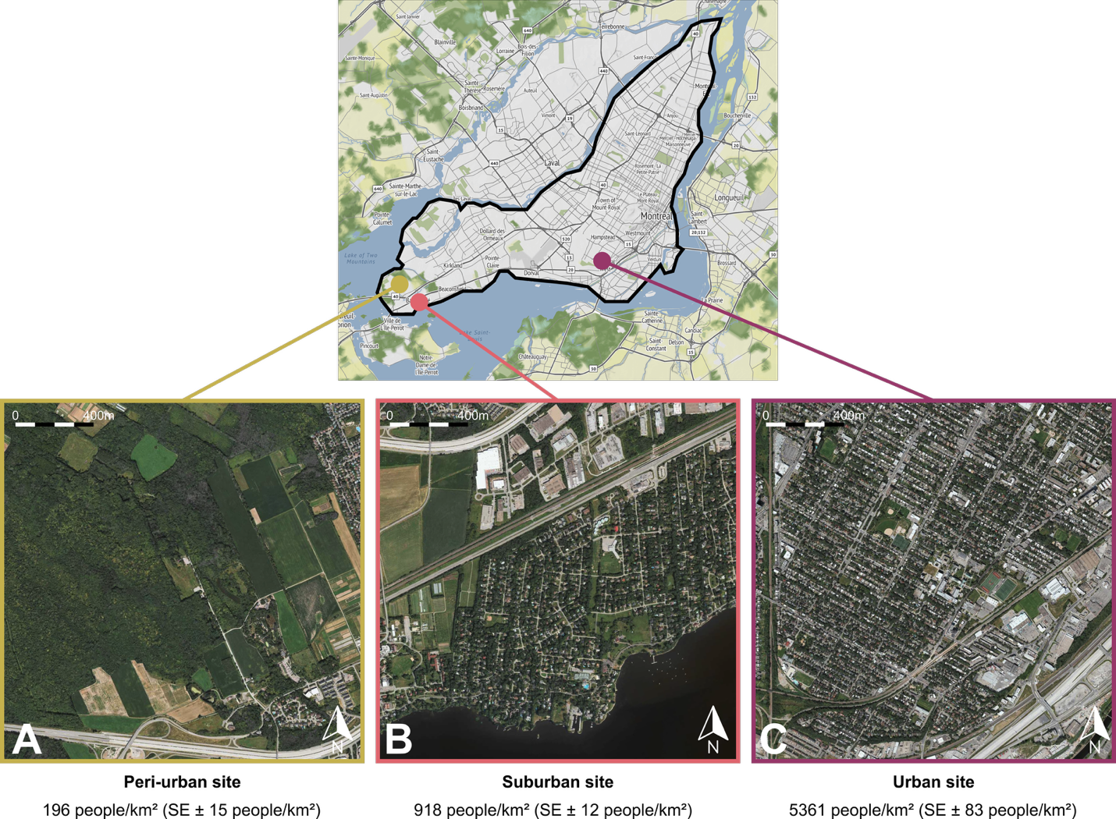Figure 1. Study locations on the Island of Montreal A) The peri-urban site is at the McGill Bird Observatory (2% of the area covered by streets and/or roads). B) The suburban site (5% of the area covered by streets and/or roads) is located in the residential Town of Baie d’Urfé. C) The urban site (13% of the area covered by streets and/or roads) is located in the Notre-Dame-de-Grâce neighbourhood.
The three translocation sites differed significantly in their level of urbanization, based on human population density data from the Cancensus Program R package (von Bergmann et al. 2021), using census data from the Government of Canada for the year 2021 (Kruskal-Wallis test and a Bonferroni-corrected pairwise Wilcoxon test, p < 0.001). All three sites are characterized by relatively high levels of green space compared to the median canopy cover for the Montreal area (~ 26%) (HealthyDesign.City 2021). As such, our gradient does not fully capture the extent of urbanization present across the entire city and should be interpreted as a localized urbanization gradient. We initially translocated a few cardinals to a highly urban area with lower canopy cover in the city core, but due to two immediate mortalities following translocation, we decided to omit that extreme of the urban gradient from our study.

Radio tagging, banding & translocation
All birds were caught during routine fall migration monitoring at MBO and were fitted with colour bands and Motus NanoTags following standard banding and morphological measurements (see Supplemental Information). Cardinals translocated to sites away from the peri-urban location (suburban and urban), as well as control birds held at the peri-urban site, underwent a holding time of 45 minutes before release to standardize treatment amongst individuals. For the winter of 2022-2023 (winter 1), we were able to consistently track 20 birds released as controls at the peri-urban site, which served as a pilot winter to assess the feasibility of the project. During the winter of 2023-2024 (winter 2), we tagged and banded 45 birds, with 15 individuals translocated to the urban site, 15 translocated to the suburban site, and 15 released as controls at the peri-urban site. In 2024-2025 (winter 3), we tagged and banded 42 birds, with 5 individuals released as controls at the peri-urban site, 16 individuals translocated to the suburban site, and 21 individuals translocated to the urban site.
Although tags used in this study were lighter than those used in previous work on cardinals, we considered the potential for tag effects when interpreting our results. Barron et al. (2013) showed that during the reproductive season, cardinals with tags (weighing 1.6 g [double the 0.8 g of the tags used in the present study]) defended their nests less vigorously, but did not change their provisioning effects. Cardinal nests with tagged parents also had lower daily survival rates and were less likely to fledge offspring (Barron et al. 2013). However, these tag effects were relatively modest and occurred across diverse habitats, making it unlikely that they would manifest only in our dense urban site while remaining undetected in peri-urban and suburban locations. Birds were banded under Animal Use Protocol 2007-5447 from McGill University and federal banding permits 10973, 10973B, 10973D issued by the Canadian Wildlife Service, and radio-tagged under Animal Use Protocol 22BF01 and 23BF01 from Environment and Climate Change Canada.

Cardinal abundance and seasonal distribution
We used the number of cardinals recorded per party-hour in Audubon Christmas Bird Count data between 1900 and 2015 to compare historical cardinal abundance in Quebec, Canada, with Maine, New York, New Hampshire, and Vermont (United States) (National Audubon Society 2020).

Non-breeding season tracking and home range estimations
We monitored tagged birds throughout the non-breeding season using an array of automated Motus towers and handheld telemetry receivers. We conducted manual radio tracking of each individual two to three times per week between the months of October and May each year. The areas monitored were ~5 km² (500 ha) at the peri-urban site, ~6 km² (600 ha) for the suburban site, and ~18 km² (1800 ha) for the urban site. Tracking effort and spatial coverage differed among sites because weather conditions and landscape structure imposed logistical constraints. At the peri-urban site, the lack of road networks and lower signal interference allowed the tracking team to move more freely and locate individuals more quickly, resulting in a smaller monitored area. In contrast, tracking the birds in suburban and urban areas meant that the tracking team’s movements were constrained by road access, built infrastructure, private land, and higher levels of radio interference. In addition, individuals released at the suburban and urban sites often moved farther away from their release location, requiring the tracking team to search across larger areas to maintain contact with tagged birds. These differences in spatial coverage reflect practical limitations of tracking birds in the heterogeneous landscape of urban environments and should be considered when comparing movement patterns across sites. The people tracking the birds by hand (trackers) aimed to record at least one GPS location for each individual per week using a Garmin ETREX 22x GPS. Trackers typically spent 5 hours tracking per session, twice per week, and started by first searching for newly relocated birds and/or birds with known recent locations. Once these individuals were found, trackers moved on to expand their search areas to find missing individuals. Details on the tracking method and estimations of precision can be found in the Supplemental Information section.
For all three study sites, we calculated the average home range size using the Kernel Density Estimation (KDE). The home range derived from the utilization distribution (UD) represents the minimum area containing a specified proportion of an individual’s space use (i.e., the GPS location recorded in the field) with the kernelUD function from the adehabitatHR: Home Range Estimation R package version 0.4.22 (Worton 1989; Calenge 2023, 2024). For example, the 95% home range represents the smallest area in which there is a 95% probability of finding the individual. We selected the 95% and 50% contours to investigate, respectively, the core area used within the home range of the birds and the broader home range excluding the most extreme locations (outliers). A minimum of 5 GPS locations were required to adequately run the function to calculate the KDEs, meaning that individuals with fewer points than this threshold were excluded.

Resource Selection Function
We compared ‘used’ vs. ‘available’ habitat using a resource selection function (RSF) for cardinals during the non-breeding season across our three sites. We used environmental and anthropogenic variables extracted from available spatial data in addition to field-collected data. This included mean and standard deviation (SD) of vegetation height (1m resolution) from OpenForest (Government and Municipalities of Quebec 2016), distance to the nearest bird feeder (collected through systematic field observations), human population density data (census unit) using the Cancensus R package (von Bergmann et al. 2021), and spatial data on the streets and roads from the island of Montreal (Ville de Montréal 2018). Unused locations were derived at a 1:1 ratio by creating random locations within 300 meters of the used location, at a random angle. We used the matched case-control design elaborated by Fortin (2005, 2009) and applied a 300 m buffer to reflect the median daily bird movement. Our analytical design (population-level RSF) included individual IDs as random effects and evaluated all used-available pairs from all individuals together. As such, we did not require a minimum number of locations per individual, as we would for an individual-level RSF. All predictors were scaled and centered prior to analyses.
We built our candidate model set to compare the relative strengths of anthropogenic and natural vegetation variables to predict cardinal habitat use. This included four a priori hypothesis-based models including, (1) the “Full model” (Used ~ Mean vegetation height + Sd vegetation height + Population density + Road length + Distance to nearest feeder + (1|Winter) + (1|Site) + (1|ID)), including all of the variables, plus the winter (years of sampling), relocation site and bird ID as random effects to account for the additive importance of anthropogenic and natural vegetation variables, (2) the “Vegetation height” model (Used ~ Mean vegetation height + (1|Winter) + (1|Site) + (1|ID)), assuming the vertical height of vegetation was the dominant variable related to habitat use by cardinals, (3) the “Sd vegetation height” model (Used ~ Sd vegetation height + (1|Winter) + (1|Site) + (1|ID)), assuming that cardinal habitat use is related to vertical vegetation composition, and (4) the “Anthropogenic” model (Used ~ Population density + Road length + Distance to nearest feeders + (1|Winter) + (1|Site) + (1|ID)), which assumed that cardinal habitat use would be related to anthropogenic variable We also included a “Null” model, with random effects only (Used ~ + (1|Winter) + (1|Site) + (1|ID)). We ranked all four models according to the corrected Akaike Information Criterion (AICc) following the method previously described by Burnham and Anderson (2002). We used Variance Inflation Factor (VIF) to test for multicollinearity among predictor variables (variables with VIF values > 10 were considered to have problematic collinearity and were removed) and Hosmer-Lemeshow as a goodness-of-fit test (Hosmer and Lemesbow 1980). VIFs ranged between 1.05 and 3.31 across all predictor variables; thus, none were removed. All statistical analyses were performed using Program R version 4.4.2 (R Core Team 2024).

Scale-of-effect
We used a data-driven approach to identify the pertinent spatial scale at which variables have the strongest relationship with a species’ response (i.e., scale-of-effect, Martin & Fahrig, 2012) by extracting variables at four spatial scales (25, 50, 100, 200 meters). We chose these spatial scales as they spanned a range that was small enough to capture finer responses as allowed by the spatial grain of the vegetation data, but also large enough to capture daily movement of tracked birds. For each scale, we ran generalized linear mixed models (GLMMs) separately for each site type (peri-urban, suburban, urban) using all five predictor variables as well as year, release location, and individual ID as random effects. We ranked models using Akaike Information Criterion (AICc) values, which take into account small sample sizes (Burnham and Anderson 2002). The best model was identified as having the lowest AICc value. We also calculated the $∆$AICc to evaluate competing models following Burnham and Anderson (2002) (models with a $∆$AICc < 2 were considered to have substantial support, competing with the best model and models with a $∆$AICc > 10 were deemed to have no support, not competing with the best model). We acknowledge that low per-individual sample sizes might reduce the precision of the scale-of-effect estimates, as models fitted on few observations per individual could be susceptible to individual-level variation driving apparent scale preferences. To mitigate this, we included individuals’ IDs as a random effect and interpret scale-of-effect results at the population level rather than as individual-level habitat selection.
Because the four buffer sizes represent nested spatial extents, we expect the variables extracted from these buffers to be positively correlated. We assessed cross-scale correlations for each predictor type using Pearson’s “r”. Correlations were highest for human population density (r = 0.96-0.99 across all sites), moderate for mean vegetation heights (r = 0.37-0.94) and road length (r = 0.32-0.95), and lowest for SD vegetation height (r = 0.33-0.84), decreasing with increasing scale separation in all cases. Variables from different scales were never included within the same model—each candidate model uses a single buffer size—so cross-scale correlations do not inflate within-model multicollinearity (all VIF < 10). The buffer comparison therefore constitutes a scale-selection exercise rather than a multi-scale additive approach. Once the scale-of-effect was determined for each location, we conducted a resource selection function at the site-type-specific spatial scale.

Results
Historical and seasonal context of Cardinals in southern Quebec
To place our winter telemetry results in the context of the species’ recent expansion into southern Quebec and its seasonal dynamics within the study region, we summarized long-term regional abundance from Christmas Bird Count (CBC) data and local bird banding records. In southern Quebec, cardinals have increased in abundance since the 1970s as documented in the CBC, reflecting the species’ well-documented northward range expansion from the northeastern United States into southern Quebec beginning in the 1960s (Figure 2).

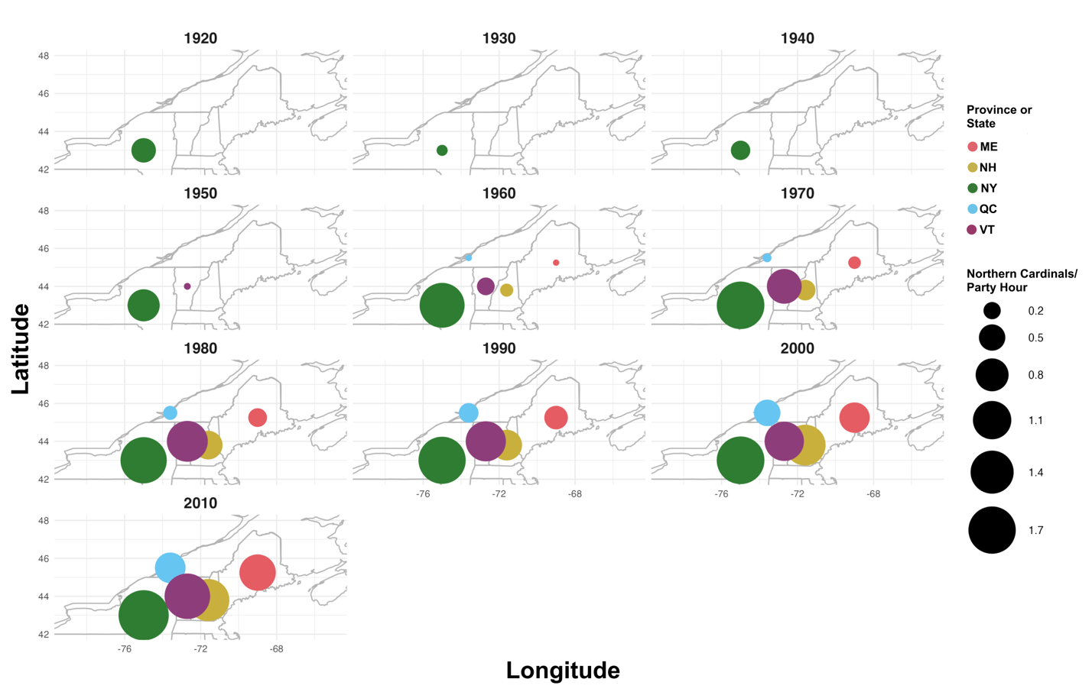
Figure 2. Number of cardinal observations per party hour between the 1920s and the 2010s according to state (United States) or province (Canada) as part of the Audubon Christmas Bird Count (CBC).
Nineteen years of banding data from the McGill Bird Observatory also revealed distinct seasonal patterns in captures (Figure 3). Capture rates were higher during the fall monitoring program (~0.75 birds/h) than during the spring program (~0.27 birds/h), accompanied by a greater proportion of unbanded individuals, indicating an influx of new birds in late fall. Although most fall captures were juveniles or individuals of unknown age (Figure S1B, C), adults also exhibited peaks in mid-May and late July (Figure S1A), suggesting that both post-fledging dispersal and local movements between breeding and wintering areas contribute to seasonal variation in captures.
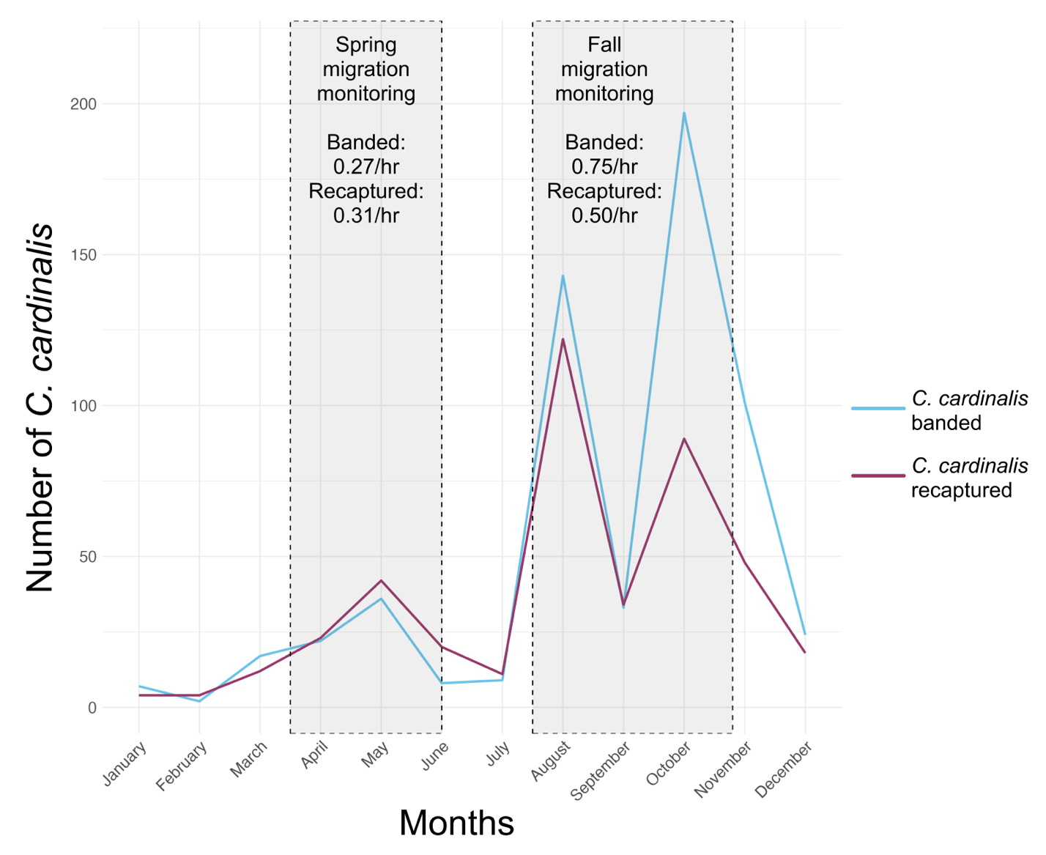Figure 3. Number of cardinals banded and recaptured at the McGill Bird Observatory (peri-urban site) between 2004 and 2022 in Montreal, Quebec, Canada. The grey boxes highlight the duration of the spring and fall migration monitoring programs, along with the approximate number of cardinals banded and recaptured per hour of mist nets being opened during the season.

Telemetry tracking of cardinals across an urban gradient

Telemetry tracking was conducted 2 to 3 days per week between October and May 2022-2024, for a total of ~288 days of monitoring per winter (Table 1). We recorded a total of 688 unique detections at the peri-urban site, 411 at the suburban site, and 265 at the urban site across the three years. The proportion of cardinals tracked one month post-release differed significantly among sites (Pearson’s χ² = 21.85, df = 2, p < 0.001). Pairwise comparisons with Holm-adjusted p-values showed significant differences between the peri-urban and urban sites (p < 0.001) and between the suburban and urban sites (p = 0.046), but not between the peri-urban and suburban sites (p = 0.073). Similarly, the proportion of cardinals tracked three months post-release differed significantly among sites (Pearson’s χ² = 22.18, df = 2, p < 0.001). Pairwise comparisons showed again significant differences between the peri-urban and urban sites (p < 0.001) and between the suburban and urban sites (p = 0.002), but not between the peri-urban and suburban sites (p = 0.518). The number of cardinals tracked at one and three months post-release, missing individuals, and confirmed mortality events are presented in Table 1.
Table 1. Number of cardinals tracked 1 and 3 months post-release, with apparent survival (48% average) and fated survival (including individuals presumed alive but outside the study area; 71% average), including known mortality events/probable causes across three sites in Montreal, Quebec, Canada between 2022 and 2025.
Site | Total number of cardinals | # tracked 1 month (apparent survival) | # tracked 3 months (apparent survival) | Missing individuals after 3 months | Confirmed mortality events and probable cause of death
Peri-urban | 41 | 34 (83%) | 28 (68%) | 13 | 6  Predation (n = 4)  Unknown (n = 2)
Suburban | 31 | 19 (61%) | 18 (58%) | 13 | 4  Predation (n = 2)  Disease (n = 1)  Unknown (n = 1)
Urban | 36 | 11 (31%) | 6 (17%) | 30 | 3  Predation (n = 1)  Window collision (n = 2)

Core areas and home ranges of cardinals across an urban gradient
We estimated core areas and home ranges for individuals with $≥$ 5 recorded GPS locations (36 individuals from the peri-urban site, 13 from the suburban site and 9 from the urban site; Figure 4). Between 5 and 48 points per individual were used to estimate the KDEs, with ≥the average number of points per bird being 18. Mean core area sizes (± SE) were 0.15 ± 0.04 km² (n = 36) at the peri-urban site, 0.08 ± 0.02 km² (n = 13) at the suburban site, and 0.28 ± 0.11 km² (n = 9) at the urban site. Mean total home range sizes (± SE) were 0.61 ± 0.13 km² (n = 36) at the peri-urban site, 0.56 ± 0.11 km² (n = 13) at the suburban site, and 1.53 ± 0.52 km² (n = 9) at the urban site. These sample sizes represent the number of cardinals that could be included in the respective KDE analyses. Core and total home range sizes were not normally distributed (Shapiro-Wilk tests: core, W = 0.624, p < 0.001; total, W = 0.698, p < 0.001), so areas were log-transformed prior to analysis

. Following transformation, the data met assumptions of normality (Shapiro-Wilk test: 50% KDE, W = 0.970, p = 0.159; 95% KDE, W = 0.969, p = 0.150) and homogeneity of variance (Levene’s test: 50% KDE, F_{2,55} = 1.07, p = 0.350; 95% KDE, F_{2,55} = 0.61, p = 0.547). Mean core home range size (95% KDE) was highest at the urban site (Figure 4), but differences among sites were not statistically significant (ANOVA: p = 0.077). There was a significant difference among the three study sites regarding total home ranges (50% KDE; ANOVA: F_{2, 55} = 3.45, p = 0.04). Post-hoc Tukey’s honestly significant difference tests showed that the only significant difference was that the total home ranges of cardinals at our urban site were larger than those at the peri-urban site (mean difference = 1.24, 95% CI [0.09, 2.38], p = 0.03); no other pairwise differences were statistically significant.
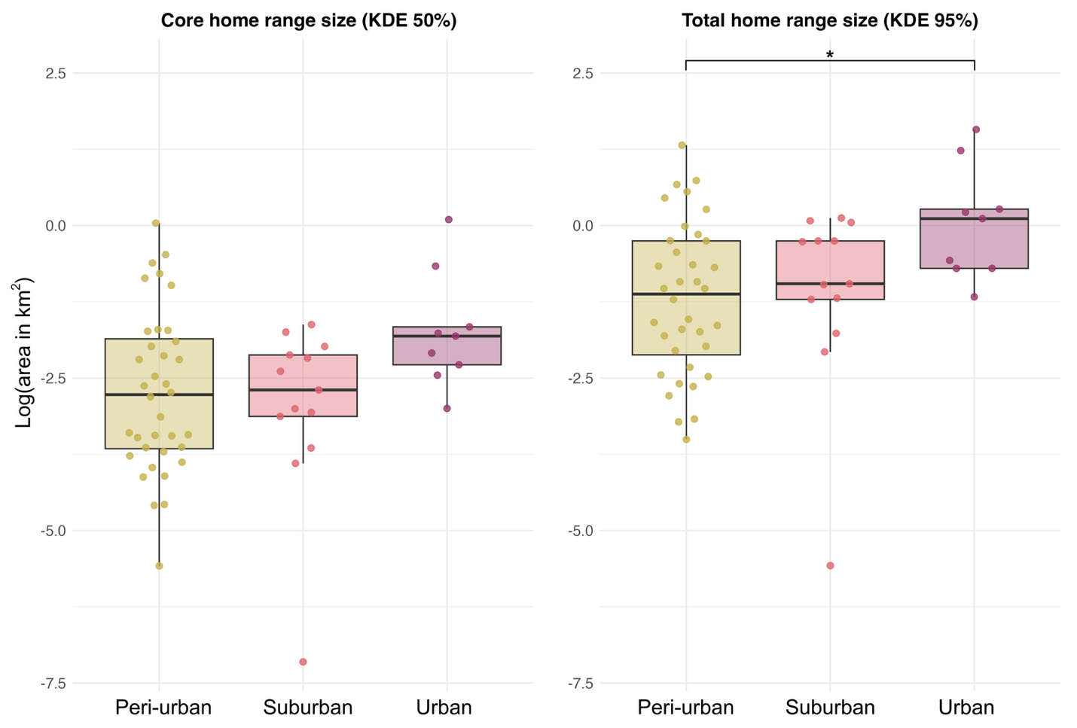Figure 4. Boxplot comparison of the core (KDE 50%) and total (KDE 95%) home ranges of cardinals in three study sites (peri-urban, suburban and urban) in Montreal, Quebec, Canada during winters between the years 2022 and 2025. We log-transformed the area (km²), and each data point corresponds to an individual’s home range (log-transformed area).

Scale of association to habitat
We compared AICc among models fit with landscape covariates measured at four different spatial scales (25, 50, 100, and 200 m radius around resighting locations). At the peri-urban site, the 50 m scale model best explained cardinal movements (Δ AICc > 4 relative to all other scales). At both the suburban and urban sites, the 25 m scale model performed best (Δ AICc > 10 relative to all other scales). Because the landscape variables we measured at different spatial scales are inherently correlated, these results indicate the scale at which habitat structure shows the strongest statistical association with cardinal movements, rather than reflecting a direct causal scale of effect.

Resource selection: used vs. available habitats
Due to differences in urbanization level and scales of effect, resource selection function models were run separately for each study site. For the peri-urban site, the global model explained the most variation seen in the data (Δ AICc > 10 relative to all other models, Supplementary Material Table S2). The full model reduced deviance by ~11.3% relative to the null model. For the suburban site, we selected the anthropogenic covariates model (human population and road density) as the most parsimonious model. Although the global model had a slightly lower AICc, the difference between the two models was very small (Δ AICc < 0.5 relative to the top model), indicating similar support for both models. Therefore, we retained the simpler anthropogenic covariates model, which reduced deviance by ~16.6% relative to the null model. Lastly, for the urban site, the global model was the best-supported candidate model (Δ AICc > 3 relative to the next best model). The global model reduced deviance by ~10.5% relative to the null model. The best model for each study site was then used to generate prediction plots on the probability of use of the habitat by cardinals according to the model variables (Table 2).
Table 2. Model parameters for the three resource selection models predicting the probability of habitat use of 56 cardinals within (25 or 50 m-radius) areas based on the average vegetation height (in meters) and its standard deviation, along with human-related environmental features such as human population density (in people/km²), road length (in meters) and distance to the nearest bird feeder (in meters). The study site, year (winter) of sampling, and the individual’s identification (ID) are included as random effects in each model.
Study Site | Variable | Coefficient estimate | Standard error | z | p
Peri-Urban | Global model – 50 meters  Mean vegetation height (m)  Standard deviation of the mean vegetation height  Mean population density (person/km²)  Road length (m)  Distance to the nearest bird feeder (m) | -1.272  1.107  -0.095  0.023  -0.347 | 0.153  0.114  0.111  0.110  0.068 | -8.329  9.709  -0.858  0.207  -5.067 | <0.001  <0.001  0.391  0.836  <0.001
Suburban | Anthropogenic covariates model – 25 meters  Mean population density (person/km²)  Road length (m)  Distance to the nearest bird feeder (m) | -0.486  1.238  -0.427 | 0.135  0.136  0.128 | -3.603  9.138  -3.342 | <0.001  <0.001  <0.001
Urban | Global model – 25 meters  Mean vegetation height (m)  Standard deviation of the mean vegetation height  Mean population density (person/km²)  Road length (m)  Distance to the nearest bird feeder (m) | 0.252  -0.458  -0.212  0.736  -0.392 | 0.180  0.191  0.131  0.135  0.141 | 1.399  -2.405  -1.620  5.438  -2.772 | 0.162  0.016  0.105  <0.001  0.006

Prediction plots of the significant fixed effects from the resource selection functions show that cardinal associations with urban habitat features varied among sites (Figure 5). In the peri-urban site, habitat use decreases as the mean vegetation height increases (Figure 5A) and the distance to the nearest bird feeder increases (Figure 5C), and increases with greater variability in vegetation height (Figure 5B). In our suburban site, cardinals’ habitat use shows little relationship with population density (Figure 5D) but increases as the mean road length increases (Figure 5E). Like our peri-urban site, the use of the habitat by cardinals also decreases as the distance to the nearest feeder increases at the suburban site (Figure 5F). At the urban site, cardinals’ probability of using the habitat decreases with increasing vegetation height standard deviation, although uncertainty is high (Figure 5G). The cardinals’ association with habitat also increased with mean road length and decreased with increasing distance to the nearest feeders. Across sites, proximity to feeders and structural complexity of the infrastructure or the vegetation consistently influenced the probability of habitat use, yet specific relationships varied. Taken together, these results indicate that winter habitat association by cardinals varies across the urbanization gradient. While feeder availability appears to be consistently associated with a higher probability of cardinals using the habitat across all sites, the habitat features associated with cardinal presence differed among the peri-urban, suburban and urban sites. This suggests that patterns of habitat use are largely context-dependent.
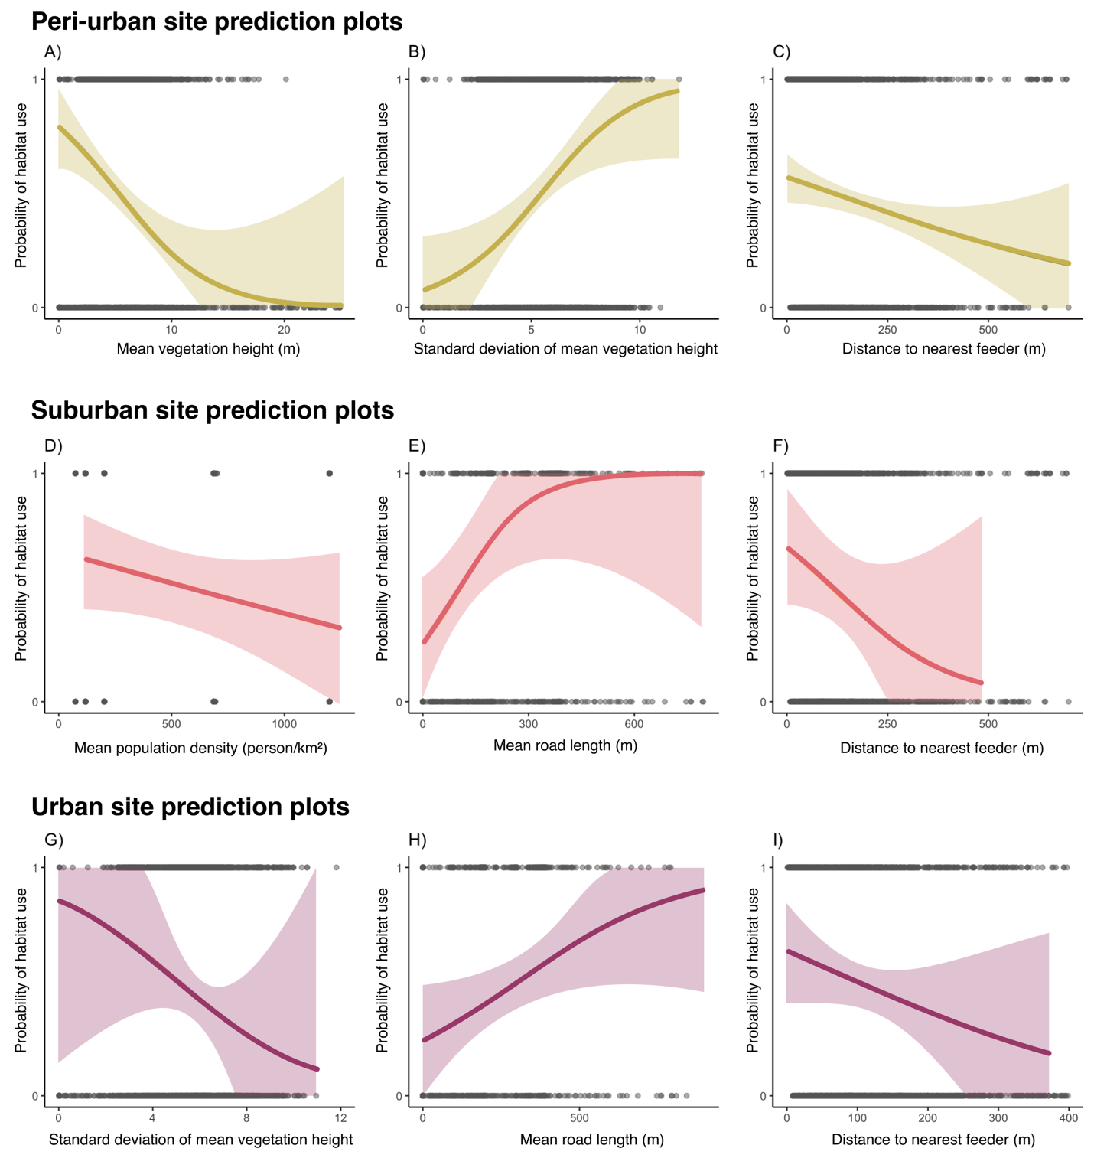Figure 5. Probability of habitat use by cardinals in a 50 m radius for the suburban site and 25 m radius for both the peri-urban and urban sites, as predicted by a generalized linear mixed effects model. Shaded areas represent 67% confidence intervals around the predicted probabilities. The model’s fixed effect variables are described in Table 3, and for each model, random effects were sampling years, translocation site, and bird ID.

Discussion
Our study examined winter space use, habitat associations, and apparent survival of cardinals across an urban gradient. Although habitat associations differed among sites, broad patterns emerged. Individuals relocated to the urban site exhibited larger home ranges and lower apparent survival than their counterparts at the suburban and peri-urban sites, while associations with environmental variables varied across the urbanization gradient. Proximity to bird feeders was consistently associated with cardinal occurrence across all sites, and individuals at the suburban and urban sites were primarily resighted in private urban green spaces (UGS) rather than larger public UGS. These findings suggest that winter habitat use by cardinals may vary according to local habitat conditions and resource availability, while anthropogenic food sources appear to be associated with space use across our range of urban environments. Specifically, bird feeders allowed the cardinal range to extend north over the past 80 years in cities, created local movements from UGS to bird feeders each fall, and meant winter habitat use was tied to bird feeder density. More broadly, our results indicate that private UGS may represent an important component of habitat usage by cardinals during winter in southern Quebec.

Larger home ranges at urban site and the importance of bird feeders
We found cardinals at our most urban site had the largest total (KDE 95%) home ranges, although this finding should be interpreted cautiously given the small sample size at this location (n = 9) and the limited number of locations available for some of the home range estimates. In addition, we did not have a truly rural site, which may also have had larger home ranges. Because we could not capture the full spectrum of urbanization, the relationship to territory size may not be linear (i.e., larger home ranges in rural and urban areas compared to smaller home ranges in peri-urban and suburban areas). P. domesticus in urban landscapes occupied smaller home ranges compared to their rural counterparts through the breeding season in Belgium (Vangestel et al. 2010). O’Donnell (2020) also suggested that birds in urban environments generally tend to have smaller home ranges. However, female cardinals venture out of their territory more often when they have supplemental feeding, compared to females that did not have access to supplemental food, leading to a trend towards larger home ranges (Humbird and Neudorf 2008). In our case, we found the opposite trend. By mapping the location of visible bird feeders, we obtained a coarse estimate of feeder density at all sites: the peri-urban site had ~13 feeders/km², the suburban site had ~35 feeders/km^{2,} and the urban site had ~12 feeders/km². Although these estimates provide useful context for interpreting site-level differences, they are not representative of all the feeders available and adequately maintained for the cardinals and should therefore be interpreted cautiously. One possible explanation is that the lower feeder density at the urban site, coupled with a potentially more challenging urban matrix, may have been associated with more extensive movements between reliable resource points. Because feeder density was not directly incorporated into our home range analyses, these interpretations should be considered as being on the speculative side. Conversely, the higher feeder density observed at the suburban site might have reduced the distance needed to move among reliable food resources. However, we want to point out that our study was not designed to test this mechanism directly. Future studies that explicitly quantify feeder availability and incorporate it into movement analyses would be valuable to evaluate whether variation in feeder density in urban areas is associated with winter home range size for birds exploiting this anthropogenic food resource.

Lower apparent survival at urban site
We found that the proportion of cardinals tracked three months post-release was similar at the peri-urban (68%) and suburban (58%) sites, but differed substantially at the urban site (17%). These differences provide insights on cardinals’ persistence within monitored areas, but they cannot be directly attributed to differences in survival. The peri-urban and suburban estimates are broadly consistent with previously reported annual survival rates for cardinals elsewhere (Ohio: 50.5-78.3%, Shustack 2008; Washington, D.C.: 40-70%, Evans et al. 2015), although a direct comparison is limited by differences in study design and the nature of the data collected. The lower tracking rates experienced at the urban site may reflect an increased mortality associated with anthropogenic hazards. The urban site was the only location where window collisions were confirmed, and these accounted for 67% (2/3) of documented mortalities. Urban environments also expose birds to additional risks, including vehicle strikes and domestic cat predation (Loss et al. 2014b; Ibáñez-Álamo et al. 2020; Lopes et al. 2024). Compared with the other sites, the urban site also contained a substantially higher density of windows, including numerous multi-storey buildings, which may have increased collision risk (Loss et al. 2014a). Alternatively, some individuals may have emigrated beyond the monitored area (>18 km²) and could not conclusively be classified as dead or alive; their subsequent fates could not be verified in the field. While confirmed mortalities demonstrate that the anthropogenic hazards contributed to losses at the urban site, the available data do not allow us to determine the relative contributions of mortality and emigration to the lower tracking rates we observed.

Small scale of association to habitat regardless of urbanization level
Cardinals were associated with habitat features at relatively fine spatial scales across all study sites, with the strongest model support at 50 m in the peri-urban site and 25 m in the suburban and urban sites. Although this pattern should be interpreted cautiously, given telemetry error (10-15 m) and correlation among habitat variables measured at adjacent scales, it is consistent with cardinals responding to fine-grained habitat features, including bird feeders, across the urban gradient. More generally, our results support previous work suggesting that urban bird responses can vary across spatial scales and that small habitat patches may contribute to avian habitat use in cities (Dale 2018; Fidino et al. 2021; Guo et al. 2023). While our study was not designed to test mechanisms underlying scale dependence, the slightly smaller scale of strongest support in the suburban and urban sites is consistent with the idea that habitat configuration may become increasingly important in more urbanized landscapes. Nineteen years of banding data from the peri-urban site indicated a largely resident population, as the proportion of banded and unbanded birds remained relatively constant throughout the year. However, a marked increase in newly captured individuals during late fall (Fig. S3) suggests local movements, including post-fledging dispersal and short-distance migration. Across scales, bird feeders and vegetation structure were associated with habitat use from third-order habitat selection to the scale of the entire home range (e.g., first order scale).

Variation of habitat associations across an urbanization gradient
Cardinals were associated with different environmental and anthropogenic habitat variables across an urban gradient, indicating that habitat associations are different among the peri-urban, suburban and urban sites. The one consistent association across study sites was the inverse relationship between habitat use and distance to the closest bird feeder—which is indeed apparent even at the scale of the entire range (Fig. 2; Robb et al. 2008). This is unsurprising as cardinals are one of the most common species at bird feeders within its range, especially during autumn and winter (Horn et al. 2014). We also found that cardinals were more likely to be found in areas with higher road cover (which may reflect higher residential development) in both the suburban and urban sites. This pattern is consistent with previous work showing a positive association between cardinals and urbanized landscapes during the breeding season (Evans et al. 2015). Comparatively, cardinal associations with natural cover differed across our urbanization gradient. At the urban site, cardinals avoided areas of highly contrasted vegetation structures, while at the peri-urban site they were more likely to occupy an area with greater standard deviation. These findings suggest that vegetation structure may be associated with winter habitat use, which is consistent with a previous study in Delaware and Maryland identifying that vegetation structure is a particularly important variable in urban areas, specifically for cardinals during the breeding season (Duren et al. 2017). Post-fledging cardinals in urban areas strongly select for habitat with a complex understory vegetation (Ausprey and Rodewald 2011). We did not find evidence of the same association with vegetation structure in the peri-urban site. The reason for this discrepancy remains unclear, although variation in habitat availability or habitat heterogeneity among sites may be contributing factors. The importance of vegetation structure and composition in birds’ habitat selection is most likely scale-dependent (Deppe and Rotenberry 2008). Our scale of effect analysis suggests that cardinals selected wintering habitats in the peri-urban location at a larger scale than the urban site. It is possible that scale-dependent differences in vegetation cues contribute to this pattern, although we caution that the difference between the scales (25 m vs. 50 m) is modest and that this interpretation remains speculative without a direct test of the vegetation composition effect.

Implications
We highlight the importance of fine-scale habitat features and resource availability in shaping the winter ecology of a resident songbird along an urban gradient. The context-dependent responses we observed underscore the importance of considering local habitat conditions and resource availability when managing UGS for resident bird species. In particular, the reliance on bird feeders and avoidance of large public UGS suggests that private UGS may play a disproportionately important role in supporting certain overwintering birds. This highlights the often-overlooked importance of private UGS in conservation, even though they are a dominant and highly diverse part of nature in cities (Goddard et al. 2010; Hutt-Taylor and Ziter 2022). While our study species is not one of conservation concern, it is culturally recognized and may serve as an important species to connect people to nature in urban areas. As urban development intensifies, integrating biodiversity-friendly practices such as preserving vertically complex vegetation and enhancing connectivity between small habitat patches may help sustain populations of resident birds that rely on UGS during the winter. Together, our results highlight how habitat association by a resident bird species is shaped by both landscape-level context and fine-scale resource availability. This multi-scale perspective demonstrates the importance of considering hierarchical habitat use in urban ecology and conservation. More broadly, our findings join a growing body of work emphasizing the ecological importance of urban landscape elements and highlight the need for inclusive UGS planning that includes both public and private green infrastructures.

Literature Cited
Altwegg R, Jenkins A, Abadi F (2014) Nestboxes and immigration drive the growth of an urban Peregrine Falcon Falco peregrinus population. Ibis 156:107–115. https://doi.org/10.1111/ibi.12125
Ausprey IJ, Rodewald AD (2011) Postfledging Survivorship and Habitat Selection Across A Rural-To-Urban Landscape Gradient. The Auk 128:293–302. https://doi.org/10.1525/auk.2011.10158
Barron DG, Weatherhead PJ, Brawn JD (2013) A Test of Radio-Transmitter Effects on Parental Investment and Productivity in the Northern Cardinal. The Condor 115:669–676. https://doi.org/10.1525/cond.2013.120149
Beddall B (1963) Range Expansion of the Cardinal and Other Birds in the Northeastern States. Wilson Bull 75:140–158
Bino G, Dolev A, Yosha D, et al (2010) Abrupt spatial and numerical responses of overabundant foxes to a reduction in anthropogenic resources. J Appl Ecol 47:1262–1271. https://doi.org/10.1111/j.1365-2664.2010.01882.x
Boggie MA, Mannan RW (2014) Examining seasonal patterns of space use to gauge how an accipiter responds to urbanization. Landsc Urban Plan 124:34–42. https://doi.org/10.1016/j.landurbplan.2014.01.001
Bressler SA, Diamant ES, Tingley MW, Yeh PJ (2020) Nests in the cities: adaptive and non-adaptive phenotypic plasticity and convergence in an urban bird. Proc R Soc B Biol Sci 287:20202122. https://doi.org/10.1098/rspb.2020.2122
Burnham KP, Anderson DR (2002) Model Selection and Multimodel Inference, 2nd edn.
Calenge C (2023) Home Range Estimation in R: the adehabitatHR Package
Calenge C (2024) adehabitatHR: Home Range Estimation

Dale S (2018) Urban bird community composition influenced by size of urban green spaces, presence of native forest, and urbanization. Urban Ecosyst 21:1–14. https://doi.org/10.1007/s11252-017-0706-x
DeCandido R, Allen D (2006) Nocturnal hunting by Peregrine Falcons at the Empire State building, New York City. Wilson J Ornithol 118:53–58. https://doi.org/10.1676/1559-4491(2006)118%5B0053:NHBPFA%5D2.0.CO;2
Deppe JL, Rotenberry JT (2008) Scale-dependent habitat use by fall migratory birds: vegetation structure, floristics, and geography. Ecol Monogr 78:461–487. https://doi.org/10.1890/07-0163.1

Duren AM, Williams CK, D’amico V (2017) Microhabitat Factors Associated with Occupancy of Songbirds in Suburban Forest Fragments in the Eastern United States. Am Midl Nat 178:189–202. https://doi.org/10.1674/0003-0031-178.2.189
Elmqvist T, Fragkias M, Goodness J, et al (2013) Urbanization, biodiversity and ecosystem services: challenges and opportunities: a global assessment. Springer Nature

Evans BS, Ryder TB, Reitsma R, et al (2015) Characterizing avian survival along a rural‐to‐urban land use gradient. Ecology 96:1631–1640. https://doi.org/10.1890/14-0171.1
Fidino M, Gallo T, Lehrer EW, et al (2021) Landscape‐scale differences among cities alter common species’ responses to urbanization. Ecol Appl 31:e02253. https://doi.org/10.1002/eap.2253
Fortin D, Beyer HL, Boyce MS, et al (2005) Wolves influence elk movements: behavior shapes a trophic cascade in Yellowstone National Park. Ecology 86:1320–1330. https://doi.org/10.1890/04-0953
Fortin D, Fortin M-E, Beyer HL, et al (2009) Group-size-mediated habitat selection and group fusion–fission dynamics of bison under predation risk. Ecology 90:2480–2490. https://doi.org/10.1890/08-0345.1
Frei B, Morales A, Cousineau A-M, Beauchamp A (2024) Montreal Northern Cardinal Winter Movements (Project 882)

Galeotti P (1994) Patterns of territory size and defence level in rural and urban tawny owl (Strix aluco) populations. J Zool 234:641–658
Goddard MA, Dougill AJ, Benton TG (2010) Scaling up from gardens: biodiversity conservation in urban environments. Trends Ecol Evol 25:90–98. https://doi.org/10.1016/j.tree.2009.07.016
Government and Municipalities of Quebec (2016) Lidar - Digital models (terrain, canopy, slope, level curve) - Open Government Portal. https://open.canada.ca/data/en/dataset/5e5d2750-d129-4952-b9fc-f824c5e480b4. Accessed 17 Nov 2025

Guo F, Buler JJ, Smolinsky JA, Wilcove DS (2023) Autumn stopover hotspots and multiscale habitat associations of migratory landbirds in the eastern United States. Proc Natl Acad Sci 120:e2203511120. https://doi.org/10.1073/pnas.2203511120
Havlíček J, Riegert J, Fuchs R (2022) A comparison of foraging-range sizes, flight distances and foraging habitat preferences in urban and rural House Sparrow (Passer domesticus) populations. Ibis 164:1227–1242. https://doi.org/10.1111/ibi.13072
HealthyDesign.City (2021) HealthyPlan.City
Hindmarch S, Elliott JE, Mccann S, Levesque P (2017) Habitat use by barn owls across a rural to urban gradient and an assessment of stressors including, habitat loss, rodenticide exposure and road mortality. Landsc Urban Plan 164:132–143
Horn DJ, Johansen SM, Wilcoxen TE (2014) Seed and feeder use by birds in the United States and Canada. Wildl Soc Bull 38:18–25. https://doi.org/10.1002/wsb.365
Hosmer DW, Lemesbow S (1980) Goodness of fit tests for the multiple logistic regression model. Commun Stat - Theory Methods 9:1043–1069. https://doi.org/10.1080/03610928008827941
Humbird SK, Neudorf DLH (2008) The effects of food supplementation on extraterritorial behavior in female Northern Cardinals. The Condor 110:392–395. https://doi.org/10.1525/cond.2008.8427
Hutt-Taylor K, Ziter CD (2022) Private trees contribute uniquely to urban forest diversity, structure and service-based traits. Urban For Urban Green 78:127760. https://doi.org/10.1016/j.ufug.2022.127760
Ibáñez-Álamo JD, Morelli F, Benedetti Y, et al (2020) Biodiversity within the city: Effects of land sharing and land sparing urban development on avian diversity. Sci Total Environ 707:135477. https://doi.org/10.1016/j.scitotenv.2019.135477

Kauffman MJ, Frick WF, Linthicum J (2003) Estimation of habitat-specitif demography and population growth for Peregrine Falcons in California. Ecol Appl 13:1802–1816. https://doi.org/10.1890/01-5324

Li G, Fang C, Li Y, et al (2022) Global impacts of future urban expansion on terrestrial vertebrate diversity. Nat Commun 13:1628. https://doi.org/10.1038/s41467-022-29324-2

Lopes AC, Rocha GOC, de Oliveira Passos MF, et al (2024) The Influence of Building Surroundings and Glass Cover in Bird Collisions. Birds 5:703–711. https://doi.org/10.3390/birds5040048
Loss SR, Will T, Loss SS, Marra PP (2014a) Bird–building collisions in the United States: Estimates of annual mortality and species vulnerability. Condor Ornithol Appl 116:8–23. https://doi.org/10.1650/CONDOR-13-090.1
Loss SR, Will T, Marra PP (2014b) Estimation of bird-vehicle collision mortality on U.S. roads. J Wildl Manag 78:763–771. https://doi.org/10.1002/jwmg.721
Lowry H, Lill A, Wong BBM (2013) Behavioural responses of wildlife to urban environments. Biol Rev 88:537–549. https://doi.org/10.1111/brv.12012

Martin AE, Fahrig L (2012) Measuring and selecting scales of effect for landscape predictors in species–habitat models. Ecol Appl 22:2277–2292. https://doi.org/10.1890/11-2224.1
Mitsuhashi I, Sako T, Teduka M, et al (2018) Home range of raccoon dogs in an urban green area of Tokyo, Japan. J Mammal 99:732–740. https://doi.org/10.1093/jmammal/gyy033
Murray MH, Sánchez CA, Becker DJ, et al (2019) City sicker? A meta‐analysis of wildlife health and urbanization. Front Ecol Environ 17:575–583. https://doi.org/10.1002/fee.2126
National Audubon Society (2020) The Christmas Bird Count Historical Results [Online]. https://www.audubon.org/community-science/christmas-bird-count. Accessed 16 Apr 2025
O’Donnell K, delBarco-Trillo J (2020) Changes in the home range sizes of terrestrial vertebrates in response to urban disturbance: a meta-analysis. J Urban Ecol 6:juaa014. https://doi.org/10.1093/jue/juaa014

R Core Team (2024) R: A Language and Environment for Statistical Computing

Reher S, Dausmann KH, Warnecke L, Turner JM (2016) Food availability affects habitat use of Eurasian red squirrels (Sciurus vulgaris) in a semi-urban environment. J Mammal 97:1543–1554. https://doi.org/10.1093/jmammal/gyw105
Riley SP, Sauvajot RM, Fuller TK, et al (2003) Effects of urbanization and habitat fragmentation on bobcats and coyotes in southern California. Conserv Biol 17:566–576
Robb GN, McDonald RA, Chamberlain DE, Bearhop S (2008) Food for thought: supplementary feeding as a driver of ecological change in avian populations. Front Ecol Environ 6:476–484. https://doi.org/10.1890/060152
Robert M, Hachey M-H, Lepage D, Couturier A (2019) Second Atlas of the Breeding Birds of Southern Québec
Rutz C (2006) Home range size, habitat use, activity patterns and hunting behaviour of urban-breeding Northern Goshawks Accipiter gentilis. ARDEA-Wagening- 94:185
Šálek M, Drahníková L, Tkadlec E (2015) Changes in home range sizes and population densities of carnivore species along the natural to urban habitat gradient. Mammal Rev 45:1–14
Šálek M, Grill S, Riegert J (2020) Nest-site selection of an avian urban exploiter, the Eurasian magpie Pica pica, across the urban-rural gradient. J Vertebr Biol 70:. https://doi.org/10.25225/jvb.20086
Seress G, Liker A (2015) Habitat urbanization and its effects on birds. Acta Zool Acad Sci Hung 61:373–408
Shustack DP (2008) Reproductive Timing of Passerines in Urbanizing Landscapes. The Ohio State University
Simberloff RA, Phillips JN, Derryberry GE, et al (2023) Communication distance predicts territory size: implications for an urban songbird. Anim Behav 203:89–99. https://doi.org/10.1016/j.anbehav.2023.05.016
Simkin RD, Seto KC, McDonald RI, Jetz W (2022) Biodiversity impacts and conservation implications of urban land expansion projected to 2050. Proc Natl Acad Sci 119:e2117297119. https://doi.org/doi:10.1073/pnas.2117297119
Smith BT, Escalante P, Hernández Baños BE, et al (2011) The role of historical and contemporary processes on phylogeographic structure and genetic diversity in the Northern Cardinal, Cardinalis cardinalis. BMC Evol Biol 11:136. https://doi.org/10.1186/1471-2148-11-136

Thompson CA, Malcolm JR, Patterson BR (2021) Individual and Temporal Variation in Use of Residential Areas by Urban Coyotes. Front Ecol Evol 9:. https://doi.org/10.3389/fevo.2021.687504
Vangestel C, Braeckman BP, Matheve H, Lens L (2010) Constraints on home range behaviour affect nutritional condition in urban house sparrows (Passer domesticus): ranging behaviour in urban House Sparrows. Biol J Linn Soc 101:41–50. https://doi.org/10.1111/j.1095-8312.2010.01493.x
Vaz S, Manes S, Khattar G, et al (2023) Global meta-analysis of urbanization stressors on insect abundance, richness, and traits. Sci Total Environ 903:165967. https://doi.org/10.1016/j.scitotenv.2023.165967
Ville de Montréal (2018) Chaussée agrégée et intersection (Base de données des actifs de voirie)
von Bergmann J, Shkolnik D, Jacobs A (2021) cancensus: R package to access, retrieve, and work with Canadian Census data and geography
Wang H, He Q, Liu X, et al (2012) Global urbanization research from 1991 to 2009: A systematic research review. Landsc Urban Plan 104:299–309
WeatherSpark Climate and Average Weather Year-Round in Montreal. In: Clim. Aver. Weather Year-Round Montr. https://weatherspark.com/y/25077/Average-Weather-in-Montr%C3%A9al-Quebec-Canada-Year-Round. Accessed 21 June 2026
Worton BJ (1989) Kernel Methods for Estimating the Utilization Distribution in Home-Range Studies. Ecology 70:164–168. https://doi.org/10.2307/1938423

Supplemental material
Cardinals tagging procedure
We mist netted cardinals (males and females) at the McGill Bird Observatory (MBO) during October and November of the year 2022, 2023 and 2024. The birds were intercepted using 30 mm Japanese Nylon nets and placed in small cotton bags to reduce stress before handling. As part of the migration monitoring being done at the MBO, we banded all cardinals with a numbered aluminum band issued by the Canadian Bird Banding Office. The individuals were sexed, aged, weighed, and randomly assigned to one of the six possible release sites consisting of translocation sites and control sites at the capture location. In addition to the aluminum band, we fitted all cardinals with a set of heat-sealed coloured plastic bands, each with a unique combination of colours. This allowed visual identification of the individuals without having to resort to a radio tag receiver. Each bird was equipped with a Lotek NanoTag (NTQB-2) weighing 0.8 grams, using soft elastics in a figure 8 harness configuration (the total weight of the tag, harness, and glue was less than 3% of cardinals’ body weight). All the radio-tags were registered as part of the Motus Wildlife Tracking System (Frei et al. 2024).
Motus tower locations
During the first winter, only 2 automated receiver towers from the Motus network were deployed. The first tower is located at the peri-urban site (4525’50.4”N 73˚56’18.6”W), while the second tower is located on top of a faculty building at McGill University’s Macdonald campus (45˚24’28.3”N 73˚56’20.3”W). For the second winter, those two towers were also used for continuous data location, with the addition of a third temporary receiver tower that we installed at the suburban site (45˚24’39.3”N 73˚55’48.3”W). Finally, during the third winter, a fourth, permanent Motus tower was installed on top of a building at Concordia University’s Loyola campus location at the urban site (45˚27’32.6”N 73˚38’30.2”W).

Detailed use of gain and signal strength when tracking
The gain is a value between 0 and 100, representing the amplification of the received signal. By increasing it, the tracker increases how sensitive the receiver is to incoming radio signals. Higher gain values increase the ability to detect weaker signals but are also subject to background noise and interference. Using a lower gain reduces noise but may result in missing weak signals. In urbanized locations, the starting gain will rarely surpass 70-80 as the receiver picks up too much noise and interference. The signal is a value ranging from 0 to 200 for the SRX800 and 0 to 250 for the SRX1200. It represents the strength of the detected transmission from a radio tag, displayed in decibels (dB) on the receiver. A stronger signal indicates that the bird is closer; trackers use this information to estimate distance and direction. Trackers begin their tracking sessions with a gain of 80-70 to increase their chances of detecting nearby individuals. Once the receiver picks up a cardinals’ tag, the tracker moves toward the direction with the strongest signal. Once a threshold of 150 dB (SRX800) or 200 dB (SRX1200) is attained, the trackers then lower the gain by 10 and repeat this process until they reach the tagged individual. The trackers only record a GPS point if the signal strength is 150 or 200 dB, with a gain of 40 or less. While visual confirmation was difficult to achieve due to the nature of the release habitats (high density of private property), prior testing with radio tags showed that we could assume the bird to be within 10-15 meters when the gain was $≤$ 30 and the signal strength $≥$ 150 dB for the SRX800 receivers (or 200 db for the SRX1200). The handheld receivers were either Lotek’s SRX800 or SRX1200. They were operated by setting the frequency to 166.380 MHz (Motus tags’ frequency for the Western hemisphere) and using both the gain and the signal strength to get as close as possible to the tagged individuals. We were usually able to detect birds that were within 200 meters of our location, and on some rare occasions were even able to pick up signals of birds located as far as 800 meters away. We did encounter a significantly higher level of static noise when tracking at the urban location, yet it was not enough to prevent us from finding birds within the detection range. Another factor that could have complicated tracking efforts was the occasional aggregation of multiple birds, which can make it difficult to obtain precise location data. In most cases, no more than two birds were observed together. When larger groups were detected, the majority typically dispersed before we could approach close enough to record a GPS location. Overall, however, such aggregations were infrequent and are therefore unlikely to have significantly affected the accuracy of our tracking data.

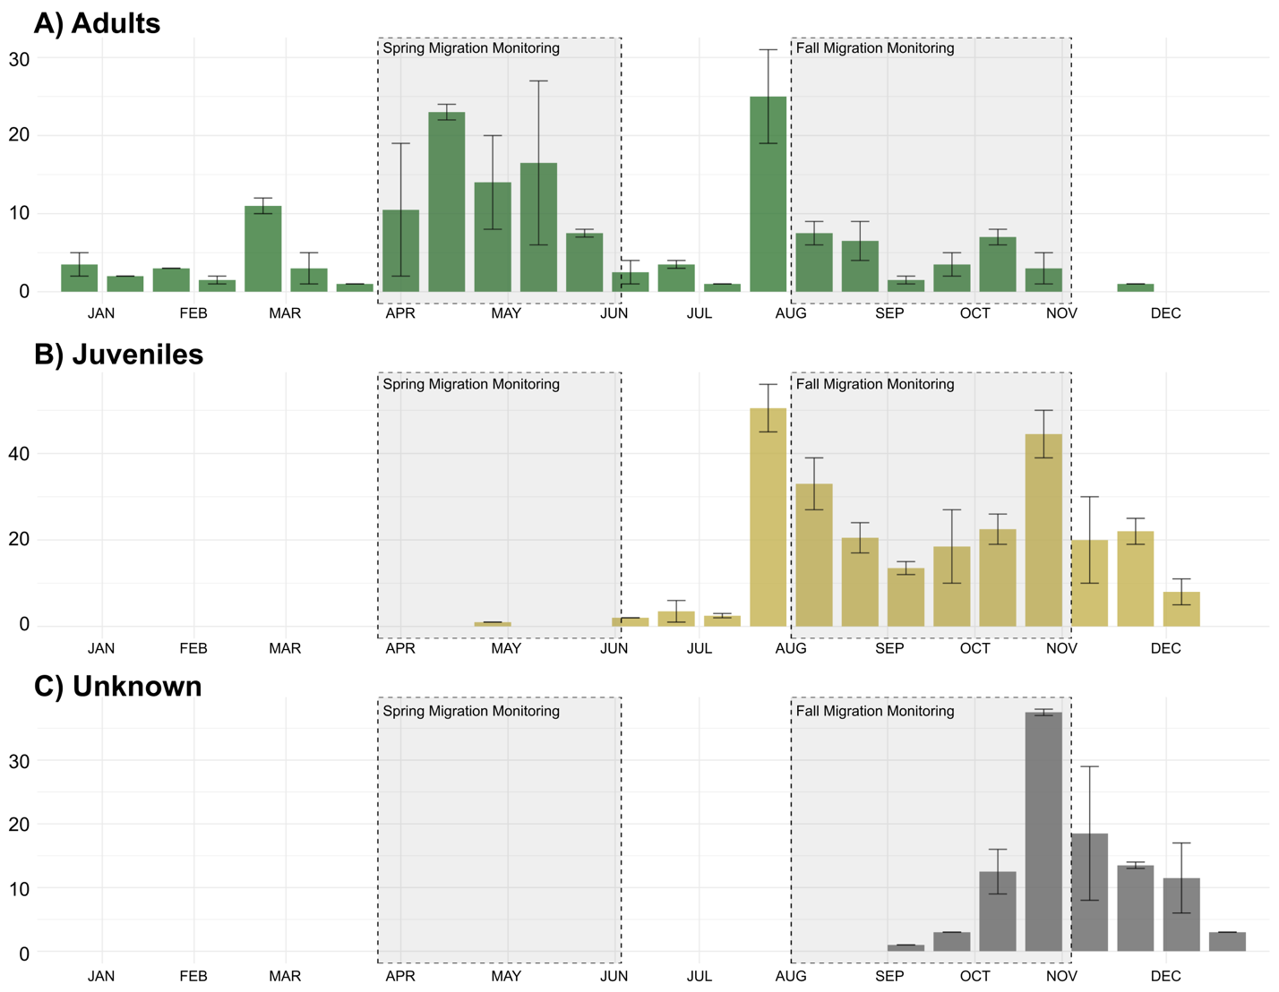Figure S1. Mean number of cardinals captured at the McGill Bird Observatory (peri-urban site) between 2004 and 2022 in Montreal, Quebec, Canada separated by age where A) shows adult birds, B) shows juvenile birds and C) shows unknown individuals.

Table S1. Model ranking using AICc of generalized linear mixed models (GLM) with a comparing scale-of-effect of landscape variables for resighting locations (n= 57) of cardinals tracked across three sites in Montreal, Quebec, Canada. The landscape variables include the mean vegetation height, the standard deviation of the vegetation height, the mean human population density, the road length and the distance to the nearest feeder.
Study site | Model |  | LL | Δ AICc | Wt
Peri-urban | 25 meters  50 meters  100 meters  200 meters |  | -722.48  -713.97  -735.69  -740.60 | 17.02  0.00  53.25  46.96 | 0.00  1.00  0.00  0.00
Suburban | 25 meters  50 meters  100 meters  200 meters |  | -296.05  -338.31  -344.25  -349.92 | 0.00  84.52  96.39  107.73 | 1.00  0.00  0.00  0.00
Urban | 25 meters  50 meters  100 meters  200 meters |  | -211.09  -225.64  -224.02  -228.79 | 0.00  29.11  25.85  35.40 | 1.00  0.00  0.00  0.00

Table S2. AIC values used to determine the best fitting model to explain cardinal’s habitat associations.
Study site |  | Model | Variables | AICc
Peri-urban |  | Full  Vegetation height  Vegetation sd  Human  Null | Mean vegetation height + sd vegetation height + mean population density + road length + distance to nearest feeder + (1|Winter) + (1|ID) + (1|Site)  Mean vegetation height+ (1|Winter) + (1|ID) + (1|Site)  Sd vegetation height+ (1|Winter) + (1|ID) + (1|Site)  Mean population density + road length + distance to nearest feeder+ (1|Winter) + (1|ID) + (1|Site)  (1|Winter) + (1|ID) + (1|Site) | 1443.696  1587.124  1596.077  1588.262  1616.101
Suburban | Full  Vegetation height  Vegetation sd  Human  Null |  | Mean vegetation height + sd vegetation height + mean population density + road length + distance to nearest feeder + (1|Winter) + (1|ID) + (1|Site)  Mean vegetation height+ (1|Winter) + (1|ID) + (1|Site)  Sd vegetation height+ (1|Winter) + (1|ID) + (1|Site)  Mean population density + road length + distance to nearest feeder+ (1|Winter) + (1|ID) + (1|Site)  (1|Winter) + (1|ID) + (1|Site) | 631.7501  728.0640  724.0187  632.1451  726.1005
Urban | Full  Vegetation height  Vegetation sd  Human  Null |  | Mean vegetation height + sd vegetation height + mean population density + road length + distance to nearest feeder + (1|Winter) + (1|ID) + (1|Site)  Mean vegetation height+ (1|Winter) + (1|ID) + (1|Site)  Sd vegetation height+ (1|Winter) + (1|ID) + (1|Site)  Mean population density + road length + distance to nearest feeder+ (1|Winter) + (1|ID) + (1|Site)  (1|Winter) + (1|ID) + (1|Site) | 444.7050  486.6402  485.2496  447.8691  484.8853

