Chapter 2: Northern cardinals (Cardinalis cardinalis) exhibit seasonal changes of onset and end of daily activities in urban areas

Authors: Cousineau, Anne-Marie¹; Frei, Barbara²; Beauchamp, Andrew T.³; Elliott, Kyle H.¹
1: Department of natural Resource Sciences, McGill University, Ste. Anne de Bellevue, Québec, Canada
2: Science and Technology Branch, Environment and Climate Change Canada, Montreal, Québec, Canada
3: Department of Biology, Advanced Facility for Avian Research, University of Western Ontario, London, Ontario, Canada

Abstract
In winter, small endotherms, such as songbirds, face the challenge of maintaining high core body temperature during both acute and chronic cold. They can adjust their behaviour to either spend less time active (indirect energy from activity to heating) or more time active (foraging for energy for heat). To test those ideas, we investigates the effect of two temperature-related dynamic temporal variables (mean lagged temperatures and single-day cold snap events) and other weather-related variables (minimum daily temperatures, maximum daily wind gust speed, precipitations and snow accumulation on the ground), on the winter timing of onset and end of the northern cardinals (Cardinalis cardinalis) daily activities relative to, respectively, sunrise and sunset in Montreal, Canada. Using automated VHF telemetry detections’ signal strength, we identified change point times corresponding to the onset and end of activity for cardinals and assessed the effect of weather and temperatures on activity timing using publicly available weather station measurements. The onset of cardinals’ activity was mostly delayed by chronic cold conditions, but surprisingly, on days of cold snap event ( $≤$ -5 ˚C temperature drop) cardinals advanced the onset of activity by ~14 minutes relative to the baseline, suggesting that they compensate increased energy demands during nighttime by “waking up” 14 minutes earlier, at the cost of being active during the coldest part of the day. Cardinals ended their daily activities earlier during acute cold snap events ( $≤$ -10 ˚C temperature drop) but delayed cessation of activity on warm days, suggesting cardinals restrict their activity on colder days to preserve energy, while exploiting milder conditions to “catch-up” on deficits. Northern cardinals overwintering in urban environments see their daily activities’ timing affected by both climatic and dynamic temporal variables. As urban habitats will most likely face increasingly frequent weather anomalies due to climate change, our results advocate for the need to consider both acute and lagged effects of weather conditions on birds.

Introduction
Animal activity budgets are critical to their fitness. Foraging behaviour, predator avoidance and thermoregulation are all examples of daily activities an animal must balance to survive (Elliott et al., 2009; Majchrzak et al., 2022; Sumasgutner et al., 2023; Visscher et al., 2018). These trade-offs are often intensified when in thermally stressful environments. Both birds and mammals face the opportunity and costs of behavioural thermoregulation (e.g., retreat to cooler microhabitats during a heat wave can limit access to profitable food patches or mating opportunities) (Cunningham et al., 2021).

Fine-scale temporal changes in temperature—such as brief cold snaps or other daily fluctuations—can have important energetic consequences, particularly for small animals with high surface-area-to-volume ratios (Pruitt & Lucier, 1958). For example, research on wintering great tits (Parus major) in southern Sweden showed that the birds with access to predictable food maintained lower body temperatures when subjected to an immune challenge (Watson et al., 2023). The same individuals were also able to revert back to their body temperature baseline in a shorter amount of time compared to great tits that didn’t have access to a predictable food source (Watson et al., 2023). These results suggest that energy availability can mediate thermoregulatory flexibility (Watson et al., 2023). These physiological trade-offs may result in behavioural shifts such as delayed emergence or reduced activity under harsh conditions. However, the degree to which fine-scale temporal temperature variation and recent thermal history—temperature lag—shape such behavioural responses in wild birds remains poorly understood (Schweiger & Frey, 2021).
In cities, species must adjust their daily activities in response to human-altered landscape and everything that comes with it (noise, artificial light at night, altered food availability) (Gumilyov et al., 2023; Silva et al., 2017; Tian et al., 2022). Activity budgets are an interesting metric to examine how wildlife respond to urbanization (Gumilyov et al., 2023; Tian et al., 2022). A striking example of the quick temporal scale at which those changes can occur comes from Spain following COVID-19 lockdown measures, when birds were more detectable (and thus more present) in urban areas, in the early morning (Gordo et al., 2021). This rapid change in behaviour could be driven by the quieter mornings in a usually crowded city (Gordo et al., 2021). In Europe, some early foragers advanced their onset of foraging time following exposition to artificial lighting (Silva et al., 2017). In Germany and Portugal, common woodpigeons (Columba palumbus) had varying time-budgets between seasons with less foraging time in winter compared to the breeding season (Masello et al., 2023). Yet interestingly, woodpigeons allocated more time to foraging in urban areas compared to their forest counterparts, showing that urban habitats can modify the time allocation across seasons (Masello et al., 2023). Such plasticity may interact with environmental stressors such as temperature, especially in winter when thermoregulation is costly and daylight hours are limited.
Similarly, long-term phenomena such as climate change are expected to have effects on animal behaviour. In temperate regions, animals rely on photoperiod and seasonal temperature to regulate behaviour, and climate change has resulted in warmer winters, decreased snow cover and more frequent extreme weather events like sudden cold snaps (Blackport, 2024). These changes impose complex energetic challenges for resident birds that must remain active through shifting and unpredictable conditions. Still, winter ecology remains understudied for many passerine species, especially in urban context where anthropogenic and climatic challenges may interact in non-additive ways (Studd et al., 2021; Sutton et al., 2021).
Small, resident songbirds adjust their daily activities throughout winter to balance energy expenditure. The northern cardinal (Cardinalis cardinalis) is a year-round resident throughout much of the eastern North America does not use torpor, but slightly decrease body temperature in winter, which could lead to a 10-16 % saving in daily energy savings (Schaeffer et al., 2015). This small decrease can potentially have big repercussions on survival, as predictive models indicate that for small wintering birds, a 15% energy saving could increase survival by 33.5% (Brodin et al., 2017). Research on the northern shrike (Lanius borealis) showed that the resting metabolic rate (RMR) measured in winter was 50% higher than the RMRs gathered from summer shrikes (potentially the result of winter acclimatization) (Paruk et al., 2015). In Norway, studies on the activity patterns of the western capercaillie (Tetrao urogallus) showed that birds’ activity was initially restricted to the light hours of the day, with activity peaks near sunset and one in the morning (Gjerde & Wegge, 1987). However, the morning peak of activity almost completely disappears in midwinter as ambient temperature seems to be a more important factor than the photoperiod(Gjerde & Wegge, 1987). By delaying the onset of their daily activities, the capercaillie may avoid unnecessary energy expenditures (Gjerde & Wegge, 1987). In central Maine, United States, turkeys were more likely to remain stationary when temperatures decreased and snow depth increased (Gonnerman et al., 2023). Considering this, we might expect cardinals to delay the onset of their daily activities as ambient temperatures get too cold, to avoid the high energy demand of thermoregulation.
Despite the large body of work on behavioural thermoregulation, few studies have specifically tested how fine-scale temperature variability—including temperature lag and cold snap events—influences the timing of daily activities in free-ranging, resident songbirds in urban areas. Here, we investigate how cardinals adjust the onset and end of their daily activities during winter. We tracked daily activities of cardinals across an urban gradient in Montreal, Quebec, Canada, using automated Motus receiver stations. To investigate how birds manage fine-scale behavioural responses to winter’s variable conditions, automated tracking system such as the Motus Wildlife Tracking System offer unique opportunities (Mckinnon et al., 2019). Motus uses sub-gram radio transmitters to monitor movements of free-ranging birds (Griffin et al., 2025; Mckinnon et al., 2019). Variability in signal strength can reliably indicate the onset and end of daily activities in small songbirds, allowing for detailed examination of daily rhythms in response to weather conditions (Beauchamp et al., 2020; Morales et al., 2022).This study has three objectives: (i) identify temporal scales of effect of cold temperature on northern cardinals, (ii) characterize “cold snap” thresholds where a sudden dip in minimum daily temperature leads to a change in daily activity, and (iii) investigate patterns of climate variables to the daily onset and end of northern cardinal winter activity.
To avoid the thermoregulatory costs of being active during the coldest part of the day,

we predict that the cardinals delay their daily onset of activities relative to sunrise as daily temperature decreases (Gonnerman et al., 2023). Moreover, we expect severe cold temperatures to have a lagging effect on both the onset and end of activity relative to sunrise and sunset, with cardinals starting their daily activities later, while ending their activities earlier for a few days in response to prolonged cold temperatures (Guiden & Orrock, 2020; Martinez, 2000; Prather et al., 2023; Schweiger & Frey, 2021). Finally, we also expect the cardinals to have later onset and earlier end of activities on days when a cold snap occurs, such that cardinal activity will be negatively correlated with those sudden temperature declines (Bissonette, 1978; Zhou et al., 2023).

Materials and methods

Study site and Motus receiver stations
Like chapter 1, this project was done entirely on the island of Montreal, in three locations with varying levels of urbanization (figure 2.1.). Continuously monitoring the cardinals’ movement required the installation of portable and permanent Motus receiver stations. The first Motus tower that we used is located at the McGill Bird Observatory (MBO) and has been deployed in 2015 (45˚25’50.4”N 73˚56’18.6” W). This tower is permanently installed at the banding station and has continuously been collecting data since its installation (meaning it collected data across all three winters of data collection for this project, between 2022 and 2025). The second Motus tower used for this project is also a permanent one, installed on the roof of a building from the McGill University MacDonald campus, deployed in 2018 (45˚24’28.2”N 73˚56’20.3”W). This receiver station was also collecting data through the entirety of the project. The third tower is in the Town of Baie d’Urfé (BDU) in a residential backyard (45˚24’39.3”N 73˚55’48.3”W). This tower was deployed temporarily for the duration of this project only. Because the first winter served as a pilot project and cardinals were only tracked at MBO, the BDU tower was deployed in October 2023 and stayed active until May 2024, before being dismantled and re-deployed in October 2024 until May 2025. Finally, the last tower deployed for this project is located on the roof of a building at the Concordia University Loyola campus (45˚27’32.7”N 73˚38’30.2”W).
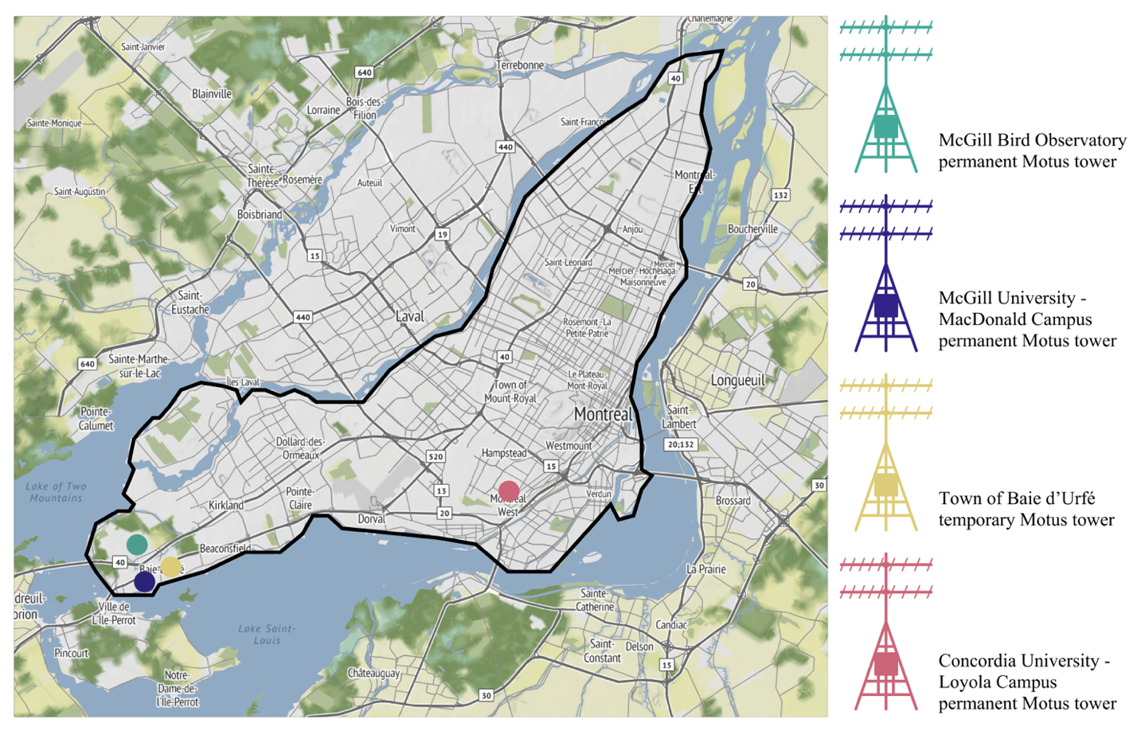Figure 2.1. Location of the Motus towers deployed between 2015 and 2025 on the island of Montreal, Quebec, Canada.

Radio tags deployment and Motus data download
We mist netted northern cardinals (males and females) at the MBO during October and November of the year 2022, 2023 and 2024. The birds were intercepted using 30 mm Japanese Nylon nets and placed in small cotton bags to reduce stress before handling. The individuals were sexed, aged, weighed, banded and randomly assigned to one of the six possible release sites (two sites at MBO, two sites in the Town of Baie d’Urfé and two sites at the Concordia University) for translocation by car. Every cardinal was equipped with a Lotek NanoTag (NTQB-2) weighing 0.8 grams, using soft elastics in a figure 8 harness configuration (the total weight of the tag, harness, and glue was less than 3% of the cardinals’ body weight). All the radio-tags were registered as part of the Motus Wildlife Tracking System (Frei et al., 2024). The birds relocated to the MBO and BDU underwent a holding time of 45 minutes before release to standardize treatment across individuals. During the winter of 2022-2023, 20 individuals fitted with trackers were released. In the following winter (2023-2024), a total of 45 birds were tagged, with 15 individuals relocated to CON, 15 relocated to BDU and 15 relocated to MBO. Finally in 2024-2025, we relocated a total of 42 birds with radio tags, including 5 individuals relocated to MBO, 16 individuals relocated to BDU, and 21 individuals relocated at CON. Birds were banded under Animal Use Protocol 2007-5447 from McGill University and federal banding permits 10973, 10973B, 10973D issued by the Canadian Wildlife Service, and radio-tagged under Animal Use Protocol 22BF01 and 23BF01 from Environment and Climate Change Canada. Upon release, the data from all four Motus towers were regularly downloaded and uploaded to the Motus Wildlife Tracking System portal. The data collected through the three consecutive winters of cardinal tracking were used to determine change point times (onset and end of activity) for all the individuals successfully detected by the Motus receiver towers.

Change point analysis
The onset and end time of diel activity was determined using radio telemetry data collected by the Motus station deployed throughout the Montreal area. Proximity to receiving antenna, transmitter orientation, and environmental obstructions can affect received signal strength, causing high signal strength variation when a tagged individual is active and low signal strength variation during periods of inactivity. Changes in signal strength variation can then be used to determine when a bird becomes active in the morning and quiescent in the evening. Following Morbey et al. (2020), we applied change point analysis to extract the time of activity onset and end based on the characteristic increase and decrease of signal variation respectively. Change points in signal variation were determined using the package “changepoint” in R ver. 4.4.2 (R Core Team, 2024), for the six-hour period centered on local sunrise for activity onset and sunset for activity end (Killick & Eckley, 2014). Sunrise and sunset times were determined for Montréal using the function getSunlightTimes in the package “suncalc” (Thieurmel & Elmarhraoui, 2022).
Unlike previous studies, we extracted activity change points using the combined dataset from multiple stations across the study region. As signals are received near-simultaneous on any stations within range, changes in the variability of received signal strength can be perceived across multiple stations in the same instance. Using the combined regional dataset allowed us to determine activity change points without needing birds to stay within detection range of single focal station or needing to analyse activity data from multiple stations separately. The study region was defined to include all station within the Montréal area, extending from latitudes 44.9655°N to 46.1320°N and longitudes -74.2796°E to -71.9254°E.
Change points were extracted for each day a bird was in the study area by first de-trending values of signal strength (sig) by taking the first differences (d_{i} = sig_{i} - sig_{i-1}, for observation i) for each antenna on each station included in the study area (i.e. figure X). Values of d among all unique antennas were then pooled and sorted by timestamp, after which the square-root of the absolute value of d (sqrt(|d|)) was calculated. This process reduces the major difference in sig among the receiver antennas as well as difference in signal strength from station proximity as birds move throughout the study region. Square root transformation emphasises the difference in the mean and variance of sig between activity states, further demarcating the change in activity pattern (Morbey et al., 2020).
Using separate automated process for the onset and end of activity, we first filtered any onset or end periods with fewer than 800 detections total to exclude periods with poor signal coverage. The function cpt.meanvar was then used to extract a single change point time (cpt) in the mean and variance of sqrt(|d|) within the six-hour period surrounding sunrise or sunset, specifying an asymptotic penalty value of 0.001 and a minimum segment length of 20. These parameters performed well to reliably identify the transition between activity states. For most change points, mean sqrt(|d|) was < 1 before the cpt and > 0.5 after the onset of activity, and mean sqrt(|d|) ranged between 0 and 2 before the cpt and < 1.5 after for the end of activity.
Post cpt extraction, filtering was conducted to exclude questionable change points, attributable primarily to gaps in the detection record. For activity onset change points, we removed any with a pre-cpt mean sqrt(|d|) > 1, post-cpt mean sqrt(|d|) < 0, a pre-cpt mean sqrt(|d|) > post-cpt mean sqrt(|d|), or a pre-cpt variance sqrt(|d|) > post-cpt variance sqrt(|d|). For activity end change points, we removed any with a pre-cpt mean sqrt(|d|) > 0.25, a post-cpt mean sqrt(|d|) > 1, a pre-cpt mean sqrt(|d|) < post-cpt mean sqrt(|d|), or a pre-cpt variance sqrt(|d|) < post-cpt variance sqrt(|d|).

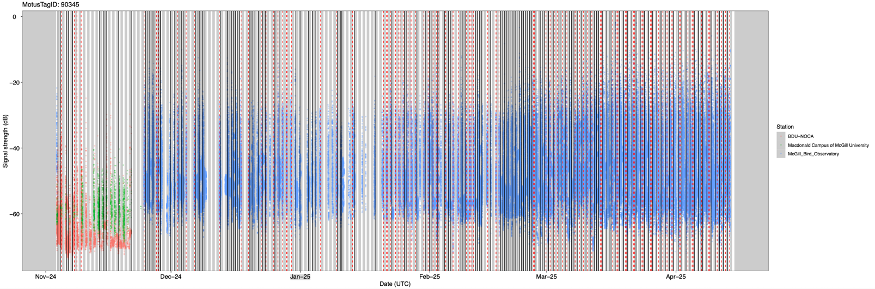
Figure X. Example of the change point times identified for a single bird’s detections in Montreal, Canada. The solid black lines represent the onset and end times identified, while the red dotted lines are change point times that were excluded in the initial post-filtering. The grey areas represent nighttime.

Weather data extraction
To investigate the effects of climate on the cardinal’s daily onset and end of activity, we got free and publicly available weather data from the Pierre-Eliott Trudeau Airport weather station (Environment and Climate Change Canada, 2022). Regarding temperature, we were able to extract data on the minimum daily temperatures (˚C), maximum daily temperatures (˚C) and the average daily temperature (˚C). We initially considered using all three temperature variables as covariates, but since concurvity tests showed that all the temperature variables were highly correlated, we only used the minimum daily temperature moving forward. We were also able to extract the daily precipitations (mm), the amount of snow accumulation on the ground (cm) and the speed of the maximum gust of wind during the day (km/h).
We then assigned the weather data from the newly created dataset to the corresponding dates in two distinct datasets for the onset and end of activity of the birds. We created two dynamic temporal variables: temperature lag and cold snap events. The temperature lags were created by extracting the daily minimum temperature 1 to 5 days before the current date’s temperature, for both the onset and end of activity. Here, we define cold snaps as sudden drops in temperatures between two consecutive days. For each change point time, we determined the difference in daily minimum temperature by subtracting the previous day’s value from the current day’s value. We assigned a binary value to the result according to three different magnitudes of cold snaps. We then categorized these differences into binary variables, based on three thresholds of temperature drops: 5˚C, 7˚C and 10 ˚C. For each threshold, if the temperature drop is equal to, or greater than the specified magnitude, the data entry is assigned a value of 1 (indicating a cold snap event happened). Otherwise, it’s assigned a value of 0 (indicating that the temperature drop wasn’t big enough to be considered a cold snap event). This step was repeated for both the onset and end of activity of the cardinals.

Scale of effect of dynamic temporal variables
The first step was to determine the scale of effect of both dynamic temporal variables, to identify which temperature lag (1 to 5 days) and which cold snap events (-5 ˚C, -7 ˚C or -10 ˚C) have the biggest impact on cardinal’s onset and end of activity. Thus, we fitted a series of generalized additive models (GAMs). The response variable, here “cpt.sr” corresponds to the onset time of activity relative to sunrise (meaning negative values are minutes before sunrise, and positive values are minutes after sunrise), and we included both environmental predictors and individual- and site-level random effects. Specifically, we modeled the effects of minimum daily temperatures (Min_temp), log-transformed precipitations (log_precip), snow accumulation on the ground (Snow_on_grnd), and maximum wind gust speed (Speed_max_gust_wind) using smooth terms. We also included random effect smooth terms for individuals (ID), the years from which the data were collected (Winter) and the study site (Site).
To assess the effects of delayed temperature, we also included smoothed lagged temperature predictors using the mean minimum temperature over the 1 to 5 previous days (Mean_lag1 to Mean_lag5), in addition to the current day’s minimum temperature. Each of these lag models were compared to a “no lag” model and a “null model” including only the random effects. Model selection and comparison were conducted using the Akaike Information Criterion (AICc) values (Burnham & Anderson, 2002). These previous modelling steps were also repeated to investigate the effect of temperature lag on the end of activity of cardinals, by simply replacing the response variable by “cpt.ss”, corresponding to the time of end of activity relative to sunset (meaning negative values are minutes before sunset, and positive values are minutes after sunset). After the most fitting temperature lag variable was established for both the onset and end of activity, we moved on to investigate the effect of cold snaps.
Again, we used GAMs models to examine whether cold snaps were associated with changes in the onset and end of activity. Cold snaps were included in the models as binary fixed-effect predictors, based on the three threshold values described earlier. We fit different models for each threshold (cold_snap5, cold_snap7 and cold_snap10), alongside smoothed terms for the minimum daily temperature, log-transformed precipitations, snow accumulation on the ground, and maximum daily wind gust speed. Once again, site and individuals were included in the models as random effects using smooth terms. Because the cold snap variable is binary, we considered them as linear terms rather than smoothed. All the models were fitted using the mgcv package in R with restricted maximum likelihood (REML) method. Model selection and comparison were also conducted using AICc values (Burnham & Anderson, 2002). Once we selected the best model of the cold snaps, we moved on to investigate the combined effects of daily temperatures, temperature lag and cold snaps altogether.

Modelling the effects of weather conditions and dynamic temporal variables on the onset and end of northern cardinal’s daily activities
Once we identified, for both the onset and end of activity, the best fitting model for the cold snaps and the temperature lag, we created models that investigate the combined effect of those variables on the activity of the cardinals. We also included all the previously mentioned weather variables and fitted a set of 5 different models. To ease reading, only the models for the onset of activity will be described, but the same models were also built for the end of activity. The first model is the “Full model” including all the variables possible (Change Point Sunrise ~ s(Minimum temperature) + s(log(Precipitations)) + s(Snow on the ground) + s(Mean temperature lag 5) + Cold snap 5 + s(Speed of maximum gust of wind) + s(Winter, bs = “re”) + s(ID, bs = “re”) + s(Site, bs = “re”)). The second model is a “Precipitation model” and focuses on both snow and rain (Change Point Sunrise ~ s(log(Precipitations)) + s(Snow on the ground) + s(Mean temperature lag 5) + Cold snap 5 + s(Winter, bs = “re”) + s(ID, bs = “re”) + s(Site, bs = “re”)). The third model we looked at is the “Temperature model”, containing only the temperature variables (Change Point Sunrise ~ s(Minimum temperature) + s(Mean temperature lag 5) + Cold snap 5 + s(Speed of maximum gust of wind) + s(Winter, bs = “re”) + s(ID, bs = “re”) + s(Site, bs = “re”)). The fourth model is the “Extreme temperature” one, including this time solely the temperature lag and cold snap variables (Change Point Sunrise ~ s(Mean temperature lag 5) + Cold snap 5 + s(Winter, bs = “re”) + s(ID, messsbs = “re”) + s(Site, bs = “re”)). Finally, the last model we looked into is the “Null model”, containing only the random effects variables (Change Point Sunrise ~ s(Winter, bs = “re”) + s(ID, bs = “re”) + s(Site, bs = “re”)). Once again, for both the onset and end of activity, we selected the best model using the lowest AICc value (Burnham & Anderson, 2002).

Results

Dynamic temporal variables model selection
The best model for the onset of activity of the cardinals is the 5-day lag model, but it’s only marginally better (< 1 Δ AICc values among all other models; figure 2.2., A). 5-day lag is defined here as the mean temperature over the previous 5 days relative to the current day of onset/end of daily activities. For the end of activity however, the best model is the 2-day lag one by far (> 10 Δ AICc values among all other models; figure 2.2., C). Regarding the cold snaps, the best model for the onset of activity turned out to be the -5 ˚C model (> 5 Δ AICc values among all other models; figure 2.2., B) and the best model for the end of activity was the -10 ˚C one (> 2 Δ AICc values among all other models; figure 2.2., D).
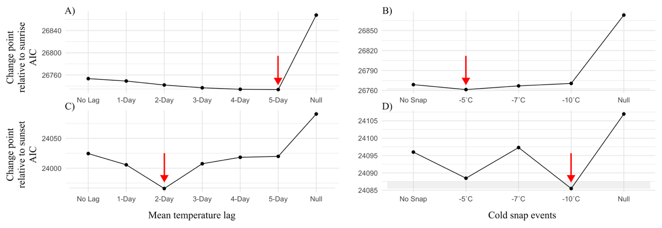
Figure 2.2. Model ranking using AICc of generalized additive models (GAMs) with a comparing scale of effect of mean temperature lag (A, C) and cold snap events (B, D) on the change point timing relative to both sunrise (A, B) and sunset (C, D) of northern cardinals (n = 64) tracked in Montreal, Quebec, Canada between 2022 and 2025. The arrow indicates the best model (lowest AIC value) and the shaded area represents a ∆AICc of 2 points.

Modelling the effect of weather conditions and dynamic temporal variables on cardinal’s daily activities
The best candidate GAM model for the onset of activity of the cardinals was the full model. The full model has a ∆ AIC value of 0 and a 22.5 AIC point difference with the next best model (precipitation model; figure 2.3.). Thus, the full model (Change Point Sunrise ~ s(Minimum temperature) + s(log(Precipitations)) + s(Snow on the ground) + s(Mean temperature lag 5) + Cold snap 5 + s(Speed of maximum gust of wind) + s(Winter, bs = “re”) + s(ID, bs = “re”) + s(Site, bs = “re”)) was selected to move forward with the analyses.
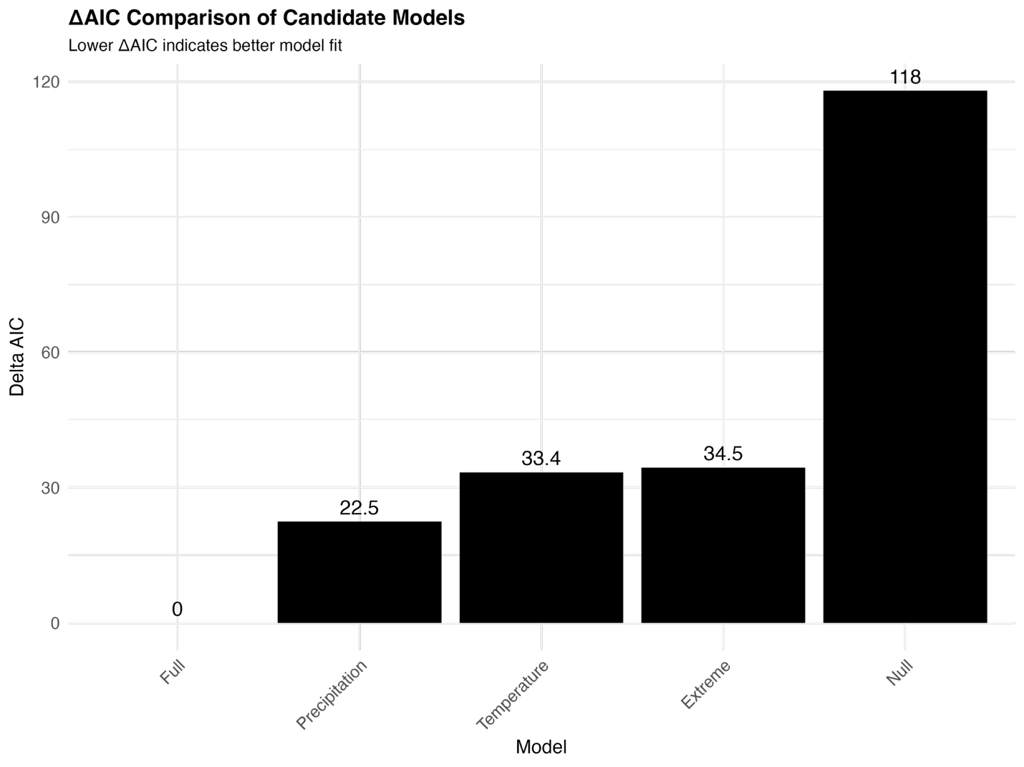Figure 2.3. Comparison of the candidate models for the onset of activity of the birds using ∆ AIC, where a lower score indicates a better model fit.
The intercept of the parametric coefficients has a value of -12.456, meaning that the baseline onset time of activity of the cardinals would be ~ 12 minutes before sunrise, when all predictors are at reference levels (table 2.1.). It’s highly significant, meaning this baseline level is indeed meaningful (table 2.1.). The cold snap -5 ˚C has an estimate value of -14.814, meaning that during cold snap events of at least -5 ˚C, cardinals become active ~ 15 minutes before the baseline (~ 27 minutes before sunrise; table 2.1.).
Out of all the variables explored, minimum daily temperatures, snow accumulation on the ground, 5-day mean temperature lag, maximum daily wind gust speed, birds’ ID and cold snap events of -5 ˚C and below, all had a significant effect on the onset of activity. Minimum temperature has an edf value of ~ 1 and is significant (p = 0.006), showing a linear relationship with the onset of activity (table 2.1.). Snow on the ground has a significant (p = 0.007), non-linear effect (edf = 3.820), indicating that the effect of snow depth has a more complex influence on the onset of activity of the birds (table 2.1.). Mean temperature lag also shows a strong, complex (edf = 5.772) and highly significant (p < 0.001) effect on the cardinal’s onset of activity (table 2.1.). Finally, the speed of maximum gust of wind has a significant (p < 0.001) and non-linear (edf = 4.600) relationship with onset of activity (table 2.1.). On a last note, looking at random effects, we notice that the ID (individual birds) is highly significant (p < 0.001), highlighting large differences among individuals in the onset of their daily activities (table 2.1.). The model explains 14.4% of the deviance, with an adjusted R² of 0.124.
GAMs results revealed that multiple environmental variables significantly influenced the cardinals’ daily onset time of their activities relative to sunrise (figure 2.4.). Minimum daily temperatures had a strong linear negative effect. As the temperature drops, the cardinals start to get active later after sunrise, while warmer temperatures are associated with earlier onset times relative to sunrise (figure 2.4., top left). Snow accumulation on the ground had a non-linear effect: onset time remains stable at low to moderate snow depths, but increased (i.e., onset is delayed) sharply at depths exceeding approximately 30 cm (figure 2.4., top middle). A similar, non-linear relationship is revealed for the 5-days mean temperature lag, with the earliest onset times occurring at intermediate lag values, while both lower and higher lag temperatures were associated with delayed onset of activity relative to sunrise (figure 2.4., top right).
Maximum wind gust speed showed a weak, non-linear relationship with a tendency for onset time to increase, but only at very high wind speeds (> 60 km/h; figure 2.4., bottom left). As for cold snap events (defined as a binary variable), birds did start their days ~ 27 minutes earlier relative to sunrise when cold snap events colder or equal to a -5 ˚C temperature drop (figure 2.4., bottom middle).
Table 2.1. Summary of GAM results (full model) predicting the effects of weather conditions on the onset of activity of northern cardinals.
Parametric coefficients
Terms | Estimate | Standard Error | t value | Pr(>|t|) | Significance
Intercept | -12.456 | 3.316 | -3.756 | < 0.001 | ***
Cold snap -5˚C | -14.814 | 5.121 | -2.893 | 0.004 | **
Smooth terms
Terms | edf | Ref.df | F | p-value | Significance
Minimum temperature | 1.050 | 1.096 | 7.155 | 0.006 | **
log(Precipitations) | 1.011 | 1.023 | 0.698 | 0.402
Snow on the ground | 3.820 | 4.717 | 3.287 | 0.007 | **
Mean temperature lag 5 days | 5.722 | 6.919 | 5.891 | < 0.001 | ***
Speed of maximum gust of wind | 4.600 | 5.464 | 4.634 | < 0.001 | ***
Winter (random effect) | 1.274 | 2.000 | 33.380 | 0.071
ID (random effect) | 41.533 | 63.000 | 3.345 | < 0.001 | ***
Site (random effect) | 0.005 | 2.000 | 0.001 | 0.556

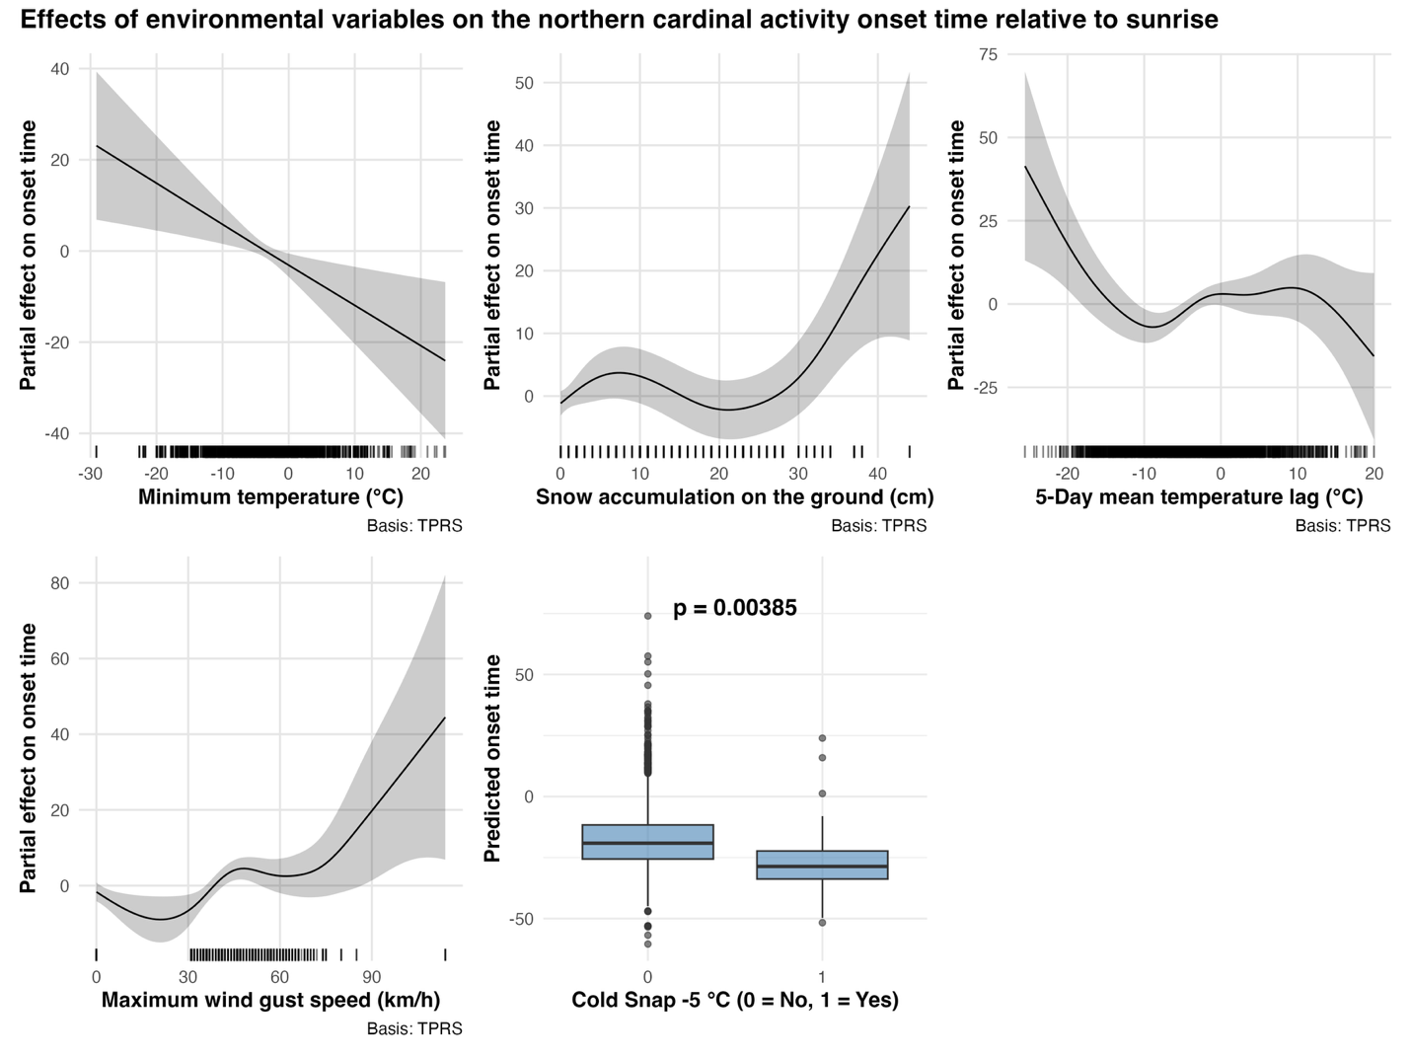Figure 2.4. Partial effect of 5 environmental variables on the northern cardinal’s daily activity onset time relative to sunrise for 64 individuals tracked in Montreal, Quebec, Canada between 2022 and 2025.
The best candidate GAM model for the end of activity of the cardinals turned out to be the temperature model. As shown in figure 2.5., the temperature model has a ∆ AIC value of 0 and a 2.6 AIC point difference with the next best model (full model). Thus, the temperature model (Change Point sunset ~ s(Minimum temperature) + s(Mean temperature lag 2) + Cold snap 10 + s(Speed of maximum gust of wind) + s(Winter, bs = “re”) + s(ID, bs = “re”) + s(Site, bs = “re”)) was selected to move forward with the analyses.
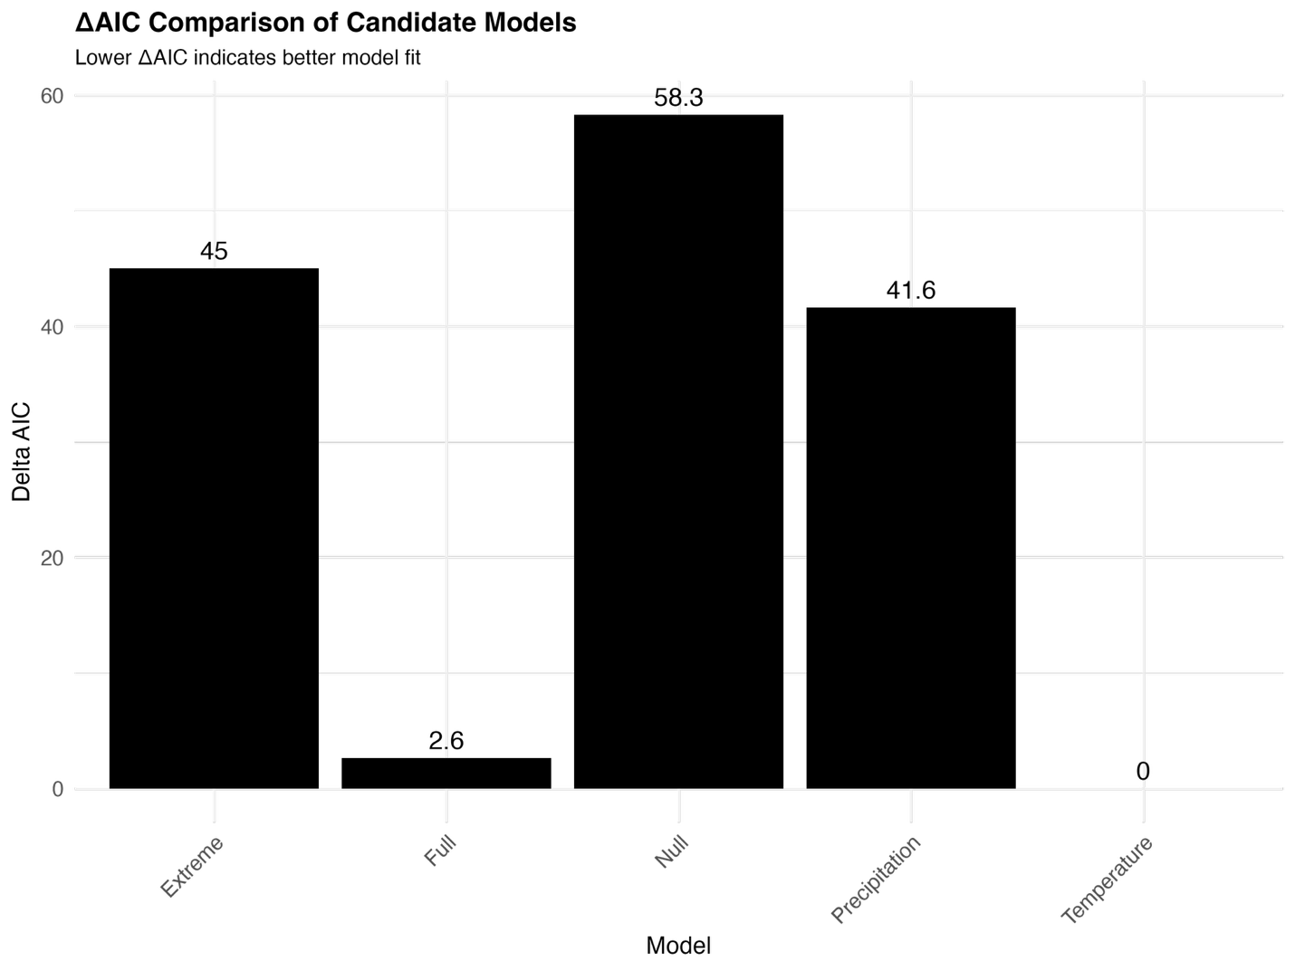Figure 2.5. Comparison of the candidate models for the end of activity of the birds using ∆ AIC, where a lower score indicates a better model fit.
The intercept of the parametric coefficients has a value of 10.465, meaning that the baseline end time of activity of the cardinals would be ~ 10 minutes after sunset, when all predictors are at reference levels (table 2.2.). It’s highly significant, meaning this baseline level is meaningful (table 2.2.). The cold snap -10 ˚C has an estimate value of -42.144, meaning that during cold snap events of at least -10 ˚C, cardinals end their daily activities ~ 42 minutes before the baseline (~ 32 minutes before sunset; table 2.2.).
Among the smooth terms, the speed of maximum gust of wind, the winter and the study site were non-significant (table 2.2.). Minimum temperature shows a strong, significant (p < 0.001) non-linear (edf = 6.371) effect, indicating that end-of-day activity is influenced in a complex way by minimum daily temperatures (table 2.2.). Mean temperature lag also shows a highly significant (p < 0.001) non-linear (edf = 7.901) effect on the cardinal’s end of activity (table 2.2.). Here as well, we notice that the ID (individual birds) is highly significant (p < 0.001), indicating individual variability (table 2.2.). The model explains 7.95% of the deviance, with an adjusted R² of 0.063.
GAMs results demonstrate multiple environmental variables are significantly related to northern cardinal’s end of activity relative to sunset (figure 2.6.). Minimum daily temperatures had a strong non-linear effect. As the temperature drops below zero, the cardinals end their daily activities later after sunset, but once -10 ˚C is reached, the cardinals go back to ending their daily activities closer to the baseline (figure 2.6., left). A non-linear relationship is also revealed for the 2-days mean temperature lag, with cardinals ending their daily activities earlier than sunset when temperatures are colder and ending their day later after sunset when the mean temperature lag of 2 days gets warmer (figure 2.6., middle). As for cold snap events of at least -10 ˚C, birds ended their day approximately half an hour before sunset on days when cold snap events happened, compared to days without cold snap events (figure 2.6., right).
Table 2.2. Summary of GAM results (extreme temperature model) predicting the effects of weather conditions on the end of activity of northern cardinals.
Parametric coefficients
Terms | Estimate | Standard Error | t value | Pr(>|t|) | Significance
Intercept | 10.465 | 1.356 | 7.719 | < 0.001 | ***
Cold snap -10˚C | -42.144 | 10.211 | -4.127 | < 0.001 | ***
Smooth terms
Terms | edf | Ref.df | F | p-value | Significance
Minimum temperature | 6.371 | 7.565 | 5.173 | < 0.001 | ***
Mean temperature lag 2 days | 7.901 | 8.580 | 6.547 | < 0.001 | ***
Speed of maximum gust of wind | 1.002 | 1.005 | 0.201 | 0.655
Winter (random effect) | 0.720 | 2.000 | 1.800 | 0.169
ID (random effect) | 26.099 | 63.000 | 0.966 | < 0.001 | ***
Site (random effect) | 0.007 | 2.000 | 0.002 | 0.436

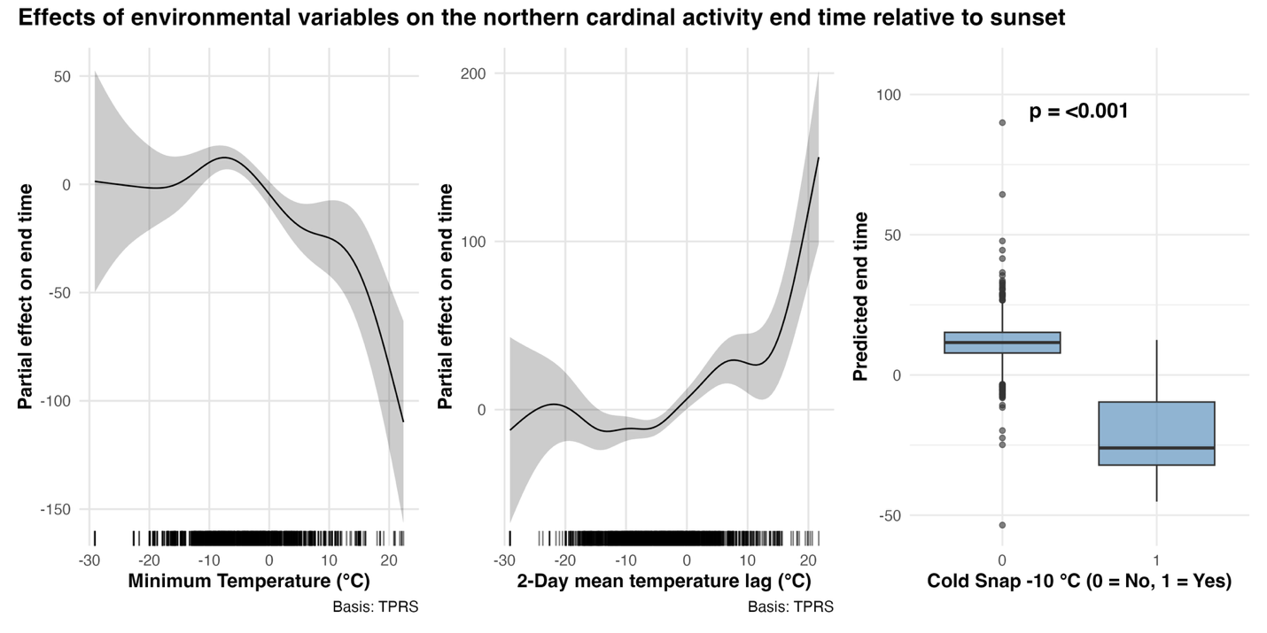Figure 2.6. Partial effect of three significant environmental variables on the northern cardinal’s daily activity end time relative to sunset for 64 individuals tracked in Montreal, Quebec, Canada between 2022 and 2025.

Discussion
In response to chronic, inclement weather (cold temperatures, high winds, high snow accumulation), cardinals started to be active later in the day, suggesting that they conserve energy. However, during cold snap events (drops in temperature of -5 ˚C day-over-day), they start their daily activities earlier, suggesting that they were actively foraging to cope with the acute thermoregulatory stress imposed by the previous night. Cardinals’ end timing of daily activity responded more to acute cold snap events (drops in temperature of -10 ˚C day-over-day) and shorter-term inclement weather, leading the birds to end their day earlier, suggesting that in those conditions, the thermoregulatory costs to keep foraging is not worth the energetic gains. Together, these results highlight the behavioural flexibility of cardinals regarding thermoregulation strategies when wintering in urban environments.

Varying scale of effect of dynamic temporal variables
Both dynamic temporal variables (temperature lag and cold snap events) had a different scale of effect whether looking at the onset or end of the cardinal’s daily activities. Our model selection showed that a temperature lag of five days was best explanatory of the onset time of the cardinals’ activity, while a two-day temperature lag was better at explaining the end time of daily activities. These findings suggest that cardinals respond to temperature cues at distinct timescales, with short-term conditions being more relevant in determining when to begin activity in the morning, and long-term conditions guiding energetic needs related to the cessation of daily activities. Previous research, on larger spatial (across a country) and temporal (annual cycle) scales have demonstrated that there is a lag effect of temperatures on 59 breeding birds of England (Pearce‐Higgins et al., 2015). A negative lagged correlation was found between hot, dry summer weather and birds’ population growth (Pearce‐Higgins et al., 2015). Resident birds’ populations appeared to increase following wet autumn months, and populations of long-distance migrants were negatively affected by May temperatures, reflecting the potential effects of a phenological mismatch in the breeding season (Pearce‐Higgins et al., 2015). More recent work in Sweden and Finland on 24 bird species showed that temperature anomalies from previous winters (lagged effect) had a negative effect on bird's body size (Bosco et al., 2023). Wing length was negatively correlated to temperature anomalies of the previous years, potentially suggesting carry-over effects related survival or dispersal (Bosco et al., 2023). Birds’ body mass was also negatively related to temperature anomalies of the same winter, suggesting this time some more immediate effects, potentially related to reduced fat reserves during the mild winters (Bosco et al., 2023). Bosco’s findings contradict Bergmann’s rule, as they found the birds in southernmost areas were heavier, suggesting that living at higher and colder latitudes cost birds more energy, depleting their fat reserves (thus leading to lighter birds). Our results are broadly aligned with prior work showing that temperature lag can affect different aspect of birds’ life cycle (e.g., Pearce-Higgins et al., 2015; Bosco et al., 2023), yet these studies mostly relied on very large spatial and temporal scales (e.g., multiple years and months, datasets spanning an entire country), whereas we tested for temperature lags over only a few days at a time and over a smaller spatial scale (the city of Montreal, Canada). Other researchers have recognized that there are very few studies investigating the lag effect of temperature on birds’ full life cycle, including both the breeding and non-breeding season (Mainwaring et al., 2021).
Regarding cold snaps events, the model including drops of at least -5 ˚C was best explanatory of the onset time of the birds’ daily activities, while the model including drops of at least -10 ˚C was best to predict the timing of cessation of activity. Our results suggests that more subtle changes in minimum temperatures are enough to have an effect on the timing at which the cardinals begin their days, and conversely the timing at which they end their daily activities depends on more drastic temperature drops. Recent work on 24 North American bird species with historical temperature data showed that during the breeding season, relative fitness was reduced following heatwaves and cold snaps in 11 and 16 of the species studied, respectively (Taff & Shipley, 2023). Taff and Shipley (2023) suggested that species were most vulnerable to extreme temperatures at range limits, which may contribute to shifts in species distribution. For example, eastern bluebirds (Sialia sialis) were vulnerable to heatwaves over most of their distribution range, especially during provisioning, but were only sensitive to cold snaps near their northern range limit (Taff & Shipley, 2023). Our results on the varying scale of effect of cold snap events for daily activities of northern cardinals seem to align with previous findings suggesting that extreme temperature events (specifically cold events) can impact bird to varying degrees and at different stages of their life history.

Colder temperatures are linked to earlier morning activity in northern cardinals
Northern cardinal’s onset of activity varies according to minimum daily temperatures, snow accumulation on the ground, a 5-day mean temperature lag, maximum daily wind gust speed and cold snaps events of -5 ˚C. As minimum daily temperatures drop, cardinals’ onset of activity begins later, and as those temperatures increase, cardinals begin their days earlier. This pattern suggests that cardinals are responsive to immediate thermal cost of activity: colder daily temperatures may push them to delay the onset of activity, potentially to preserve energy. This would be consistent with behavioural thermoregulation seen in other wintering birds (e.g., Gjerde & Wegge, 1987; Gonnerman et al., 2023). Snow accumulation on the ground had a non-linear, yet somewhat similar effect on the onset of activity. It seems that snow depths below 30 cm are not eliciting a strong response from cardinals, but past this apparent threshold, we notice a steep increase of the onset time of activity relative to sunrise (meaning the birds start to get active later when snow cover reaches a certain depth). This could reflect reduced mobility or foraging opportunities as deeper snow can encumbers ground foraging birds such as the northern cardinal (Maccarone, 1987). Heavy snow conditions could potentially increase the cost-benefit ratio of early activity. Maximum daily wind gust speed also has an apparent threshold. Below 60 km/h, there’s seemingly no effect of wind gust speed on the bird’s onset of activity, yet when wind gust speed surpasses 60 km/h, the birds are once again delaying the onset of their daily activities. Our results suggest that cardinals have a window of tolerance for lower wind gust speed. Wind was shown to increase heat loss through convection, increasing thermoregulatory demands, which may drive birds to delay the onset of their morning activities (Walsberg, 1986). When investigating the effect of 5-day mean temperature lag, we see that when mean temperature of the last 5 days are between -10 ˚C and 10 ˚C, there is no apparent effect on the onset of activity. However, when the 5-day mean temperatures go below -10 ˚C, cardinals start their morning activities later after sunrise, and when 5-day mean temperatures go above 10 ˚C, cardinals begin their mornings before sunrise. This pattern may reflect cardinals “catching up” on foraging during milder conditions (starting activity before sunrise) or avoid additional resource depletion during cold spell by delaying the onset of activity. These lag effects of temperatures are consistent with findings in other species, where recent thermal conditions shapes short-term behavioural decisions (Schweiger & Frey, 2021). Interestingly, the effect of cold snap events below or equal to -5 ˚C had a highly significant and unexpected effect on the cardinals’ onset of activities. The birds started their mornings ~15 minutes earlier than the baseline (~12 minutes before sunrise) during cold snaps events, making it a total of ~27 minutes earlier than sunrise. This result contrasts with broader patterns of later onset of activity during harsh conditions and may point to a distinct behavioural strategy (Gjerde & Wegge, 1987; Gonnerman et al., 2023; Taff & Shipley, 2023). One possibility is that the cardinals increase their foraging efforts whenever cold snaps happen in anticipation of higher energy demands due to ambient minimum temperatures going well below zero. On the opposite, this could indicate that the increased energy requirements to keep warm overnight were too steep (despite falling into torpor) meaning the cardinals had to forage earlier the following morning to stay warm and replenish energy, at the cost of being active in the coldest part of the day (Bednekoff & Houston, 1994; Broggi et al., 2007; Evans, 1969; Madsen et al., 2021). Our findings would suggest that cardinals are able to adjust their behaviour not only to preserve energy, but also to proactively meet energetic challenges to come.

Cardinals only end their day earlier if subjected to extreme cold
While we expected colder temperatures to constrain activity duration, our results show that warmer minimum temperatures were associated with an earlier end to daily activities. This could reflect a compensatory response where cardinals reduce their activity duration on warmer days, due to reduced foraging urgence when thermoregulatory costs are lower. These results partially contrasts with other findings in different species such as the common woodpigeon, which showed increased foraging activity in urban areas during winter (Masello et al., 2023). Our results also align with the notion that birds are subjected to the forces of both starvation and predation, and that combined these forces influence daily foraging routines (Bonter et al., 2013; McNamara et al., 1994). Our results may indicate that once cardinals meet their caloric need (usually way before sunset), they tend to end daily activities earlier to avoid predation risk (Bonter et al., 2013; McNamara et al., 1994). There was also a non-linear effect of a 2-day mean temperature lag. Birds initially ended their days earlier following moderately cold temperatures, but this effect decreased as 2-day mean lag temperature reached -20 ˚C, suggesting that feeding was potentially not making up for the energy savings of entering torpor or dropping body temperatures. Such lagged responses could indicate cumulative energetic costs or shifts in foraging strategies to adjust to short-term cold spells. This aligns with similar findings in other songbirds, where cold exposure on multiple days influences behaviour differently compared to single-day exposure (Schweiger & Frey, 2021). Interestingly, we also see that warmer 2-day mean temperatures were associated with later end times. This asymmetry may indicate that while cardinals end their daily routines earlier during cold phases to preserve energy, the also exploit warmer days to extend their daily activities to compensate previous deficits. Finally, the effect of -10 ˚C cold snap events was highly significant and meant that birds would end their daily activities ~42 minutes before the baseline (which is ~ 10 minutes after sunset). This behavioural shift underscores the acute impact of extreme temperature events, seemingly triggering early activity cessation. This pattern is consistent with prior research showing that birds reduce movement and remain more stationary during extreme cold and snow conditions (Gonnerman et al., 2023; Prather et al., 2023). We could also hypothesise that cardinals end their foraging earlier as the energy gain from feeding in extreme cold would not be worth compared to the energy savings of entering torpor earlier. Blem (1975) also suggested that birds may avoid accumulating unnecessary fat reserves during winter (which can lead to increased energetic demands to fly, and thus reduce agility against predators; Blem, 1975) mainly because of predation pressures. Together, these results reveal a complex, asymmetric response of northern cardinals’ activity cessation relative to temperature cues, where short-term (2-day mean temperature lag) and acute cold snap events (-10 ˚C) both affecting the end of daily activities.

Implications
Our findings have shown that northern cardinals in urban environments adjust both the onset and end of their daily activities in response to dynamic temporal variables and climatic conditions. This behavioural plasticity could help counteract acute energy deficits during extreme cold events but may also make them sensitive to the intensity and frequency of such events. As urban environments will most likely experience increasingly frequent weather anomalies due to climate change, our results support the need to consider both acute and lagged effects of weather conditions when investigating winter survival, daily activities and resource use. In addition, understanding fine-scale responses of resident bird species could inform urban stakeholders who wish to maintain accessible foraging resources and thermal refuges to support overwintering bird populations.

Beauchamp, A. T., Guglielmo, C. G., & Morbey, Y. E. (2020). Stopover refuelling, movement and departure decisions in the white-throated sparrow: The influence of intrinsic and extrinsic factors during spring migration. Journal of Animal Ecology, 89(11), 2553–2566. https://doi.org/10.1111/1365-2656.13315
Bednekoff, P. A., & Houston, A. I. (1994). Optimizing Fat Reserves over the Entire Winter: A Dynamic Model. Oikos, 71(3), 408. https://doi.org/10.2307/3545828
Bissonette, J. A. (1978). The Influence of Extremes of Temperature on Activity Patterns of Peccaries. The Southwestern Naturalist, 23(3), 339. https://doi.org/10.2307/3670240
Blackport, R. (2024). Amplified warming of North American cold extremes linked to human-induced changes in temperature variability. 15(5864). https://doi.org/10.1038/s41467-024-49734-8
Blem, C. R. (1975). GEOGRAPHIC VARIATION IN WING-LOADING OF THE HOUSE SPARROW. The Wilson Bulletin, 87(4).
Bonter, D. N., Zuckerberg, B., Sedgwick, C. W., & Hochachka, W. M. (2013). Daily foraging patterns in free-living birds: Exploring the predation–starvation trade-off. Proceedings of the Royal Society B: Biological Sciences, 280(1760), 20123087. https://doi.org/10.1098/rspb.2012.3087
Bosco, L., Otterbeck, A., Fransson, T., Lindén, A., Piha, M., & Lehikoinen, A. (2023). Increasing winter temperatures explain body size decrease in wintering bird populations of Northern Europe—But response patterns vary along the spatioclimatic gradient. Global Ecology and Biogeography, 32(12), 2100–2110. https://doi.org/10.1111/geb.13754
Brodin, A., Nilsson, J.-Å., & Nord, A. (2017). Adaptive temperature regulation in the little bird in winter: Predictions from a stochastic dynamic programming model. Oecologia, 185(1), 43–54. https://doi.org/10.1007/s00442-017-3923-3
Broggi, J., Hohtola, E., Koivula, K., Orell, M., Thomson, R. L., & Nilsson, J. ‐Å. (2007). Sources of variation in winter basal metabolic rate in the great tit. Functional Ecology, 21(3), 528–533. https://doi.org/10.1111/j.1365-2435.2007.01255.x
Burnham, K. P., & Anderson, D. R. (2002). Model Selection and Multimodel Inference (2nd ed.).
Cunningham, S. J., Gardner, J. L., & Martin, R. O. (2021). Opportunity costs and the response of birds and mammals to climate warming. Frontiers in Ecology and the Environment, 19(5), 300–307. https://doi.org/10.1002/fee.2324
Elliott, Woo, K. J., & Benvenuti, S. (2009). Do activity costs determine foraging tactics for an arctic seabird? Marine Biology, 156(9), 1809–1816. https://doi.org/10.1007/s00227-009-1214-1
Environment and Climate Change Canada. (2022). Daily Weather Data Report [Dataset]. https://climate.weather.gc.ca/climate_data/daily_data_e.html?hlyRange=2008-01-08%7C2025-07-22&dlyRange=2002-12-23%7C2025-07-22&mlyRange=%7C&StationID=30165&Prov=QC&urlExtension=_e.html&searchType=stnName&optLimit=specDate&StartYear=1840&EndYear=2025&selRowPerPage=25&Line=0&searchMethod=contains&Month=7&Day=16&txtStationName=Trudeau&timeframe=2&Year=2025
Evans, P. R. (1969). Winter Fat Deposition and Overnight Survival of Yellow Buntings (Emberiza citrinella L.). The Journal of Animal Ecology, 38(2), 415. https://doi.org/10.2307/2781
Frei, B., Morales, A., Cousineau, A.-M., & Beauchamp, A. (2024). Montreal Northern Cardinal Winter Movements (Project 882) [Dataset]. Motus Wildlife Tracking System, Birds Canada. https://motus.org/
Gjerde, I., & Wegge, P. (1987). Activity patterns of Capercaillie, Tetrao urogallus, during winter. Ecography, 10(4), 286–293. https://doi.org/10.1111/j.1600-0587.1987.tb00770.x
Gonnerman, M., Shea, S. A., Sullivan, K., Kamath, P., Overturf, K., & Blomberg, E. (2023). Dynamic winter weather moderates movement and resource selection of wild turkeys at high‐latitude range limits. Ecological Applications, 33(1), e2734. https://doi.org/10.1002/eap.2734
Gordo, O., Brotons, L., Herrando, S., & Gargallo, G. (2021). Rapid behavioural response of urban birds to COVID-19 lockdown. Proceedings of the Royal Society B: Biological Sciences, 288(1946), 20202513. https://doi.org/10.1098/rspb.2020.2513
Griffin, A. S., Gapes, C., Williams, L. A., Taylor, M., Kyte, R., Little, G., & Little, J. (2025). Using motus automated telemetry to quantify habitat use and movement in a Far Eastern Curlew within the Hunter Estuary, NSW, Australia.
Guiden, P. W., & Orrock, J. L. (2020). Seasonal shifts in activity timing reduce heat loss of small mammals during winter. Animal Behaviour, 164, 181–192. https://doi.org/10.1016/j.anbehav.2020.04.014
Gumilyov, L. N., Byulegenova, B. B., & Turemuratov, O. Zh. (2023). Urbanization as a global trend: Causes and consequences. 142(1), 37–42. https://doi.org/10.32523/2616-6887/2023-142-1-37-42
Killick, R., & Eckley, I. A. (2014). changepoint: An R Package for Changepoint Analysis. Journal of Statistical Software, 58, 1–19. https://doi.org/10.18637/jss.v058.i03
Maccarone, A. D. (1987). Effect of Snow Cover on Starling Activity and Foraging Patterns. The Wilson Bulletin, 99(1), 94–97.
Madsen, A. E., Vander Meiden, L. N., & Shizuka, D. (2021). Social partners and temperature jointly affect morning foraging activity of small birds in winter. Behavioral Ecology, 32(3), 407–415. https://doi.org/10.1093/beheco/araa134
Mainwaring, M. C., Nord, A., & Sharp, S. P. (2021). Editorial: The Impact of Weather on the Behavior and Ecology of Birds. Frontiers in Ecology and Evolution, 9, 777478. https://doi.org/10.3389/fevo.2021.777478
Majchrzak, Y. N., Peers, M. J. L., Studd, E. K., Menzies, A. K., Walker, P. D., Shiratsuru, S., McCaw, L. K., Boonstra, R., Humphries, M., Jung, T. S., Kenney, A. J., Krebs, C. J., Murray, D. L., & Boutin, S. (2022). Balancing food acquisition and predation risk drives demographic changes in snowshoe hare population cycles. Ecology Letters, 25(4), 981–991. https://doi.org/10.1111/ele.13975
Martinez, C. (2000). Daily activity patterns of Great Bustards Otis tarda. Ardeola, 47(1), 57–68.
Masello, J. F., Rast, W., Schumm, Y. R., Metzger, B., & Quillfeldt, P. (2023). Year-round behavioural time budgets of common woodpigeons inferred from acceleration data using machine learning. Behavioral Ecology and Sociobiology, 77(4), 40. https://doi.org/10.1007/s00265-023-03306-w
Mckinnon, E. A., Laplante, M.-P., Love, O. P., Fraser, K. C., Mackenzie, S., & Vézina, F. (2019). Tracking Landscape-Scale Movements of Snow Buntings and Weather-Driven Changes in Flock Composition During the Temperate Winter. Frontiers in Ecology and Evolution, 7, 329. https://doi.org/10.3389/fevo.2019.00329
McNamara, J. M., Houston, A. I., & Lima, S. L. (1994). Foraging Routines of Small Birds in Winter: A Theoretical Investigation. Journal of Avian Biology, 25(4), 287. https://doi.org/10.2307/3677276
Morales, A., Frei, B., Mitchell, G. W., Bégin-Marchand, C., & Elliott, K. H. (2022). Reduced diurnal activity and increased stopover duration by molting Swainson’s Thrushes. Ornithology, 139(2), ukab083. https://doi.org/10.1093/ornithology/ukab083
Morbey, Y. E., Beauchamp, A. T., Bonner, S. J., & Mitchell, G. W. (2020). Evening locomotor activity during stopover differs on pre-departure and departure days in free-living songbirds. Journal of Avian Biology, 51(11). https://doi.org/10.1111/jav.02448
Paruk, J., Cooper, S., Mangan, A., Brady, R., & Tucker, L. (2015). Resting Metabolic Rates of Adult Northern Shrikes (Lanius excubitor) Wintering in Northern Wisconsin. WILSON JOURNAL OF ORNITHOLOGY, 127(3), 510–514.
Pearce‐Higgins, J. W., Eglington, S. M., Martay, B., & Chamberlain, D. E. (2015). Drivers of climate change impacts on bird communities. Journal of Animal Ecology, 84(4), 943–954. https://doi.org/10.1111/1365-2656.12364
Prather, R. M., Dalton, R. M., Barr, B., Blumstein, D. T., Boggs, C. L., Brody, A. K., Inouye, D. W., Irwin, R. E., Martin, J. G. A., Smith, R. J., Van Vuren, D. H., Wells, C. P., Whiteman, H. H., Inouye, B. D., & Underwood, N. (2023). Current and lagged climate affects phenology across diverse taxonomic groups. Proceedings of the Royal Society B: Biological Sciences, 290(1990), 20222181. https://doi.org/10.1098/rspb.2022.2181
Pruitt, W. O., & Lucier, C. V. (1958). Winter Activity of Red Squirrels in Interior Alaska. Journal of Mammalogy, 39(3), 443. https://doi.org/10.2307/1376165
R Core Team. (2024). R: A Language and Environment for Statistical Computing (Version 4.4.2) [Computer software]. R Foundation for Statistical Computing. https://www.R-project.org/
Schaeffer, P., Komer, M. C., & Corder, K. (2015). Energy savings due to the use of shallow body temperature reduction in overwintering Northern Cardinals. ResearchGate, 3(1). https://doi.org/10.1186/s40317-015-0078-z
Schweiger, B. R., & Frey, J. K. (2021). Weather determines daily activity pattern of an endemic chipmunk with predictions for climate change. Climate Change Ecology, 2, 100027. https://doi.org/10.1016/j.ecochg.2021.100027
Silva, A. D., Diez-Méndez, D., & Kempenaers, B. (2017). Effects of experimental night lighting on the daily timing of winter foraging in common European songbirds. Journal of Avian Biology, 48(6), 862–871. https://doi.org/10.1111/jav.01232
Studd, E. K., Bates, A. E., Bramburger, A. J., Hayden, B., Henry, H. A. L., Humphries, M. M., Martin, R., McMeans, B., Moise, E., O’Sullivan, A., Sharma, S., Sinclair, B., Sutton, A. O., Templer, P. H., & Cooke, S. J. (2021). Nine maxims for winter ecology. BioScience, 71(8), 820–830. https://doi.org/10.1093/biosci/biab032
Sumasgutner, P., Cunningham, S. J., Hegemann, A., Amar, A., Watson, H., Nilsson, J. F., Andersson, M. N., & Isaksson, C. (2023). Interactive effects of rising temperatures and urbanisation on birds across different climate zones: A mechanistic perspective. Global Change Biology, 29(9), 2399–2420. https://doi.org/10.1111/gcb.16645
Sutton, A. O., Studd, E. K., Fernandes, T., Bates, A. E., Bramburger, A. J., Cooke, S. J., Hayden, B., Henry, H. A. L., Humphries, M. M., Martin, R., McMeans, B., Moise, E., O’Sullivan, A. M., Sharma, S., & Templer, P. H. (2021). Frozen out: Unanswered questions about winter biology. Environmental Reviews, 29(4), 431–442. https://doi.org/10.1139/er-2020-0127
Taff, C. C., & Shipley, J. Ryan. (2023). Inconsistent shifts in warming and temperature variability are linked to reduced avian fitness. Nature Communications, 14(1), 7400. https://doi.org/10.1038/s41467-023-43071-y
Thieurmel, B., & Elmarhraoui, A. (2022). suncalc: Compute Sun Position, Sunlight Phases, Moon Position and Lunar Phase (Version 0.5.1) [R packag]. https://CRAN.R-project.org/package=suncalc
Tian, Y., Tsendbazar, N.-E., van Leeuwen, E., Fensholt, R., & Herold, M. (2022). A global analysis of multifaceted urbanization patterns using Earth Observation data from 1975 to 2015. Landscape and Urban Planning, 219, 104316. https://doi.org/10.1016/j.landurbplan.2021.104316
Tobolka, M., Zolnierowicz, K. M., & Reeve, N. F. (2015). The effect of extreme weather events on breeding parameters of the White Stork Ciconia ciconia. Bird Study, 62(3), 377–385. https://doi.org/10.1080/00063657.2015.1058745
Visscher, D. R., Unger, A., Grobbelaar, H., & DeWitt, P. D. (2018). Bird foraging is influenced by both risk and connectivity in urban parks. Journal of Urban Ecology, 4(1), juy020. https://doi.org/10.1093/jue/juy020
Walsberg, G. E. (1986). Thermal Consequences of Roost-site Selection: The Relative Importance of Three Modes of Heat Conservation. The Auk, 103(1), 1–7. https://doi.org/10.1093/auk/103.1.1
Watson, H., Nilsson, J., & Nilsson, J. F. (2023). Thermoregulatory costs of the innate immune response are modulated by winter food availability in a small passerine. Journal of Animal Ecology, 92(5), 1065–1074. https://doi.org/10.1111/1365-2656.13914
Zhou, R., Hua, R., Tang, Z., & Hua, L. (2023). Daily and Seasonal Activity Patterns of Plateau Pikas (Ochotona curzoniae) on the Qinghai–Tibet Plateau, China, and Their Relationship with Weather Condition. Animals, 13(10), 1689. https://doi.org/10.3390/ani13101689

